

Faculty of Engineering

Cairo University

Computer Engineering Department

Snakino

An Embedded Systems Project

Submitted to:

Dr. Bassem Ibrahim

Table of Contents

Team Members 4

Introduction 5

Components Description 6

Arduino UNO 6

Description 6

Specifications 6

Reason of usage 6

Schematic 7

Price 7

8x8 Led Matrix + MAX7219 module 7

Description 7

Specifications 7

Reason of usage 8

Schematic 8

Wiring Instructions 8

Price 8

Analog Joystick 8

Description 8

Specifications 9

Reason of usage 9

Schematic 9

Wiring Instructions 9

Price 9

Buzzer 10

Description 10

Specifications 10

Reason of usage 10

Schematic 10

Wiring Instructions 10

Price 10

Design Models 11

Functional Diagram 11

Timing Diagram 12

Finite State Machine 13

Sequence Chart 14

Design Schematic 15

Real connections view 16

# Team Members

|  |  |  |
| --- | --- | --- |
| Name | Section | Bench Number |
| Ahmed Nasser Ahmed Abdrabo | 1 | 8 |
| Ahmed Hisham Eid Elmorsy | 1 | 9 |
| Abdelrahman Ahmed Mohamed Farid | 1 | 33 |
| Youssef Walid Hassan | 2 | 34 |

# Introduction

Snakino is a 2-player snake game, where each player competes against the other, the end-goal of the game for a player is to survive longer than the other player.

Each player controls his/her snake using an analog joystick, if a player hits the wall of the grid or hits the other snake, he/she loses.

Food is spawned across the grid in random points, any snake eats that food will have its length increase by one, which will make it harder for the other player to navigate across the map, and will make it easier for the longer snake to win the game.

Whenever the game ends, a buzzer will play different sound tones. If it buzzes once, it means that player 1 won the game, if it buzzes twice, it means that player 2 won the game.

At the beginning of each game, each player must signal that he is ready by clicking on the button on the analog stick.

If the power to the microcontroller is lost, the game will resume at the place it was at when the power returns, each player must signal that he/she is ready again before resuming the game.

# Components Description

## Arduino UNO

### Description

Arduino Uno is a microcontroller board based on the ATmega328P (datasheet). It has 14 digital input/output pins (of which 6 can be used as PWM outputs), 6 analog inputs, a 16 MHz ceramic resonator (CSTCE16M0V53-R0), a USB connection, a power jack, an ICSP header and a reset button. It contains everything needed to support the microcontroller; simply connect it to a computer with a USB cable or power it with AC-to-DC adapter or battery to get started. You can tinker with your Uno without worrying too much about doing something wrong, worst-case scenario you can replace the chip for a few dollars and start over again.

### Specifications

* Microcontroller: ATmega328
* Operating Voltage: 5V
* Input Voltage (recommended): 7-12V
* Input Voltage (limits): 6-20V
* Digital I/O Pins: 14 (of which 6 provide PWM output)
* Analog Input Pins: 6
* DC Current per I/O Pin: 40 mA
* DC Current for 3.3V Pin:50 mA
* Flash Memory: 32 KB (ATmega328) of which 0.5 KB used by bootloader
* SRAM: 2 KB (ATmega328)
* EEPROM: 1 KB (ATmega328)
* Clock Speed: 16 MHz

### Reason of usage

Used to coordinate components and control the system.

### Schematic

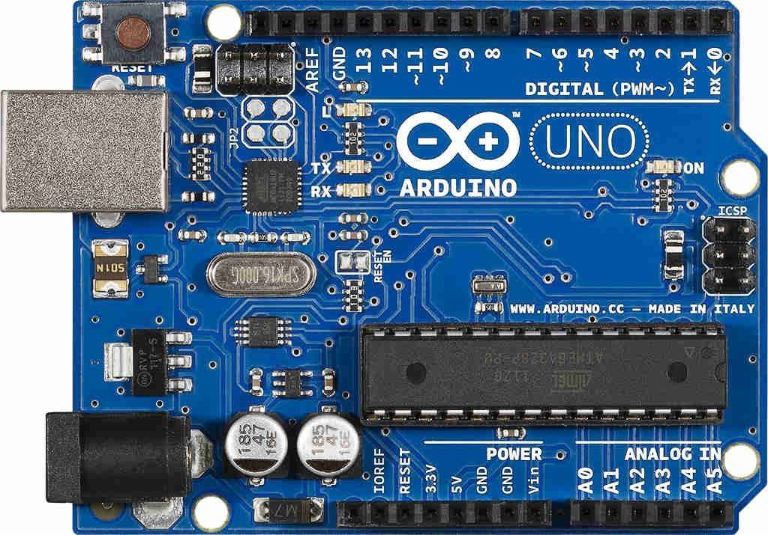

Figure 1: Arduino Uno

### Price

EGP 155

## 8x8 Led Matrix + MAX7219 module

### Description

An 8x8 cathode red led matrix, powered with a MAX7219 module which interfaces with the led matrix and keeps the state recorded on the state.

### Specifications

* A single module can drive an 8 x 8 common cathode lattice
* Operating voltage: 5V
* Size: 5 x 3.2 x 1.5 cm (L x W x H)
* LED color: red
* With four screws hole, aperture 3mm
* With input and output interfaces, supports multiple modules cascade

### Reason of usage

4 of this are used to display the game on a 16x16 led matrix.

### Schematic

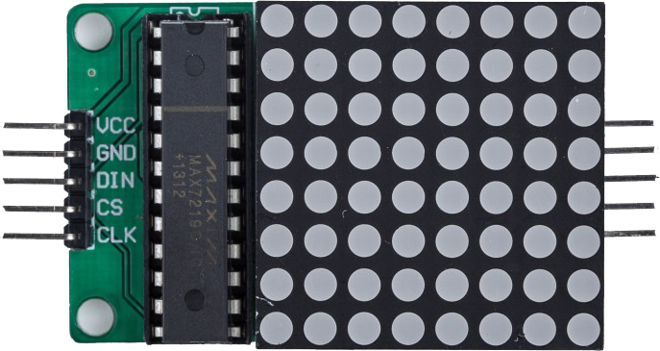

Figure 2: 8x8 Led Matrix + MAX7219

### Wiring Instructions

* VCC: Connected to a 5V source
* GND: Connected to ground source
* DIN: SPI DIN pin
* CS: Chip select SPI pin
* CLK: Clock SPI pin.

Multiple MAX7219 can be connected with each other in a daisy-chain fashion and we will only need to interface with one through the Arduino.

### Price

55 EGP

## Analog Joystick

### Description

An analog stick with a clickable button that gives the X and Y offset through an analog output to the Arduino.

### Specifications

* Power: 0.01W
* Interface: Dual 10K potentiometers with common ground
* Operating temp range: +32°F to +158°F (0°C to +70°C)

### Reason of usage

2 of this are used to control the direction of movement of each snake

### Schematic

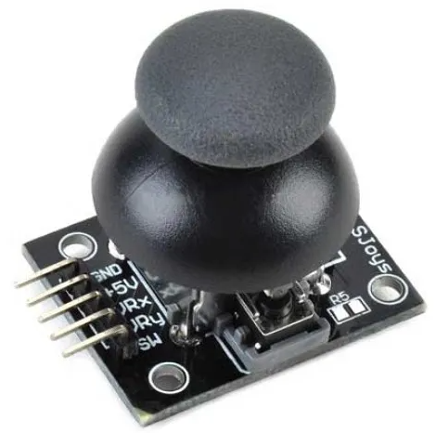

Figure 3: Analog Joystick

### Wiring Instructions

* GND: ground
* +5V: 5V DC
* VRx: voltage proportional to x position
* VRy: voltage proportional to y position
* SW: switch pushbutton

### Price

50 EGP

## Buzzer

### Description

A 6v buzzer

### Specifications

* Rated Frequency: 4,100Hz
* Operating Voltage: 6 Vdc
* Current Consumption: 7mA @ 6Vdc
* Sound Pressure Level(30cm): 70dB @ 6Vdc
* Dimensions: 13mm Diameter, 7mm High, Pin Spacing – 7mm.
* Label Color: Blue

### Reason of usage

One of this is used to indicate who won the game, and to indicate which player clicked ready.

### Schematic

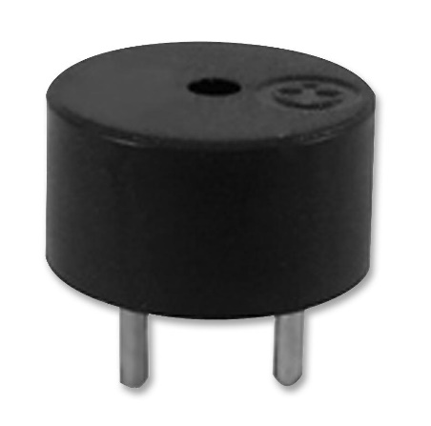

Figure 4: 6V Buzzer

### Wiring Instructions

* 6V pin: Connected to high voltage
* GND pin: Connected to ground

### Price

5 EGP

# Design Models

## Functional Diagram

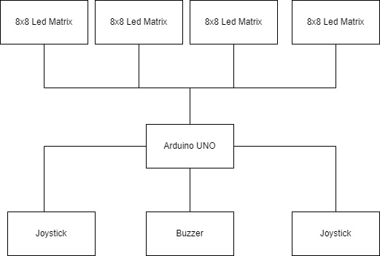

Figure 5: Functional Diagram

The microcontroller works as the middle layer between the inputs of the joystick and the outputs of each led matrix and the buzzer.

## Timing Diagram

The system is event based, we regularly check joystick inputs, calculate the new system states if one game step has passed, and then we print the new system states over to the led matrices.

The system can only process one event at a time, but because there is no blocking operations in the code, the game functions as if everything is asynchronous.

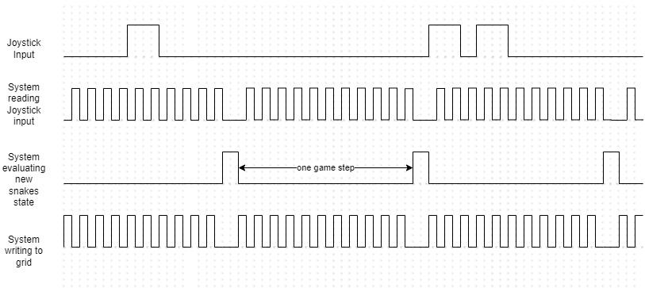

Figure 6: Timing Diagram

## Finite State Machine

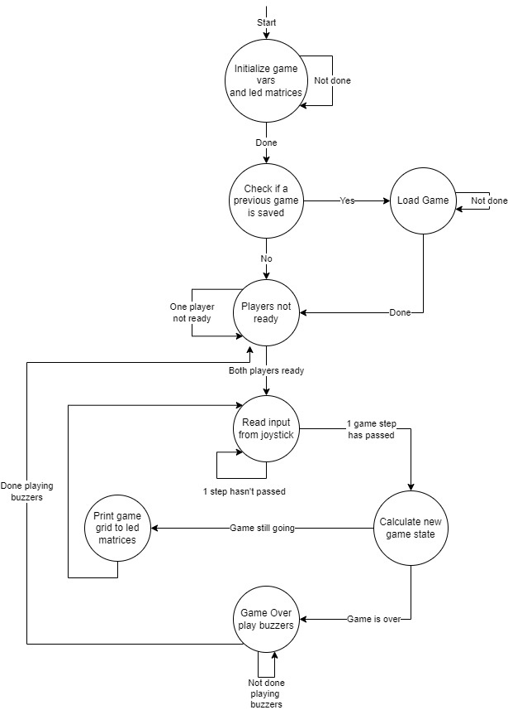

Figure 7: Finite State Machine

## Sequence Chart

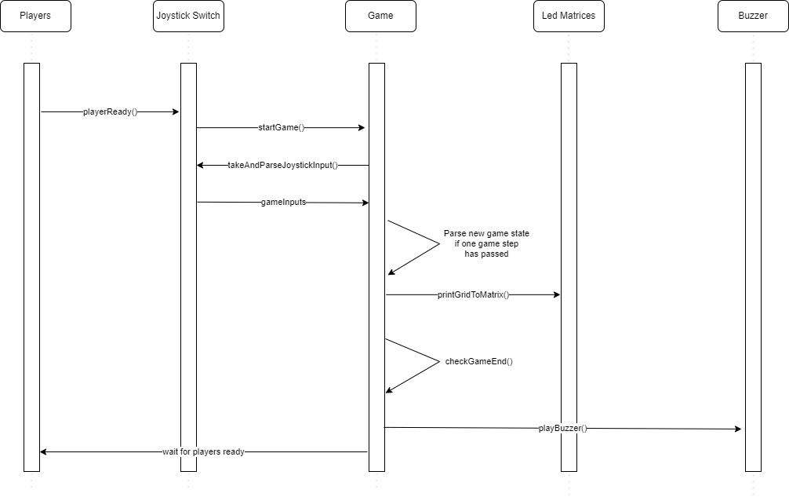

Figure 8: Sequence Chart

## Design Schematic

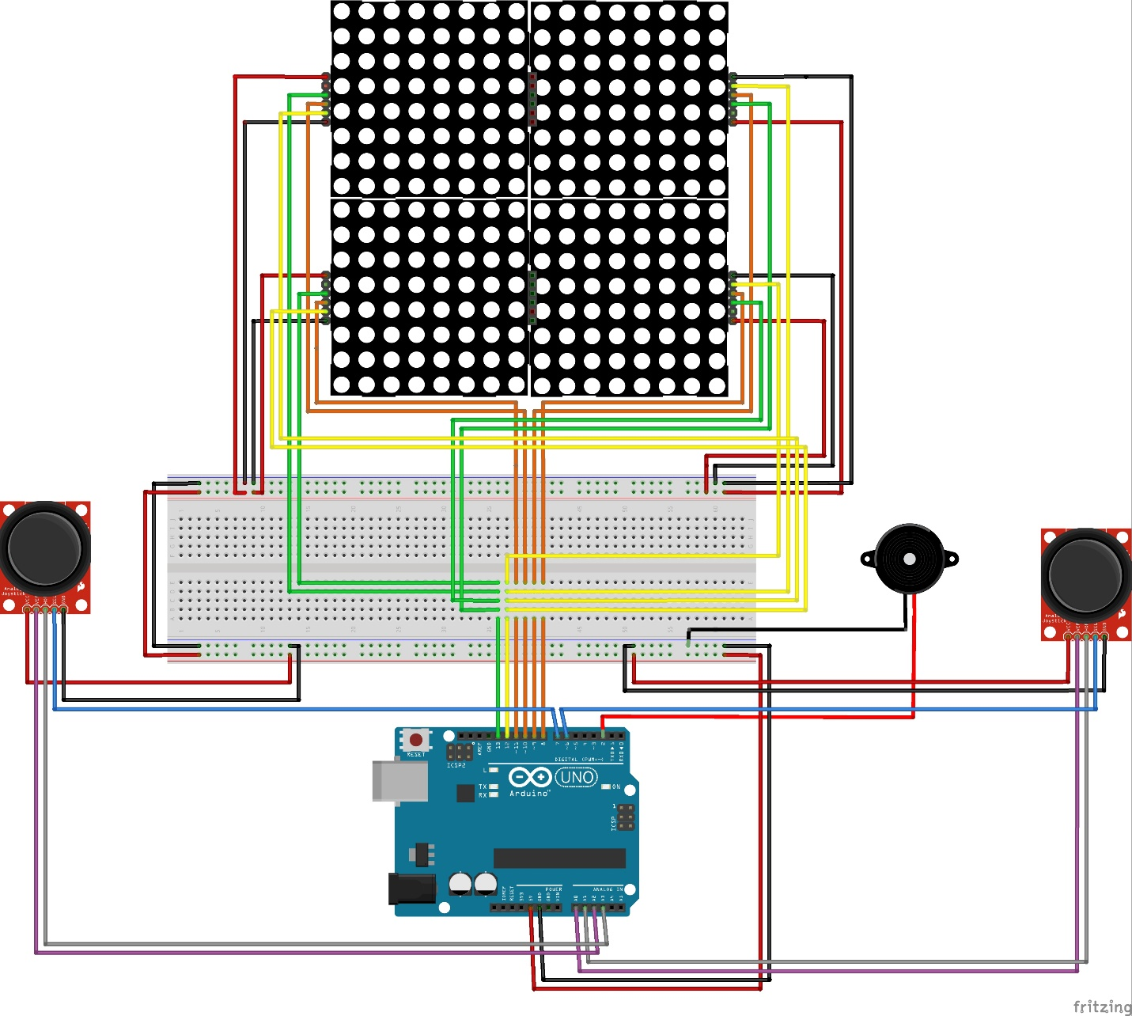

Figure 9: Design Schematic

## Real connections view

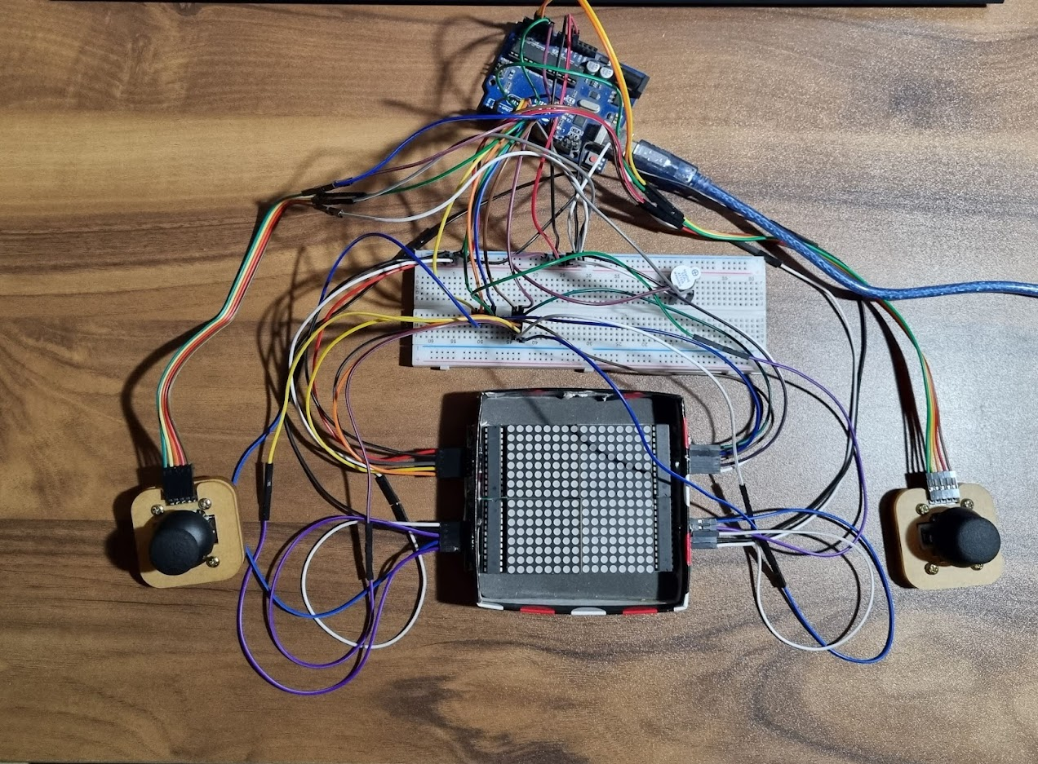

Figure 10: Real connections view