Technical:

Stock has an average low, high, closed date etc.

In forex

Brief reason why I am interested leveraging algorithms and deep learning on currencies.

*Regarding on the currency trading several factors has to be considered.*

As recent trump presidency, stock markets are very causation on his policy as well as the global market. To execute the “Make America Great Again: agenda, Trump Trade calls for a 45% tariff against Chinese products and 35% tariff against goods from Mexico (according to Forbes on Trump trade adviser).

*- 50Billion investment from Japan Softbank.*

*- Raising taxes on the riches*

*Trade war between China*

- America trade deficit

- No to TPP

- fall in china currency

*China One belt one road, a development infrastructure connecting with Eurasia.* That is a 65% of sworld’s population and 1/3 of world GDP according to Kevin Sneader, Senior partners at McKinsey Singapore. The project requires roughly 2 to 3 trillion per year raising by AIIB in Hong Kong.

- Slowing down of the China econ

*One suggested the trump effect would benefit Africa.*

Last but no least, *Brexit shorts in their sterlings* after Theresa May’s commitment during mid Jan. Streling value fell steeply against dollar.

Therefore, I am interested to explore the currencies trading between nations, because there are lots of currencies flowing from different directions.

Not to mention, reshaping hea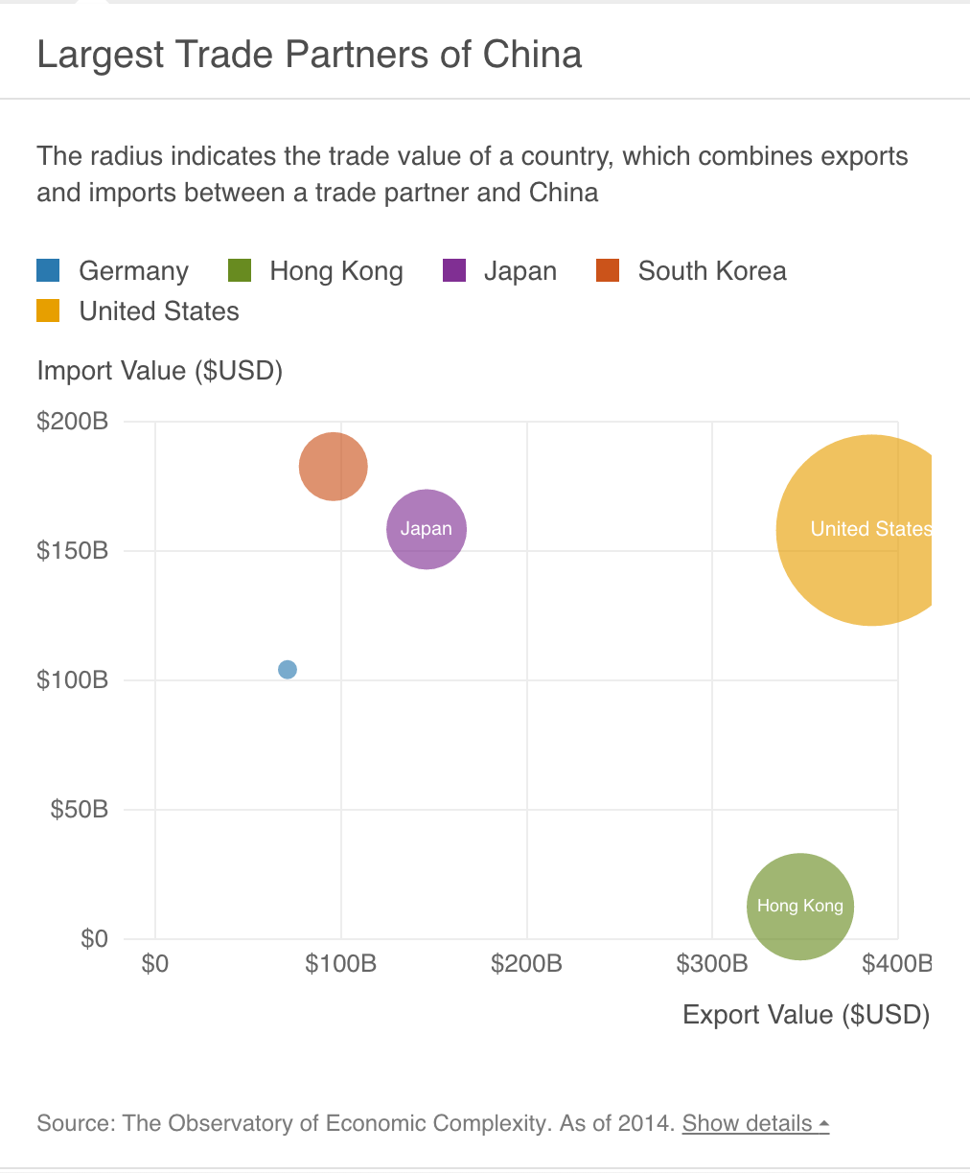lth care

**Data types:**

Most of the financial

Date,Bid High,Ask High,Bid Low,Ask Low,Bid Average,Ask Average

Other comes in :

Name ,Type (such as put, call or option), Global X , Opt out Currency, Clear point, changes

**Technically**

Candlestick plotting is one of the major ways for the technical traders to use on their trades

Currencies are traded in pips – the little points that moves up or down.

RRL methods produced more stable results than those using Q-learning methods and were also less complex computationally. They also found that a good choice of objective function was vital in order to achieve optimal performance.

However, when it was dipping deeper on this topic, Using Recurrent Neural Networks To Forecasting of Forex V.V.Kondratenko1 and Yu. A Kuperin2 suggested. “First, neural networks analysis does not presume any limitations on type of input

information as technical analysis does. It could be as indicators of time series, as information

about behavior of another financial instruments. It is not without foundation, that neural

networks are used exactly by institutional investors (pension funds for example), that deal with

big portfolios and for whom correlations between different markets are essential.

Second, in contrast to technical analysis, which is based on common recommendations,

neural networks are capable to find optimal, for given financial instrument, indicators and build

optimal, for given time series, forecasting strategy.”

Therefore , I am going to use neural network learning algorithms, namely

standard Backpropagation (BP), Scaled Conjugate

Gradient Algorithm (SCG) and Backpropagation with

regularization (BPR). From the paper Forecasting of Currency Exchange Rates using ANN: A Case Study, suggested it has less of those constraits.

Ref:

<http://www.marketwatch.com/story/currency-trading-volume-falls-for-first-time-in-15-years-2016-09-01>

<http://www.mckinsey.com/global-themes/china/chinas-one-belt-one-road-will-it-reshape-global-trade>

<http://www.chinafile.com/china-africa-project/how-donald-trump-could-give-china-real-boost-africa>

<http://www.forbes.com/sites/alexcapri/2017/01/19/how-trumps-trade-advisers-are-planning-to-shake-up-china/2/#6e5cffcb4ae6>

<http://stackoverflow.com/questions/3139879/how-do-i-get-currency-exchange-rates-via-an-api-such-as-google-finance>

<https://www.toptal.com/data-science/algorithmic-trading-a-practical-tale-for-engineers>

<http://stackoverflow.com/questions/29298789/pandas-efficient-vwap-calculation>

<https://kashifaslamblog.wordpress.com/2016/05/18/forex-data-and-lstm-tensorflow-neural-networks/>