***Documentation about used architectures in deep learning***

**ResNet Implementation**

**Xception Finetuning**

**DenseNet Finetuning**

***ResNet (Residual Networks):***

ResNet is a powerful deep learning architecture, ideal for tasks such as image classification, including tree species classification. It is known for its ability to train very deep neural networks efficiently by using residual learning.

ResNet introduces **residual blocks**, which solve the vanishing gradient problem by allowing gradients to flow directly through skip connections. These connections bypass the standard convolutional layers.

**Step-by-Step Implementation**

Step 1: Data Preparation

Dataset: High-quality images of tree species.

Preprocessing:

* Resize images to 224×224224 \times 224224×224.
* Normalize pixel values.
* Augment data (e.g., flipping, rotation).

Step 2: Define Residual Block

Step 3: Build ResNet Model

Step 4:Train the Model

*Plotting training accuracy and loss*

*Confusion Matrix*

*Classification Report (Precision, Recall, F1-score(*

*ROC and AUC curve*

***Pros and Cons***

***Pros***

1. **Handles Vanishing Gradients**:
   * Skip connections allow information to flow through layers easily.
2. **Efficient Feature Learning**:
   * Residual learning enables deeper networks without performance degradation.
3. **Good for Image Classification**:
   * Proven performance in datasets like ImageNet.
4. **Scalability**:
   * ResNet variants (e.g., ResNet-18, ResNet-50, ResNet-101) allow flexibility.

***Cons***

1. **Computationally Intensive**:
   * Requires more memory and compute power compared to shallow networks.
2. **Overfitting Risk**:
   * Deep networks can overfit on small datasets without augmentation.

***Why ResNet for Tree Species Classification?***

1. **Handles Fine-Grained Features**:
   * Tree species images often have subtle differences (leaf shape, texture). ResNet’s deep layers capture these details.
2. **Robust Against Overfitting**:
   * Skip connections enable stable training, even for high-resolution images.
3. **Transfer Learning**:
   * Pre-trained ResNet models on ImageNet can be fine-tuned on tree datasets for faster convergence.

**Potential Dataset:**

* Use datasets like iNaturalist or specialized tree species datasets.

***Xception Architecture for Tree Species Classification:***

Xception (Extreme Inception) is a convolutional neural network that uses depthwise separable convolutions to achieve an efficient and effective feature extraction. It is well-suited for tasks with subtle visual differences, such as tree species classification.

Xception is based on the idea of replacing the standard Inception modules with **depthwise separable convolutions**, which separate spatial and cross-channel feature extraction.

**Depthwise Convolution**: Applies a single filter to each channel independently.

**Step-by-Step Implementation :**

**Step 1:** Load Pre-Trained Xception

Xception is available pre-trained on ImageNet, which makes it an excellent choice for fine-tuning on a tree species classification dataset.

**Step 2:** Add Custom Classification Layers

Add task-specific layers for tree species classification.

**Step 3:** Compile the Model

Set up the model for training.

**Step 4:** Train the Model

First, train only the custom layers, then fine-tune the entire model.

*Plot accuracy and loss curves*

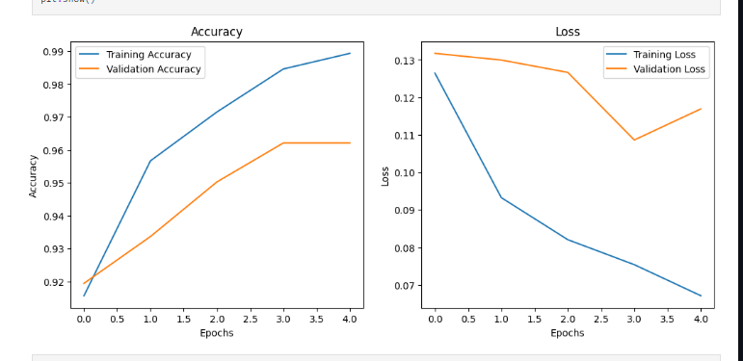

*Confusion matrix visualization*

*Classification Report (Precision, Recall, F1-score(*

ROC and AUC curve

***Pros and Cons of Xception***

**Advantages**

* **Efficient Computation**:
  + Depthwise separable convolutions reduce the number of parameters and computations.
* **Good for Fine-Grained Classification**:
  + Separates spatial and channel information, capturing subtle features in tree species.
* **Pre-Trained Weights**:
  + Availability of pre-trained weights on ImageNet accelerates convergence.

**Disadvantages**

* **Complexity**:
  + Depthwise separable convolutions can be harder to implement and debug.
* **Performance on Small Datasets**:
  + Requires sufficient data or strong augmentations to avoid overfitting.

***Why Xception for Tree Species Classification?***

**Advantages for the Task**

1. **Captures Subtle Differences**:
   * Tree species classification often involves small differences in leaf patterns, textures, or bark features. Xception’s depthwise separable convolutions are adept at extracting such details.
2. **Efficient with Large Datasets**:
   * Handles high-resolution images and large datasets efficiently.
3. **Pre-Trained Transfer Learning**:
   * Leverages pre-trained weights to fine-tune on tree-specific datasets.

***DenseNet (Densely Connected Convolutional Networks) for Tree Species Classification:***

DenseNet introduces a unique architecture where every layer is connected to every other subsequent layer. This dense connectivity promotes feature reuse, reduces the number of parameters, and enhances gradient flow, making it an excellent choice for fine-grained image classification tasks like tree species classification.

Each layer in the block receives inputs from all preceding layers and passes its output to all subsequent layers.

**Step-by-Step Fine-Tuning Implementation**

**Step 1: Load Pre-Trained DenseNet**

DenseNet pre-trained on ImageNet is a good starting point for tree species classification.

python

**Step 2: Add Custom Classification Layers**

Add layers for tree species classification.

**Step 3: Compile the Model**

Compile with an optimizer and loss function suitable for classification

**Step 4: Train the Model**

Fine-tune the model in two stages:

1. Train only the custom layers.
2. Unfreeze and fine-tune the entire network.

**Pros and Cons of DenseNet**

**Advantages**

1. **Efficient Feature Reuse**:
   * Dense connections ensure that features learned in earlier layers are directly available to later layers.
2. **Fewer Parameters**:
   * Avoids redundant computation by reusing features.
3. **Improved Gradient Flow**:
   * Dense connectivity alleviates vanishing gradient issues.
4. **Better Generalization**:
   * Works well for datasets with subtle inter-class differences, like tree species.

**Disadvantages**

1. **Computationally Intensive**:
   * Requires more memory for feature map storage due to concatenation.
2. **May Overfit on Small Datasets**:
   * Dense connections can lead to overfitting without proper regularization.

**Why DenseNet for Tree Species Classification?**

**Advantages for the Task**

1. **Fine-Grained Feature Recognition**:
   * Captures subtle differences in tree leaf shapes, textures, and patterns.
2. **Gradient Flow**:
   * Ensures effective training, even with deep architectures.
3. **Feature Reuse**:
   * Effective use of small datasets, as learned features are reused across layers.

**Dataset Considerations**

* Dataset: High-resolution images of tree species.
* Augmentation Techniques:
  + Flipping, rotation, cropping, color jittering.

|  |  |  |  |
| --- | --- | --- | --- |
| Feature | ResNet | Xception | DenseNet |
| Key Idea | Residual learning through skip connections. | Depthwise separable convolutions for efficiency. | Dense connectivity between layers for feature reuse. |
| Primary Strength | Enables very deep networks without vanishing gradients. | Efficient computation and fine-grained feature extraction. | Maximizes feature reuse and improves gradient flow |
| Computational Efficiency | Moderate (requires skip connections). | High (depthwise separable convolutions reduce computations). | Lower efficiency due to concatenated feature maps. |
| Training Speed | Slower for deeper models. | Faster due to separable convolutions. | Slower due to concatenations and memory usage. |
| Feature Extraction | Learns hierarchical features well. | Excels at capturing spatial and channel-wise information. | Reuses learned features across all layers. |
| Gradient Flow | Good due to skip connections. | Moderate, depends on depth. | Excellent, thanks to dense connections. |
| Overfitting Risk | Moderate, needs proper regularization. | Moderate, depends on data augmentation. | Lower risk due to efficient feature usage. |

**Which Model Is Best for Tree Species Classification?**

**Dataset Size and Complexity**

1. **Small Dataset with Subtle Variations**:  
   Use **DenseNet** for feature reuse and improved generalization.
2. **Large Dataset with Subtle Variations**:  
   Use **Xception** for efficient computation and fine-grained classification.
3. **Large Dataset with Distinct Classes**:  
   Use **ResNet**, especially deeper variants like ResNet-50 or ResNet-101.

**Considerations for Tree Species**

* Tree species datasets often involve subtle differences in leaves, bark, and structure. Xception and DenseNet are particularly well-suited due to their efficient feature extraction and ability to handle fine-grained details.
* If the dataset has enough examples and computational resources are not constrained, ResNet provides robust performance.