# Needed material

|  |  |  |
| --- | --- | --- |
| **Biological**  **material** | **Polymodal cages** | **Software** |
| Mouse | *(TO add if photometry/opto/ephys TTL is needed)*  473 nm laser source [Thorlabs ]  593 nm laser source Patch Cords  Fiber cables  Arduino-Uno boards Webcam | * iSPY (Camera) * POLY * POLYFILES * Arduino IDE 1.8.15 * Bonsai 2.6.2 |

# Safety Information – For more information, look at the complete safety data sheet

# General Rules: *is POLY imagine ref.*

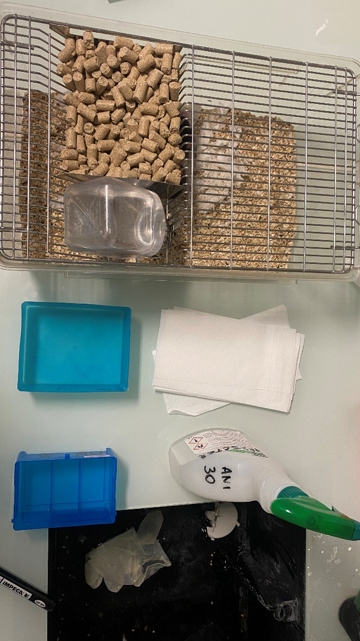the idea is to minimize the stress and disturbance of internal state of the animal as much as possible.

* change gloves; between WT and KO;
* clean in between.....
* Use different weight things
* to mark; you touch the tail, and not press.. then the animal is ok

Figure 1

# Polymodal Cages Preparation

* Turn on the computer and the Polymodal cages unit
* Make sure the postes are well connected and clean

In the desktop/; make sure all required files are there



1. Open **iSPY** software to load the cameras;
   * Confirm all is working and detecting.
   * Minimize into tray
2. Open **POLY**
   * It will load for a bit; and open a screen with the 4 postes

***(Picture 1.2)***

***Confirm it is POLY 6.1 by IMETRONIC 20/06/22***

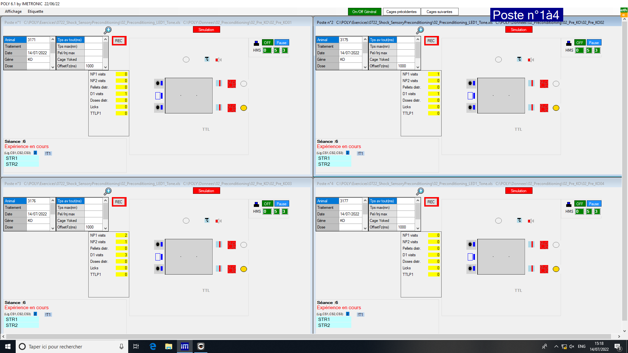

As you can see the interface is divided into 4 Postes 1 to 4; which correspond to the cages

Simply the idea here is to

* 1) load an exercise
* 2) Configure animals
* 3) Save/Load a session file

Within that a lot of repetition; yet careful attention to the details

# Configure Experiment

Now let’s run a test; into one post

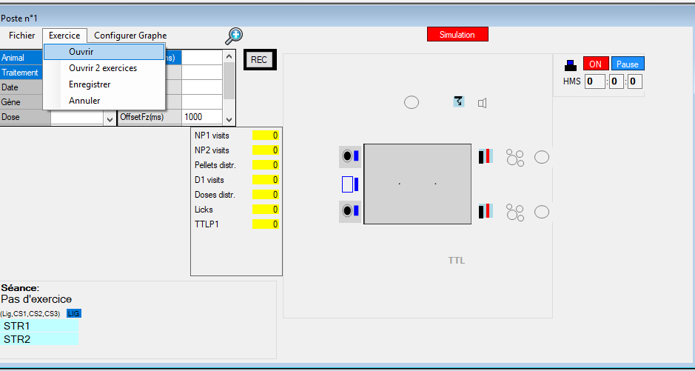

1. Press Exercise >>Ouvrir: **SELECT THE EXERCISE YOU’RE DOING**

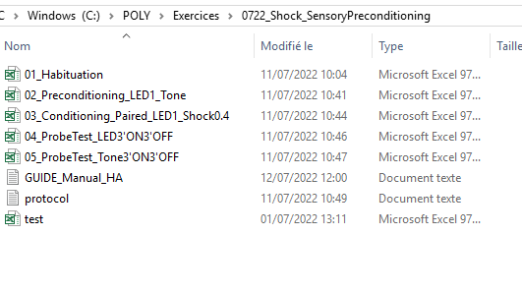

* e.g: 02_Preconditioning_LED1_Tone.xls Now a tone is to be coupled to a light for [add protocol details]10 of the seconds; in this exercise it is repeated for 6 sessions.
* In C:/POLY>IMETRONIC/ Test_tout.xls This is to test all the components of the cages (Nose Poke NP, Distiller D, Shock, Sound, LED/HLED)

* Refer to the manual [Polymodal user guide_marsicano2022] for further details

* 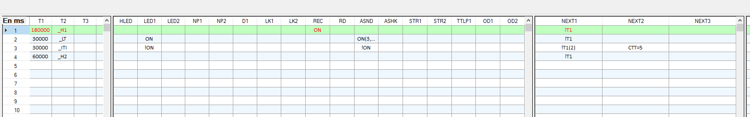CONFIRM EXERCISE IS WELL WRITTEN; and loaded.

1. **Next Step is to configure the animal sessions.**

Each session can be loaded; You have to individually load in each box the correct ones: e.g: **Poste 01**:

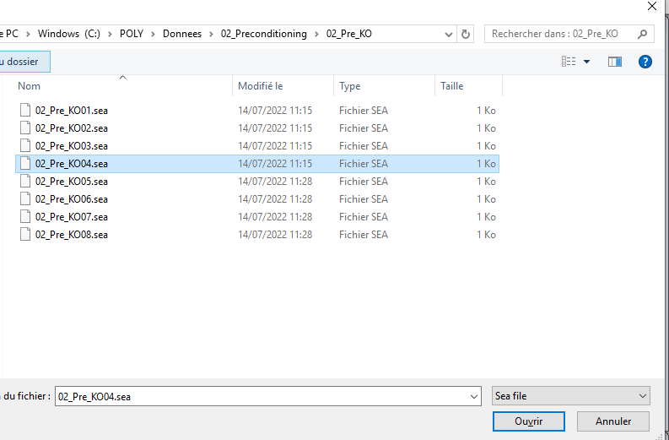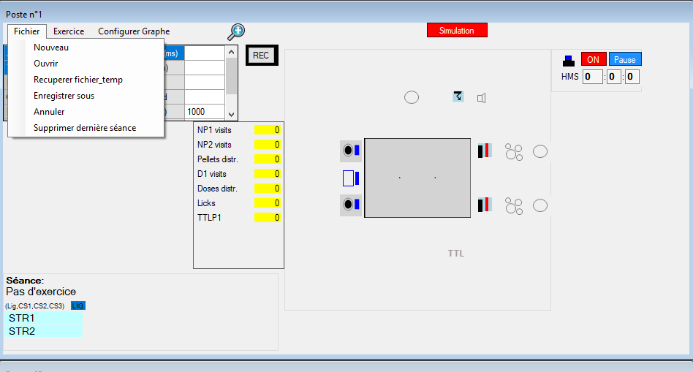Fichier>> **Nouveau** [if for the first time]; **Ouvrir** [If repeating a session]

Fichier>>Ouvrir:02_Preconditioning/02_Pre_%Gene%

(e.g)/02_Pre_KO:>> 02_Pre_KO01.sea

1. **a box will come up: it says {Séances précédentes...}**

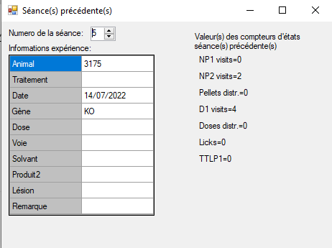

Confirm Animal ID, Date and Gene [Wt vs. KO]

Repeat iPoste:nPostes

Etiquette: Modify Date and confirm gene.

# Record

# 

NOW ALL your configuration is ready; you confirm all is well written

And confirm your timing.. SET ON/OFF General and start recording

# 

To confirm the experience is recording and saving;

* + 1. Pret pour experience changes into : Experience en cours
    2. The video starts recording ; don’t try to touch it; just observe, and don’t press REC from the software; it is already encoded in the exercise

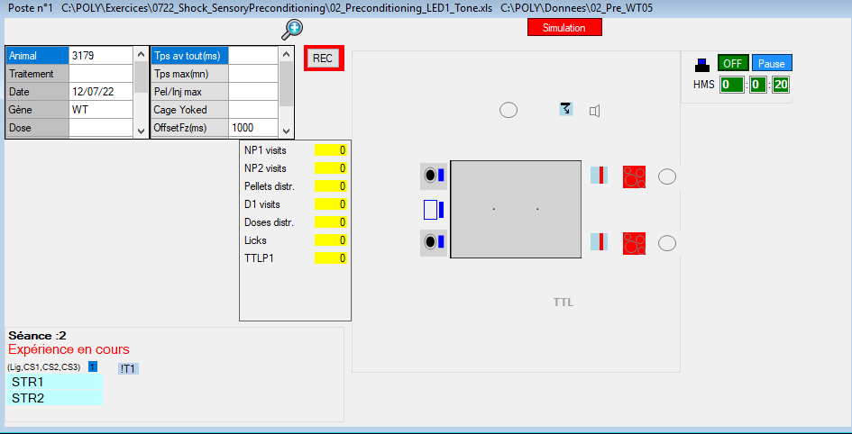

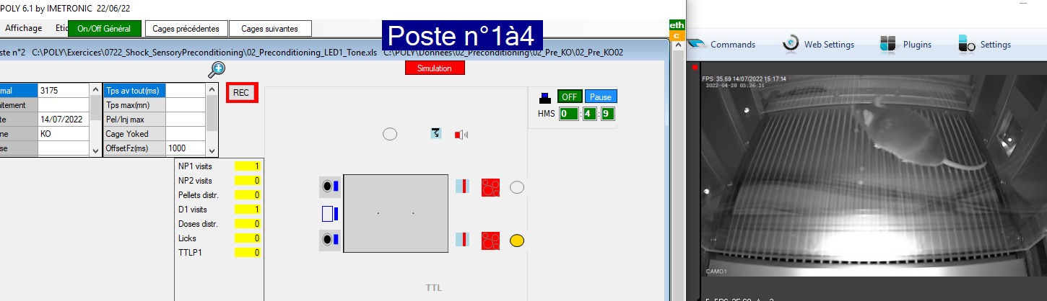

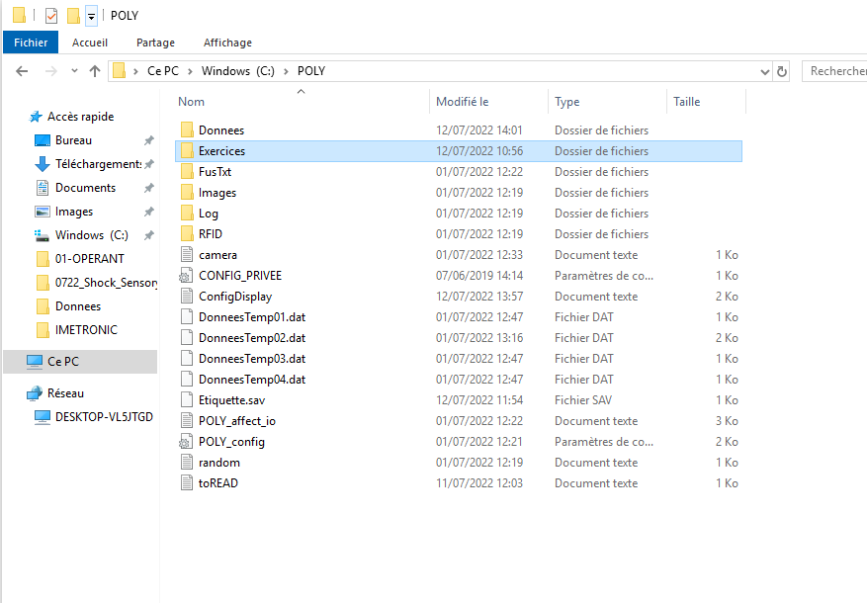

# Analyze

Now let’s analyze our data

# ANNEX 1

* Weigh the mice before test. As recorded in the sheet
* Bring one group of animal to the behavior paradigm. Set up the system/computer while mice habituate to the room.
* *N.B: Make sure that there*

*2 training sessions separated 1h*

*The shock is an aggressive manipulation;*

*so better make it as easy for an animal as possible*

*Pay attention to whatever you introduce to that grid; as mice can get distracted as humans; quiet easily; if such a vivid memory creation experience is undergone.*

*As yesterday you've completed youre sixth session of the exercise; all is supposed to be well...*

*You will enter the grid; there are no remains of food, pee, stool or bedding of another place: {meaning cleaning well; and making sure what is there; resembles what was at house>> yet the context is different}*

*Mice leave out a lot of traces, better watch out for cleaning*

*Then;*

*PROTOCOL:*

*0- 3 min [180000ms] : H1 {Baseline}*

*1- 8 secs [8000ms] : HLED(ON) {Light}*

*1- 2 secs [2000ms] : ASHCK(ON(i0.4)) {Shock: [ON;iON],[if @ON = ON(iX); i=intensity; X="float"]*

*2- 1 min [60000ms] : ITI_1 [HLED(!ON),ASHCK(!ON) {ITI_"n"} {CTT=idxn}*

*$$$$ __++LSx... TTL Iteration:LSx --> ITI_x-1 $$$$*

*3- 1 min [60000ms] : H2 {End}*

*1,2 Iteration: "args": n[ITI]; n [HLED:ASHCK]*

*notes@THE DAY@*

*SHOCK seems to be quiet remarkable for mice, i notice that the indicator LED is not lid; however one can clearly hear an animal sqeuak following a 2s shock; it seems we're printing bad memories association for the light*

*====================================*

*Tomorrow is here:*

*2 Probe tests (one with light and the other with tone) each session 3 min off and then 3 min On, separated at least 1h (both in the morning).*

*.*

*Probe Test 1: Fear: 3 min off and then 3 min On: LED*

*PROTOCOL:*

*0- 3 min [180000ms] : T1= H1; T2=_OFF {Baseline}*

*1- 3 min [180000ms] : T1= HLED(ON); T2=_OFF {Light}*

*$$$$ __++LSx... TTL Iteration:LSx --> ITI_x-1 $$$$*

*3- 1 min [60000ms] : H2 {End}*

*1,2 Iteration: "args": n[ITI]; n [HLED:ASHCK]*

*then;*

*Probe Test 2: Fear: 3 min off and then 3 min On: LED*

*PROTOCOL:*

*0- 3 min [180000ms] : T1= H1; T2=_OFF {Baseline}*

*1- 3 min [180000ms] : T1= ASND(ON); T2=_ON {Light}*

*ON(3,3000)*

*!ON*

*$$$$ __++LSx... TTL Iteration:LSx --> ITI_x-1 $$$$*

*3- 1 min [60000ms] : H2 {End}*

*1,2 Iteration: "args": n[ITI]; n [HLED:ASHCK]*

* *is no laser coming through the “sleeve”. If there is laser leaking, then you need to attach the cable again (i.e., there is a misconnection). You may see laser on top of the skull, that is fine.*

