SPI-Protocol

# Overview

|  |  |
| --- | --- |
| Advantages | Disadvantages |
| Speed: I²C=3.4MBs & SPI 10-20MBs | More Pins than I²C |
| Simple Shift Register | No Inter-Slave communication |
| Support Multiple Slaves | Separate SS Lines |
| Less Energy | No FLow COntrol |
|  | Only 1 Master on SPI Bus |



## Read/Write Example

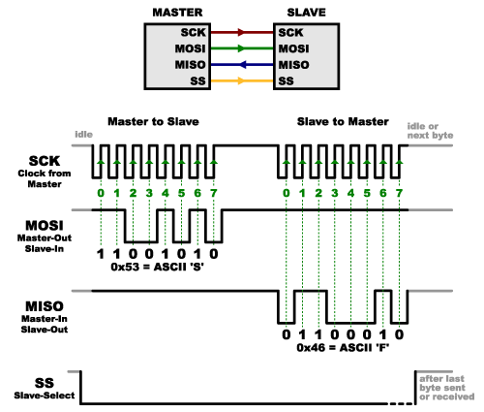

## 

## Source: <https://circuitdigest.com/microcontroller-projects/arduino-spi-communication-tutorial>

## Master Arduino Code:

#include<SPI.h> //Library for SPI

#define LED 7

#define ipbutton 2

int buttonvalue;

int x;

void setup (void){

Serial.begin(115200); //Starts Serial Communication at Baud Rate 115200

pinMode(ipbutton,INPUT); //Sets pin 2 as input

pinMode(LED,OUTPUT); //Sets pin 7 as Output

SPI.begin(); //Begins the SPI commnuication

SPI.setClockDivider(SPI_CLOCK_DIV8); //Sets clock for SPI communication at 8 (16/8=2Mhz)

digitalWrite(SS,HIGH); //Setting SlaveSelect as HIGH (So master doesnt connnect with slave)

}

void loop(void){

byte Mastersend,Mastereceive;

buttonvalue = digitalRead(ipbutton); //Reads the status of the pin 2

//Logic for Setting x value (To be sent to slave) depending upon input from pin 2

if(buttonvalue == HIGH){

x = 1;

}

else{

x = 0;

}

digitalWrite(SS, LOW); //Starts communication with Slave connected to master

Mastersend = x;

Mastereceive=SPI.transfer(Mastersend); //Send the mastersend value to slave also receives value from slave

//Logic for setting the LED output depending upon value received from slave

if(Mastereceive == 1){

digitalWrite(LED,HIGH); //Sets pin 7 HIGH

Serial.println("Master LED ON");

}

else{

digitalWrite(LED,LOW); //Sets pin 7 LOW

Serial.println("Master LED OFF");

}

delay(1000);

}

## Slave Arduino Code:

//SPI SLAVE (ARDUINO)

//SPI COMMUNICATION BETWEEN TWO ARDUINO

//CIRCUIT DIGEST

//Pramoth.T

#include<SPI.h>

#define LEDpin 7

#define buttonpin 2

volatile boolean received;

volatile byte Slavereceived,Slavesend;

int buttonvalue;

int x;

void setup(){

Serial.begin(115200);

pinMode(buttonpin,INPUT); // Setting pin 2 as INPUT

pinMode(LEDpin,OUTPUT); // Setting pin 7 as OUTPUT

pinMode(MISO,OUTPUT); //Sets MISO as OUTPUT (Have to Send data to Master IN

SPCR |= _BV(SPE); //Turn on SPI in Slave Mode

received = false;

SPI.attachInterrupt(); //Interupt ON is set for SPI commnication

}

ISR (SPI_STC_vect){ //Inerrrput routine function

Slavereceived = SPDR; // Value received from master if store in variable slavereceived

received = true; //Sets received as True

}

void loop(){

if(received){ //Logic to SET LED ON OR OFF depending upon the value receieved from master

if (Slavereceived==1){

digitalWrite(LEDpin,HIGH); //Sets pin 7 as HIGH LED ON

Serial.println("Slave LED ON");

}

else{

digitalWrite(LEDpin,LOW); //Sets pin 7 as LOW LED OFF

Serial.println("Slave LED OFF");

}

buttonvalue = digitalRead(buttonpin); // Reads the status of the pin 2

if (buttonvalue == HIGH){ //Logic to set the value of x to send to master

x=1;

}

else{

x=0;

}

Slavesend=x;

SPDR = Slavesend; //Sends the x value to master via SPDR

delay(1000);

}

}

## Testing

A proper test can be done in the next sprint. First I have to organize some LED’s, resistors and buttons.

To detect errors during transmitting and receiving a checksum or CRC could be realized. This could also be part of the next sprint.