**ARDHI UNIVERSITY**



**SCHOOL OF EARTH SCIENCES, REAL ESTATES, BUSINESS AND INFORMATICS**

**DEPARTMENT OF COMPUTER SYSTEMS AND MATHEMATICS**

**STUDENT’S NAMES:**

REUBEN NSAMAKA LIMBU 28658/T.2022

HOLYFISHER MARO

**SUPERVISOR NAME:**

DR. GODFREY LUWEMBA

**TITLE:**

MANAGEMENT PLANS AND WEB-GIS FOR DYNAMIC CONSERVATION OF PUBLIC SPACE IN KINONDONI MUNICIPAL

**CHAPTER ONE**

**INTRODUCTION**

**1.1 General introduction**

Public spaces are essential to cities because they provide opportunities for various activities, such as leisure and socialization, that enhance the urban environment. These open spaces are often affected by rapid population growth, leading to limited urban infrastructure and environmental degradation. It is crucial to manage and protect these spaces from harm caused by humans and other factors. Through technology, open spaces can be better managed using Web-GIS (Geographical Information System). Web-GIS enables municipal management to oversee these spaces by allowing real-time data collection and spatial analysis to support decision-making.

Open space, in its most basic form, refers to land areas that are free from permanent structures. These spaces can encompass parks, gardens, plazas, waterfronts, and even vacant lots. They provide a sense of spaciousness, connection to nature, and areas for recreation and socialization. Recognizing the growing importance of open spaces, urban planners and policymakers are increasingly prioritizing their preservation and expansion. Initiatives to create more parks, pedestrian zones, and green corridors are gaining momentum worldwide. The concept of "smart cities" includes the integration of open spaces as a core element of urban development. (Godreja, 2020).

Urban planning and design, organized open space refers to that land use category, not built upon, which may be either natural or man-made, or land developed as gardens for recreation purposes, amenity, conservation of land and other natural resources, historic or scenic landscapes, and for outstanding beauty. It can also be regarded as green belts which are essential in checking the growth and decay of urban centres. According to Mumford (1969), the main underlying philosophy of open spaces is their social purpose as gathering places and their biological functions. Environmental planning is the beginning of a new era where the functional, aesthetic and recreational needs of the people in terms of space and environment are considered together. According to Greenwood and Edwards (1981), environmental planning is cultural adaptation that takes full account of natural systems, in which we can avoid becoming victims of our own culture. (Ali, 1997).

This study aims to use Web-GIS technology for the efficient management and protection of open spaces in the Kinondoni municipality of Dar-es- Salaam. This approach will make it easier for urban planners and managers to monitor and ensure that public spaces are maintained for proper social use. This system will allow the municipality to view open spaces through maps. If someone needs to use a specific open space, they can send a request through the system, and the municipality will know the location of the request and can reach the area easily. Through this system, it will help the managers of open spaces in the Kinondoni Municipality to manage open spaces more easily, leading to cleaner districts and better management of open spaces

**1.2 Problem Statement**

In the past, the method of managing open spaces in Kinondoni District involved traveling by vehicle to reach the specific area. This approach was difficult and made managing open spaces challenging, leading to problems such as environmental pollution and the destruction of these areas. Since this method was time-consuming and inefficient, we are developing a new system called "Management Plans and Web-GIS for Dynamic Conservation of Public Space".

There are several articles I’ve gone through that discuss how to protect open spaces, but they don’t mention how Web-GIS can be used for managing these spaces. The difference between my project and those articles is that my project will focus on using Web-GIS technology to help manage open spaces in the district. While the other studies they do not explore how a Web-GIS system can provide real-time data, improve planning, and make management of these spaces more efficient.

My project will show how integrating Web-GIS can enhance decision-making and make the management of open spaces more dynamic and interactive. This system will allow the municipality to view open spaces through maps. If someone needs to use a specific open space, they can send a request through the system, and the municipality will know the location of the request and can reach the area easily. Through this system, it will help the managers of open spaces in the Kinondoni Municipality to manage open spaces more easily, leading to cleaner districts and better management of open spaces.

**1.3 Objectives**

**1.3.1 General Objective**

The General objective of this study is to develop a Management Plans and Web-GIS for Dynamic Conservation of Public Space in Kinondoni Municipal.

**1.3.2 Specific Objectives**

The following are the specific objectives of this study.

1. To design system for Management Plans and Web-GIS for Dynamic Conservation of Public Space in Kinondoni Municipal.
2. To Implement the system for Management Plans and Web-GIS for Dynamic Conservation of Public Space in Kinondoni Municipal.
3. To test and validate the system of Management Plans and Web-GIS for Dynamic Conservation of Public Space in Kinondoni Municipal.

**1.5 Research Questions**

1. What are the key requirements and expectations of users for a management plan and Web-GIS system for dynamic conservation of public spaces in Kinondoni Municipal?
2. How can the system be designed to meet the specific needs and expectations of users identified in the previous objective?
3. What steps are required to effectively implement the management plans and Web-GIS system for dynamic conservation in Kinondoni Municipal?
4. What criteria should be used to assess the performance of the system in terms of user satisfaction, data accuracy, and system efficiency?

**1.6 Significance of the study**

Through this project, it will be possible to support various aspects such as social interaction, better management of open spaces in Kinondoni District, and the preservation of recreational areas. So, the municipal management's ability to view their district using maps, it will make it easier for them to identify any illegal activities occurring in certain areas and respond quickly to reports from the public.

**CHAPTER TWO**

**LITERATURE REVIEW**

**2.1 Related Works**

In the study “Development of Web-GIS platform for Environmental Monitoring and Conservation of the Moringato Catchment in Kenya” by (Wisdom Kipkemboi, Bartholomew Kuria, Arthur Sichangi & Johanna Wanjala, 2023), developed a web-GIS Platform for Environmental Monitoring and Conservation of the Muringato Catchment in Kenya. Monitoring and protecting the environment is a major goal for various stakeholders due to the continuous degradation by anthropogenic factors and climate change occurrences. Developing web-based geographic information system (GIS) platforms have been proposed as one environmental monitoring tool because of their easy operability, accessibility, and ability to present data.

<https://link.springer.com/article/10.1007/s41651-023-00143-3?fromPaywallRec=true#citeas>

Ravinder *et al.* (2020) developed Web-GIS Integrated Open-source mashup technology as a cue for integrated management in costal megacities. Coastal resource management plays a crucial role in sustainable development, especially in urban coastal areas. To address the need for better information and data in coastal cities, a Web-GIS-based decision support framework, called the Coastal Management Information System (CMIS), has been developed for Mumbai.

<https://link.springer.com/article/10.1007/s11852-020-00734-y?fromPaywallRec=true>

Costantino *et al.* (2019) Implemented of a system Web-GIS open-source for the protection and sustainable management of rural heritage. the aim of the work was to develop a Web-GIS platform for the management and as supporting tool in the planning and development processes, through a territory representation. The “web-mapping” tool has been designed according to a client/server architecture and has been made entirely with open-source Quantum GIS desktop software, by adopting solutions that facilitate interoperability between different systems that need to communicate with each other on the Web.

<https://link.springer.com/article/10.1007/s12518-019-00275-6#citeas>

Shimaa *et al.* (2023) developed Urban Facility Management Improving Livability through Smart Public Space in Smart Sustainable Cities. This research aims to adopt intelligent technologies applied in public spaces to facilitate livability through urban facility management (UFM) involvement in improving livability. The establishment of intelligent systems in the architecture industry goes hand in hand with the growing advancement of science and technology in several aspects of human life. A fundamental key to the success of smart cities is the high quality of livability offered to their residents and visitors. The UFM can enable livability by providing data centers, access controls, integrated security systems, monitoring, smart waste, energy and water management in public spaces.

Link, <https://scholar.google.com/scholar?hl=en&as_sdt=0%2C5&q=Urban+Facility+Management+Improving+Livability+through+Smart+Public+Space+in+Smart+Sustainable+Cities&btnG=>

Zavratnik *et al.* (2020) in their project of Sustainable and Community-Centered Development of Smart Cities and Village. The article highlights the need to rethink and reconceptualize the accepted concepts of smart cities and villages by shifting the attention from technology and technological solutions and moving it towards understanding the significance of communities and sustainability. The idea of sustainability is central to debates on visions of the future and has entered many global, national and regional developmental agendas. The main purpose of the article is to highlight the need to rethink and reconceptualize the accepted concepts of smart cities and villages by shifting the attention from technology and technological solutions and moving it towards communities and sustainability. This way we can support a shift from a mainly techno-centric to a more community-centric development of rural and urban living communities of the future.

<https://scholar.google.com/scholar?hl=en&as_sdt=0%2C5&q=Veronika+et+al.+%282020%29+titled+Sustainable+and+Community-Centered+Development+of+Smart+Cities+and+Village&btnG=>

cite, Zavratnik, V., Podjed, D., Trilar, J., Hlebec, N., Kos, A., & Stojmenova Duh, E. (2020). Sustainable and community-centred development of smart cities and villages. *Sustainability*, *12*(10), 3961.

**2.2 Summary of literature review**

|  |  |  |  |  |
| --- | --- | --- | --- | --- |
| s/n | **Author’s name and year** | **Technologies used** | | |
|  |  | **WIFI** | **GSM** | **Dht22** |
|  | *Ravindar, et al, 2020* | **√** | **√** | X |
|  | *Veronika, et al, 2020* | **√** | **√** | **√** |
|  | *Shimaa, et al, 2023* | **√** | **√** | **√** |
|  | *Costantino, et al, 2019* | **√** | **√** | X |
|  | *Charles N. Nundai, 2023* | **√** | **√** | **√** |
|  | Our research | **√** | **√** | X |

**CHAPTER THREE**

**METHODOLOGY**

|  |  |  |  |  |  |
| --- | --- | --- | --- | --- | --- |
| s/n | Specific objective | Research question | Method | Tool | Deliverable |
| 1. | To gather user requirement for Web-Gis Application | How can web-GIS facilitate real-time data collections and analysis for managing open spaces? | Survey and Questionnaire | Google forms | System Requirement specification |
| 2. | To design Web-Gis application | What role does stakeholder participation play in the development of dynamic management plans for open spaces using web-GIS? | System architecture | StarUML, DFD, ERD | System design document (SDD) |
| 3. | To implement and develop web-Gis application | How can Web-GIS tools enhance public engagement and awareness in the conservation and management of open spaces? | Dynamic System Development Methodology  (DSDM) | Angular, Django  And Graphql, PostgreSQL and PostGIS and Github | Working Web-Gis application |
| 4. | To test and validate web-Gis application | To Implement Management Plans and Web-GIS for Dynamic Conservation for Public Space in Kinondoni Municipal. | Unit testing | Jest, Computer | Working Web-Gis application |

**CHAPTER FOUR**

**SCHEDULE OF ACTIVITIES**

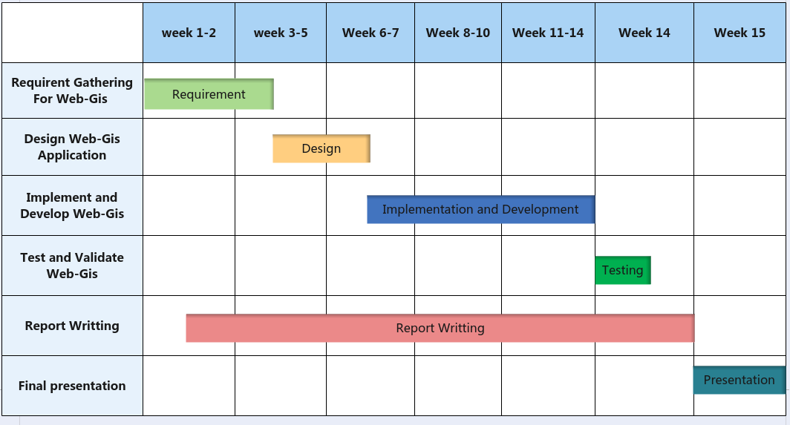

<https://link.springer.com/article/10.1007/s12518-019-00275-6>

to cite the above article,

Costantino, D., Angelini, M.G., Alfio, V.S. *et al.* Implementation of a system WebGIS open-source for the protection and sustainable management of rural heritage. *Appl Geomat* **12**, 41–54 (2020). https://doi.org/10.1007/s12518-019-00275-6

# <https://link.springer.com/article/10.1007/s41651-023-00143-3?fromPaywallRec=true>

Kipkemboi, W., Kuria, B.T., Kuria, D.N. *et al.* Development of a Web-GIS Platform for Environmental Monitoring and Conservation of the Muringato Catchment in Kenya. *J geovis spat anal* **7**, 13 (2023). https://doi.org/10.1007/s41651-023-00143-3

https://link.springer.com/article/10.1007/s11852-020-00734-y?fromPaywallRec=true

reference

Dhiman, R., VishnuRadhan, R., Inamdar, A.B. *et al.* Web-GIS integrated open source mashup technology as a cue for integrated management in coastal megacities. *J Coast Conserv* **24**, 18 (2020). <https://doi.org/10.1007/s11852-020-00734-y>

https://www.sciencedirect.com/science/article/abs/pii/S0098300416308160?via%3Dihub