**Name: Bharat Chandra**

**AWS Big Data: MapReduce Assignment**

**Problem statement:**

You work as a Big Data Engineer at GrapeVine Pvt. Ltd. Your company is currently working on English language analytics using Hadoop. You have been assigned certain tasks for the fulfillment of this activity. You’re currently using AWS services.

Link for the dataset: https://intellipaat-course-attachments.s3.ap-south-1.amazonaws.com/Hadoop/hadoop_dataset.rar

**Tasks to be completed:**

1. Find out the count of each word in the ‘Shakespeare.txt’ dataset in the ‘Shakespeare.rar’**(Attached final_output.csv for all word counts in folder**

**)**

2. Find out the count of each word using two reducers only **(Attached final_output.csv for all word counts in folder**

**)**

3. Find out the most commonly used words (Words with the count over 100 are considered

common)

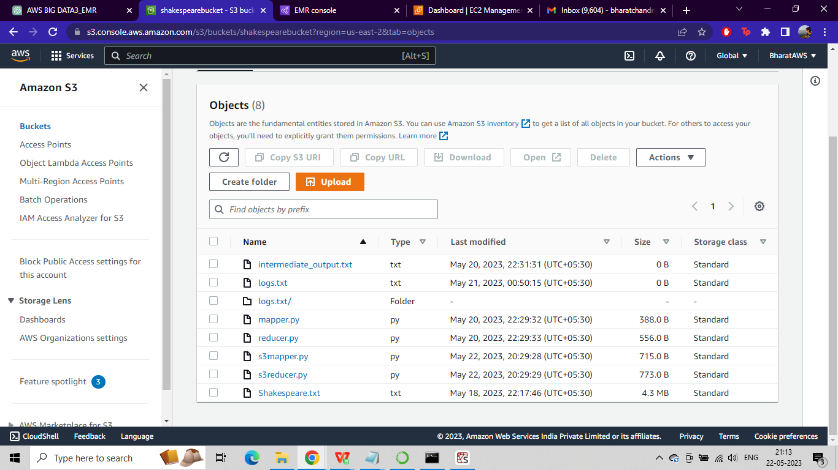

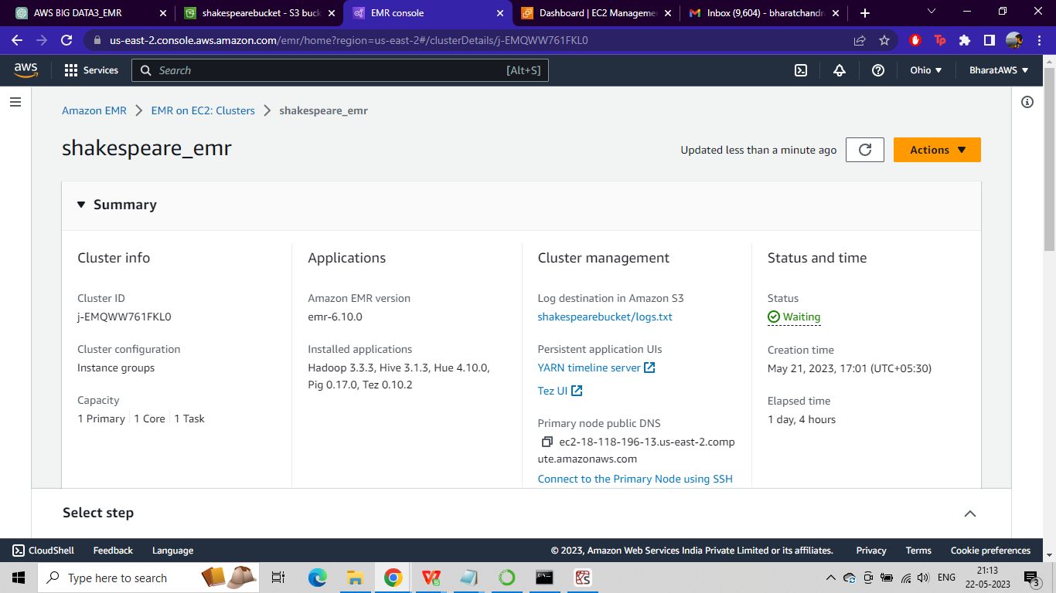

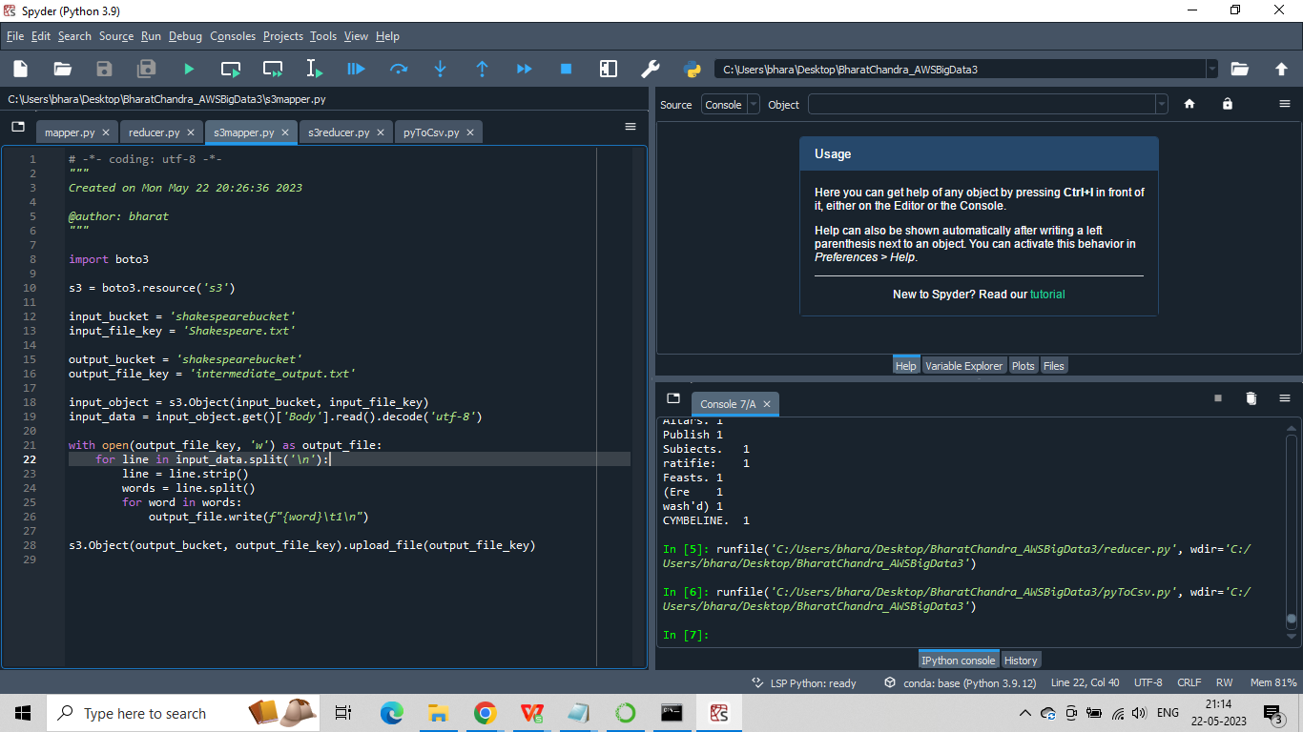

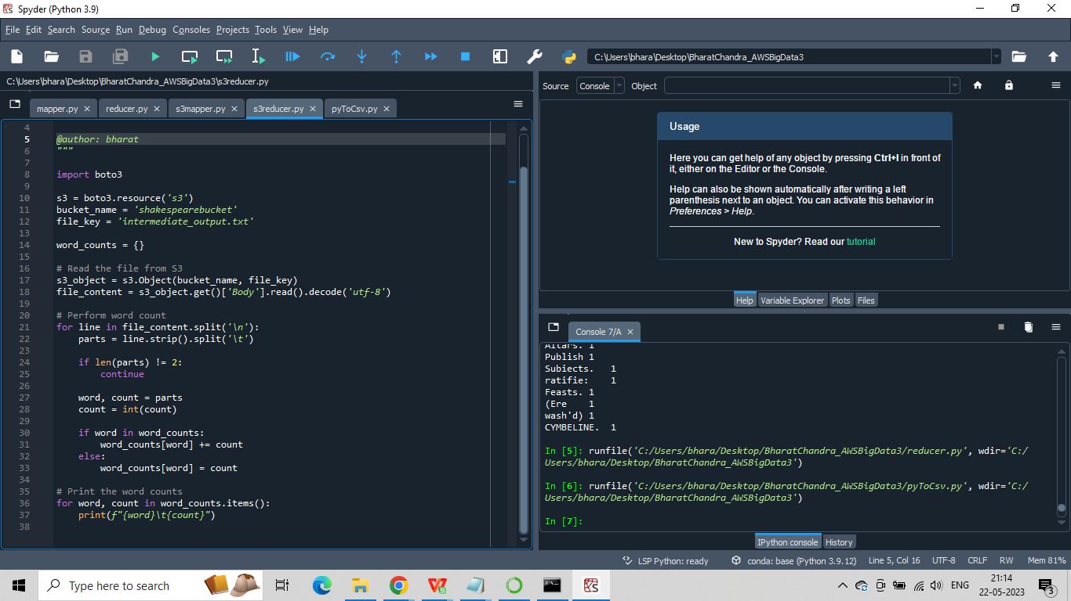

Attached final_output.csv for all word counts in folder

**Most common words:**

|  |  |
| --- | --- |
| **Word** | **Count** |
| of | 14571 |
| This | 1028 |
| is | 7459 |
| our | 2695 |
| most | 905 |
| these | 1000 |
| the | 21652 |
| are | 2777 |
| all | 2688 |
| world, | 104 |
| be | 5454 |
| sure | 208 |
| to | 14978 |
| for | 5372 |
| your | 6186 |
| before | 472 |
| take | 934 |
| a | 12121 |
| at | 2074 |
| in | 8779 |
| this | 4669 |
| We | 611 |
| you | 9838 |
| on | 2293 |
| an | 1307 |
| next | 120 |
| Do | 277 |
| not | 6761 |
| To | 2831 |
| The | 3321 |
| By | 679 |
| and | 16624 |
| Since | 131 |
| get | 235 |
| further | 129 |
| by | 2593 |
| should | 1291 |
| or | 1632 |
| new | 191 |
| from | 2086 |
| which | 1220 |
| we | 2284 |
| do | 1695 |
| any | 730 |
| with | 6217 |
| now | 1374 |
| one | 1242 |
| time | 613 |
| better | 456 |
| nor | 554 |
| till | 383 |
| last | 170 |
| day | 431 |
| such | 1147 |
| A | 1513 |
| may | 1311 |
| often | 106 |
| those | 411 |
| who | 512 |
| wish | 169 |
| first | 341 |
| please | 289 |
| has | 127 |
| it | 5329 |
| that | 7179 |
| will | 3825 |
| do, | 117 |
| but | 3411 |
| see | 1065 |
| least | 117 |
| more | 1578 |
| about | 313 |
| two | 547 |
| each | 164 |
| rather | 261 |
| hundred | 102 |
| If | 1430 |
| then | 2387 |
| as | 3861 |
| away | 361 |
| One | 172 |
| 1 | 202 |
| ten | 101 |
| thousand | 287 |
| present | 193 |
| At | 203 |
| end | 177 |
| some | 1015 |
| good | 1984 |
| so | 3046 |
| something | 110 |
| it, | 623 |
| want | 113 |
| All | 327 |
| made | 662 |
| For | 1636 |
| other | 505 |
| When | 696 |
| if | 1896 |
| I | 19071 |
| still | 305 |
| would | 1882 |
| send | 210 |
| how | 966 |
| You | 1299 |
| could | 512 |
| past | 101 |
| go | 525 |
| through | 201 |
| bin | 190 |
| Why | 880 |
| They | 428 |
| tell | 768 |
| might | 389 |
| there | 984 |
| wrong | 122 |
| free | 111 |
| what's | 133 |
| you. | 213 |
| It | 886 |
| can | 931 |
| part | 263 |
| not, | 444 |
| within | 193 |
| must | 1249 |
| like | 1366 |
| no | 2368 |
| without | 244 |
| set | 373 |
| forth | 231 |
| they | 1776 |
| cannot | 664 |
| But | 2326 |
| Some | 215 |
| you, | 1043 |
| hold | 297 |
| it. | 241 |
| word | 286 |
| long | 296 |
| when | 1140 |
| does | 120 |
| into | 518 |
| (as | 139 |
| Honor | 131 |
| were | 1263 |
| time, | 222 |
| In | 954 |
| here | 416 |
| Nay | 207 |
| answer | 191 |
| me: | 339 |
| & | 581 |
| selfe | 739 |
| liue | 302 |
| King | 809 |
| As | 1240 |
| out | 925 |
| words | 203 |
| had | 1194 |
| being | 477 |
| thus | 407 |
| very | 608 |
| why | 293 |
| did | 1245 |
| way, | 112 |
| play | 185 |
| place | 188 |
| was | 1856 |
| common | 120 |
| day, | 223 |
| times | 143 |
| many | 430 |
| them | 1271 |
| high | 172 |
| My | 1544 |
| father | 123 |
| him | 3120 |
| England | 111 |
| best | 342 |
| my | 10465 |
| he | 4051 |
| great | 688 |
| though | 356 |
| his | 5783 |
| name | 345 |
| What | 1749 |
| come | 1115 |
| Prince | 219 |
| left | 204 |
| put | 420 |
| them. | 111 |
| what | 2121 |
| So | 833 |
| thing | 342 |
| off | 257 |
| way | 330 |
| me | 4702 |
| make | 1362 |
| right | 202 |
| hope | 256 |
| thou | 4020 |
| gentle | 287 |
| O, | 113 |
| haue | 5023 |
| hath | 1541 |
| euer | 538 |
| since | 249 |
| looke | 473 |
| Not | 423 |
| Lord | 1199 |
| Kings | 178 |
| Gentleman | 122 |
| Noble | 442 |
| O | 1101 |
| ill | 154 |
| things | 224 |
| feare, | 102 |
| feare | 350 |
| know | 1305 |
| their | 1768 |
| while | 135 |
| beene | 325 |
| thinke | 748 |
| both | 374 |
| them, | 318 |
| much | 795 |
| him, | 988 |
| owne | 597 |
| done | 335 |
| There | 391 |
| finde | 373 |
| dead, | 144 |
| onely | 210 |
| keepe | 365 |
| worthy | 148 |
| noble | 115 |
| man | 1001 |
| neere | 140 |
| hands | 146 |
| meanes | 187 |
| And | 7029 |
| shew | 257 |
| Your | 587 |
| From | 321 |
| Well | 205 |
| wil | 182 |
| stand | 360 |
| wee | 218 |
| so, | 359 |
| That | 2608 |
| doth | 705 |
| be, | 175 |
| worth | 114 |
| sit | 135 |
| know, | 152 |
| himselfe | 233 |
| death | 337 |
| pray | 486 |
| where | 615 |
| His | 475 |
| hand | 350 |
| him. | 274 |
| yours | 104 |
| wit | 108 |
| againe, | 231 |
| againe | 284 |
| doe | 1022 |
| whom | 285 |
| bee | 269 |
| Like | 164 |
| well, | 295 |
| Richard | 105 |
| Henry | 148 |
| Lear. | 174 |
| draw | 150 |
| thy | 3488 |
| too | 796 |
| 'Tis | 523 |
| true, | 141 |
| Were | 165 |
| Or | 638 |
| ne're | 105 |
| thine | 295 |
| These | 203 |
| Should | 134 |
| her | 2759 |
| art | 644 |
| against | 425 |
| indeed | 115 |
| th' | 434 |
| I, | 614 |
| therefore | 338 |
| thee | 1945 |
| bid | 273 |
| lye | 142 |
| little | 374 |
| Thou | 789 |
| meane | 223 |
| thought | 271 |
| farre | 194 |
| lesse | 151 |
| thee, | 531 |
| seeke | 174 |
| call | 391 |
| vs, | 266 |
| life | 342 |
| heare | 665 |
| on, | 170 |
| Of | 864 |
| all, | 217 |
| Rome | 120 |
| hast | 526 |
| He | 1071 |
| came | 253 |
| Our | 359 |
| Nature | 133 |
| weare | 150 |
| Which | 777 |
| she | 1399 |
| Yet | 319 |
| Thy | 343 |
| Art | 105 |
| he, | 108 |
| Who | 549 |
| turne | 183 |
| thinkes | 121 |
| well | 936 |
| Looke | 180 |
| face | 173 |
| eyes | 263 |
| fight | 129 |
| yet | 988 |
| hence, | 123 |
| night, | 199 |
| Master | 308 |
| now, | 275 |
| done, | 175 |
| King. | 711 |
| Where | 510 |
| gone | 173 |
| is, | 273 |
| soone | 109 |
| shall | 2816 |
| world | 259 |
| Here | 163 |
| Shall | 397 |
| Nor | 312 |
| once | 257 |
| Then | 971 |
| Till | 182 |
| rest | 182 |
| Be | 411 |
| canst | 104 |
| An | 127 |
| Can | 137 |
| That's | 124 |
| Exit | 322 |
| Actus | 154 |
| Scena | 218 |
| Enter | 2026 |
| Heere | 255 |
| Speake | 134 |
| fall | 196 |
| Enter. | 413 |
| Take | 177 |
| Good | 425 |
| Master, | 107 |
| him? | 135 |
| Nay, | 263 |
| vs | 1086 |
| remember | 121 |
| loue | 909 |
| peace | 120 |
| more, | 194 |
| vse | 236 |
| giue | 923 |
| comfort | 111 |
| vpon | 1240 |
| borne | 144 |
| bring | 347 |
| cry | 106 |
| minde | 126 |
| warrant | 137 |
| lay | 217 |
| King, | 385 |
| Prince, | 109 |
| let's | 127 |
| An. | 139 |
| liues | 116 |
| Though | 181 |
| euery | 400 |
| sweare | 158 |
| Let's | 113 |
| leaue | 486 |
| Now | 644 |
| dye | 141 |
| (my | 199 |
| With | 894 |
| saw | 209 |
| braue | 119 |
| doubt | 111 |
| Against | 126 |
| poore | 452 |
| Had | 137 |
| God | 463 |
| Haue | 410 |
| ere | 397 |
| No | 616 |
| Tell | 146 |
| heart | 422 |
| there's | 164 |
| care | 126 |
| deere | 198 |
| am | 1932 |
| full | 334 |
| Father | 327 |
| More | 191 |
| Did | 218 |
| neuer | 852 |
| thoughts | 107 |
| eyes, | 136 |
| thee: | 165 |
| mine | 776 |
| soule | 157 |
| downe, | 123 |
| vnto | 339 |
| Out | 122 |
| three | 292 |
| old | 435 |
| Sir, | 553 |
| house, | 131 |
| me, | 1336 |
| Hath | 274 |
| me? | 226 |
| How | 983 |
| Duke | 444 |
| Mother | 123 |
| She | 316 |
| said | 202 |
| Was | 191 |
| worse | 102 |
| hither | 152 |
| brother | 125 |
| call'd | 126 |
| FALSE | 177 |
| Being | 101 |
| mine, | 141 |
| say, | 347 |
| hauing | 103 |
| hearts | 117 |
| that, | 172 |
| trust | 115 |
| power | 157 |
| beleeue | 142 |
| o'th' | 167 |
| hence | 131 |
| Crowne | 101 |
| Oh | 605 |
| bad | 113 |
| Pro. | 318 |
| faire | 464 |
| dead | 211 |
| purpose | 105 |
| Will | 386 |
| foule | 162 |
| it: | 250 |
| whose | 341 |
| backe | 161 |
| you? | 249 |
| heauen, | 105 |
| beare | 383 |
| vp | 748 |
| lou'd | 109 |
| Would | 226 |
| heere | 623 |
| 'tis | 692 |
| reason | 155 |
| Fortune | 103 |
| after | 262 |
| Come | 564 |
| away, | 153 |
| On | 182 |
| strong | 116 |
| thou, | 102 |
| sonne | 123 |
| that's | 248 |
| say | 912 |
| Is | 747 |
| vnder | 178 |
| home | 147 |
| charge | 113 |
| Must | 123 |
| y | 133 |
| dost | 195 |
| Let | 706 |
| now? | 132 |
| Before | 106 |
| Sir | 575 |
| Oh, | 124 |
| so: | 195 |
| brought | 171 |
| selfe, | 389 |
| helpe | 182 |
| heere, | 163 |
| heard | 280 |
| let | 1275 |
| thanke | 243 |
| Doe | 146 |
| Goe | 132 |
| goe | 432 |
| kinde | 158 |
| him: | 291 |
| do's | 114 |
| speake | 698 |
| There's | 164 |
| enough | 150 |
| Lord, | 894 |
| Vpon | 293 |
| night | 280 |
| shalt | 263 |
| breath | 133 |
| vp, | 151 |
| light | 134 |
| you: | 281 |
| haue, | 104 |
| hard | 118 |
| else | 269 |
| wilt | 215 |
| houre | 161 |
| Ile | 1585 |
| No, | 283 |
| thee. | 154 |
| there, | 132 |
| Fathers | 188 |
| sweet | 406 |
| eye | 143 |
| sir, | 577 |
| lost | 165 |
| nothing | 358 |
| goes | 127 |
| Most | 170 |
| May | 179 |
| Lords, | 185 |
| fit | 123 |
| Queene | 209 |
| Make | 138 |
| come, | 258 |
| ha's | 160 |
| Father, | 193 |
| Come, | 272 |
| hate | 102 |
| What, | 175 |
| seene | 170 |
| men, | 170 |
| Are | 290 |
| bound | 126 |
| mans | 131 |
| follow | 204 |
| mee | 279 |
| Exeunt. | 639 |
| cold | 109 |
| Ant. | 450 |
| comes | 471 |
| Therefore | 192 |
| tongue | 177 |
| Well, | 257 |
| seeme | 131 |
| almost | 116 |
| saue | 138 |
| truth | 124 |
| speake, | 104 |
| daughter | 134 |
| returne | 120 |
| it? | 151 |
| matter | 166 |
| hee | 535 |
| beseech | 188 |
| too, | 196 |
| her: | 127 |
| strange | 162 |
| Whose | 213 |
| head | 197 |
| no, | 147 |
| loose | 146 |
| cause | 186 |
| betweene | 149 |
| men | 454 |
| talke | 151 |
| Go | 230 |
| die | 112 |
| knew | 137 |
| Thus | 144 |
| euen | 280 |
| this? | 187 |
| TRUE | 422 |
| out, | 139 |
| sleepe | 108 |
| Brother | 160 |
| that? | 107 |
| hand, | 248 |
| in, | 119 |
| What's | 166 |
| Their | 126 |
| another | 236 |
| same | 175 |
| one, | 142 |
| man, | 356 |
| makes | 285 |
| none | 289 |
| foure | 108 |
| he's | 103 |
| pay | 101 |
| tooke | 124 |
| God, | 130 |
| kisse | 124 |
| Mistris | 169 |
| downe | 338 |
| young | 135 |
| Pray | 135 |
| breake | 193 |
| become | 117 |
| Lady | 259 |
| grace | 137 |
| verie | 118 |
| loue, | 266 |
| glad | 111 |
| dare | 165 |
| desire | 147 |
| holy | 145 |
| fellow | 111 |
| husband | 108 |
| halfe | 182 |
| mee, | 114 |
| life, | 208 |
| serue | 145 |
| Lord? | 131 |
| proue | 195 |
| Lord. | 142 |
| told | 198 |
| Why, | 136 |
| then, | 244 |
| certaine | 114 |
| gone, | 129 |
| so? | 118 |
| this, | 261 |
| cut | 131 |
| woman | 137 |
| kill | 150 |
| Queene, | 140 |
| Giue | 282 |
| not: | 113 |
| Euen | 216 |
| well: | 140 |
| Such | 119 |
| Sonne, | 107 |
| base | 105 |
| Sonne | 148 |
| giuen | 154 |
| tender | 113 |
| heauen | 201 |
| place, | 103 |
| her, | 373 |
| yong | 197 |
| Lady, | 150 |
| wife | 139 |
| Loue, | 167 |
| Her | 153 |
| meet | 107 |
| Say | 117 |
| body | 101 |
| bloody | 150 |
| gaue | 199 |
| ouer | 118 |
| teares | 104 |
| ye | 184 |
| welcome | 166 |
| late | 116 |
| pardon | 155 |
| friends | 113 |
| Highnesse | 135 |
| Lords | 148 |
| aske | 117 |
| spoke | 105 |
| found | 169 |
| heart, | 216 |
| Grace | 201 |
| newes | 126 |
| good, | 106 |
| gracious | 158 |
| head, | 138 |
| Royall | 164 |
| sent | 238 |
| honest | 214 |
| youth | 103 |
| Val. | 162 |
| Loue | 246 |
| Iul. | 175 |
| Luc. | 305 |
| Madam, | 223 |
| sir | 325 |
| loues | 157 |
| Madam | 141 |
| shame | 147 |
| knowes | 140 |
| knowne | 115 |
| Court | 103 |
| will, | 160 |
| morrow | 187 |
| Ah | 102 |
| shee | 173 |
| Sil. | 105 |
| stay | 240 |
| house | 143 |
| change | 105 |
| words, | 105 |
| Duk. | 117 |
| happy | 107 |
| Call | 103 |
| Ladies | 118 |
| Duke. | 205 |
| me. | 230 |
| blood | 238 |
| death, | 236 |
| La. | 129 |
| Du. | 108 |
| Peace | 126 |
| meete | 128 |
| part, | 110 |
| see, | 105 |
| off, | 101 |
| 2 | 186 |
| Iohn | 168 |
| Shal. | 125 |
| Fal. | 327 |
| Pist. | 119 |
| Heauen | 191 |
| English | 118 |
| Qu. | 367 |
| Gods | 238 |
| mad | 117 |
| French | 119 |
| Host. | 103 |
| All. | 108 |
| France | 126 |
| blood, | 140 |
| Clo. | 447 |
| Mar. | 291 |
| i'th' | 148 |
| France, | 154 |
| Leo. | 151 |
| Lady. | 109 |
| Iohn. | 145 |
| Prince. | 129 |
| Prin. | 259 |
| Boy. | 172 |
| Bast. | 165 |
| Mes. | 110 |
| Ber. | 217 |
| Kin. | 177 |
| Ros. | 252 |
| Hel. | 121 |
| Pet. | 107 |
| Brutus | 101 |
| Por. | 135 |
| Rome, | 101 |
| Orl. | 118 |
| Cel. | 107 |
| Ol. | 124 |
| Hor. | 153 |
| Par. | 149 |
| Vio. | 121 |
| To. | 146 |
| Mal. | 111 |
| Pol. | 106 |
| Cleo. | 210 |
| Kent. | 111 |
| Yorke. | 161 |
| Rich. | 438 |
| Yorke, | 115 |
| Falst. | 143 |
| War. | 103 |
| Bru. | 200 |
| Corio. | 126 |
| Rom. | 161 |
| Tim. | 195 |
| Caesar | 191 |
| Caesar, | 107 |
| Cassi. | 108 |
| Macb. | 137 |
| Ham. | 337 |