DATE
PROGRAM : 01 | Program to implement Best First Search

SOURCE CODE:
from queue import PriorityQueue
def best_first_search(graph, start, goal):
"""
Best-First Search prioritizes nodes that appear to be closest to the goal
using a heuristic (in this case, just the edge weights).
It doesn't guarantee the shortest path but is often fast.
"""
visited = set()
pq = PriorityQueue()
pq.put((0, start))
path = []
total_cost = 0
print("\n╔══════════════════════════════╗")
print("║ Best-First Search (Greedy) ║")
print("╚══════════════════════════════╝")
print("\nGraph Connections:")
for node in graph:
print(f" {node} → {graph[node]}")
while not pq.empty():
cost, node = pq.get()
if node in visited:
continue
print(f"\nVisiting: {node} (Current Cost: {cost})")
visited.add(node)
path.append(node)
total_cost += cost
if node == goal:
print("\n Goal Node Reached!")
break
for neighbor, weight in graph[node]:
if neighbor not in visited:
print(f" Adding neighbor: {neighbor} with weight {weight}")
pq.put((weight, neighbor))
print("\n════════ Results ════════")
print(f"Path: {' → '.join(path)}")
print(f"Total Cost: {total_cost}")
graph = {
'S': [('A', 5), ('B', 2)],
'A': [('C', 4), ('D', 1)],
'B': [('E', 3), ('F', 6)],
'C': [],
'D': [('G', 2)],
'E': [],
'F': [],
'G': []
}
best_first_search(graph, 'S', 'G')

OUTPUT:
╔══════════════════════════════╗
║ Best-First Search (Greedy) ║
╚══════════════════════════════╝
Graph Connections:
S → [('A', 5), ('B', 2)]
A → [('C', 4), ('D', 1)]
B → [('E', 3), ('F', 6)]
C → []
D → [('G', 2)]
E → []
F → []
G → []
Visiting: S (Current Cost: 0)
Adding neighbor: A with weight 5
Adding neighbor: B with weight 2
Visiting: B (Current Cost: 2)
Adding neighbor: E with weight 3
Adding neighbor: F with weight 6
Visiting: E (Current Cost: 3)
Visiting: A (Current Cost: 5)
Adding neighbor: C with weight 4
Adding neighbor: D with weight 1
Visiting: D (Current Cost: 1)
Adding neighbor: G with weight 2
Visiting: G (Current Cost: 2)
Goal Node Reached!
════════ Results ════════
Path: S → B → E → A → D → G
Total Cost: 13
Note: Best-First doesn't guarantee optimal path!

DATE
PROGRAM : 02 | Program to implement A* Algorithm

SOURCE CODE:
from queue import PriorityQueue
def a_star_search(graph, start, goal, h):
"""
A* Search combines actual path cost (g) with heuristic estimate (h)
to find the optimal path. It's guaranteed to find the shortest path
if the heuristic is admissible (never overestimates).
"""
open_set = PriorityQueue()
open_set.put((h[start], start))
g = {start: 0}
parent = {start: None}
visited = set()
print("\n╔══════════════════════════╗")
print("║ A* Search ║")
print("╚══════════════════════════╝")
print("\nGraph Connections:")
for node in graph:
print(f" {node} → {graph[node]}")
print("\nHeuristic Values (h):", h)
while not open_set.empty():
f, current = open_set.get()
if current in visited:
continue
print(f"\nVisiting: {current} (F={f}, G={g[current]}, H={h[current]})")
visited.add(current)
if current == goal:
break
for neighbor, cost in graph[current]:
tentative_g = g[current] + cost
if neighbor not in g or tentative_g < g[neighbor]:
g[neighbor] = tentative_g
f = tentative_g + h[neighbor]
open_set.put((f, neighbor))
parent[neighbor] = current
print(f" Updated {neighbor}: G={tentative_g}, F={f}")
path = []
node = goal
total_cost = g[goal]

while node:
path.append(node)
node = parent[node]
path.reverse()
print("\n════════ Results ════════")
print(f"Optimal Path: {' → '.join(path)}")
print(f"Total Cost: {total_cost}")
print("Note: A* guarantees optimal path with admissible heuristic!")

graph = {
'A': [('B', 1), ('C', 3)],
'B': [('D', 3), ('E', 1)],
'C': [('F', 5)],
'D': [],
'E': [],
'F': []
}
h = {'A': 5, 'B': 4, 'C': 3, 'D': 2, 'E': 1, 'F': 0}
a_star_search(graph, 'A', 'F', h)

OUTPUT:
╔══════════════════════════╗
║ A* Search ║
╚══════════════════════════╝
Graph Connections:
A → [('B', 1), ('C', 3)]
B → [('D', 3), ('E', 1)]
C → [('F', 5)]
D → []
E → []
F → []
Heuristic Values (h): {'A': 5, 'B': 4, 'C': 3, 'D': 2, 'E': 1, 'F': 0}
Visiting: A (F=5, G=0, H=5)
Updated B: G=1, F=5
Updated C: G=3, F=6
Visiting: B (F=5, G=1, H=4)
Updated D: G=4, F=6
Updated E: G=2, F=3
Visiting: E (F=3, G=2, H=1)
Visiting: C (F=6, G=3, H=3)
Updated F: G=8, F=8
Visiting: D (F=6, G=4, H=2)
Visiting: F (F=8, G=8, H=0)

════════ Results ════════
Optimal Path: A → C → F
Total Cost: 8
Note: A* guarantees optimal path with admissible heuristic!

DATE
PROGRAM : 03 | Program to implement AO* Algorithm

SOURCE CODE:
def ao_star(node, graph, heuristic, path_map):
if not graph[node]: # Leaf node
return heuristic[node], [node]
options = []
for option in graph[node]:
total_cost = 0
total_path = []
for child in option:
cost, sub_path = ao_star(child, graph, heuristic, path_map)
total_cost += cost
total_path.extend(sub_path)
options.append((total_cost, option, total_path))

# Choose the best option (min cost)
best_cost, best_children, best_path = min(options, key=lambda x: x[0])
heuristic[node] = best_cost
path_map[node] = (best_children, best_path)
print(f"Best path from {node}: {best_children}, Cost: {best_cost}")
return best_cost, [node] + best_path

# Define the AND-OR graph
graph = {
'A': [('B',), ('C', 'D')],
'B': [('E', 'F'), ('G',)],
'C': [],
'D': [],
'E': [('H',)],
'F': [('I',)],
'G': [],
'H': [],
'I': []
}

# Initial heuristic values (for leaf nodes only)
heuristic = {
'A': None,
'B': None,
'C': 3,
'D': 4,
'E': None,
'F': None,
'G': 6,
'H': 2,
'I': 1
}

# This will store the best subpaths chosen during the AO* process
path_map = {}
# Start AO* from node 'A'
cost,final_path = ao_star('A', graph, heuristic, path_map)
print("\n✅ Optimal Path:", " -> ".join(final_path))
print("🧮 Total Cost:", cost)

OUTPUT:
Best path from E: ('H',), Cost: 2
Best path from F: ('I',), Cost: 1
Best path from B: ('E', 'F'), Cost: 3
Best path from A: ('B',), Cost: 3
✅ Optimal Path: A -> B -> E -> H -> F -> I
🧮 Total Cost: 3

DATE
PROGRAM :04 | Program to Hill Climbing Algorithm

SOURCE CODE:
#Hill Climbing Algorithm for block world
import random
class BlockWorld:
def __init__(self, blocks, goal):
self.blocks = blocks
self.goal = goal

def get_possible_moves(self):
moves = []
for i in range(len(self.blocks)):
for j in range(len(self.blocks)):
if i != j:
new_state = self.blocks[:]
new_state[i], new_state[j] = new_state[j], new_state[i]
moves.append(new_state)
return moves

def evaluate(self):
return sum(1 for i in range(len(self.blocks)) if self.blocks[i] == self.goal[i])

def is_goal_state(self):
return self.blocks == self.goal

def hill_climbing(block_world):
current_state = block_world.blocks
current_score = block_world.evaluate()
step = 0

print(f"Step {step}: {current_state}, Cost: {current_score}")
while not block_world.is_goal_state():
step += 1
possible_moves = block_world.get_possible_moves()
next_move, next_score = None, current_score
for move in possible_moves:
block_world.blocks = move
score = block_world.evaluate()
if score > next_score:
next_move, next_score = move, score
if next_move is None:
break
current_state, current_score = next_move, next_score

block_world.blocks = current_state

print(f"Step {step}: {current_state}, Cost: {current_score}")

return block_world.blocks

initial_state = ['b', 'c','d','a']
goal_state = ['a','b', 'c','d']

block_world = BlockWorld(initial_state, goal_state)

print("Initial State:", block_world.blocks)
print("Goal State:", goal_state)
solution = hill_climbing(block_world)
print("\nFinal Solution:", solution)

OUTPUT:
Initial State: ['b', 'c', 'd', 'a']
Goal State: ['a', 'b', 'c', 'd']
Step 0: ['b', 'c', 'd', 'a'], Cost: 0
Step 1: ['c', 'b', 'd', 'a'], Cost: 1
Step 2: ['d', 'b', 'c', 'a'], Cost: 2
Step 3: ['a', 'b', 'c', 'd'], Cost: 4
Final Solution: ['a', 'b', 'c', 'd']

DATE
PROGRAM : 05 | Program to implement Minimax Algorithm

SOURCE CODE:
# Hardcoded leaf values (bottom of tree)
leaf_values = [14, 7, 9, 2, 11, 6, 18, 4] # 8 leaf nodes

# Minimax Algorithm
def minimax(depth, index, is_max, values):
# Base case: if at leaf node
if depth == 3:
return values[index]

# If maximizer's turn
if is_max:
left = minimax(depth + 1, index * 2, False, values)
right = minimax(depth + 1, index * 2 + 1, False, values)
return max(left, right)

# If minimizer's turn
else:
left = minimax(depth + 1, index * 2, True, values)
right = minimax(depth + 1, index * 2 + 1, True, values)
return min(left, right)

# Root call (MAX player)
best_value = minimax(0, 0, True, leaf_values)

# Output
print("Leaf values:", leaf_values)
print("Best value according to Minimax:", best_value)

OUTPUT:
Leaf values: [14, 7, 9, 2, 11, 6, 18, 4]
Best value according to Minimax: 11

DATE
PROGRAM : 06 | Program to implement Alpha Beta Pruning

SOURCE CODE:
def alpha_beta_pruning(values, depth, alpha, beta, index, is_maximizing, visited):
if depth == 0:
visited.append(values[index])
return values[index]
if is_maximizing:
best = float('-inf')
for i in range(2):
val = alpha_beta_pruning(values, depth - 1, alpha, beta, index * 2 + i, False, visited)
best = max(best, val)
alpha = max(alpha, best)
if beta <= alpha:
break
return best
else:
best = float('inf')
for i in range(2):
val = alpha_beta_pruning(values, depth - 1, alpha, beta, index * 2 + i, True, visited)
best = min(best, val)
beta = min(beta, best)
if beta <= alpha:
break
return best
# Input
depth = int(input("Enter tree depth (e.g., 3): "))
leaf_count = 2 ** depth
values = list(map(int,input(f"Enter {leaf_count} leaf values: ").split()))
if len(values) != leaf_count:
print(f"Error: You must enter exactly {leaf_count} values.")
else:
visited = []
result = alpha_beta_pruning(values, depth, float('-inf'), float('inf'), 0, True, visited)
print("\nOptimal value:", result)
print("Nodes visited:", visited)
print("Nodes pruned:", set(values) - set(visited))

OUTPUT:
Enter tree depth (e.g., 3): 3
Enter 8 leaf values: 2 4 6 8 1 3 5 7

Optimal value: 4
Nodes visited: [2, 4, 6, 1, 3]
Nodes pruned: {8, 5, 7}

DATE
PROGRAM : 07 | Program to implement N-Queens problem

SOURCE CODE:
def print_board(board):
for row in board:
print(" ".join("Q" if col else "." for col in row))
print()
def is_safe(board, row, col, n):

# Check this column on the upper side
for i in range(row):
if board[i][col]:
return False

# Check upper left diagonal
i, j = row, col
while i >= 0 and j >= 0:
if board[i][j]:
return False
i -= 1
j -= 1

# Check upper right diagonal
i, j = row, col
while i >= 0 and j < n:
if board[i][j]:
return False
i -= 1
j += 1
return True

def solve_n_queens_util(board, row, n, solutions):
if row == n:
# Deep copy of board configuration
solution = [["Q" if col else "." for col in r] for r in board]
solutions.append(solution)
return

for col in range(n):
if is_safe(board, row, col, n):
board[row][col] = True
solve_n_queens_util(board, row + 1, n, solutions)
board[row][col] = False # backtrack

def solve_n_queens(n):
board = [[False for _ in range(n)] for _ in range(n)]
solutions = []
solve_n_queens_util(board, 0, n, solutions)
return solutions

n = 4
solutions = solve_n_queens(n)
print(f"Total solutions for {n}-Queens: {len(solutions)}")
for sol in solutions:
for row in sol:
print(" ".join(row))
print()

OUTPUT:
Total solutions for 4-Queens: 2
. Q . .
. . . Q
Q . . .
. . Q .

. . Q .
Q . . .
. . . Q
. Q . .

DATE
PROGRAM : 08 | Program to implement Water-Jug Problem

SOURCE CODE:
from collections import deque
def water_jug_bfs(jug1, jug2, target):
visited = set()
queue = deque()
# Start from (0, 0)
queue.append((0, 0))
visited.add((0, 0))
while queue:
x, y = queue.popleft()
print(f"Visited state: X = {x}L, Y = {y}L")
if x == target or y == target:
print("Goal reached!")
return True
next_states = set()
next_states.add((jug1, y))
next_states.add((x, jug2))
next_states.add((0, y))
next_states.add((x, 0))
pour = min(x, jug2 - y)
next_states.add((x - pour, y + pour))
pour = min(y, jug1 - x)
next_states.add((x + pour, y - pour))
for state in next_states:
if state not in visited:
visited.add(state)
queue.append(state)
print("No solution found.")
return False
jug1_capacity = 4
jug2_capacity = 3
target = 2
water_jug_bfs(jug1_capacity, jug2_capacity, target)

OUTPUT:
Visited state: X = 0L, Y = 0L
Visited state: X = 4L, Y = 0L
Visited state: X = 0L, Y = 3L
Visited state: X = 1L, Y = 3L
Visited state: X = 4L, Y = 3L
Visited state: X = 3L, Y = 0L
Visited state: X = 1L, Y = 0L
Visited state: X = 3L, Y = 3L
Visited state: X = 0L, Y = 1L
Visited state: X = 4L, Y = 2L
Goal reached!
True

DATE
PROGRAM : 09 | Program to implement Cryptarithmetic problem

SOURCE CODE
import itertools
def solve_manual_cryptarithmetic():
# Input words from user
word1 = input("Enter the first word: ").strip().upper()
word2 = input("Enter the second word: ").strip().upper()
result = input("Enter the result word: ").strip().upper()
# Extract unique letters
letters = set(word1 + word2 + result)
if len(letters) > 10:
print("Too many unique letters (maximum is 10).")
return
letters = list(letters)
leading_letters = {word1[0], word2[0], result[0]}
for perm in itertools.permutations(range(10), len(letters)):
letter_to_digit = dict(zip(letters, perm))
# Skip if any leading letter is 0
if any(letter_to_digit[char] == 0 for char in leading_letters):
continue
def word_to_number(word):
return int(''.join(str(letter_to_digit[c]) for c in word))
num1 = word_to_number(word1)
num2 = word_to_number(word2)
res = word_to_number(result)
if num1 + num2 == res:
print(f"\n✅ Solution Found!")
print(f"{word1} = {num1}")
print(f"{word2} = {num2}")
print(f"{result} = {res}")
print(f"Letter Mapping: {letter_to_digit}")
return
print("❌ No solution found.")
solve_manual_cryptarithmetic()

OUTPUT:
Enter the first word: eat
Enter the second word: that
Enter the result word: apple

✅ Solution Found!
EAT = 819
THAT = 9219
APPLE = 10038
Letter Mapping: {'T': 9, 'L': 3, 'A': 1, 'E': 8, 'P': 0, 'H': 2}

DATE
PROGRAM : 10 | Implementation of Text-Preprocessing using NLTK (Tokenization, Stemming, Lemmatization and Stop words Removal)

SOURCE CODE:
import nltk
nltk.download('punkt')
nltk.download('punkt_tab')
nltk.download('stopwords')
nltk.download('wordnet')

from nltk.tokenize import word_tokenize
from nltk.corpus import stopwords
from nltk.stem import PorterStemmer, WordNetLemmatizer

text = "NLTK helps with running, runs and words."

# Tokenization
tokens = word_tokenize(text)
print("Tokens:", tokens)

# Stopword Removal
filtered = [w for w in tokens if w.isalpha()
and w.lower() not in stopwords.words('english')]
print("Filtered:", filtered)

# Stemming
print("Stems:", [PorterStemmer().stem(w) for w in filtered])

# Lemmatization
print("Lemmas:", [WordNetLemmatizer().lemmatize(w) for w in filtered])

OUTPUT:
Tokens: ['NLTK', 'helps', 'with', 'running', ',', 'runs', 'and', 'words', '.']
Filtered: ['NLTK', 'helps', 'running', 'runs', 'words']
Stems: ['nltk', 'help', 'run', 'run', 'word']
Lemmas: ['NLTK', 'help', 'running', 'run', 'word']

DATE
PROGRAM : 11 | Build a rule-based chatbot that responds to user input with predefined answers

SOURCE CODE:
from transformers import BlenderbotTokenizer, BlenderbotForConditionalGeneration
model_name = "facebook/blenderbot-400M-distill"
tokenizer = BlenderbotTokenizer.from_pretrained(model_name)
model = BlenderbotForConditionalGeneration.from_pretrained(model_name)
print("Chatbot : Hello! Type 'bye' to exit.")

while True:
user_input = input("You: ")
if user_input.lower() == "bye":
print("Chatbot : Goodbye ")
break

inputs = tokenizer([user_input], return_tensors="pt")
reply_ids = model.generate(**inputs)
response = tokenizer.decode(reply_ids[0], skip_special_tokens=True)
print("Chatbot :", response)

OUTPUT:
Loading weights: 100%
355/355 [00:00<00:00, 9276.31it/s]
Chatbot : Hello! Type 'bye' to exit.
You: HELLO
Chatbot : Hello! How are you today? I just got back from a walk in the park.
You: WHAT ARE YOU DOING
Chatbot : I am going on a cruise to the Bahamas. I am so excited!
You: what is your name
Chatbot : My name is Sarah. Do you have any pets? I have a dog.
You: no tell me about your pet
Chatbot : I have a dog and a cat. I love them both so much. Do you have any pets?
You: no but i like dog
Chatbot : I like dogs too, but I don't have one. Do you have any pets?
You: bye
Chatbot : Goodbye

PART-B

Price in Work Hours

Machine Learning Lab
Department of Computer Science
Submitted by:
Jyothi R – M25MC07
Rakshitha R – M25MC66

Price in Work Hours
An NLP-Powered Web Application that Converts Prices into Hours of Work, Country by Country

1. Introduction
A price tag means very different things to different people. A smartphone that costs 1,200 USD is a few days of work for a salaried employee in Germany, but it can be several months of work for someone earning the average income in India. A raw price hides this difference, so comparing prices across countries by currency conversion alone is misleading.
Price in Work Hours is a web application that expresses the price of any product as the number of hours a typical worker must work to afford it, in each of 20 countries. Because "hours of work" is a unit that every person understands, it makes purchasing power directly comparable across very different economies.
The project also acts as a personal-finance companion. It lets a user enter their own salary, log expenses and see them as working days, and receive budgeting advice. All language handling in the application (understanding typed queries, fixing typos, categorising products, writing insight sentences and running the chatbot) is done with the Natural Language Toolkit (NLTK) and rule-based logic, so no paid language-model API key is needed anywhere.
Objectives
- Convert a product price into hours of work for each selected country using real income and exchange-rate data.
- Let users type queries in natural language (for example "iphon in Germny") and have the system understand them, including spelling mistakes.
- Provide a context-aware chatbot that answers follow-up questions about the current results.
- Generate readable, automatically written reports (verdict, summary and key takeaways) using Natural Language Generation.
- Help individuals understand their own money through a wage calculator, expense tracker, goal planner and rule-based advisor.

2. Project Overview
Problem statement. Existing currency converters show what a price is worth in another currency but not what it costs a person there. There is no simple, interactive tool that connects prices, local incomes and working time, and that a non-technical user can operate by typing a plain sentence.
Proposed solution. A Flask web application with a dashboard front end. The server uses NLTK to interpret the user's text, fetches exchange rates and income statistics from public APIs, applies the hours-of-work formula and returns ranked results with a generated explanation.

Core formula
hours = (price in local currency / income figure) x annual working hours
hourly = annual income / annual working hours
daily = hourly x hours per day monthly = annual income / 12
The income figure depends on the measure the user selects (three income modes):
Mode | Income figure used | Source
Average income | GDP per capita in local currency | World Bank, NY.GDP.PCAP.CN
Minimum wage | Approximate national minimum / floor wage | Preset table in data.py
PPP-adjusted | GDP per capita adjusted for cost of living (international $) | World Bank, NY.GDP.PCAP.PP.CD

Key features
- Smart search bar: parses sentences such as "laptop 80000 INR using minimum wage" and fills in the item, price, currency, countries and income mode, showing "understood" chips (including typo fixes).
- Context-aware assistant: a floating chatbot that remembers the current product and results and understands follow-ups such as "what about Japan?".
- Result report: overall verdict (Easy buy to Long-term goal), cheapest / median / hardest tiles, a written summary and key takeaways.
- Basket comparison and 5-year trend: total work hours for several products, and how the currency-driven cost of one product has moved over five years.
- Money flow (guided steps): Salary, Expenses, Savings and days, AI advisor, Analyser.
- Wage calculator and Country wages: convert pay between hourly, daily, weekly, monthly and annual, and see each country's income as hourly, daily and monthly wages.
- Expense tracker, My spending and Goal planner: expenses and subscriptions shown as work hours and working days.
- Live prices: Google Shopping prices through SerpApi, or a price typed by hand.
Technology stack
Layer | Technology
Language | Python 3
Back end | Flask (REST-style JSON routes)
NLP | NLTK (tokenizer, POS tagger, WordNet, stopwords, lemmatizer, edit distance, Naive Bayes)
Front end | HTML, CSS and JavaScript single-page dashboard (templates/index.html)
External data | World Bank API, Frankfurter exchange-rate API, SerpApi (Google Shopping)
Client storage | Browser localStorage (pay profile, expenses, recent searches)
Testing | pytest

3. System Architecture
The system follows a three-tier design: a browser-based presentation layer, a Flask application layer, and a set of data sources. The application layer is split into small modules so that each concern can be tested on its own.
+----------------------------------------------------------+
| BROWSER (templates/index.html - single-page dashboard) |
| Sidebar pages, smart search bar, floating chatbot, |
| charts; localStorage for pay profile and expenses |
+---------------------------+------------------------------+
| JSON over HTTP (fetch)
+---------------------------v------------------------------+
| FLASK APPLICATION LAYER |
| app.py routes, calculation, caching |
| nlp.py NLTK: parse, normalize, categorize, |
| insight/report (NLG), chatbot |
| wages.py pay conversions, country wage rows |
| advisor.py rule-based budgeting advisor |
| data.py countries, currencies, hours, min wages |
+---------------------------+------------------------------+
|
+---------------------------v------------------------------+
| EXTERNAL DATA |
| World Bank API (income) Frankfurter API (FX rates) |
| SerpApi / Google Shopping (live product prices) |
+----------------------------------------------------------+

Module responsibilities
File | Responsibility
app.py | Flask routes; fetches income and exchange rates; computes hours; caches live-price results for 10 minutes
nlp.py | All NLTK processing: typo correction, query parsing, product categorisation, insight and report generation, intent-classifying chatbot
wages.py | Pure functions to convert between pay periods and to build the country-wages table
advisor.py | Rule-based advisor using income-share guidelines (no API key)
data.py | Static tables: 20 countries with currency and annual working hours, minimum-wage table, aliases, currency symbols, category keywords, income modes
templates/index.html | The dashboard user interface and client-side logic
test_app.py | 29 offline unit tests

API endpoints
Route | Method | Purpose
/ | GET | Serves the dashboard
/api/parse | POST | NLTK parsing of a typed query
/api/chat | POST | Context-aware chatbot reply and optional UI action
/api/compare | POST | Hours of work per country, insight and report
/api/basket | POST | Total hours across several items, per country
/api/trend | POST | 5-year currency-driven trend for one country
/api/wage/convert | POST | Hourly / daily / weekly / monthly / annual conversion
/api/country-wages | GET | Each country's income as hourly, daily and monthly wage
/api/advisor | POST | Budgeting advice from the user's expense context
/api/products | GET | Live Google Shopping prices (needs SERPAPI_KEY)

4. NLP Techniques and NLTK Components Used
NLTK is used in nlp.py for six distinct tasks. When the app first starts, the required NLTK datasets (punkt, punkt_tab, averaged_perceptron_tagger, wordnet, stopwords) are downloaded once if they are missing; afterwards it runs offline.
NLTK component | Where and why it is used
word_tokenize | Splits free text such as "iPhone $1,200 in India and Germany" into tokens so prices, currency symbols, countries and item words can be identified.
pos_tag (averaged perceptron tagger) | Tags each token; nouns (NN*) are taken as the name of the item being priced. If the tagger misses a brand name, words before the price are used instead.
edit_distance (with transpositions) | Typo correction. A misspelled word is matched to the nearest word in a vocabulary of country and product names (e.g. Germny to Germany, iphon to iphone).
WordNet (wordnet.synsets) | Safety check for typo correction: any word WordNet knows is a real English word and is never altered.
stopwords | Removes filler words so category tagging and the chatbot's features focus on meaningful words.
WordNetLemmatizer | Reduces words to base form (phones to phone) for product-category tagging and for the chatbot's features.
NaiveBayesClassifier | Machine-learning classifier that predicts the chatbot intent of a message.

Typo correction. A word is considered for correction only if it is alphabetic, at least four letters long, not already a known term and not a real English word (WordNet). The nearest vocabulary word is accepted only if the edit distance is within 1 (words up to 6 letters) or 2 (longer words) and the first letter matches. This avoids "correcting" genuine words.
Query parsing. parse() normalises the text, tokenises it and then:
- finds the currency from a symbol ($, ₹, €, £, ¥), a word (rupees, dollars) or an ISO code;
- chooses the price as a number next to a currency token; otherwise the first number of 100 or more, so small numbers like the 16 in iPhone 16 are treated as model numbers, not prices;
- finds countries by name and alias (UK, America);
- extracts the item using POS-tagged nouns, keeping a following model number;
- infers the currency from the country when only a price is given (1200 in India becomes INR);
- detects the income mode (minimum wage, PPP, average).
Product categorisation. Lemmatised tokens are matched against keyword lists for four categories: electronics, food, clothing and luxury (otherwise "other"). The category chooses the explanatory note in the report.
Intent classification (chatbot). A Naive Bayes classifier is trained on a hand-labelled set of short example sentences covering eight intents: greet, help, explain, compare, countries, result, followup and thanks. Features are a bag of lemmas with stopwords removed. Country names, product names and numbers are replaced by placeholders (_country, _product, _num) so that "what about Japan" and "what about Brazil" look identical to the classifier. A message is accepted only if the top class probability is at least 0.3; otherwise the intent is "unknown" and help is shown.
Hybrid design. Clear-cut commands (start over, "I earn ...", basket, trend, a message that contains a price) are handled first by regular-expression rules. The classifier handles the remaining open-ended messages. This makes the bot predictable for commands and flexible for conversation.
Natural Language Generation. Reports are produced from templates filled with computed values, for example: "{Item} costs a worker in {cheapest country} about {X}, but {Y} in {hardest country}: a {N}x gap." Durations are phrased naturally (minutes, hours or working days). A verdict level is derived from the median hours:
Median hours | Verdict
8 or less | Easy buy
up to 40 | Comfortable
up to 160 | Noticeable
up to 800 | Major expense
above 800 | Long-term goal

5. System Design and Workflow
Main workflow: from a typed sentence to a ranked result

User types: "iPhone 16 in India and Germany"
|
v
1. /api/parse -> normalize (typo fix) -> tokenize -> POS tag
-> extract item, price, currency, countries, mode
|
v
2. Price missing? -> /api/products (SerpApi live price) or manual price
|
v
3. /api/compare
a. Fetch FX rates (Frankfurter) into each country's currency
b. Fetch income figure for the chosen mode (World Bank / min-wage table)
c. hours = converted price / income x annual working hours
d. Sort ascending and assign global rank
e. nlp.insight() and nlp.report() -> verdict, summary, takeaways
|
v
4. Browser renders the results table, tiles, report, shareable PNG card

Chatbot workflow
Message + context (item, price, countries, last results) from browser
|
v
normalize -> parse
|
+-- strong rule matched? (reset, "I earn", basket, trend) -> action
+-- price in message? -> compare immediately
+-- else Naive Bayes intent (probability >= 0.3)
greet / help / explain / countries / result / followup / thanks
|
v
JSON { reply, action } -> browser speaks the reply and performs the action
(e.g. jump to a page, run a comparison)

Money-flow design. The sidebar guides the user through ordered steps:
1 Salary (wage calculator and saved pay profile),
2 Expenses (dated expenses by category),
3 Savings and days (monthly savings, savings rate, working days spent, and days needed at a typical wage in other countries),
4 AI advisor and
5 Analyser (charts of spending by category and month, highest in red). The product-comparison tools are under "More tools".
Design decisions
- Pure functions for maths. The hours formula, wage conversions and report generator have no network calls, so they can be unit-tested offline.
- Privacy by design. The pay profile, expenses and recent searches are kept in the browser's localStorage and never sent to a database.
- Graceful degradation. If income data is missing for a country, that row is skipped instead of showing an error. If no API key is set, a price can be typed by hand.
- Quota protection. Live-price results are cached for 10 minutes.
- Addressable pages. Each dashboard page has its own address (for example /#wages) and the assistant can navigate to the right page itself.

6. Dataset Description and Preprocessing
The project does not use a single static dataset. It combines live public data with small curated tables.
Data | Description | Type
Income, nominal | World Bank NY.GDP.PCAP.CN: latest GDP per capita in local currency | Live API
Income, PPP | World Bank NY.GDP.PCAP.PP.CD: GDP per capita in international dollars | Live API
Exchange rates | Frankfurter API (latest rates, and historical rates for the trend view) | Live API
Product prices | SerpApi, Google Shopping (up to 6 priced results per search, 5 markets: US, IN, GB, DE, JP) | Live API (key needed)
Countries table | 20 countries: ISO code, name, currency, approximate annual working hours | data.py
Minimum-wage table | Approximate annual minimum / floor wage in local currency for each of the 20 countries | data.py
Chatbot training set | Hand-labelled example sentences across 8 intents | nlp.py
Category keywords | Word lists for electronics, food, clothing, luxury | data.py

Countries covered: United States, India, United Kingdom, Germany, France, Japan, Brazil, China, Mexico, Indonesia, South Africa, Turkey, Philippines, Poland, South Korea, Thailand, Australia, Canada, Switzerland and Norway.
Preprocessing steps
- Normalisation / typo correction: unknown alphabetic words are matched to the nearest country or product word by edit distance; real English words (WordNet) are protected.
- Tokenisation: word_tokenize splits text into words, numbers and symbols.
- Numeric handling: numbers are read with thousand separators removed (1,200 becomes 1200); numbers below 100 without a currency are treated as model numbers.
- POS tagging: nouns identify the item; a fallback handles brand names the tagger misses.
- Stopword removal and lemmatisation: applied before category tagging and chatbot feature extraction.
- Generalisation: country names, products and numbers become placeholders for the classifier.
- Data cleaning: missing income values or exchange rates cause that country to be skipped; the data year used is shown with each result.
Data caveats. Working hours and minimum wages are rounded, approximate figures for educational comparison, not official statistics. World Bank data is annual and can lag by one to two years.

7. Implementation Details
The application is implemented in Python (Flask) with a single-page JavaScript front end.
7.1 Core calculation (app.py)
def compare_rows(price, cur, isos, mode, fx_cache):
rows = []
for iso in isos:
name, lc, hours_yr = COUNTRIES[iso]
target = "USD" if mode == "ppp" else lc
rate = 1.0 if target == cur else fx_cache.get(target)
denom, year, label = denominator(iso, mode)
converted = price * rate
rows.append({"iso": iso, "name": name,
"hours": converted / denom * hours_yr, ...})
rows.sort(key=lambda r: r["hours"]) # cheapest in hours first
for i, r in enumerate(rows, 1):
r["rank"] = i # global rank
return rows

7.2 Typo correction (nlp.py)
def normalize(text):
for tok in re.findall(r"\w+|\W+", text):
low = tok.lower()
if tok.isalpha() and len(tok) >= 4 and low not in _KNOWN \
and not wordnet.synsets(low): # real words are never altered
fix = _closest(low) # edit_distance(..., transpositions=True)
...

7.3 Wage conversion (wages.py). convert() accepts exactly one pay figure (hourly, daily, weekly, monthly or annual) plus the user's schedule (hours per day, days per week, weeks per year) and returns all five values and the hours worked per year. Invalid input (zero or negative pay, schedule out of range) raises an error that the API returns as HTTP 400.
7.4 Advisor (advisor.py). The advisor compares each expense category with an income-share guideline (for example Bills 35%, Food 15%, Transport 10%, Shopping 10%, Entertainment 5%). Categories above the guideline are flagged with the amount to trim, the equivalent working days per month and a practical tip, followed by the projected new savings. It also answers questions on affordability, emergency fund (3 to 6 months of expenses), the 50/30/20 rule, yearly projections and budgets.

7.5 Running the project
pip install -r requirements.txt
python app.py # open http://127.0.0.1:5100
# optional, for live prices:
set SERPAPI_KEY=your_key_here (Windows) / export SERPAPI_KEY=... (Mac/Linux)

7.6 Screenshots of the web pages and system output
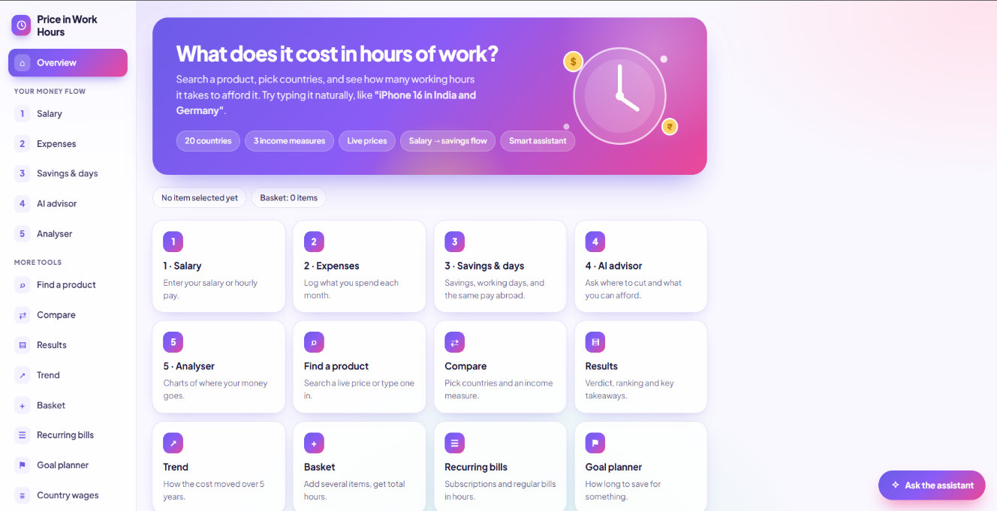

Figure 7.1: Home page of the Price in Work Hours dashboard
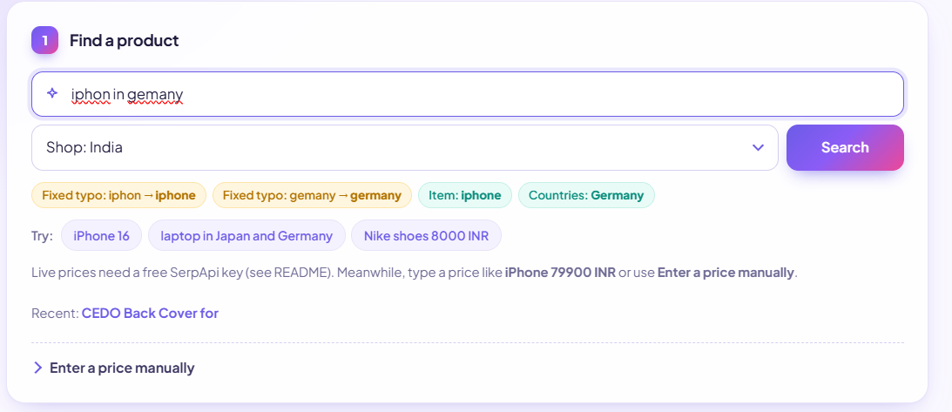
Figure 7.2: Smart search correcting spelling mistakes

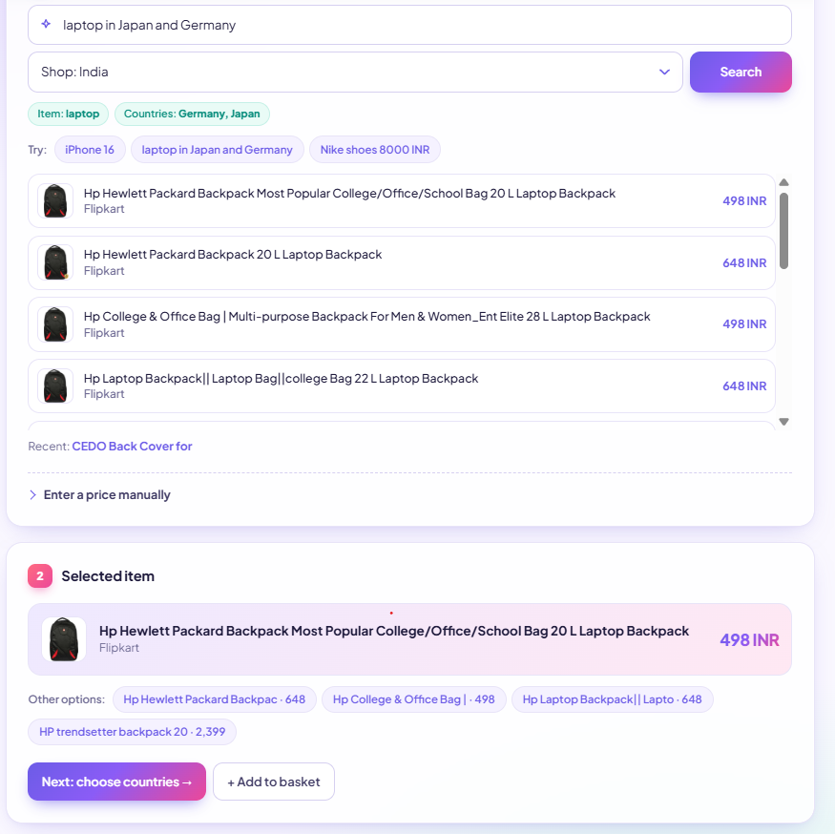
Figure 7.3: Find a product page with live prices
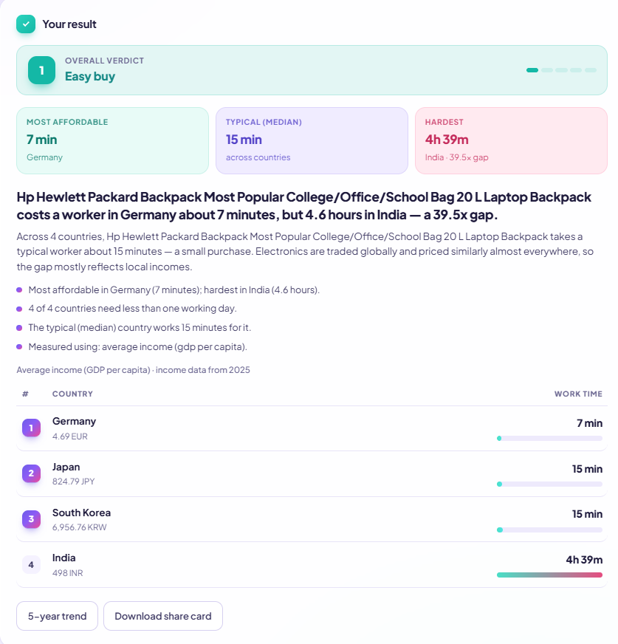

Figure 7.4: Country comparison results with verdict and report

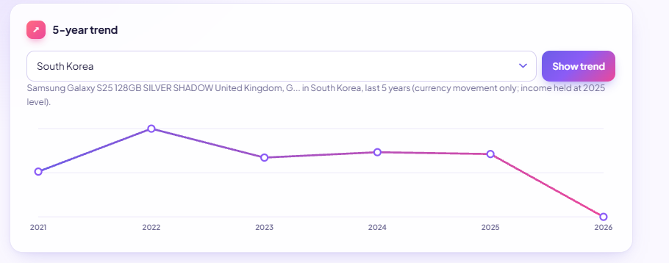

Figure 7.5: 5-year trend chart for one product and country
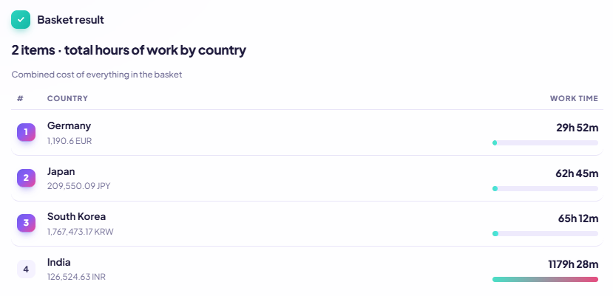

Figure 7.6: Basket comparison showing total work hours per country

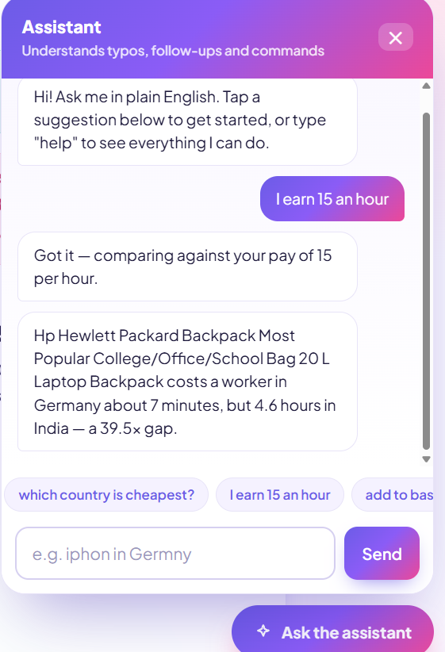

Figure 7.7: Context-aware chatbot answering follow-up questions
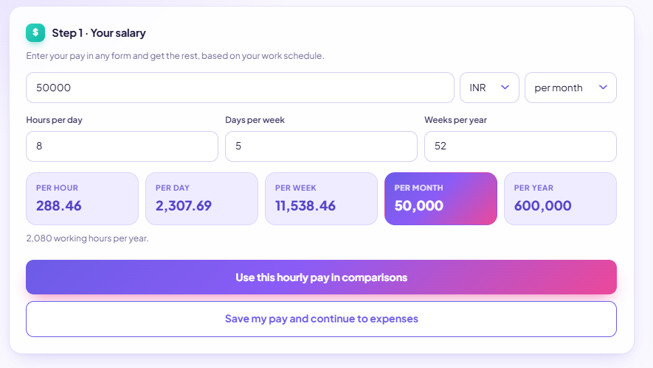
Figure 7.8: Step 1 - Salary and wage calculator

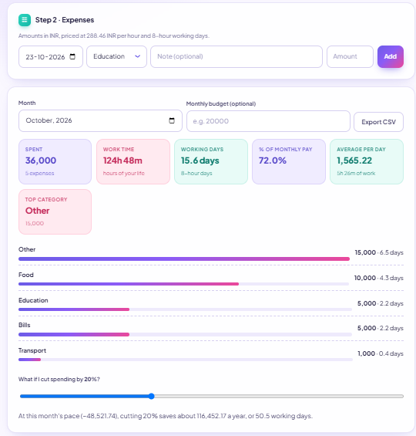
Figure 7.9: Country wages with currency selector

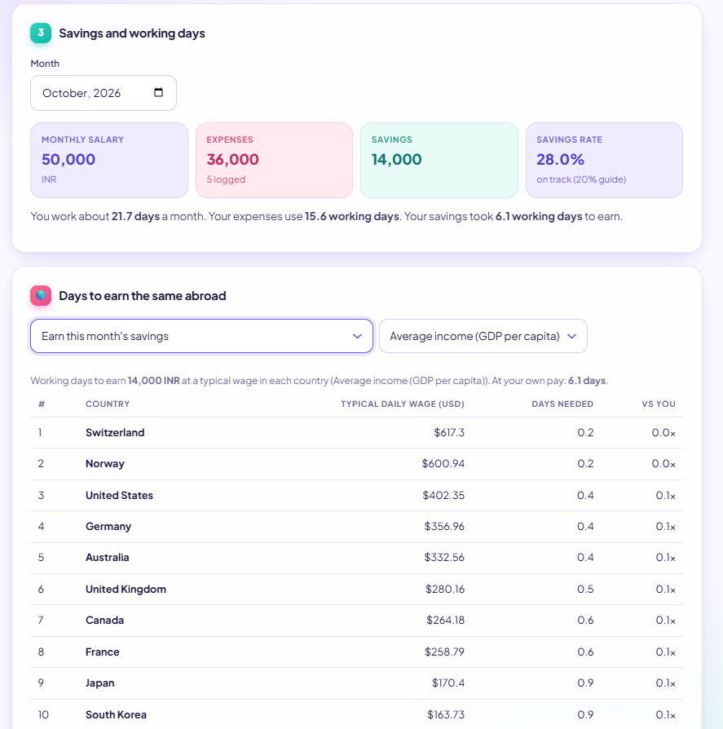

Figure 7.10: Step 2 - Expense tracker with working days and budget progress

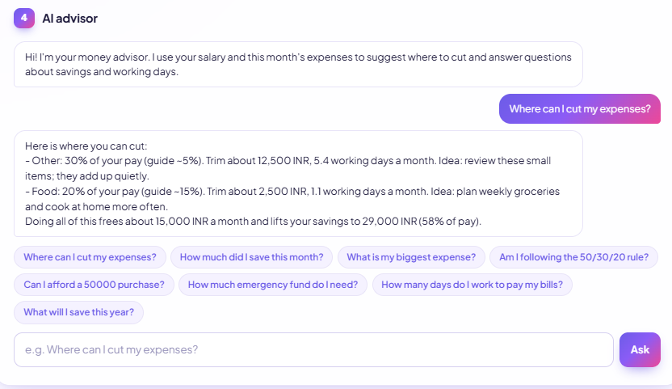
Figure 7.11: Step 3 - AI advisor recommendations on where to cut spending

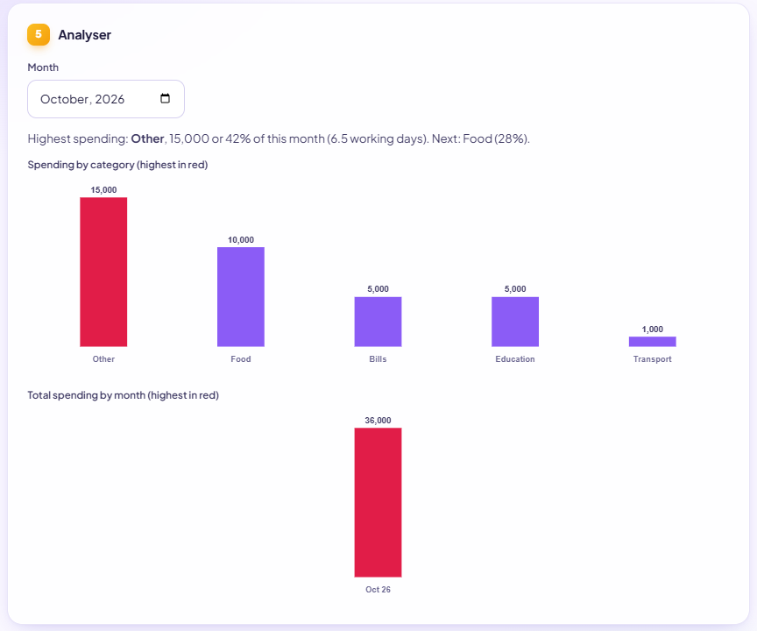
Figure 7.12: Step 4 - Analyser charts of spending by category and month
System Output
User input | Parsed result
iPhone 16 in India and Germany | item: iPhone 16; countries: India, Germany; category: electronics; price: not given (the 16 is a model number)
laptop 80000 INR using minimum wage | item: laptop; price: 80000; currency: INR; mode: minimum wage; category: electronics
iphon in Germny | corrections: iphon to iphone, Germny to germany; item: iphone; country: Germany
pizza $12 in Japan | item: pizza; price: 12; currency: USD; country: Japan; category: food

{'price': None, 'currency': None, 'currency_inferred': False, 'countries': ['IND', 'DEU'], 'item': 'iPhone 16', 'category': 'electronics', 'mode': None, 'corrections': []}
{'price': 80000.0, 'currency': 'INR', 'currency_inferred': False, 'countries': [], 'item': 'laptop', 'category': 'electronics', 'mode': 'minwage', 'corrections': []}
{'price': None, 'currency': None, 'currency_inferred': False, 'countries': ['DEU'], 'item': 'iphone', 'category': 'electronics', 'mode': None, 'corrections': [['iphon', 'iphone'], ['Germny', 'germany']]}
{'price': 12.0, 'currency': 'USD', 'currency_inferred': False, 'countries': ['JPN'], 'item': 'pizza', 'category': 'food', 'mode': None, 'corrections': []}
{'reply': 'Got it — comparing against your monthly pay of 3000.', 'action': {'type': 'set_pay', 'value': 3000.0, 'period': 'monthly'}}
{'reply': 'Comparing iPhone for Japan...', 'action': {'type': 'compare', 'price': 1200, 'currency': 'USD', 'countries': ['JPN'], 'item': 'iPhone'}}

Chatbot message | Reply / action
how does it work | Explains the formula and data sources
which countries do you support | Lists the 20 supported countries
I earn 3000 a month | Action set_pay: monthly pay of 3000
what about Japan? (with iPhone 1200 USD in context) | Action compare: same item and price for Japan
start over | Action reset

8. Testing and Validation
Approach. The project has 29 automated unit tests written with pytest in test_app.py. They make no network calls (external data is replaced by mocks), so they run anywhere and give repeatable results. All 29 tests pass.
$ pytest -q
............................. [100%]
29 passed
Area tested | Tests | What is verified
Query parsing and typo logic | 6 | Price, currency and country extraction; currency symbols; model numbers not treated as prices; currency inferred from country; typo fixing without altering real words; electronics categorisation
Hours formula and ranking | 4 | Nominal formula gives the expected hours; rows with missing rates are skipped; rows are ranked ascending by hours; minimum-wage and coordinate tables cover all 20 countries
Chatbot | 8 | Greeting intent; a message with a price builds a compare action; follow-up reuses the previous item; follow-up with also/too appends a country and fixes a typo; measure switching; commands (basket, trend, reset); answers about results; pay with a period ("3000 a month")
Report generator | 2 | Verdict, summary, bullets and stats structure; /api/compare returns a report
Wage calculator | 6 | Monthly input gives consistent hourly and daily values; conversions round-trip between every period; invalid input is rejected; country wage rows are correct and skip missing data; wage endpoints work
Advisor | 3 | Flags categories above guideline; savings, affordability and top-category answers; requires a salary first, and the endpoint works

Validation by example. The wage formula was checked by hand: a monthly pay of 3,000 with an 8-hour day, 5-day week and 52-week year gives 2,080 working hours a year, so hourly pay is 3,000 x 12 / 2,080 = 17.31, daily pay is 138.46 and annual pay is 36,000, matching the program output.
Edge cases handled
- Misspelled countries and products are corrected; genuine English words are left alone.
- Small numbers (model numbers) are not mistaken for prices.
- Countries with missing income or exchange-rate data are skipped without crashing.
- Zero, negative or out-of-range pay and schedule values return a clear error.
- Messages the classifier is unsure about (probability below 0.3) fall back to a help message.

9. Results and Discussion
The system meets its objectives: it understands typed queries, converts prices to hours of work for 20 countries, explains the result in plain language and supports personal budgeting.
Worked example .Suppose the report generator is given an iPhone 16 and three countries: Germany needs 40 hours, Japan 55 hours and India 600 hours. The system produces:
- Headline: iPhone 16 costs a worker in Germany about 5.0 working days, but 75.0 working days in India: a 15.0x gap.
- Verdict: Noticeable (median 55 hours, about 6.9 working days).
- Takeaways: most affordable in Germany, hardest in India; no country gets it under one working day; the median country works about 6.9 working days for it.
Advisor example. For a monthly pay of 40,000 INR with 32,000 spent (Bills 15,000, Food 9,000, Shopping 6,000, Transport 2,000), the advisor flags Bills at 38% (guide 35%), Food at 22% (guide 15%) and Shopping at 15% (guide 10%). It suggests trimming about 6,000 INR a month in total (about 3 working days at 250 INR per hour), lifting savings to 14,000 INR, or 35% of pay.
Discussion
- Insight. The same product can take a few days of work in a high-income economy and several months in a lower-income one. Electronics, which are priced almost the same worldwide, show the widest gaps, while locally priced goods such as food are less reliable when converted directly (the report states this).
- Choice of measure matters. Average income, minimum wage and PPP-adjusted income answer different questions: how a typical worker, a low-paid worker, or a worker adjusted for local living costs experiences the same price.
- NLP effectiveness. The hybrid rules-plus-Naive-Bayes design keeps commands accurate while still handling open conversation. Placeholder generalisation lets a small training set work for any country or product.
- Cost and privacy. No paid language-model service is needed, and personal financial data stays in the user's browser.
Limitations
- GDP per capita is a national average that includes non-workers, so it estimates typical income, not anyone's actual pay.
- The minimum-wage and working-hours tables are approximations and vary by region, sector and year.
- Frankfurter covers only currencies tracked by the European Central Bank, so some currencies (for example the Nigerian naira) are unavailable.
- The 5-year trend re-fetches past exchange rates but holds income at its latest value, so it shows only the currency-driven part of the change.
- The chatbot's training set is small and hand-made, so unusual phrasings may fall back to the help message.
- Live prices depend on a SerpApi key; the free plan allows 250 searches a month.

10. Conclusion
Price in Work Hours turns an abstract price into something every person understands: time spent working. By combining World Bank income data, live exchange rates and product prices with NLTK-based language understanding, the application lets anyone type a plain sentence and instantly see how affordable a product is in 20 countries, with a ranked table, an automatically written report and a context-aware assistant.
The project demonstrates practical use of NLP techniques (tokenisation, part-of-speech tagging, lemmatisation, stopword removal, edit-distance spelling correction, WordNet, Naive Bayes intent classification and template-based text generation) inside a complete web application. Its extension into a personal-finance toolkit (wage calculator, expense tracker, goal planner and advisor) shows how the same "hours of work" idea can help individuals plan their own spending. The 29 passing offline tests give confidence in the calculations, parsing logic and chatbot behaviour.

11. Future Enhancements
- Persistent personal income: let a user's income and pay profile persist and pre-fill across sessions and devices (for example with optional sign-in).
- Cost-of-living adjustment beyond PPP: use local price indices for categories such as food, rent and transport for more realistic comparisons.
- Browser extension: show "hours of work" directly on shopping sites next to the price.
- Currency volatility alerts: notify the user when a country's exchange rate has moved sharply.
- More countries and currencies: extend beyond the 20 supported countries and handle currencies not covered by the ECB rates.
- Richer NLP: grow the training set, add multilingual input (for example Hindi and Kannada), and try a trained sequence model or transformer-based intent classifier.
- Real income time series: use historical wage data so the 5-year trend reflects income growth as well as currency change.
- Mobile app and voice input: a mobile front end with speech-to-text for the assistant.
- Exportable reports: download comparison and expense reports as PDF or spreadsheet files.

