1)Implementation of Apriori algorithm
from itertools import combinations
T = [
{'Milk','Bread','Butter'}, {'Bread','Butter'}, {'Milk','Bread'},
{'Milk','Butter'}, {'Bread','Butter','Eggs'}, {'Milk','Bread','Butter'}
]
S, C = .5, .7
def sup(x): return sum(x <= t for t in T)/len(T)
items = set().union(*T)
freq = []

for k in range(1, len(items)+1):
f = {frozenset(x) for x in combinations(items,k) if sup(set(x)) >= S}
if not f: break
freq += f
print("Frequent Itemsets:")
for x in freq: print(set(x), round(sup(set(x)),2))
print("\nAssociation Rules:")
for x in freq:
for r in range(1,len(x)):
for a in combinations(x,r):
a,b=set(a),set(x)-set(a)
conf=sup(a|b)/sup(a)
if conf>=C: print(a,"->",b,round(conf,2))
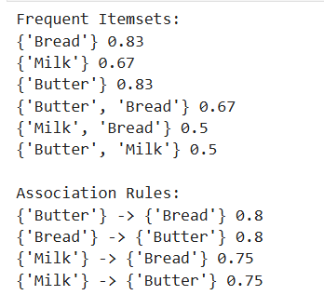

2)Implementation of Classification mode K-nearest neighbour
from sklearn.model_selection import train_test_split
from sklearn.neighbors import KNeighborsClassifier
from sklearn.metrics import accuracy_score

X = [[1,2], [2,3], [3,4], [6,7], [7,8], [8,9]]
y = ['Red', 'Red', 'Red', 'Blue', 'Blue', 'Blue']

X_train, X_test, y_train, y_test = train_test_split(
X, y, test_size=0.25, random_state=42
)

model = KNeighborsClassifier(n_neighbors=3)
model.fit(X_train, y_train)

pred = model.predict(X_test)

print("Actual:", y_test)
print("Predicted:", pred)
print("Accuracy:", accuracy_score(y_test, pred))

print("New Prediction:", model.predict([[5,6]]))
OUTPUT
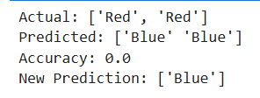

3)Implementation of linear regression model.
from sklearn.model_selection import train_test_split
from sklearn.linear_model import LinearRegression
from sklearn.metrics import mean_squared_error, r2_score
import matplotlib.pyplot as plt

# Dataset
X = [[1], [2], [3], [4], [5],
[6], [7], [8], [9], [10]]

y = [10, 20, 30, 40, 50,
60, 70, 80, 90, 100]

# Split dataset
X_train, X_test, y_train, y_test = train_test_split(
X, y, test_size=0.2, random_state=42
)

# Train model
model = LinearRegression()
model.fit(X_train, y_train)

# Prediction
y_pred = model.predict(X_test)

# Results
print("Actual:", y_test)
print("Predicted:", y_pred)
print("MSE:", mean_squared_error(y_test, y_pred))
print("R2 Score:", r2_score(y_test, y_pred))

# New prediction
print("Prediction for 12:", model.predict([[12]])[0])

# Regression Line
line = model.predict(X)

plt.scatter(X, y)
plt.plot(X, line)
plt.xlabel("X")
plt.ylabel("Y")
plt.title("Linear Regression")
plt.show()
OUTPUT

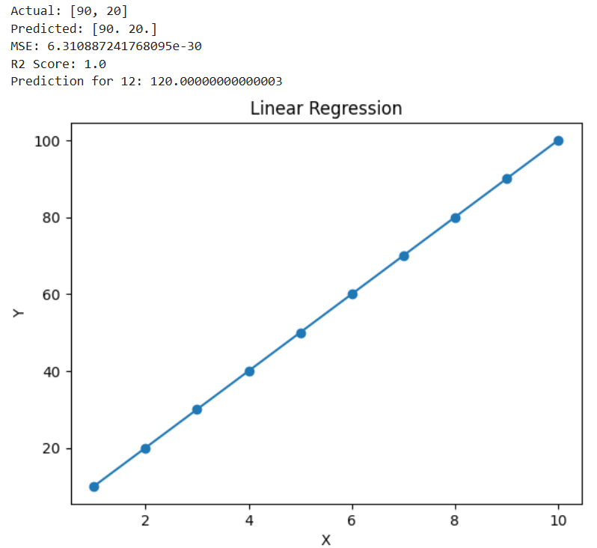

4)Demonstrate Data visualization.
import pandas as pd
import matplotlib.pyplot as plt
import seaborn as sns

file = input("Enter CSV file name: ")
df = pd.read_csv(file)

print("\nData Loaded Successfully!")
print(df.head())

print("\n--- DATA VISUALIZATION MENU ---")
print("1. Histogram")
print("2. Bar Chart")
print("3. Line Chart")
print("4. Scatter Plot")
print("5. Box Plot")
print("6. Pie Chart")
print("7. Heatmap")
print("8. Exit")

while True:
choice = int(input("\nEnter your choice: "))

if choice == 1:
sns.histplot(df["Marks"], kde=True)
plt.title("Marks Distribution")
plt.show()

elif choice == 2:
sns.barplot(x="Name", y="Marks", data=df)
plt.title("Marks by Student")
plt.xticks(rotation=45)
plt.show()

elif choice == 3:
plt.plot(df["Name"], df["Marks"], marker="o")
plt.title("Marks Trend")
plt.xticks(rotation=45)
plt.show()

elif choice == 4:
sns.scatterplot(x="StudyHours", y="Marks", data=df)
plt.title("Study Hours vs Marks")
plt.show()

elif choice == 5:
sns.boxplot(y=df["Marks"])
plt.title("Marks Box Plot")
plt.show()

elif choice == 6:
df["Gender"].value_counts().plot.pie(autopct="%1.1f%%")
plt.title("Gender Distribution")
plt.ylabel("")
plt.show()

elif choice == 7:
sns.heatmap(df.select_dtypes("number").corr(), annot=True)
plt.title("Correlation Heatmap")
plt.show()

elif choice == 8:
print("Program Ended")
break

else:
print("Invalid Choice")

OUTPUT
Enter CSV file name: s.csv

Data Loaded Successfully!
Name Age Marks Attendance StudyHours Gender
0 John 20 85 90 5 Male
1 Sara 21 92 95 7 Female
2 Mike 20 70 80 3 Male
3 Anna 22 88 92 6 Female
4 David 21 65 75 2 Male

--- DATA VISUALIZATION MENU ---
1. Histogram
2. Bar Chart
3. Line Chart
4. Scatter Plot
5. Box Plot
6. Pie Chart
7. Heatmap
8. Exit

Enter your choice: 1
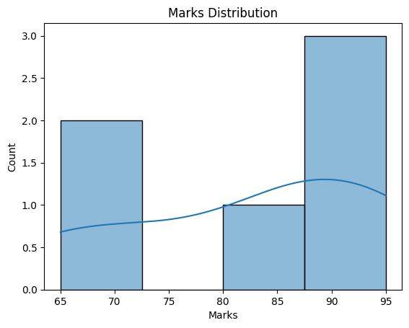

Enter your choice: 2
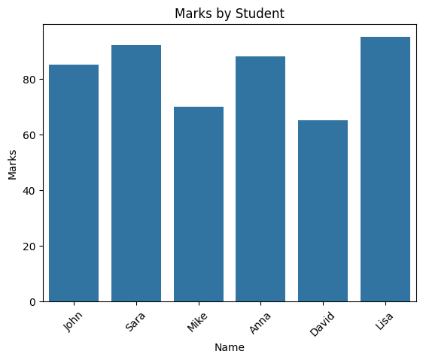

Enter your choice: 3
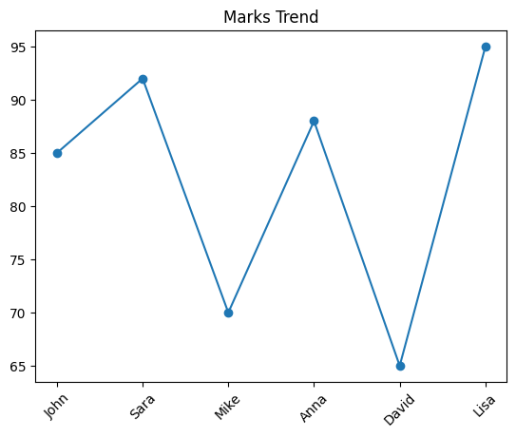

Enter your choice: 4
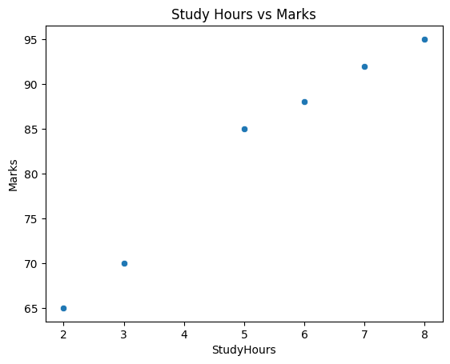

Enter your choice: 5
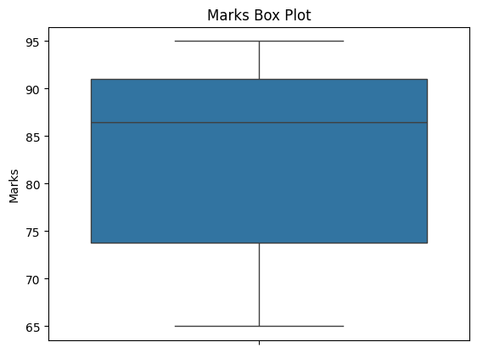

Enter your choice: 6
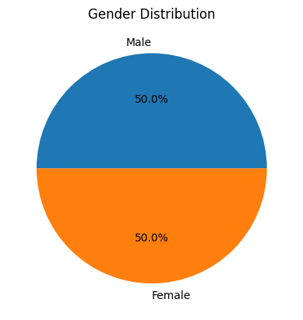

Enter your choice: 7
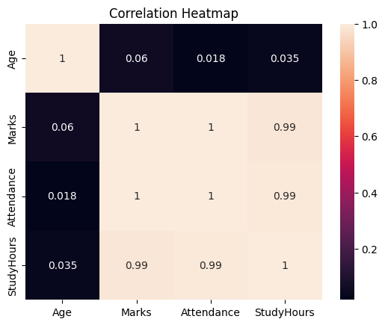

Enter your choice: 8
Program Ended

5)Implementation of classification models-Naïve bayes clasiifier
from sklearn.model_selection import train_test_split
from sklearn.naive_bayes import GaussianNB
from sklearn.metrics import accuracy_score

# Attendance (%) and Marks (%)
X = [
[90, 85],
[85, 80],
[95, 90],
[60, 55],
[65, 60],
[70, 65],
[88, 82],
[55, 50]
]

y = [
'Pass', 'Pass', 'Pass', 'Fail',
'Fail', 'Fail', 'Pass', 'Fail'
]

# Split data
X_train, X_test, y_train, y_test = train_test_split(
X, y, test_size=0.25, random_state=42
)

# Train Naive Bayes model
model = GaussianNB()
model.fit(X_train, y_train)

# Predict
y_pred = model.predict(X_test)

print("Actual:", y_test)
print("Predicted:", y_pred)
print("Accuracy:", accuracy_score(y_test, y_pred))

# New student prediction
print("New Student:", model.predict([[85, 78]])[0])

OUTPUT
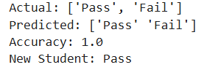

6) Implementation of classification models-Decision trees
from sklearn.model_selection import train_test_split
from sklearn.tree import DecisionTreeClassifier
from sklearn.metrics import accuracy_score

# Attendance (%) and Marks (%)
X = [
[90, 85], [85, 80], [95, 90],
[60, 55], [65, 60], [70, 65],
[88, 82], [55, 50]
]

y = [
'Pass', 'Pass', 'Pass',
'Fail', 'Fail', 'Fail',
'Pass', 'Fail'
]

# Split data
X_train, X_test, y_train, y_test = train_test_split(
X, y, test_size=0.25, random_state=42
)

# Create and train model
model = DecisionTreeClassifier(random_state=42)
model.fit(X_train, y_train)

# Prediction
y_pred = model.predict(X_test)

print("Actual:", y_test)
print("Predicted:", y_pred)
print("Accuracy:", accuracy_score(y_test, y_pred))

# New student prediction
print("New Student:", model.predict([[85, 78]])[0])

OUTPUT
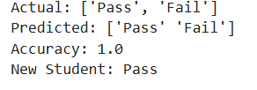

7 ) Implementation of classification models-Random forest
from sklearn.model_selection import train_test_split
from sklearn.ensemble import RandomForestClassifier
from sklearn.metrics import accuracy_score

# Attendance (%) and Marks (%)
X = [
[90, 85], [85, 80], [95, 90],
[60, 55], [65, 60], [70, 65],
[88, 82], [55, 50]
]

y = [
'Pass', 'Pass', 'Pass',
'Fail', 'Fail', 'Fail',
'Pass', 'Fail'
]

# Split data
X_train, X_test, y_train, y_test = train_test_split(
X, y, test_size=0.25, random_state=42
)

# Create and train model
model = RandomForestClassifier(
n_estimators=10,
random_state=42
)

model.fit(X_train, y_train)

# Prediction
y_pred = model.predict(X_test)

print("Actual:", y_test)
print("Predicted:", y_pred)
print("Accuracy:", accuracy_score(y_test, y_pred))

# New student prediction
print("New Student:", model.predict([[85, 78]])[0])

OUTPUT
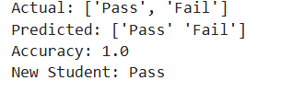

8)Implementation of Regression models-Multiple
from sklearn.model_selection import train_test_split
from sklearn.linear_model import LinearRegression
from sklearn.metrics import r2_score

# Area(sqft), Bedrooms, Age(years)
X = [
[1000, 2, 10],
[1200, 2, 8],
[1500, 3, 7],
[1800, 3, 5],
[2000, 4, 4],
[2200, 4, 3],
[2500, 4, 2],
[2800, 5, 1]
]

# House Price (Lakhs)
y = [40, 48, 60, 72, 82, 90, 105, 120]

# Split data
X_train, X_test, y_train, y_test = train_test_split(
X, y, test_size=0.25, random_state=42
)

# Train model
model = LinearRegression()
model.fit(X_train, y_train)

# Prediction
y_pred = model.predict(X_test)

print("Actual Prices:", y_test)
print("Predicted Prices:", y_pred)
print("R2 Score:", r2_score(y_test, y_pred))

# Predict new house price
new_house = [[1600, 3, 5]]
print("Predicted House Price:",
model.predict(new_house)[0], "Lakhs")

OUTPUT
