IT 402 – SYSTEM INTEGRATION AND ARCHITECTURE
FINAL PROJECT

CASPTONE PROJECT TITLE

MEMBER NAME 1
MEMBER NAME 2
MEMBER NAME 3
MEMBER NAME 4
MEMBER NAME 5

BSIT 4 SECTION BATCH

Submitted to:
MS. GENALYN D. VILLAFUERTE

- CAPSTONE PROJECT DETAILS

- CAPSTONE PROJECT DESCRIPTION:
- BACK-END:
- FRONT-END:
- SOFTWARE DEVELOPMENT METHODOLOGY USED:
- GANTT CHART:
Sample only:
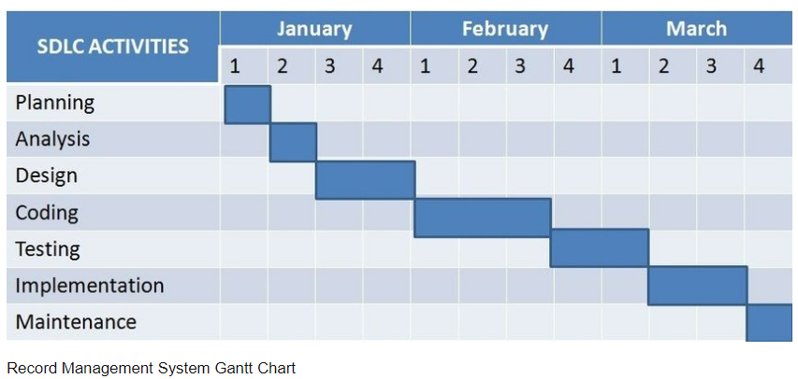

- SITEMAP DIAGRAM:
Sample only:
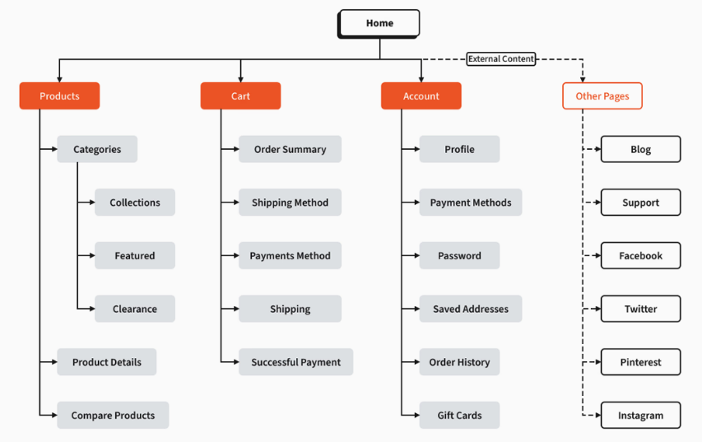

- USE CASE DIAGRAM:
Sample only
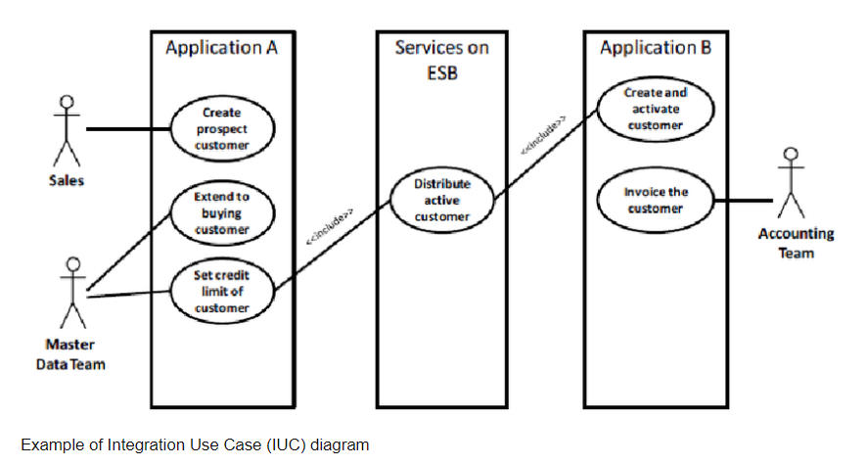
- ENTITY-RELATIONSHIP (ER) DIAGRAM:
Sample:
Database name: LIbraryData
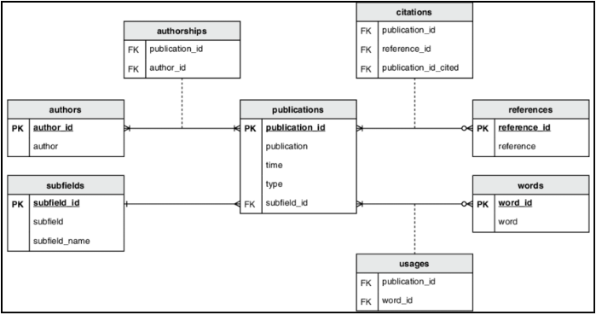

- TABLE DESIGN:
Sample:
Table name: employees
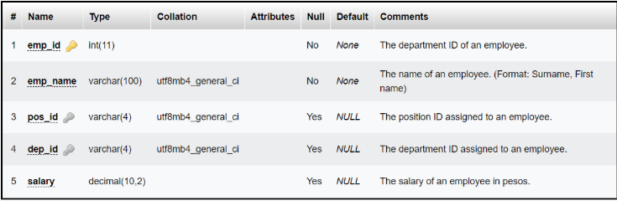

- TEST CASES AND EVIDENCE
Test Case ID: | Module:
Test Title:
Priority: | Test Type:
Preconditions:

Test Steps:
- Abc

Test Data:

Expected Result:

Actual Result:

Attached video: enroll-001.mp4
Tester Name:

- DATA VALIDATION TESTING:
Test Case ID: | Module:
Table Name: | Field Name:
Validation Rule/s:

Sample Valid Value:

Action if Validation Rule/s are Met:

Action if Validation Rule/s are Not Met:

Actual Result:

Attached video: validation-001.mp4
Implementation:

- SECURITY TESTING
Test Case ID: | Module:
Security Testing Against:

Method Used and Test Steps:

Expected Result:

Actual Result:

Attached video: SEC-001.mp4
Implementation:

