DiscordMail
And an assessment of DiscordApp
Table of Contents
Introduction 1
General Adequacy 1
Period of Storing 2
Security of DiscordApp 2
DM Messaging 3
Guild Messaging 3
Transport of Personal Data 4
Transfer of Personal Information to Discord Inc. 4

I could not find the autocorrect feature in LibreOffice. Words may be spelt incorrectly. If in doubt, guess, or ask the author (me!) to fix it.

Introduction
DiscordMail is a service which redirects emails. After a user has registered for a email from DiscordMail, the user obtains an email address, which can be used to send and receive emails.
Currently, emails that are sent from the account are not recorded whatsoever by Moustacheminer Server Services, and emails received are instantly redirected and not stored.
In the near future, emails received by the account are recorded, to allow for the subject to download a copy of the email received. Other than user convenience and for technical debugging, such as in the case of not being able to receive emails, or if the service breaks down, emails will not be processed (to search for information).

General Adequacy
Unfortunately, the nature of information cannot be determined easily. This is because the body of emails received cannot be generalised to a specific topic. For example, the body may or may not contain personal information. Under this uncertainty, all of the data that is passed through the Moustacheminer Server Services DiscordMail Service will be determined as sensitive personal information, even if it may not be.
DiscordMail as a service will save and redirect a shortened version to the recipient. Incoming data is processed by Mailgun Technologies, Inc., which is in compliance with the EU-U.S. Privacy Shield. Data will be then stored by Moustacheminer Server Services, and a text based email is then redirected to Discord Inc., a business which has not currently registered with the EU-U.S. Privacy Sheild. For a security analysis for Discord Inc., see Security of DiscordApp. Because information is sent to only the recipient, information is at a lower risk of being accidentally released, because information is not distributed widely.
Users can obtain the full information (HTML, not just text) by logging in the website via an OAuth2 authentication scheme, reducing who can access the personal information without storing passwords.
In order to view this, the specific user the message is sent to (or the users the owner has allowed to view) has to log in using an email, password, and if applicable, a second authentication code that is generated automatically on the user’s mobile device, or sent to the user.
Personal information sent from DiscordMail to Discord can therefore not be read by other people in the scope of other users, because of the requirements to authenticate.

Period of Storing
To provide users with a long lasting expierience, the rich HTML document is stored indefinitely, until the termination of either the user’s DiscordMail account, DiscordMail or Moustacheminer Server Services.

Security of DiscordApp
Discord Inc., formally named “Hammer and Chisel Inc.” is a business ran in the USA providing an online messaging service for instant messaging, voice communications with VoIP and later, video based communications.
Moustacheminer Server Services are interested in using the instant messaging portion of the “Discord” software to distribute information that may contain personal information to relevant owners, through a mail service, called DiscordMail
“DiscordMail” as a product already exists, but does not currently store personally identifiable information. This report analyses the adequacy of Discord as a handler of information outside the EEA, inside the USA.
Discord performs messaging through three different methods:
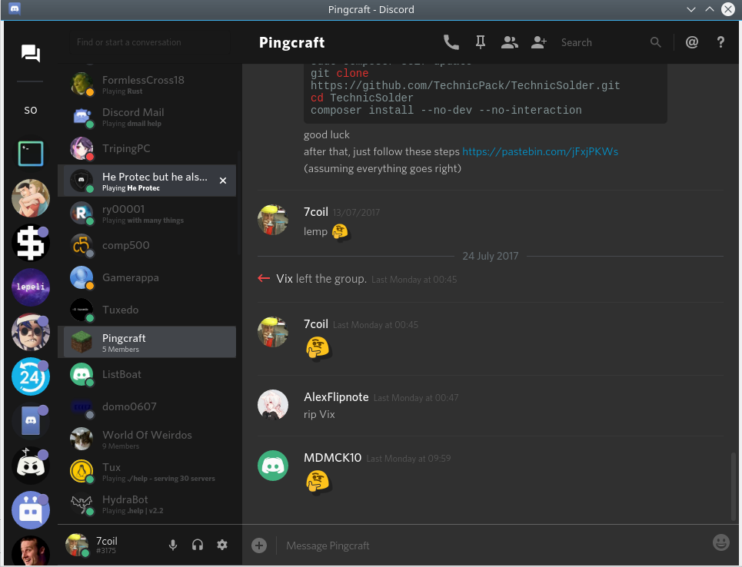Illustration 1: An image of the Discord software, showing a group messaging chat.
- User to User Messaging (DM)
- Group Messaging
- Server Messaging (Guild)
In our use case scenario for DiscordMail, only DM and Guild based chats are relevant, as DiscordMail only operates under those two methods.

DM Messaging
DM Messaging is where a single user can communicate with a single other user and/or bot. The DiscordMail service currently uses this to send emails to specific users, when an email is sent to a tag.

Guild Messaging
DiscordMail also operates under a Guild based system, where emails can be sent to the guild, for larger groups instead of directly to a singular user.
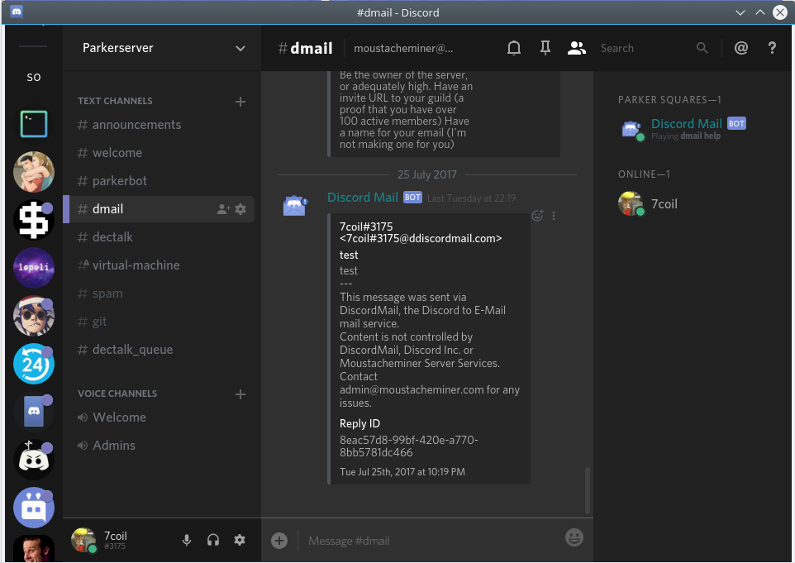Illustration 2: Although this is in a group chat, the potentially personal messages have been set to view only by the owner of the E-Mail to relevant people.
Under this scenario, the owner of the Guild can set permissions within Discord to allow and deny access to viewing personal information. This means the owner has control of who can see what.
Information is therefore not released to anyone but the relevant recipient, unless the recipient decides to allow others to view the inbox.

Transport of Personal Data
Discord and it’s respecitive API uses TLS 1.2, which securely encrypts data transmitted from DiscordMail to Discord, preventing MITM attacks, securing the personal data from being viewed by unintended recipients.

Transfer of Personal Information to Discord Inc.
Based on the security and privacy agreements shown by Discord Inc., as reported above, it can be determined that Discord Inc. is an adequate host for personal information, and can be trusted to store the information without risk of breaching the Data Protection Act. This conclusion means that Moustacheminer Server Services will proceed to register for the Data Protection Act to store the personal information, and continue innovating in our applications.

