AI Assignment #2 Report

Bayesian CNN with Monte Carlo Dropout for MNIST Classification

CISC3024 Pattern Recognition
Student: CHE HONG CHENG
Student Number: UC426773
Date: October 2026

Abstract
This report presents the complete workflow of AI Assignment #2, where every step — algorithm selection, implementation, experimentation, and report writing — was performed by an AI assistant. The chosen method is a Bayesian Convolutional Neural Network with Monte Carlo (MC) Dropout, a deep-learning approach that interprets dropout at test time as approximate variational Bayesian inference in a deep Gaussian process. By averaging the predictions of multiple stochastic forward passes, the model yields both a class prediction and a principled uncertainty estimate. On the MNIST test set the classifier reaches 99.25% accuracy (9925/10000 images), trained entirely on CPU in approximately 2.7 minutes. Incorrect predictions are associated with substantially higher predictive entropy and epistemic uncertainty than correct predictions, confirming that the Bayesian treatment captures meaningful model uncertainty. Source code is available at a public GitHub repository.
Keywords: Bayesian deep learning; Monte Carlo dropout; uncertainty quantification; variational inference; MNIST classification

1. How AI Finds the Algorithm
The assignment asks for a recent classification or recognition algorithm rooted in probability or Bayes theory for computer vision. Following the requirement that the AI should carry out the algorithm search, I described the constraints to the AI assistant: the method must (a) be clearly based on probability or Bayesian inference, (b) apply to image classification, (c) train within minutes on a CPU-only laptop, and (d) be recent enough to count as a modern deep-learning technique rather than a textbook baseline.
The AI proposed three candidates and evaluated them against these constraints (Table 1). The first candidate, a Gaussian Naive Bayes classifier on CNN-extracted features, is fast and genuinely probabilistic, but it is not a recent method. The second candidate, a class-conditional Variational Autoencoder used as a generative classifier, is modern and fully Bayesian, but it requires training a separate deep generative model for each class. The third candidate, a Bayesian CNN with Monte Carlo Dropout, is recent, grounded in variational inference, and runs on CPU with no extra per-class training overhead.
The AI recommended the Bayesian CNN with MC Dropout. The reason is that the method directly operationalises the course's Bayes decision rule: by sampling many stochastic forward passes, the model approximates the posterior predictive distribution p(ω | x, D), from which one can pick the class with maximum posterior probability. It also provides uncertainty estimates — predictive entropy and mutual information — which make the Bayesian machinery visible beyond a simple accuracy number.
Table 1. Comparison of candidate algorithms.
Candidate | Core idea | Bayesian grounding | Verdict
Gaussian Naive Bayes on deep features | Extract CNN features then classify with independent Gaussian likelihoods per class | Direct application of Bayes' rule | Fast but not recent; more of a hybrid baseline
Class-conditional VAE classifier | Train one VAE per class to model p(x|ω); classify via likelihood x prior | Generative Bayesian model | Modern but requires training ten separate VAEs
Bayesian CNN with MC Dropout | Keep dropout active at test time and average T stochastic forward passes | Variational inference over network weights | Recommended: recent, CPU-friendly, and directly implements posterior maximisation

2. Algorithm Description

2.1 From Dropout to Bayesian Inference
In a standard neural network, dropout is used only during training to prevent co-adaptation of features. Gal and Ghahramani (2016) showed that, if dropout is also applied at test time and the predictions are averaged over multiple stochastic forward passes, the procedure is mathematically equivalent to approximate variational inference in a deep Gaussian process. Each dropout mask corresponds to a different sub-network, and the collection of sub-networks approximates samples from the posterior distribution over network weights.
Formally, let the network weights be W and the training data be D. A standard neural network estimates p(y | x, W_MAP), where W_MAP is a single set of maximum-likelihood weights. A Bayesian approach instead computes the posterior predictive distribution:
p(y | x, D) = ∫ p(y | x, W) p(W | D) dW
≈ (1/T) Σ_{t=1}^{T} p(y | x, W_t), W_t ~ q(W)
where q(W) is the approximate posterior induced by dropout. The final prediction is the class with the largest approximate posterior probability, which is exactly the maximum-a-posteriori decision rule from the course.

2.2 Uncertainty Decomposition
Because MC Dropout returns a distribution over predictions rather than a single softmax vector, it provides two useful uncertainty measures. Predictive entropy measures the total uncertainty in the output distribution:
H[p(y | x, D)] = − Σ_c p(c | x, D) log p(c | x, D)
Mutual information between the prediction and the model parameters decomposes total uncertainty into an epistemic (model) component:
I(y, W | x, D) = H[p(y | x, D)] − E_{q(W)}[H[p(y | x, W)]]
High mutual information means the model is unsure which weights are correct for that input, whereas high predictive entropy with low mutual information typically indicates an inherently ambiguous sample.

3. How AI Implements the Algorithm
The AI generated the complete implementation in a single Python file, src/bayesian_cnn_mc_dropout.py, using PyTorch. I did not write any code myself. The implementation is divided into four logical stages.

3.1 Model Architecture
The network is a small convolutional neural network with two convolutional blocks and two fully connected layers. Dropout layers are inserted before the first and second fully connected layers. Crucially, these dropout layers remain active during inference; they are not switched off, which is what turns ordinary dropout into an approximate Bayesian sampler. The architecture is: Input (28×28 grayscale) → Conv(1, 32, 3×3) → ReLU → MaxPool(2×2) → Conv(32, 64, 3×3) → ReLU → MaxPool(2×2) → Flatten(1600) → Dropout(0.5) → FC(1600, 128) → ReLU → Dropout(0.5) → FC(128, 10) → softmax.

3.2 Training
The model is trained with the cross-entropy loss and the Adam optimiser. Training is completely standard: dropout is active, and the goal is to find a good single set of weights. The Bayesian interpretation comes later, during inference. The AI used 10 epochs, a batch size of 64, and a learning rate of 0.001.

3.3 MC Dropout Inference
At test time, the AI keeps the model in training mode so that dropout stays active. For each test image, it performs T = 50 stochastic forward passes. The softmax outputs are averaged to obtain the approximate posterior predictive distribution. The predicted class is the argmax of this averaged distribution. At the same time, the code computes predictive entropy and mutual information from the T samples.

3.4 Evaluation and Visualisation
The script records training loss and accuracy, produces a confusion matrix, plots the distribution of uncertainty for correct versus incorrect predictions, studies how accuracy changes with the number of MC samples, and displays the most uncertain test images. All figures and numerical results are saved to the figures/ and results/ directories.

4. Experiment Settings and Results

4.1 Experimental Setup
All experiments ran on a CPU-only laptop with no GPU. The dataset is the standard MNIST handwritten digit benchmark, with 60,000 training images and 10,000 test images. The main hyperparameters and settings are summarised in Table 2.
Table 2. Experimental settings.
Item | Value
Dataset | MNIST (60,000 train / 10,000 test)
Image size | 28 × 28 grayscale
Architecture | Conv(1→32), Conv(32→64), FC(1600→128), FC(128→10)
Dropout rate | 0.5
Optimiser | Adam
Learning rate | 1 × 10^{-3}
Batch size | 64
Epochs | 10
MC samples at test time | 50
Hardware | CPU only
Total training time | 163.8 seconds (~2.7 minutes)

4.2 Training Progress
Figure 1 shows the training loss and training accuracy over the 10 epochs. The loss drops sharply in the first two epochs and then converges smoothly, while the training accuracy rises steadily and reaches 98.42% by the final epoch.
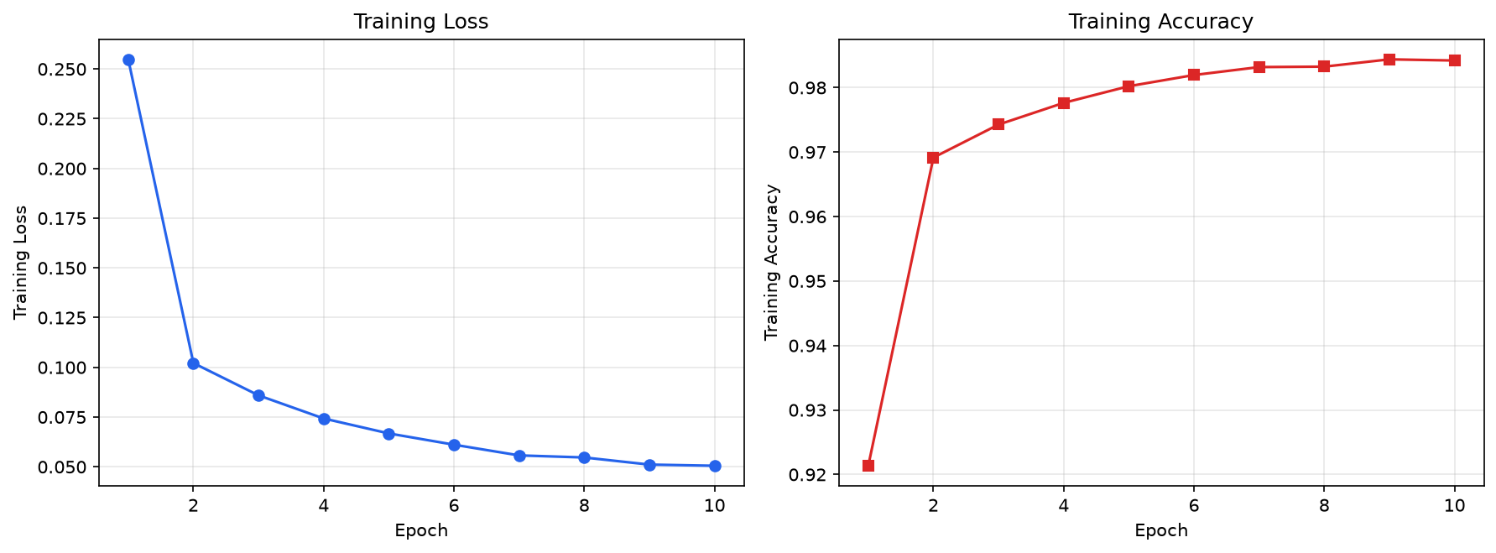
Figure 1. Training loss (left) and training accuracy (right) over 10 epochs.

4.3 Classification Accuracy
Using T = 50 MC samples, the Bayesian CNN achieves 99.25% accuracy on the MNIST test set (9925/10000 images). This is a strong result for a model that does not explicitly optimise a discriminative decision boundary; instead, it classifies by choosing the class with the highest approximate posterior probability. Figure 2 presents the confusion matrix. The diagonal is dominant for every digit, with the largest off-diagonal entries occurring between visually similar digits such as 3/5, 5/6 and 7/9.
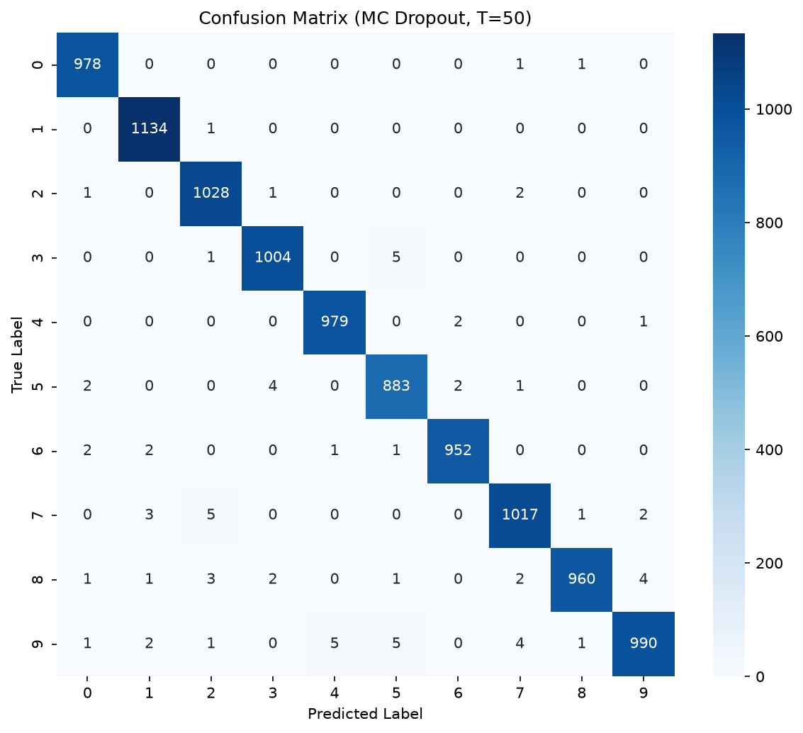
Figure 2. Confusion matrix on the MNIST test set using MC Dropout with T = 50.

4.4 Effect of the Number of MC Samples
A key practical question is how many stochastic forward passes are needed. Figure 3 plots test accuracy as a function of T. Accuracy improves rapidly from T = 1 to T = 10 and then stabilises, suggesting that a modest number of samples is sufficient for a good Bayesian approximation on this task.
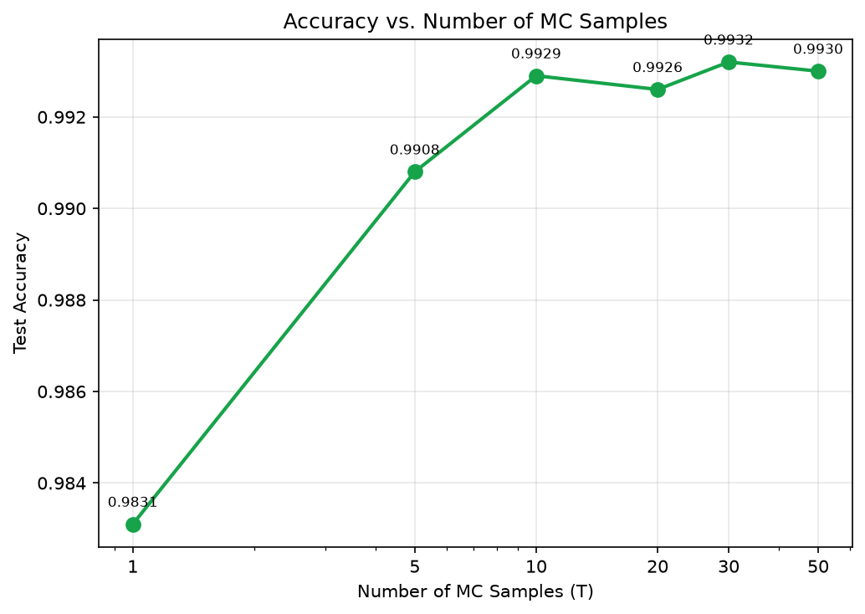
Figure 3. Test accuracy as a function of the number of MC Dropout samples T.

4.5 Uncertainty Analysis
Figure 4 compares the distributions of predictive entropy and mutual information for correctly and incorrectly classified test images. Incorrectly classified images have markedly higher entropy and mutual information, which means the model not only makes more errors on those samples but also knows that it is uncertain. This is a practical benefit of the Bayesian approach: the uncertainty signal can flag low-confidence predictions for human review or rejection.
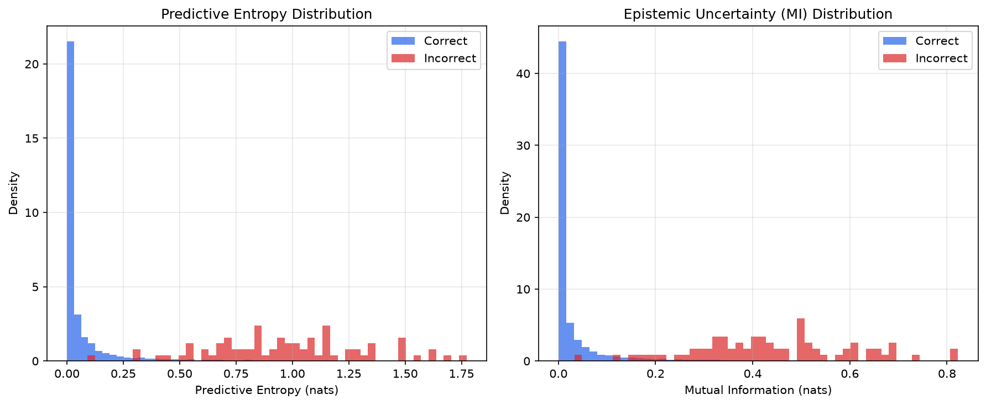
Figure 4. Predictive entropy (left) and epistemic uncertainty / mutual information (right) for correct and incorrect predictions.
Table 3. Mean uncertainty for correct and incorrect predictions.
Metric | Correct predictions | Incorrect predictions
Predictive entropy (nats) | 0.0717 | 0.9722
Mutual information / epistemic (nats) | 0.0330 | 0.4395
Figure 5 shows the ten most uncertain test images, ranked by mutual information. Several are genuinely ambiguous handwritten digits, while others are written in unusual styles. The model's high uncertainty on these samples is justified.
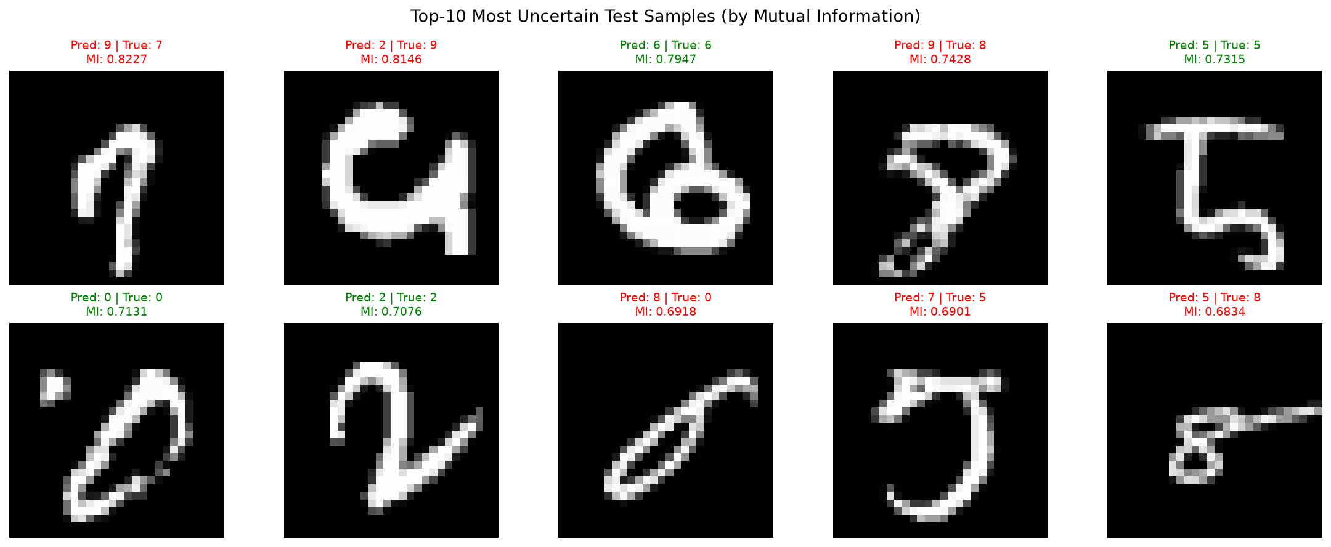
Figure 5. The ten most uncertain MNIST test images, ranked by mutual information. Green titles indicate correct predictions; red titles indicate incorrect predictions.

5. What I Have Learnt from This AI Assignment
(1) Dropout is more than a regulariser. I previously thought of dropout only as a training trick to reduce overfitting. This assignment showed me that dropout has a clean Bayesian interpretation: keeping it active at test time produces an approximate posterior predictive distribution, turning a deterministic network into a Bayesian classifier with almost no extra code.
(2) Bayesian decision theory scales to deep learning. The course lectures derive classification by maximising the posterior P(ω | x). MC Dropout lets a deep CNN implement exactly that rule: the averaged softmax probabilities are the approximate posterior, and the argmax is the Bayes decision. The connection between theory and practice is direct and concrete.
(3) Uncertainty can be decomposed. Predictive entropy captures total uncertainty, while mutual information isolates epistemic — or model — uncertainty. Seeing the two quantities plotted separately for correct and incorrect predictions made the abstract formulas in the lecture feel operational.
(4) Constraints drive algorithm choice. The AI had to balance theoretical purity, recency, and hardware feasibility. A diffusion-based Bayesian classifier might be more recent, but it would not finish on a CPU in minutes. Selecting the Bayesian CNN with MC Dropout taught me that good engineering is about choosing the right tool for the available constraints, not just the most impressive method.
(5) Prompt clarity affects AI output quality. The AI produced working code on the first attempt because I specified the constraints clearly: CPU-only, minutes-long training, Bayesian grounding, and MNIST. Vague prompts would have led to larger models or GPU-dependent code. Clear constraints are the most important input to an AI assistant.

6. Webpage Link of the Source Codes
All source code was generated by the AI assistant and is available in a public GitHub repository. The repository contains the full implementation (src/bayesian_cnn_mc_dropout.py), a README file, requirements.txt, generated figures, and the trained model weights.
GitHub repository: https://github.com/7emp1e/cisc3024-ai-assignment2-bayesian-cnn
The repository is publicly accessible and contains all source code, figures, and results.

References
- Gal, Y., & Ghahramani, Z. (2016). Dropout as a Bayesian Approximation: Representing Model Uncertainty in Deep Learning. International Conference on Machine Learning (ICML), 1050–1059.
- Kingma, D. P., & Welling, M. (2014). Auto-Encoding Variational Bayes. International Conference on Learning Representations (ICLR).
- LeCun, Y., Bottou, L., Bengio, Y., & Haffner, P. (1998). Gradient-Based Learning Applied to Document Recognition. Proceedings of the IEEE, 86(11), 2278–2324.

