Project proposal

Position control experiment prototype

Submitted by:

1. Mostafa Eliwa
2. Ahmed AlGhannam
3. Ahmed Nashaat

Supporting Faculty:

Dr. Mostafa Abdalla

# Introduction:

There is a large market in Egypt and neighboring markets for scientific lab equipment and demonstrators. As a group of ZC graduates, we recognize the ability for ZC to create value for this market. We propose a first project to investigate this possibility. The project aims at producing first prototype for a motor position control. The goal is to produce fully functional prototype sufficient for demonstrating the basic principles of the control theory.

The project plan is to design the structural casing, electrical component, the scientific content and the user interface.

# Description

## Scientific content

The experiment’s purpose is to get students to know the basic principles of control such as PID control.

Students will have a fully functioning electromechanical system that is ready to take an input and respond with the corresponding output. They will have the chance to experiment with the system and find its characteristics before controlling it.

The students will be exposed to the control logic of the system and can change the controllers parameters based on their own designs and observe the output of their controller on the system.

## Structural design

The project will be encased in acrylic casing. The design will take into consideration the being rigid and appealing. The following figure shows our initial design of the outer casing.

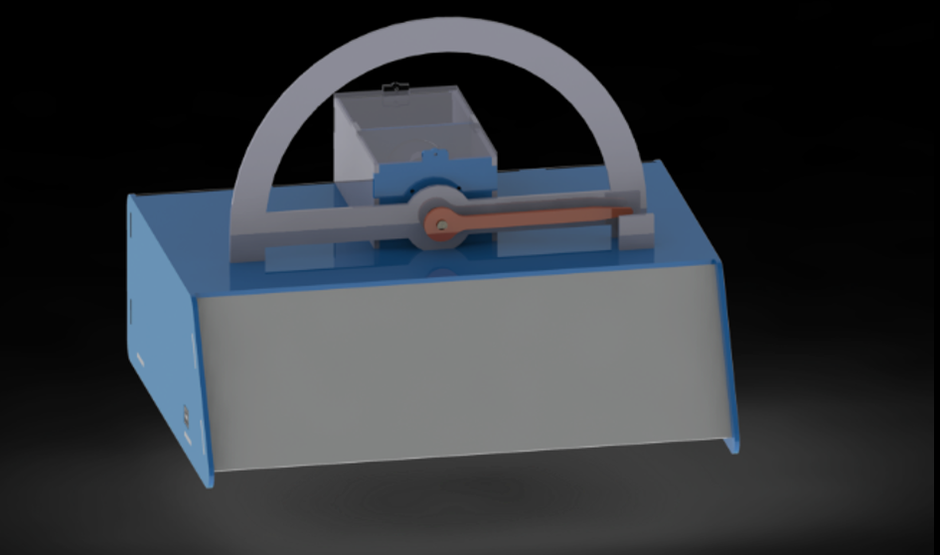

Figure 1: A 3D view of the concept experiment.

## Electrical components

The electrical components will serve the basic functionality of the experiment. It will consist of:

1. DC motor
2. Motor driver
3. Microcontroller (Arduino in this case)
4. Power supply

## User interface

The user interface will be implemented in MATLAB GUI designer. MATLAB was chosen as it’s usually available for all the students and don’t require extra installations for additional software.

The student will interact with the controller of the system through the GUI interface. He/she will be able to send his control parameters to the system and observe the output graphed on the GUI.

# Final Output

The final output will be appealing and finely structured basic position control experiment that covers the principles of pid control and allow students to easily interact with the controlled system and observe their own results.

The final output will not be a minimum viable project (meaning it won’t be suitable to be marketed yet) however it will be a first stage proof of concept.

# Budget

Estimated budget for mechanical and electrical components 5000 L.E.