Appendix Data:

Image A

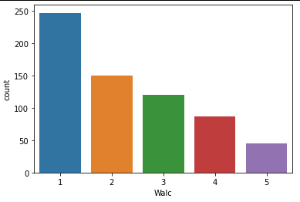

Image B

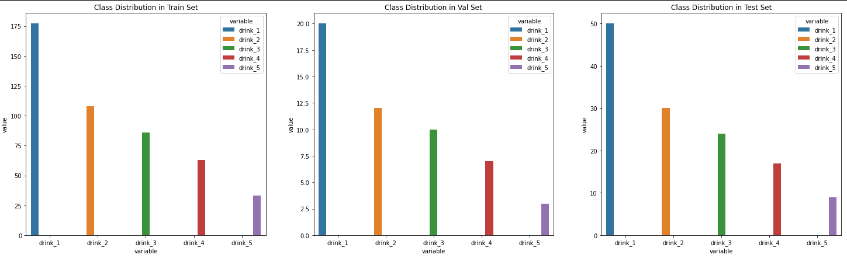

Appendix A

|  |  |
| --- | --- |
| Activation Function | ReLU |
| Loss Function | Cross Entropy Loss |
| Optimizer | Adam |
| Training Epochs | 300 |
| Batch Size | 16 |
| Learning Rate | 0.0007 |
| Number of Hidden Layers | 1 |
| Hidden Layers: Inputs and Outputs | 1: (512) => (256) |
| Batch Normalization | Input Layer: 512, Hidden Layer 1: 256 |
| Early Stopping Patience | - |
| Drop Out Rate | - |
| Last Epoch Information | Epoch 300: | Train Loss: 0.04254 | Val Loss: 2.83884 | Train Acc: 100.000| Val Acc: 30.769 |
| Test Accuracy | 36% |

Output table screen shot:

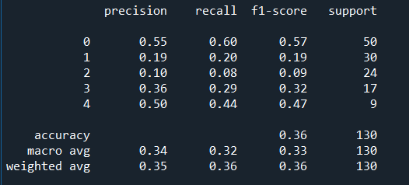

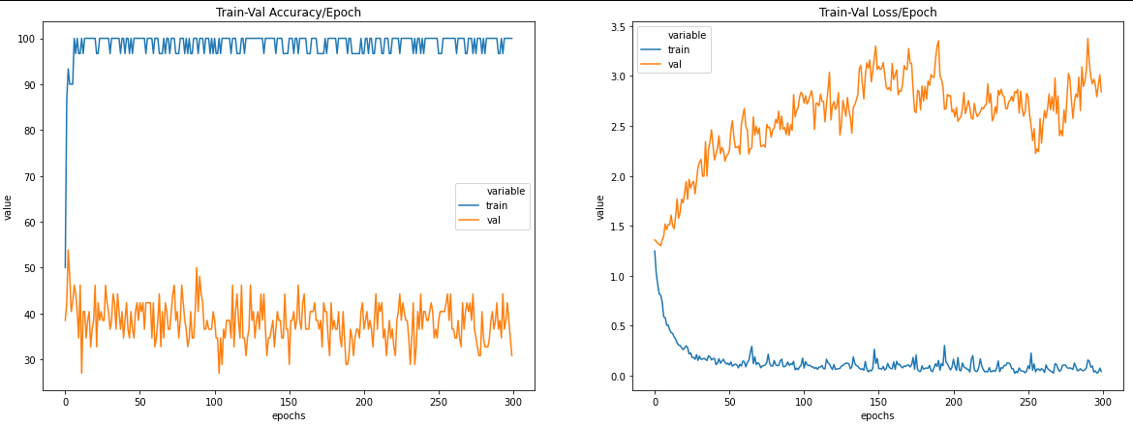

Appendix B

|  |  |
| --- | --- |
| Activation Function | ReLU |
| Loss Function | Cross Entropy Loss |
| Optimizer | SGD |
| Training Epochs | 200 |
| Batch Size | 16 |
| Learning Rate | 0.0007 |
| Number of Hidden Layers | 1 |
| Hidden Layers: Inputs and Outputs | 1: (512) => (256) |
| Batch Normalization | Input Layer: 512, Hidden Layer 1: 256 |
| Early Stopping Patience | - |
| Drop Out Rate | - |
| Last Epoch Information | Epoch 200: | Train Loss: 1.42068 | Val Loss: 1.43115 | Train Acc: 6.667| Val Acc: 38.462 |
| Test Accuracy | 38% |

Output table screen shot:

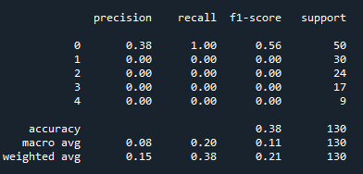

Appendix C

|  |  |
| --- | --- |
| Activation Function | ReLU |
| Loss Function | Cross Entropy Loss |
| Optimizer | Adam |
| Training Epochs | 300 |
| Batch Size | 32 |
| Learning Rate | 0.0007 |
| Number of Hidden Layers | 1 |
| Hidden Layers: Inputs and Outputs | 1: (512) => (256) |
| Batch Normalization | Input Layer: 512, Hidden Layer 1: 256 |
| Early Stopping Patience | - |
| Drop Out Rate | - |
| Last Epoch Information | Epoch 300: | Train Loss: 0.00193 | Val Loss: 4.13492 | Train Acc: 100.000| Val Acc: 40.385 |
| Test Accuracy | 40% |

Output table screen shot:

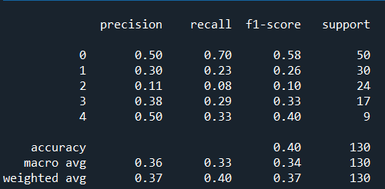

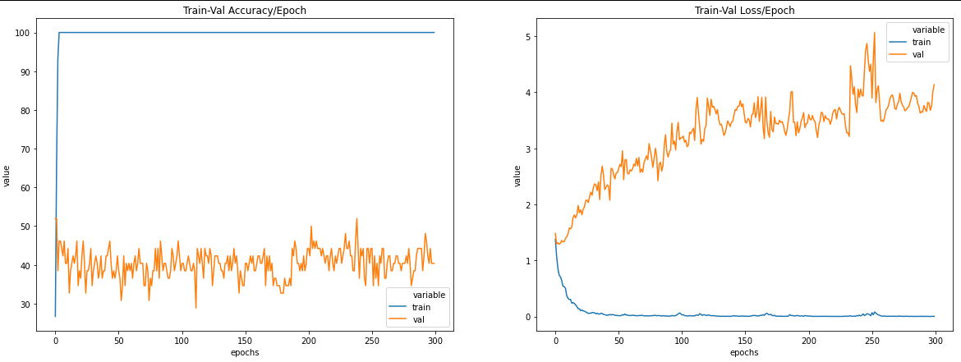

Appendix D

|  |  |
| --- | --- |
| Activation Function | ReLU |
| Loss Function | Cross Entropy Loss |
| Optimizer | Adam |
| Training Epochs | 200 |
| Batch Size | 16 |
| Learning Rate | 0.0007 |
| Number of Hidden Layers | 1 |
| Hidden Layers: Inputs and Outputs | 1: (1024) => (512) |
| Batch Normalization | Input Layer: 1024, Hidden Layer 1: 512 |
| Early Stopping Patience | - |
| Drop Out Rate | - |
| Last Epoch Information | Epoch 200: | Train Loss: 0.07149 | Val Loss: 3.78730 | Train Acc: 96.667| Val Acc: 26.923 |
| Test Accuracy | 38% |

Output table screen shot:

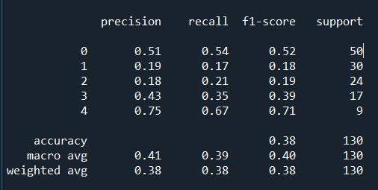

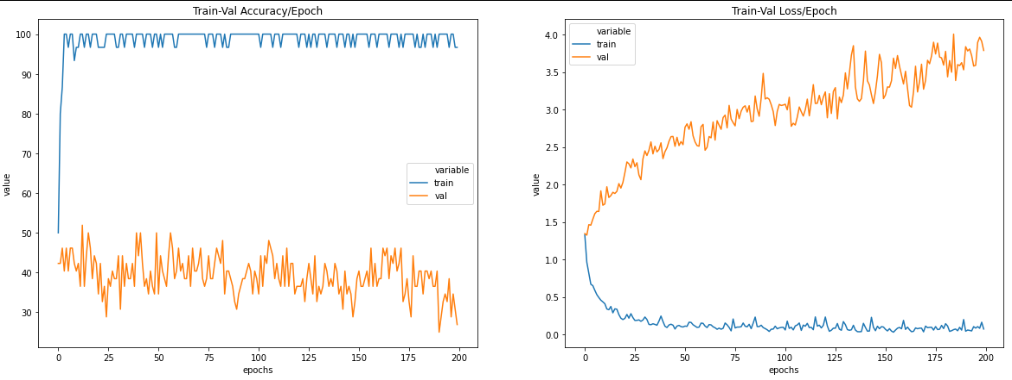

Appendix E

|  |  |
| --- | --- |
| Activation Function | ReLU |
| Loss Function | Cross Entropy Loss |
| Optimizer | Adam |
| Training Epochs | 200 |
| Batch Size | 16 |
| Learning Rate | 0.0007 |
| Number of Hidden Layers | 2 |
| Hidden Layers: Inputs and Outputs | 1: (512) => (256) 2: (256) => (128) |
| Batch Normalization | Input Layer: 512, Hidden Layer 1: 256, Hidden Layer 2: 128 |
| Early Stopping Patience | - |
| Drop Out Rate | - |
| Last Epoch Information | Epoch 200: | Train Loss: 0.08759 | Val Loss: 3.19291 | Train Acc: 96.667| Val Acc: 30.769 |
| Test Accuracy | 42% |

Output table screen shot:

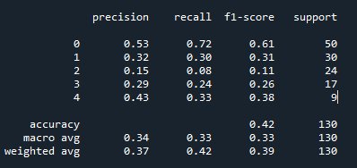

Appendix F

|  |  |
| --- | --- |
| Activation Function | ReLU |
| Loss Function | Cross Entropy Loss |
| Optimizer | Adam |
| Training Epochs | 200 |
| Batch Size | 16 |
| Learning Rate | 0.00007 |
| Number of Hidden Layers | 2 |
| Hidden Layers: Inputs and Outputs | 1: (512) => (256) 2: (256) => (128) |
| Batch Normalization | Input Layer: 512, Hidden Layer 1: 256, Hidden Layer 2: 128 |
| Early Stopping Patience | - |
| Drop Out Rate | - |
| Last Epoch Information | Epoch 200: | Train Loss: 0.08966 | Val Loss: 1.90381 | Train Acc: 100.000| Val Acc: 34.615 |
| Test Accuracy | 42% |

Output table screen shot:

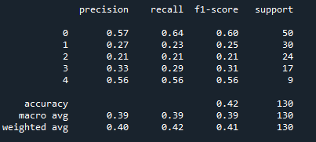

Appendix G

|  |  |
| --- | --- |
| Activation Function | ReLU |
| Loss Function | Cross Entropy Loss |
| Optimizer | Adam |
| Training Epochs | 200 |
| Batch Size | 32 |
| Learning Rate | 0.0007 |
| Number of Hidden Layers | 2 |
| Hidden Layers: Inputs and Outputs | 1: (512) => (256) 2: (256) => (128) |
| Batch Normalization | Input Layer: 512, Hidden Layer 1: 256, Hidden Layer 2: 128 |
| Early Stopping Patience | - |
| Drop Out Rate | - |
| Last Epoch Information | Epoch 200: | Train Loss: 0.00513 | Val Loss: 3.05927 | Train Acc: 100.000| Val Acc: 40.385 |
| Test Accuracy | 39% |

Output table screen shot:

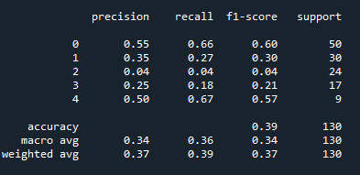

Appendix H

|  |  |
| --- | --- |
| Activation Function | ReLU |
| Loss Function | Cross Entropy Loss |
| Optimizer | Adam |
| Training Epochs | 200 |
| Batch Size | 16 |
| Learning Rate | 0.0007 |
| Number of Hidden Layers | 2 |
| Hidden Layers: Inputs and Outputs | 1: (1024) => (512) 2: (512) => (256) |
| Batch Normalization | Input Layer: 1024, Hidden Layer 1: 512, Hidden Layer 2: 256 |
| Early Stopping Patience | - |
| Drop Out Rate | - |
| Last Epoch Information | Epoch 200: | Train Loss: 0.08633 | Val Loss: 3.25121 | Train Acc: 100.000| Val Acc: 34.615 |
| Test Accuracy | 38% |

Output table screen shot:

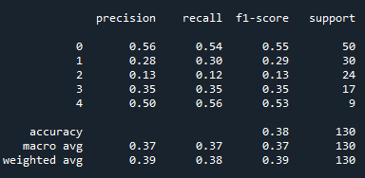

Appendix I

|  |  |
| --- | --- |
| Activation Function | ReLU |
| Loss Function | Cross Entropy Loss |
| Optimizer | Adam |
| Training Epochs | 200 |
| Batch Size | 16 |
| Learning Rate | 0.007 |
| Number of Hidden Layers | 2 |
| Hidden Layers: Inputs and Outputs | 1: (1024) => (512) 2: (512) => (256) |
| Batch Normalization | Input Layer: 1024, Hidden Layer 1: 512, Hidden Layer 2: 256 |
| Early Stopping Patience | - |
| Drop Out Rate | - |
| Last Epoch Information | Epoch 200: | Train Loss: 0.19520 | Val Loss: 3.64504 | Train Acc: 96.667| Val Acc: 42.308 |
| Test Accuracy | 42% |

Output table screen shot:

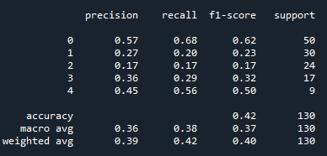

Appendix J

|  |  |
| --- | --- |
| Activation Function | ReLU |
| Loss Function | Cross Entropy Loss |
| Optimizer | Adam |
| Training Epochs | 200 |
| Batch Size | 16 |
| Learning Rate | 0.0007 |
| Number of Hidden Layers | 2 |
| Hidden Layers: Inputs and Outputs | 1: (256) => (128) 2: (128) => (64) |
| Batch Normalization | Input Layer: 256, Hidden Layer 1: 128, Hidden Layer 2: 64 |
| Early Stopping Patience | - |
| Drop Out Rate | - |
| Last Epoch Information | Epoch 200: | Train Loss: 0.14128 | Val Loss: 2.63619 | Train Acc: 100.000| Val Acc: 34.615 |
| Test Accuracy | 39% |

Output table screen shot:

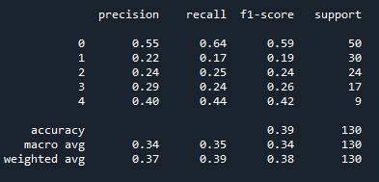

Appendix K

|  |  |
| --- | --- |
| Activation Function | ReLU |
| Loss Function | Cross Entropy Loss |
| Optimizer | Adam |
| Training Epochs | 200 |
| Batch Size | 16 |
| Learning Rate | 0.0007 |
| Number of Hidden Layers | 3 |
| Hidden Layers: Inputs and Outputs | 1: (512) => (256) 2: (256) => (128) 3: (128) => (64) |
| Batch Normalization | Input Layer: 512, Hidden Layer 1: 256, Hidden Layer 2: 128, Hidden Layer 3: 64 |
| Early Stopping Patience | - |
| Drop Out Rate | - |
| Last Epoch Information | Epoch 200: | Train Loss: 0.11458 | Val Loss: 2.97218 | Train Acc: 100.000| Val Acc: 46.154 |
| Test Accuracy | 42% |

Output table screen shot:

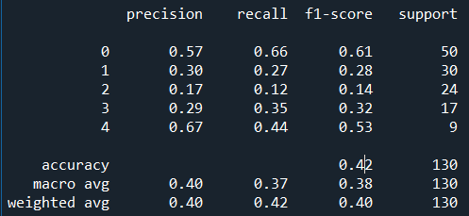

Appendix L

|  |  |
| --- | --- |
| Activation Function | ReLU |
| Loss Function | Cross Entropy Loss |
| Optimizer | Adam |
| Training Epochs | 200 |
| Batch Size | 16 |
| Learning Rate | 0.0007 |
| Number of Hidden Layers | 3 |
| Hidden Layers: Inputs and Outputs | 1: (2048) => (1024) 2: (1024) => (512) 3: (512) => (256) |
| Batch Normalization | Input Layer: 2048, Hidden Layer 1: 1024, Hidden Layer 2: 512, Hidden Layer 3: 256 |
| Early Stopping Patience | - |
| Drop Out Rate | - |
| Last Epoch Information | Epoch 200: | Train Loss: 0.04682 | Val Loss: 3.26323 | Train Acc: 100.000| Val Acc: 44.231 |
| Test Accuracy | 35% |

Output table screen shot:

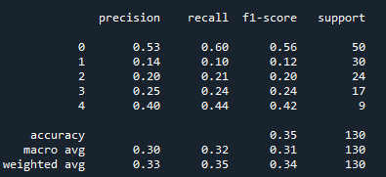

Appendix M

|  |  |
| --- | --- |
| Activation Function | ReLU |
| Loss Function | Cross Entropy Loss |
| Optimizer | Adam |
| Training Epochs | 200 |
| Batch Size | 16 |
| Learning Rate | 0.0007 |
| Number of Hidden Layers | 4 |
| Hidden Layers: Inputs and Outputs | 1: (512) => (256) 2: (256) => (128) 3: (128) => (64) 4: (64) => (32) |
| Batch Normalization | Input Layer: 2048, Hidden Layer 1: 1024, Hidden Layer 2: 512, Hidden Layer 3: 256, Hidden Layer 4: 256 |
| Early Stopping Patience | - |
| Drop Out Rate | - |
| Last Epoch Information | Epoch 200: | Train Loss: 0.18398 | Val Loss: 2.32281 | Train Acc: 96.667| Val Acc: 40.385 |
| Test Accuracy | 40% |

Output table screen shot:

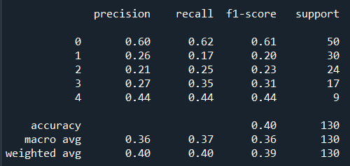

Appendix N

|  |  |
| --- | --- |
| Activation Function | ReLU |
| Loss Function | Cross Entropy Loss |
| Optimizer | Adam |
| Training Epochs | 200 |
| Batch Size | 16 |
| Learning Rate | 0.0007 |
| Number of Hidden Layers | 4 |
| Hidden Layers: Inputs and Outputs | 1: (1024) => (512) 2: (512) => (256) 3: (256) => (128) 4: (128) => (64) |
| Batch Normalization | Input Layer: 1024, Hidden Layer 1: 512, Hidden Layer 2: 256, Hidden Layer 3: 128, Hidden Layer 4: 64 |
| Early Stopping Patience | - |
| Drop Out Rate | - |
| Last Epoch Information | Epoch 200: | Train Loss: 0.11862 | Val Loss: 2.52515 | Train Acc: 100.000| Val Acc: 38.462 |
| Test Accuracy | 41% |

Output table screen shot:

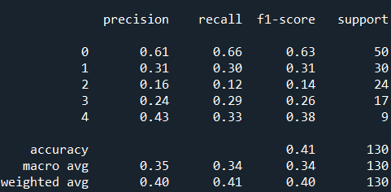

Appendix O

|  |  |
| --- | --- |
| Activation Function | ReLU |
| Loss Function | Cross Entropy Loss |
| Optimizer | Adam |
| Training Epochs | 200 |
| Batch Size | 16 |
| Learning Rate | 0.0007 |
| Number of Hidden Layers | 5 |
| Hidden Layers: Inputs and Outputs | 1: (512) => (256) 2: (256) => (128) 3: (128) => (64) 4: (64) => (32) 5: (32) => (16) |
| Batch Normalization | Input Layer: 512, Hidden Layer 1: 256, Hidden Layer 2: 128, Hidden Layer 3: 64, Hidden Layer 4: 32, Hidden Layer 5: 16 |
| Early Stopping Patience | - |
| Drop Out Rate | - |
| Last Epoch Information | Epoch 200: | Train Loss: 0.21391 | Val Loss: 2.13607 | Train Acc: 100.000| Val Acc: 34.615 |
| Test Accuracy | 36% |

Output table screen shot:

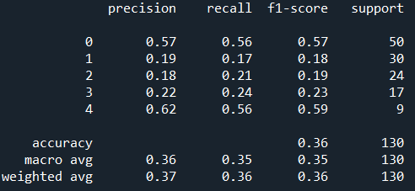

Appendix P

|  |  |
| --- | --- |
| Activation Function | ReLU |
| Loss Function | Cross Entropy Loss |
| Optimizer | Adam |
| Training Epochs | 200 |
| Batch Size | 16 |
| Learning Rate | 0.0007 |
| Number of Hidden Layers | 5 |
| Hidden Layers: Inputs and Outputs | 1: (1024) => (512) 2: (512) => (256) 3: (256) => (128) 4: (128) => (64) 5: (64) => (32) |
| Batch Normalization | Input Layer: 1024, Hidden Layer 1: 512, Hidden Layer 2: 256, Hidden Layer 3: 128, Hidden Layer 4: 64, Hidden Layer 5: 32 |
| Early Stopping Patience | - |
| Drop Out Rate | - |
| Last Epoch Information | Epoch 200: | Train Loss: 0.13348 | Val Loss: 2.54188 | Train Acc: 100.000| Val Acc: 36.538 |
| Test Accuracy | 39% |

Output table screen shot:

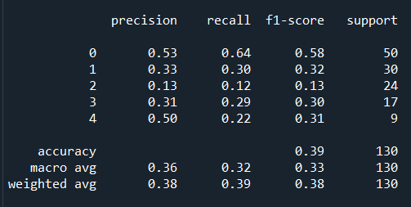

Appendix Q

|  |  |
| --- | --- |
| Activation Function | ReLU |
| Loss Function | Cross Entropy Loss |
| Optimizer | Adam |
| Training Epochs | 200 |
| Batch Size | 16 |
| Learning Rate | 0.0007 |
| Number of Hidden Layers | 6 |
| Hidden Layers: Inputs and Outputs | 1: (512) => (256) 2: (256) => (128) 3: (128) => (64) 4: (64) => (32) 5: (32) => (16) 6: (16) => (8) |
| Batch Normalization | Input Layer: 512, Hidden Layer 1: 256, Hidden Layer 2: 128, Hidden Layer 3: 64, Hidden Layer 4: 32, Hidden Layer 5: 16, Hidden Layer 5: 8 |
| Early Stopping Patience | - |
| Drop Out Rate | - |
| Last Epoch Information | Epoch 200: | Train Loss: 0.37764 | Val Loss: 2.12405 | Train Acc: 96.667| Val Acc: 32.692 |
| Test Accuracy | 34% |

Output table screen shot:

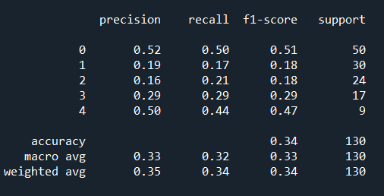

Appendix R

|  |  |
| --- | --- |
| Activation Function | ReLU |
| Loss Function | Cross Entropy Loss |
| Optimizer | Adam |
| Training Epochs | 200 |
| Batch Size | 16 |
| Learning Rate | 0.0007 |
| Number of Hidden Layers | 6 |
| Hidden Layers: Inputs and Outputs | 1: (1024) => (512) 2: (512) => (256) 3: (256) => (128) 4: (128) => (64) 5: (64) => (32) 6: (32) => (16) |
| Batch Normalization | Input Layer: 1024, Hidden Layer 1: 512, Hidden Layer 2: 256, Hidden Layer 3: 128, Hidden Layer 4: 64, Hidden Layer 5: 32, Hidden Layer 5: 16 |
| Early Stopping Patience | - |
| Drop Out Rate | - |
| Last Epoch Information | Epoch 200: | Train Loss: 0.30472 | Val Loss: 2.37141 | Train Acc: 96.667| Val Acc: 38.462 |
| Test Accuracy | 38% |

Output table screen shot:

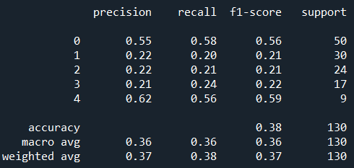

Appendix S

|  |  |
| --- | --- |
| Activation Function | ReLU |
| Loss Function | Cross Entropy Loss |
| Optimizer | Adam |
| Training Epochs | 200 |
| Batch Size | 16 |
| Learning Rate | 0.007 |
| Number of Hidden Layers | 6 |
| Hidden Layers: Inputs and Outputs | 1: (1024) => (512) 2: (512) => (256) 3: (256) => (128) 4: (128) => (64) 5: (64) => (32) 6: (32) => (16) |
| Batch Normalization | Input Layer: 1024, Hidden Layer 1: 512, Hidden Layer 2: 256, Hidden Layer 3: 128, Hidden Layer 4: 64, Hidden Layer 5: 32, Hidden Layer 5: 16 |
| Early Stopping Patience | - |
| Drop Out Rate | - |
| Last Epoch Information | Epoch 200: | Train Loss: 0.33242 | Val Loss: 2.11070 | Train Acc: 96.667| Val Acc: 44.231 |
| Test Accuracy | 42% |

Output table screen shot:

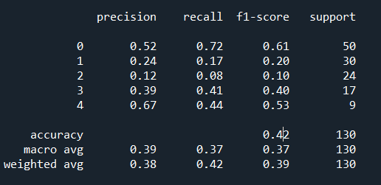

Appendix T

|  |  |
| --- | --- |
| Activation Function | ReLU |
| Loss Function | Cross Entropy Loss |
| Optimizer | Adam |
| Training Epochs | 200 |
| Batch Size | 16 |
| Learning Rate | 0.007 |
| Number of Hidden Layers | 6 |
| Hidden Layers: Inputs and Outputs | 1: (1024) => (512) 2: (512) => (256) 3: (256) => (128) 4: (128) => (64) 5: (64) => (32) 6: (32) => (16) |
| Batch Normalization | Input Layer: 1024, Hidden Layer 1: 512, Hidden Layer 2: 256, Hidden Layer 3: 128, Hidden Layer 4: 64, Hidden Layer 5: 32, Hidden Layer 5: 16 |
| Early Stopping Patience | - |
| Drop Out Rate | 0.2 |
| Last Epoch Information | Epoch 200: | Train Loss: 0.57295 | Val Loss: 1.78169 | Train Acc: 96.667| Val Acc: 44.231 |
| Test Accuracy | 42% |

Output table screen shot:

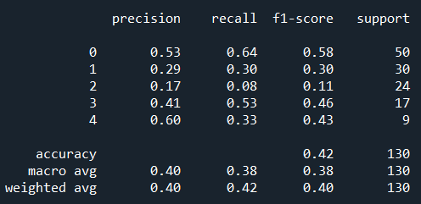

Appendix U

|  |  |
| --- | --- |
| Activation Function | ReLU |
| Loss Function | Cross Entropy Loss |
| Optimizer | SGD, weight decay = 0.01 |
| Training Epochs | 200 |
| Batch Size | 16 |
| Learning Rate | 0.007 |
| Number of Hidden Layers | 6 |
| Hidden Layers: Inputs and Outputs | 1: (1024) => (512) 2: (512) => (256) 3: (256) => (128) 4: (128) => (64) 5: (64) => (32) 6: (32) => (16) |
| Batch Normalization | Input Layer: 1024, Hidden Layer 1: 512, Hidden Layer 2: 256, Hidden Layer 3: 128, Hidden Layer 4: 64, Hidden Layer 5: 32, Hidden Layer 5: 16 |
| Early Stopping Patience | - |
| Drop Out Rate | 0.2 |
| Last Epoch Information | Epoch 200: | Train Loss: 1.15199 | Val Loss: 1.32413 | Train Acc: 53.333| Val Acc: 44.231 |
| Test Accuracy | 46% |

Output table screen shot:

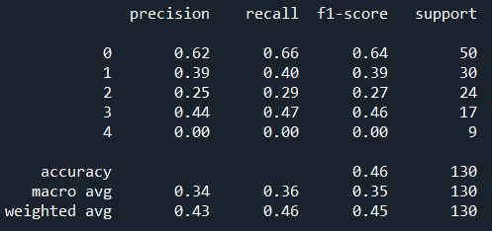

Appendix V

|  |  |
| --- | --- |
| Activation Function | ReLU |
| Loss Function | Cross Entropy Loss |
| Optimizer | SGD, weight decay = 0.01 |
| Training Epochs | 150 |
| Batch Size | 16 |
| Learning Rate | 0.0007 |
| Number of Hidden Layers | 3 |
| Hidden Layers: Inputs and Outputs | 1: (512) => (256) 2: (256) => (128) 3: (128) => (64) |
| Batch Normalization | Input Layer: 512, Hidden Layer 1: 256, Hidden Layer 2: 128, Hidden Layer 3: 64 |
| Early Stopping Patience | - |
| Drop Out Rate | 0.2 |
| Last Epoch Information | Epoch 150: | Train Loss: 0.93559 | Val Loss: 1.34033 | Train Acc: 83.333| Val Acc: 46.154 |
| Test Accuracy | 42% |

Output table screen shot:



Appendix W

|  |  |
| --- | --- |
| Activation Function | ReLU |
| Loss Function | Cross Entropy Loss |
| Optimizer | SGD, weight decay = 0.01 |
| Training Epochs | 300 |
| Batch Size | 16 |
| Learning Rate | 0.007 |
| Number of Hidden Layers | 1 |
| Hidden Layers: Inputs and Outputs | 1: (512) => (256) |
| Batch Normalization | Input Layer: 512, Hidden Layer 1: 256 |
| Early Stopping Patience | - |
| Drop Out Rate | - |
| Last Epoch Information | Epoch 300: | Train Loss: 0.93910 | Val Loss: 1.12516 | Train Acc: 73.333| Val Acc: 50.000 |
| Test Accuracy | 45% |

Output table screen shot:

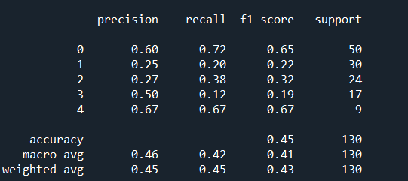

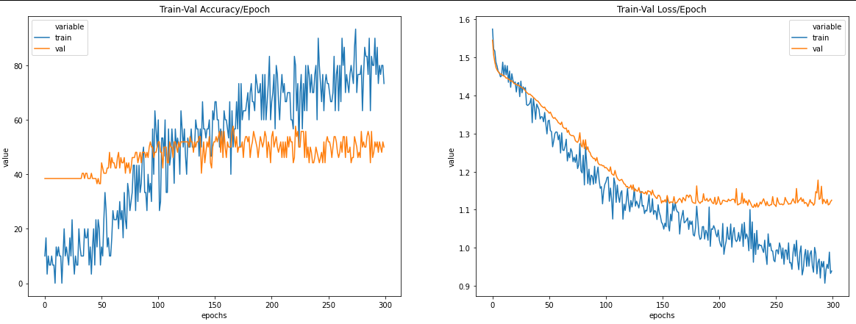

Appendix X

|  |  |
| --- | --- |
| Activation Function | ReLU |
| Loss Function | Cross Entropy Loss |
| Optimizer | SGD, weight decay = 0.0001 |
| Training Epochs | 10000 |
| Batch Size | 32 |
| Learning Rate | 0.007 |
| Number of Hidden Layers | 1 |
| Hidden Layers: Inputs and Outputs | 1: (512) => (256) |
| Batch Normalization | - |
| Early Stopping Patience | 20 |
| Drop Out Rate | 0.1 |
| Last Epoch Information | Epoch 276: | Train Loss: 0.99649 | Val Loss: 1.08610 | Train Acc: 93.333| Val Acc: 57.692 |
| Test Accuracy | 43% |

Output table screen shot:

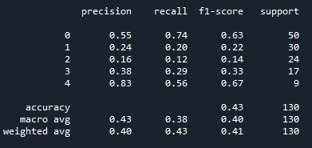

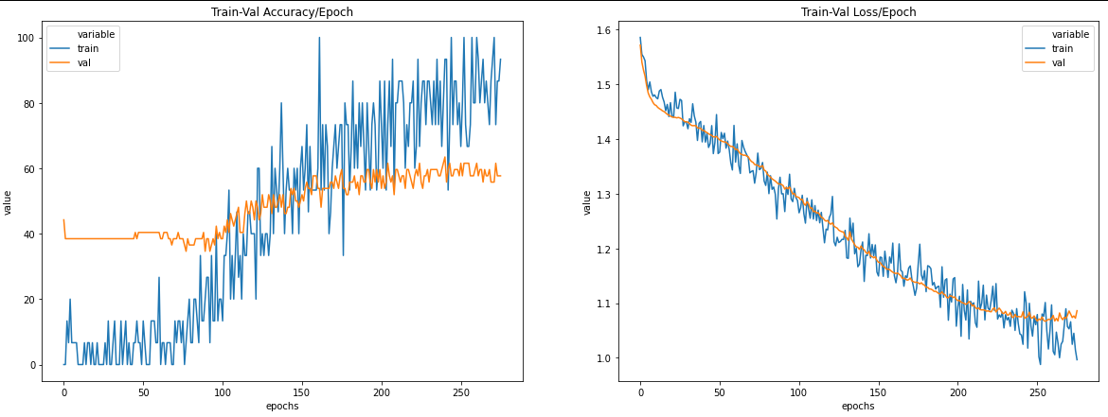

Appendix Y

|  |  |
| --- | --- |
| Activation Function | ReLU |
| Loss Function | Cross Entropy Loss |
| Optimizer | SGD, weight decay = 0.001 |
| Training Epochs | 300 |
| Batch Size | 32 |
| Learning Rate | 0.007 |
| Number of Hidden Layers | 1 |
| Hidden Layers: Inputs and Outputs | 1: (512) => (256) |
| Batch Normalization | - |
| Early Stopping Patience | - |
| Drop Out Rate | 0.1 |
| Last Epoch Information | Epoch 300: | Train Loss: 1.16879 | Val Loss: 1.11471 | Train Acc: 66.667| Val Acc: 50.000 |
| Test Accuracy | 48% |

EPOCHS = 300

Output table screen shot:

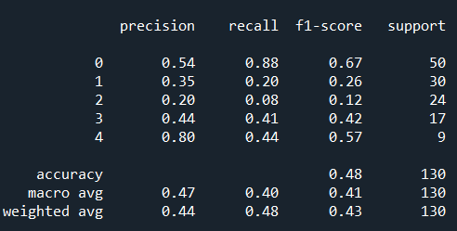

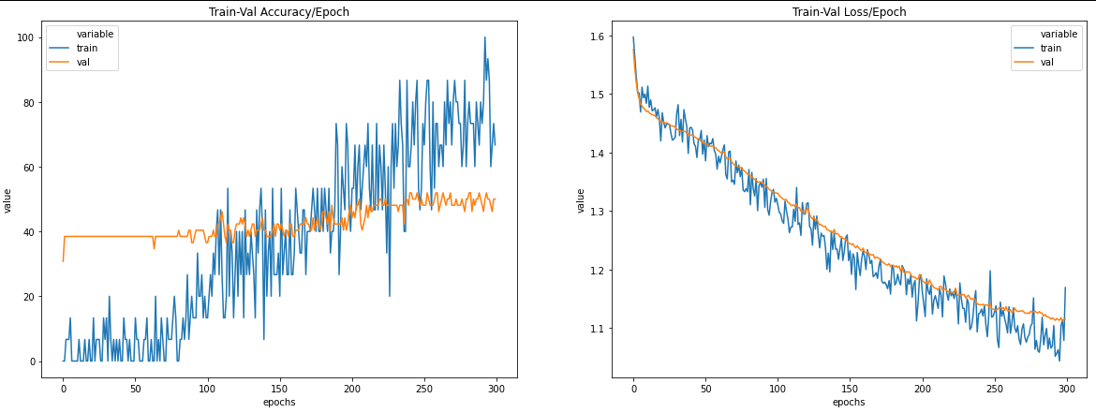

Appendix Z

|  |  |
| --- | --- |
| Activation Function | ReLU |
| Loss Function | Cross Entropy Loss |
| Optimizer | SGD, weight decay = 0.001 |
| Training Epochs | 300 |
| Batch Size | 32 |
| Learning Rate | 0.007 |
| Number of Hidden Layers | 1 |
| Hidden Layers: Inputs and Outputs | 1: (512) => (256) |
| Batch Normalization | - |
| Early Stopping Patience | - |
| Drop Out Rate | 0.2 |
| Last Epoch Information | Epoch 300: | Train Loss: 1.06376 | Val Loss: 1.11708 | Train Acc: 93.333| Val Acc: 55.769 |
| Test Accuracy | 47% |

Output table screen shot:

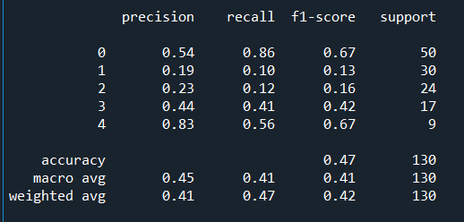

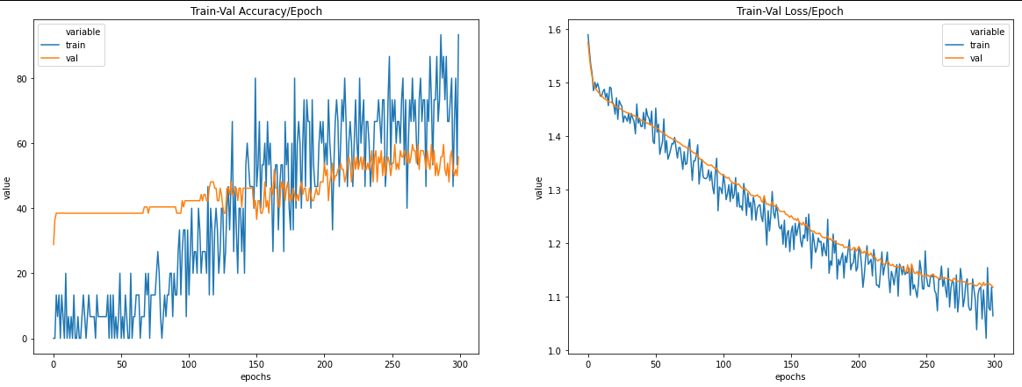

Appendix AA

|  |  |
| --- | --- |
| Activation Function | ReLU |
| Loss Function | Cross Entropy Loss |
| Optimizer | SGD, weight decay = 0.001 |
| Training Epochs | 300 |
| Batch Size | 32 |
| Learning Rate | 0.007 |
| Number of Hidden Layers | 1 |
| Hidden Layers: Inputs and Outputs | 1: (512) => (256) |
| Batch Normalization | - |
| Early Stopping Patience | - |
| Drop Out Rate | 0.3 |
| Last Epoch Information | Epoch 300: | Train Loss: 1.13414 | Val Loss: 1.13454 | Train Acc: 73.333| Val Acc: 50.000 |
| Test Accuracy | 48% |

Output table screen shot:

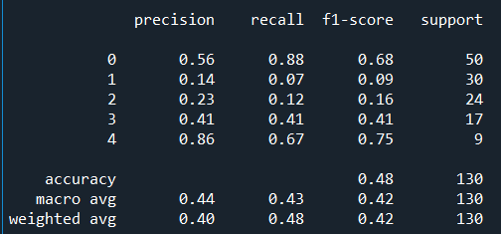

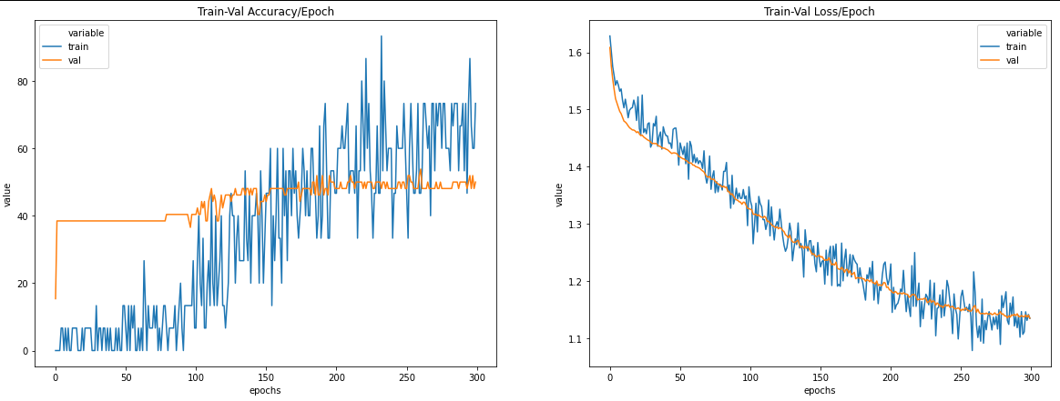

Appendix AB

|  |  |
| --- | --- |
| Activation Function | ReLU |
| Loss Function | Cross Entropy Loss |
| Optimizer | SGD, weight decay = 0.001 |
| Training Epochs | 10000 |
| Batch Size | 32 |
| Learning Rate | 0.007 |
| Number of Hidden Layers | 1 |
| Hidden Layers: Inputs and Outputs | 1: (512) => (256) |
| Batch Normalization | - |
| Early Stopping Patience | 20 |
| Drop Out Rate | 0.1 |
| Last Epoch Information | Epoch 296: | Train Loss: 1.04244 | Val Loss: 1.12140 | Train Acc: 80.000| Val Acc: 48.077 |
| Test Accuracy | 52% |

Output table screen shot:

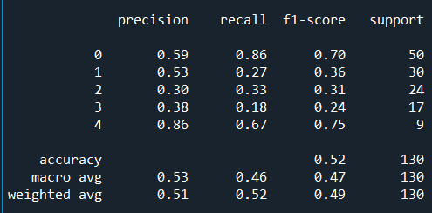

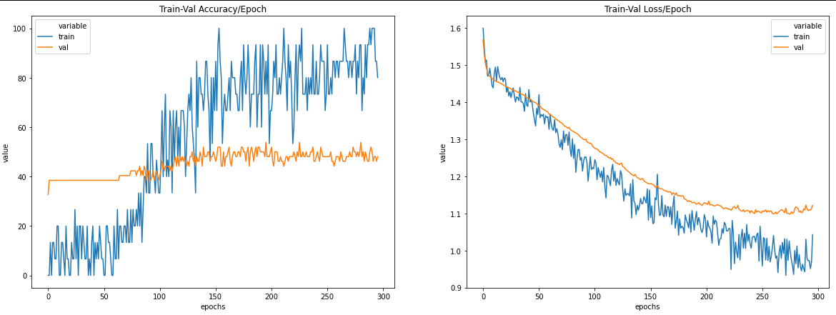

Appendix AC

|  |  |
| --- | --- |
| Activation Function | ReLU |
| Loss Function | Cross Entropy Loss |
| Optimizer | SGD, weight decay = 0.001 |
| Training Epochs | 10000 |
| Batch Size | 32 |
| Learning Rate | 0.007 |
| Number of Hidden Layers | 1 |
| Hidden Layers: Inputs and Outputs | 1: (512) => (256) |
| Batch Normalization | - |
| Early Stopping Patience | 100 |
| Drop Out Rate | 0.1 |
| Last Epoch Information | Epoch 384: | Train Loss: 0.88907 | Val Loss: 1.16580 | Train Acc: 100.000| Val Acc: 50.000 |
| Test Accuracy | 47% |

Output table screen shot:

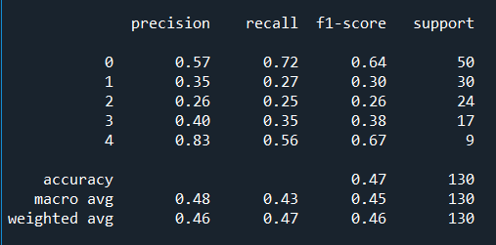

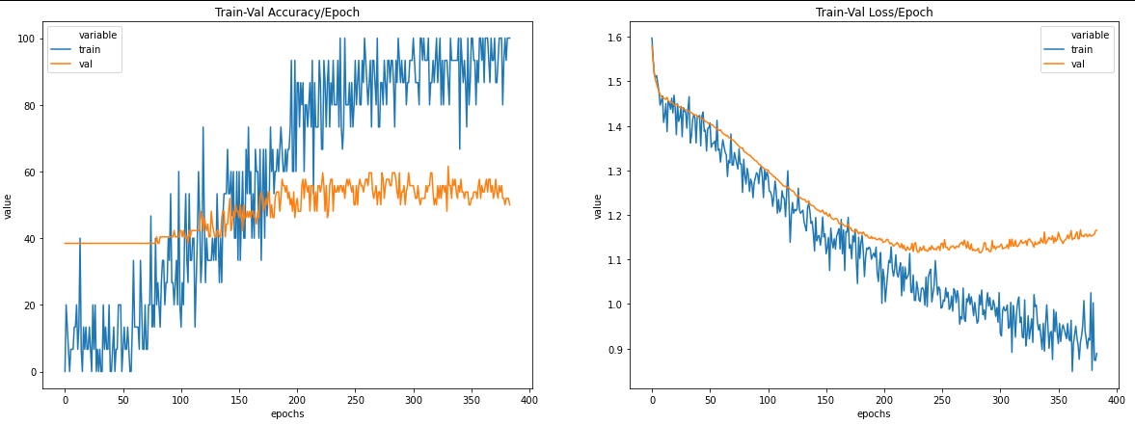

Appendix AD

|  |  |
| --- | --- |
| Activation Function | LeakyReLU |
| Loss Function | Cross Entropy Loss |
| Optimizer | SGD, weight decay = 0.001 |
| Training Epochs | 10000 |
| Batch Size | 32 |
| Learning Rate | 0.007 |
| Number of Hidden Layers | 1 |
| Hidden Layers: Inputs and Outputs | 1: (512) => (256) |
| Batch Normalization | - |
| Early Stopping Patience | 20 |
| Drop Out Rate | 0.1 |
| Last Epoch Information | Epoch 322: | Train Loss: 1.00613 | Val Loss: 1.17306 | Train Acc: 73.333| Val Acc: 48.077 |
| Test Accuracy | 45% |

Output table screen shot:

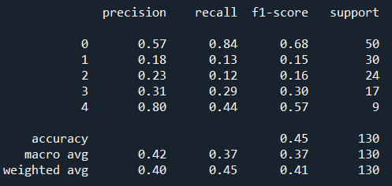

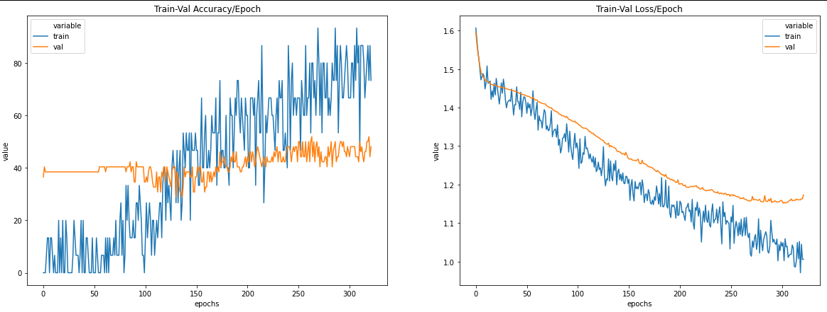

Appendix AE

|  |  |
| --- | --- |
| Activation Function | LeakyReLU |
| Loss Function | Cross Entropy Loss |
| Optimizer | SGD, weight decay = 0.001 |
| Training Epochs | 10000 |
| Batch Size | 32 |
| Learning Rate | 0.007 |
| Number of Hidden Layers | 1 |
| Hidden Layers: Inputs and Outputs | 1: (512) => (256) |
| Batch Normalization | - |
| Early Stopping Patience | 100 |
| Drop Out Rate | 0.1 |
| Last Epoch Information | Epoch 421: | Train Loss: 0.96482 | Val Loss: 1.16665 | Train Acc: 80.000| Val Acc: 44.231 |
| Test Accuracy | 48% |

Output table screen shot:

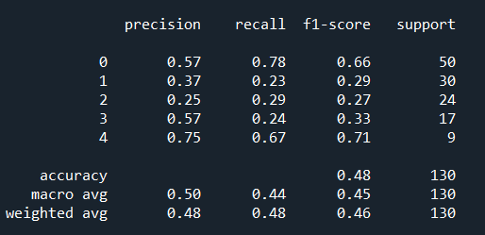

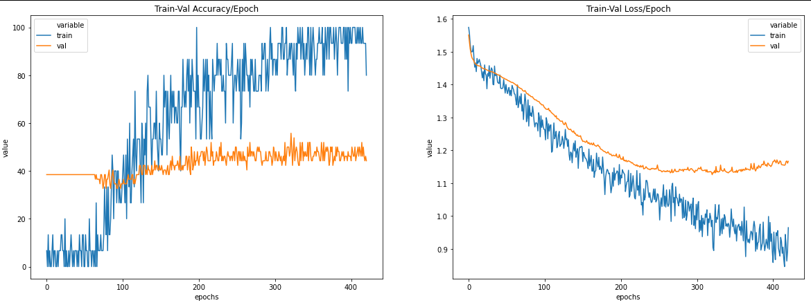

Appendix AF

|  |  |
| --- | --- |
| Activation Function | Hardswish |
| Loss Function | Cross Entropy Loss |
| Optimizer | SGD, weight decay = 0.001 |
| Training Epochs | 10000 |
| Batch Size | 32 |
| Learning Rate | 0.007 |
| Number of Hidden Layers | 1 |
| Hidden Layers: Inputs and Outputs | 1: (512) => (256) |
| Batch Normalization | - |
| Early Stopping Patience | 20 |
| Drop Out Rate | 0.1 |
| Last Epoch Information | Epoch 612: | Train Loss: 1.10404 | Val Loss: 1.11871 | Train Acc: 60.000| Val Acc: 53.846 |
| Test Accuracy | 50% |

Output table screen shot:

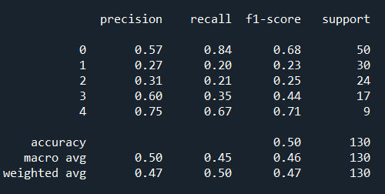

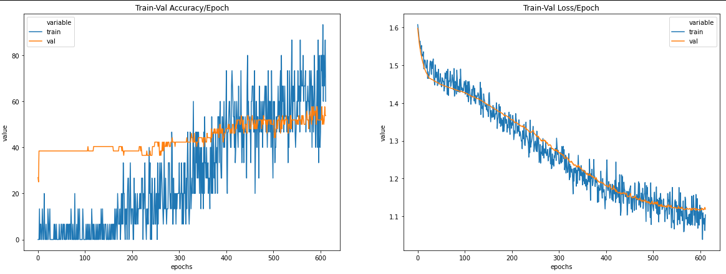

Appendix AG

|  |  |
| --- | --- |
| Activation Function | Hardswish |
| Loss Function | Cross Entropy Loss |
| Optimizer | SGD, weight decay = 0.001 |
| Training Epochs | 10000 |
| Batch Size | 32 |
| Learning Rate | 0.007 |
| Number of Hidden Layers | 1 |
| Hidden Layers: Inputs and Outputs | 1: (512) => (256) |
| Batch Normalization | - |
| Early Stopping Patience | 100 |
| Drop Out Rate | 0.1 |
| Last Epoch Information | Epoch 691: | Train Loss: 1.14419 | Val Loss: 1.09624 | Train Acc: 40.000| Val Acc: 51.923 |
| Test Accuracy | 48% |

Output table screen shot:

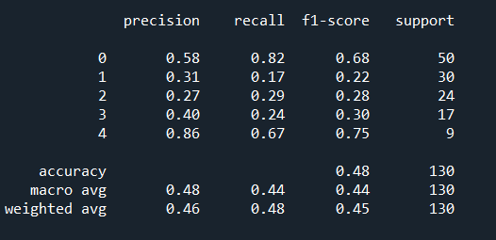

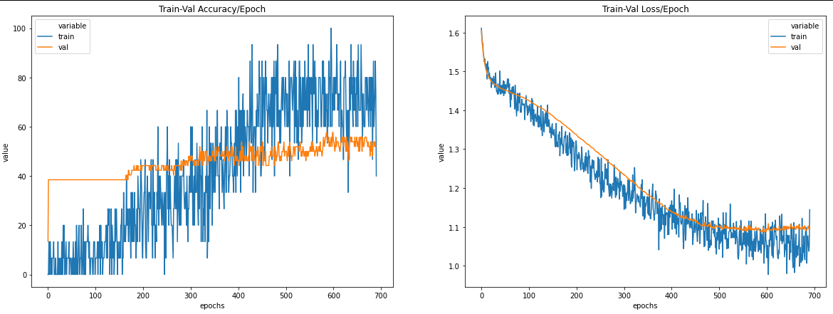

Appendix AH

|  |  |
| --- | --- |
| Activation Function | ReLU |
| Loss Function | Cross Entropy Loss |
| Optimizer | SGD, weight decay = 0.001 |
| Training Epochs | 300 |
| Batch Size | 32 |
| Learning Rate | 0.007 |
| Number of Hidden Layers | 2 |
| Hidden Layers: Inputs and Outputs | 1: (512) => (256) 2: (256) => (128) |
| Batch Normalization | - |
| Early Stopping Patience | - |
| Drop Out Rate | 0.1 |
| Last Epoch Information | Epoch 300: | Train Loss: 1.11420 | Val Loss: 1.11584 | Train Acc: 53.333| Val Acc: 53.846 |
| Test Accuracy | 49% |

Output table screen shot:

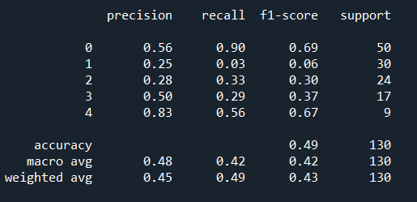

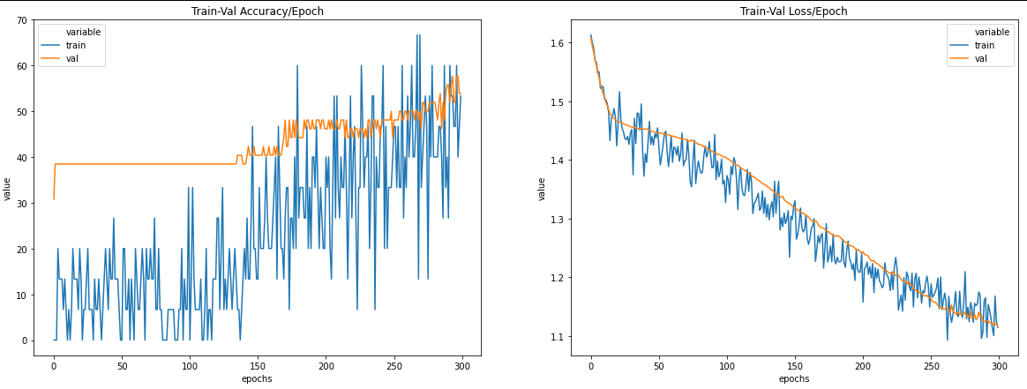

Appendix AI

|  |  |
| --- | --- |
| Activation Function | ReLU |
| Loss Function | Cross Entropy Loss |
| Optimizer | SGD, weight decay = 0.001 |
| Training Epochs | 10000 |
| Batch Size | 32 |
| Learning Rate | 0.007 |
| Number of Hidden Layers | 2 |
| Hidden Layers: Inputs and Outputs | 1: (512) => (256) 2: (256) => (128) |
| Batch Normalization | - |
| Early Stopping Patience | 20 |
| Drop Out Rate | 0.1 |
| Last Epoch Information | Epoch 368: | Train Loss: 1.05560 | Val Loss: 1.11449 | Train Acc: 73.333| Val Acc: 53.846 |
| Test Accuracy | 48% |

Output table screen shot:

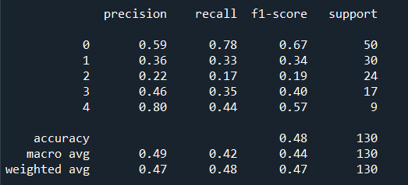

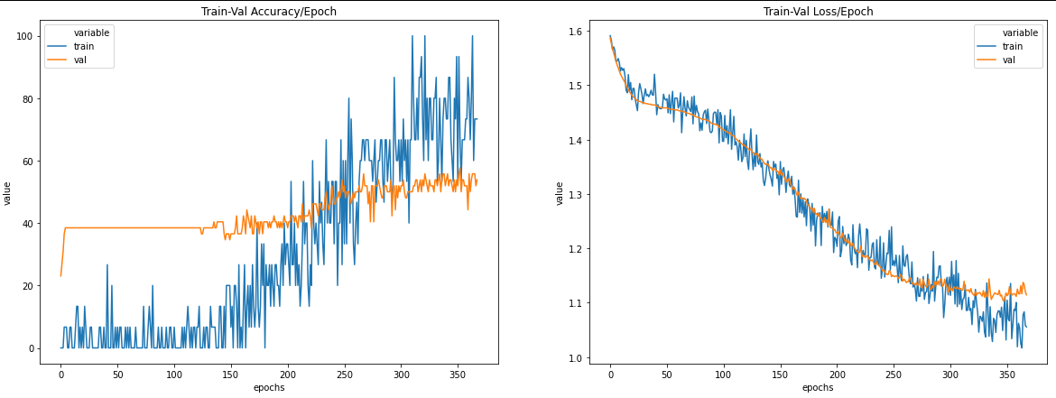

Appendix AJ

|  |  |
| --- | --- |
| Activation Function | ReLU |
| Loss Function | Cross Entropy Loss |
| Optimizer | SGD, weight decay = 0.001 |
| Training Epochs | 10000 |
| Batch Size | 32 |
| Learning Rate | 0.007 |
| Number of Hidden Layers | 3 |
| Hidden Layers: Inputs and Outputs | 1: (512) => (256) 2: (256) => (128) 3: (128) => (64) |
| Batch Normalization | - |
| Early Stopping Patience | 20 |
| Drop Out Rate | 0.1 |
| Last Epoch Information | Epoch 361: | Train Loss: 1.03909 | Val Loss: 1.16008 | Train Acc: 73.333| Val Acc: 46.154 |
| Test Accuracy | 50% |

Output table screen shot:

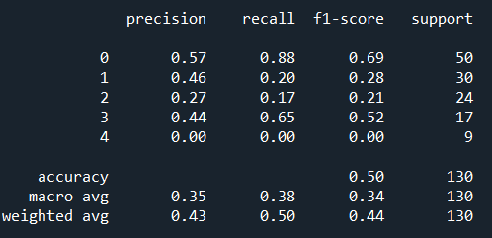  
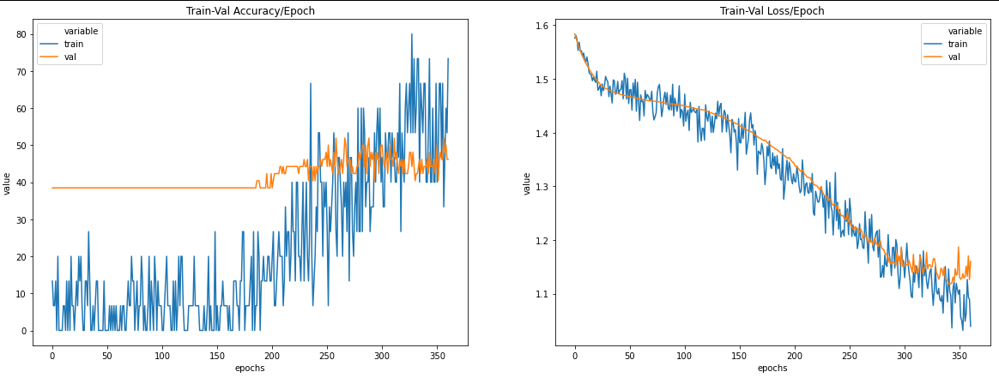

Appendix AK

Data Split: Train – 64%, Validation – 16% ,Test: 20%

|  |  |
| --- | --- |
| Activation Function | ReLU |
| Loss Function | Cross Entropy Loss |
| Optimizer | SGD, weight decay = 0.001 |
| Training Epochs | 10000 |
| Batch Size | 32 |
| Learning Rate | 0.007 |
| Number of Hidden Layers | 1 |
| Hidden Layers: Inputs and Outputs | 1: (512) => (256) |
| Batch Normalization | - |
| Early Stopping Patience | 20 |
| Drop Out Rate | 0.1 |
| Last Epoch Information | Epoch 224: | Train Loss: 1.09780 | Val Loss: 1.28799 | Train Acc: 76.923| Val Acc: 50.962 |
| Test Accuracy | 44% |

Output table screen shot:

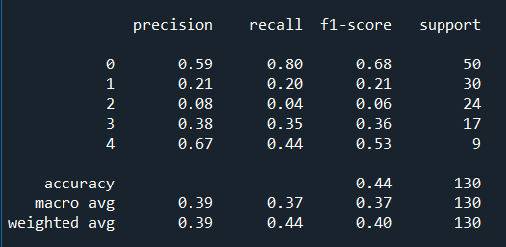

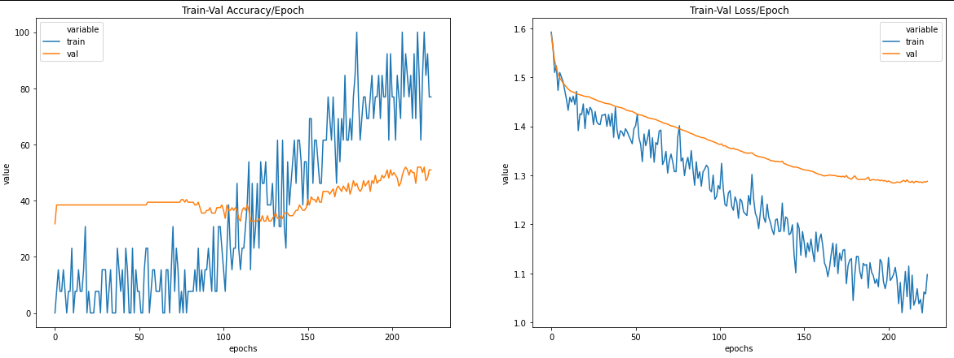

Appendix AL

Data Split: Train – 81%, Validation – 9% ,Test: 10%

|  |  |
| --- | --- |
| Activation Function | ReLU |
| Loss Function | Cross Entropy Loss |
| Optimizer | SGD, weight decay = 0.001 |
| Training Epochs | 10000 |
| Batch Size | 32 |
| Learning Rate | 0.007 |
| Number of Hidden Layers | 1 |
| Hidden Layers: Inputs and Outputs | 1: (512) => (256) |
| Batch Normalization | - |
| Early Stopping Patience | 20 |
| Drop Out Rate | 0.1 |
| Last Epoch Information | Epoch 198: | Train Loss: 1.04097 | Val Loss: 1.24517 | Train Acc: 64.706| Val Acc: 40.678 |
| Test Accuracy | 40% |

Output table screen shot:

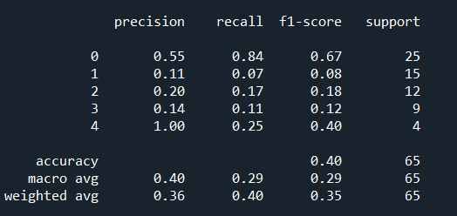

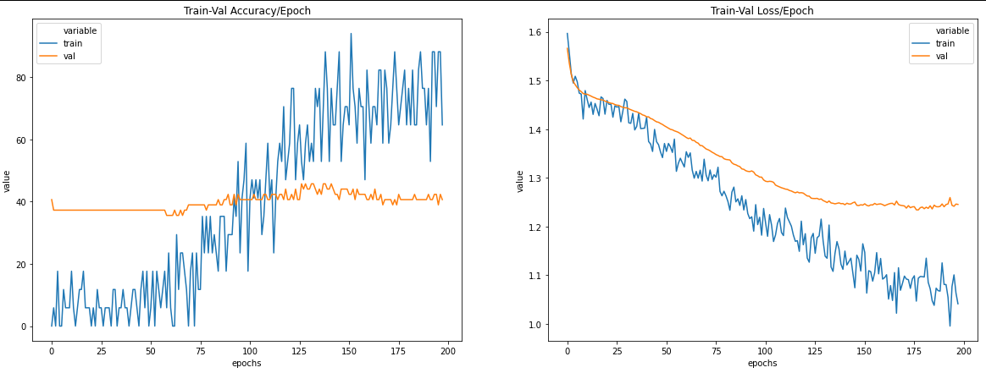

Appendix AM

|  |  |
| --- | --- |
| Activation Function | ReLU |
| Loss Function | Cross Entropy Loss |
| Optimizer | Adam |
| Training Epochs | 10000 |
| Batch Size | 32 |
| Learning Rate | 0.007 |
| Number of Hidden Layers | 1 |
| Hidden Layers: Inputs and Outputs | 1: (512) => (256) |
| Batch Normalization | - |
| Early Stopping Patience | 20 |
| Drop Out Rate | 0.1 |
| Last Epoch Information | Epoch 023: | Train Loss: 0.31766 | Val Loss: 2.79718 | Train Acc: 100.000| Val Acc: 36.538 |
| Test Accuracy | 42% |

Output table screen shot:

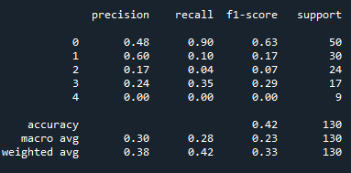

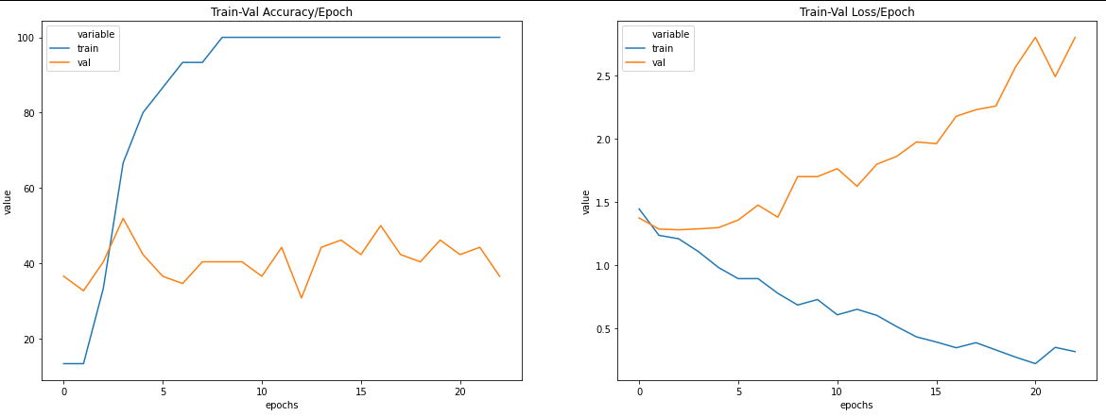

Appendix AN

Data Split: Train – 81%, Validation – 9% ,Test: 10%

|  |  |
| --- | --- |
| Activation Function | ReLU |
| Loss Function | Cross Entropy Loss |
| Optimizer | SGD, weight decay = 0.01 |
| Training Epochs | 10000 |
| Batch Size | 32 |
| Learning Rate | 0.007 |
| Number of Hidden Layers | 1 |
| Hidden Layers: Inputs and Outputs | 1: (512) => (256) |
| Batch Normalization | Input Layer: 512, Hidden Layer 1: 256 |
| Early Stopping Patience | 20 |
| Drop Out Rate | 0.1 |
| Last Epoch Information | Epoch 039: | Train Loss: 0.51671 | Val Loss: 1.41744 | Train Acc: 100.000| Val Acc: 36.538 |
| Test Accuracy | 42% |

Output table screen shot:

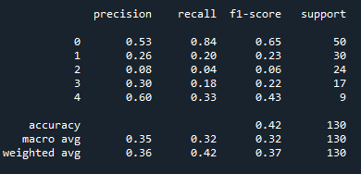

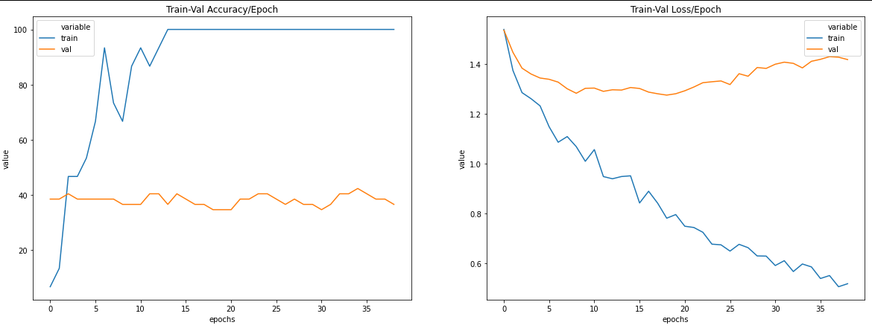

Appendix AO

|  |  |
| --- | --- |
| Activation Function | ReLU |
| Loss Function | Cross Entropy Loss |
| Optimizer | Adam |
| Training Epochs | 300 |
| Batch Size | 16 |
| Learning Rate | 0.0007 |
| Number of Hidden Layers | 1 |
| Hidden Layers: Inputs and Outputs | 1: (512) => (256) |
| Batch Normalization | Input Layer: 512, Hidden Layer 1: 256 |
| Early Stopping Patience | - |
| Drop Out Rate | - |
| Last Epoch Information | Epoch 300: | Train Loss: 0.0228 | Val Loss: 3.5525 | Train Acc: 96.667| Val Acc: 38.462 |
| Test Accuracy | 38% |

Output table screen shot:

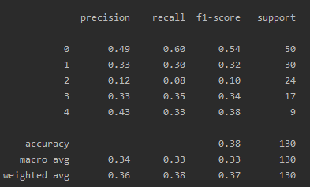

Appendix AP

|  |  |
| --- | --- |
| Activation Function | ReLU |
| Loss Function | Cross Entropy Loss |
| Optimizer | Adam |
| Training Epochs | 58 |
| Batch Size | 16 |
| Learning Rate | 0.0038493557916637407 |
| Number of Hidden Layers | 1 |
| Hidden Layers: Inputs and Outputs | 1: (4589) => (2294) |
| Batch Normalization | Input Layer: 4589, Hidden Layer 1: 2294 |
| Early Stopping Patience | - |
| Drop Out Rate | - |
| Last Epoch Information | Epoch 058: | Train Loss: 0.13564 | Val Loss: 3.74467 | Train Acc: 100.000| Val Acc: 38.462 |
| Test Accuracy | 37% |

Output table screen shot:

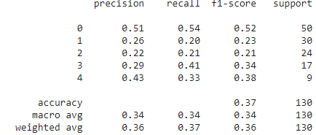

Appendix AQ

|  |  |
| --- | --- |
| Activation Function | ReLU |
| Loss Function | Cross Entropy Loss |
| Optimizer | Adam |
| Training Epochs | 300 |
| Batch Size | 16 |
| Learning Rate | 0.2 |
| Number of Hidden Layers | 3 |
| Hidden Layers: Inputs and Outputs | 1: (256) => (128) 2: (128) => (64) 3: (64) => (32) |
| Batch Normalization | Input Layer: 256, Hidden Layer 1: 128, Hidden Layer 2: 64, Hidden Layer 3: 32 |
| Early Stopping Patience | - |
| Drop Out Rate | - |
| Last Epoch Information | Epoch 300: | Train Loss: 0.20646 | Val Loss: 6.52117 | Train Acc: 100.000| Val Acc: 28.846 |
| Test Accuracy | 39% |

Output table screen shot:

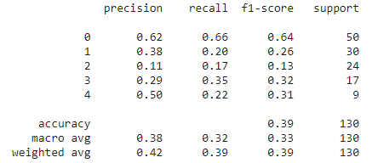

Appendix AR 4

|  |  |
| --- | --- |
| Activation Function | ReLU |
| Loss Function | Cross Entropy Loss |
| Optimizer | Adam |
| Training Epochs | 80 |
| Batch Size | 16 |
| Learning Rate | 0.19727524535520638 |
| Number of Hidden Layers | 2 |
| Hidden Layers: Inputs and Outputs | 1: (2962) => (1481) 2: (1481) => (740) |
| Batch Normalization | Input Layer: 2962, Hidden Layer 1: 1481, Hidden Layer 2: 740 |
| Early Stopping Patience | - |
| Drop Out Rate | - |
| Last Epoch Information | Epoch 080: | Train Loss: 0.92283 | Val Loss: 1.61058 | Train Acc: 63.333| Val Acc: 50.000 |
| Test Accuracy | 44% |

Output table screen shot:

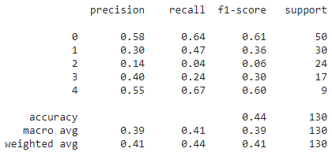

Appendix AS

|  |  |
| --- | --- |
| Activation Function | ReLU |
| Loss Function | Cross Entropy Loss |
| Optimizer | SGD |
| Training Epochs | 76 |
| Batch Size | 105 |
| Learning Rate | 0.013920344480894973 |
| Number of Hidden Layers | 3 |
| Hidden Layers: Inputs and Outputs | 1: (6595) => (3298) 2: (3298) => (1649) 3: (1649) => (824) |
| Batch Normalization | Input Layer: 6595, Hidden Layer 1: 3298, Hidden Layer 2: 1649, Hidden Layer 3: 824 |
| Early Stopping Patience | - |
| Weight Decay | 0.8516583412890875 |
| Drop Out Rate | 0.2934481075639418 |
| Last Epoch Information | Epoch 076: | Train Loss: 1.01109 | Val Loss: 1.36337 | Train Acc: 100.000| Val Acc: 44.231 |
| Test Accuracy | 42% |

Output table screen shot:

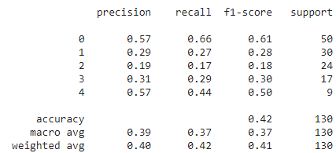

Appendix AT

|  |  |
| --- | --- |
| Activation Function | ReLU |
| Loss Function | Cross Entropy Loss |
| Optimizer | Adam |
| Training Epochs | 260 |
| Batch Size | 125 |
| Learning Rate | 0.00015054303711951883 |
| Number of Hidden Layers | 3 |
| Hidden Layers: Inputs and Outputs | 1: (4749) => (3298) 2: (3298) => (1649) 3: (1649) => (824) |
| Batch Normalization | Input Layer: 4749, Hidden Layer 1: 3298, Hidden Layer 2: 1649, Hidden Layer 3: 824 |
| Early Stopping Patience | - |
| Weight Decay | 0.35890558069944384 |
| Drop Out Rate | 0.036093945652246474 |
| Last Epoch Information | Epoch 260: | Train Loss: 0.12290 | Val Loss: 1.51080 | Train Acc: 100.000| Val Acc: 36.538 |
| Test Accuracy | 48% |

Output table screen shot:

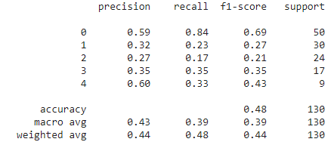

Appendix AU

|  |  |
| --- | --- |
| Activation Function | ReLU |
| Loss Function | Cross Entropy Loss |
| Optimizer | SGD |
| Training Epochs | 52 |
| Batch Size | 74 |
| Learning Rate | 0.00948236203858607 |
| Number of Hidden Layers | 2 |
| Hidden Layers: Inputs and Outputs | 1: (6068) => (3034) 2: (3034) => (1517) |
| Batch Normalization | Input Layer: 6068, Hidden Layer 1: 3034, Hidden Layer 2: 1517 |
| Early Stopping Patience | - |
| Weight Decay | 0.16317779064178467 |
| Drop Out Rate | 0.1314163376390934 |
| Last Epoch Information | Epoch 052: | Train Loss: 0.38496 | Val Loss: 1.38251 | Train Acc: 100.000| Val Acc: 34.615 |
| Test Accuracy | 45% |

Output table screen shot:

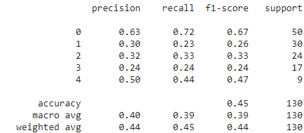

Appendix AV 8

|  |  |
| --- | --- |
| Activation Function | ReLU |
| Loss Function | Cross Entropy Loss |
| Optimizer | SGD |
| Training Epochs | 135 |
| Batch Size | 19 |
| Learning Rate | 0.007146503748942547 |
| Number of Hidden Layers | 1 |
| Hidden Layers: Inputs and Outputs | 1: (7877) => (3939) |
| Batch Normalization | Input Layer: 7877, Hidden Layer 1: 3939 |
| Early Stopping Patience | - |
| Weight Decay | 0.4278550745917246 |
| Drop Out Rate | 0.22873144020458944 |
| Last Epoch Information | Epoch 135: | Train Loss: 0.69038 | Val Loss: 1.32140 | Train Acc: 100.000| Val Acc: 48.077 |
| Test Accuracy | 43% |

Output table screen shot:

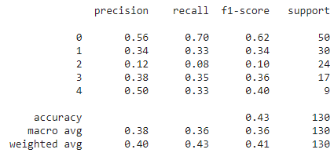

Appendix AW

|  |  |
| --- | --- |
| Activation Function | ReLU |
| Loss Function | Cross Entropy Loss |
| Optimizer | SGD |
| Training Epochs | 8538 |
| Batch Size | 54 |
| Learning Rate | 0.0007539524474668675 |
| Number of Hidden Layers | 2 |
| Hidden Layers: Inputs and Outputs | 1: (8538) => (4269) 2: (4269) => (2134) |
| Batch Normalization | Input Layer: 8538, Hidden Layer 1: 4269, Hidden Layer 2: 2134 |
| Early Stopping Patience | 0.5340685918653861 |
| Weight Decay | 0.6080295007545474 |
| Drop Out Rate | 0.7786589029651306 |
| Last Epoch Information | Epoch 052: | Train Loss: 0.38496 | Val Loss: 1.38251 | Train Acc: 100.000| Val Acc: 34.615 |
| Test Accuracy | 45% |

Appendix AX

|  |  |
| --- | --- |
| Activation Function | ReLU |
| Loss Function | Cross Entropy Loss |
| Optimizer | SGD |
| Training Epochs | 203 |
| Batch Size | 21 |
| Learning Rate | 0.019473904989422124 |
| Number of Hidden Layers | 1 |
| Hidden Layers: Inputs and Outputs | 1: (2624) => (1312) |
| Batch Normalization | Input Layer: 2624, Hidden Layer 1: 1312 |
| Early Stopping Patience | 20 |
| Weight Decay | 0.001 |
| Drop Out Rate | 0.46674072359143415 |
| Last Epoch Information | Epoch 066: | Train Loss: 0.90298 | Val Loss: 1.23355 | Train Acc: 86.957| Val Acc: 51.923 |
| Test Accuracy | 49% |

Output table screen shot:

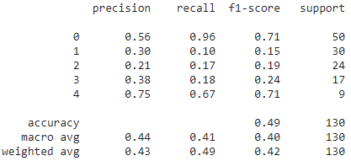

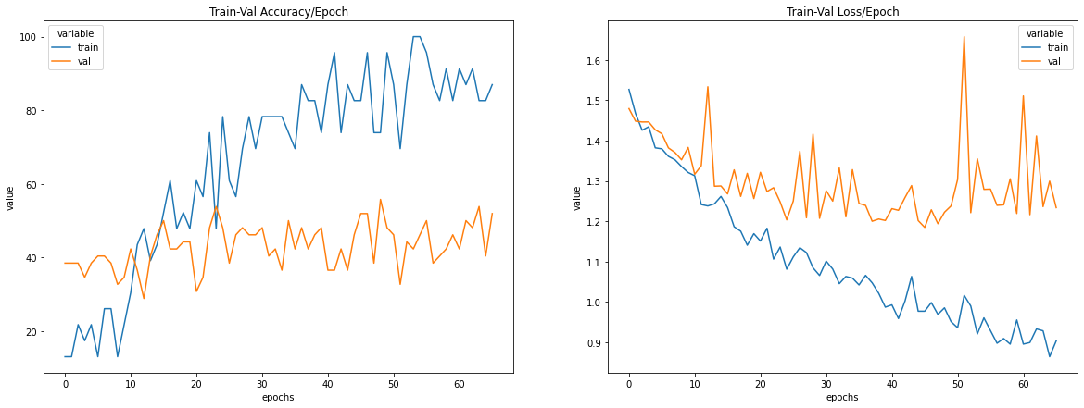

Appendix AZ

|  |  |
| --- | --- |
| Activation Function | ReLU |
| Loss Function | Cross Entropy Loss |
| Optimizer | SGD |
| Training Epochs | 157 |
| Batch Size | 63 |
| Learning Rate | 0.00022009709124994273 |
| Number of Hidden Layers | 1 |
| Hidden Layers: Inputs and Outputs | 1: (3798) => (1899) |
| Batch Normalization | Input Layer: 3798, Hidden Layer 1: 1899 |
| Early Stopping Patience | 0.8134192433402521 |
| Weight Decay | 0.6086040733570699 |
| Drop Out Rate | 0.7594671450530076 |
| Last Epoch Information | Epoch 157: | Train Loss: 1.41896 | Val Loss: 1.44941 | Train Acc: 0.000| Val Acc: 38.46 |
| Test Accuracy | 38% |

Output table screen shot:

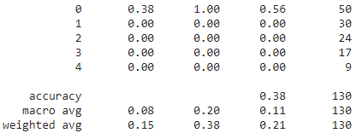

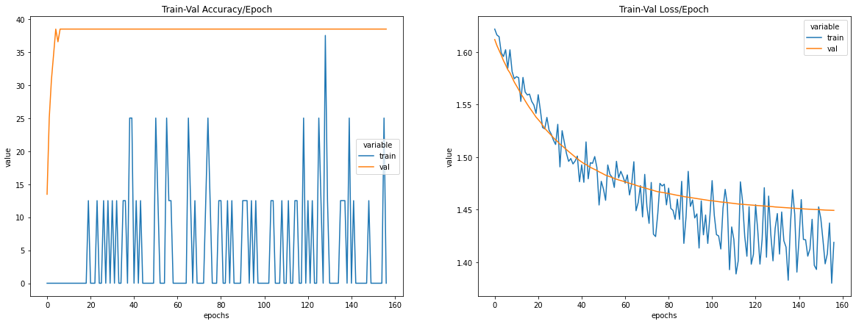

Appendix BA

|  |  |
| --- | --- |
| Activation Function | Hardswish |
| Loss Function | Cross Entropy Loss |
| Optimizer | SGD |
| Training Epochs | 8895 |
| Batch Size | 87 |
| Learning Rate | 0.0006327001948782599 |
| Number of Hidden Layers | 1 |
| Hidden Layers: Inputs and Outputs | 1: (2639) => (1319) |
| Batch Normalization | Input Layer: 2639, Hidden Layer 1: 1319 |
| Early Stopping Patience | - |
| Weight Decay | 0.4264997841858085 |
| Drop Out Rate | 0.42359007485630035 |
| Last Epoch Information | Epoch 8895: | Train Loss: 1.54611 | Val Loss: 1.53685 | Train Acc: 0.000| Val Acc: 38.462 |
| Test Accuracy | 38% |

Output table screen shot:

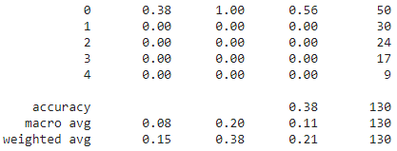

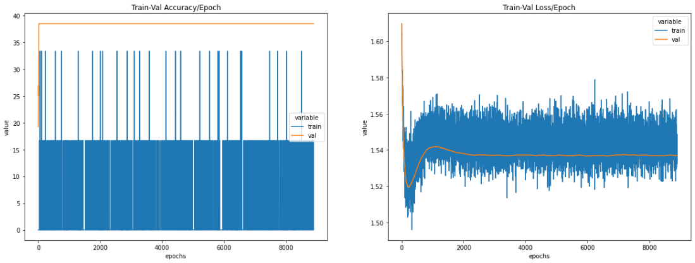

Appendix BB

|  |  |
| --- | --- |
| Activation Function | LeakyReLU |
| Loss Function | Cross Entropy Loss |
| Optimizer | SGD |
| Training Epochs | 4066 |
| Batch Size | 20 |
| Learning Rate | 0.378637059648244 |
| Number of Hidden Layers | 1 |
| Hidden Layers: Inputs and Outputs | 1: (2784) => (1392) |
| Batch Normalization | - |
| Early Stopping Patience | - |
| Weight Decay | 0.014236697245389222 |
| Drop Out Rate | 0.030501206666231157 |
| Last Epoch Information | Epoch 4066: | Train Loss: 1.22724 | Val Loss: 1.30061 | Train Acc: 29.167| Val Acc: 44.231 |
| Test Accuracy | 43% |

Output table screen shot:

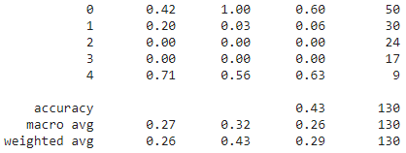

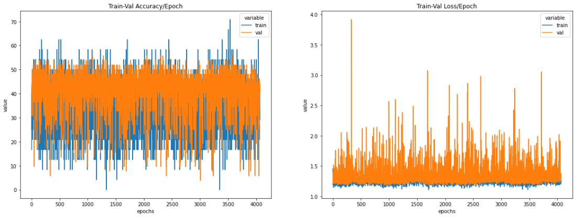

Appendix BC

|  |  |
| --- | --- |
| Activation Function | ReLU |
| Loss Function | Cross Entropy Loss |
| Optimizer | SGD |
| Training Epochs | 500 |
| Batch Size | 36 |
| Learning Rate | 0.0045 |
| Number of Hidden Layers | 3 |
| Hidden Layers: Inputs and Outputs | 1: (2048) => (1024) 2: (1024) => (512) 3: (512) => (256) |
| Batch Normalization | - |
| Early Stopping Patience | - |
| Weight Decay | 0.01 |
| Drop Out Rate | 0.15 |
| Last Epoch Information | - |
| Test Accuracy | 51% |

Output table screen shot:

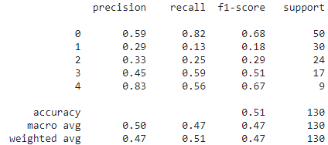

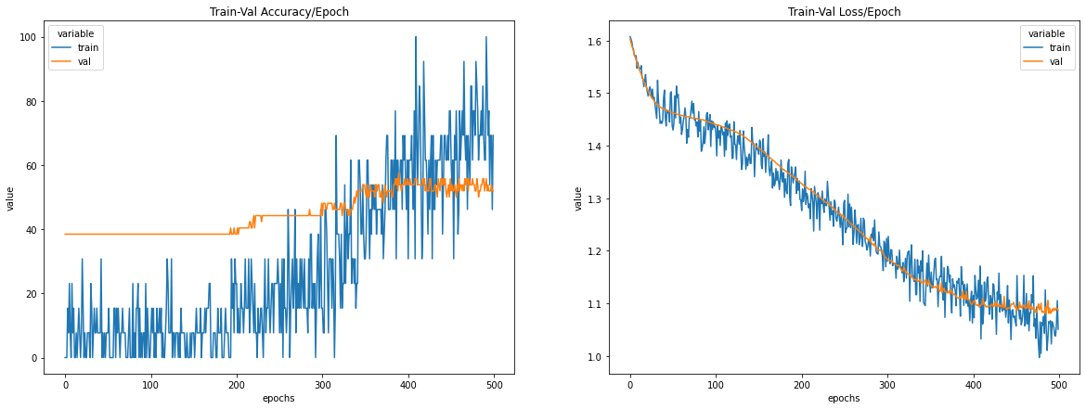

Appendix BD

|  |  |
| --- | --- |
| Activation Function | ReLU |
| Loss Function | Cross Entropy Loss |
| Optimizer | SGD |
| Training Epochs | 800 |
| Batch Size | 36 |
| Learning Rate | 0.0055 |
| Number of Hidden Layers | 3 |
| Hidden Layers: Inputs and Outputs | 1: (2048) => (1024) 2: (1024) => (512) 3: (512) => (256) |
| Batch Normalization | - |
| Early Stopping Patience | - |
| Weight Decay | 0.01 |
| Drop Out Rate | 0.15 |
| Last Epoch Information | Epoch 800: | Train Loss: 0.63405 | Val Loss: 1.33776 | Train Acc: 100.000| Val Acc: 34.615 |
| Test Accuracy | 44% |

Output table screen shot:

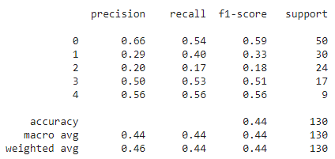

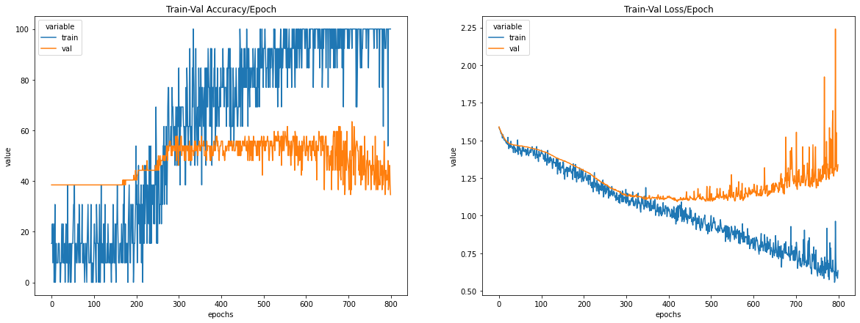

Appendix BE

|  |  |
| --- | --- |
| Activation Function | ReLU |
| Loss Function | Cross Entropy Loss |
| Optimizer | SGD |
| Training Epochs | 800 |
| Batch Size | 36 |
| Learning Rate | 0.005 |
| Number of Hidden Layers | 3 |
| Hidden Layers: Inputs and Outputs | 1: (2048) => (1024) 2: (1024) => (512) 3: (512) => (256) |
| Batch Normalization | - |
| Early Stopping Patience | - |
| Weight Decay | 0.01 |
| Drop Out Rate | 0.15 |
| Last Epoch Information | Epoch 800: | Train Loss: 0.77542 | Val Loss: 1.29845 | Train Acc: 100.000| Val Acc: 36.538 |
| Test Accuracy | 42% |

Output table screen shot:

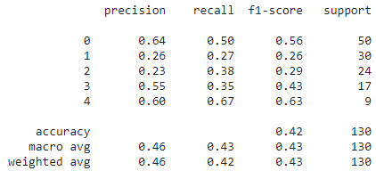

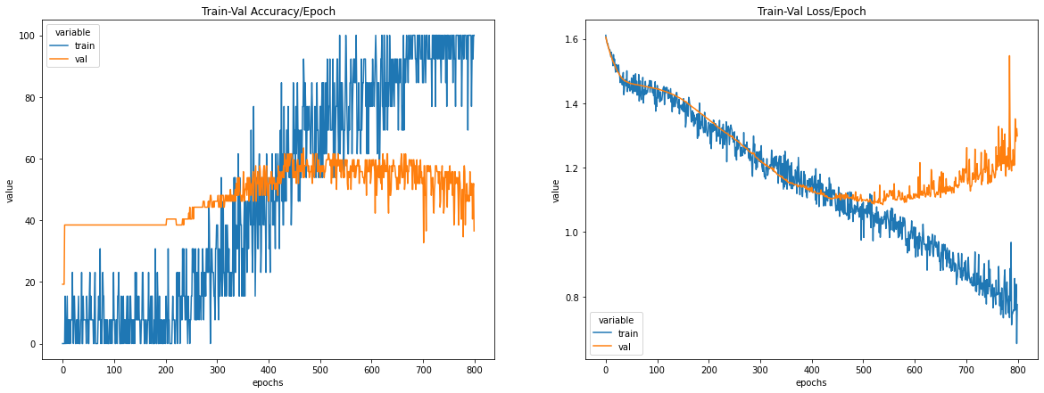

Appendix BF

|  |  |
| --- | --- |
| Activation Function | ReLU |
| Loss Function | Cross Entropy Loss |
| Optimizer | SGD |
| Training Epochs | 900 |
| Batch Size | 36 |
| Learning Rate | 0.0032 |
| Number of Hidden Layers | 3 |
| Hidden Layers: Inputs and Outputs | 1: (2048) => (1024) 2: (1024) => (512) 3: (512) => (256) |
| Batch Normalization | - |
| Early Stopping Patience | - |
| Weight Decay | 0.01 |
| Drop Out Rate | 0.15 |
| Last Epoch Information | Epoch 858: | Train Loss: 0.99290 | Val Loss: 1.14043 | Train Acc: 69.231| Val Acc: 46.154 |
| Test Accuracy | 51% |

Output table screen shot:

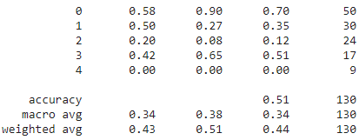

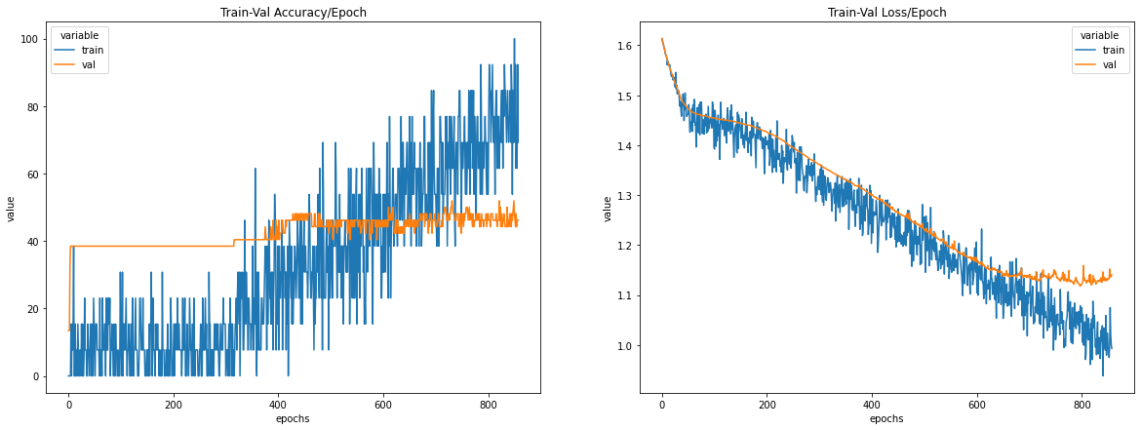

Appendix BG

|  |  |
| --- | --- |
| Activation Function | ReLU |
| Loss Function | Cross Entropy Loss |
| Optimizer | SGD |
| Training Epochs | 1000 |
| Batch Size | 25 |
| Learning Rate | 0.0023 |
| Number of Hidden Layers | 2 |
| Hidden Layers: Inputs and Outputs | 1: (1024) => (512) 2: (512) => (256) |
| Batch Normalization | - |
| Early Stopping Patience | - |
| Weight Decay | 0.01 |
| Drop Out Rate | 0.01 |
| Last Epoch Information | Epoch 1000: | Train Loss: 0.93929 | Val Loss: 1.07883 | Train Acc: 94.737| Val Acc: 53.846 |
| Test Accuracy | 51% |

Output table screen shot:

