MOBILE ASPECTS
Create Cronjob SSH
Technical Reference Documentation

Document Version | Version 1.0.0(1)
Date | December 2025
Initiated By | M. Rahim
Organization | Mobile Aspects
Classification | Confidential – Internal Use Only
Status | Draft

CREATE CRONJOB SSH

Create backup script
===========================================
sudo nano /usr/local/bin/cron_check_ssh.sh

Write
==========================================
#!/bin/bash

if systemctl is-active --quiet ssh; then
echo "SSH OK"
else
echo "SSH DOWN - restarting"
systemctl restart ssh
fi
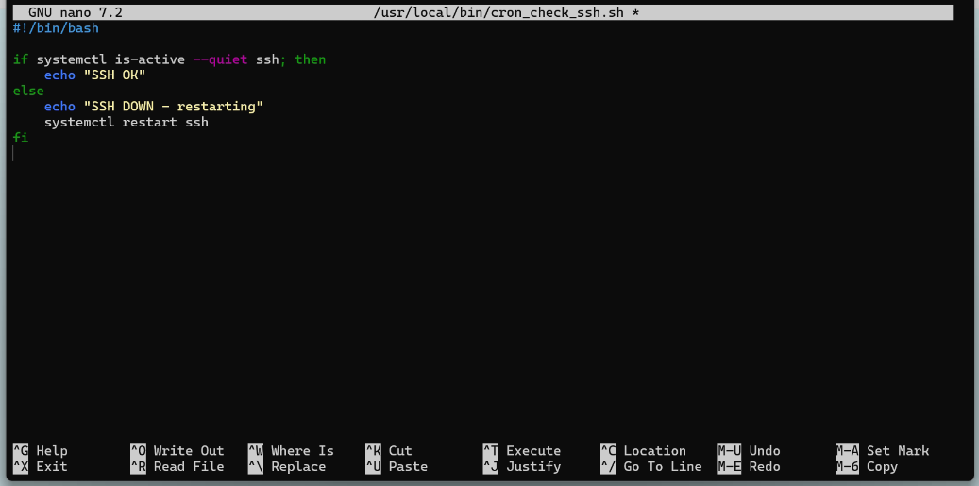
Then control X, yes and Enter

executable
=============================================
sudo chmod +x /usr/local/bin/cron_check_ssh.sh

Edit crontab:
===================
sudo crontab -e

Select 1
===================
Select an editor. To change later, run 'select-editor'.
1. /bin/nano <---- easiest
2. /usr/bin/vim.tiny
3. /bin/ed

Choose 1-3 [1]:
1

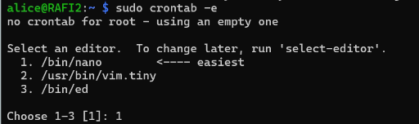

add
===========================
# Check SSH every 5 minutes
*/60 * * * * /usr/local/bin/cron_check_ssh.sh
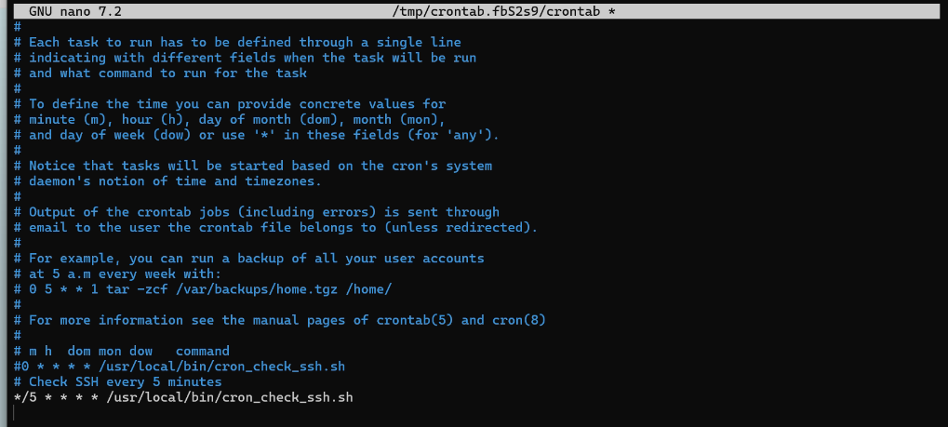

Control X, yes and Enter

TEST WITH STOP SSH
sudo systemctl stop ssh

Document Control
Field | Details
Document Title | Create Cronjob SSH — Technical Reference
Version | 1.0.0(1)
Initiated By | M. Rahim
Organization | Mobile Aspects
Date | December 2025
Review Cycle | As required upon system changes

This document is the property of Mobile Aspects and is intended for internal use only. Unauthorized distribution or reproduction is prohibited.

