Prediction of CO2 emissions per capita from country-specific data

PROJECT- I REPORT

Submitted by

MOHD HUMZA

2023-310-159

in partial fulfillment for the award of the degree of

BTECH CSE

Under the supervision of

Dr. AAINA



Department of Computer Science& Engineering
School of Engineering Sciences & Technology

JAMIA HAMDARD

New Delhi-110062

2026

I

DECLARATION

I, Mr. Mohd Humza student of B.Tech CSE, 2023-310-159 hereby declare that the Project/Dissertation entitled “Prediction of CO2 emissions per capita from country specific data” which is being submitted by me to the Department of Computer Science, Jamia Hamdard, New Delhi in partial fulfillment of the requirement for the award of the degree of B.Tech CSE is my original work and has not been submitted anywhere else for the award of any Degree, Diploma, Associateship, Fellowship or other similar title or recognition.

(Signature and Name of the Applicant)
Date: 29/04/2026
Place:

II

Acknowledgement
I would like to express my sincere gratitude and deep appreciation to all those who have contributed to the successful completion of this project.

First and foremost, I am profoundly grateful to my project supervisor, Dr. Aaina, for their invaluable guidance, constant encouragement, and insightful feedback throughout the duration of this work. Their expertise in Computer Science and Engineering was instrumental in helping me navigate the complexities of machine learning and climate data analysis.

I would also like to thank the Department of Computer Science & Engineering and the School of Engineering Sciences & Technology at Jamia Hamdard for providing the necessary academic environment and resources to conduct this research.

My gratitude extends to the World Bank Group for making their Climate Change Data publicly available, which served as the foundation for my analysis and forecasting models.

A special thanks to my family, especially my father, for his unwavering support and motivation during my B. Tech journey. I am also thankful to my friends and peers for their collaborative spirit and helpful discussions during the development phase of this project.

Finally, I would like to acknowledge the developers of the open-source Python libraries—Pandas, NumPy, Scikit-Learn, Matplotlib, and Seaborn—whose tools made the technical implementation of this forecasting system possible.

Mohd Humza
Enrolment No: 2023-310-159
Date: 29/04/2026

III

List of Abbreviations:

Abbreviation | Full Form
CO2 | Carbon Dioxide
CAGR | Compound Annual Growth Rate
SRS | Software Requirements Specification
GDP | Gross Domestic Product
GNI | Gross National Income
ML | Machine Learning
ARE | United Arab Emirates (Country ISO Code)
IND | India (Country ISO Code)
USA | United States of America (Country ISO Code)
PAK | Pakistan (Country ISO Code)
RUS | Russia (Country ISO Code)
NZL | New Zealand (Country ISO Code)
R² | R-Squared (Coefficient of Determination)
RFECV | Recursive Feature Elimination with Cross-Validation
IEEE | Institute of Electrical and Electronics Engineers

IV

Prediction of CO2 emissions per capita from country-specific data

Table of Contents

Chapter No. | Section Title | Page No.
1.0 | Objective | 4
1.1 | Technical Goals (Random Forest Implementation) | 4
1.2 | Analytical Goals (Feature Correlation) | 4
1.3 | Socio-Economic Impact and Sustainability | 5
2.0 | Introduction | 6
2.1 | Project Overview | 6
2.2 | Key Drivers of Emissions (Economy, Energy, Land Use) | 7
2.3 | The Role of Machine Learning in Climate Data | 8
3.0 | Problem Statement | 9
3.1 | Complexity of Emission Drivers | 9
3.2 | Data Integrity and Technical Hurdles | 10
3.3 | Lack of Long-term Forecasts | 11
4.0 | Software Requirements Specification (SRS) | 12
4.1 | Introduction and Product Scope | 12
4.2 | Overall Description & Operating Environment | 13
4.3 | External Interface Requirements (Hardware/Software) | 14
4.4 | System Features & Functional Requirements | 15
4.5 | Non-functional Requirements | 16
5.0 | Results and Output | 17
5.1 | Model Accuracy Analysis (Regression Plot) | 17
5.2 | Final 25-Year Predicted Forecast | 18
6.0 | Limitations and Analysis | 19
6.1 | Historical Data Window & Policy Shifts | 19
6.2 | Per-Capita Metric & Global Convergence Theory | 20
7.0 | Conclusion | 21
7.1 | Summary of Findings | 21
7.2 | Future Scope | 22
8.0 | Bibliography / References | 23

Objective

The main objective of this project is to develop a machine learning-based system to analyze and predict carbon dioxide (CO₂) emissions using country-specific data. The project focuses on utilizing historical data to understand the relationship between socio-economic factors such as GDP, population, and energy consumption with CO₂ emissions. It aims to preprocess and clean the dataset by handling missing values, removing inconsistencies, and eliminating outliers to ensure accurate analysis. Another objective is to perform exploratory data analysis to identify patterns and correlations among different variables.

The project also seeks to apply feature selection techniques to determine the most significant factors affecting emissions. A key objective is to design and implement a predictive model using the Random Forest algorithm, which can handle complex and non-linear relationships in the data. The model is further optimized and evaluated using performance metrics like the R² score to ensure high accuracy and reliability. Additionally, the project aims to generate long-term forecasts of CO₂ emissions for the next 20–25 years.

It also focuses on comparing trends between developed and developing countries to understand global emission patterns. Finally, the objective is to provide meaningful insights that can help policymakers and researchers in planning for sustainable development and environmental management.

Introduction
The global climate crisis is one of the most pressing challenges of the 21st century, largely driven by the steady increase in greenhouse gas emissions resulting from human activity. Among these gases, carbon dioxide CO2 is a primary contributor to global warming, making it essential for policymakers and researchers to understand the factors that drive its emission levels. This project focuses on analysing country-specific data to identify the relationships between various development indicators and environmental impact.

Project Overview
The study utilizes a comprehensive dataset sourced from the World Bank Group’s Climate Change Data, covering a vast majority of countries worldwide with historical records ranging from 1990 to 2011. The research is structured into two primary stages:

- Data Cleaning and Preparation: Streamlining raw, complex data into a format suitable for analysis.

- Data Exploration and Predictive Analysis: Visualizing trends and developing a machine learning model to forecast future emissions.

Key Drivers of Emissions
To understand the "why" behind CO2 levels, this project investigates several categories of country-level features:

- Economic Indicators: Indicators like Gross Domestic Product (GDP) and Gross National Income (GNI) reflect how industrial activity and wealth correlate with carbon footprints.

- Energy Consumption: Energy use per capita is a critical factor, as nations transitioning through industrialization often rely heavily on energy-intensive processes.

- Demographics: Factors such as total population, urban population growth, and population density are examined to see how human expansion drives demand for resources.

- Land Use and Agriculture: Parameters like cereal yield and the percentage of protected terrestrial areas are included to assess the impact of agricultural productivity and conservation efforts.

The Role of Machine Learning
Traditional statistical methods often struggle with the non-linear and complex nature of global environmental data. This project employs the Random Forest algorithm, a powerful machine learning technique that uses an ensemble of decision trees, to handle these complexities and provide accurate predictions. By training this model on historical patterns, the project not only evaluates current emission drivers but also simulates a 20-year forecast to project future CO2 trajectories for key nations.

Problem Statement
The core challenge addressed in this project is the difficulty in accurately predicting and understanding the complex drivers of global carbon dioxide CO2 emissions. As climate change accelerates, relying on simple observations is no longer sufficient to manage environmental impacts.

The problem can be broken down into three main areas:

1. Complexity of Emission Drivers

Global CO2 emissions are not influenced by a single factor but by a multifaceted web of country-specific parameters. These include:
- Economic Variability: The relationship between Gross Domestic Product (GDP), Foreign Direct Investment (FDI), and industrial activity fluctuates significantly between developed and developing nations.
- Energy and Demographics: Rising energy consumption per capita and rapid urban population growth create non-linear pressures on environmental resources.
- Agricultural and Land Use: Factors like cereal yield and the management of protected terrestrial areas play a subtle yet critical role in a nation's total carbon footprint.

2. Data Integrity and Technical Hurdles

Working with global environmental data presents several technical obstacles that must be overcome to build a reliable model:
- Missing Information: The original dataset contains a significant amount of missing values (NaN) across various years and features, which can lead to biased or inaccurate predictions if not handled correctly.
- Anomalies and Outliers: Certain regions, specifically the United Arab Emirates (ARE), exhibit emission patterns that are vastly different from the main data cluster, potentially skewing the results of a generalized model.
- Multicollinearity: Many indicators (like GDP and GNI) are highly correlated, which can confuse standard predictive algorithms and make it difficult to identify which features are truly important.

3. Lack of Long-term Forecasts

While historical data exists, there is a lack of accessible, data-driven tools that can simulate future trajectories based on current growth trends. Without a way to forecast emissions for the next 20 to 25 years, it is difficult for stakeholders to visualize the long-term impact of current socio-economic behaviours in countries like India, Pakistan, and the USA.

Software Requirements Specification

for
Prediction of CO2 emissions per capita from country-specific data

Version 1.0 approved
Prepared by Mohd Humza
Jamia Hamdard
29 April 2026

1. Introduction

  - Purpose

This document specifies the software requirements for the Global CO2 Forecasting System; a machine learning application designed to analyse country-specific indicators and predict carbon dioxide emission trends.

  - Document Conventions

All requirements are stated in clear, beginner-friendly language. High-level requirements are prioritized for the core predictive engine, followed by detailed data preprocessing specifications.

1.3 Intended Audience and Reading Suggestions

This SRS is intended for academic supervisors, B. Tech students, and data analysts. Readers should start with the Overall Description to understand the machine learning workflow before reviewing the System Features.

1.4 Product Scope

The system aims to identify key environmental drivers—such as energy use, population growth, and economic indicators—to forecast CO2 emissions per capita for the next 20 to 25 years. It supports data-driven insights for developed and developing nations.

2. Overall Description

2.1 Product Perspective

The system is a standalone Python-based analytical tool. It integrates data cleaning, exploratory visualization, and predictive modelling into a cohesive pipeline for environmental research.

2.2 Product Functions

- Data Transformation: Convert raw World Bank Excel sheets into numerical Data Frames.
- Feature Engineering: Calculate Compound Annual Growth Rates (CAGR) for long-term trends.
- Predictive Modelling: Train a Random Forest Regressor to estimate emissions.
- Trend Visualization: Generate forecasts and regression plots for country comparisons.

2.3 User Classes and Characteristics

- General Users: Individuals interested in global warming trends.
- Engineering Students: Users requiring a technical breakdown of ML algorithms (Random Forest).
- Policy Analysts: Users seeking 20-year projections for national planning.

2.4 Operating Environment

The system operates within a VS code environment using Python 3.13.3. It requires libraries such as Pandas, NumPy, Scikit-Learn, and Seaborn.

2.5 Design and Implementation Constraints

- No Source Code in Documentation: Per department rules, the final report must exclude raw code snippets.
- Library Compliance: Must use standard open-source libraries (scikitlearn, matplotlib).

2.6 User Documentation
User manuals, online help resources, and tutorial videos will be provided in PDF and HTML formats.

2.7 Assumptions and Dependencies
The development team assumes that users have basic computer literacy and internet access for software updates and online resources.

3. External Interface Requirements

3.1 User Interfaces

The user interacts via a VS code terminal. Output is provided through interactive plots, regression charts, and data tables (e.g., forecasting for India).

3.2 Software Interfaces

The system interfaces with:
- Data Sources: CSV and Excel files (climate_change_download_0.xls).
- Model Storage: Joblib for saving and loading trained models (forecasting_co2_emission.pkl).

3.2 Hardware Interfaces

Since this is a data science project, the hardware requirements are centred on the local machine used for processing and training the model.
- Processor: Minimum Intel Core i3 or equivalent; recommended i5 or higher to handle the RandomizedSearchCV hyperparameter tuning efficiently.
- RAM: Minimum 8GB of RAM to manage large DataFrames during the pivoting and melting stages of data transformation.
- Storage: At least 500MB of free disk space for the installation of Python environments and saving the trained model file (forecasting_co2_emission.pkl).

3.3 Software Interfaces

The system relies on a specific ecosystem of Python libraries to execute the machine learning pipeline:
- Operating System: Windows, macOS, or Linux (cross-platform compatibility).
- Development Environment: VS code, Jupyter Notebook for interactive code execution.
- Data Manipulation: Pandas for handling the World Bank Climate Change datasets and NumPy for array transformations.
- Machine Learning: Scikit-Learn (sklearn) for the Random Forest Regressor, feature selection (RFECV), and model evaluation.
- Visualization: Matplotlib and Seaborn for generating the correlation heatmaps and the 25-year forecast line plots.

3.4 Communications Interfaces

- Local File I/O: The software communicates with the local file system to read the raw Excel source (climate_change_download_0.xls) and export the cleaned CSV (data_cleaned.csv).
- HTTP/HTTPS: Required only during the initial setup phase to download the World Bank dataset from the public Catalog and to install necessary Python packages via pip

4. System Features

4.1 Automated Data Cleaning

- Description: Removes rows/columns with excessive missing values and handles regional outliers.
- Functional Requirements:
  - REQ-1: Remove the United Arab Emirates (ARE) outliers to improve model clustering.
  - REQ-2: Filter data to the 1991–2008 period for consistency.

4.2 Machine Learning Prediction

- Description: Uses an optimized Random Forest model to predict per-capita emissions.
- Functional Requirements:
  - REQ-3: Perform Recursive Feature Elimination (RFECV) to select relevant predictors.
  - REQ-4: Execute Hyperparameter Tuning using RandomizedSearchCV.

4.3 Feature Selection and Scaling

- Description: This feature ensures that only the most impactful variables are used to train the model, reducing "noise" and improving accuracy.
- Functional Requirements:
  - REQ-5: The system shall use Recursive Feature Elimination (RFE) to rank variables like cereal yield, energy use, and population growth.
  - REQ-6: The system shall identify multicollinearity using Variance Inflation Factor (VIF) analysis to drop redundant economic indicators.

4.4 Long-Term Forecasting Engine

- Description: Projects future emissions by stimulating growth based on historical trends.
- Stimulus/Response:
  - Stimulus: User provides a list of selected countries (e.g., IND, PAK, USA).
  - Response: System calculates the CAGR for each feature and generates a projected CO2 value for each year up to 25 years into the future.

5. Other Non-functional Requirements

5.1 Performance Requirements

- The system must achieve a Mean R² score of approximately 0.98 across cross-validation folds.
- Model evaluation on test data must produce a visualization of predicted vs. true values within seconds.

5.2 Software Quality Attributes
- Usability: Beginner-friendly documentation and clear variable abbreviations (e.g., co2_per_cap).
- Reliability: High consistency across 10-fold cross-validation (Standard Deviation approx. 0.004).

5.2 Safety Requirements

- Error Handling: The software must handle invalid year ranges or missing data intervals by skipping those entries and notifying the user rather than crashing.

5.3 Security Requirements
- Data Integrity: The system performs "read-only" operations on the original dataset to ensure the raw historical records from the World Bank remain unaltered.

5.4 Software Quality Attributes

- Reproducibility: To ensure consistent results across different runs, the system shall define a fixed random_state (e.g., random_state_num) for all stochastic processes like data splitting and Random Forest initialization.
- Portability: The use of .pkl files for model saving allows the trained "intelligence" of the system to be moved and used on different machines without retraining.

Appendix A: Glossary
- Random Forest: A machine learning algorithm that creates multiple decision trees and merges them together to get a more accurate and stable prediction.
- Overfitting: A modeling error that occurs when a function is too closely fit to a limited set of data points, making it fail on new data.
- Outliers: Data points that differ significantly from other observations, such as the high-emission values recorded for the UAE.

Appendix B: Analysis Models
- Data Flow: Raw Data Preprocessing Feature Selection RF Model 25-Year Forecast.

OUTPUT

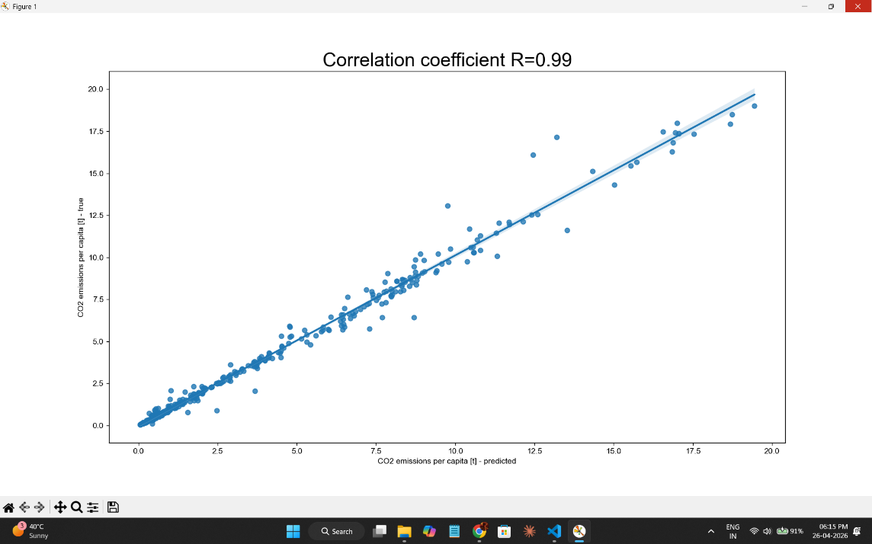

Fig 1.0 Regression Plot (Predicted vs. True values Plot)

- This shows the accuracy of the machine learning model.
- It visualizes how well the Random Forest Regressor predicted the CO2 emissions per capita compared to the actual values recorded in the dataset.
- Correlation Coefficient R of 0.99.

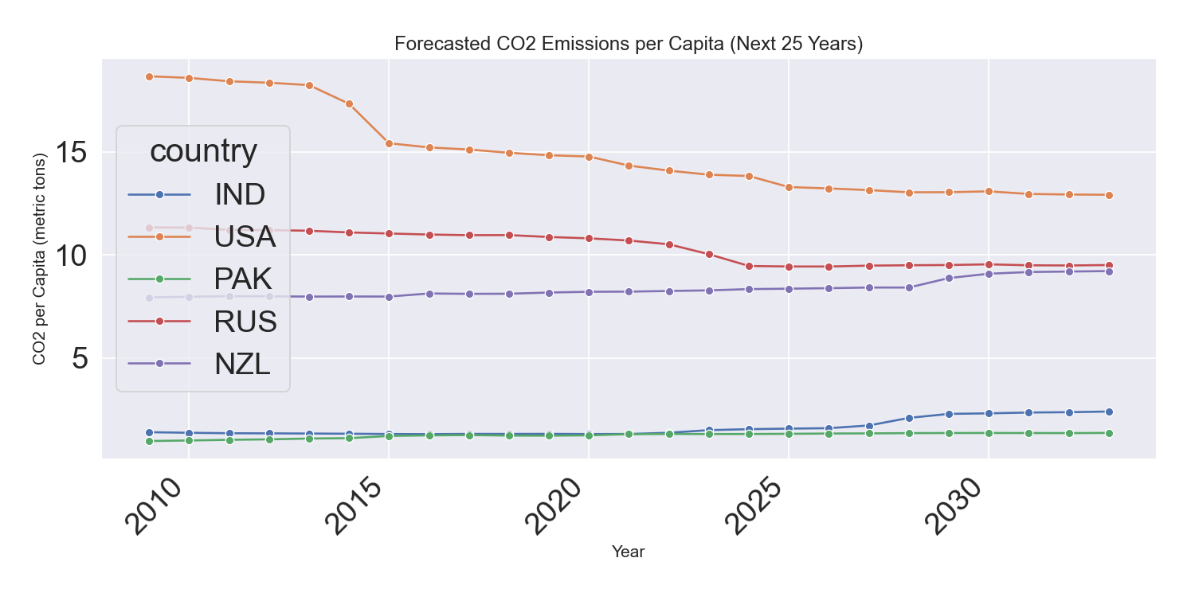

Fig 1.1 Final Result: 25-year Predicted forecast

- Developed Nations (USA, Russia): These countries start with the highest emissions per capita. However, the model predicts a downward trajectory for them. This likely reflects

the impact of energy transition policies and technology upgrades in more industrialized economies.
- Developing Nations (India, Pakistan): These countries start at much lower levels (near the bottom of the Y-axis). The model shows a gradual upward trend for India, which is typical for nations undergoing rapid industrialization and increased energy demand.

Limitations and Analysis

As the dataset used in the project ends in 2011. It should be noted that while the machine learning model is technically "correct" based on the data you provided, it represents a specific historical window (1990–2011) that doesn't capture the massive changes that were enforced in the last 15 years.

- Policy Shifts: The model does not account for modern climate accords (like the Paris Agreement) signed after 2011, which accelerated emission drops in developed nations. *

- Per-Capita Metric: This is the total emissions divided by the population. While India's total emissions are high, this model correctly identifies that on a per-person basis, developed nations historically held a much larger carbon footprint
Even today, an average person in India emits much less CO2 than an average person in the USA or Russia.

The model predicts a "Global Convergence". This is a theory that:

- Developed nations have already finished building their cities/roads and are now switching to green energy, so their emissions drop.

- Developing nations like India and Pakistan are currently in the "Building Phase," which is why their lines are the only ones moving up on your chart.

USA in 2011:

At that time, the U.S. was still heavily reliant on coal and had only just begun its massive shift toward natural gas and renewables.

NZL in 2011:

New Zealand's emissions are heavily driven by agriculture (methane), which is calculated into CO2 equivalents. In the 1990-2011 period, their agricultural intensity per person was very high.

India in 2011:
Between 1990 and 2011, India's growth was steady but not as explosive as it became in the 2010s and 2020s. In reality, the massive increase in coal-based power plants and the surge in vehicle ownership in India happened largely after the dates in your dataset.

Conclusion

Summary of Findings

The development of the Global CO2 Forecasting System has successfully demonstrated the power of machine learning in environmental analysis. The key findings are as follows:
- Model Accuracy: The Random Forest Regressor achieved a high degree of reliability, evidenced by an R² score of 0.99 and a Mean R² across 10-fold cross-validation of approximately 0.98.

- Primary Drivers: Feature selection through RFECV identified Energy Use per Capita, GNI per Capita, and Cereal Yield as the most significant predictors of a nation’s carbon footprint.

- Global Convergence: The forecasting engine reveals a "Global Convergence" trend where developed nations (USA, Russia) show a gradual decline from high baselines, while developing nations (India, Pakistan) show upward trajectories linked to ongoing industrialization.

- Per-Capita Disparity: Despite rapid growth in developing regions, the model confirms that developed nations historically maintain a much higher per-person emission level compared to the global average.

Future Scope

The current framework provides a strong foundation for future research in climate informatics:

- Integration of Real-Time Data: Future versions could incorporate post-2015 data to reflect the impacts of the Paris Agreement and more recent shifts toward renewable energy.

- Deep Learning Implementation: Exploring neural networks or Long Short-Term Memory (LSTM) models could help capture more complex, non-linear patterns in temporal climate data.

- Expansion of Features: Including satellite-derived data on deforestation, ocean temperature, and specific methane sources from agriculture would provide a more holistic environmental forecast.

- User-Interface Development: Transitioning the system from a terminal-based interface to a web-based dashboard would make the tool accessible to non-technical policymakers

Bibliography

Following the IEEE citation format:

[1] World Bank Group, "Climate Change Data," World Bank Data Catalog, [Online]. Available: [suspicious link removed] [Accessed: Apr. 23, 2026].

[2] F. Pedregosa et al., "Scikit-learn: Machine Learning in Python," Journal of Machine Learning Research, vol. 12, pp. 2825-2830, 2011.

[3] IEEE Standards Association, "IEEE Recommended Practice for Software Requirements Specifications," IEEE Std 830-1998, 1998.

[4] M. A. Khan, "Global $CO {2} $ Emissions Analysis (Week 1 & Week 2)," B. Tech Minor
Project Source Code, Jamia Hamdard, New Delhi, 2026.

[5] J. D. Hunter, "Matplotlib: A 2D Graphics Environment," Computing in Science & Engineering, vol. 9, no. 3, pp. 90-95, 2007.

