Random Taco Cookbook

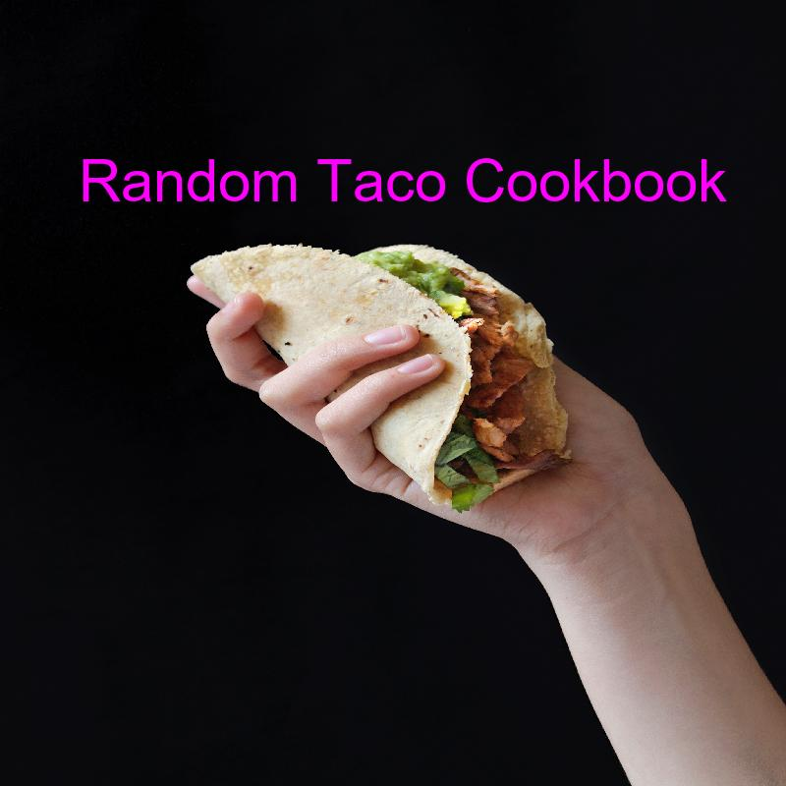

Miguel Andrade

https://taco-1150.herokuapp.com/random/?full_taco=true

# Red Cabbage Filling & Sweet Potato and Apple Hash with Guacamole (Simple) and Packaged Seasonings in/in a Hard Corn Shells (Traditional; US)

## Hard Corn Shells (Traditional; US)  
======================  
  
Mistakenly thought by many to be traditionally Mexican, hard shells were actually popularized in the US in the mid-20th century.  
  
While they can certainly be made at home (if you have access to a deep-fryer), the best method of obtaining hard taco shells is to head to the grocery store.

## Red Cabbage Filling  
===================================  
  
* 1/2 head of red cabbage, shredded  
* 3 chopped green onions  
* 1/2 bunch of finely chopped cilantro  
* 2-3 squeezed limes  
  
1. Mix all ingredients in large bowl

## Sweet Potato and Apple Hash  
===========================  
  
Sweet potatoes are my go-to taco punch-up. I was going my normal route of making small (1/4" or so) cubes of sweet potatoes when I thought: Hey, it's fall, I'm going to add an apple in there. Fuck yes.  
  
* 2 Small sweet potatoes (you'd be amazed how little sweet potato you need for tacos)  
* 1 Small apple  
* One can diced green chilis  
* A couple pinches of chili powder  
* A queeze of honey  
* Pat o' butter  
  
Mix this all into a pan, with about 1/4 cup of water, and boil it all up until the water goes away, toss in the butter, and continue to pan-fry until things get a little browned.

## Guacamole (Simple)  
=========  
  
If you're not in the mood to be fussy, this could be considered a minimum-viable guacamole recipe.  
  
* 2 ripe avocados  
* 2-4 limes, depending on juiciness, delivering 2-4T of lime juice  
* 1 diced tomato (seeded if it's a big one)  
* salt (to taste)  
* hot sauce (to taste; Frank's Red Hot is a standard, but go with what you like)  
  
1. Scoop the avocado meat into a bowl and mash them with a fork. Leave it a bit lumpy as we will do more stirring in a bit and we don't want to over-work them.  
2. Add the chopped tomato.  
3. Add the lime juice; hold some back for later adjustment).  
4. Add ½t salt.  
5. Add 2T hot sauce.  
6. Stir with the fork again.  
7. Taste.  
8. Adjust salt/lime/hot sauce as desired.  
  
This recipe will support one average-size bag of chips, so adjust quantities based on expectations.

## Packaged Seasonings  
==============  
  
Lest we be accused of snobbery, let's acknowledge that a taco is a taco, and taco night can be well-served by not having to think at all.  
  
Feel free to use the pre-packaged seasoning of your choice. When I'm in an old-school mood, I head straight for...  
  
* Old El Paso Taco Seasoning