Experiment -2
NAME: GOWTHAM KUMAR PS
ROLL NO:240701826
Develop low-fidelity paper prototypes for a banking app and convert them into digital wireframes using Inkscape.
FRAME 1:
LOGIN PAGE:
The login page is used for user authentication. It contains input fields for entering the username and password along with a login button.

Components Used:
- Title text (LOGIN PAGE)
- Username input field
- Password input field
- Login button

🔹 Tools Used:
- Rectangle Tool (to create input fields and button)
- Text Tool (to add labels and headings)
- Align and Distribute Tool (to maintain proper layout)

🔹 Design Description:
- A title "LOGIN PAGE" is placed at the top center.
- Below the title, two rectangular input fields are created for Username and Password.
- A Login button is placed below the input fields.
- All elements are aligned centrally for a clean and simple layout.
- The design follows a low-fidelity approach using only basic shapes and text without colors or images.

LOGIN PAGE:

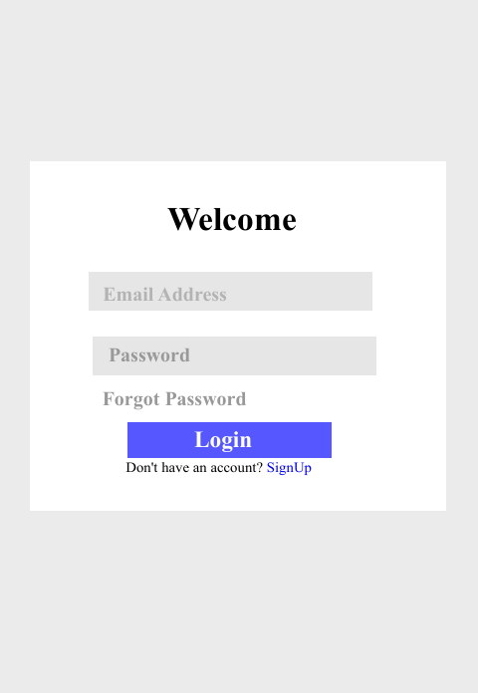

FRAME 2:
DASHBOARD PAGE:

The dashboard page is the main interface of the banking application. It provides users with quick access to essential banking features such as checking balance, transferring money, and paying bills.

🔹 Objective:
To design a simple and user-friendly dashboard interface using low-fidelity wireframe techniques.

🔹 Components Used:
- Title text (DASHBOARD)
- Welcome text (Welcome User)
- Buttons for:
  - Check Balance
  - Transfer Money
  - Bill Payment

🔹 Tools Used:
- Rectangle Tool (to create buttons)
- Text Tool (to add labels and headings)
- Align and Distribute Tool (to arrange elements properly)

🔹 Design Description:
- The title "DASHBOARD" is placed at the top center.
- A welcome message "Welcome User" is displayed below the title.
- Three rectangular buttons are placed vertically:
  - Check Balance
  - Transfer Money
  - Bill Payment
DASHBOARD PAGE:
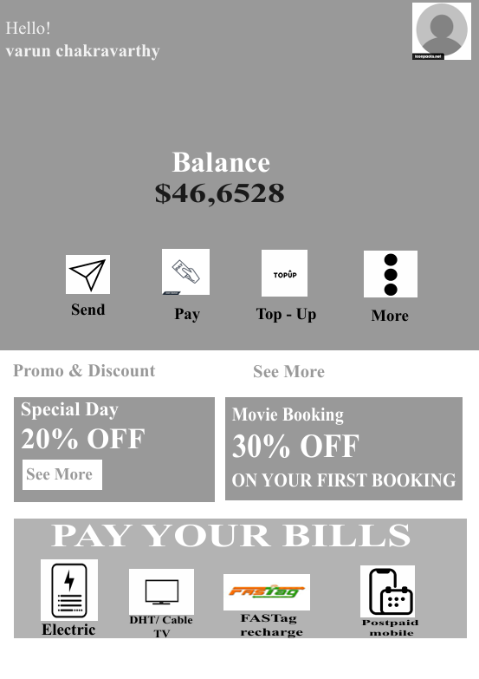

FRAME 3:
BALANCE PAGE DESIGN:
Introduction:
The balance page is used to display the available account balance of the user in a simple and clear format.

🔹 Objective:
To design a simple interface that shows the user’s account balance using a low-fidelity wireframe.

🔹 Components Used:
- Title text (BALANCE)
- Balance display text
- Back button

🔹 Tools Used:
- Rectangle Tool (to create button)
- Text Tool (to display balance and labels)
- Align Tool (for proper positioning)

🔹 Design Description:
- The title "BALANCE" is placed at the top center.
- The account balance is displayed in the middle (e.g., ₹5000).
- A Back button is placed below the balance text.
FRAME 3 :

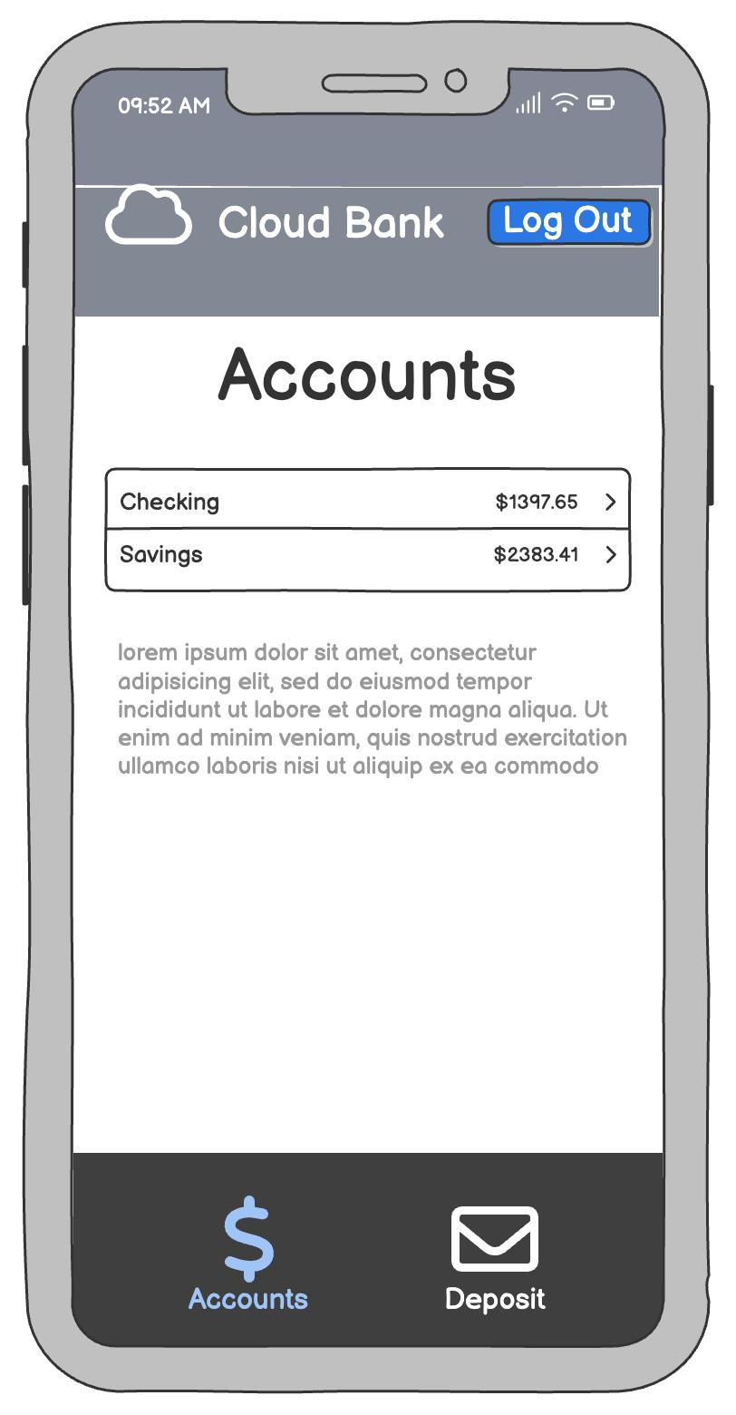

FRAME 4:
TRANSFER PAGE DESIGN:
Introduction:
The transfer page allows users to send money to another account by entering required details such as account number and amount.

🔹 Objective:
To design a simple money transfer interface using low-fidelity wireframe techniques.

🔹 Components Used:
- Title text (TRANSFER)
- Account Number input field
- Amount input field
- Send button

🔹 Tools Used:
- Rectangle Tool (to create input fields and button)
- Text Tool (to add labels)
- Align Tool (to arrange elements properly)

🔹 Design Description:
- The title "TRANSFER" is placed at the top center.
- Two input fields are created:
  - Account Number
  - Amount
- A Send button is placed below the input fields.
- All elements are aligned centrally with equal spacing.

FRAME 4:

