Operando Aggregate-Induced Emission Monitoring for Inverse Projection Design in Vat Photopolymerization 3D Printing
A. Overview & Statement of Objectives
- One brief paragraph with high level overview of why printing is important, specifying why light-based is important, and noting active challenges associated with part fidelity for objects that contain both large and small features in particular.
- Global (vision-level) question: Can operando monitoring of resin state, coupled with real-time closed-loop inverse design, overcome the fundamental tradeoff between resolution and speed in vat photopolymerization?
- Local (project-specific) question: Can aggregate-induced emission–based operando imaging of resin viscosity be used as a baseline for an inverse design framework that dynamically modulates grayscale projection during printing, enabling uniform, near-ideal feature fidelity across length scales in vat photopolymerization?
To answer the local question we will systematically develop and validate an operando, feedback-controlled manufacturing framework for vat photopolymerization that couples embedded sensing with inverse projection design (Fig. 1A). We hypothesize that real-time, spatially resolved measurements of resin state obtained via aggregate-induced emission (AIE) can be translated into control-relevant process descriptors and used within an inverse design framework to dynamically modulate projection exposure, thereby decoupling manufacturing fidelity from throughput limitations. Achieving this necessitates (i) the development of robust, manufacturable AIE-enabled resin formulations that provide quantitative operando observability of cure state, (ii) the formulation of an inverse, control-oriented model that maps observed process states to optimized projection inputs, and (iii) the integration of these capabilities into a closed-loop digital light processing system capable of real-time decision-making during printing. We propose three Aims that leverage our group’s demonstrated expertise in polymer science, additive manufacturing, modeling, and microfabrication. Specifically, we will develop a Sensing Platform (Aim 1), Inverse Design (Aim 2), and 3D Demonstration (Aim 3). This work builds upon the teams’ prior collaborative efforts and NSF-funded work through a Future Manufacturing Research Grant.
B. Background and Significance
Advancements in photopolymer chemistry, digital optical devices, and artificial intelligence (AI)-ready computing resources have expanded the use of plastics manufactured via vat photopolymerization additive manufacturing for biomedical devices, microelectronics, and other value-added industries. One key driver is the increase in resolution and fidelity (accuracy) of VPP down to the micron level; it is now possible to cure a single pixel of resin to an XY-resolution of 5×5 µm² [ref???]. However, to make this a scalable and reproducible process, we propose working on a two-pronged approach as described below.
Xxx (short section overviewing the relevant background in (i) in situ or operando monitoring in vat 3D printing platforms, (ii) AIE as a method in monitoring curing kinetics in general, and (iii) inverse design strategies (Jerry Qi stuff, others?).
B.1. Monitoring Strategies in Vat 3D Printing Platforms to Improve Curing Fidelity. Xxx
B.1.1 Monitoring strategies in Vat 3D printing
1. Various sensors: (1) Optical sensors: the conversion of relevant functional groups (FTIR, Raman); visualizing geometry and detecting defects (microscope imaging); refractive index monitoring (color Schlieren imaging); measure the mechanical properties (atomic force microscopy).
(2) Thermal sensors: thermochromic pigment as an indicator, monitoring the color change trend in the printing area; thermistors/photo-DSC to monitor the temperature change.
(3) Mechanical sensors: strain gauge force sensors, variable resistance or tension sensors to measure adhesive forces during different printing layers.
(4) Interferometric sensors: measure physical and chemical properties, such as refractive index and thickness.

(5) Ultrasonic sensors: the longitudinal wave travel principle to characterize the dynamically changing Young’s Modulus.
2. Limitations: (1) instrumental: expensive, intrusive, time-consuming, and limited in lab-scale research.
(2) mechanism: how accurately the target properties can be related to the real polymerization process.
(3) close loop feedback: how to combine monitoring with machine learning for data analysis and simulated predictions, further in-situ repair.

As widely applied in biomedical implants to soft robotic and flexible electronics, Vat 3D printing is highly sensitive to local light dose, oxygen inhibition, heat/mass transport, as well as resin chemistry.{Citation} Even small fluctuations can be translated into large errors in feature size, surface quality, and mechanical performance, which can dramatically compromise the fidelity of the final print. Various monitoring techniques have been developed to understand the printing dynamics and part properties. Traditional spectroscopic methods such as Fourier-transform Infrared Spectroscopy (FT-IR) and Raman microscopy often measure the conversion of relevant functional groups, but only on a limited area. Other optical imaging techniques monitor physical changes, for example, visualizing geometry by high-resolution microscopy, or monitoring refractive index gradients through color Schlieren imaging. However, these often require complex optical systems and often only capture single view of a printed part. Interferometry has also been adopted for in-situ curing monitoring in Vat 3D printing. The altered optical path length from the increasing cured thickness and refractive index can generate a time-varying fringe/phase shift, through extracting which the cured height/curing velocity can be quantified. While interferometry offers high precision, raw interferometric data often requires accurate calibration of the resin's refractive index evolution and sophisticated signal processing algorithms to extract valid data from noise. Zhao et al. applied machine learning-aided sensor data processing to filter good pixels with higher signal-to-noise ratio and further estimate each voxel’s refractive index. By developing a correlation model between refractive index and DoC, a prediction error of 16.2% in subsequent printing process was achieved. Apart from these commonly used optical sensors, traditional thermal and force sensors are also utilized to analyze the generated heat and monitor the downward force on the printing platform during the printing process, respectively. These signals, however, are indirect and lacks part specificity.
Recently, Atomic Force Microscopy (AFM) have been explored for in-situ DLP observation. Killgore. et al. applied a nanocylinder-tipped AFM cantilever to characterize a single in situ printed voxel and quantify local cure kinetics and viscosity dynamics with micrometer-scale spatial resolution and submillisecond temporal resolution. Despite the high accuracy, AFM is expensive and intrusive, the cantilever tip needs to touch liquid resin and cured part, which could cause liquid perturbation. Ultrasonic Testing (UT) has also been introduced as a non-invasive solution for volumetric monitoring. Jamshidi dana et al. demonstrated that in-situ ultrasonic monitoring could reliably identify internal defects as small as 0.249 mm² and achieve a dimensional accuracy of approximately 0.2 mm by analyzing wave propagation through layers. However, effective transmission in UT often requires good acoustic coupling between the sensor and the printing substrate, any air gap or delamination can completely block the signal, potentially leading to false readings.
While these monitoring strategies have successfully elucidated various global and local aspects in Vat 3D printing, most of them remain fundamentally limited by commonly existing tradeoffs. They either provide high precision but require complex signal processing and calibration (e.g., interferometry and UT) or achieve high spatial/temporal resolution at the expense of intrusiveness and limited throughput (AFM). And many of the instruments like FT-IR and AFM are incompatible with commercial VPP printers. To overcome these hardware constraints and trade-offs, a more integrated approach is highly desirable. Such a strategy should provide an in-situ monitoring signal that is (i) directly linked to polymer network formation, (ii) spatially resolved at the voxel/layer scale, and (iii) simple enough to integrate into practical DLP/VPP platforms.

B.1.2 Aggregation-Induced Emission in polymer science
1. What is AIE, why and how does it work in the study of polymers (sensitive to the surrounding microenvironments)
2. In what way AIE works in polymer science? (polymerization and dissolution/swelling; structural motions and evolutions; superstructure and self-healing)
3. How has AIE been used in 3D printing? (only a few, the prints’ quality and monitoring the process, at the macro level)
4. How can 3D printing benefit from AIE? (visuality, structural tunability, cost effective additive, sensitivity)

Fluorescence sensing has been demonstrated powerful in its ability to provide high-contrast and real-time optical signal with high sensitivity, even at low concentrations. Unlike many electrical or mechanical sensors that require direct contact or wiring, fluorescence can be read out remotely and noninvasively. Moreover, fluorophores can be easily engineered through molecular structural design, endowing fluorescence sensors with high chemical selectivity. For example, pyrene has been applied to monitor polymerization rate and glass transition through the excimer formation, and Nile red was used for quantitative monitoring of micropolarity, microviscosity and the sol-gel transition temperature of a copolymer hydrogel. Rhodamines and fluorescein are the bright labels for structure tracking and stress reporting in epoxy resins. These fluorescent dyes are often highly emissive for great sensitivity when molecularly dissolved. However, in the rigid matrix of polymers, conventional fluorescent molecules often experience emission quenching due to the non-radiative decay from π-π stacking, which is called aggregation-causing quenching (ACQ). Moreover, photobleaching which causes decreased fluorescence signal is a concern for these planar dyes. vibration-induced emission (VIE) is another kind of emission mechanism; the fluorophores usually feature in structure with V-shaped polycyclic conjugated molecules with flexible units. Those fluorophores can undergo a bent-to-planar geometrical change and the reverse in the excited state under external stimuli, resulting in ratiometric response. Tian et. al reported using VIE molecule as a “fluorescent ruler” to measure the microphase separation of polyurethanes films in situ and in real time. Since VIE often depends on a very delicate balance of excited-state conformational change, its color ratio can be strongly affected by many external factor including viscosity, free volume, temperature, polarity, and even local stresses. This can make the VIE signal more confounded. Also the “always-on” fluorescence signal results in a very poor Signal-to-Noise Ratio (SNR).
Under such conditions, fluorophores featuring aggregation-induced emission (AIE) characteristics exhibit great advantages. In diluted solution, the dynamic bond rotations of AIE molecules consume the excited-state energy upon excitation, thus fluorescence is quenched. While in aggregated form or solid state, due to the dual effect of restricted intramolecular rotation (RIR) and highly twisted molecular conformations inhibiting strong 𝜋–𝜋 stacking, strong fluorescence is emitted. Given this unique property, AIE has been widely used as monitoring technique in polymer science. For example, the commercial AIEgens tetraphenylethylene (TPE) was simply doped into polystyrene polymer to monitor the glass transition. The fluorescence of TPE was observed to change dramatically at the glass transition temperature, due to the restricted intramolecular rotation in the glassy state. TPE unit has also been incorporated into the initiator or monomer to participate in the polymerization and visualize the process in-situ. TPE fluorescence intensity increases gradually with polymerization degree increasing, owing to viscosity change from the continuous matrix solidification. This technique has been widely used for monitoring various polymerization processes, such as bulk polymerization, precipitation polymerization, interfacial polymerization, atom transfer radical polymerization (ATRP), and reversible addition fragmentation chain transfer (RAFT) polymerization. The twisted and flexible structures of AIE molecules make them ideal for monitoring any spatial conformation and microenvironment changes in polymer science, including dissolution/swelling, self-assembly, crystallization, as well as self-healing process.
The integration of AIE with 3D printing shows great potential in the fields of electronics, smart materials, 4D printing, and sensors. AIE’s “turn-on” emission upon aggregation/solidification creates a built-in optical readout that is especially attractive for process monitoring in printed polymers. However, only a few reports have leveraged this fluorescence change as an in-situ signal during printing. For example, Wei et al. developed two types of AIE stereolithography resins (thermoset and thermoplastic). Both resins are nearly non-emissive in the liquid state but become progressively emissive during printing as polymerization restricts AIEgens motion, enabling real-time visualization of print progress. Wang et al. designed and synthesized a series of tetraarylethene-based fluorescent dyes with AIE properties. These dyes can photosensitize diaryliodonium salt for the curing of acrylate monomer and epoxy oligomer, meanwhile show strong blue fluorescence in DLP printed models. AIEgens were also incorporated within DLP printable multi-responsive materials, and act as reporters of the change in microscopic free volume and polymer chain mobility caused by external stimuli. Despite these initial successes, most existing approaches remain qualitative and limited to global volume-averaged measurements. A robust, voxel-resolved AIE monitoring strategy capable of providing precise, quantitative feedback for closed-loop control in Vat 3D printing remains an appealing challenge.

B.2. Inverse Design and Grayscale Projection to Optimize Vat 3D Printing. Xxx
B.2.1 Simulation Model
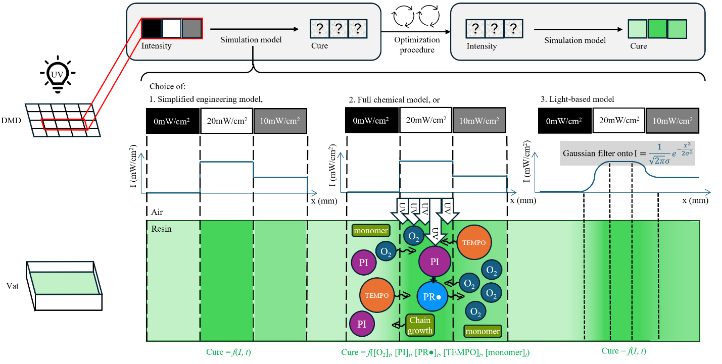
A complete, accurate simulation model of the light-to-cure response of the system is necessary for open-loop (i.e., feedback-less) control of the VPP print. This model shall describe the degree of cure over time for each voxel. Many researchers have attempted their own models, ranging in complexity, as described below and shown in Figure 1 below.
Figure 1: A simulation model can be a choice between simplified engineering model, full chemical model, or light-based model. The optimization procedure will then be built on top of the simulation model such that if a target cure is given, the optimization will calculate the ideal intensities that give the best results.

- A simplified engineering model was proposed by the seminal paper by Jacobs (1992) ¹ which argued that the amount of light can be characterized by dosage (a simple multiplication of time and light intensity), also known as dose or exposure. They also argued for an induction dosage or critical exposure, below which no curing will occur, above which curing occurs at increasing depths (i.e. in the direction of light propagation) as measured via video cameras or physical measurements ^{2,3} . Since its publication, others have cautioned against the reciprocity of intensity and time in the calculation of dosage for various reasons, preferring instead to edit the curve by adding an exponent to intensity (or time) ^{4–6} . This model can result in very imprecise constants ⁷ and does not deal with blurring in the final cure, but is fast and simple.
- Taki’s ^{8–10} , Bowman’s ¹¹ , and Qi’s ^{12,13} groups described the complete mechanism through initiation, propagation, and termination reactions, each with its rate constants, thus confirming oxygen as the primary cause of the induction time ^{14,15} . However, these full chemical models require various hard-to-find constants. The blur of the final print is explicitly modeled due to the diffusion of the chemical constituents; oxygen is the smallest diffusive molecule and hence is the primary driver of blur. These models are notably computationally expensive.
- Various other groups ^{16–19} recognize blurring as an issue, but ascribe it to camera and light (setup) issues. A side effect of their light-based models is their disregard of the potentially beneficial effects of oxygen as a scavenger.

We propose the use of a light-based model combined with a reduced chemical model utilizing AIE which allows us to monitor the degree of cure over time, pixel-by-pixel. We thus avoid the computational expense of the full chemical model. It should also be noted that most, but not all, existing models are applied in 2D over a single layer rather than in 3D over several layers, due to a. computational ease, and b. a temporal lag in the physical printing of different layers which requires the introduction of new constant(s) to accurately capture this phenomenon. In this proposal, we shall have to set up the 2D model first, before expanding the model into 3D, perhaps by investigating if several independent instances of 2D models give equivalent results as a full 3D model.
In the cases of 2D polymerization, we organized the process that most directly determines the curing map into two categories: inhibitive and facilitative factors.
Inhibitive effects were mainly expressed by inhibitor-radicals reaction and inhibitor diffusion evolving with time fast. Oxygen and TEMPO as inhibitor in our formulation will directly react with propagating and initiating radicals and thereby delay polymerization. Meanwhile, the diffusive behavior allows them to be transported through the resin and extend the suppression beyond the locations where they are initially present.
The facilitative phenomenon was considered in a much broad manner here, to be more specific it provides an effective description of spatial spread of light intensity and all associated promotion of local photochemistry, including light divergence, scattering, potentials of photon flux redistribution and in general all other factors that may lead to unwanted overcure beyond the nominally projected regions. One critical assumption we made is that the facilitative responses are highly local compared to inhibitive diffusion and will not change with time, instead it captures the dominant coupling of all promotional elements while avoiding computation cost of repeatedly recalculating the optical field as resin polymerizes.
B.2.2 Kinetics-informed grayscale inverse design – Open-loop Static Control Projection
Optimization models can be built based on the simulation model, which can produce one projected image per layer, which we call ‘static’. Existing literature can be classed into a few categories:
- Linear programming problems, which tend to be computationally expensive and require careful representation of the problem ^{6,16} .
- Neural networks, which might not be explicable, and require training on a lot of data partially derived from experiments and partially augmented artificially ^{20–22} .
- Bespoke models, which come with their own benefits and drawbacks. ²³ did so but generalized the blurring of one pixel sitting next to just one other, and is inapplicable to blurring over two or more pixels. ¹⁷ optimized images using an assumption that projected light is lower than expected, but does not assume that projected light can be higher than expected (such as a dark pixel adjacent to a bright pixel). ²⁴ used a bespoke circle-packing algorithm, but required sub-divisions of pixels which can be computationally expensive.
- Direct optimization, which was achieved with reasonable success ^{18,25} . No training is required.

We propose the use of direct optimization for the static optimization model, which we hypothesize is achievable given the advances in open-source machine learning frameworks and image processing software brought about by artificial intelligence, as well as the general increase in computational power available to consumer GPUs running such software. We hypothesize that only a few experimental runs are required to determine operational constants.
We utilized a kinetics-informed grayscale inverse design approach to calculate ideal grayscale value for each pixel and generate compensated mask from desired curing target. Our optimization approach begins with a target curing pattern and specified times at which that pattern should reach designed degree of cure (DoC). For each candidate grayscale mask, the chemical model predicts entire spatial change within target time. A pixel-level loss function evaluates the differences between target and prediction. Automatic differentiation back propagates the error through the simulation to determine how each projected pixel should change, and a gradient-momentum based optimizer, Adam, updates the mask for next iteration until final error converges. Thus, our model can output one specifically optimized mask for single pattern without ^{20,26,27}.
B.2.3 Optimization Model – Open-loop Dynamic Control Projection
There are much fewer optimization models allowing for an editable DMD projection (i.e., ‘dynamic’ videos), likely due to commercial VPP users preferring to have each layer printed as fast as possible. Some preliminary articles have reported the use of dynamic images which can allow higher accuracy ¹⁷, or even sub-pixel resolution [Cang 2025, SFF 2025, not yet published].
We propose the use of iterative learning control as a dynamic optimization model.
B.2.4 Closed-loop Control Projection
Simulation models are not necessary for closed-loop control of the VPP print, as the feedback system can work in tandem with the projection system to correct errors. There have been few articles exploring the topic, with ²⁸ using FTIR as a feedback mechanism, ²⁹ using an interferometric measurement of thickness as a feedback mechanism, and finally ³⁰ using temperature logged by thermocouples as an indirect feedback mechanism; the latter, being indirect, required a model to convert temperature to degree of cure. The relative lack of research is directly due to the lack of easily installed monitoring systems. Comparatively, commercially available metal powder bed fusion systems (e.g., SLM Solutions) already boast monitoring systems with automatic shut-off functions; one co-PI has had extensive experience in closed-loop control of metal powder bed fusion systems. We propose the use of AIE to act as the feedback mechanism when fluorescence can be captured via video camera as a proxy for cure.
B.3. 3D Demonstration
B.3.1 Expansion of all previous simulations and optimization algorithms into 3D
Asdf
B.3.2 Expansion of all previous simulations and optimization algorithms into 3D
Asdf

C. Prior NSF Research
The present proposal builds upon collaborative efforts between the PI’s research teams, in-part through a previously funded NSF-FMRG Grant (No. 2229036), titled “FMRG: Cyber: Manufacturing USA: Cyber-Enabled, High-Throughput Manufacturing of Multi-Material, 3D Nanostructures” (10/1/2022-9/30/2026). In this effort, our group’s laid a foundation for Xxx. The work was disseminated in Xxx papers and Xxx oral presentations, as well as Xxx filed patent applications. It financially supported X graduate students, X undergraduate students, and X postdocs.
C.1. Intellectual Merit. The PI’s research group’s have developed capabilities of relevance to the present proposal on synthesizing AIE formulations with varying inhibition levels, building a machine capable of single-layer AIE characterization, setting up a single-layer (“2D”) simulation, and setting up an optimization procedure on top of the single-layer simulation.
Synthesizing AIE formulations.
Building an AIE-capable machine.
Setting up a single-layer simulation: We first discretize a single layer into pixels, and describe the pixels’ oxygen levels, TEMPO (inhibitor) level (if used), and degree of cure as one variable (a numpy tensor rank 2, or matrix) each. This was done in Python. Before the simulation begins, the code imports a grayscale image and a projection intensity, which then calculates each pixel’s intensity. We blur the light at this point according to a Gaussian convolutional kernel, and assume that the light is invariant from this point on. As time progresses per time-step, the dosage can be calculated per pixel (chemically speaking, we equate generated radicals to dosage). A set of rules follow:
- Dosage is first used to decrease the oxygen level according to a linear slope.
- If dosage is left over after oxygen level decreases to zero, the leftover dosage is used to decrease TEMPO level according to another linear slope (if used).
- If dosage is left over after TEMPO reaches zero, the leftover dosage is used to increase degree of cure according to a simplified exponential curve (ref - see MSEC)
- Oxygen and TEMPO are each allowed to diffuse according to Fick’s Laws or a Gaussian convolutional kernel.
This is described in the left part of Figure 2 below.
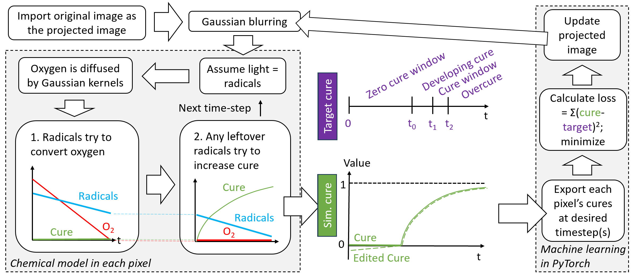Figure 2: Schematic of the single-layer simulation and optimization model.
We first note the choice of mechanism for molecular diffusion: either through Fick’s Laws, or a Gaussian convolutional kernel. Our first, naive choice was to use Fick’s Laws for diffusion, but this resulted in an upper bound to the time-step according to the Courant-Friedrichs-Lewy condition, which greatly increases computational runtime. The second choice is adapted from Swiss EPFL paper, which approximates diffusion but runs faster – we found this to give identical results (ref – ASPE-euspen paper).
We then note the requirement of six experimentally determined parameters:- light-blurring Gaussian standard deviation (sigma), dosage-to-oxygen linear slope, oxygen-diffusion Gaussian sigma, dosage-to-TEMPO linear slope (if used), TEMPO-diffusion Gaussian sigma (if used), and the dosage-to-cure exponential curve. We first disregard TEMPO by using a TEMPO-free formulation. We then effectively disregard oxygen diffusion and light blurring by projecting a large uniform circle onto the resin, and analyzing only the middle of the circle, where we assume oxygen diffusion and light blurring is too far away to give any effect. The fluorescence can be normalized to give degree of cure from 0 to 1. For any tested intensity, we can extract dosage-to-oxygen linear slope and dosage-to-cure exponential curves, which we have found to be quite repeatable. By conducting such tests over a range of intensities, we can fit these parameters to an equation, and as such we can interpolate the parameters for any given intensity.
We now analyze oxygen diffusion and light blurring by projecting an L-shape, which includes 1 internal and 5 external corners. Oxygen, being an inhibitor, will only affect the external corners, whereas light blurring will affect internal and external corners, and as such we can differentiate the relative importance of either parameter. We simulate multiple runs of L-shapes using different parameter values, and find that light blurring plays a much larger role in decreasing fidelity than oxygen diffusion, and can only be estimated by eye to an accuracy of about fifty microns in standard deviation, which does not vary at different intensity levels. The effects of oxygen diffusion are minor. We give an example of the poor experimental and simulated fidelity of a star shape in Figure 3a~d. We can do the same for TEMPO, given varying TEMPO formulations.
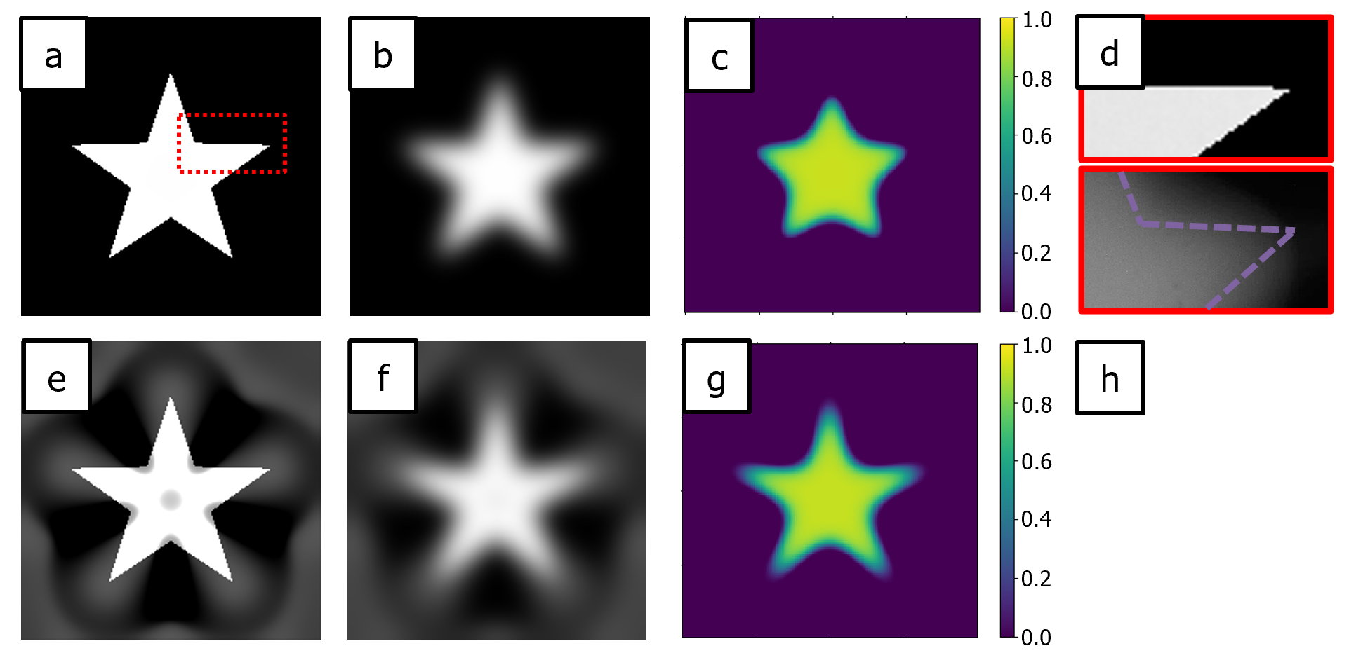Figure 3: a) a projected star shape, b) the light-blurred star shape, c) the simulated cure (color-mapped), d) a zoomed-in comparison of projected star shape and experimental cure. e~h) an optimized star shape.
Building an optimization model on top of the simulation. We achieved this by converting most Python variables to PyTorch variables, and designating projection intensity and grayscale pixels as parameters editable by the algorithm. As the optimization algorithm is gradient descent-based, we require a non-zero gradient in the entire cure function, which we achieve by editing the pre-induction-dosage cure to have a negative, monotonically increasing linear slope. As in Figure 2, we also judiciously select a cure window (t1~t2) in which the target shape should be fully cured, with an optional inclusion of a timestep in which no shape should cure (0~t0), and the degree of cure at these timesteps can be used for the loss calculation. PyTorch can automatically conduct optimizations based on the loss function, and the results for the star shape can be seen in Figure 3e~h.

C.2. Broader Impacts. Our prior work established accessible pathways to xxx
In addition to broader impacts on the research enterprise, we have xxx. Building on this momentum, we will xxx as detailed in Section F below.
D. Research Effort. Xxx. We will examine how a Sensing Platform (Aim 1), Inverse Design (Aim 2), and a 3D Demonstration (Aim 3) can balance feature fidelity and printing speed in an economical vat photopolymerization platform. All three Aims rely on complementary expertise in polymer science, additive manufacturing, modeling, and microfabrication by Cullinan and Page.
D.1. Universal Characterization Platforms Across Aims. To avoid repetition in subsequent sections we include here a comprehensive list of characterization techniques that the Cullinan and Page labs are equipped to employ for the proposed research efforts. Xxx.
D.2. Aim 1: Manufacturing Sensing Platform. We hypothesize that aggregate-induced emission dyes and processing conditions can be engineered to provide quantitative, spatially resolved operando readouts of resin viscosity and cure state during photopolymerization. This will be accomplished by (Aim 1.1) Xxx, (Aim 1.2) Yyy, and (Aim 1.3) Zzz.
Rationale for the Aim. Xxx.
Fundamental Science Questions. (1) Xxx? (2) Xxx? (3) Xxx? (4) Xxx? (5) Xxx?
Preliminary Results. Xxx
Aim 1.1. Xxx. Xxx
Aim 1.2. Yyy. Xxx
Aim 1.3. Zzz. Xxx
Potential Challenges and Mitigation Strategies. Xxx.
D.3. Aim 2: Inverse Design. We hypothesize that operando images can be used to train and validate an inverse design framework that maps observed cure dynamics to optimized grayscale projection patterns. To realize this framework, we will: (Aim 2.1) Build up a simulation; (Aim 2.2) Yyy; and (Aim 2.3) Zzz.
Rationale for the Aim. Xxx.
Fundamental Science Questions. (1) Xxx? (2) Xxx? (3) Xxx? (4) Xxx? (5) Xxx?
Preliminary Results. Xxx
Aim 2.1. Xxx. Xxx
Compare Swiss to ours also
Aim 2.2. Yyy. Xxx (Open Loop Control)
Aim 2.3. Zzz. Xxx (Closed Loop Control)
Potential Challenges and Mitigation Strategies. Xxx.
D.4. Aim 3: 3D Demonstration. We hypothesize that our inverse-design framework can be deployed in a real-time DLP 3D printing system to achieve uniform, high-fidelity curing across disparate feature sizes. To realize this capability, we will (Aim 3.1) Xxx, and (Aim 3.2) Yyy.
Rationale for the Aim. Xxx
Fundamental Science Questions. (1) Xxx? (2) Xxx? (3) Xxx? (4) Xxx? (5) Xxx?
Preliminary Results. Xxx
Aim 3.1. Xxx. Xxx
Aim 3.2. Yyy. Xxx
Potential Challenges and Mitigation Strategies. Xxx.
E. Intellectual Merit

F. Broader Impacts

References.

