SIMATS ENGINEERING
ASSESSMENT TOOL 3

COURSE NAME:Artificial Intelligence COURSE CODE: CSA1715

COURSE OUTCOME COVERED

CO1: Apply AI basics such as intelligent agents and uninformed search methods to solve problems effectively. ( BL3)

Assessment Tool Weightage: 20%

Annexure A
MCQs

Code of Conduct:
I V. Venkata Karthik Reddy (192472241) certify that this submission is my original work
and that I have adhered to the guidelines specified for this assessment.
I understand that any violation of academic integrity rules will result in disciplinary action.
Signature of the student: Karthik Reddy

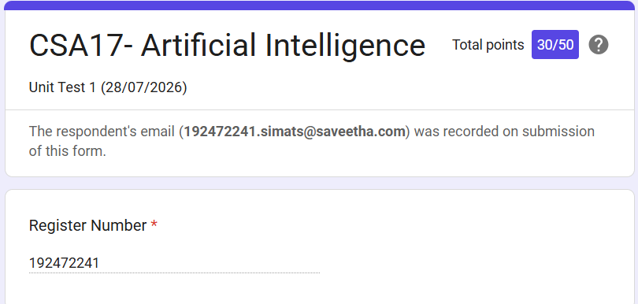

Criteria | Weightage | Level 4 (Exemplary) | Level 3 (Proficient) | Level 2 (Developing) | Level 1 (Beginning)
Problem Understanding | 20% | Clearly interprets problem, identifies all parameters and requirements accurately | Understands problem with minor gaps | Partial understanding; misses key elements | Misinterprets or unable to understand problem
Method Selection | 20% | Selects most appropriate method/formula with strong justification | Selects correct method with minor errors | Inappropriate or partially correct method | Unable to select method
Solution Process | 25% | Logical, systematic steps with correct approach throughout | Mostly correct steps with minor mistakes | Disorganized steps; multiple errors | No clear process
Accuracy of Calculation | 20% | All calculations accurate; correct final answer | Minor calculation errors | Frequent errors; incorrect final answer | No valid calculations
Interpretation of Results | 15% | Clearly interprets results with units and engineering relevance | Basic interpretation with minor omissions | Limited or unclear interpretation | No interpretation
Problem Understanding | 20% | Clearly interprets problem, identifies all parameters and requirements accurately | Understands problem with minor gaps | Partial understanding; misses key elements | Misinterprets or unable to understand problem
RUBRICS FOR CALCULATION:

