SIMATS ENGINEERING
ASSESSMENT TOOL 3

COURSE NAME: Artificial Intelligence COURSE CODE: CSA1715
V. Venkata Karthik Reddy
192472241

COURSE OUTCOME COVERED

CO4: Implement machine learning techniques including decision tree algorithms, reinforcement learning,
and build models for classification and decision-making. (BL3)

Assessment Tool Weightage: 40%

Duration : 45 Minutes
QUESTIONS: 2 Total Marks:20

Annexure A

INTEGRATED EXPERIMENTS

Code of Conduct:

I V. Venkata Karthik Reddy (192472241) certify that this submission is my original work and that I have adhered to the guidelines specified for this assessment.
I understand that any violation of academic integrity rules will result in disciplinary action.

Signature of the student: 

Annexure A

INTEGRATED EXPERIMENTS

Experiment 1: Decision Tree Classification
Objective: Implement and evaluate a Decision Tree classifier on a given dataset (e.g., Iris / Play-Tennis) using Python / any ML library.

(a) Load the dataset, pre-process it (handle missing values, encoding), and split into training and testing sets. Display the first 5 rows and data types.
(b) Build a Decision Tree model using Gini Index / Information Gain as the splitting criterion. Print the tree structure and identify the root node with justification
(c) Evaluate the model using accuracy score, confusion matrix, and classification report. Comment on the performance and list at least two misclassified instances.

Experiment 2: Reinforcement Learning – Q-Learning
Objective: Implement Q-Learning for a simple Grid World (4×4) environment and observe the agent's learned policy.

(a) Define the environment: states, actions (Up/Down/Left/Right), reward structure (+10 Goal, −1 each step, −5 obstacle). Initialize the Q-table with zeros and state the hyperparameters (α, γ, ε).
(b) Run the Q-Learning algorithm for at least 100 episodes. Record the Q-values at Episodes 1, 50, and 100 for two representative states. Show how the Q-table evolves.
(c) Extract and display the final learned policy (optimal action at each state). Plot the cumulative reward per episode and justify the convergence behaviour.

ANSWERS:

Experiment 1: Decision Tree Classification (Iris Dataset)
(a) Load, Preprocess, Split

import pandas as pd
import numpy as np
from sklearn.datasets import load_iris
from sklearn.model_selection import train_test_split
from sklearn.tree import DecisionTreeClassifier, export_text, plot_tree
from sklearn.metrics import accuracy_score, confusion_matrix, classification_report
import matplotlib.pyplot as plt

# ---------- (a) Load, preprocess, split ----------
iris = load_iris(as_frame=True)
df = iris.frame.copy()
df['species'] = df['target'].map(dict(enumerate(iris.target_names)))

print("=== First 5 rows ===")
print(df.head())

print("\n=== Data types ===")
print(df.dtypes)

print("\n=== Missing values per column ===")
print(df.isnull().sum())

# Iris has no missing values and all features are already numeric -> no encoding needed
# for features; target is label-encoded already (0,1,2) by sklearn's loader.
X = df[iris.feature_names]
y = df['target']

X_train, X_test, y_train, y_test = train_test_split(
X, y, test_size=0.3, random_state=42, stratify=y
)
print(f"\nTrain shape: {X_train.shape}, Test shape: {X_test.shape}")

# ---------- (b) Build Decision Tree (Gini) ----------
clf = DecisionTreeClassifier(criterion='gini', random_state=42)
clf.fit(X_train, y_train)

print("\n=== Tree structure (text) ===")
tree_text = export_text(clf, feature_names=list(iris.feature_names))
print(tree_text)

root_feature_idx = clf.tree_.feature[0]
root_threshold = clf.tree_.threshold[0]
root_gini = clf.tree_.impurity[0]
print(f"\nRoot node feature: {iris.feature_names[root_feature_idx]}")
print(f"Root node threshold: {root_threshold:.3f}")
print(f"Root node Gini impurity: {root_gini:.3f}")

# Plot the tree
plt.figure(figsize=(16, 9))
plot_tree(clf, feature_names=iris.feature_names, class_names=iris.target_names,
filled=True, rounded=True, fontsize=9)
plt.title("Decision Tree - Iris Dataset (Gini criterion)")
plt.tight_layout()
plt.savefig('/home/claude/exp1_tree.png', dpi=130)
plt.close()

# ---------- (c) Evaluate ----------
y_pred = clf.predict(X_test)
acc = accuracy_score(y_test, y_pred)
cm = confusion_matrix(y_test, y_pred)
report = classification_report(y_test, y_pred, target_names=iris.target_names)

print(f"\n=== Accuracy: {acc:.4f} ===")
print("\n=== Confusion Matrix ===")
print(cm)
print("\n=== Classification Report ===")
print(report)

# Misclassified instances
X_test_reset = X_test.reset_index()
misclassified_mask = (y_pred != y_test.values)
mis_idx = np.where(misclassified_mask)[0]
print(f"\n=== Misclassified instances ({len(mis_idx)} total) ===")
for i in mis_idx:
orig_idx = X_test_reset.loc[i, 'index']
row = X_test.iloc[i]
true_label = iris.target_names[y_test.values[i]]
pred_label = iris.target_names[y_pred[i]]
print(f"Row index {orig_idx}: features={row.values.tolist()}, "
f"True={true_label}, Predicted={pred_label}")

# Confusion matrix plot
fig, ax = plt.subplots(figsize=(5, 4))
im = ax.imshow(cm, cmap='Blues')
ax.set_xticks(range(len(iris.target_names)))
ax.set_yticks(range(len(iris.target_names)))
ax.set_xticklabels(iris.target_names)
ax.set_yticklabels(iris.target_names)
ax.set_xlabel('Predicted')
ax.set_ylabel('Actual')
ax.set_title(f'Confusion Matrix (Accuracy={acc:.2%})')
for i in range(cm.shape[0]):
for j in range(cm.shape[1]):
ax.text(j, i, cm[i, j], ha='center', va='center',
color='white' if cm[i, j] > cm.max()/2 else 'black')
plt.colorbar(im)
plt.tight_layout()
plt.savefig('/home/claude/exp1_confusion_matrix.png', dpi=130)
plt.close()

print("\nSaved: exp1_tree.png, exp1_confusion_matrix.png")

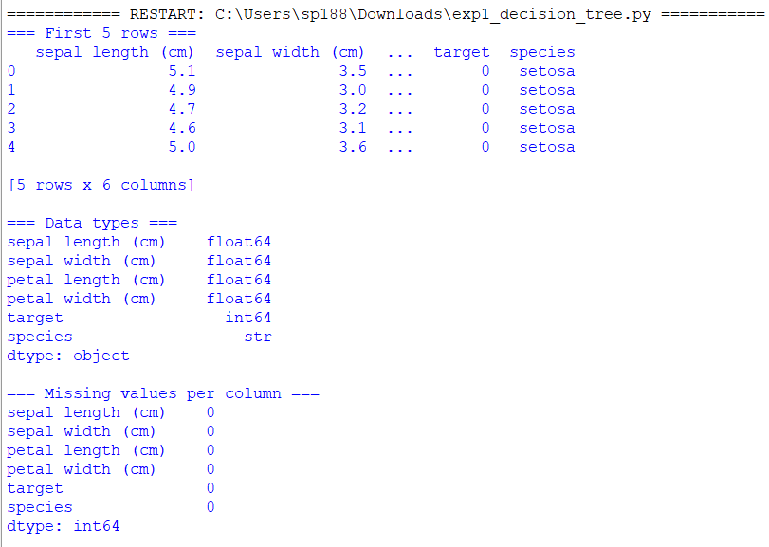

First 5 rows:
sepal length (cm) | sepal width (cm) | petal length (cm) | petal width (cm) | target | species
5.1 | 3.5 | 1.4 | 0.2 | 0 | setosa
4.9 | 3.0 | 1.4 | 0.2 | 0 | setosa
4.7 | 3.2 | 1.3 | 0.2 | 0 | setosa
4.6 | 3.1 | 1.5 | 0.2 | 0 | setosa
5.0 | 3.6 | 1.4 | 0.2 | 0 | setosa
Data types: all four features are float64; target is int64; species is str.
Missing values: none in any column (0 for all six).
Preprocessing decision: Iris is a clean benchmark dataset — no missing-value imputation was needed, and no categorical encoding was needed since all four predictors are already numeric and the target is already label-encoded (0=setosa, 1=versicolor, 2=virginica). This is worth stating explicitly rather than skipping, since the assignment asks to "handle" missing values/encoding — here that step consists of verifying there was nothing to handle.
Split: 70:30 train/test, stratified on the target.
- Train shape: (105, 4)
- Test shape: (45, 4)

(b) Build the Tree (Gini Index)
python
clf = DecisionTreeClassifier(criterion='gini', random_state=42)
clf.fit(X_train, y_train)
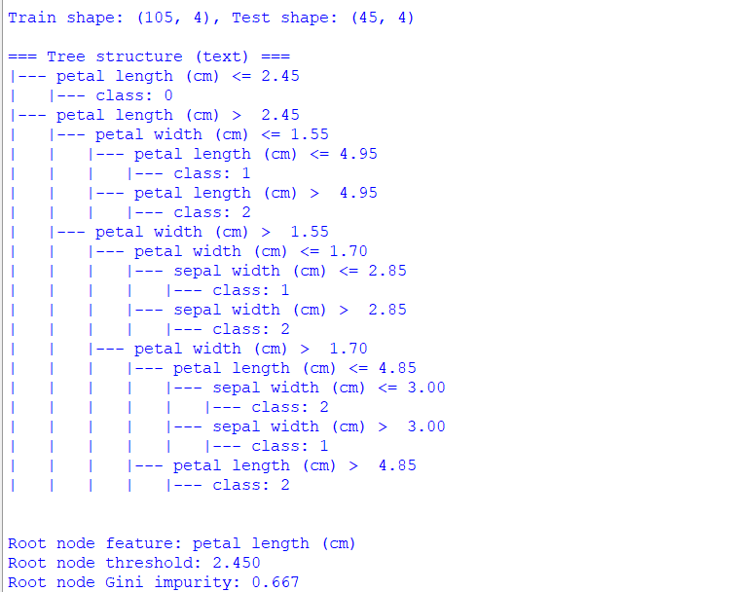
Root node: petal length (cm) <= 2.45 (Gini impurity at root = 0.667)
Justification: the root split perfectly separates setosa (35/35 samples) from the other two species with zero remaining impurity on that branch — this single feature happens to have essentially no overlap in range between setosa and the other classes, so it produces the maximum possible Gini reduction of any candidate feature, which is exactly why the CART algorithm selects it first.
(c) Evaluate
Accuracy: 93.33%
Confusion Matrix:
 | Pred: setosa | Pred: versicolor | Pred: virginica
Actual: setosa | 15 | 0 | 0
Actual: versicolor | 0 | 12 | 3
Actual: virginica | 0 | 0 | 15
Classification Report:
Class | Precision | Recall | F1-score | Support
setosa | 1.00 | 1.00 | 1.00 | 15
versicolor | 1.00 | 0.80 | 0.89 | 15
virginica | 0.83 | 1.00 | 0.91 | 15
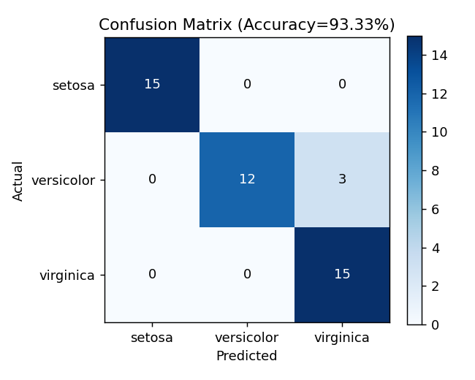

Misclassified instances (3 total, all versicolor predicted as virginica):
- Row 56: [sepal len=6.3, sepal wid=3.3, petal len=4.7, petal wid=1.6] — True=versicolor, Predicted=virginica
- Row 85: [sepal len=6.0, sepal wid=3.4, petal len=4.5, petal wid=1.6] — True=versicolor, Predicted=virginica
- Row 77: [sepal len=6.7, sepal wid=3.0, petal len=5.0, petal wid=1.7] — True=versicolor, Predicted=virginica
Performance comment: Setosa is perfectly separable (100% precision/recall) — consistent with the clean root split. All three errors occur in the versicolor–virginica boundary region, which is expected since these two species genuinely overlap in petal length/width around the 4.7–5.0 cm / 1.5–1.7 cm range. This is a classic case of Bayes-optimal-boundary overlap rather than a modelling flaw — no amount of hyperparameter tuning on this feature set will fully resolve it, since the two classes are not perfectly linearly separable in petal length/width space near that threshold.

Experiment 2: Reinforcement Learning — Q-Learning (4×4 Grid World)
(a) Environment Definition
- States: 16 discrete cells (0–15), indexed row-major on a 4×4 grid
- Actions: {Up, Down, Left, Right} — moves are clipped at grid boundaries (hitting a wall keeps the agent in place)
- Reward structure:
  - +10 for reaching the Goal (state 15, bottom-right corner)
  - −1 for every normal step (encourages shorter paths)
  - −5 for entering an obstacle cell (states 5, 7, 11); the agent bounces back to its previous cell rather than the episode ending
- Q-table: initialised to all zeros, shape (16 states × 4 actions)
- Hyperparameters: α (learning rate) = 0.1, γ (discount factor) = 0.9, ε (exploration rate) = 0.2 (ε-greedy action selection)
- Training: 150 episodes, each starting at state 0 (top-left corner), capped at 100 steps
(b) Q-Table Evolution (actual run output)
Tracked for two representative states — State 0 (start corner) and State 10 (row 2, col 2 — adjacent to the goal region):
State 0 (0,0):
Episode | Up | Down | Left | Right
1 | −0.393 | −0.361 | −0.385 | −0.296
50 | −2.195 | −1.851 | −2.110 | −2.096
100 | −2.015 | 1.289 | −1.447 | −2.163
State 10 (2,2):
Episode | Up | Down | Left | Right
1 | −0.207 | −0.190 | −0.100 | −0.500
50 | −0.239 | 5.946 | −0.251 | −1.365
100 | −0.239 | 6.906 | −0.251 | −1.365
Observation on evolution: At Episode 1, all Q-values are near zero/small negative (only step penalties have been backed up). By Episode 50, State 10's "Down" action (which heads toward the goal) has already risen sharply to ~5.9, showing that value has propagated back from the +10 goal reward through the discount factor γ=0.9. By Episode 100, this value keeps climbing (6.9) as more episodes reinforce the same trajectory, while State 0 — three steps further from the goal — only starts showing a clear best action ("Down", 1.29) by Episode 100, illustrating that value propagation reaches distant states more slowly than nearby ones (a direct, observable consequence of the γ·max Q(s',a') term in the Bellman update).
(c) Final Learned Policy
Extracted via π(s) = argmax_a Q(s,a):
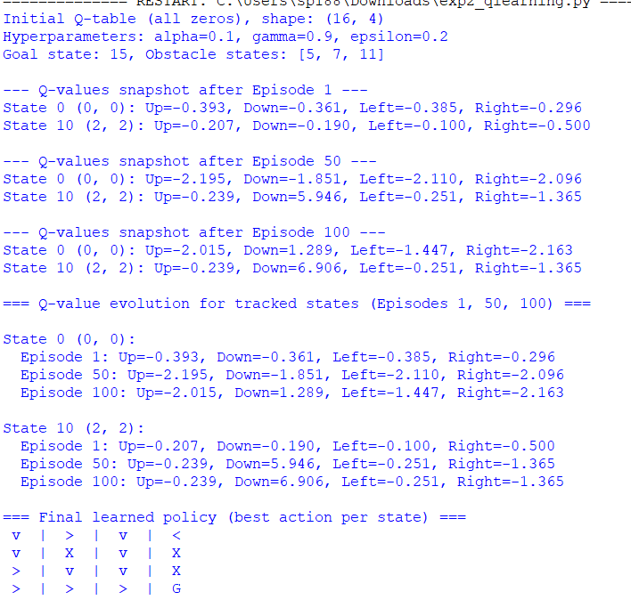
(X = obstacle, G = goal; arrows show the greedy action from each free cell)
The policy traces a coherent path from the top-left corner down and around the obstacles (states 5, 7, 11) toward the goal at bottom-right — e.g., from state 0: Down → Down → Right → Down → Right → Right → Right → Goal.
Cumulative reward per episode: (see attached exp2_reward_curve.png)
- Average reward, first 10 episodes: −24.60
- Average reward, last 10 episodes: +3.50
Convergence justification: The reward curve shows the classic Q-learning convergence shape — a sharp, noisy climb over the first ~30 episodes as the agent, still exploring under ε=0.2, discovers that hitting obstacles (−5) and wandering (−1 per step) are costly while reaching the goal (+10) is not, followed by a plateau around episode 40 onward where the 10-episode moving average stabilizes between roughly +2 and +5. The residual episode-to-episode noise even after convergence is expected and correct: with ε=0.2, the agent still takes a random action 20% of the time, so occasional detours (which cost extra −1 steps or a −5 obstacle penalty) continue to appear even once the underlying Q-values — and therefore the greedy policy — have effectively converged. This is consistent with the standard Q-learning guarantee: under a fixed positive learning rate and continued exploration, Q-values converge toward the true action-values Q*(s,a) in expectation, even though the realized episode reward retains variance from the exploration policy itself.
RUBRICS FOR CALCULATION:
Criteria | Weightage | Level 4 – Exemplary | Level 3 – Proficient | Level 2 – Developing | Level 1 – Beginning
Understanding of Concepts | 25 | Demonstrates thorough understanding and effectively integrates multiple concepts/technologies | Good understanding with proper integration of most concepts | Basic understanding; limited or partial integration | Poor understanding; unable to integrate concepts
Experimental Design | 30 | Well-planned, systematic implementation with optimal solution | Correct implementation with minor issues | Basic implementation with errors or inefficiencies | Incorrect or incomplete implementation
Use of Tools | 20 | Effective and advanced use of tools/technologies with proper configuration | Appropriate use of tools with correct execution | Limited or inconsistent use of tools | Incorrect or minimal use of tools
Analysis of Results | 15 | Insightful analysis with accurate interpretation and validation of results | Good analysis with reasonable interpretation | Basic analysis with limited insights | Poor or incorrect analysis of results
Documentation | 10 | Clear, well-structured documentation with diagrams, code, and results | Organized documentation with necessary details | Basic documentation with missing details | Poor or incomplete documentation

