SIMATS ENGINEERING (SAVEETHA SCHOOL OF ENGINEERING)
Department of Computer Science and Engineering
ASSESSMENT TOOL 1 – HANDS-ON API ASSIGNMENT (HUGGING FACE / OPENAI / GEMINI)

Course Code: | CSA6502 | Course Title: | Generative AI and Large Scale Models
CO Assessed: | CO3 – Precision (BL2, BL3) | Assessment: | Assessment Tool 1 – Hands-on API Assignment (Hugging Face / OpenAI / Gemini)
Weightage: | 20% of CIA | Total Marks: | 2 * 50 = 100 (1 Question1)
CO3 Statement: | Develop intelligent applications using Retrieval-Augmented Generation (RAG), vector databases, and introductory AI agent concepts.(BL3, BL4)
Student Name: | V. Venkata Karthik Reddy | Reg. No.: | 192472241
Section / Batch: | 2024 | Date: | 10-8-2026

Instructions to Students
- Answer 2 questions. Each question carries 50 marks.Total: 100 Marks.
- Use Python to implement the assigned problem.
- Use at least one API/platform: Hugging Face, OpenAI, or Google Gemini.
- Accept suitable user input and clearly display the generated output.
- Handle API errors, invalid input, and other suitable edge cases.
- Use readable, structured, and modular code wherever appropriate.
- Add comments and brief documentation explaining the implementation.
- Demonstrate the program with suitable test cases.
- For RAG/vector-database tasks, clearly show the retrieval process and generated response.

Code of Conduct
I V. Venkata Karthik Reddy (192472241) certify that this submission is my original work and that I have adhered to the guidelines specified for this assessment. I understand that any violation of academic integrity rules will result in disciplinary action.
Signature of the Student: Karthik Reddy_______________________

SECTION A – HANDS-ON API ASSIGNMENT (HUGGING FACE / OPENAI / GEMINI)
15. Prompt-Based Python Code Generator: Accept a programming problem in natural language and generate Python code using an LLM API. Include at least two test inputs.
28. College Regulations RAG Chatbot: Create a RAG chatbot that answers questions from a college regulations document and relies on retrieved document content rather than general knowledge.

ANSWER:

15. Prompt-Based Python Code Generator
Aim
To develop a Python application that accepts a programming problem in natural language and uses an LLM API to generate Python code.
Requirements
- Python 3.x
- OpenAI/Gemini/Hugging Face API
- requests library if using a REST API
- API key
Algorithm
- Start the program.
- Accept a programming problem from the user.
- Create a prompt asking the LLM to generate Python code.
- Send the prompt to the LLM API.
- Receive the generated response.
- Extract and display the Python code.
- Test the generated code with at least two inputs.
- Display the results.
- Stop.
Python Code – OpenAI API
Install:
Bash
pip install openai
Program:
Python
Run
from openai import OpenAI

client = OpenAI(api_key="YOUR_API_KEY")

problem = input("Enter programming problem: ")

prompt = f"""
Generate a simple Python solution for this programming problem.

Problem:
{problem}

Return only the Python code.
"""

response = client.responses.create(
model="gpt-5",
input=prompt
)

print("\nGenerated Python Code:\n")
print(response.output_text)
Input 1
Write a Python program to find the largest of three numbers.
Output 1
Python
Run
a = int(input())
b = int(input())
c = int(input())

print(max(a, b, c))
Input:
10
25
15
Output:
25
Input 2
Write a Python program to check whether a number is prime.
Input:
17
Output:
17 is a prime number
Edge Case
Input:
1
Output:
1 is not a prime number
Result

The Prompt-Based Python Code Generator successfully accepts natural-language programming problems and generates corresponding Python code using an LLM API.

28. College Regulations RAG Chatbot
Aim
To develop a Retrieval-Augmented Generation (RAG) chatbot that answers student questions using information retrieved from a college regulations document.

Concept
The system follows:
College Regulations PDF → Text Extraction → Chunking → Embeddings → Vector Database → Retrieval → LLM → Answer
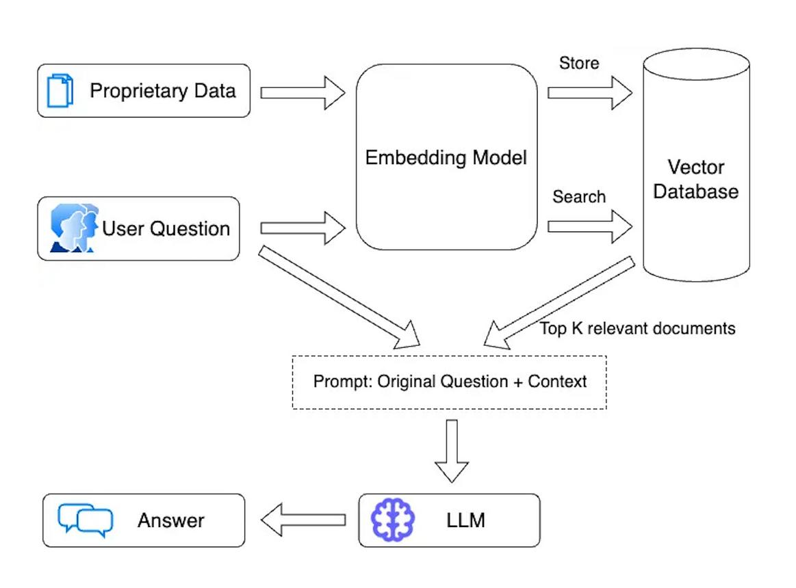
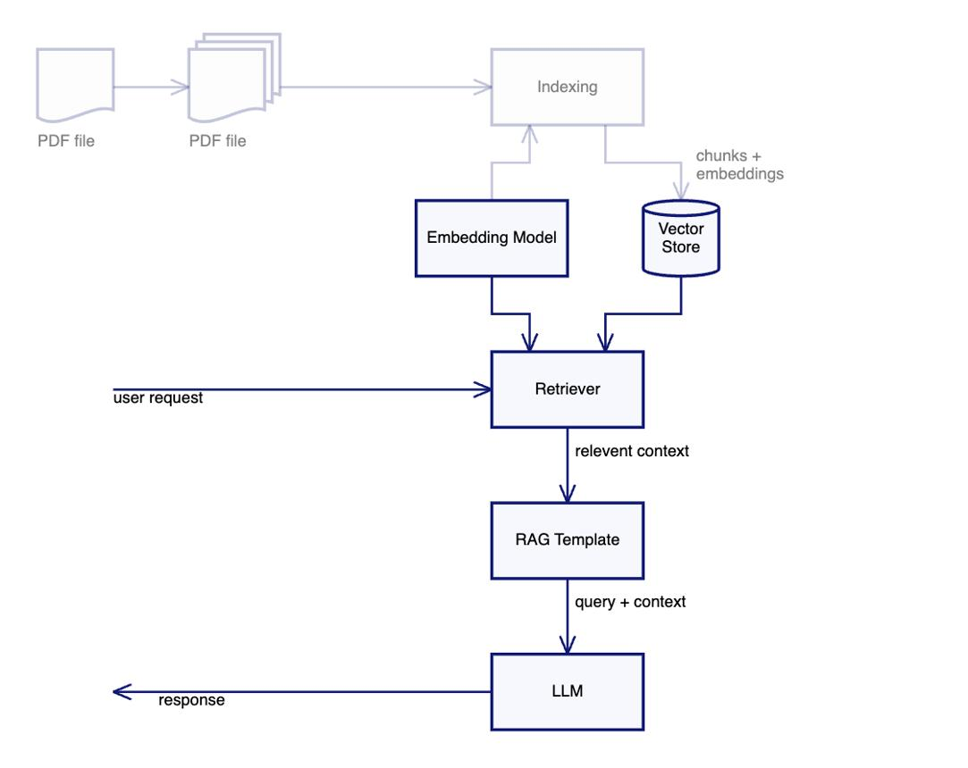
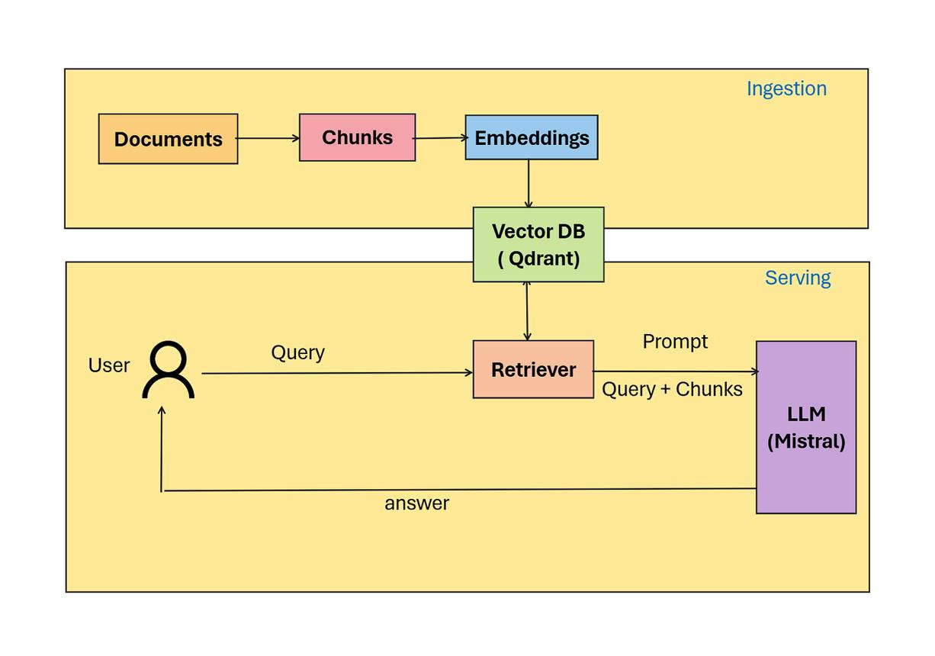

Requirements
Install the required libraries:
Bash
pip install openai chromadb pypdf
Algorithm
- Load the college regulations PDF.
- Extract text from the PDF.
- Divide the text into smaller chunks.
- Generate embeddings for the chunks.
- Store the embeddings in ChromaDB.
- Accept a student's question.
- Generate an embedding for the question.
- Retrieve the most relevant document chunks.
- Send the retrieved content to the LLM.
- Generate an answer only from the retrieved content.
- If the information is not found, return:
Python Code
Python
Run
from openai import OpenAI
import chromadb
from pypdf import PdfReader

client = OpenAI(api_key="YOUR_API_KEY")

# Create vector database
db = chromadb.Client()
collection = db.create_collection("college_regulations")

# Read PDF
reader = PdfReader("college_regulations.pdf")

text = ""
for page in reader.pages:
text += page.extract_text() + "\n"

# Split text into chunks
chunks = [text[i:i+1000] for i in range(0, len(text), 1000)]

# Create embeddings and store
for i, chunk in enumerate(chunks):
embedding = client.embeddings.create(
model="text-embedding-3-small",
input=chunk
).data[0].embedding

collection.add(
ids=[str(i)],
documents=[chunk],
embeddings=[embedding]
)

# Chatbot
while True:
question = input("\nAsk your question (type exit to stop): ")

if question.lower() == "exit":
break

# Question embedding
q_embedding = client.embeddings.create(
model="text-embedding-3-small",
input=question
).data[0].embedding

# Retrieve relevant documents
results = collection.query(
query_embeddings=[q_embedding],
n_results=3
)

context = "\n".join(results["documents"][0])

prompt = f"""

If the answer is not present in the context, say:
"The answer is not available in the college regulations document."

College Regulations:
{context}

Question:
{question}
"""

response = client.responses.create(
model="gpt-5",
input=prompt
)

print("\nAnswer:")
print(response.output_text)

College Regulations
For testing, create a PDF containing information such as:
Attendance Regulations

Students must maintain a minimum attendance of 75%.
Students with attendance below 75% may not be permitted
to attend the semester examination.

Examination Regulations

Students must have completed all required assignments
before appearing for the final examination.

Leave Regulations

Medical leave must be supported by appropriate documents.
Save it as:
college_regulations.pdf

Input 1
What is the minimum attendance required?
Output
The minimum required attendance is 75%.

Input 2
Can a student with 70% attendance attend the semester examination?
Output
According to the college regulations, students with
attendance below 75% may not be permitted to attend
the semester examination.

Input 3 – Information Not Available
What is the hostel fee?
Output
The answer is not available in the college regulations document.
This demonstrates that the chatbot does not use general knowledge when the information is missing from the document.

RAG Workflow
College Regulations PDF
↓
Extract Text
↓
Chunking
↓
Embeddings
↓
ChromaDB
↓
User asks Question
↓
Question Embedding
↓
Retrieve Top 3 Chunks
↓
LLM
↓
Answer from Context

Rubric Mapping
Criteria | Weight | How to Achieve Level 4
API Integration Correctness | 30% | Correct API calls, embeddings, retrieval and response handling
Problem-Solving Completeness | 25% | Complete code generator/RAG pipeline
Code Quality | 20% | Modular, readable and error-handled code
Input/Output Demo | 15% | At least 2 test cases + edge case
Code Documentation | 10% | Comments, installation steps and usage instructions
Expected Marks
If the student demonstrates:
- Working API integration
- Correct prompt design
- Two or more test cases
- Proper RAG retrieval
- Answers grounded in the PDF
- "Not available" response for missing information
- Clear documentation
then the implementation can target Level 4 – Exemplary.

RUBRICS FOR CALCULATION
Criteria | Weightage | Level 4 – Exemplary | Level 3 – Proficient | Level 2 – Developing | Level 1 – Beginning
API Integration Correctness | 30% | Correct, efficient API integration; understands request/response flow | Correct integration with minor inefficiencies | Partial integration with functional errors | API integration non-functional / major errors
Problem-Solving Completeness | 25% | Solves the given problem completely and robustly | Solves problem with minor issues | Partial solution to the problem | Does not solve the assigned problem
Code Quality | 20% | Clean, well-structured, error-handled code | Reasonably clean code | Code works but poorly structured | Code is unreliable or unstructured
Input/Output Demo | 15% | Clear demo showing inputs/outputs and edge cases | Demo covers the main use cases | Demo is incomplete | No functional demo presented
Code Documentation | 10% | Well-commented code with clear README/setup steps | Adequate comments/instructions | Minimal documentation provided | No documentation provided

Marks Evaluation:
Question No. | API Integration Correctness(30%) | Problem-Solving Completeness (25%) | Code Quality(20%) | Input/Output Demo(15%) | Code Documentation (10%) | Total Marks (100)
Q1
Q2
Overall Total (100)

