Results
I. Ranking coefficients
From the executed code to rank the coefficients: the features with the greatest predictive coefficients were Rolling standard deviation, yang zhang volatility estimator, five and ten moving averages of log returns, and 5 day rolling standard deviation of log returns.

Feature | Coefficient | Absolute coefficient
std_10 | 0.818186 | 0.818186
rolling_std | -0.814477 | 0.814477
std_5 | -0.814477 | 0.814477
volatility_5 | -0.814477 | 0.814477
yang_zhang | 0.788453 | 0.788453
ma_10 | 0.293861 | 0.293861
log_return | 0.196096 | 0.196096
momentum_5 | 0.182764 | 0.182764
garman_klass | 0.171577 | 0.171577
parkinson_vol | -0.152569 | 0.152569
volume_lag1 | 0.150323 | 0.150323
ma_5 | -0.106306 | 0.106306
rolling_mean | -0.106306 | 0.106306
rogers_satchell | -0.068182 | 0.068182
volume_change | 0.053894 | 0.053894
return_lag1 | 0.039189 | 0.039189

Figure 14. Ranking of feature coefficients
Yang Zhang volatility estimator being one of the highest contributors is in line with expectations as its key feature is addressing the shortcoming of the Parkinson, Garman-Klass, and Roger-Satchell estimator of not having overnight volatility as part of its computation
volatility_5, rolling_std, and std_5 are the most important features, suggesting that short-term volatility is most critical for predicting future volatility.
Features like log_return and return_lag1 have smaller coefficients, indicating they have less influence on the model's predictions.
II. Best parameters for the seven primary models
From the executed code to choose the best parameter for each model is as follows:
Model | Best parameter
Decision Tree | {'max_depth': 3}
Random Forest | {'n_estimators': 200}
Logistic Regression | {'C': 1}
KNN | {'n_neighbors': 10}
SVM | {'C': 1, 'gamma': 0.01}
XGBoost | {'learning_rate': 0.1, 'max_depth': 3, 'n_estimators': 50}
LightGBM | {'learning_rate': 0.01, 'n_estimators': 500, 'num_leaves': 31}

Figure 15. Best parameters per model
The selected parameters from the grid search suggests that the default setting for models performed best on the given dataset. For the Decision Tree, a shallow depth of 3 was best, indicating that a small number of splits was sufficient and deeper trees likely led to overfitting. The Random Forest performed best with the highest number of estimators tested (200), more trees typically reduce overfitting. Logistic Regression model performed best with default regularization (C=1). The K-Nearest Neighbors chose 10 neighbors, showing that mores neighbors helped reduce sensitivity to noise. For the Support Vector Machine, the default regularization parameter (C=1) combined with a low gamma (0.01) resulted in a smoother decision boundary. The dataset is likely reasonably linear or have simple non-linear separation. XGBoost performed best with a small tree depth (3), a moderate learning rate (0.1), and fewer boosting rounds (50). LightGBM selected a very slow learning rate (0.01), more boosting rounds (500), and a smaller number of leaves (31), meaning that incremental learning with simple structures generalized better. Overall, the results point to a dataset with enough data to classify well.
III. ROC AUC results
Below is the resultant of the ROC AUC plot.
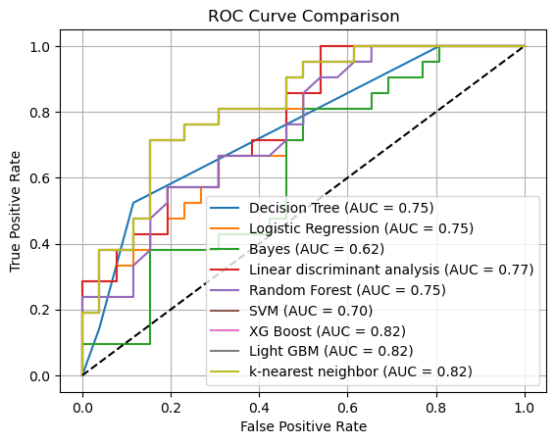
Figure 16. ROC AUC plot
The AUC scores reflect the models ability to distinguish between classes, with 1.0 being perfect and 0.5 being no better than random guessing. From the plot we can infer that:
The best performing models are KNN (AUC: 0.822), XGBoost (0.82), and LightGBM (0.82). These scores indicate suggest these models are capturing important patterns in the data.
Next up is LDA (0.769), logistic regression (0.755) and the decision tree (0.748). They also performed reasonably well, indicating that simpler models can classify well.
Random Forest (0.746) is the worst performer of the tree based models which is surprising as it is typically robust and meant to outperform the likes of Decision Tree. Support Vector Machine (0.70) shows moderate performance. Lastly, Naive Bayes (0.625) lags significantly behind, which is expected as it is the simplest of all the models, if a model weren’t able to trump the Bayes score it suggest an extremely poorly tuned model.
Overall, KNN and the boosting models performed the classification the best.
IV. Classification score summaries
To then choose from three models, it is best to consider their scores to find which performed the best. The scores of the eliminated models will not be discussed in this section but are available in the appendices below [15]. The scoring metric used for the cross validation score is balanced accuracy. Balanced accuracy is used for imbalanced datasets to account for class distributions[14].

Model | Accuracy | Macro precision | Macro recall
KNN | 0.55 | 0.28 | 0.50
LightGBM | 0.70 | 0.70 | 0.70
XGBoost | 0.74 | 0.74 | 0.74
Figure 17. Summary table of scores

Model | Mean balanced accuracy | Standard deviation | Cross validation scores
KNN | 0.6505 | 0.0246 | 0.618421052631579, 0.6710526315789473, 0.6228070175438596, 0.672514619883041, 0.6681286549707602
LightGBM | 0.6768 | 0.0536 | 0.6198830409356726, 0.7529239766081872, 0.72953216374269, 0.6432748538011696, 0.6388888888888888
XGBoost | 0.7123 | 0.1033 | 0.5423976608187134, 0.7529239766081872, 0.7032163742690059, 0.7002923976608187, 0.8625730994152047
Figure 18. Cross validation scores

KNN significantly underperformed, especially with a poor accuracy score, despite its decent AUC score. In addition, though it has a low standard deviation across cross validation scores, it consistently underperformed across each of its folds.
LightGBM provided a stronger balances between precision and recall, indicating better generalization and more reliable classification for both classes. LightGBM has a slightly better mean balanced accuracy than KNN and is stable making it a safer model choice.
XGBoost performed the best overall, with the highest precision, recall, and accuracy. It effectively handles class differences better and appears the leading model to use to perform the classification. XGBoost has the highest mean balanced accuracy, indicating it correctly identifies both classes. Though it has a higher standard deviation, it churned out better accuracy. The cross validation results showed a mean balanced accuracy of 0.71, with some variability across folds, suggesting that while performance can fluctuate slightly depending on the data split, the model remains generally strong.

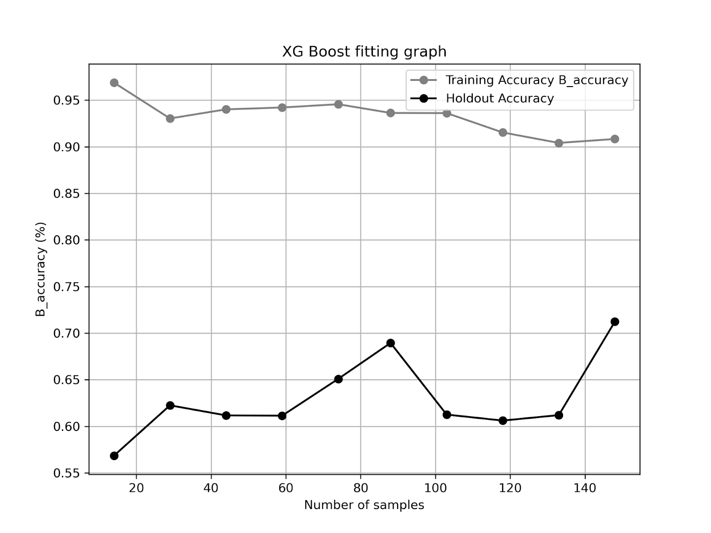
Figure 19. XGBoost Fitting graph

The fitting graph reinforces this conclusion: although there is a clear gap between the high training accuracy and the lower holdout accuracy there’s an upward trend in holdout performance as sample size increases. This suggests the model's generalization improves with more data. Overall, the test outcomes confirms that XGBoost is a solid and dependable choice for forecasting volatility.
V. Using model on new data to make a prediction

Once XGBoost was solidified as the model of choice it was then tested on the data from January through April 2025 to see how well it can predict volatility, and the results are as following.
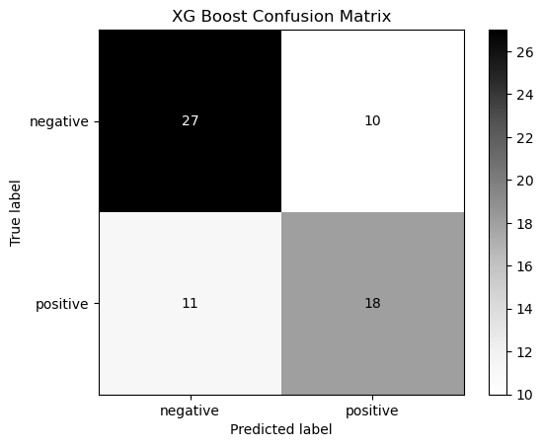
Figure 20. XG Confusion matrix
The confusion matrix shows that the model performs well in separating between volatility down and volatility up. Out of 66 total predictions, it correctly classified 27 instances of volatility down and 18 instances of volatility up. There were 10 cases where volatility down was misclassified as up and 11 where volatility up was incorrectly predicted as down.
 | precision | recall | f1-score
Volatility down | 0.71 | 0.73 | 0.72
Volatility up | 0.64 | 0.62 | 0.63

Accuracy | 0.68
Precision | 0.68
Recall | 0.68
Figure 21. XG classification report
The model demonstrates slightly better precision and recall when predicting volatility down compared to volatility up. However, the number of misclassifications is fairly even between both classes. On the January to April 2025 new data, it achieved an average accuracy, precision, and recall of 0.68, demonstrating some reliability in generalization.
In summary, the confusion matrix and classification report reflect a balanced and generally reliable performance in predicting volatility shifts.

