
Coursework Report
Group 7


Concept and Design
The concept is based off of a Disney animated movie called Treasure Planet. The ship was used as reference for our own sci-fi looking pirate ship that flies in space. The ship has two floors. There will be crew members operating the upper deck as well as crew members on the lower deck. They will be operating the ship while it sails. The project uses Legos to render the ship and the crew of the ship.
There will be five cameras showing the ship and its crew from multiple different angles. These will allow the user to have a more interactive experience while exploring the ship and its surroundings. The main camera is a free roam camera allocated mainly to the ship and the other four cameras are allocated to the planets. The user can use the cameras to move around the assets in the project.
The layout and interactivity will be as simple as can be in order not to overwhelm the user. Clear instructions, descriptions and elements such as sounds, text and colours will be provided to help make the interface user friendly.

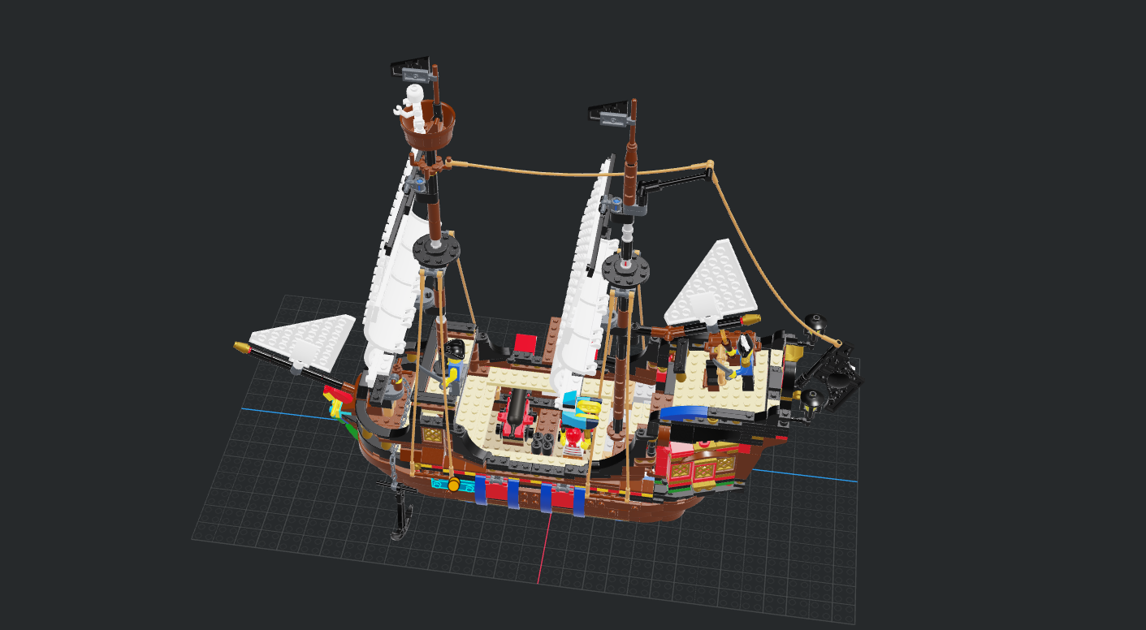
This is the prototype for the ship.

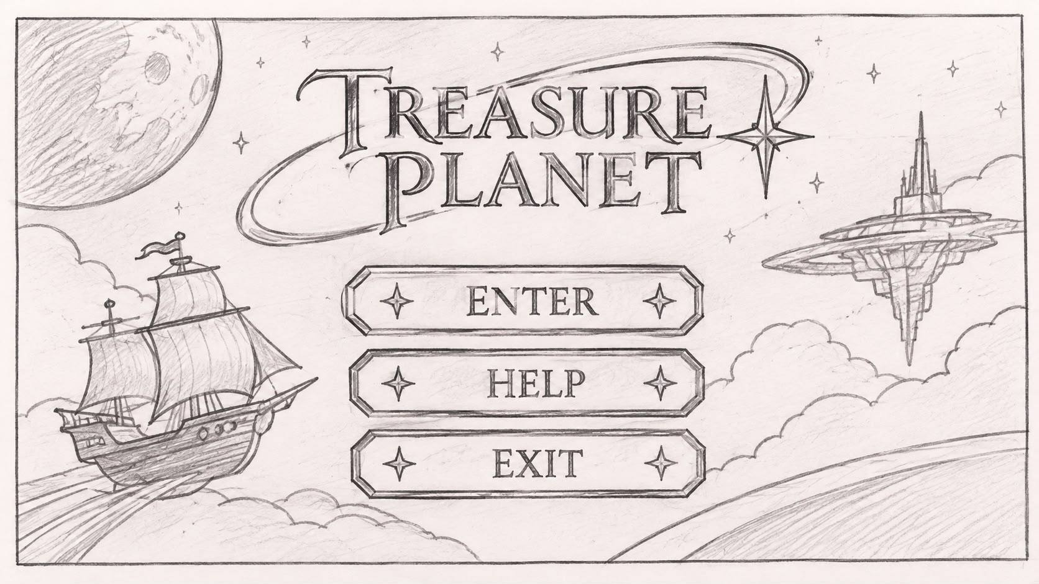
The design used for the main menu.
Project Methodology
The methodology chosen is the Waterfall Methodology because it is a very straight forward and simple process. It makes it easy as one process takes place after another.

Navigation Framework
Navigation uses the mouse and keyboard. Buttons will be implemented in the main menu to aid the user. These will allow the user to access different camera angles around the ship and planets. The user is able to switch between cameras and zoom in and out at places where the feature is available. The main camera allows the user to orbit the ship and zoom in and out.
The keyboard controls allow the user to switch between cameras as well as control elements on the main menu such as; “Esc to exit or go back” and “Enter to select”. The keyboard controls mainly work for the main camera and mimic the way the mouse works with orbiting and zooming.

Animations
There will be animations applied to each crew member as they move around the ship. The ship will have moving parts that will be animated to show it moving in space. The background will include planets which will be rotating in place. The crew on the steering wheel will be animated to occasionally turn the wheel to simulate the steering of the ship.

Lighting, Shaders and Textures
One of the goals is to make the interface user friendly. This means the colours, textures and lighting play a big part in this. As a result, specific assets were chosen and rendered to achieve the goal. A palette of colours was chosen to better suit the setting and atmosphere of the project. This makes the project more visually appealing and readable of the user.

UI Efficiency
The main concept of the UI is to be as user-friendly as possible. This is implemented with the use of the waterfall methodology. The user is first shown the main menu where they have the option to exit or enter the ship to explore. The process follows a system of one option leads to another making it easy for the user to follow along.

Group meetings

Meeting | Date | Tasks | Results
1 | 22/09/2026 | Assigning tasks | The tasks to be done were chosen by each member
2 | 6/10/2026 | Setting up a shared GitHub account | All members came together to brainstorm details for the shared GitHub account details and it was created
3 | 20/10/2026 | Preparing the video for the submission on 29/10/2026 | The process of the progress video recording was discussed
4 | 10/11/2026 | Getting started on reviewing Group 3’s project and finalisation of the group project | The peer review was done. The main project was finished and the final video was recorded to be submitted.

