Individual Report
Caleb Kokoti – w2092329

Main Idea
In this project we are to make an interactive interface in Unity. I took up the leadership role to delegate tasks to group members. The roles were decided on our first group meeting. I took the initiative to start researching on what the project is going to be about, what assets to be used and how it meant to be done. I suggested that we use assets form Meca Bricks as it makes it easier to edit, design and import assets.

Shared Accounts
I started to create the accounts we would be needed namely; a shared google account, a shared GitHub account, a shared unity account and a shared unity account for the group. I also created a WhatsApp group to keep the team in contact. I made all login details such as usernames and passwords available to the team so they can access any account at anytime they are available to work on the project.
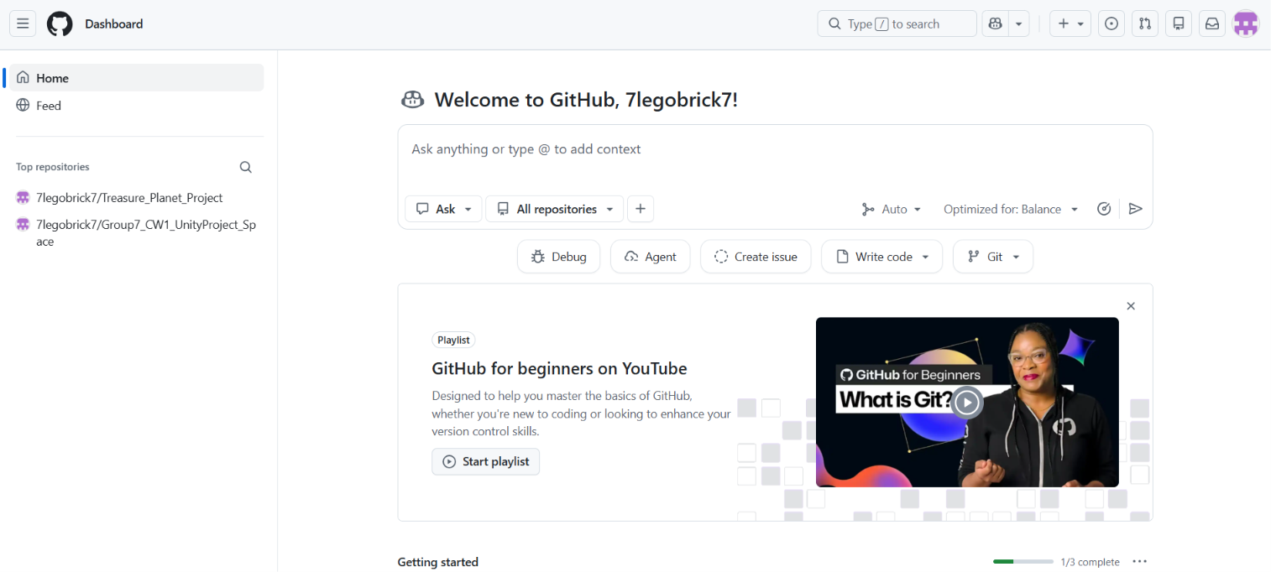
A picture of the shared GitHub account

Initial Concept
I also came up with the idea to use the movie Treasure Planet as reference to make a 3d model of a pirate ship in space. I then searched for the initial assets such as characters and ship models to be decided on by the team to use for the project. After finding the initial assets for the team, I called a meeting and we decided which on was to be used and how to use them. After helping I helped the person in charge of the assets and designs navigate and use the Meca bricks workshop to edit, import and export assets.

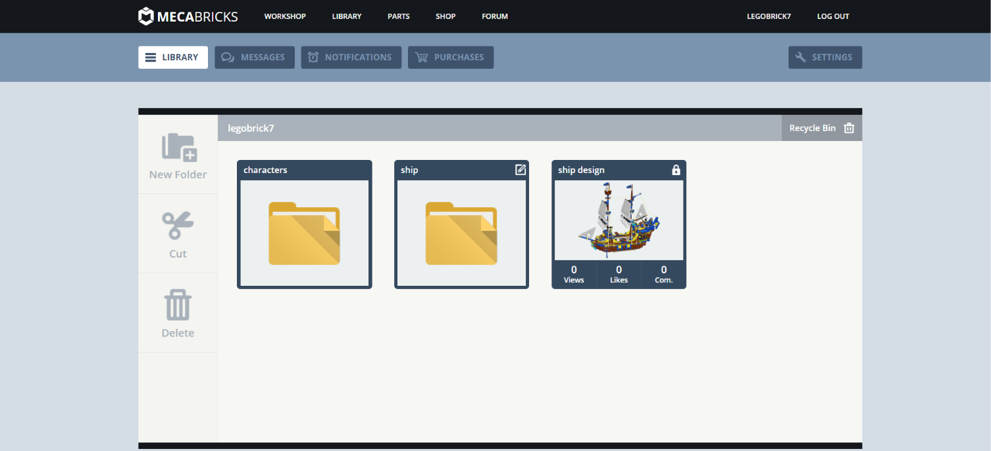
Initial assets and models that I provided before deciding on what to use.

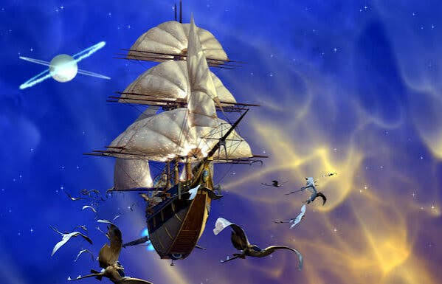
The original reference of the movie for the ship and background.

I was in charge of the group report. I made a draft and showed it to the team to help them know more about how the project is supposed to work and give more information about other intricacies of the project. I also created the folders and files needed with the right naming conventions in the GitHub account to help the team know the structure of how the files are supposed to be organised.
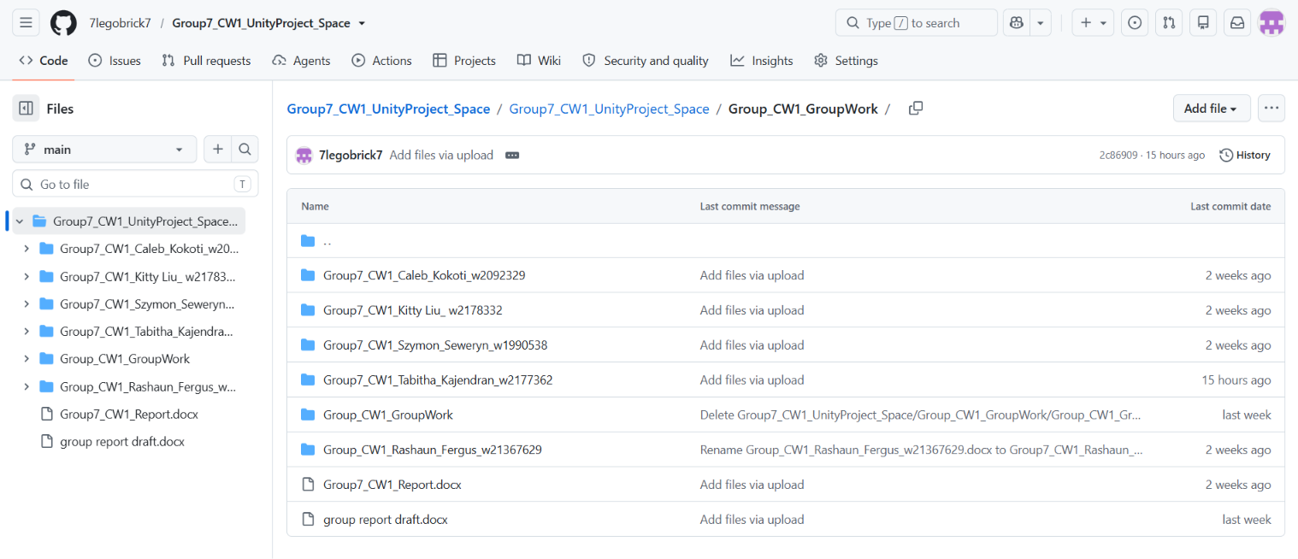
The GitHub account with all the files and folders of the project.

Animated Minifigure
The first task I had to complete was creating the Lego Figure in mechabricks, to then be added to the overall project model. The Lego figure I had created is a Pirate which is on the ship at the cannons, the animation for said Figure is them hitting the cannon in fury with their hand and foot, as you can see in the screenshots below.
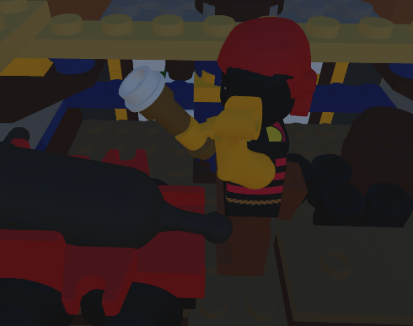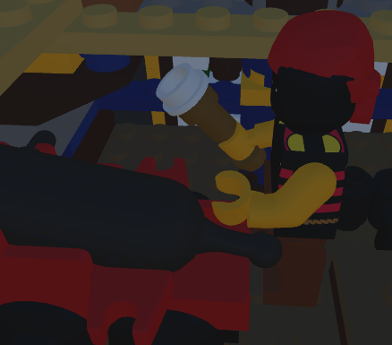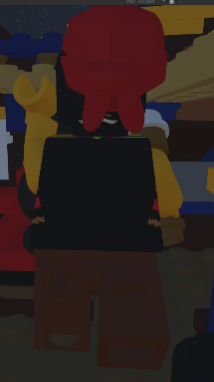
As you can see in the screenshots above, the arm raises up and smacks the cannon and the leg kicks it from below, this is all for the animation of this Lego figure.

