Individual Report
Below shows all of the following work I’ve contributed to this Coursework.
CREATE AND WRITE DOWN FINAL VIDEO
Unity Build – Scene Creation, Scripts, Assets
Scene Creation
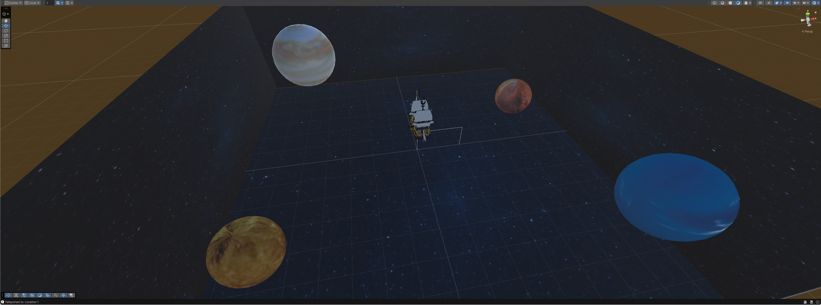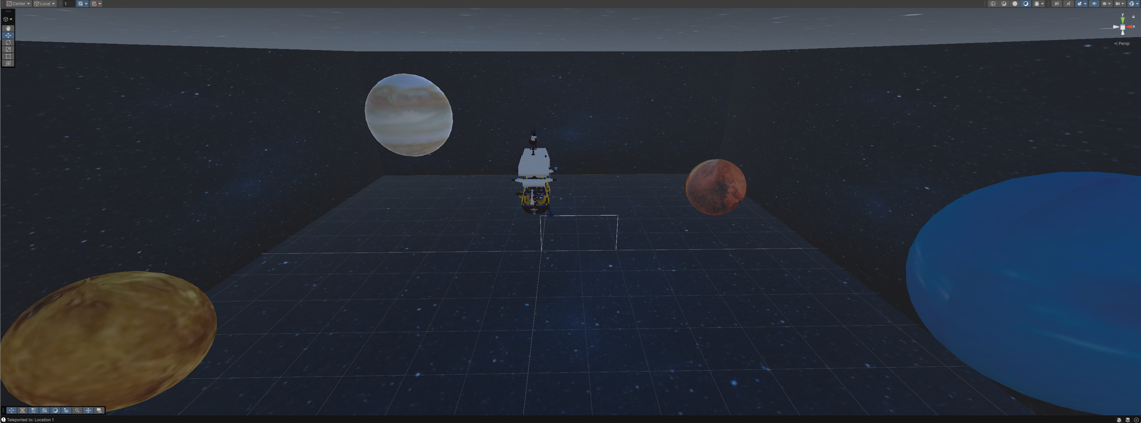
Within the Images above it shows the Sample Scene I’ve formed using the assets the group had made for the Project, I have made everything myself, aside from everything on the ship (Aside from the Ship Captain).
Scripts
I have created all scripts used within the project; these scripts are:
Free-Roam Camera: Camera can move around the 3D Environment using WSAD + Mouse Controls.
CanvasTextToggles: Hides and Shows Canva Text (TMP) on button press (U)
CameraWaypoint: Used to Teleport Camera to various positioned Empty Game Objects on Map.
CameraWaypointManager: Placed on Camera to link with the Empty Game Objects to perform the Teleportation to the various locations on the Map.

Assets
Below are all the Assets I’ve personally contributed to the Project.

Planets
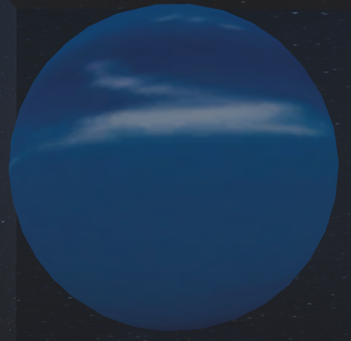
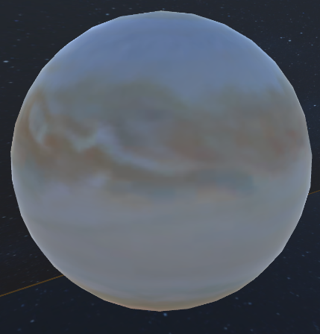
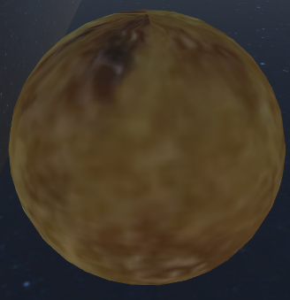
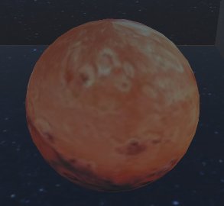

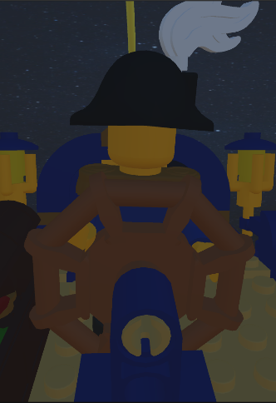
Ship Captain

Space Walls


Animations
Below shows all the animations Ive contributed to making on the project with a description of the animation step by step below.

Ship Captain – Lego Figure
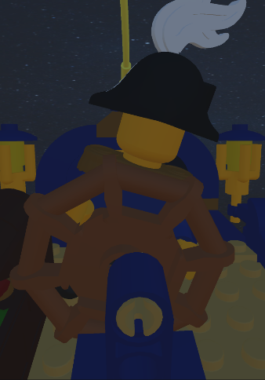
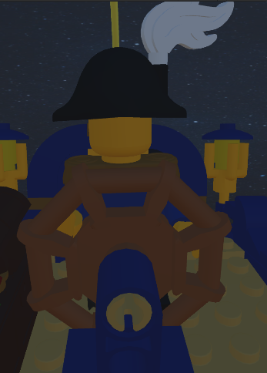


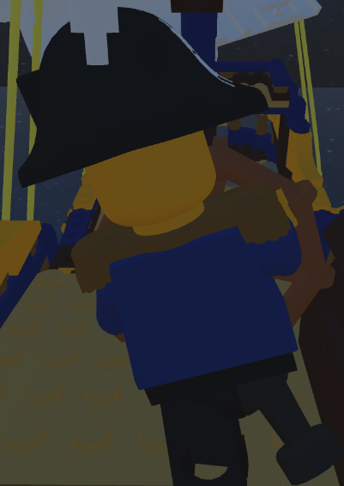
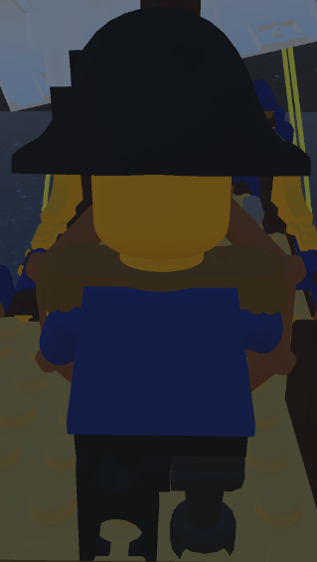
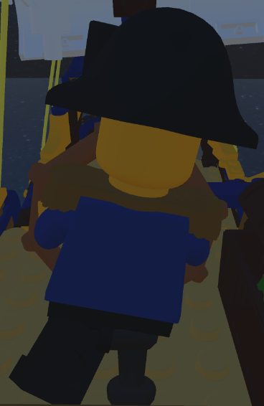
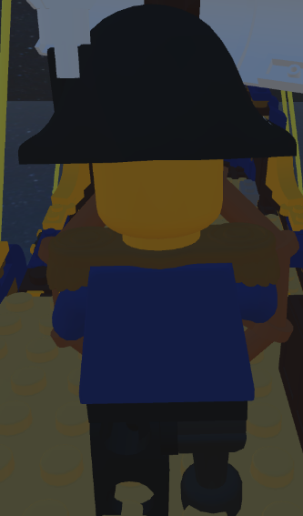

As you can see in the screenshots above, the ship’s captain has 3 unique positions he takes during hit animation. He starts in his initial position, holding the steering wheel straight, legs firm on the ground. The second position is him rotating to the right, as he does so his peg-leg stays on the ground as his left leg lifts off the ground, then returns to position 1. The third position is him rotating in the opposite direction but then has his left leg on the ground instead of his peg-leg, which is then in the air to show him gaining stability whilst steering the ship.

Planets – Unity Objects
Mars
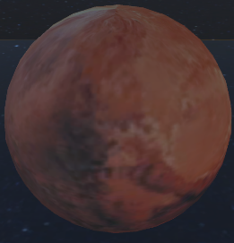

Venus
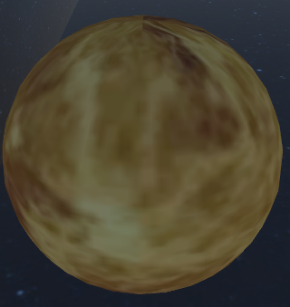
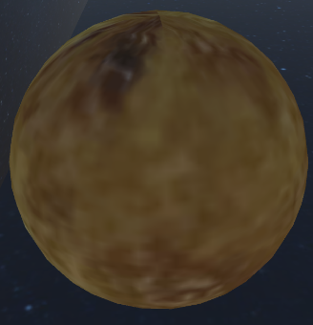

Neptune
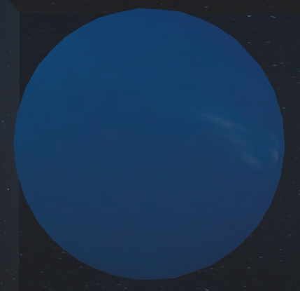

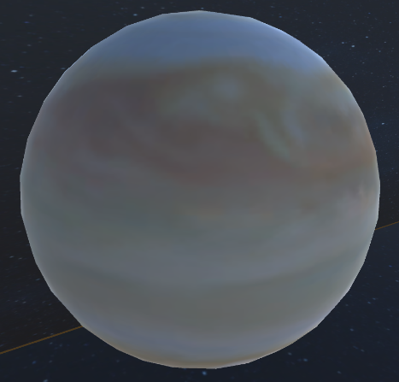
Jupiter

As you can see all the planets rotate constantly, unique features to note with each of the Planets is that they all rotate at different speeds based on their real-life rotation speeds.
Work in Progress (WIP) Video
I made 100% of the contribution to the development of the Work In Progress video made by the Group.

GRAB IMAGE OF CREATION ON CLIPCHAMP SAVE FILE

