深 圳 大 学 实 验 报 告

课程名称： 数字图像处理

实验项目名称： Exp 5: Integrated Experiment

学院： 电子与信息工程学院

专业： 电子信息工程

指导教师： 李斌

报告人：廖祖颐 学号： 2022110131 班级： 文华班

实验时间： 2024年 5 月 28 日
6月4 日、11 日 、18 日、25日
实验报告提交时间： 2024 年 6 月 27 日

教务部制
实验目的（Aim of Experiment）：
- Be familiar with the operations of morphological image processing.
- Be familiar with the operations of image segmentation.
- Try to design GUI in Python.

实验内容与要求（Experiment Steps and Requirements）：
- Erosion, Dilation, Opening and Closing. (a) Load the RGB image clock2.jpg. Convert it to grayscale and then convert it into a binary image using a threshold of 0.5. (b) Use an SE as [1 1 1; 1 1 1; 1 1 1] to obtain the binary morphological erosion, dilation, opening and closing of the binary image. Display them in the same figure with sub-figures. Add the corresponding title to the sub-figure. (c) Use an SE as [1 0 0; 0 1 0; 0 0 1] to obtain the binary morphological erosion, dilation, opening and closing of the binary image. Display them in the same figure with sub-figures. Add the corresponding title to the sub-figure. (d) Load the RGB image zebras.jpg. Convert it to grayscale. (e) Use a 3x3 SE to obtain the grayscale morphological erosion, dilation, opening and closing of grayscale image. Display them in the same figure with sub-figures. Add the corresponding title to the sub-figure. (f) Use a 7x7 SE to obtain the grayscale morphological erosion, dilation, opening and closing of grayscale image. Display them in the same figure with sub-figures. Add the corresponding title to the sub-figure. (Hint: skimage.morphology.binary_erosion, skimage.morphology.binary_dilation, skimage.morphology.binary_opening, skimage.morphology.binary_closing, skimage.morphology.erosion, skimage.morphology.dilation, skimage.morphology.opening and skimage.morphology.closing)
- Boundary Extraction and Hole Filling. (a) Load the image boundary.tif. Convert it into a binary image. (b) Use a 5x5 SE of 1s to obtain the binary morphological erosion of the binary image. (c) Obtian the boundary of the binary image via performing the difference between the binary image and its erosion image. (d) Load the image holefiling.tif. Convert it into a binary image. (e) Fill the holes in binary objects. (Hine:scipy.ndimage.binary_fill_holes) (f) Display them in the same figure with sub-figures. Add the corresponding title to the sub-figure.
- Thining and Convex Hull. (a) Load the image CT.tif. Convert it into a binary image. (b) Perform morphological thinning of a binary image. (Hint:skimage.morphology.thin, set the parameter of max_iter to 5, 50, and none, respectively.) (c) Compute the convex hull image of a binary image. (Hint:skimage.morphology.convex_hull_image) (d) Display them in the same figure with sub-figures. Add the corresponding title to the sub-figure.
- Top-hat (white top-hat) and Bottom-hat (black top-hat) Transformation. (a) Load the grayscale image rice.tif. Convert it into a binary image with a threshold of 0.5. (b) Perform top-hat transformation to the grayscale image. (Hint:skimage.morphology.white_tophat, set the parameter of footprint to skimage.morphology.square(81)) (c) Obtain thresholded top-hat image and convert it into a binary image. (d) Perform bottom-hat transformation to the grayscale image. (Hint:skimage.morphology.black_tophat, set the parameter of footprint to skimage.morphology.square(81)) (e) Obtain thresholded bottom-hat image and convert it into a binary image. (f) Display them in the same figure with sub-figures. Add the corresponding title to the sub-figure.
- Edge Detection. (a) Load the image building.tif. (b) Find edges in an image using the Roberts' cross operators, Sobel operators, Prewitt operators, and the Canny algorithm. (Hint:skimage.filters.roberts, skimage.filters.sobel, skimage.filters.prewitt, skimage.feature.canny) (c) Display them in the same figure with sub-figures. Add the corresponding title to the sub-figure.
- Edge-Based Segmentation. (a) Load the coins image in skimage. (Hint:skimage.data.coins())(b) Use Canny algorithm to obtain the edge image. (Hint:skimage.feature.canny, set the parameter of sigma to 3) (c) Fill the holes to obtain the segmented image. (Hint:scipy.ndimage.binary_fill_holes) (c) Display the images in the same figure with sub-figures. Add the corresponding title to the sub-figure.
- Hough transform. (a) Load the image triangle_circle.png. Convert it to grayscale. (b) Perform a straight-line Hough transform to the grayscale image. (Hint:skimage.transform.hough_line) (c) Obtain the peaks in a straight-line Hough transform. (Hint:skimage.transform.hough_line_peaks) (d) Highlight the detected lines by red color. (Hint:matplotlib.pyplot.axline) (e) Display them in the same figure with sub-figures. Add the corresponding title to the sub-figure.
- Thresholding-Based Segmentation. (a) Load the image shade_text1.tif. (b) Perform automatic image thresholding by Otsu's method to get the threshold value. (Hint:skimage.filters.threshold_otsu) (c) Transform the grayscale image into a binary image using the threshold value obtained by Otsu's method. (d) Compute a moving average threshold. (Hint:cv2.blur) (e) Obtain the result of local thresholding using moving averages. (f) Display them in the same figure with sub-figures. Add the corresponding title to the sub-figure.
- Image Processing Software with GUI.
- Use QT or other tools to design an image processing toolbox with GUI. There is no limitation on implementations.
- The GUI contain at least one basic image processing function, can it can display the input image and the processed image.
- Submit a video recording to demonstrate the function of your GUI design in your report.

实验代码及数据结果（Experiment Codes and Results）：

1.Erosion, Dilation, Opening and Closing.
(a) Load the RGB image clock2.jpg. Convert it to grayscale and then convert it into a binary image using a threshold of 0.5.
(b) Use an SE as [1 1 1; 1 1 1; 1 1 1] to obtain the binary morphological erosion, dilation, opening and closing of the binary image. Display them in the same figure with sub-figures. Add the corresponding title to the sub-figure.
(c) Use an SE as [1 0 0; 0 1 0; 0 0 1] to obtain the binary morphological erosion, dilation, opening and closing of the binary image. Display them in the same figure with sub-figures. Add the corresponding title to the sub-figure.
(d) Load the RGB image zebras.jpg. Convert it to grayscale.
(e) Use a 3x3 SE to obtain the grayscale morphological erosion, dilation, opening and closing of grayscale image. Display them in the same figure with sub-figures. Add the corresponding title to the sub-figure.
(f) Use a 7x7 SE to obtain the grayscale morphological erosion, dilation, opening and closing of grayscale image. Display them in the same figure with sub-figures. Add the corresponding title to the sub-figure.
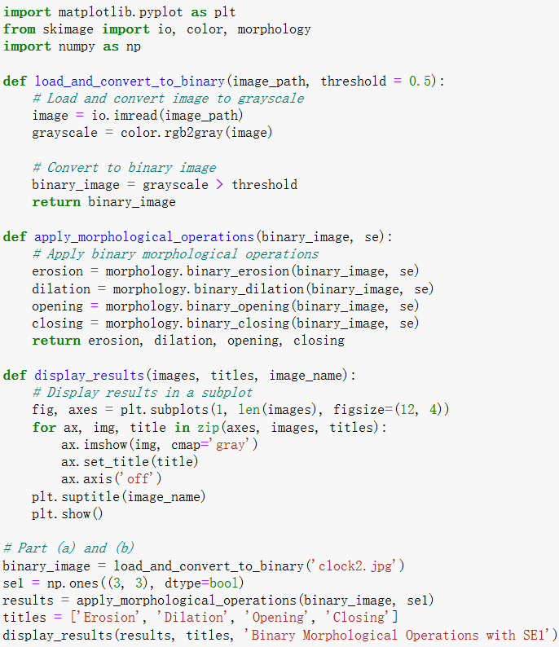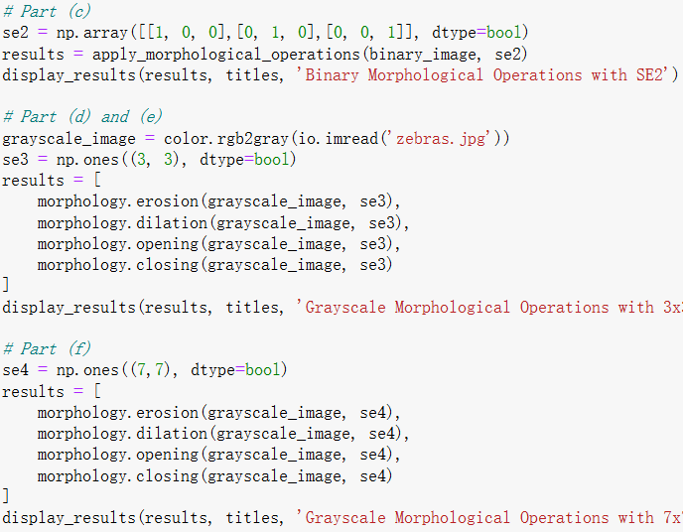
Fig 1.1 Code
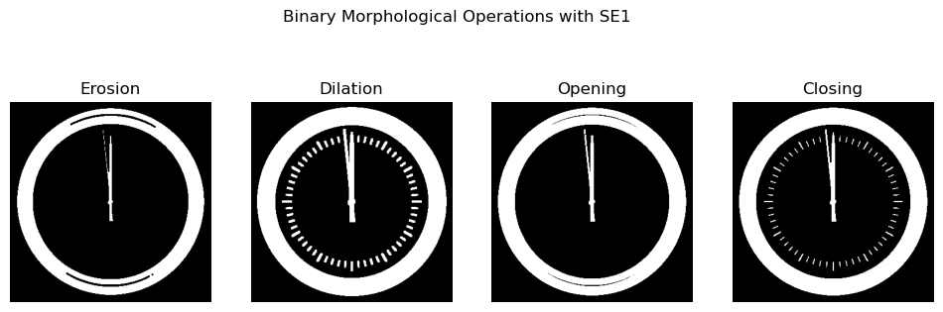

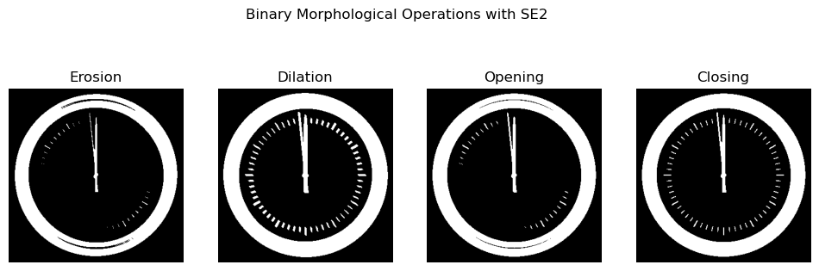
Fig 1.2 Results of Binary Morphological
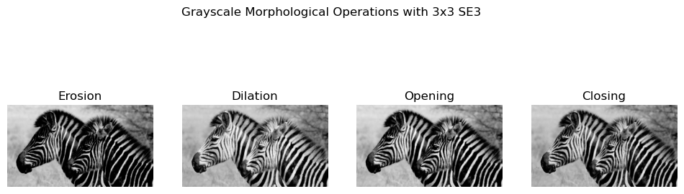
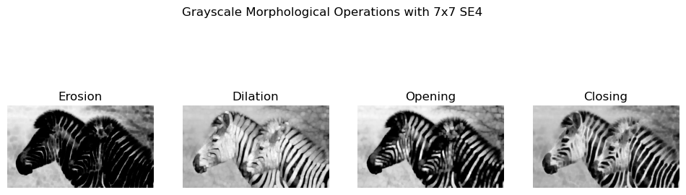
Fig 1.3 Results of Grayscale Morphological

2.Boundary Extraction and Hole Filling.
(a) Load the image boundary.tif. Convert it into a binary image.
(b) Use a 5x5 SE of 1s to obtain the binary morphological erosion of the binary image.
(c) Obtian the boundary of the binary image via performing the difference between the binary image and its erosion image.
(d) Load the image holefiling.tif. Convert it into a binary image.
(e) Fill the holes in binary objects. (Hine:scipy.ndimage.binary_fill_holes)
(f) Display them in the same figure with sub-figures. Add the corresponding title to the sub-figure.

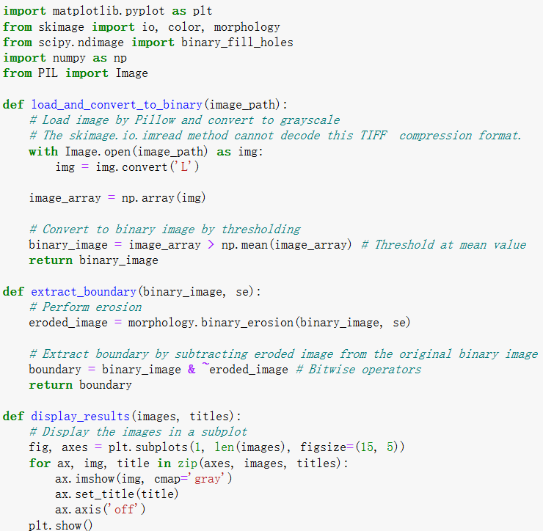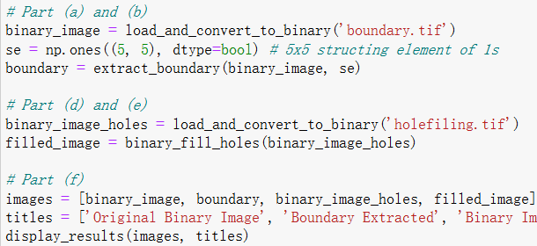
Fig 2.1 Code
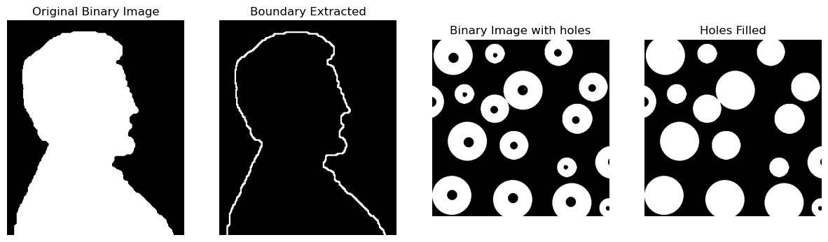
Fig 2.2 Results
3.Thining and Convex Hull.
(a) Load the image CT.tif. Convert it into a binary image.
(b) Perform morphological thinning of a binary image.
(c) Compute the convex hull image of a binary image.
(d) Display them in the same figure with sub-figures. Add the corresponding title to the sub-figure.
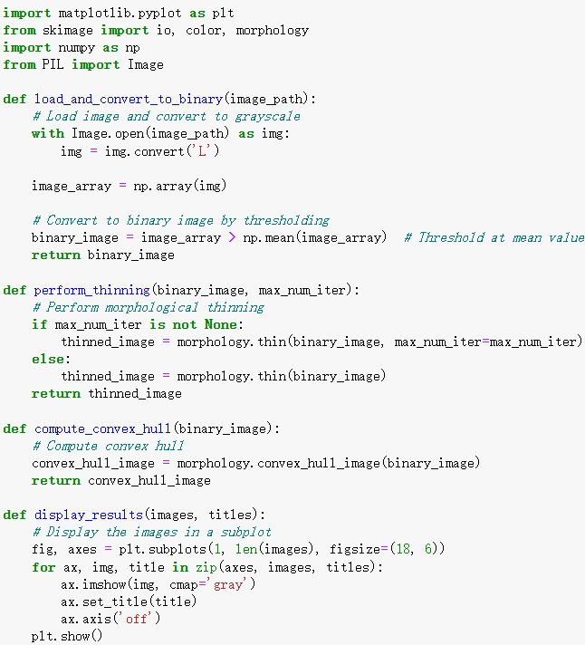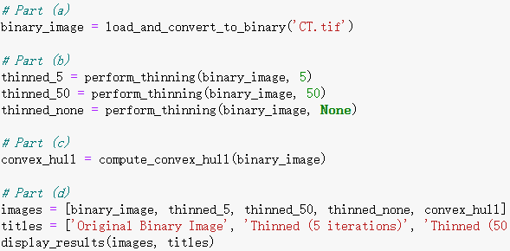
Fig 3.1 Code
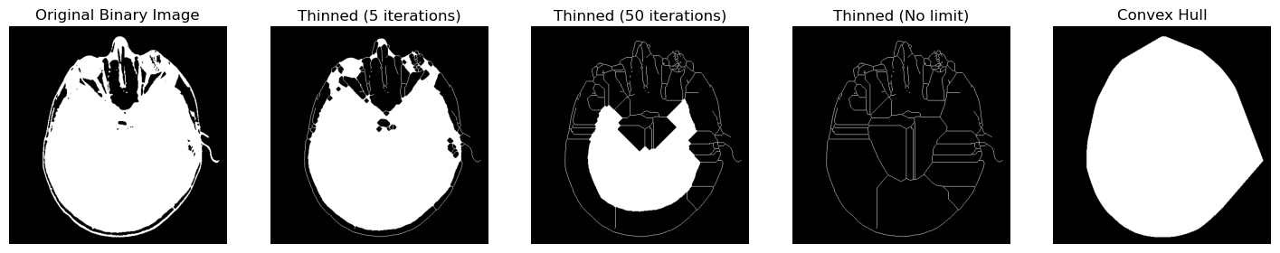
Fig 3.2 Results
4.Top-hat (white top-hat) and Bottom-hat (black top-hat) Transformation.
(a) Load the grayscale image rice.tif. Convert it into a binary image with a threshold of 0.5.
(b) Perform top-hat transformation to the grayscale image.
(c) Obtain thresholded top-hat image and convert it into a binary image.
(d) Perform bottom-hat transformation to the grayscale image.
(e) Obtain thresholded bottom-hat image and convert it into a binary image.
(f) Display them in the same figure with sub-figures. Add the corresponding title to the sub-figure.
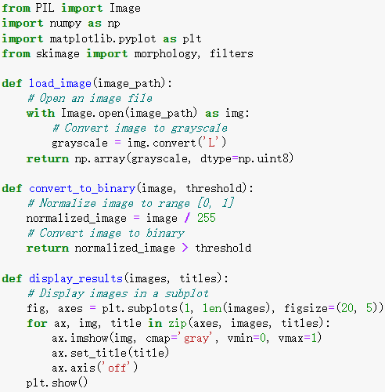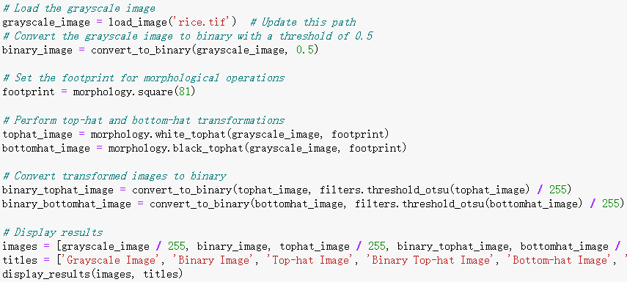
Fig 4.1 Code
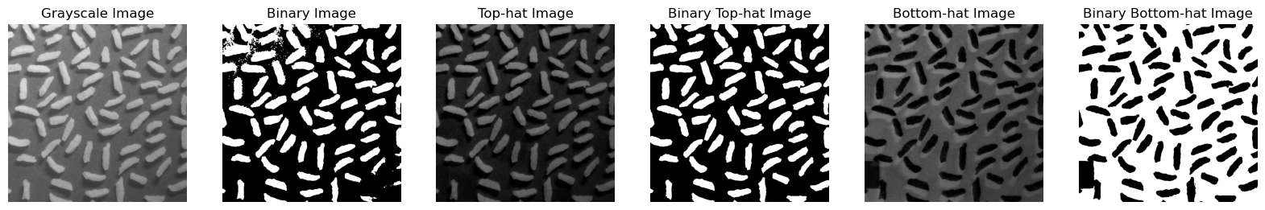
Fig 4.2 Results
5.Edge Detection.
(a) Load the image building.tif.
(b) Find edges in an image using the Roberts' cross operators, Sobel operators, Prewitt operators, and the Canny algorithm.
(c) Display them in the same figure with sub-figures. Add the corresponding title to the sub-figure.

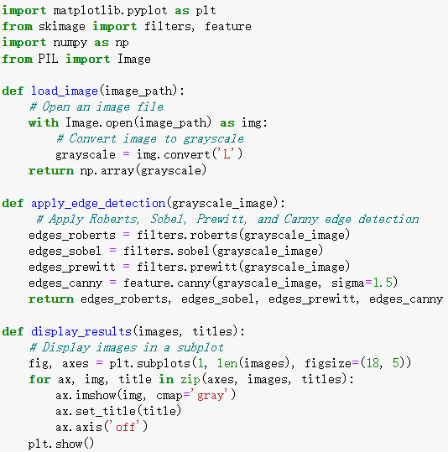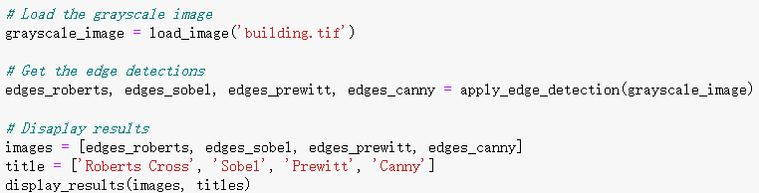
Fig 5.1 Code
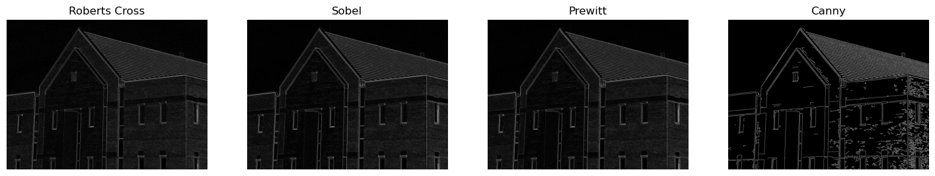
Fig 5.2 Results
6.Edge-Based Segmentation.
(a) Load the coins image in skimage.
(b) Use Canny algorithm to obtain the edge image.
(c) Fill the holes to obtain the segmented image.
(d) Display the images in the same figure with sub-figures. Add the corresponding title to the sub-figure.
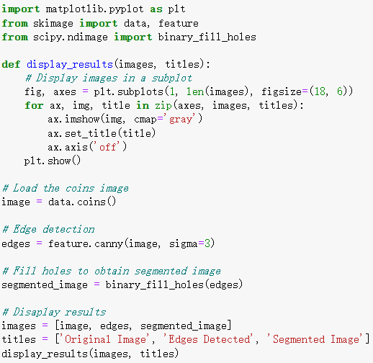
Fig 6.1 Code
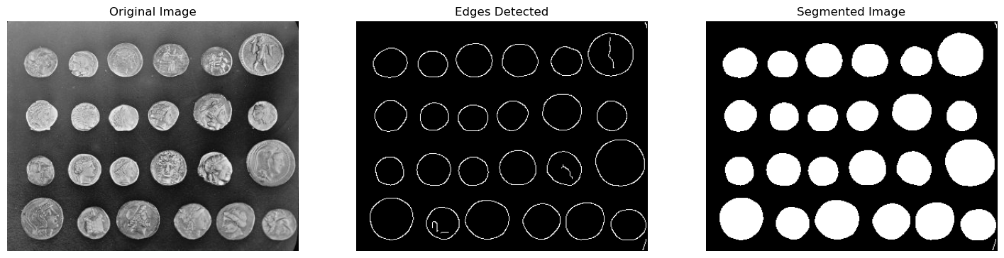
Fig 6.2 Results
7.Hough transform.
(a) Load the image triangle_circle.png. Convert it to grayscale.
(b) Perform a straight-line Hough transform to the grayscale image.
(c) Obtain the peaks in a straight-line Hough transform.
(d) Highlight the detected lines by red color.
(e) Display them in the same figure with sub-figures. Add the corresponding title to the sub-figure.
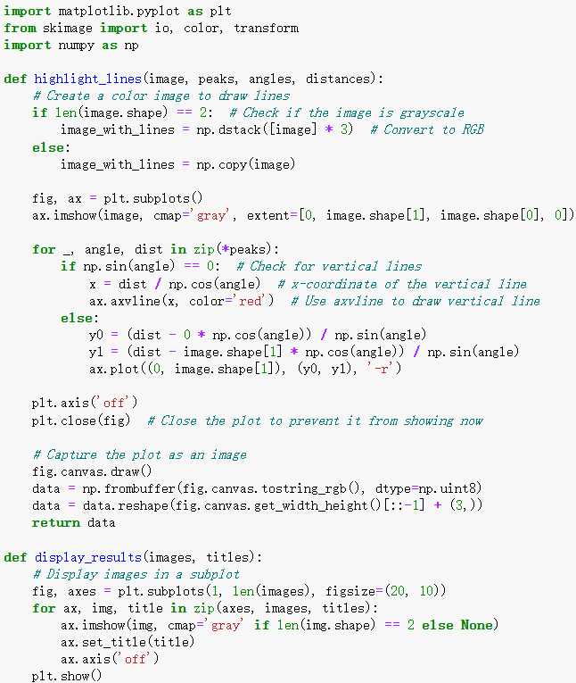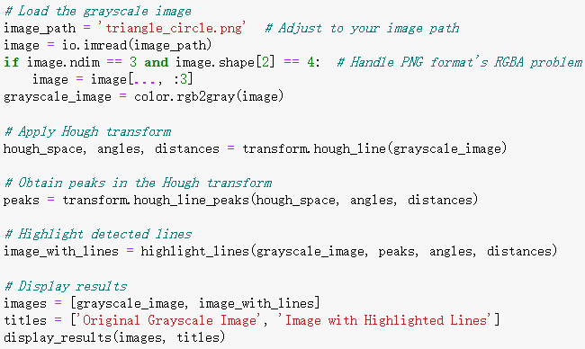
Fig 7.1 Code
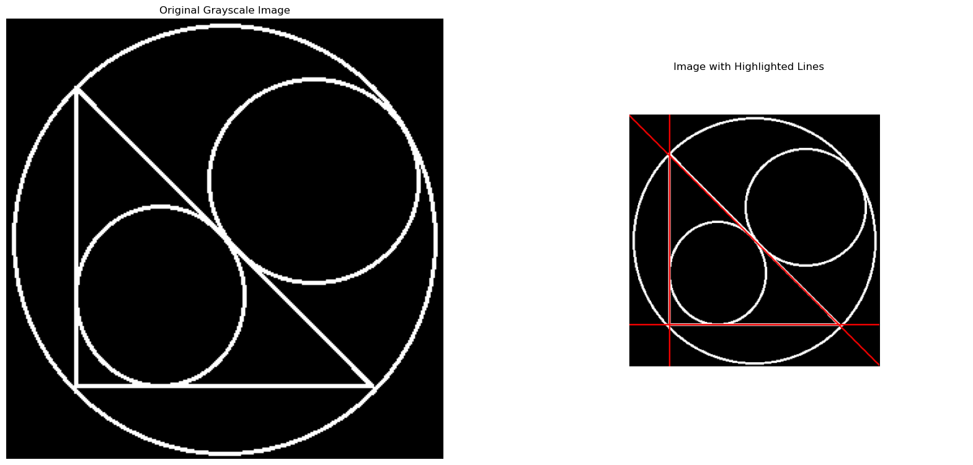
Fig 7.2 Results
8.Thresholding-Based Segmentation.
(a) Load the image shade_text1.tif.
(b) Perform automatic image thresholding by Otsu's method to get the threshold value.
(c) Transform the grayscale image into a binary image using the threshold value obtained by Otsu's method.
(d) Compute a moving average threshold.
(e) Obtain the result of local thresholding using moving averages.
(f) Display them in the same figure with sub-figures. Add the corresponding title to the sub-figure.
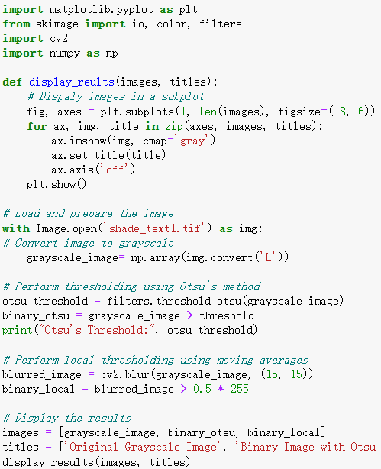
Fig 8.1 Code
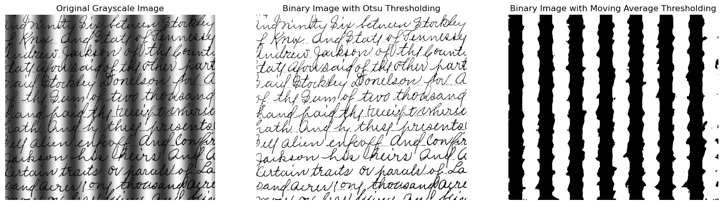
Fig 8.2 Results

实验分析与结论（Analysis and Conclusion）：

- Erosion, Dilation, Opening and Closing.
Analysis:
Binary Morphological Operations: Erosion removes pixels from the edges of objects in the binary image, making them appear smaller. Dilation adds pixels to the edges, making objects appear larger. Opening (erosion followed by dilation) helps remove small objects or isolated noise. Closing (dilation followed by erosion) helps fill small holes and gaps within objects. The diagonal shape of SE2 significantly impacts the operations, affecting the shape of objects in a direction-specific manner.
Grayscale Morphological Operations: The size of the SE directly influences the intensity of operations. A larger SE (7x7) results in more significant morphological changes. Erosion and dilation affect the contrast of light and dark areas in grayscale images, enhancing or blurring edges. Opening and closing affect the overall texture of the image, smoothing out textures or enhancing details.
Conclusion:
This experiment demonstrates how different morphological operations impact images depending on the type of operation and the shape and size of the SE used. Binary morphological operations emphasize changes in boundaries and shapes, while grayscale operations affect the texture and contrast of the image. The choice of SE is crucial to the outcomes, indicating that selecting the appropriate SE based on specific needs is vital in practical applications. These operations have wide applications in image preprocessing, feature extraction, and image restoration.
- Boundary Extraction and Hole Filling
Analysis:
Boundary Extraction: The boundary extraction process effectively highlights the edges of the object in the binary image. By subtracting the eroded image from the original, only the outermost pixels of objects remain, illustrating the object boundaries clearly. This technique is useful in applications where edge detection is critical, such as feature extraction and object delineation.
Hole Filling: The hole filling process successfully identifies and fills internal gaps within objects in the binary image, which can be crucial for creating uniform objects for further analysis. This operation is significant in preprocessing steps where complete object shapes are necessary for accurate analysis or when preparing data for machine learning algorithms that rely on shape and contour features.
Conclusion:
The experiment successfully demonstrates the use of binary morphological operations to extract boundaries and fill holes in binary images. These operations are foundational for further image analysis and processing tasks. By manipulating the structure of the image at a pixel level, significant features such as edges and internal gaps can be effectively isolated or amended, which has practical applications in various fields of computer vision and image processing.
- Thining and Convex Hull.
Analysis:
Morphological Thinning: Thinning (5 iterations) provides a moderate level of thinning, reducing some of the peripheral structures but retaining most of the original features. Thinning (50 iterations) results in a much more reduced structure, showing significant erosion of the original features, emphasizing the major structural lines. Thinning (No limit) further refines the image to its skeletal structure, showing the minimal set of pixels that can represent the form of the original image without any redundancy.
Convex Hull: The Convex Hull operation computes the smallest convex shape that can encompass the original binary image. This image is useful for bounding shape analysis and can be used in object detection frameworks where a rough estimate of object location is required.
Conclusion:
The experiment effectively demonstrates the utility and effects of morphological thinning and convex hull computations on binary images. Thinning operations, particularly those without iteration limits, are potent tools for image analysis, providing a skeletonized version of the image which is beneficial for analyzing structural properties of objects. Convex hulls provide a simple and efficient way to estimate the bounding region for objects, which can assist in various image processing applications such as object tracking and scene analysis. These techniques are instrumental in reducing data complexity and enhancing computational efficiency in image processing tasks.
- Top-hat (white top-hat) and Bottom-hat (black top-hat) Transformation
Analysis:
Top-Hat Transformation: The white top-hat image effectively highlights small bright regions within the image that are not captured well in the original binary conversion. This is particularly useful for emphasizing features that are lighter than their surroundings and smaller than the structuring element used.
Bottom-Hat Transformation: Conversely, the black top-hat transformation highlights small dark features within the image. This transformation is useful for detecting darker features against a predominantly bright background, again based on the size criterion set by the structuring element.
Binary Images from Transformations: The binary images derived from both transformations show a stark isolation of the features highlighted by each technique. These binary versions are crucial for applications where feature extraction requires clear differentiation from the background.
Conclusion:
The experiment successfully demonstrates the utility of top-hat and bottom-hat transformations in extracting and emphasizing specific features from a grayscale image based on their brightness and size relative to a defined structuring element. These transformations are highly beneficial in preprocessing steps for feature extraction, especially in scenarios where contrast between features and background is subtle. The ability to manipulate and extract these features using morphological operations provides a powerful toolset for image analysis, particularly in fields like materials science and biological imaging, where such features are often indicative of critical properties.
- Edge Detection
Analysis:
Roberts Cross: This method is sensitive to subtle edge variations but may not perform as robustly in high noise conditions compared to other methods. It emphasizes diagonal edges due to its operator structure.
Sobel: Known for its effectiveness in detecting both horizontal and vertical edges, the Sobel operator provides a good balance between edge response strength and noise suppression. It produces thicker edges, which can be beneficial for better visualization.
Prewitt: Similar to the Sobel operator, the Prewitt operator is also effective at detecting horizontal and vertical edges but uses a different approximation for the gradient. It usually results in less emphasis on diagonal edges compared to Sobel.
Canny: This algorithm is quite sophisticated, involving multiple stages to detect edges, including noise reduction, gradient calculation, non-maximum suppression, and hysteresis thresholding. It provides the clearest and most continuous edges, making it highly suitable for further image analysis tasks.
Conclusion:
The experiment successfully demonstrates the distinct characteristics and suitability of each edge detection method for different image analysis applications. The Roberts Cross operator, while simple, highlights fine details. The Sobel and Prewitt operators are more robust in general conditions and are better at capturing more substantial structural edges. On the other hand, the Canny edge detector, with its multi-stage process, excels in providing high-quality and precise edge delineation.
Understanding the nuances of each method allows for better strategic choices in image processing applications, depending on the specific requirements such as noise levels, edge continuity, and computational efficiency
- Edge-Based Segmentation
Analysis:
Canny Edge Detection: Initially, the Canny algorithm was applied to the coins image with a higher sigma value (sigma=3), which helps in reducing noise while preserving the edges. This step is crucial as it directly influences the quality of edge detection, which is a fundamental component for accurate segmentation.
Hole Filling: After detecting edges, the next step involved filling the holes within these edges to segment the objects (coins) from the background. The binary_fill_holes function from the scipy.ndimage module was used, which assumes that all holes are surrounded by true pixels. This method effectively transformed the edge outlines into solid shapes, thereby isolating each coin.
Conclusion:
The edge-based segmentation technique demonstrated in this experiment is a robust method for segmenting objects in images where the objects are well-defined against the background. The Canny edge detector proved to be effective in capturing detailed edges of the coins, which is essential for the subsequent segmentation step. Filling the holes inside the detected edges then allowed for the clear delineation and extraction of each coin, illustrating the potential of this method in applications like object counting, quality control in manufacturing, or digital archiving in numismatics.
This experiment not only showcases the practical application of combining edge detection with morphological operations but also highlights the importance of parameter tuning (such as the sigma value in the Canny algorithm) to adapt the techniques to specific characteristics of the input image.
- Hough transform
Analysis:
Grayscale Conversion: The first step was converting the original image to grayscale, which simplifies the data by reducing dimensionality and focuses the subsequent analysis strictly on intensity variations, which are fundamental for edge detection.
Hough Transform: We applied the Hough Transform, which is particularly effective in detecting lines by transforming points in the image space to curves in the parameter space. This transform accumulates votes in the Hough space, where each point in the image votes for all the lines that could pass through it.
Peaks in Hough Space: By identifying peaks in the Hough space, we were able to locate lines that are strongly supported by collinear points in the image. These peaks correspond to potential lines in the image space.
Highlighting Lines: The detected lines were highlighted in red on the original grayscale image. This visualization helps in clearly identifying how well the Hough Transform has performed in detecting straight lines in the presence of other geometric shapes.
Conclusion:
The Hough Transform proved to be a robust tool for line detection in images with complex geometric patterns. Despite the simplicity of the input (basic geometric shapes), the method effectively identified and highlighted the predominant straight lines. This experiment underscores the utility of the Hough Transform in applications where precise line detection is required, such as in automated inspection systems, robotics, and other areas of computer vision.
This experiment also highlights the importance of parameter tuning in the Hough Transform and the role of visual feedback in verifying the accuracy of detected lines. Such techniques are indispensable in the preprocessing stages of more complex image analysis tasks, where accurate detection of basic features (like lines) is crucial.
- Thresholding-Based Segmentation
Analysis:
Otsu's Method: Otsu's algorithm calculates an optimal threshold separating the foreground (text) from the background, minimizing the intra-class variance. This global thresholding approach is simple yet effective under varying image conditions, as it automatically determines the threshold based on the grayscale distribution.
Moving Average Thresholding: This local thresholding technique uses a blurred version of the original image to determine variable thresholds. By averaging nearby pixels with a kernel size, typically larger like (15, 15), this method can adapt to local changes in lighting and contrast, which might be particularly useful in unevenly illuminated images.
Conclusion:
Otsu's Thresholding provided a more accurate binary representation of the text against the background, maintaining legibility and clarity. This method is generally more robust for images with well-differentiated histogram peaks of foreground and background.
Moving Average Thresholding created a binary image that over-segmented the background, especially in areas with gradient changes, resulting in loss of textual information. This indicates that while local thresholding can adapt to local variances, it may not always be suitable for images with complex backgrounds or subtle changes in foreground and background intensities.
These findings highlight the importance of choosing an appropriate thresholding method based on the specific characteristics of the image. Otsu's method is preferable for its simplicity and effectiveness in a wide range of conditions, whereas local thresholding methods like the moving average can be tailored for specific situations where background intensity varies significantly across the image.
- Image Processing Software with GUI
As the video shown

指导教师批阅意见：

成绩评定：

实验态度  10分 | 实验步骤及代码  40分 | 实验数据与结果  40分 | 实验分析与结论  10分

指导教师签字：李斌
2024 年 6 月 30 日
备注：

