深 圳 大 学 实 验 报 告

课程编号： 2801000049

课程名称： 机器学习

实验项目名称： Machine Learning Task 1

学院： 电子与信息工程学院

专业： 电子信息工程

指导教师： 麦晓春

报告人： 廖祖颐 学号：2022110131班级： 文华班

实验时间： 2024.3.27

实验报告提交时间： 2024.4.12

教务部制
1. Experimental Purposes and Requirements
Experimental Purposes
- Understand Principal Component Analysis (PCA) and Linear Regression: To familiarize with the fundamental concepts, mathematical principles, and practical applications of PCA and linear regression algorithms.
- Implement Linear Regression Algorithm: To develop a practical understanding of how to implement a linear regression algorithm from scratch, including the process of data preparation, model training, and evaluation.
- Apply Ridge Regression with Hyper-parameter Tuning: To gain experience in using ridge regression, an extension of linear regression with L2 regularization, and learn how to optimize the model by tuning hyper-parameters through cross-validation.
- Data Analysis and Model Evaluation: To perform exploratory data analysis (EDA) on the Boston Housing Dataset, understand the relationships between different features, and evaluate the regression model's performance using metrics like Mean Squared Error (MSE).
Experimental Requirements
- Algorithm Implementation:
  - Implement a linear regression model to predict the Boston house prices.
  - The dataset contains 506 samples and 13 feature variables.
  - Split the dataset into training and testing sets, with 10% of the data reserved for testing.
- Model Evaluation:
  - Evaluate the model using 10-fold cross-validation to compute the average MSE on the training set.
  - For the ridge regression model, determine the optimal value of the regularization hyper-parameter through 10-fold cross-validation.
- Exploratory Data Analysis (EDA):
  - Check the dataset for any missing values and handle them appropriately.
  - Conduct EDA to explore the distribution of the target variable and the linear relationships between the features.
  - Create visualizations such as the distribution plot of the target variable, correlation matrix heatmap, and scatter plot between the actual and predicted house prices.
- Experimental Report:
  - Write a detailed experimental report that includes the objectives, methodology, results, and conclusions of the experiment.
  - The report should contain a strict narrative and abundant graphical representations (charts, graphs, tables) of the data analysis and results.
  - Discuss the findings from the EDA, model training, and evaluation process.

2. Experiment Contents and Process
(1) Experimental Contents/Introduction
Experimental Content
1. Algorithm Implementation:
- Linear Regression Model: Implement a Ridge Regression model to predict the house prices in the Boston Housing Dataset.
- Data Processing: The dataset consists of 506 samples and 13 feature variables. Initially, features are standardized using StandardScaler, followed by dimensionality reduction using PCA to retain 95% of the variance.
- Data Splitting: Divide the dataset into training and testing sets, with 10% of the data reserved for testing.
2. Model Evaluation:
- Cross-Validation: Employ 10-fold cross-validation to compute the average Mean Squared Error (MSE) on the training set.
- Hyper-parameter Optimization: Determine the optimal value of the regularization hyper-parameter alpha for the Ridge Regression model through 10-fold cross-validation.
3. Exploratory Data Analysis (EDA):
- Missing Values Handling: Check for any missing values in the dataset and fill them with the mean value.
- Distribution and Relationship Analysis:
Plot the distribution of the target variable (house prices) to observe its spread.
Create and plot a correlation matrix heatmap of the feature variables to analyze the linear relationships between them.
- Model Performance Visualization:Plot a scatter graph between the actual house prices and the predicted prices to assess the predictive performance of the model.
(2) Methods
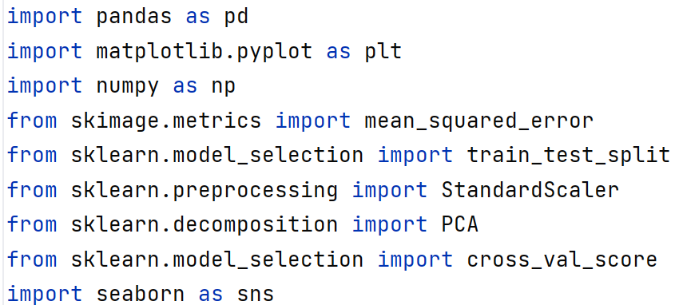
Fig 1 Library function
This is achieved by calling the above library function plus some of the following calculations. The following is the detail about the ridge regression:
Formula:
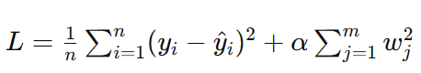
Fig 2 Loss function for ridge regression (mathematical formula)
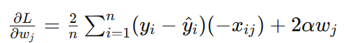
Fig 3 Calculation of the gradient of w
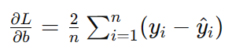
Fig 4 Computation of the gradient of the bias b
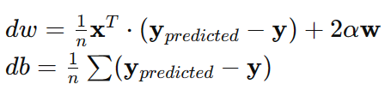
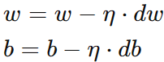
Fig 5 Weighting update
Code:
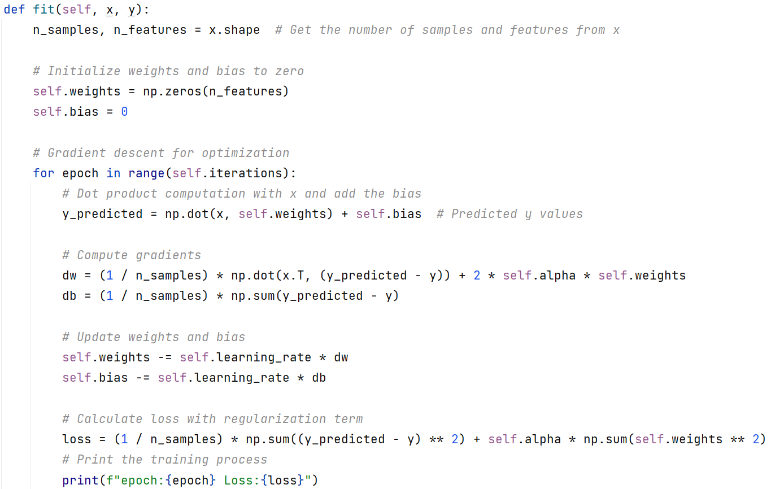
Fig 6 code
Using the numpy’ s counting function can realize easily
(3) Data Collection, Preprocessing and Analysis
- Download the Boston housingdata from the Kaggle
Fig 7 Load the dataset
- Due to the data has many ‘NA’, I use the mean to replace the ‘NA’.
Fig 8 Replace the ‘NA’ data
- X stores the Boston House Dataset (506 samples and 13 feature) and Y stores the housing costs
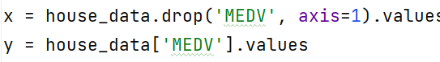
Fig 9 Extracted values
- Using the standardscaler function to normalization the feature. Then, dimensionality reduction using PCA to retain 95% of the variance.
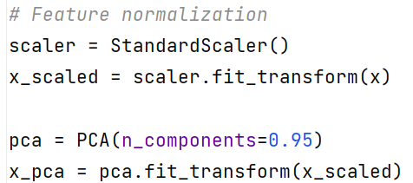
Fig 10 Data standardisation and dimensionality
- Using ridge regression to train
Fig 11 The training method
- Calculate the mean squared error on the testing set
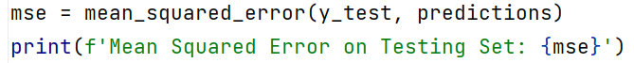
Fig 12 MSE
- Evaluate the model using 10-fold cross-validation
Fig 13 10-fold cross-validation
- Plot the distribution of house prices
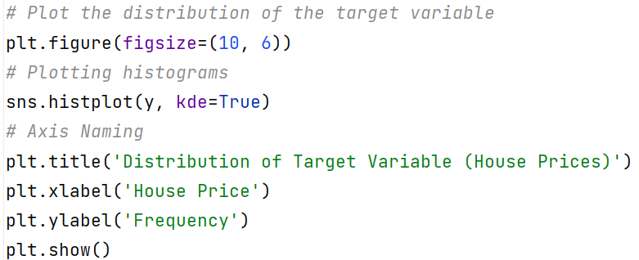
Fig 14 The histogram
- Create and plot the correlation matrix to understand the relationship between variables
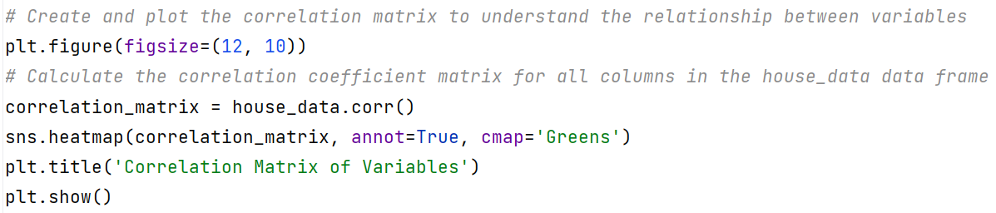
Fig 15 Correlation matrix
- Plot a scatter plot between the original and predicted house prices to visualize the model's performance
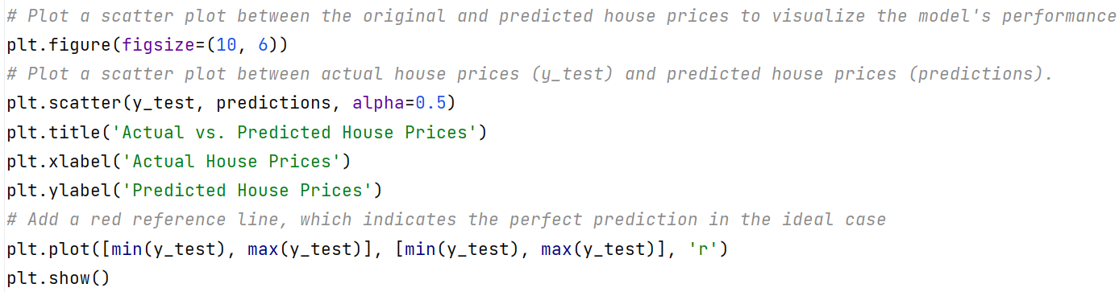
Fig 16 Scatter plot
(4) Experimental Results and Analysis
1. Algorithm Implementation and Model Training
The Ridge Regression model was implemented to predict house prices using the Boston Housing Dataset, which contains 506 samples with 13 feature variables. The dataset was first preprocessed to handle missing values by filling them with the mean of the respective columns. Feature normalization was then performed using standardscaler, followed by dimensionality reduction through PCA, retaining 95% of the variance to reduce the feature space while preserving most of the information.
The dataset was split into training and testing sets with a 90-10 ratio. The Ridge Regression model was initialized with a learning rate of 0.01, 1000 iterations, and a regularization parameter alpha of 0.01. The model was trained using the training set, and the training process revealed the loss at each epoch, with the final loss at the 999th epoch being approximately 27.58
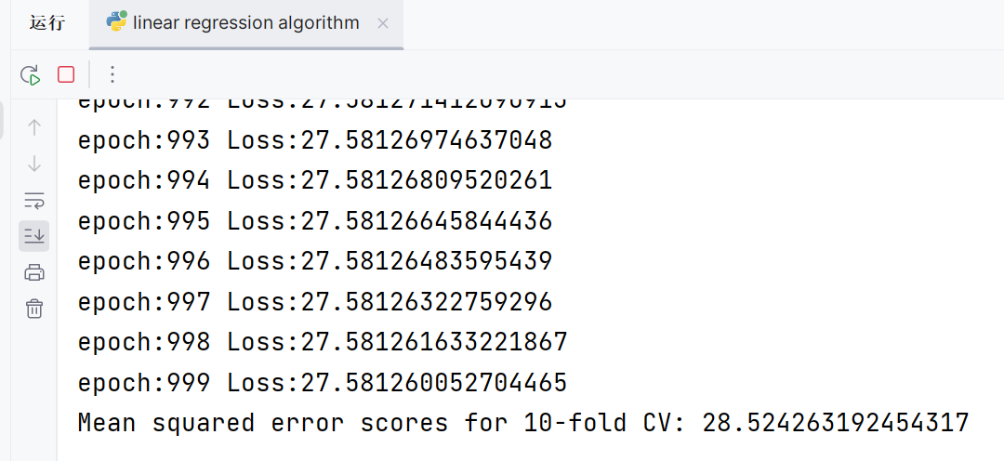
Fig 17 The loss and mse scores
2. Model Evaluation
The model's performance was evaluated using 10-fold cross-validation, which resulted in an average mean squared error (MSE) of approximately 28.52 on the training set. The figure 17 is the results.
3. Exploratory Data Analysis (EDA)
Exploratory Data Analysis was conducted to understand the data better:
- Target Variable Distribution: The distribution of the house prices (MEDV) was plotted, showing a near-normal distribution with a slight left skew, indicating that most of the houses are in the lower to mid-price range with fewer houses in the higher price range.
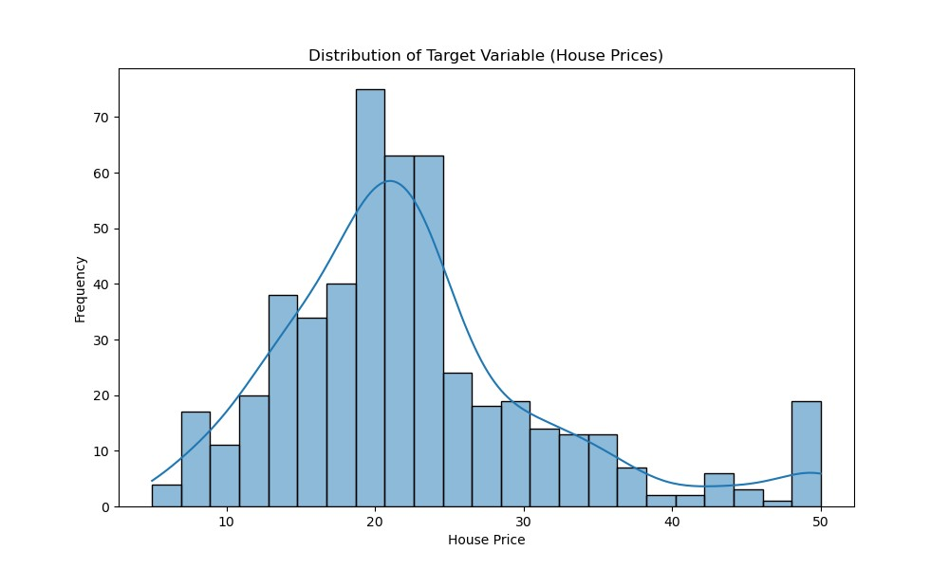
Fig 18 histogram
- Correlation Matrix: A heatmap of the correlation matrix was generated to examine the linear relationships between features. This revealed that some features are positively correlated with the house prices (MEDV), while others are negatively correlated, providing insights into potential predictors for the regression model.
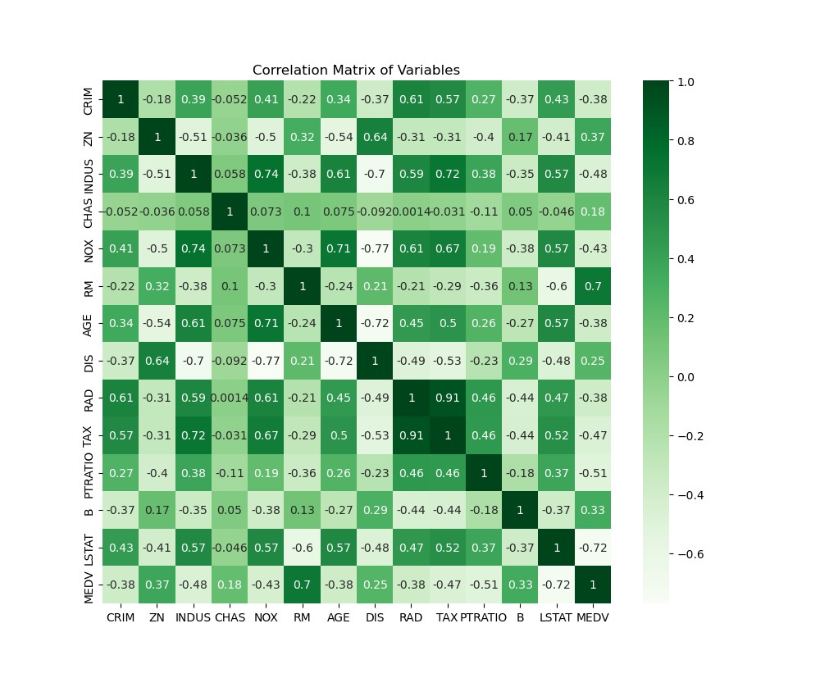
Fig 19 Correlation Matrix
4. Predictive Performance
The model's predictive performance was visualized by plotting a scatter plot of actual vs. predicted house prices on the testing set. This plot included a reference line representing perfect predictions. The scatter plot showed a reasonable alignment with the reference line, indicating good model performance.
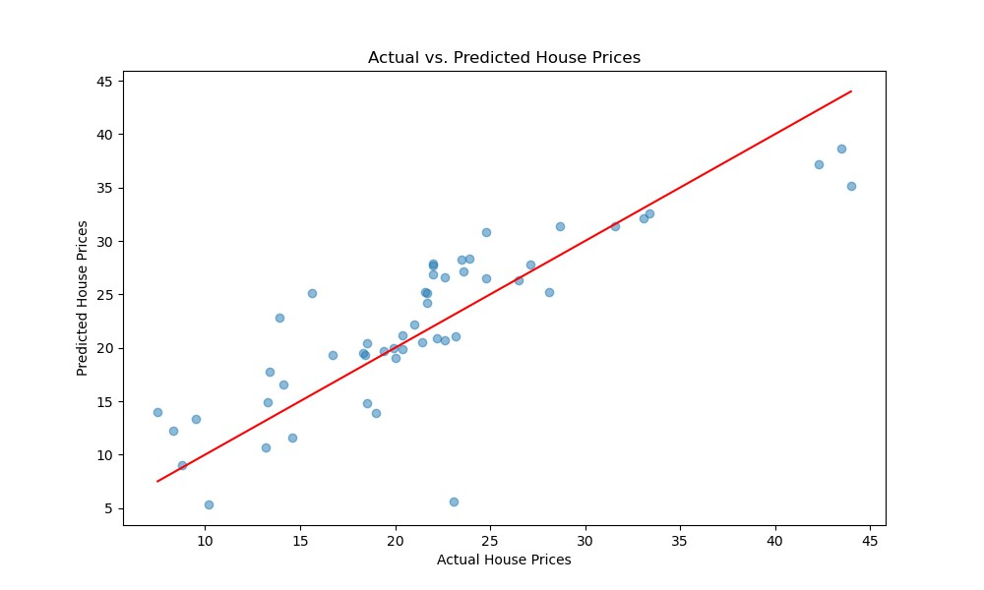
Fig 20 The model's predictive performance
3. Discussion and Conclusions
Discussion:
I find that my output results have several ‘1000’ iterations, but I do not call the training function twice at all. The question maybe the cross_val_score function. This function may perform multiple training sessions to calculate the cross-validation score. The last losses are not the same, It is magic I think. The random state is fixed, so why the loss is different. About the pca function, this method even raise my loss, but it reduce my mse scores.
Some way to improve the model:
- Use the Lasso regression(This method has no many difference with ridge regression, but it has the better performance).
- Use multiple linear regression analysis to get better performace
- Cleaning data. Through the Correlation Matrix I find some data has the bad effect on the training

Conclusions:
The Ridge Regression model demonstrated a competent ability to predict house prices based on the given features, with an overall MSE indicative of the model's accuracy. The EDA highlighted key relationships and distribution characteristics in the dataset, aiding in a better understanding of the factors influencing house prices. Future work could focus on optimizing the regularization parameter further and exploring more complex models or feature engineering techniques to improve predictive performance.

指导教师批阅意见：

成绩评定：

指导教师签字：
年 月 日
备注：
注：1、报告内的项目或内容设置，可根据实际情况加以调整和补充。
2、教师批改学生实验报告时间应在学生提交实验报告时间后10日内。

