深 圳 大 学 实 验 报 告

课程名称： 数字图像处理

实验项目名称： Exp 4 Image Compression

学院： 电子与信息工程学院

专业： 电子信息工程

指导教师： 李斌

报告人： 学号： 班级： 文华班

实验时间： 2024年 5月 7 日、5 月 14 日、5月 21 日

实验报告提交时间： 2024 年 5 月 25 日

教务部制
实验目的（Aim of Experiment）：
- Be familiar with some basic image fidelity assessment methods such as MSE, PSNR and SSIM.
- Be familiar with the process of JPEG compression.
- Be familiar with Discrete Cosine Transform, Huffman Coding, and Predictive Coding.

实验内容与要求（Experiment Steps and Requirements）：
- Compression Ratio and Relative Coding Redundancy. (a) Load the image bunny.png. Save it as a JPEG image with a quality factor of 90, 60, 10, respectively. Name the images as b90.jpg, b60.jpg, b10.jpg, respectively. (b) Display the original image and the compressed images. (c) Calculate the Compression Ratio and Relative Data Redundancy between the PNG image and JPEG images according to the file sizes. (Tips: os.path.getsize)
- Fidelity Criteria. (a) Load the saved JPEG images. Use functions from skimage.metrics to calculate MSE, PSNR, and SSIM values between the PNG image and JPEG images. (b) Implement a SSIM function by yourself according to [1].
[1] Wang Z, Bovik AC, Sheikh HR, Simoncelli EP. Image quality assessment: from error visibility to structural similarity. IEEE Trans Image Process. 2004 Apr;13(4):600-12.
- Simulation of a Part of JPEG Compression. (a) Load the grayscale image lenagray.tiff. (b) Shift the pixel intensity by -128. (c) Divide the image into non-overlapped 8 ∗ 8 subimages and perform 8 ∗ 8 block DCT on each subimage. (Tips: cv2.dct or scipy.fftpack.dct) (d) Use a quantization table with QF=50 for quantization. (e) Perform lossless predictive coding (difference coding) of DC coefficients by using the coefficient in the previous subimage as reference (a raster scan mannar). (f) Sort 63 AC coefficients in each block in a ZigZag order. Converted them into a one-dimensional vector. (g) Save all the compressed data into a Numpy data format (refered to as NPY/NPZ (.npy or .npz) file) (Tips: np.save or np.savez). (h) Compress the npy/npz file to a zip file (refered to as NPZzip). Compress the TIFF image to another zip file (refered to as TIFFzip). (i) Calculate the Compression Ratio between the TIFF image and the NPY/NPZ file according to the file sizes. Calculate the Compression Ratio between the TIFF image and the NPZzip file according to the file sizes. Calculate the Compression Ratio between the TIFFZzip and the NPZzip according to the file sizes. (j) Load the above saved file. Decode it to a recovered image. (k) Compute the MSE and PSNR of the recovered image, and display it with the original image side by side.

实验代码及数据结果（Experiment Codes and Results）：
- Compression Ratio and Relative Coding Redundancy.
- Load the image bunny.png. Save it as a JPEG image with a quality factor of 90, 60, 10, respectively. Name the images as b90.jpg, b60.jpg, b10.jpg, respectively.
(b) Display the original image and the compressed images.
(c) Calculate the Compression Ratio and Relative Data Redundancy between the PNG image and JPEG images according to the file sizes. (Tips: os.path.getsize)
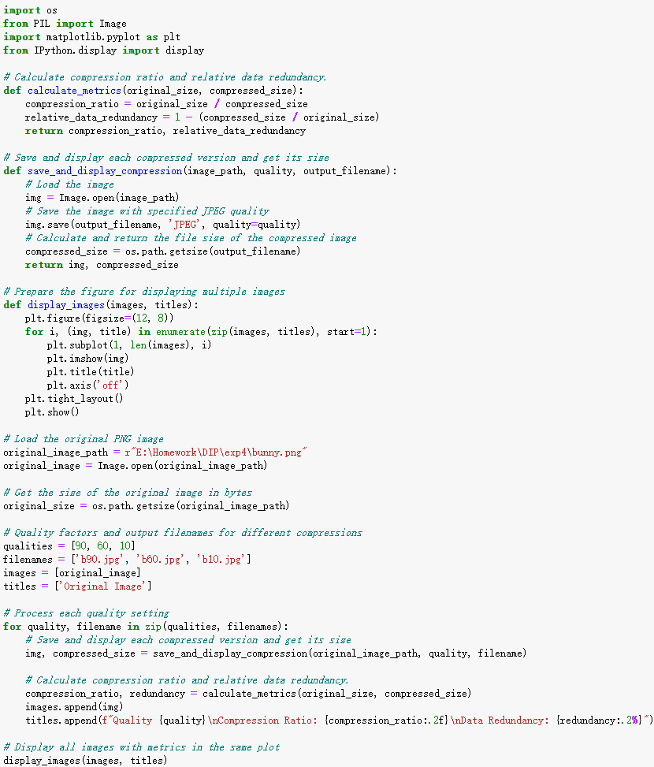
Fig 1.1 Code
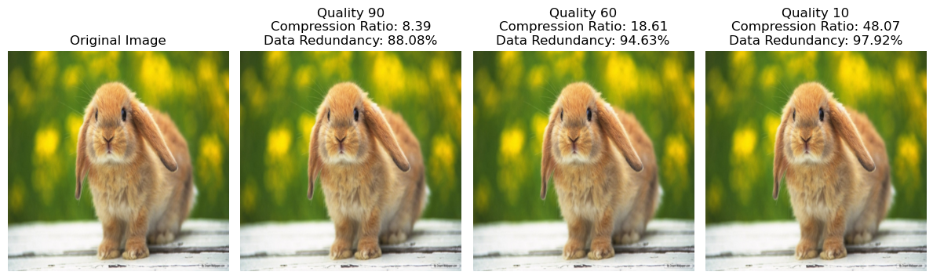
Fig 1.2 Results

(2) Fidelity Criteria.
(a) Load the saved JPEG images. Use functions from skimage.metrics to calculate MSE, PSNR, and SSIM values between the PNG image and JPEG images.
(b) Implement a SSIM function by yourself according to [1].
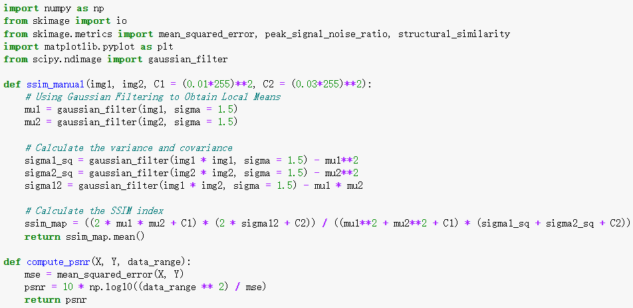
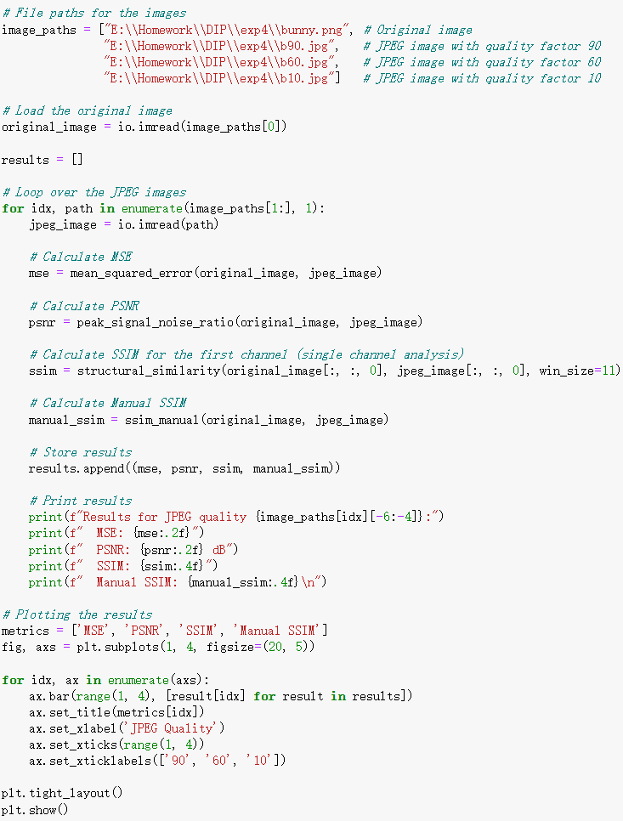
Fig 2.1 Code
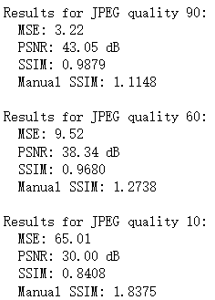
Fig 2.2 Results
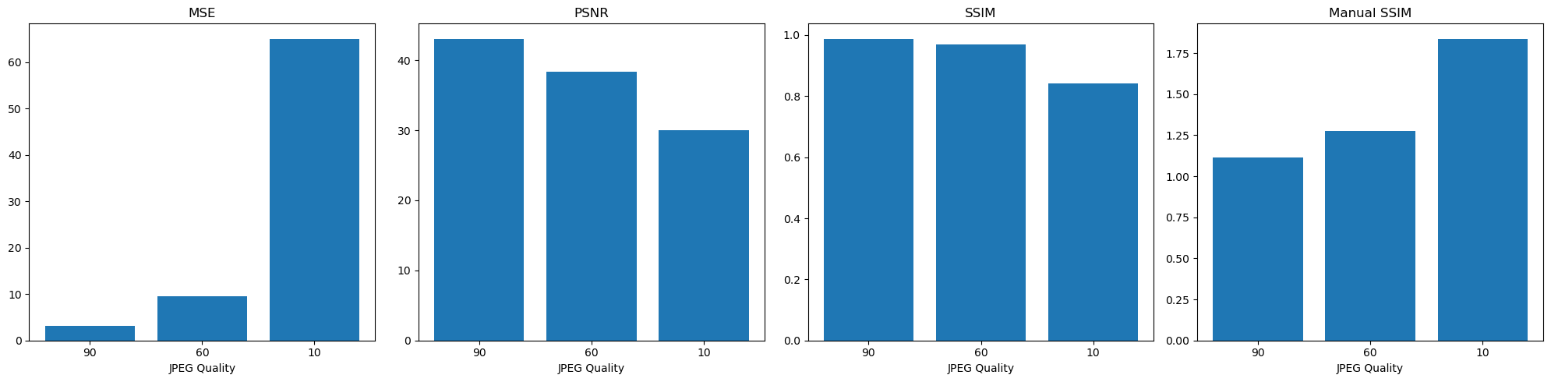
Fig 2.3 Results

(3) Simulation of a Part of JPEG Compression.
(a) Load the grayscale image lenagray.tiff.
(b) Shift the pixel intensity by -128.
(c) Divide the image into non-overlapped 8 ∗ 8 subimages and perform 8 ∗ 8 block DCT on each subimage. (Tips: cv2.dct or scipy.fftpack.dct)
(d) Use a quantization table with QF=50 for quantization.
(e) Perform lossless predictive coding (difference coding) of DC coefficients by using the coefficient in the previous subimage as reference (a raster scan mannar).
(f) Sort 63 AC coefficients in each block in a ZigZag order. Converted them into a one-dimensional vector.
(g) Save all the compressed data into a Numpy data format (refered to as NPY/NPZ (.npy or .npz) file) (Tips: np.save or np.savez).
(h) Compress the npy/npz file to a zip file (refered to as NPZzip). Compress the TIFF image to another zip file (refered to as TIFFzip).
(i) Calculate the Compression Ratio between the TIFF image and the NPY/NPZ file according to the file sizes. Calculate the Compression Ratio between the TIFF image and the NPZzip file according to the file sizes. Calculate the Compression Ratio between the TIFFZzip and the NPZzip according to the file sizes.
(j) Load the above saved file. Decode it to a recovered image.
(k) Compute the MSE and PSNR of the recovered image, and display it with the original image side by side.
The code has a very, very detailed implementation and comments
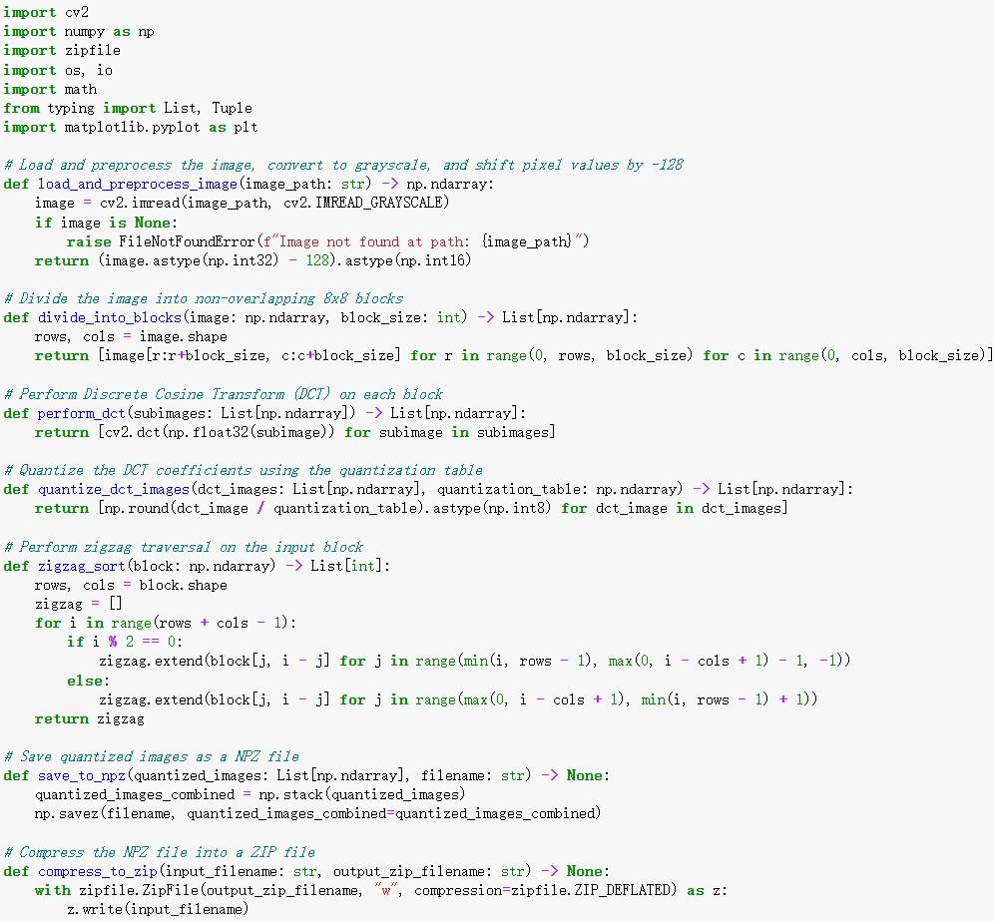
Fig 3.1 Code(each function)
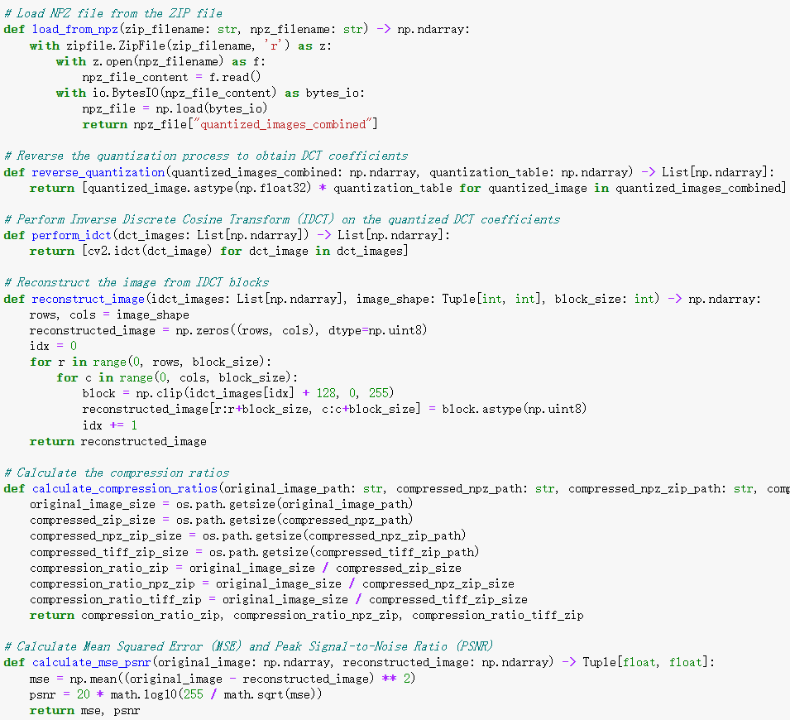
Fig 3.2 Code(each function)
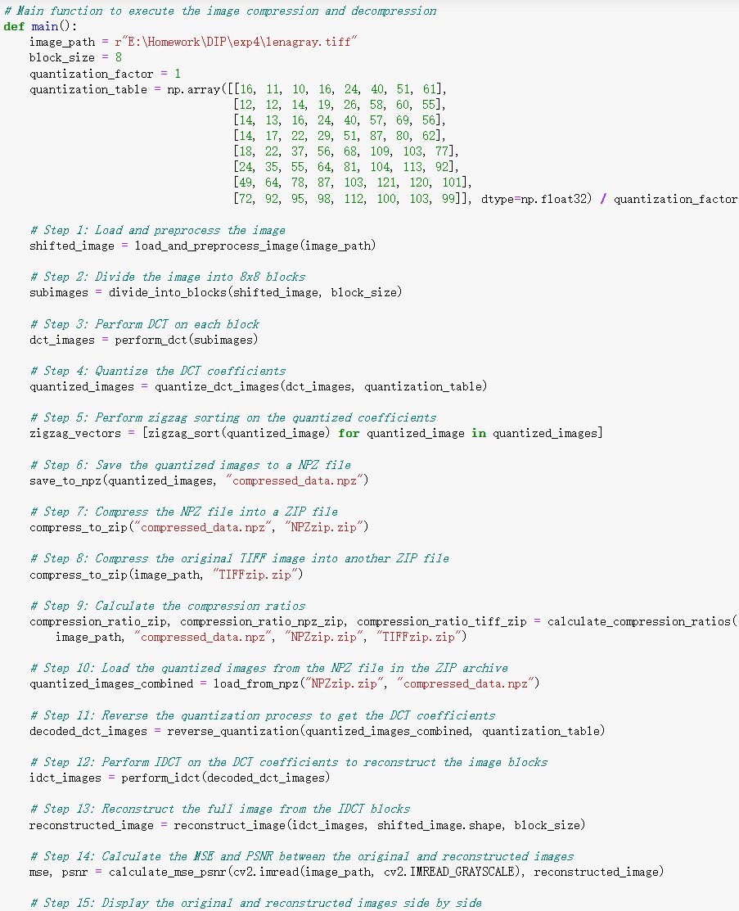
Fig 3.3 Code(The main function)
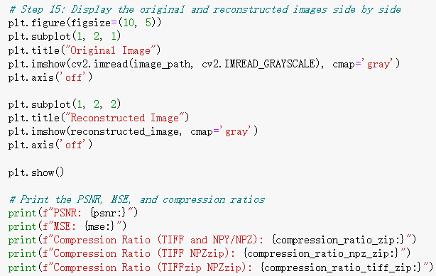
Fig 3.4 Code(result output)
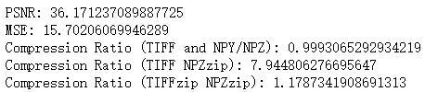
Fig 3.5 Results
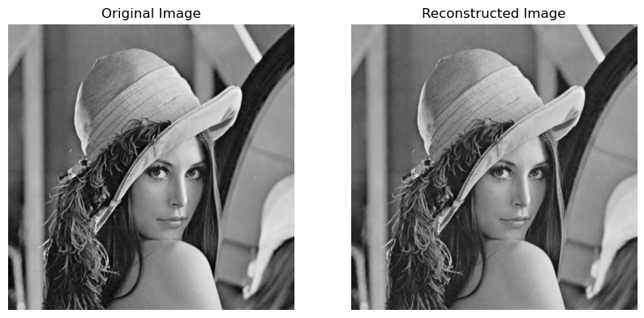
Fig 3.6 Results

深圳大学学生实验报告用纸
实验分析与结论（Analysis and Conclusion）：
- Compression Ratio and Relative Coding Redundancy
Analysis:
From the figures, it can be seen that as the JPEG quality factor decreases, the image compression ratio gradually increases, and the data redundancy also increases. Specifically:
Quality 90: Compression ratio is 8.39, data redundancy is 88.08%.
Quality 60: Compression ratio is 18.61, data redundancy is 94.63%.
Quality 10: Compression ratio is 48.07, data redundancy is 97.92%.
Compression Ratio: An increase in the compression ratio means a decrease in the size of the compressed file relative to the original file size. A high compression ratio is usually accompanied by a reduction in image quality.
Data Redundancy: An increase in data redundancy reflects the degree of information loss during compression. High data redundancy means that more of the original data has been compressed or discarded.
Conclusion:
This experiment demonstrates that the JPEG compression quality factor has a significant impact on image compression effectiveness. Lower quality factors can achieve higher compression ratios and data redundancy but at the cost of image quality. In practical applications, a balance between image quality and file size needs to be struck according to specific needs. For instance, a lower quality factor can be chosen to save storage space or speed up transmission, while a higher quality factor should be selected for applications that require high image quality. Moreover, the choice of image compression techniques should also consider the intended use of the image and the needs of the audience.

- Fidelity Criteria
Paper analysis
In terms of specific calculations, SSIM considers the difference between two image blocks to consist of the following components:
Brightness, corresponding to the mean
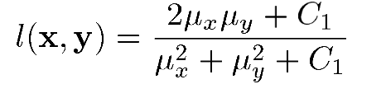
Contrast, corresponding to variance or standard deviation
This is a description of the distribution of image pixel values over the entire dynamic range
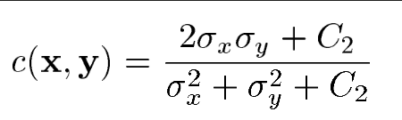
Structure, corresponding to the cosine similarity
It refers to the description of the relative positions and proportions of pixels, which has little to do with the absolute size of the pixel values in the image.
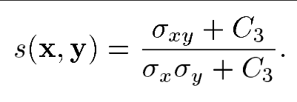
It must be satisfied the condition
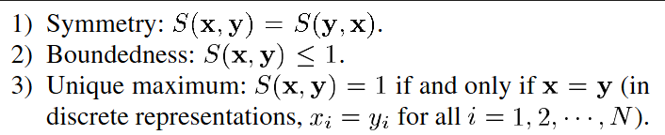
Overall. The information in these three dimensions forms a complementary relationship, forming a description of image quality under the joint constraints of all three. The follow formula are the keys
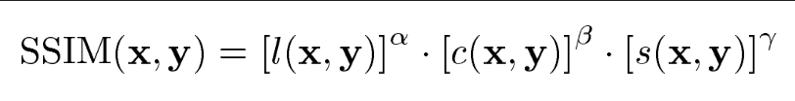
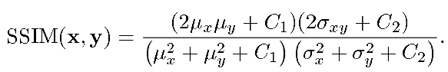
As for the constant value, the paper say as follow:
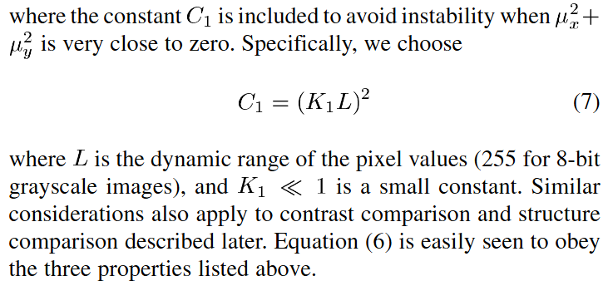
The value of c in the paper is K1=0.01, K2=0.03 L is 255 because it is an 8bits image. I do the same, but it doesn't really matter. The performance of the SSIM index algorithm is fairly insensitive to variations of these values.
Analysis
Based on the change in quality factors, the following specific values are obtained:
JPEG Quality 90: MSE: 3.22, PSNR: 43.05 dB, SSIM: 0.9879, Manual SSIM: 1.1148
JPEG Quality 60: MSE: 9.52, PSNR: 38.34 dB, SSIM: 0.9680, Manual SSIM: 1.2738
JPEG Quality 10: MSE: 65.01, PSNR: 30.00 dB, SSIM: 0.8408, Manual SSIM: 1.8375
- MSE: As JPEG quality decreases, MSE significantly increases, indicating more errors introduced by compression.
- PSNR: PSNR decreases with lower quality, and higher PSNR generally indicates better image quality.
- SSIM: SSIM value decreases as JPEG quality lowers, indicating reduced structural similarity and lower image quality.
- Manual SSIM: This value theoretically should be between 0 and 1, but it exceeds this range in the experiment, possibly due to calculation methods or parameter settings. It is necessary to check if the implementation aligns with the standard SSIM calculation method.
Conclusion
JPEG compression quality significantly affects image quality. At lower quality factors, image loss is evident, making it suitable for applications where storage space is limited but image quality requirements are low. Higher quality factors preserve better visual quality, suitable for applications demanding higher image quality. SSIM and PSNR are powerful tools for evaluating the impact of image compression and can be used together to assess the performance of image processing algorithms. Further investigation and correction of the manual SSIM calculation method are needed to ensure it remains within a reasonable range and accurately reflects changes in image quality.
- Simulation of a Part of JPEG Compression
Analysis
Comparison of Original and Reconstructed Images: The original and reconstructed images are visually very similar, with good detail preservation.
- PSNR: The PSNR of the reconstructed image is 36.17 dB, indicating high image quality.
- MSE: The MSE of the reconstructed image is 15.70, which is relatively low.
Compression Ratios:
- TIFF to NPY/NPZ: 0.9993, indicating almost no compression.
- TIFF to NPZzip: 7.94, showing that ZIP files provide effective compression.
- TIFFzip to NPZzip: 1.18, indicating that NPZ compression offers additional space savings compared to compressing the original TIFF image alone
Conclusion
This experiment demonstrates that partial JPEG simulation (including DCT and quantization) can effectively compress images while maintaining high image quality. A PSNR value of 36.17 dB indicates that the reconstructed image has minimal visual differences from the original, making it suitable for general image compression needs.
Compression ratio analysis shows that while individual NPY/NPZ files do not significantly reduce size, further compression with ZIP can notably decrease file size. This suggests that additional file compression is beneficial for storing and transmitting JPEG compressed images.
Each step in the compression process (such as quantization and predictive coding) directly affects the final image quality and file size. Compression parameters and techniques should be carefully selected based on specific application scenarios to achieve optimal results.

指导教师批阅意见：

成绩评定：

实验态度  10分 | 实验步骤及代码  40分 | 实验数据与结果  40分 | 实验分析与结论  10分

指导教师签字：李斌
2024 年 5 月 30 日
备注：

