Shenzhen University

Report of The Experiments

Course： Information Security and Blockchain

Topic： Ethereum and Smartcontract

Class： Wenhua

StudentID： 2022110131

Name： Zuyi Liao

Date： 2024/12/29

Score：

1. Experiment Content
1) Write a simple smart contract, simulate deploying it and calling it.

先配环境

2) (Optional) Write a simple, smart contract for issuing your own ERC20 tokens (name your own token names), and deploy it to the ethereum test network, and perform a transfer demonstration.
2. The experimental code and results screenshots
·Task1: Write a simple smart contract, simulate deploying it and calling it.
·Experimental environment: Remix IDE
·Programming Language: solidity
·Experimental settings:
Remix VM (Shanghai) with 10 virtual accounts, each with 100 ETH

The core functions of smart contracts:
Simulate ownership transfer through smart contract, with a transfer fee of 1ETH.
Interested buyers need to pay 1 ETH to the smart contract first. After the buyer makes a request, only the current owner's account can agree to the transfer. Subsequently, ownership is transferred to the buyer, and the previously paid 1ETH is transferred from the contract account to the transferor's wallet.
At the same time, before the ownership owner agrees to the transfer, the buyer can directly apply for a refund through the smart contract, refunding the 1ETH previously paid to the contract account to the buyer's account.

The solidity code:
// SPDX-License-Identifier: MIT
pragma solidity ^0.8.0;

contract OwnershipTransfer {
address payable public owner;
address payable public buyer;
uint256 public transferFee = 1 ether;

event OwnershipTransferred(address indexed previousOwner, address indexed buyer);

constructor() {
owner = payable(msg.sender);
}

modifier onlyOwner() {
require(msg.sender == owner, "Only the owner can call this function.");
_;
}

modifier onlyBuyer() {
require(msg.sender == buyer, "Only the buyer can call this function.");
_;
}

function transferOwnership() public payable {
require(msg.value == transferFee, "Payment amount must be 1 ETH.");

buyer = payable(msg.sender);
}

function acceptOwnership() public onlyOwner {
require(buyer != address(0), "New owner address is not set.");
emit OwnershipTransferred(owner, buyer);
owner.transfer(address(this).balance);
owner = buyer;
buyer = payable(address(0));
}

function Refund() public onlyBuyer {
require(buyer != address(0), "Invalid address!");
buyer.transfer(transferFee);
buyer = payable(address(0));
}
}

Key code explanation:
Modifiers: Modifiers are code that can be executed before and/or after a function call. Modifiers can be used to restrict function access, validate function inputs, and protect against attack vectors.

# Only the owner can call the function to approve the transfer request.
modifier onlyOwner() {
require(msg.sender == owner, "Only the owner can call this function.");
_;
}
# The specific function for owner
function acceptOwnership() public onlyOwner

# Only the buyer can call the function to request a refund.
modifier onlyBuyer() {
require(msg.sender == buyer, "Only the buyer can call this function.");
_;
}
# The specific function for buyer
function Refund() public onlyBuyer

# Transfer 1 ETH from the contract account to the transferor
owner.transfer(address(this).balance);

# This function is payable and the interested buyers need to pay 1ETH to the contract account in order to apply for ownership
function transferOwnership() public payable {
require(msg.value == transferFee, "Payment amount must be 1 ETH.");

buyer = payable(msg.sender);
}

·During the process of Remix calling the smart contract
Red Button Functions: Functions with red buttons are payable and can create transactions that accept Ether. The value for these transactions is entered in the "Value" field, located beneath the "Gas Limit" field. These also incur gas fees upon execution.

Note that Address 0 is a special address in a smart contract used to represent invalid or invalid addresses. Compile and deploy the aforementioned Solidity code in Remix IDE.
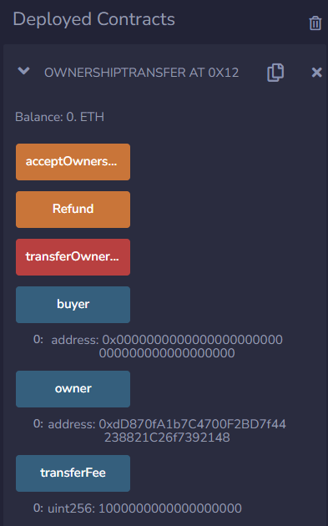
Fig.1.1 The call interface of the smart contract

The smart contract name: OwnershipTransfer
The contract account address: 0x12190647C38e2D35BAa6F4d6da44475285fee5d1

From the Fig.1.1, we can know that the ownership is held by the external account that deploys the contract initially. Specifically, the address of the owner is
0xdD870fA1b7C4700F2BD7f44238821C26f7392148
Current balance of the address above: 98.999999999999007735 ether. Note that the deployment of the contract requires gas consumption, and Remix will charge a certain deployment fee based on the complexity of your code.

The transfer fee is 1ether and there is no any interested buyer at this time. As a result, the buyer’s address shows an invalid string: 0x0000000000000000000000000000000000000000.

The presentation of 1 ether: 1000000000000000000. In the simulation environment, the numerical representation of Ethereum has an accuracy of 18 decimal places.

The interested buyer: 0x4B0897b0513fdC7C541B6d9D7E929C4e5364D2dB
The balance of the account: 100.999999999997565332 ether
After the buyer pay 1 ether to the contract account the balance is 99.999999999997519818 ether.
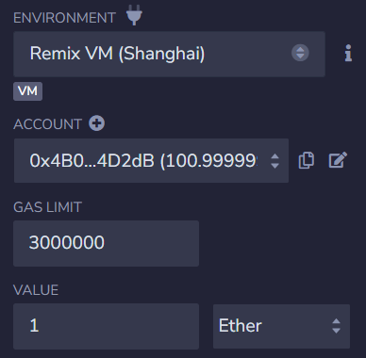
Fig.1.2 The setting of payment amount
After the buyer clicked the red button function -- “transferOwnership” (gas-consumed), the successful payment log information is shown below.
Fig.1.2 The successful payment log information

At the same time, we can check the owner and the buyer about their address. The address information is shown in the Fig.1.3. Also, the balance of the contract account is 1 ETH.
The address of buyer: 0x4B0897b0513fdC7C541B6d9D7E929C4e5364D2dB
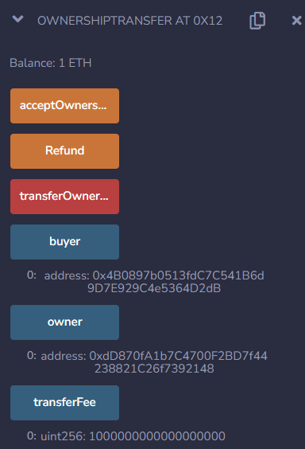
Fig.1.3 The call interface of the smart contract

However, the buyer withdrew the request and would like to apply for a refund (gas-consumed), at that time the owner has not yet approved to the transfer.
Fig.1.4 The successful refund log information

After a refund, the balance of buyer’s wallet: 100.999999999997488892 ether

Now let’s simulate the complete transfer process.
Another buyer:
0x1aE0EA34a72D944a8C7603FfB3eC30a6669E454C (96.99999999999883608 ether)

Note that non owners cannot agree to transfer, otherwise the contract will report an error as shown below.
Fig.2.1 The failed approval log information
The owner clicked the bottom “acceptOwnership” (gas-consumed) and successful log is shown below.
Fig.2.2 The successful approval log information
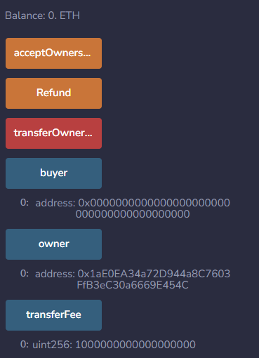
Fig.2.3 The call interface of the smart contract

From the figure above, we could observe that the owner's address has changed, and the balance in the contract account has become 0, indicating that 1 ETH has been paid to the transferor's account.
As a result, we have simulated the process of refund and successful transfer. We can see that this third-party free transfer process is completely transparent, and the transaction does not require payment to intermediaries. We only need to pay a small portion of the running code gas, which is undoubtedly beneficial for both buyers and sellers.

Task2: Write a simple, smart contract for issuing your own ERC20 tokens (name your own token names), and deploy it to the ethereum test network, and perform a transfer demonstration.
·Experimental environment: Remix IDE
·Programming Language: solidity
·Experimental settings:
Injected Provider – MetaMask Sepolia (11155111) network

ERC stands for Ethereum Request for Comment, and 20 is the proposal identifier number. ERC-20 was designed to improve the Ethereum network.
ERC-20 is one of the most significant ERCs. It has emerged as the technical standard for writing smart contracts on the Ethereum blockchain network, used for token implementation. ERC-20 contains a set of rules that all Ethereum based tokens must follow.
ERC-20 defines tokens as blockchain-based assets that can be sent/received and have value. ERC-20 tokens are similar to Bitcoin and Litecoin in many aspects. However, the most significant difference is that instead of running on their own blockchain network, ERC-20 coins run on Ethereum’s blockchain network and use gas as the transaction fee.

There are a multitude of ERC20-compliant tokens already operational on the Ethereum blockchain, developed by different groups. These implementations vary, with some focusing on reducing gas costs and others prioritizing enhanced security. For a robust and secure implementation, many developers opt to use OpenZeppelin's ERC20 token standard. OpenZeppelin provides a well-tested, community-audited library of reusable smart contracts, which includes a reliable and secure framework for ERC20 tokens, making it a preferred choice for ensuring compliance and security in token development.
For ease and security, we’ll use the OpenZeppelin ERC-20 contract to create our token. With OpenZeppelin, we don’t need to write the whole ERC-20 interface. Instead, we can import the library contract and use its functions.

In this example, 1 million tokens are minted and assigned to the address that deploys the contract. The number of tokens is adjusted by the decimals value, which defaults to 18 in the OpenZeppelin implementation.

The solidity code:
// SPDX-License-Identifier: MIT
pragma solidity ^0.8.20;

import "@openzeppelin/contracts/token/ERC20/ERC20.sol";

contract MyToken is ERC20 {
constructor() ERC20("Humble", "HB") {
_mint(msg.sender, 1000000 * (10 ** uint256(decimals())));
}
}

The token name and symbol: Humble, HB
The Contract address: 0x2CBf68c8F69B0c59671016b9FC971094B60aEfB2

After compiling and deploying the smart contract, we can see our contract on a blockchain explorer, a beginner-friendly useful tool used to analyze various blockchain data. After searching our contract's address on Etherscan Sepolia Explorer, we could see our token name and token symbol under the Token Tracker section. The transactions of ERC20 Token -- Humble is shown below.
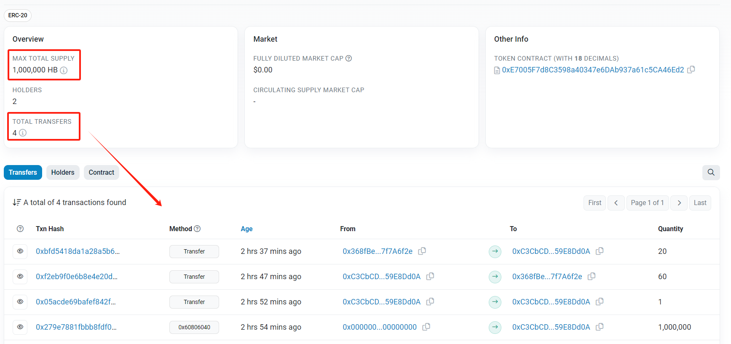
Fig.2.4 The transactions of my ERC20 Token -- Humble(HB)
To see my token in my MetaMask, I copy the deployed contract’s address and open MetaMask, click on the Import tokens button and paste the contract’s address in the Token contract address field. Then MetaMask will fetch the Token Symbol and decimals automatically. After that, we can see the token “HB” had been added to my wallet (Account1); it will be available under the assets section in MetaMask.
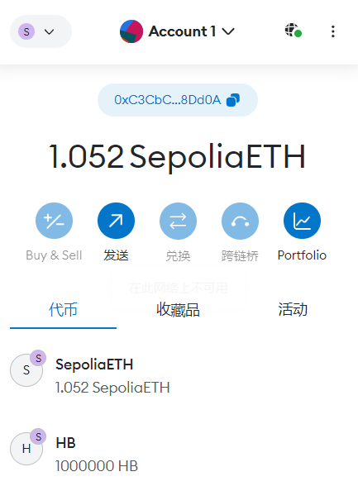
Fig.3.1 The ERC20 Token(HB) in my MetaMask wallet

After that, we can implement other functions in the smart contract in two MetaMask accounts.
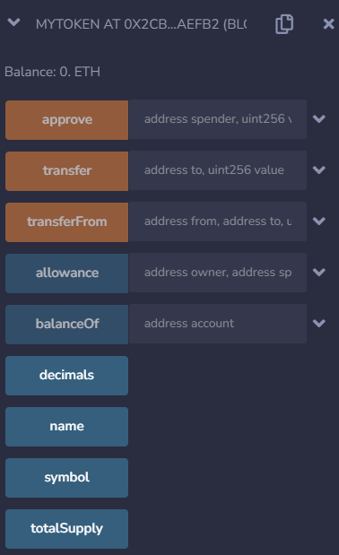
Fig.3.2 The call interface of the smart contract MyToken (ERC20)

The mandatory functions are listed below with explanations.

totalSupply: A method that defines the total supply of your tokens; when this limit is reached, the smart contract will refuse to create new tokens.
balanceOf: A method that returns the number of tokens a wallet address has.
transfer: A method that takes a certain amount of tokens from the total supply and gives it to a user.
transferFrom: Another type of transfer method that is used to transfer tokens between users.
approve: This method verifies whether a smart contract is allowed to allocate a certain amount of tokens to a user, considering the total supply.
allowance: This method is exactly the same as the approved method except that it checks if one user has enough balance to send a certain amount of tokens to another.

Here I show the process of transfer operation between two MetaMask account. After transferring 60HB from account1 to account2, we could observe that the 60HB appears in the token list of account2. The call process and the result are shown in the Fig.3.3. The functions with orange Button are gas consumed.

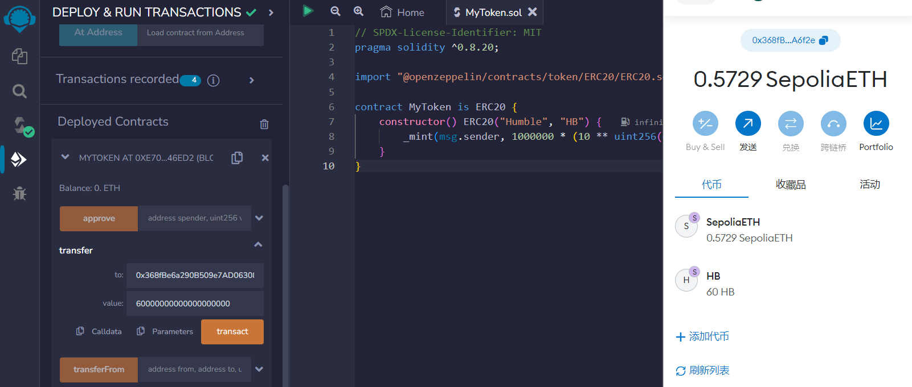
Fig.3.3 Transferring 60HB from account1 to account2

·For convenience, we will directly demonstrate other function functions on the virtual account.

Address “0x5B38Da6a701c568545dCfcB03FcB875f56beddC4” denote account A
Address “0x5c6B0f7Bf3E7ce046039Bd8FABdfD3f9F5021678” denote account B
Address “0x17F6AD8Ef982297579C203069C1DbfFE4348c372” denote account C

Firstly, the initial amount of HB of account A is 10000000HB.
Then, 20HB is transferred to account B from account A.
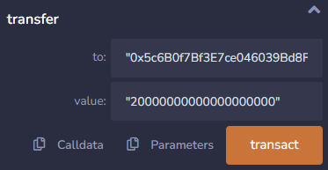
The function “approve”: Approve the spender account to transfer certain value tokens from one's own account.
Owner is A, the approved spender is B. The value is 50HB.
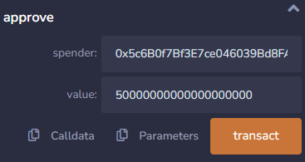

Then we convert to the account B. Then we call the “transferFrom” function. Here the account B implement the function to make 10HB transfer from account A to account C.
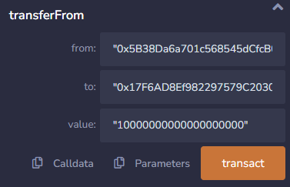
After that, we call the function “allowance” to check the amount of tokens spender can still extract, which is 40HB left.
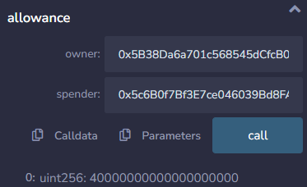
In the end, we check the balance of three account. The token amount of account A reduced 30HB. The token amount of account B increased 20HB. The token amount of account C increased 10HB.
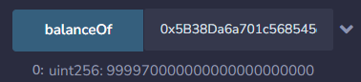
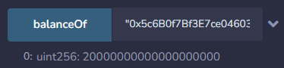
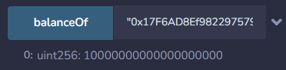
Fig.3.4 The balance of three account after all the operations above

Before the emergence of ERC-20, everyone who created tokens had to reinvent the wheel, which means all tokens were different from each other. For example, if a developer wanted to work with another token, they had to understand the entire smart contract code of that token due to the lack of any specific structure or guidelines for building new tokens. This was particularly painful for wallets and exchange platforms - adding different types of tokens required developers to go through the code of each and every token and understand it in order to handle those tokens on their platforms.
In a word, wallets and exchanges use the ERC-20 standard to integrate various standardized tokens onto their platforms and also facilitate easy exchange between ERC-20 tokens and other tokens. The ERC-20 token standard has made interaction between tokens almost seamless and painless.

