Shenzhen University

Report of The Experiments

Course： Information Security and Blockchain

Topic： Hash Function and AES

Class： wenhua honor class

StudentID： 2022110131

Name： Zuyi Liao

Date： 2024.9.3——2024.9.30

Score：

1. Experiment Content
Task Chosen
b. Refer to the online code for SHA-256 and AES implementations, and write a certain interface (non-DOS interface) to them respectively, to be able to finish calculating the Hash value for a file (e.g. 1.txt), and to be able to encrypt and decrypt the file.

2. The experimental code and results screenshots
（1）Code
import hashlib # For SHA-256 hash calculation
from cryptography.hazmat.primitives.ciphers import Cipher, algorithms, modes # For AES encryption/decryption
from cryptography.hazmat.backends import default_backend
from cryptography.hazmat.primitives import padding # For handling block size padding
import os # For generating random numbers (e.g., AES key and IV)
import tkinter as tk
from tkinter import ttk
from tkinter import filedialog, messagebox
# 1. Compute the SHA-256 hash of a file
def calculate_sha256(file_path):
"""
Computes the SHA-256 hash of the given file.
Parameters:
file_path (str): Path to the file
Returns:
str: SHA-256 hash of the file
"""
sha256_hash = hashlib.sha256() #
Create a SHA-256 hash object
with open(file_path, "rb") as f: # Open the file in binary mode
for byte_block in iter(lambda: f.read(4096), b""): # Read the file in chunks to prevent memory overflow
sha256_hash.update(byte_block) # Update the hash object
return sha256_hash.hexdigest() # Return the hexadecimal hash value
# 2. AES encryption and decryption class
class AESCipher:
"""
AES encryption and decryption class.
"""
def __init__(self, key):
"""
Initializes the AES key.
Parameters:
key (bytes): 32-byte AES key
"""
self.key = key # Store the key
self.backend = default_backend() # Use the default cryptographic backend
self.block_size = algorithms.AES.block_size # AES block size (128 bits)
def encrypt(self, plaintext):
"""
Encrypts data using AES.
Parameters:
plaintext (bytes): Plain text data
Returns:
bytes: Encrypted cipher text, including the IV
"""
iv = os.urandom(16) # Generate a 16-byte random IV (Initialization Vector)
cipher = Cipher(algorithms.AES(self.key), modes.CBC(iv), backend=self.backend) # Create AES cipher object
encryptor = cipher.encryptor() # Create an encryptor
# Use PKCS7 padding to make plaintext length a multiple of block size
padder = padding.PKCS7(self.block_size).padder()
padded_data = padder.update(plaintext) + padder.finalize()
# Encrypt data
ciphertext = encryptor.update(padded_data) + encryptor.finalize()
return iv + ciphertext # Return the combination of IV and cipher text
def decrypt(self, ciphertext):
"""
Decrypts data using AES.
Parameters:
ciphertext (bytes): Cipher text, including the IV
Returns:
bytes: Decrypted plain text data
"""
iv = ciphertext[:16] # Extract the IV from the cipher text
actual_ciphertext = ciphertext[16:] # Extract the actual cipher text
cipher = Cipher(algorithms.AES(self.key), modes.CBC(iv), backend=self.backend) # Create AES cipher object
decryptor = cipher.decryptor() # Create a decryptor
# Decrypt data
decrypted_padded_data = decryptor.update(actual_ciphertext) + decryptor.finalize()
# Remove padding
unpadder = padding.PKCS7(self.block_size).unpadder()
decrypted_data = unpadder.update(decrypted_padded_data) + unpadder.finalize()
return decrypted_data
# GUI Application
class Application(tk.Tk):
def __init__(self):
super().__init__()
self.title("File Hash and AES Encryption Tool")
self.geometry("500x300")
self.resizable(False, False)
self.key = os.urandom(32) # Generate a 32-byte AES-256 key
self.aes_cipher = AESCipher(self.key)
self.create_widgets()
def create_widgets(self):
# Use ttk styles
style = ttk.Style()
style.theme_use('clam') # Available themes: clam, alt, default, classic
# Main frame
main_frame = ttk.Frame(self, padding="10")
main_frame.pack(fill=tk.BOTH, expand=True)
# File selection section
file_frame = ttk.LabelFrame(main_frame, text="File Selection", padding="10")
file_frame.pack(fill=tk.X, expand=False)
self.file_label = ttk.Label(file_frame, text="No file selected.")
self.file_label.pack(side=tk.LEFT, padx=5)
self.select_button = ttk.Button(file_frame, text="Select File", command=self.select_file)
self.select_button.pack(side=tk.RIGHT, padx=5)
# Operation buttons section
button_frame = ttk.Frame(main_frame, padding="10")
button_frame.pack(fill=tk.BOTH, expand=True)
self.hash_button = ttk.Button(button_frame, text="Compute SHA-256 Hash", command=self.compute_hash, state=tk.DISABLED)
self.hash_button.pack(fill=tk.X, pady=5)
self.encrypt_button = ttk.Button(button_frame, text="Encrypt File", command=self.encrypt_file, state=tk.DISABLED)
self.encrypt_button.pack(fill=tk.X, pady=5)
self.decrypt_button = ttk.Button(button_frame, text="Decrypt File", command=self.decrypt_file, state=tk.DISABLED)
self.decrypt_button.pack(fill=tk.X, pady=5)
# Status bar
self.status_var = tk.StringVar()
self.status_var.set("Ready")
status_bar = ttk.Label(self, textvariable=self.status_var, relief=tk.SUNKEN, anchor=tk.W)
status_bar.pack(side=tk.BOTTOM, fill=tk.X)
def select_file(self):
file_path = filedialog.askopenfilename()
if file_path:
self.file_path = file_path
self.file_label.config(text=f"Selected File: {os.path.basename(file_path)}")
self.hash_button.config(state=tk.NORMAL)
self.encrypt_button.config(state=tk.NORMAL)
self.decrypt_button.config(state=tk.NORMAL)
self.status_var.set(f"Selected File: {os.path.basename(file_path)}")
def compute_hash(self):
hash_value = calculate_sha256(self.file_path)
messagebox.showinfo("SHA-256 Hash", f"File: {os.path.basename(self.file_path)}\nHash Value:\n{hash_value}")
self.status_var.set("SHA-256 hash computation completed")
def encrypt_file(self):
with open(self.file_path, "rb") as f:
file_data = f.read()
encrypted_data = self.aes_cipher.encrypt(file_data)
encrypted_file_path = self.file_path + ".enc"
with open(encrypted_file_path, "wb") as f:
f.write(encrypted_data)
messagebox.showinfo("Encryption", f"File encrypted successfully.\nSaved as {encrypted_file_path}")
self.status_var.set(f"File encrypted and saved as {os.path.basename(encrypted_file_path)}")
def decrypt_file(self):
if not self.file_path.endswith(".enc"):
messagebox.showwarning("Decryption", "Selected file is not an encrypted file (.enc).")
self.status_var.set("Decryption failed: Not an encrypted file")
return
with open(self.file_path, "rb") as f:
encrypted_data = f.read()
try:
decrypted_data = self.aes_cipher.decrypt(encrypted_data)
decrypted_file_path = self.file_path.replace(".enc", ".dec")
with open(decrypted_file_path, "wb") as f:
f.write(decrypted_data)
messagebox.showinfo("Decryption", f"File decrypted successfully.\nSaved as {decrypted_file_path}")
self.status_var.set(f"File decrypted and saved as {os.path.basename(decrypted_file_path)}")
except Exception as e:
messagebox.showerror("Decryption Error", f"An error occurred during decryption:\n{e}")
self.status_var.set("An error occurred during decryption")
# Run the application
if __name__ == "__main__":
app = Application()
app.mainloop()
（2）Results Screenshots
Step One：
Create a new .txt file for encryption and decryption processing
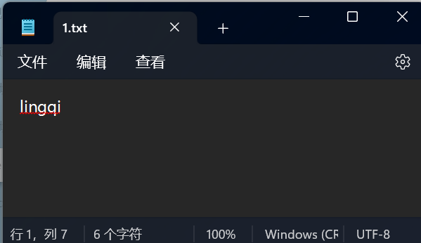
Step Two:
Run the program and read the txt
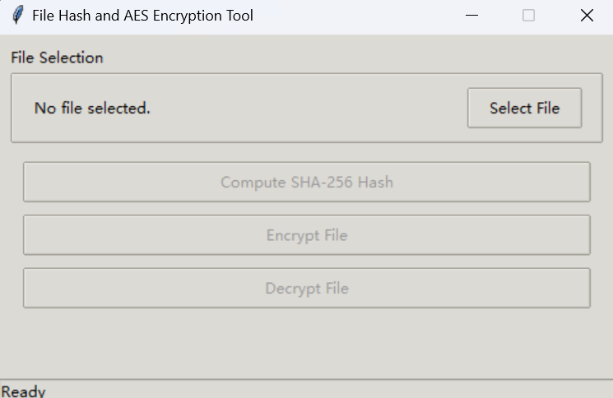

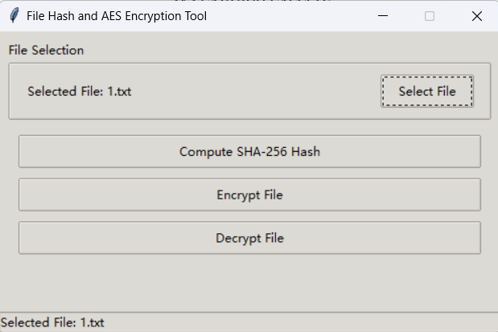
Step Three：
Compute SHA-256 Hash
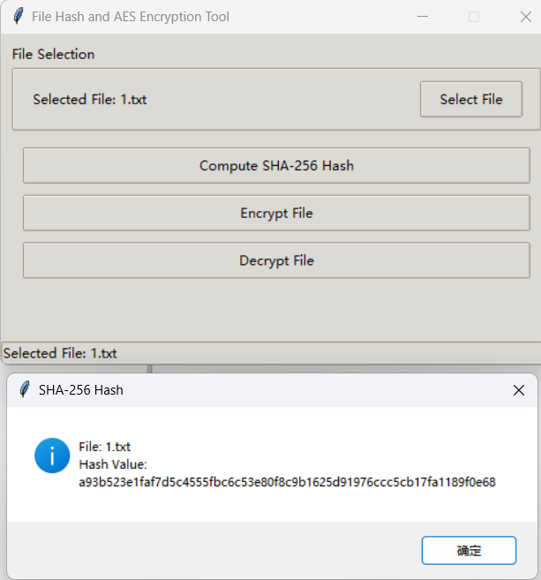
Step Four：
Encrypt File
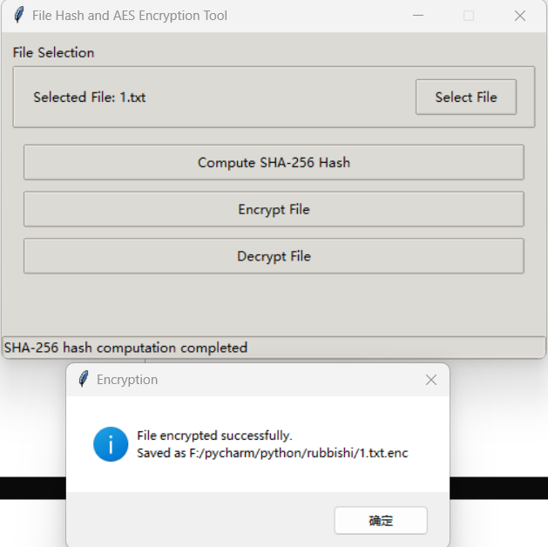
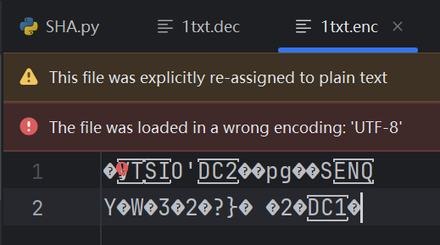
Step Five：
Decrypt File
