**深 圳 大 学 实 验 报 告**

**课程名称：­ 随机信号处理**

**实验项目名称： Experiment one**

**学院： 电子与信息工程学院**

**专业： 电子信息工程**

**指导教师： 孙维泽**

**报告人： 廖祖颐 学号： 2022110131**

**班级： 文华班**

**实验时间： 2024.3.17-2023.4.12**

**实验报告提交时间： 2024.4.12**

**教务处制**

Description of format:

* Use Times New Roman, 12 pt, single column, single line spacing.
* When inserting figures and tables, title of the figures and tables must be included.
* Do not change ‘1、Purposes of the experiment’ and ‘2、Design task and detail requirement’.

**1、Purposes of the experiment**

1. Use Matlab to show some commonly used distribution of random variables.
2. Use correct equations (Bayes’ theorem) to design a strategy for the games in ‘3. Advance’ and ‘4. Extra’.
3. Analyze the results and draw reasonable conclusions

**2、Design task and detail requirement**

See ‘Appendix 1 – Task and requirement for experimental report 1.doc’.

**3、The result and Analysis**

* **Part 1:** submit your programs only.
* **Part 2:**

1. **Your result figures**

Below are eight figures displaying histograms, estimated PDFs/PMFs, and actual PDFs/PMFs generated by the computer for data drawn from the Rayleigh, Poisson, Uniform, and Exponential distributions. Each distribution is illustrated with two sets of data: one consisting of 50 random points and another with 5000 random points

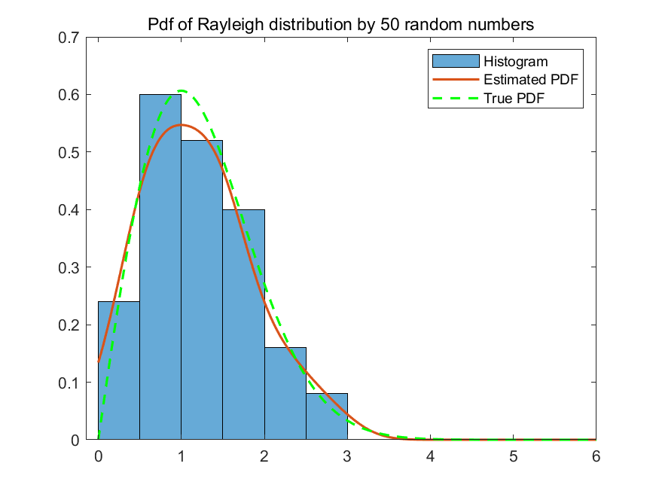

Fig 1 Rayleigh distribution of 50

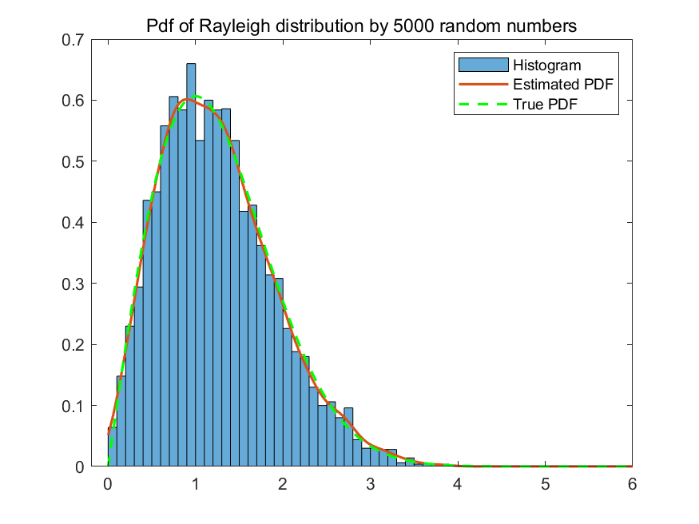

Fig 2 Rayleigh distribution of 5000

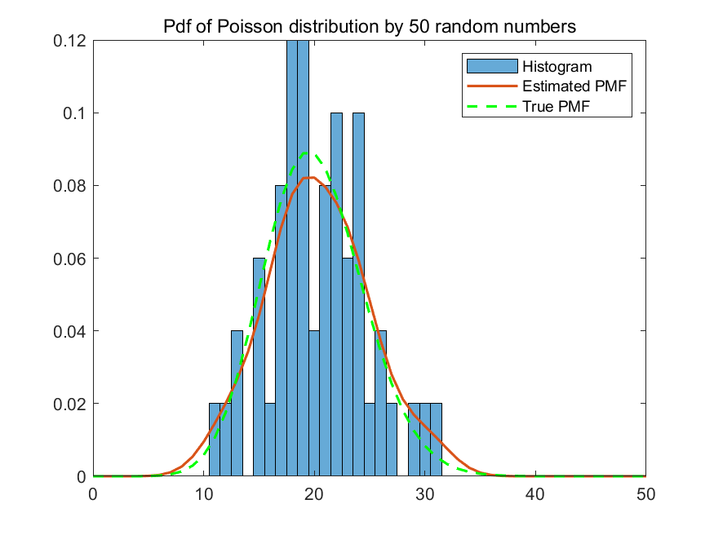

Fig 3 Poisson distribution of 50

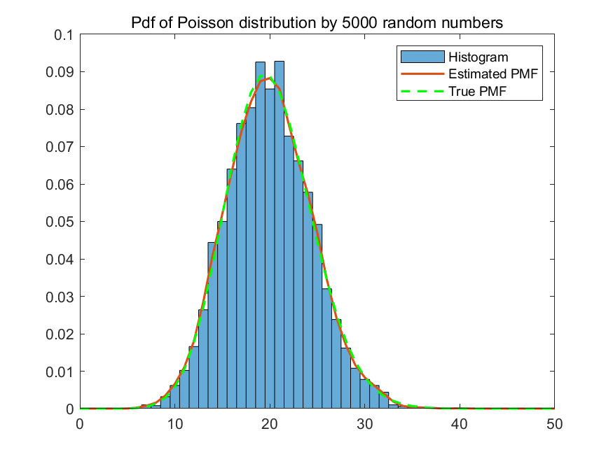

Fig 4 Poisson distribution of 5000

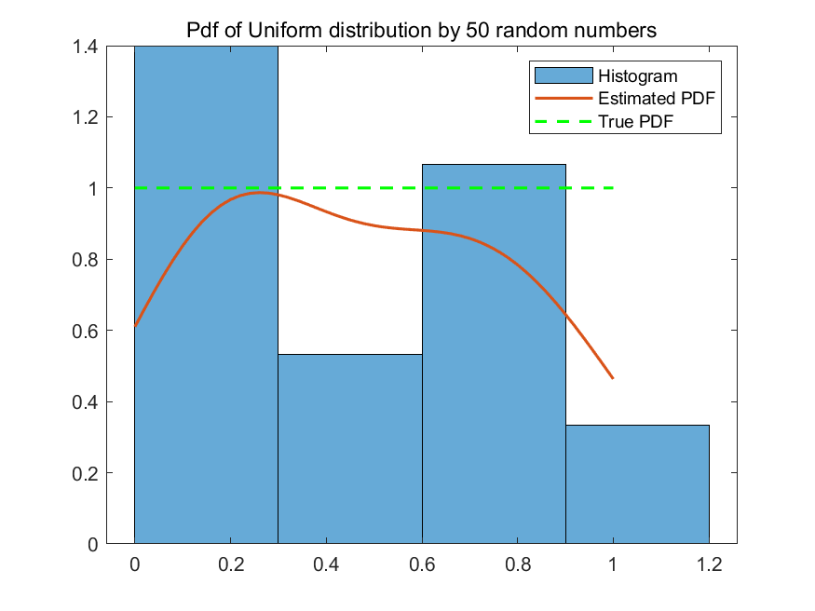

Fig 5 Uniform distribution of 50

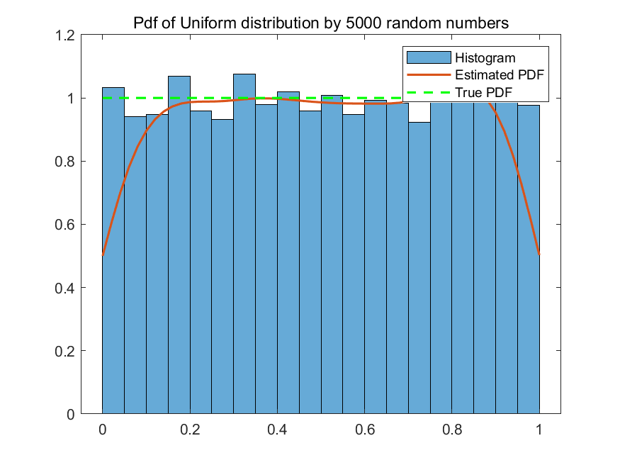

Fig 6 Uniform distribution of 5000

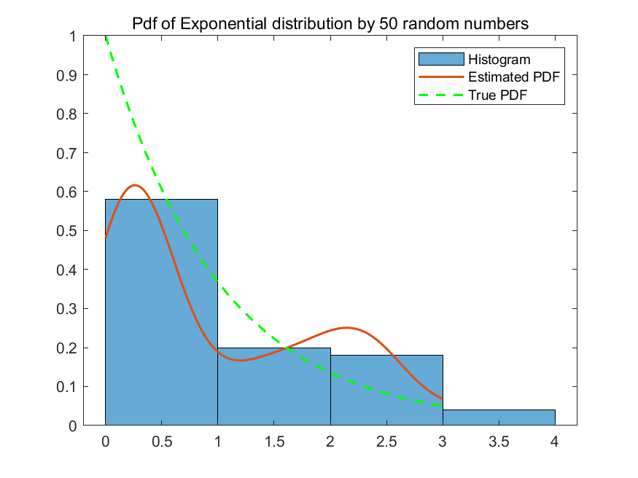

Fig 7 Exponential distribution of 50

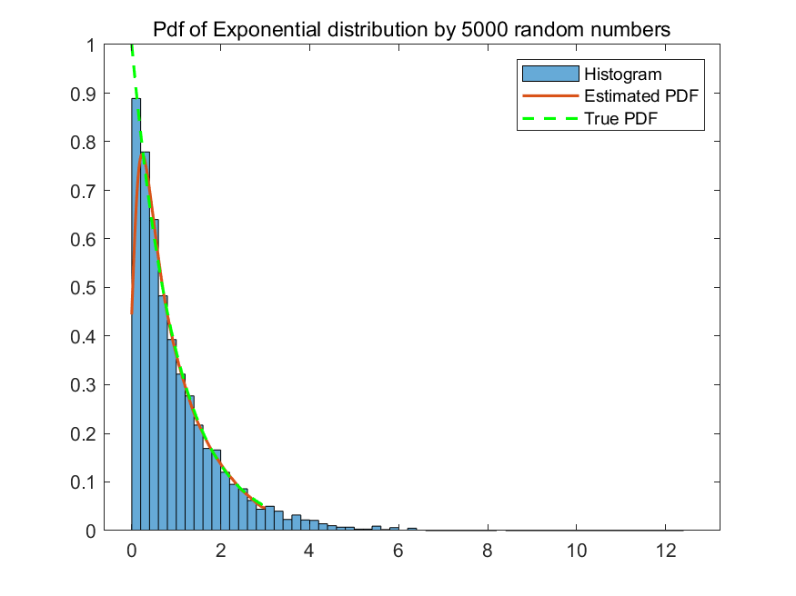

Fig 8 Exponential distribution of 5000

1. **You analysis**

**1. Rayleigh Distribution:**

* **Characteristics:** Continuous with a bell-shaped curve, characterized by a single scale parameter and heavier tails compared to a normal distribution.
* **Simulation Approach:** We generate either 50 or 5000 random numbers from the Rayleigh distribution using **makedist** and **random** functions, collected in a vector named **x1**. We then estimate the PDF over values from 0 to 6 with increments of 0.02 using **ksdensity**. Visualization includes:
  + A normalized histogram for relative frequency.
  + The estimated PDF from **ksdensity**.
  + The actual PDF derived from the **pdf** function.
* **Findings:** The 5000-point data set yields a smoother and more accurate PDF, illustrating the benefits of increased sample size for continuous distribution analysis.

**2. Poisson Distribution:**

* **Characteristics:** Discrete, typically used to model the number of events within a specified interval, governed by a mean or rate parameter.
* **Simulation Approach:** For a mean of 20, we generate sets of 50 or 5000 random numbers. The PMF is estimated and compared using:
  + A normalized histogram.
  + Estimated PMF from **ksdensity**.
  + Actual PMF plotted for reference.
* **Findings:** Larger datasets (5000 points) show a smoother and more precise PMF, confirming that more data points improve estimation accuracy for discrete distributions.

**3. Uniform Distribution:**

* **Characteristics:** Continuous, defined by uniform outcomes within specified bounds, resulting in a rectangular shape.
* **Simulation Approach:** We generate 50 or 5000 samples and use Kernel Density Estimation (KDE) to estimate the PDF. This involves:
  + Histograms showing sample distribution.
  + KDE-based estimated PDF alongside the actual PDF.
* **Findings:** Increased sample sizes lead to an estimated PDF that closely resembles the actual PDF, demonstrating KDE's reliability. Adjustments in range and step size (from 0.02 to 0.2) significantly affect the resolution and smoothness of the estimation.

**4. Exponential Distribution:**

* **Characteristics:** Continuous, used to model the time between events in a Poisson process, characterized by a rate parameter.
* **Simulation Approach:** We generate either 50 or 5000 random numbers and apply KDE to estimate the PDF. We examine:
  + Histograms of the numbers.
  + Both estimated and actual PDFs.
* **Findings:** A larger number of data points (5000) results in a smoother and more accurate PDF, highlighting the importance of sample size in accurately capturing the distribution's characteristics. The selection of step size and range impacts the precision and comprehensiveness of the results.
* **Part 3:Advance**

1. **Explain the reason of your strategy?**

The strategy codes are shown as follow. My strategy is when the probability of counterparty betray p>0.5 in next trade, I will trust the counterparty in next trade, otherwise, I will call the police.

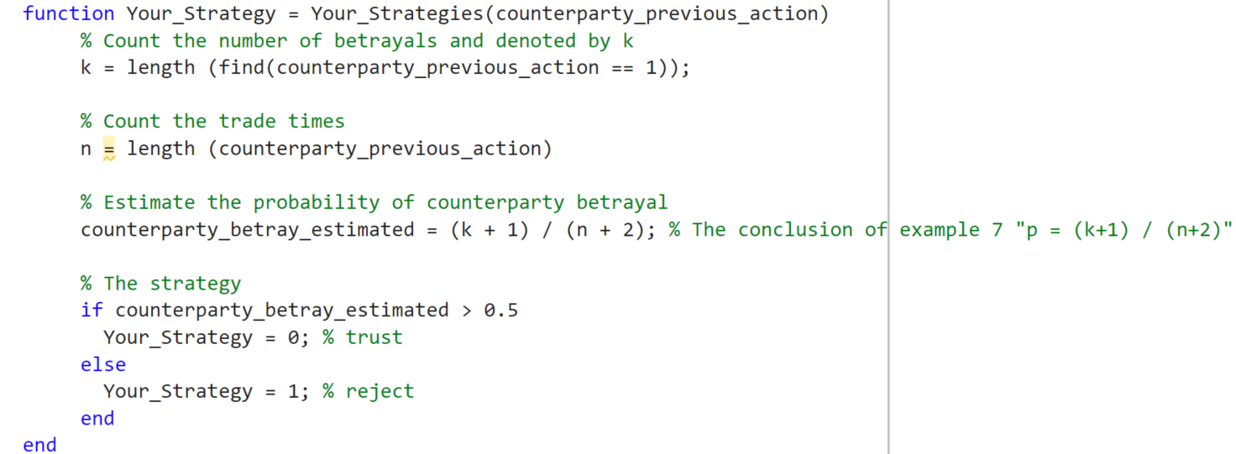

Fig 9 The strategy

We let the p represents the probability of betray of the counterparty whose PDF is uniform distribution in interval (0,1). In addition, we define counterparty betray k times in n specific trades as event A. Since we have 10 previous action record where we can know how much time did the counterparty betray us. In other words, now A event is counterparty betray k times in 10 specific trades.

Soin order to get a high return as far as possible, we should predict the probability of counterparty betray in the next trade according to A. So the distribution we should calculate first is *fP|A*(*p|A*) which represents the updated information given the event A. It is obvious that directly calculate this probability is difficult. But fortunately, according to Bayesian formula, *fP|A*(*p|A*)= $\frac{P(A|P=p)fP(p)}{P(A)}$. So we should calculate $P(A|P=p$) and $P(A)$ first. Given event A is a binomial distribution trail, $P(A|P=p$)=*pk(1-p)n-k*. So P(A)= $\int_{0}^{1}{P(A|P=p)}fP(p)$*dp= $\frac{(n-k)!k!}{(n+1)!}$.*So the *fP|A*(*p|A*)= $\frac{(n+1)!}{(n-k)!k!}$*pk(1-p)n-k*,*0<p<1*.

The probability of counterparty betray in the next trade is defined as P(B). Now *P(B)*= $\int_{0}^{1}{P(B|P=p)fp(p|A)}$*dp= $\frac{k+1}{n+2}$.* In conclusion, if we want to predict the probability of counterparty betray in the next trade, we just calculate the betray time in the previous action and the previous trade times.

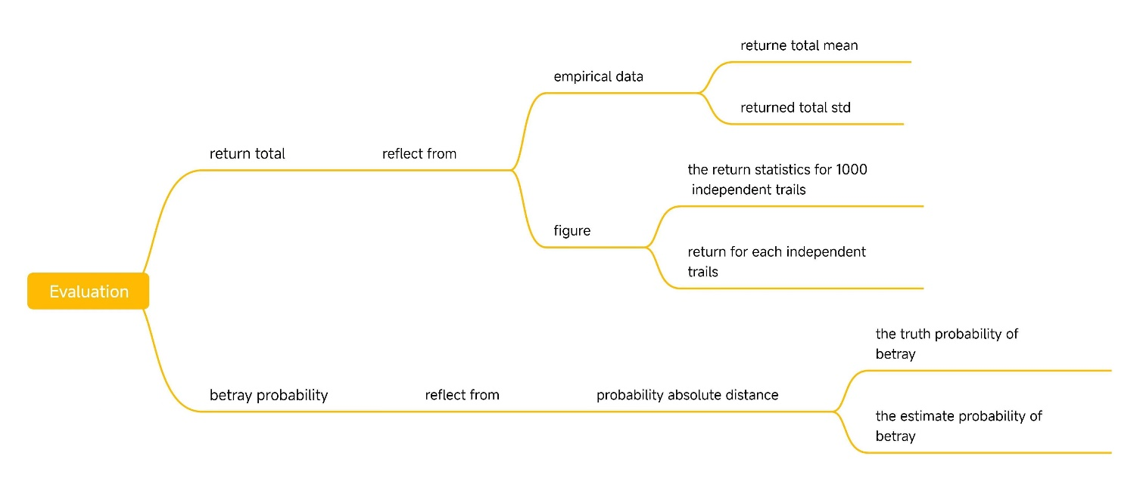

Fig 10 The strategy frame

1. **Betray Probability:**

* To gauge the accuracy of the betrayal probability estimate, you calculate the residual between the true betrayal probability and the estimated betrayal probability. Notably, only the last estimate from the trials is used for this calculation, under the assumption that estimates improve with increasing trials.

1. **Return Total:**

* The evaluation of return total is conducted using two methods:

**Figure Analysis:** You create visual representations of the returns data. This includes plotting return statistics across the trials to analyze the frequency of specific return outcomes, and a scatter plot to visually assess the distribution of returns across each trial.

**Empirical Data Analysis:** You compute the mean and standard deviation of the total returns to quantitatively evaluate your strategy. A relatively high mean combined with a low standard deviation indicates that your strategy is effective, whereas unfavorable values suggest it may be unreasonable.

1. **Results and analysis**
2. **Trade Time and Return Relationship:**

* In the figure 11 analysis, a scatter plot demonstrates the relationship between trade time and return across 1000 trials. Due to the large number of data points, the plot appears dense, but a general trend suggests that returns are predominantly above zero, indicating frequent wins.
* Additionally, a histogram was used to detail the frequency of specific return outcomes, further illustrating the distribution of returns.

1. **Return Distribution Insights:**

* The figure 12 highlights that the minimum return is around -200, while the maximum return peaks at 1000, suggesting a high likelihood of positive returns (calculated as 83.33% probability of a positive outcome).
* Observations from the histogram show that bins representing positive returns are more prevalent and taller compared to those for negative returns, supporting the effectiveness of your strategy.

1. **Quantitative Analysis of Returns:**

* The average total return from these trials is calculated at 488, with a variance of 310.55. This indicates that, on average, trading 100 times under this strategy with a counterparty who has a uniformly distributed betrayal probability, you can expect to achieve approximately 491 in returns.

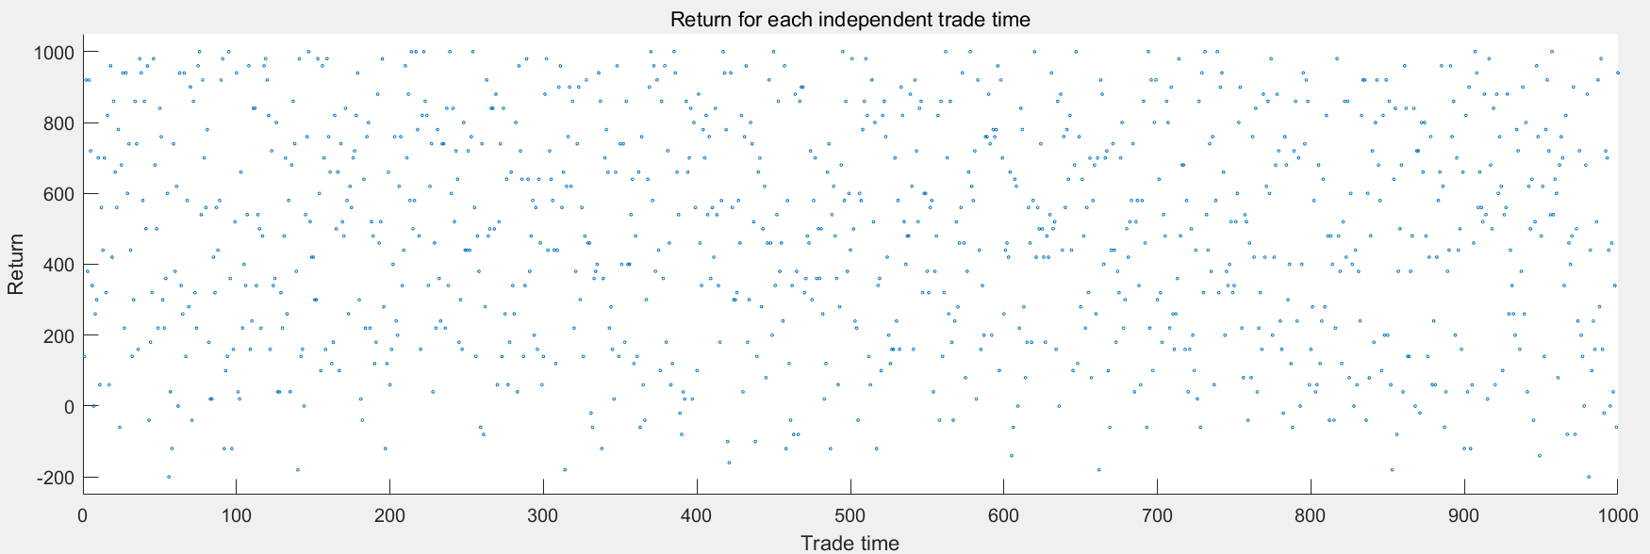

Fig 11 Relationship between trade time and return

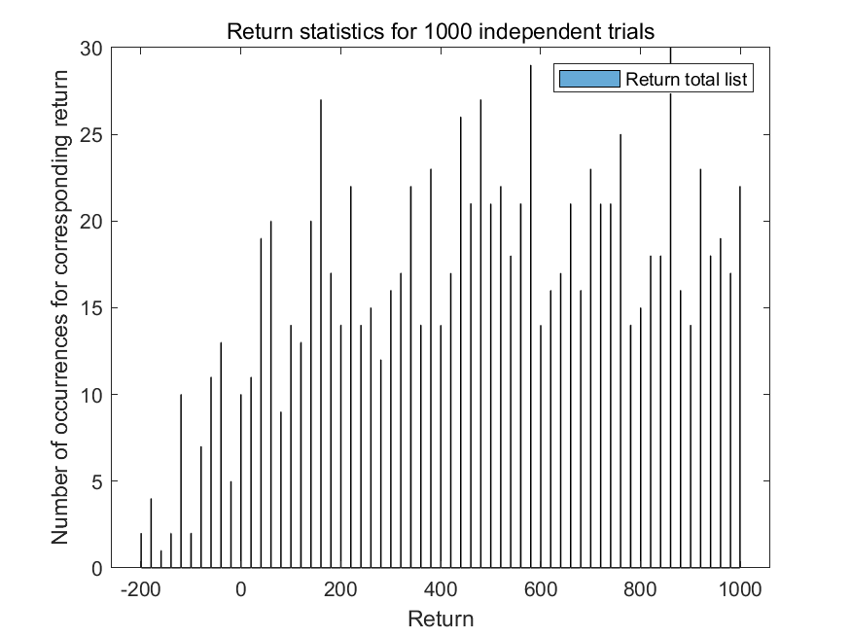 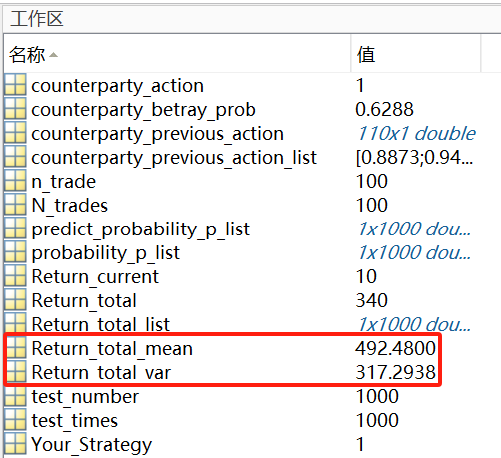

Fig 12 The return and workplace

* **Part 4:Extra**

1. **Your program, and the flow chart of your program**
2. **The reason of your strategy**
3. **Results and analysis, together with: What indicator/indicators is/are used for evaluation? Explain it/them.**

**4、Conclusion**

In the first experiment, I learned to plot the Probability Density Functions (PDFs) for various distributions, such as Uniform, Rayleigh, and Exponential distributions. These plots helped me understand basic characteristics of each distribution.

Additionally, I developed strategies for different scenarios within a game, discovering that changes in game rules can affect the outcomes even if the strategy previously proved effective under different conditions.

I also applied probability concepts, like Bayes' theorem, to devise strategies aimed at optimizing outcomes. Moreover, I adopted statistical data analysis and graphical visualization techniques to assess the performance of my strategies.

|  |
| --- |
| 指导教师批阅意见：  成绩评定：  指导教师签字：  年 月 日 |
| 备注： |

注：1、报告内的项目或内容设置，可根据实际情况加以调整和补充。

2、教师批改学生实验报告时间应在学生提交实验报告时间后10日内。