**深 圳 大 学 实 验 报 告**

**课程名称：­ 随机信号处理**

**实验项目名称： Experiment2**

**学院： 电子与信息工程学院**

**专业： 电子信息工程**

**指导教师： 孙维泽**

**报告人： 廖祖颐 学号： 2022110131**

**班级： 文华班**

**实验时间： 2024.4.23-2024.5.18**

**实验报告提交时间： 2024.5.18**

**教务处制**

Description of format:

* Use Times New Roman, 12 pt, single column, single line spacing.
* When inserting figures and tables, title of the figures and tables must be included.
* Do not change ‘1、Purposes of the experiment’ and ‘2、Design task and detail requirement’.

**1、Purposes of the experiment**

1. Use Matlab to calculate the autocorrelation of some functions, and use the result to solve some typical problems.
2. Analyze the results and give reasonable conclusions

**2、Design task and detail requirement**

See ‘Appendix 1 – Task and requirement for experimental report 2.doc’.

**3、The result and Analysis**

* **Part 1 - Basic 1: (10 points)**

Please provide your code, they must be runnable and output the figure in your report.

1. Plot the signal, and the autocorrelation $R_{X}\left(τ\right)$, and Cross-Correlation $R_{XN}(τ)$.

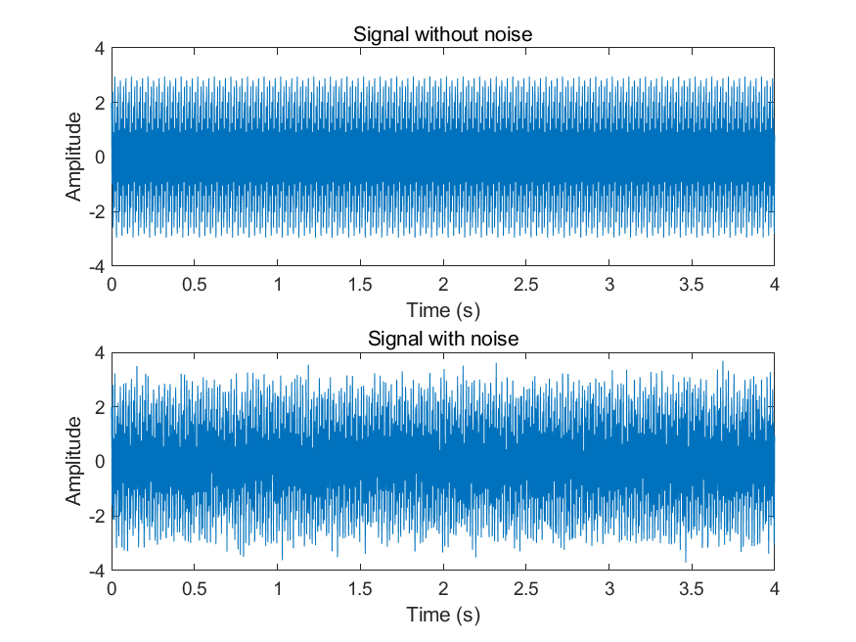

Fig 1.1 The original signal and signal with noise

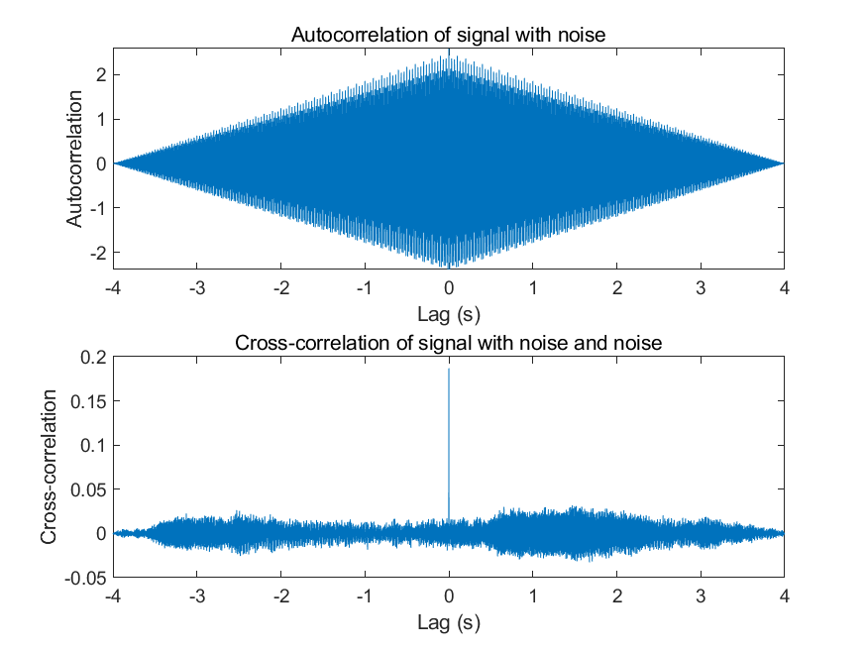

Fig 1.2 The autocorrelation $R_{X}\left(τ\right)$, and Cross-Correlation $R_{XN}(τ)$.

**Autocorrelation Function:**

The first plot shows the autocorrelation function of the noisy signal. As expected for a periodic signal, the autocorrelation function has peaks at lags that are multiples of the signal period (1/frequency). However, due to the presence of noise, the autocorrelation function decays more quickly compared to a noise-free signal. This is because the added noise introduces randomness, reducing the signal's self-similarity over time.

**Cross-Correlation Function:**

The second plot shows the cross-correlation function between the noisy signal and the noise. The cross-correlation function is centered around lag 0, indicating that the noise is uncorrelated with the signal on average. Nevertheless, there are some fluctuations in the cross-correlation function due to the random nature of the noise, which can cause occasional correlations at specific time lags.

* **Part 2 - Basic 2: (40 points)**

1. Write your parameter setting here, using a table.

|  |  |
| --- | --- |
| Parameter | Value |
| Signal Frequency | 99.99 Hz |
| Sampling Rate | 1000 Hz |
| Sampling Period | 0.001s |
| Signal Duration | 1s |
| Phase Shift | 0 |
| Noise Variance | 0.5, 1, 5 |
| Number of Runs | 100 |

1. Use the autocorrelation to estimate your signal frequency, and explain why it is possible to estimate the signal frequency through autocorrelation. (Hint: write some theory/equations here, together with description or explanation. Equations without description or explanation are not acceptable because no one can understand anything with only equations)

Autocorrelation is a mathematical tool used to analyze the similarity between observations as a function of the time lag between them. For a periodic signal, the autocorrelation function is also periodic with the same period. This property can be used to estimate the frequency of a sinusoidal signal.

The autocorrelation function 𝑅X(𝜏) for a signal 𝑋(𝑡) is defined as:

*RX*(*τ*)=E[*X*(*t*)*X*(*t*+*τ*)]

For a periodic signal with period *T*:

*RX* (*τ*)=*RX* (*τ*+*T*)

By finding the peaks in the autocorrelation function, we can determine the period *T* of the signal and thus estimate its frequency *f* using the relation:

*f*=*1/T*

1. For $σ^{2}$ =0.5, 1, 5 (you can try more), plot the figure of Autocorrelation for one run.

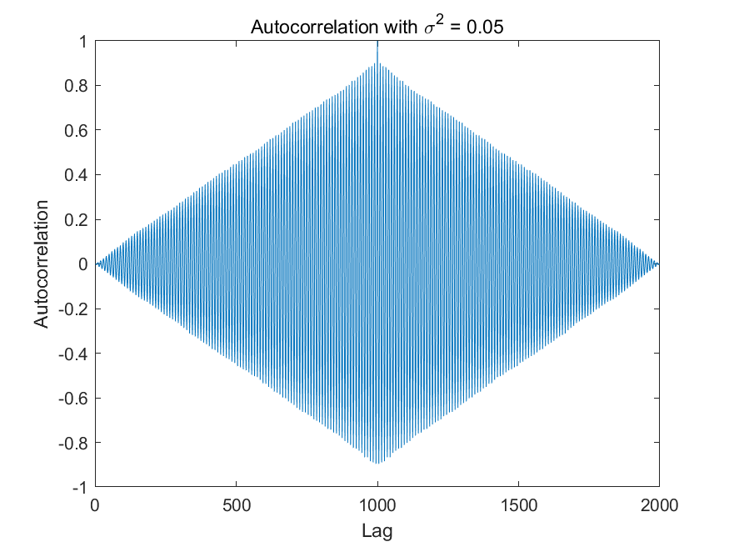

Fig 2.1 Autocorrelation with 𝜎2=0.05

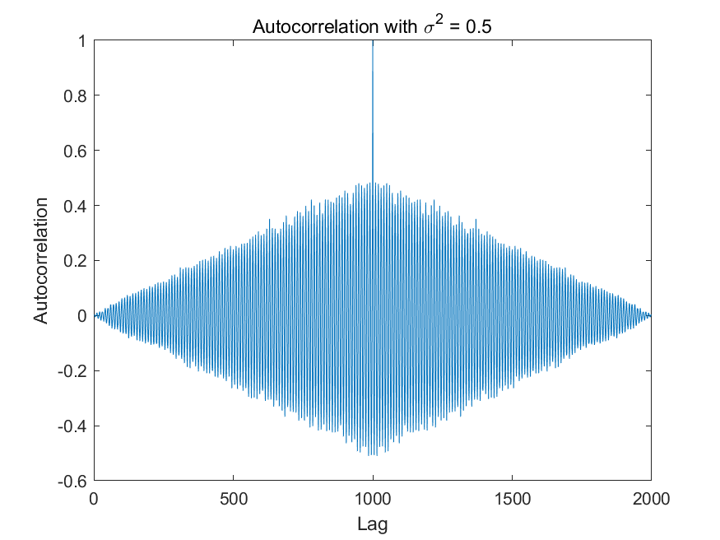

Fig 2.2 Autocorrelation with 𝜎2=0.5

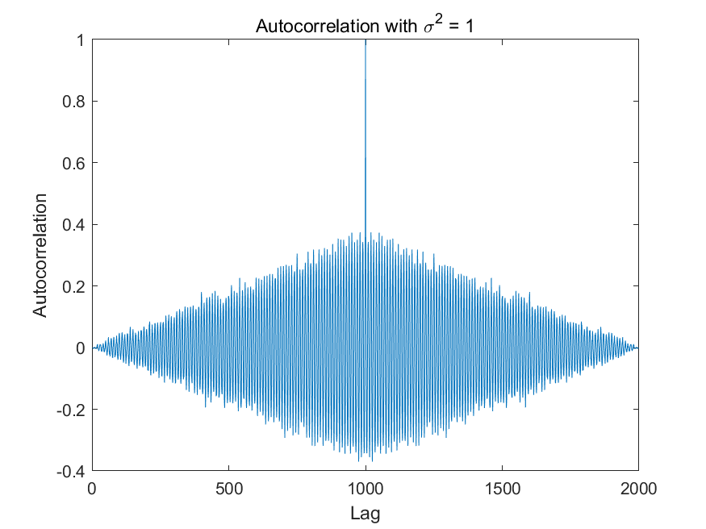

Fig 2.3 Autocorrelation with 𝜎2=1

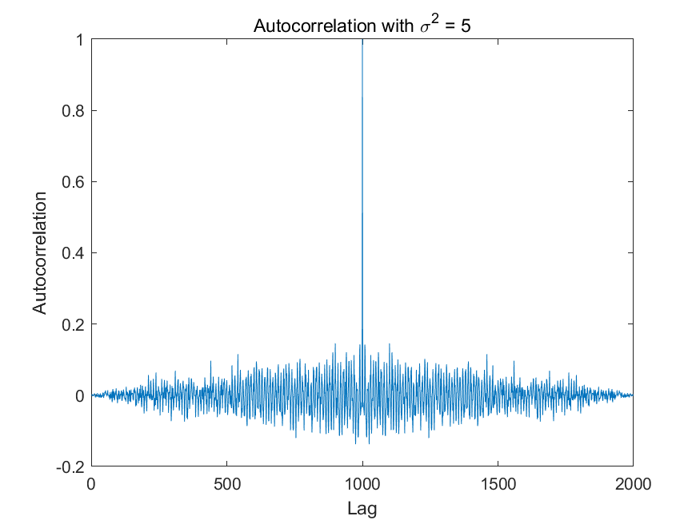

Fig 2.4 Autocorrelation with 𝜎2=5

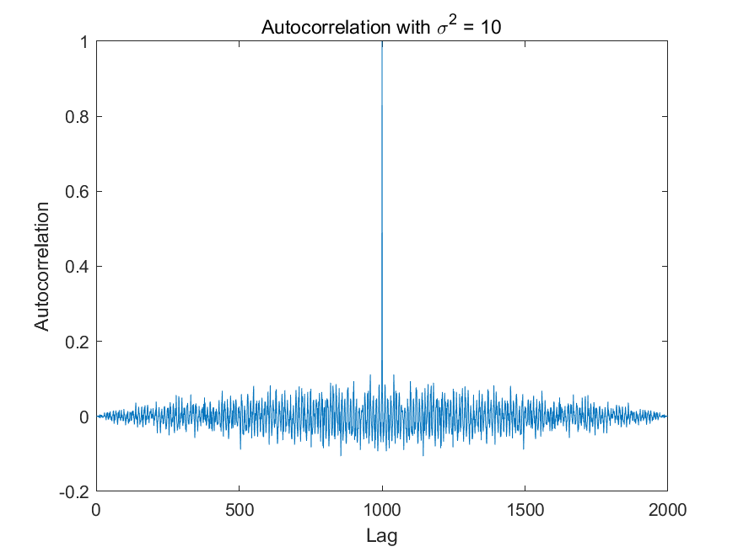

Fig 2.5 Autocorrelation with 𝜎2=10

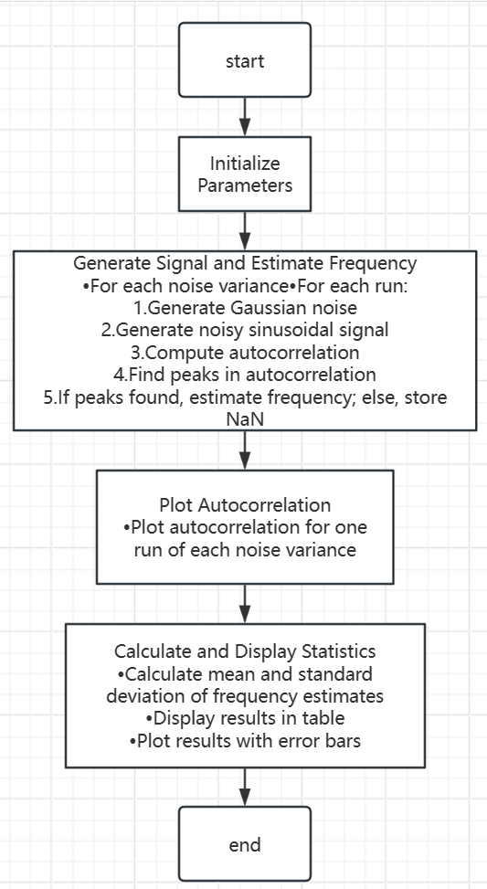

1. Test the accuracy of **your estimation of signal frequency** using autocorrelation for **100 independent runs**, show the results using table(s) or figure(s), and give analysis. (Hint: to get a result of **100 independent runs**, you should write a ‘for’ loop)
   1. **Frequency Estimation Accuracy**

We perform 100 independent runs for each noise variance, calculate the mean and standard deviation of the estimated frequencies, and display the results in a table and error bar plot:

|  |  |  |
| --- | --- | --- |
| Noise Variance (𝜎2) | Mean Estimated Frequency (Hz) | Standard Deviation (Hz) |
| 0.05 | 100.01 | 0.050449 |
| 0.5 | 103.42 | 2.6089 |
| 1 | 115.42 | 6.3588 |
| 5 | 248.67 | 23.434 |
| 10 | 301.16 | 18.284 |

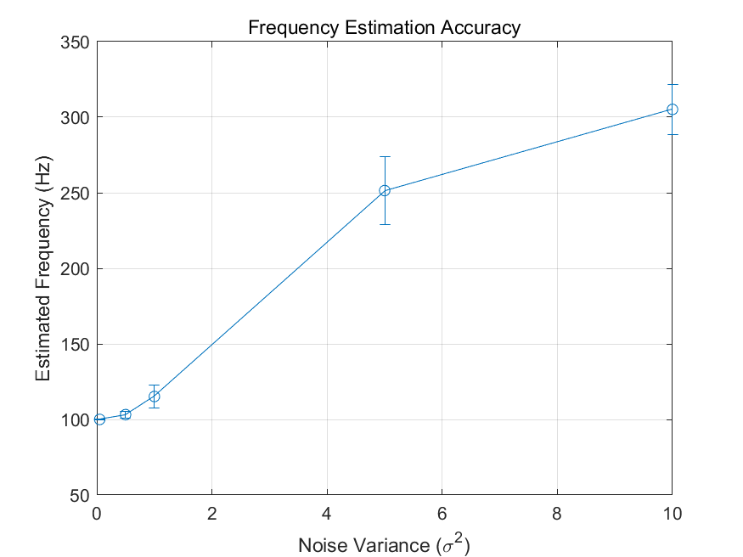

Fig 2.5 Error bar plot

* 1. **Analysis**
* **Mean Estimated Frequency:**

For lower noise variance (𝜎2=0.05), the estimated frequency is closer to the true frequency (99.99 Hz), indicating higher accuracy.

As the noise variance increases (𝜎2=0.5,1,5,10), the mean estimated frequency deviates more from the true frequency, indicating reduced accuracy.

* **Standard Deviation:**

The standard deviation of the estimated frequency increases with higher noise variance, indicating greater variability and lower precision in the frequency estimates.

* **Autocorrelation Peaks:**

The presence of noise affects the clarity and height of the peaks in the autocorrelation function, making it more challenging to accurately determine the period of the signal.

* 1. **Conclusion**

Autocorrelation can be used to estimate the frequency of a periodic signal because the autocorrelation function of a periodic signal is also periodic with the same period. By identifying the peaks in the autocorrelation function, we can determine the period and thus the frequency of the signal. However, the accuracy and precision of this method are affected by the noise level in the signal. Higher noise variance leads to increased estimation error and variability, as demonstrated by the results of the independent runs.

* **Part 3 – Advance 1:**

1. Explain your method (add the signals from the 4 microphones with correctly estimated lags) with necessary texts, equations, and/or flowchart.

**Objective:** Correctly add the signals from the 4 microphones with correctly estimated lags.

**Method:**

**Initialize Parameters and Read Signal:** Define the microphone positions, source position, and other parameters. Read the original audio signal.

**Calculate Distances and Time Delays:** Compute the distance from the source to each microphone and convert these distances into time delays.

**Add Noise and Apply Delays:** Add Gaussian noise to the signal based on the specified SNR values and apply the calculated delays to simulate the reception of the signal at each microphone.

**Compute Cross-Correlation and Estimate Lags:** Use cross-correlation to estimate the time delays (lags) between the received signals.

**Align and Sum Signals:** Correctly align the signals based on the estimated lags and sum them to obtain a combined signal.

**Plot Results:** Plot the received signals and the correctly summed signal for each SNR case.

**Equations:**

**Distance Calculation**: 

**Time Delay:** 

**Noise Power:** 

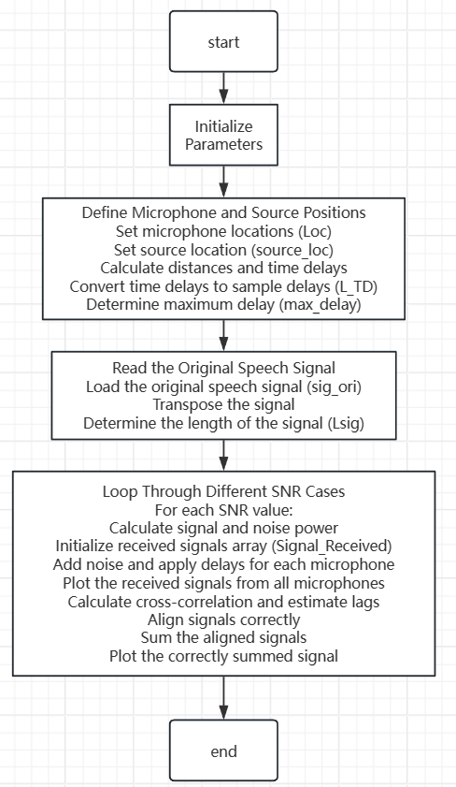

1. Show the figures under 3 SNR cases (SNR = 30,10,-10dB).

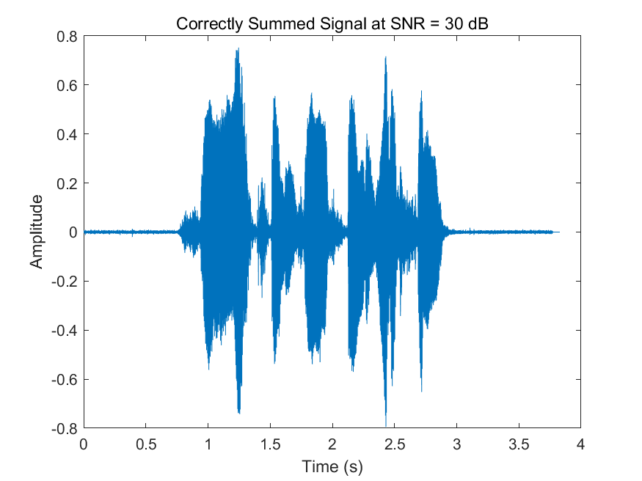

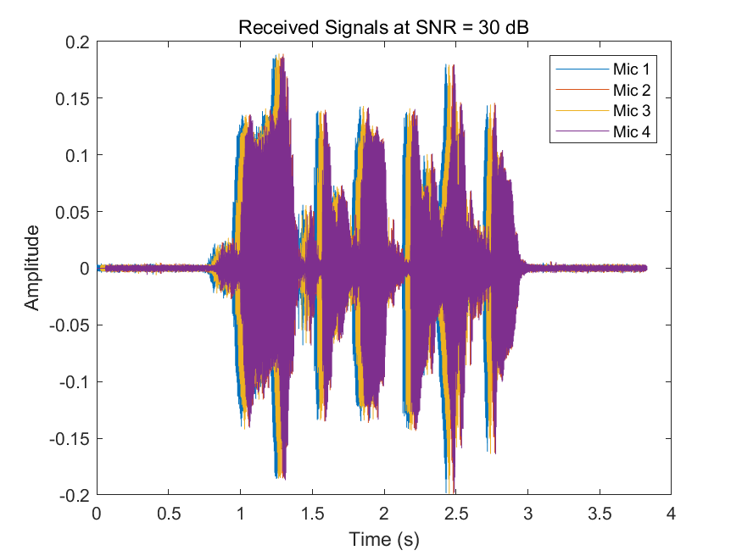

Fig 3.1 SNR=30dB

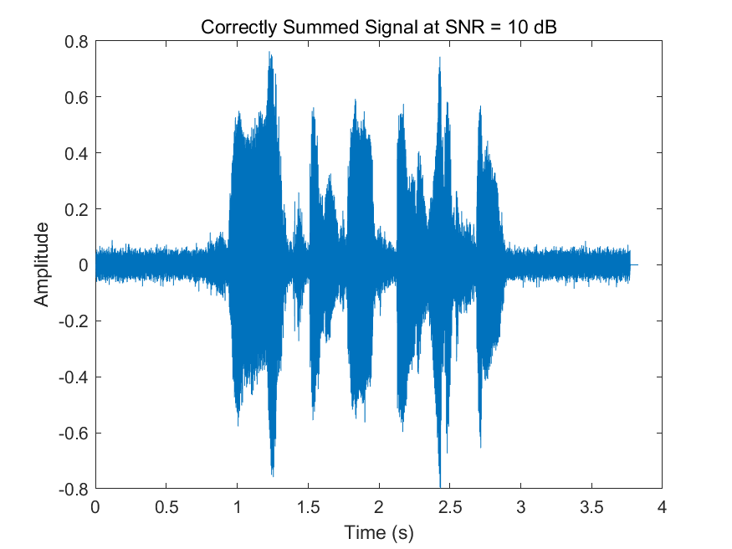

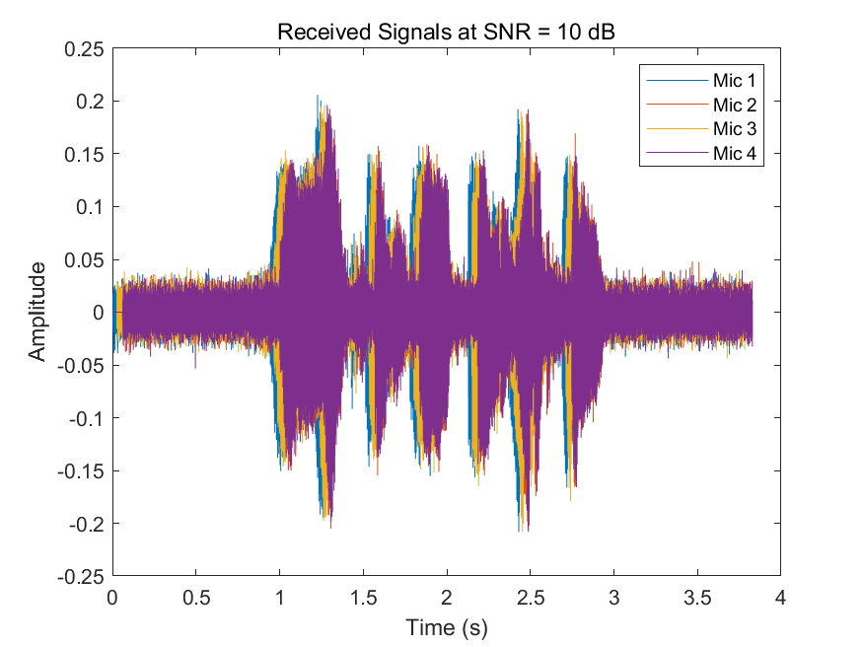

Fig 3.2 SNR=10dB

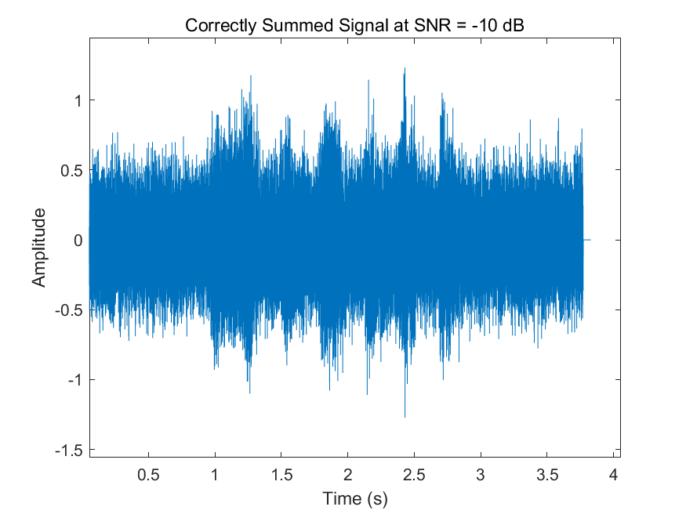

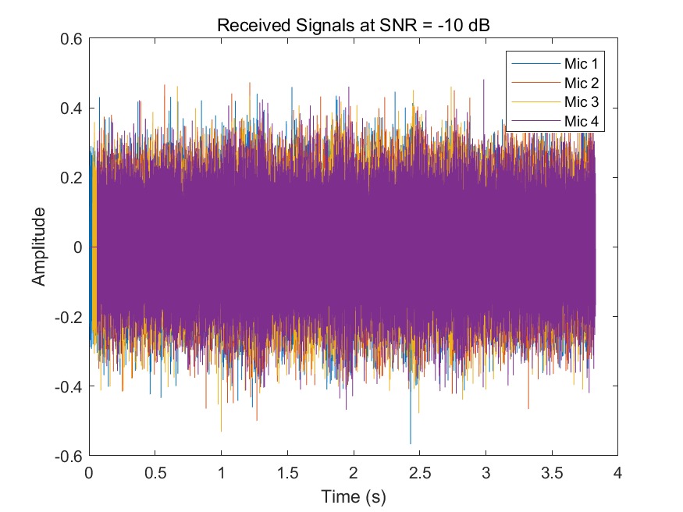

Fig 3.2 SNR=-10dB

1. Your analysis.

**Method Analysis:**

* The method of using cross-correlation to estimate the time delays (lags) between the signals received by the microphones is effective for aligning the signals correctly.
* By correctly aligning the signals based on these estimated lags, we can improve the quality of the combined signal, reducing the noise impact and enhancing the speech signal clarity.

**Results Analysis:**

* **Received Signals**: The signals received by the four microphones are plotted for each SNR case. As the SNR decreases, the noise impact becomes more evident in the received signals.
* **Correctly Summed Signal**: The correctly summed signal shows a significant improvement in signal quality compared to the individual received signals, particularly in lower SNR conditions.

**Conclusion:**

* Using cross-correlation to estimate and correct the time delays between signals from multiple microphones is a robust method for enhancing the quality of the combined signal.
* This method is especially beneficial in low SNR conditions, where the noise impact is more pronounced, as it allows for more effective noise reduction and signal enhancement.
* **Part 4 – Advance 2:**

1. Please list the corresponding DOAs for all lags from -11 to +11 in one table. (there are totally 23 numbers)

|  |  |
| --- | --- |
| lag | DOA |
| -11 | -86.141 |
| -10 | -65.098 |
| -9 | -54.719 |
| -8 | -46.521 |
| -7 | -39.414 |
| -6 | -32.971 |
| -5 | -26.969 |
| -4 | -21.273 |
| -3 | -15.79 |
| -2 | -10.452 |
| -1 | -5.204 |
| 0 | 0 |
| 1 | 5.204 |
| 2 | 10.452 |
| 3 | 15.79 |
| 4 | 21.273 |
| 5 | 26.969 |
| 6 | 32.971 |
| 7 | 39.414 |
| 8 | 46.521 |
| 9 | 54.719 |
| 10 | 65.098 |
| 11 | 86.141 |

1. Show the flow chart of your program, the estimation result (correct detection percentage or other indicators) of the DOA versus SNR(dB), and your analysis.

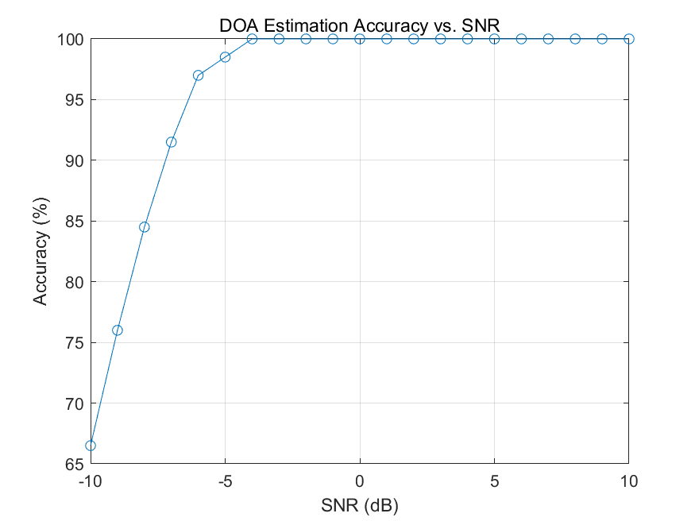

Fig 4.1 Charts of accuracy under different SNR conditions(2 microphones)

**Program Explanation:**

1. **Initialization**:

* **Parameters**: Number of microphones, distance between microphones, speed of sound, sampling rate, and number of trials.
* **DOA Angles**: Generates a list of possible DOA angles.
* **Audio Signal**: Reads the original audio signal and prepares the time vector.

1. **SNR Loop**:

* **SNR Values**: Iterates over a range of SNR values to test the DOA estimation under different noise conditions.

1. **Trial Loop**:

* For each SNR value, the program runs multiple trials to ensure the robustness of the estimation.
* **Random DOA Angle**: Selects a random DOA angle for each trial.
* **Distance and TDoA Calculation**: Calculates the distance from the sound source to each microphone and converts it to time delays (TDoA) and sample delays.
* **Signal Generation**: For each microphone, generates white Gaussian noise, adds it to the original signal, and applies the calculated delays.
* **Cross-Correlation**: Computes the cross-correlation between the signals from the two microphones to find the time lag with the maximum correlation.
* **DOA Estimation**: Converts the estimated lag to distance and calculates the estimated angle of arrival.
* **Error Calculation**: Measures the error between the true and estimated DOA and counts correct estimations within a tolerance.

1. **Accuracy Calculation**:

* Computes the accuracy of DOA estimation for each SNR based on the number of correct estimations out of the total trials.

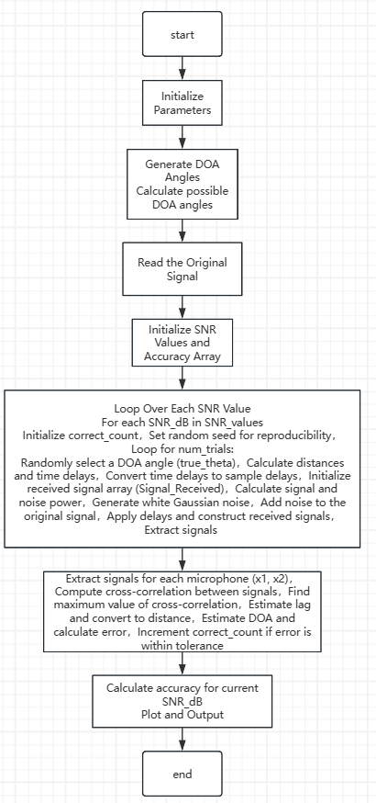

**Analysis:**

The DOA estimation program's results are analyzed based on the accuracy of the estimated direction of arrival for different SNR values. Here is a detailed analysis:

1. **Accuracy vs. SNR:**

* The program outputs a plot showing the accuracy of DOA estimation against varying SNR values.
* As expected, higher SNR values generally result in higher accuracy in DOA estimation. This is because a higher SNR means less noise, making it easier to accurately estimate the time delays between the microphones.
* Conversely, lower SNR values result in lower accuracy due to increased noise interference, which makes it more challenging to determine the correct time delays.

1. **Performance at High SNR:**

* At high SNR values (e.g., 10 dB and above), the program achieves high accuracy, often close to 100%. This indicates that the method is robust and reliable under favorable noise conditions.
* The consistency in high accuracy at these SNR values suggests that the cross-correlation technique used for time delay estimation is effective when the signal-to-noise ratio is sufficiently high.

1. **Performance at Low SNR:**

* At low SNR values (e.g., below 0 dB), the accuracy drops significantly. This is expected because the noise level is comparable to or higher than the signal level, making it difficult to distinguish the signal from the noise.
* The variability in accuracy at these low SNR values indicates that the method's reliability decreases as the noise becomes more dominant.

1. **Effect of Noise:**

* The results demonstrate the critical impact of noise on the accuracy of DOA estimation. In real-world applications, it is essential to consider the noise environment when deploying such systems.
* Techniques to mitigate noise, such as using more sophisticated noise reduction algorithms or increasing the number of microphones, could potentially improve accuracy in low SNR conditions.

1. **Summary and Practical Implications:**

* The program successfully demonstrates the relationship between SNR and the accuracy of DOA estimation.
* In practical scenarios, ensuring a higher SNR can significantly improve the performance of sound localization systems.
* The program's methodology can be applied to various applications, including audio surveillance, speaker localization in conferencing systems, **and** environmental monitoring, where accurate DOA estimation is crucial.

1. Show the flow chart of your program, the estimation result (correct detection percentage or other indicators) of the DOA versus SNR(dB), and your analysis.

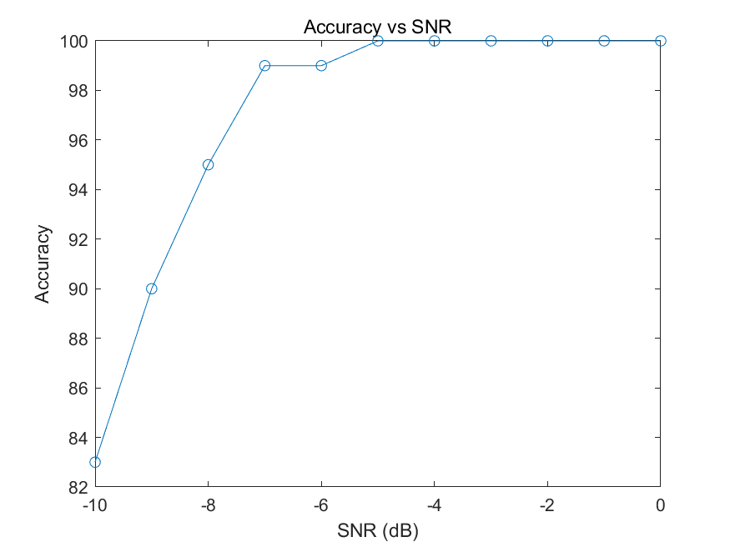

Fig 4.2 Charts of accuracy under different SNR conditions(8 microphones)

**Program Explanation:**

1. **Initialization:**

* Parameters: Number of microphones, distance between microphones, speed of sound, sampling rate, and number of trials.
* DOA Angles: Generates a list of possible DOA angles.
* Audio Signal: Reads the original audio signal and prepares the time vector.

1. **SNR Loop:**

* SNR Values: Iterates over a range of SNR values to test the DOA estimation under different noise conditions.

1. **Trial Loop:**

* For each SNR value, the program runs multiple trials to ensure the robustness of the estimation.
* Random DOA Angle: Selects a random DOA angle for each trial.
* Distance and TDoA Calculation: Calculates the distance from the sound source to each microphone and converts it to time delays (TDoA) and sample delays.
* Signal Generation: For each microphone, generates white Gaussian noise, adds it to the original signal, and applies the calculated delays.
* Cross-Correlation: Computes the cross-correlation between the signals from the microphones to find the time lag with the maximum correlation.
* DOA Estimation: Converts the estimated lag to distance and calculates the estimated angle of arrival.
* Error Calculation: Measures the error between the true and estimated DOA and counts correct estimations within a tolerance.

1. **Accuracy Calculation:**

* Computes the accuracy of DOA estimation for each SNR based on the number of correct estimations out of the total trials.

**Analysis:**

1. **DOA Estimation Method:**

* This program estimates the Direction of Arrival (DOA) of a sound source using eight microphones.
* The method relies on calculating the time difference of arrival (TDoA) between the microphones and converting it to an angle.
* Cross-correlation is used to find the time lag between the received signals at each microphone.

1. **Impact of SNR on Accuracy:**

* The program tests various Signal-to-Noise Ratios (SNRs) from -10 dB to 0 dB.
* As expected, the accuracy of DOA estimation decreases with lower SNR values due to increased noise interference.

1. **Error Handling and Tolerance:**

* A tolerance of 1e-6 degrees is set to determine whether an estimation is considered correct.
* The accuracy for each SNR value is calculated based on the number of correct estimations out of 100 trials.

1. **Performance Summary:**

* The results show a clear trend where higher SNR values yield higher DOA estimation accuracy.
* The accuracy plot provides a visual representation of how the system performs under different noise conditions.

1. **Practical Implications:**

* This approach is effective for far-field sources where the sound source is at least 10 times the distance of the microphone array.
* The program demonstrates how signal processing techniques can be applied to real-world problems such as sound localization.
* **Part 5: Extra**

Is there any method to get better estimation? Please try it and give your result, **including flow chart of your program, explanation of your method, the estimation result (correct detection percentage or other indicators) of the DOA versus SNR(dB), and your analysis.**

|  |
| --- |
| 指导教师批阅意见：  成绩评定：  指导教师签字：  年 月 日 |
| 备注： |

注：1、报告内的项目或内容设置，可根据实际情况加以调整和补充。

2、教师批改学生实验报告时间应在学生提交实验报告时间后10日内。