# Question:

1. 编程验证Gibbs效应。
2. 信号的自相关和互相关函数实验。已知序列)的自相关函数为

两个序列的互相关函数为

现有三个信号，, 其中为周期序列， 为随机噪声序列，编程完成下列任务：

1. 生成以上所述三个信号，各信号的参数根据你的实验自行设定；
2. 画出三个信号的自相关函数，并对实验结果进行分析和讨论；
3. 画出三个信号的两两互相关函数，并对实验结果进行分析和讨论。

# Design

## The first question

1. **Parameter Setting**: First, the period *T* and angular frequency *ω* are defined, along with the number of Fourier series terms *N* and the time vector *t*.
2. **Original Square Wave Signal**: A square wave signal *x* is created, which is set to 1 within the interval [−*π*/2,*π*/2] and 0 in other intervals.
3. **Fourier Series Approximation**: The original square wave signal is approximated using a Fourier series. Since the square wave signal is an odd function, only sine terms are needed, and only odd terms are required. Therefore, the loop starts from 1, with a step size of 2, up to *N*.
4. **Plotting**: The original square wave signal and the Fourier series approximation are plotted, using different line styles and colors to distinguish them.

## The second question

1. **Signal Generation**:
   * Create a time vector 𝑡*t* to define the time base for the signals.
   * Generate two periodic signals 𝑥1*x*1 and 𝑥2*x*2 with different frequencies.
   * Generate a random noise signal 𝑥3*x*3 to simulate interference in real environments.
2. **Correlation Function Calculation**:
   * Use MATLAB's **xcorr** function to compute the autocorrelation functions for each signal, as well as the cross-correlation functions between signal pairs.
   * Choose the 'unbiased' estimation method to ensure that the correlation functions are not affected by the length of the signals, thereby obtaining accurate statistical information.
3. **Results Visualization**:
   * Utilize MATLAB's plotting functions to separately display the autocorrelation functions for each signal and the cross-correlation functions between signal pairs.

# Result

## The first question

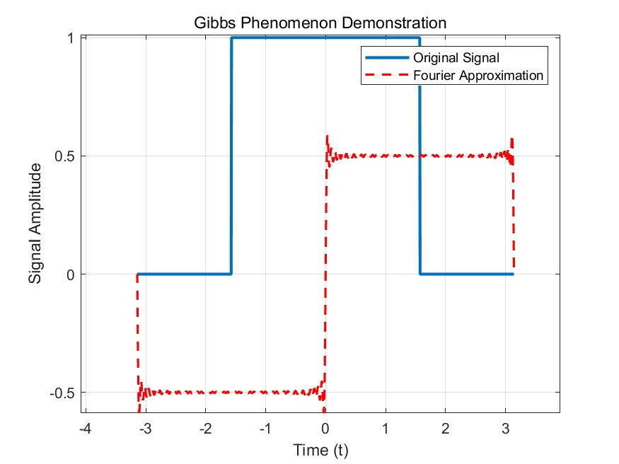

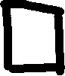

Fig 1 Gibbs output

The area marked by the black square is the Gibbs phenomenon.

## The second question

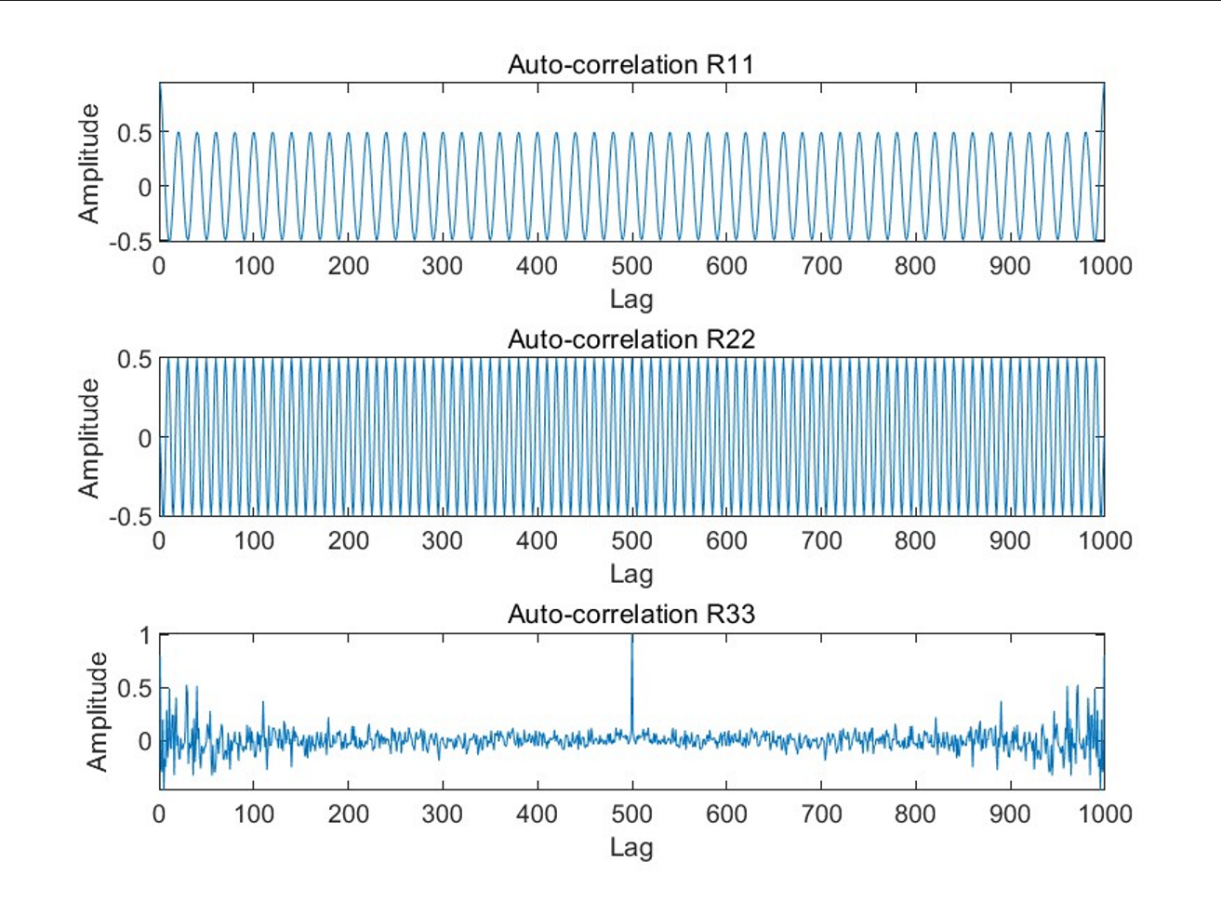

Fig 2 Auto-correlation

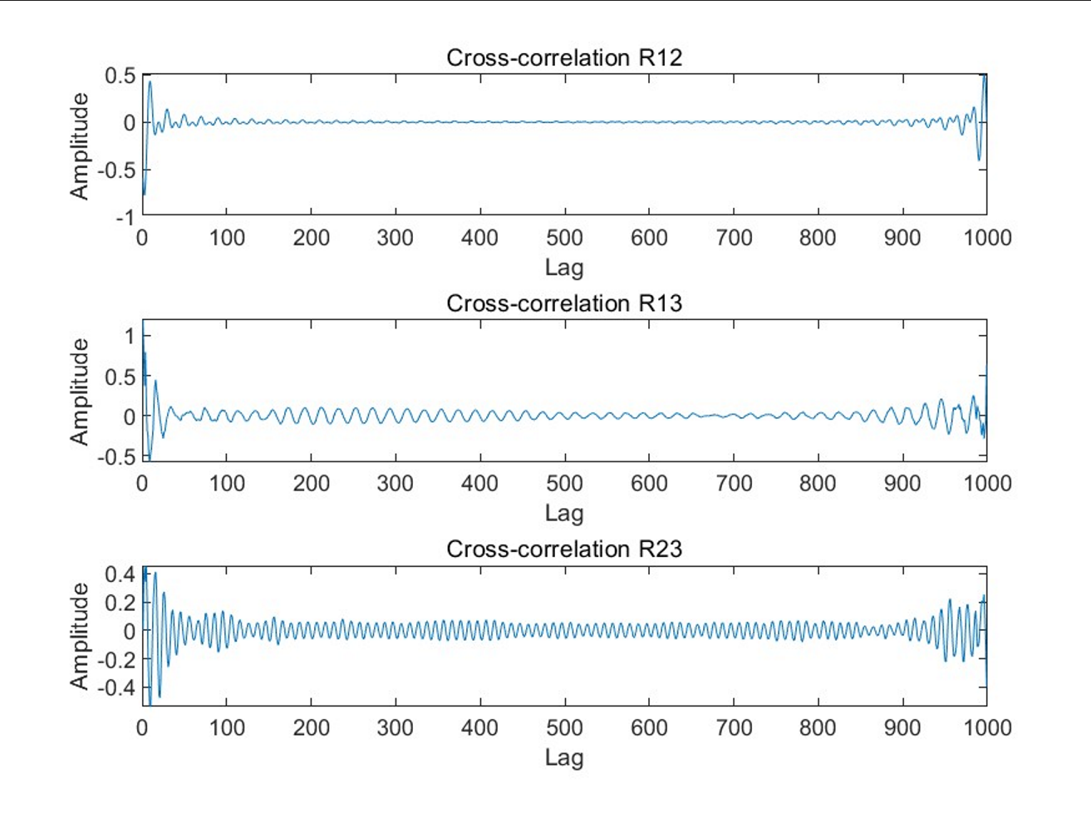

Fig 2 Cross-correlation

# Analysis

## The first question

1. **Original Signal**: The original square wave signal has a distinct jump from 0 to 1 within the interval [−π/2,π/2].
2. **Fourier Approximation**: The Fourier series approximation of the signal exhibits oscillations near the jump points of the square wave signal, which is a typical characteristic of the Gibbs phenomenon. As the number of terms increases, the approximated signal becomes increasingly close to the original signal over most of the interval, but the Gibbs phenomenon still persists near the jump points.
3. **Oscillation Phenomenon**: At the jump points of the square wave signal (i.e., t=−π/2 and t=π/2), the oscillations in the Fourier approximated signal are most pronounced. The amplitude of oscillations decreases with an increase in the number of approximation terms, but they do not disappear completely.

## The second question

1. **Autocorrelation Function Analysis**
   * Periodic Signals (x1 and x2): The autocorrelation functions show a clear periodic pattern, indicating that the periodic signals are highly correlated with their time-shifted versions. This periodicity is due to the inherent repetitive patterns of the signals.
   * Random Noise Signal (x3): Its autocorrelation function peaks at zero lag and quickly decays to near zero. This indicates a lack of correlation between different time points in the random noise, consistent with the characteristics of random noise.
2. **Cross-Correlation Function Analysis**
   * R12 (x1 and x2): As the two periodic signals have different frequencies, the cross-correlation function does not exhibit clear periodicity and the overall correlation is low.
   * R13 and R23 (Periodic Signals and Random Noise): The values of these functions are close to zero, indicating almost no linear correlation between the periodic signals and the random noise.

# Conclusion

## The first question

* **Gibbs Phenomenon**: When using a Fourier series to approximate functions with discontinuities, especially near the discontinuities, oscillations occur, which is known as the Gibbs phenomenon.
* **Approximation Effect**: As the number of terms in the Fourier series increases, the approximated signal becomes increasingly closer to the original signal, but the oscillations near the discontinuities still persist.
* **Oscillation Amplitude**: The amplitude of oscillations decreases as the number of Fourier series terms increases, but it does not disappear completely, indicating an inherent limitation of the Fourier series approximation near discontinuities.

## The second question

* **Periodic Signals**: The autocorrelation function of a periodic signal exhibits clear periodicity because the signal itself has repetitive patterns. This indicates a high degree of self-similarity at different time points for periodic signals.
* **Random Noise Signal**: The autocorrelation function of a random noise signal peaks at zero lag and quickly decays, which is consistent with the characteristics of a random process, meaning there is no significant correlation between signal values at different time points.
* **Correlation Between Signals**: The cross-correlation functions between periodic signals, as well as between periodic signals and random noise, show low correlation. This indicates that there is almost no linear relationship between periodic signals of different frequencies and between periodic signals and random noise.

# Code appendix

## The first question

% Parameter settings

T = 2*pi; % Set the period to 2π, which is the basic period of the square wave signal

omega = 2*pi/T; % Compute the angular frequency, which is the basic angular frequency of the square wave in its frequency domain representation

N = 100; % Set the number of terms in the Fourier series, which determines the approximation accuracy of the square wave

t = linspace(-pi, pi, 1000); % Create a time vector ranging from -π to π with 1000 points, used to plot the signal

% Original square wave signal

x = double(abs(t) <= pi/2); % Generate the square wave signal, with high level (1) in the middle and low level (0) on the sides

% Fourier series approximation

x_approx = zeros(size(t)); % Initialize the Fourier approximation signal array, same size as time vector t

for n = 1:2:N % For odd terms from 1 to N

x_approx = x_approx + (2/(n*pi)) * sin(n * omega * t); % Calculate the contribution of each term using the Fourier series formula and accumulate

end

% Plotting

figure;

plot(t, x, 'LineWidth', 2);

hold on;

plot(t, x_approx, 'r--', 'LineWidth', 1.5);

xlabel('Time (t)');

ylabel('Signal Amplitude');

legend('Original Signal', 'Fourier Approximation');

title('Gibbs Phenomenon Demonstration');

grid on;

## The second question

% Parameter settings

N = 500; % Length of the signal

t = (0:N-1)'; % Time vector

% Signal generation

x1 = cos(2*pi*0.05*t); % Generate a periodic signal x1 with frequency 0.05 cycles/sample

x2 = sin(2*pi*0.10*t); % Generate a periodic signal x2 with frequency 0.10 cycles/sample

x3 = randn(N,1); % Generate a random noise signal x3

% Compute auto-correlation functions

R11 = xcorr(x1, x1, 'unbiased'); % Auto-correlation of signal x1, normalized to be unbiased

R22 = xcorr(x2, x2, 'unbiased'); % Auto-correlation of signal x2, normalized to be unbiased

R33 = xcorr(x3, x3, 'unbiased'); % Auto-correlation of signal x3, normalized to be unbiased

% Compute cross-correlation functions

R12 = xcorr(x1, x2, 'unbiased'); % Cross-correlation between signals x1 and x2, normalized to be unbiased

R13 = xcorr(x1, x3, 'unbiased'); % Cross-correlation between signals x1 and x3, normalized to be unbiased

R23 = xcorr(x2, x3, 'unbiased'); % Cross-correlation between signals x2 and x3, normalized to be unbiased

% Plot auto-correlation functions

figure;

subplot(3,1,1);

plot(R11);

title('Auto-correlation R11');

xlabel('Lag');

ylabel('Amplitude');

subplot(3,1,2);

plot(R22);

title('Auto-correlation R22');

xlabel('Lag');

ylabel('Amplitude');

subplot(3,1,3);

plot(R33);

title('Auto-correlation R33');

xlabel('Lag');

ylabel('Amplitude');

% Plot cross-correlation functions

figure;

subplot(3,1,1);

plot(R12);

title('Cross-correlation R12');

xlabel('Lag');

ylabel('Amplitude');

subplot(3,1,2);

plot(R13);

title('Cross-correlation R13');

xlabel('Lag');

ylabel('Amplitude');

subplot(3,1,3);

plot(R23);

title('Cross-correlation R23');

xlabel('Lag');

ylabel('Amplitude');