Cover Page

Foodbyt

"Delivering Taste, One Order at a Time"

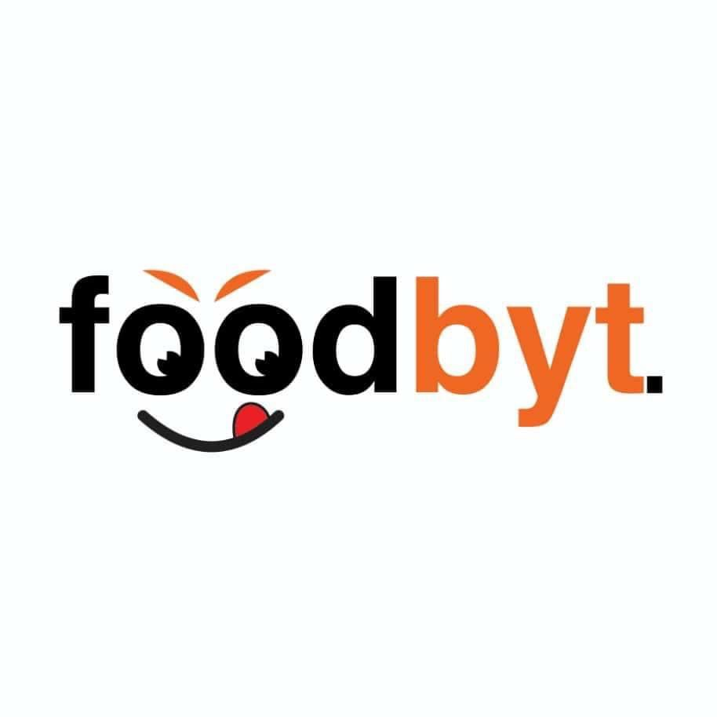

**Table of Contents**

1. Introduction

2. Mission and Vision

3. Business Model

4. Key Features

5. Target Market

6. Competitive Advantage

7. Revenue Model

8. Future Plans

9. Contact Information

1. Introduction

Foodbyt is a revolutionary food delivery platform designed to connect restaurants with customers seamlessly. Based in Maiduguri, Nigeria, Foodbyt charges no commission fees to restaurants. Instead, our revenue comes solely from delivery fees, making it a cost-effective solution for restaurants. With user-friendly mobile apps for customers and restaurants, as well as an internal dashboard for real-time order tracking, Foodbyt is set to transform the food delivery industry in Maiduguri and beyond.

2. Mission and Vision

- Mission: To revolutionize food delivery by providing a seamless platform for restaurants and customers, ensuring convenience, speed, and affordability.

- Vision: To become the leading food delivery platform in Maiduguri, empowering local restaurants and delighting customers with exceptional service.

3. Business Model

- Restaurants: Free to join, no commission fees.

- Customers: Pay for food and delivery fees.

- Revenue Source: Delivery fees (currently ₦800 per order).

4. Key Features

- For Restaurants:

- Report Generation: Access detailed sales and performance reports.

- Real-Time Order Updates: Get instant notifications for new orders.

- Wallet Balance: Track earnings in real-time.

- Automatic Wallet Withdrawal: Withdraw funds automatically to your bank account.

- For Customers:

- Easy-to-Use App: Browse menus, place orders, and track deliveries.

- Real-Time Order Tracking: Know exactly where your order is.

- Multiple Payment Options: Pay via card, bank transfer, or cash on delivery.

- Internal Dashboard:

- Track all orders in real-time.

- Monitor delivery progress and assign drivers.

5. Target Market

- Restaurants: Local eateries, cafes, and food businesses in Maiduguri looking to expand their reach.

- Customers: Busy professionals, students, and families in Maiduguri seeking convenient food delivery options.

6. Competitive Advantage

- No Commission Fees: Restaurants keep 100% of their food sales.

- Transparent Pricing: Customers pay only for food and delivery (₦800 per order).

- Advanced Features: Wallet balance, automatic withdrawal, and real-time updates for restaurants.

- User-Friendly Apps: Designed for ease of use for both customers and restaurants.

7. Revenue Model

- Primary Revenue: Delivery fees (₦800 per order).

- Projected Daily Revenue: 100 orders/day x ₦800 = ₦80,000/day.

- Projected Monthly Revenue: ₦80,000/day x 30 days = ₦2,400,000/month.

- Future Plans: Introduce dynamic pricing based on distance.

8. Future Plans

- Expand to other cities in Nigeria.

- Introduce dynamic delivery pricing based on distance.

- Add loyalty programs and promotional tools for restaurants.

9. Contact Information

- Website: foodbyt.com

- Email: info@foodbyt.com

- Phone: +234 123 456 7890

- Social Media: TODO