**Machine Learning Essentials: Hands-on Techniques for Unsupervised Clustering**

Sat, January 13, 2018

11:00 AM – 1:30 PM MST

**Lab Prerequisite: Installation of Jupyter with Python 3.6**

Prepared by Raghav Jandhyala and Pallavi Sridhar

1. Download Anaconda installation which includes Jupyter and Python 3.6

URL: [https://www.anaconda.com/download/](https://isolate.menlosecurity.com/1/3735928037/https:/www.anaconda.com/download/)

1. Download and install Python 3.6 version for Windows / Mac

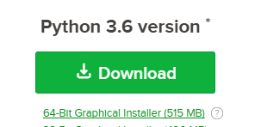

1. On windows , search anaconda and chose Anaconda Navigator.. this may take few seconds to open

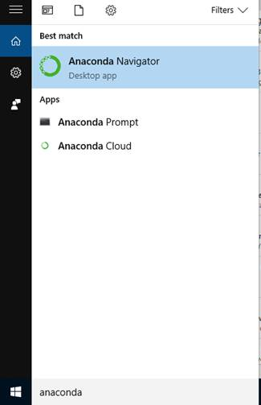

4. Launch Jupyter

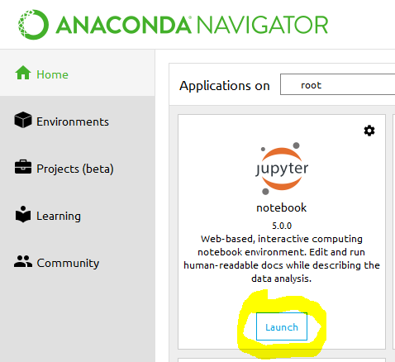

5. Create a folder on your desktop where you want to store your lab exercises e.g. Galvanize_Lab1 and in Jupyter Navigate to that folder

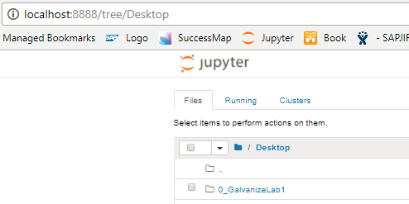

6. Click: New->Python 3 to create your new notebook

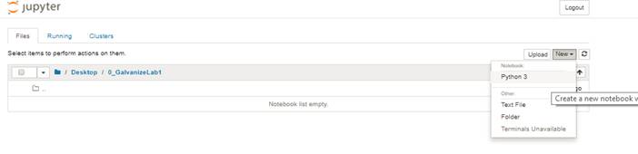

7. Make sure libraries are installed and working. Type in the following

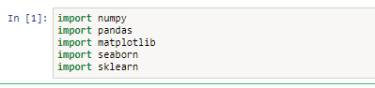

8. Run using highlighted button: cid:image011.png@01D38BAD.026D7FD0

9. If you get any errors (for example sklearn does not exist), you may need to install the package. To do so open Anaconda Prompt (search from windows) and in command prompt enter: pip install sklearn