**Software Requirements**

**Specification**

**For**

**College Schedule**

## Version 1.0 Approved

**Prepared *by***

**Hossam Hassan Farouk  
Muhammad Sayed Ahmed  
Amr Rajab Naseem**

**Abdulrahman Muhammad Nasiruddin  
Ahmed Kamal Mahmoud  
Abdel Naser Ahmed Abdel Mohsen**

# Table of Contents

Table of Contents ii

Revision History Error! Bookmark not defined.

1. Introduction 1
   1. Purpose 1
   2. Document Conventions 1
   3. Intended Audience and Reading Suggestions 1
   4. Project Scope 1
   5. References 1
2. Overall Description 2
   1. Product Perspective 2
   2. Product Features 3
   3. User Classes and Characteristics 3
   4. Operating Environment 3
   5. Design and Implementation Constraints 3
   6. User Documentation 4
   7. Assumptions and Dependencies 4
3. System Features 4
   1. Data and application hosting on Google Apps 4
   2. Sign up and log in 4
   3. Reset or forget password ………………………………………………………………………….4
   4. Checking app internet connection …………………………………………………………………4
   5. Supporting feedback from students 6
   6. Showing college Schedule 6
   7. Change or Editing Schedule 6
   8. Web controller interface receive feedbacks 7
   9. Web interface supports sending Alerts ………………………………………………………….….7
   10. Web interface Data Storing …………………………………………………………………...…….7
   11. Web interface algorithm helper ……………………………………………………………………7
   12. Guide notification system ………………………………………………………………………….7
   13. Sending images as alerts ……………………………………………………………………………7
   14. Urgent Notification for Professors ………………………………………………………………….7
4. External Interface Requirements 7
   1. User Interfaces 7
   2. Hardware Interfaces 7
   3. Software Interfaces 7
   4. Communications Interfaces 8
5. Other Nonfunctional Requirements 8
   1. Performance Requirements 8
   2. Safety Requirements 8
   3. Security Requirements 8
   4. Software Quality Attributes 9

# Introduction

## Purpose

This document specifies a simplified subset of College Schedule version 1.0 functionality allowing users to capture requirements in a single structured requirement specification document andEase of making the schedule of lectures for students in a faster and more accurate manner, and the ease of communication between the college and the teaching staff specialized in making the schedule By collecting special appointments for the teaching staff, setting up lectures, preventing conflicts, and easing possible conflict resolution.

**

## Document Conventions

*No document conventions are being used at this time.*

## Intended Audience and Reading Suggestions

*This document is intended to be used by members of the project team to implement and verify the system's correct functioning.*

## Project Scope

College Schedule is a mobile application and web that allows users:

* + - To Show the changes that occur in the college schedule.
    - To Help Staff manage their schedule efficiently.
    - To provide ways for communications between Staff and Students.
    - Our algorithm will help in making the schedule and control its difficulty changes easily.
    - To give the staff college makes proper decisions.

## References

* *Composer Tutorial.*

# Overall Description

## Product Perspective

College Schedule is a new system for displaying and editing schedule, the context diagram in Figure 1 illustrates the external entities and system interfaces, the system is expected to evolve over at least three releases.

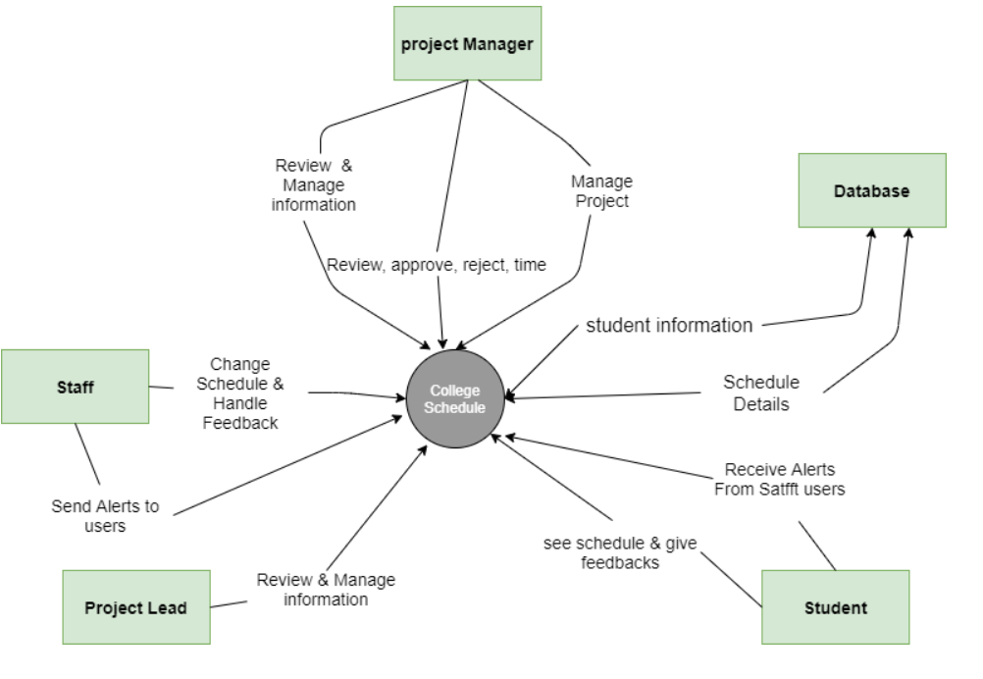

**Figure 1**

Context diagram for college schedule

## Product Features

FE-1: Data and application hosting on Google Apps

FE-2: Sign up and log in.

FE-3: support sending Alerts and receiving feedback.

FE-4: control the schedule changes from web interface.

## User Classes and Characteristics

|  |  |
| --- | --- |
| Project Manager | A Project Manager is a special employee or group of employees which are in charge of managing a particular project. Project Managers will use the new system in the same way as a regular user but will also need the ability to view project status and approve/reject changes. Project Managers will also need the ability to manage employees associated with their projects as well. |
| Staff | The person who is responsible for editing the schedule and sending alerts and receiving feedbacks. |
| User | The user is the person who use the app for searching and booking for sections and lectures. |

## Operating Environment

|  |  |
| --- | --- |
| OE-1: | System is not dependent on geographical areas. |
| OE-2: | System shall operate in newest versions of all android versions. |
| OE-3: | There should be no constraint on users being able to access the system at a given  time. |
| OE-4: | Data is generated and stored in the Google App Engine database. |
| OE-5: | Continuous service is preferred, but as long as there is no data loss, minor service  interruptions can be tolerated. |
| OE-6: | Personal data will be stored in the database, so the Google App Engine database  must be secure. |
| OE-7: | Kotlin library will be needed to create the user interface for the system. |

## Design and Implementation Constraints

|  |  |
| --- | --- |
| CO-1: | All data shall be stored on Google App Engine. |
| CO-2: | User interface shall be composed using Kotlin library. |
| CO-3: | We Use Composer in our Web Controller Interface. |
| CO-4: | We Use PHP in our Web Controller Interface. |
| CO-5: | Who use Web interface must be responsible from the college staff. |

## User Documentation

*No user documentation information currently.*

## Assumptions and Dependencies

|  |  |
| --- | --- |
| AS-1: | No more than 20 GB of data stored on Google App Engine |
| AS-2: | No more than 100k page views monthly. |
| AS-3: | Users have a Google Account with which they can login. |
| DE-1: | Free Google App Engine account |
| DE-2: | Kotlin library (for user interface). |
| DE-3: | Use PHP & MYSQL for staff control web interface. |

# System Features

## Data and application hosting on Google Apps

### Description and Priority

*Application will need to be hosted on Google App Engine.*

*Priority: high.*

### Stimulus/Response Sequences

*Not applicable.*

### Functional Requirements

*Not applicable.*

## Sign up and log in

### Description and Priority

Users of “College Schedule” can sign up using username and password easily also log in using their username and password.

Priority: medium.

### Stimulus/Response Sequences.

Stimulus: User requests to sign up with full name, username and password. Response: System checks information validity then store user information. Stimulus: User requests to log in with username and password.

Response: System checks password and username validity then redirect user to home page.

### Functional Requirements.

|  |  |
| --- | --- |
| **Sign up** | The system shall allow a user to sign up. |
| **Log in** | The system shall allow a user who is logged in to sections and lectures. |
| **Forget Password** | The system shall allow a user to enter a new password if he forgets his/her current password depending on his/her E-mail. |
| **Reset password** | The system shall allow a user to reset password by many options. |
| **Remember User**  **Credentials** | The application remembers user credentials after login from first time. |
| **Verify User Credentials** | The application verifies user e-mail and validates it. |

* 1. **internet connection Checking app** 
     1. **Description and priority**

**The app check internet before fetch or send data to the firebase.**

* + 1. **Stimulus/Response sequences.**

**Not Applicable.**

* + 1. **Functional Requirements.**

|  |  |
| --- | --- |
| **Internet**  **Connection**  **status** | **The app checks internet connection status before sending or receiving data from the internet.** |

## Upload information and features of the schedule.

**3.4.1 Description and Priority**

**staff** of the college should be able to upload the schedule information and its new editing.

### Stimulus/Response Sequences.

Stimulus: staff requests to upload new information.

Response: System returns form should be filled out by Schedule information. Stimulus: User requests to edit time of sections or lectures.

Response: System store information then Staff see it.

### Functional Requirements.

|  |  |
| --- | --- |
| **Upload**  **information** | The system shall allow the Staff to upload new sections or lectures and add or edit existing one. |
| **Display data** | The system shall display Student Information (e-mail – Name – phone number). |
| **Store**  **information** | The system shall store information of schedule in database. |

## Supporting feedback from students

* + 1. **Description and Priority**

The system should support sending feedback from students.

### Stimulus/Response Sequences.

Not applicable.

### Functional Requirements.

|  |  |
| --- | --- |
| **feedback** | The system shall allow to send feedback of students in  college. |

## Showing college Schedule

* + 1. **Description and Priority**

The system shall allow user to display the time of his lectures and sections.

### Stimulus/Response Sequences.

Not applicable.

.

### Functional Requirements.

|  |  |
| --- | --- |
| **Searching for lectures and sections** | The system shall allow user to search for his sections and lectures. |

## Change or Editing Schedule

* + 1. **Description and Priority**

The system should Allow Staff to use Web controller interface to make needed changes on it.

### Stimulus/Response Sequences.

Stimulus: User requests to change some lectures or sections time. Response: System receive all feedbacks and make proper decisions about it.

### Functional Requirements.

|  |  |
| --- | --- |
| **Display** | The system shall display all lectures and sections. |
| **showing** | The system shall allow a user to display his appointments. |
| **feedback** | The system shall allow a user to send his thoughts and Conflicts. |

* 1. **web interface Data Storing**
     1. **Description and Priority**

The system should Allow Staff to store data locally before taking its final editing decision.

* + 1. **Stimulus/Response Sequences.**

Stimulus: staff wants to make changes or send Alerts to the App.

Response: students see the changes onto their android applications in Schedule or new notification.

* + 1. **Functional Requirements**

|  |  |
| --- | --- |
| **Storing**  **Data** | The system allow staff to store data locally before submitting it onto firebase database. |
| **Database** | Th firebase Database system used to store or retrieve data from the internet to show changes instantly to students. |

* 1. **Web interface algorithm helper**

**3.9.1 Description and Priority**

The system will help staff to make best choice when putting data into college schedule to help staff faster than usual.

**3.9.2** **Stimulus/Response Sequences.**

When collecting data from professors and teach assistants to make the schedule best way.

* + 1. **Functional Requirements.**

|  |  |
| --- | --- |
| **Algorithm helper** | This algorithm help staff to arrange the schedule and make suggestions for him/her to choose from. |

## Web controller interface

* + 1. **Description and Priority**

The system shall allow Staff to handle feedbacks and makes proper changes on the app.

### Stimulus/Response Sequences.

Not applicable.

### Functional Requirements.

|  |  |
| --- | --- |
| **Contact with Staff** | The system shall allow a user to contact with Staff to able to makes changes on the schedule. |

* 1. **web controller interface supports sending Alerts**

**3.11.1 Description and Priority**

the system shall allow staff to send important Alerts to the students on the app.

### 3.11.2 Stimulus/Response Sequences.

### Not applicable.

### Functional Requirements.

|  |  |
| --- | --- |
| **Send Alerts**  **From Staff** | The system shall allow the Staff to Send important Alerts to student on their android app. |

# 

# Guide Notification system

# 3.12.1 Description and priority

# The system shows guide notification for web application.

# 3.12.2 Stimulus/Response Sequences

# When inserting Schedule Data into the Application.

# 3.12.3 Functional Requirements.

# 

|  |  |
| --- | --- |
| Show guiding Alerts for inserting data | The system shows guide messages(alerts) during insertion of data. |

# sending images as alerts

# 3.13.1 Description and priority

# Admin or staff can send urgent alerts to android app by

# Using images.

# 3.13.2 Stimulus/Response Sequences

# Not applicable.

# 3.13.3 Functional Requirements

# 

# 

|  |  |
| --- | --- |
| Sending alert images | The system shall allow send images as an alert for students. |

# Urgent Notification for Professors

# 13.14.1 Description and Priority

# Professors can send urgent notification for students.

# 13.14.2 stimulus/Response Sequences

# Not Applicable.

# 13.14.3 functional Requirements

# 

|  |  |
| --- | --- |
| Sending urgent alerts | Special system features for professors to send urgent notification directly to students. |

# 

# External Interface Requirements

## User Interfaces

UI-1: Android application shall support hardware as well as virtual keyboard input.

## Hardware Interfaces

No hardware interfaces have been identified.

## Software Interfaces

### SI-1: Time Management System

SI-1.1: The time management system shall transmit data to be stored on Google App Engine.

**SI-2: Database -** The system shall communicate with a database through a programmatic interface for the following operations**:**

SI-2.1: To manage employee, client, and project data. SI-2.2: To allow a user to submit timesheets/leave time.

SI-2.3: To allow an administrator/project manager to approve/reject time. SI-2.4: To store brand and theme preferences.

## Communications Interfaces

CI-1: The system shall send a notification to the user to inform them of new changes.

CI-2: The system shall send an email message to confirm registration with the system. CI-3: The system shall send a notification to inform the user of new instant messages.

# Other Nonfunctional Requirements

## Performance Requirements

PE-1: Application should be load in no more 4 seconds.

PE-2: Responses to queries shall take no longer than 7 seconds to load onto the screen after the user submits the query.

## Safety Requirements

No safety requirements have been identified

## Security Requirements

SE-1: Users shall be required to log in to the system for contact with system.

SE-2: The system shall permit only staff members who are on the list of authorized administrators to create or edit.

SE-3: The system shall permit users who are not project managers or administrators to view only their own information, not the information of other users.

SE-4: All network transactions that involve personally identifiable information shall be encrypted.

## Software Quality Attributes

No software quality attributes have been identified.