Web Development
Lab 1
  - Name: Mahmoud Mohamed Hussein
Code: 24P0479
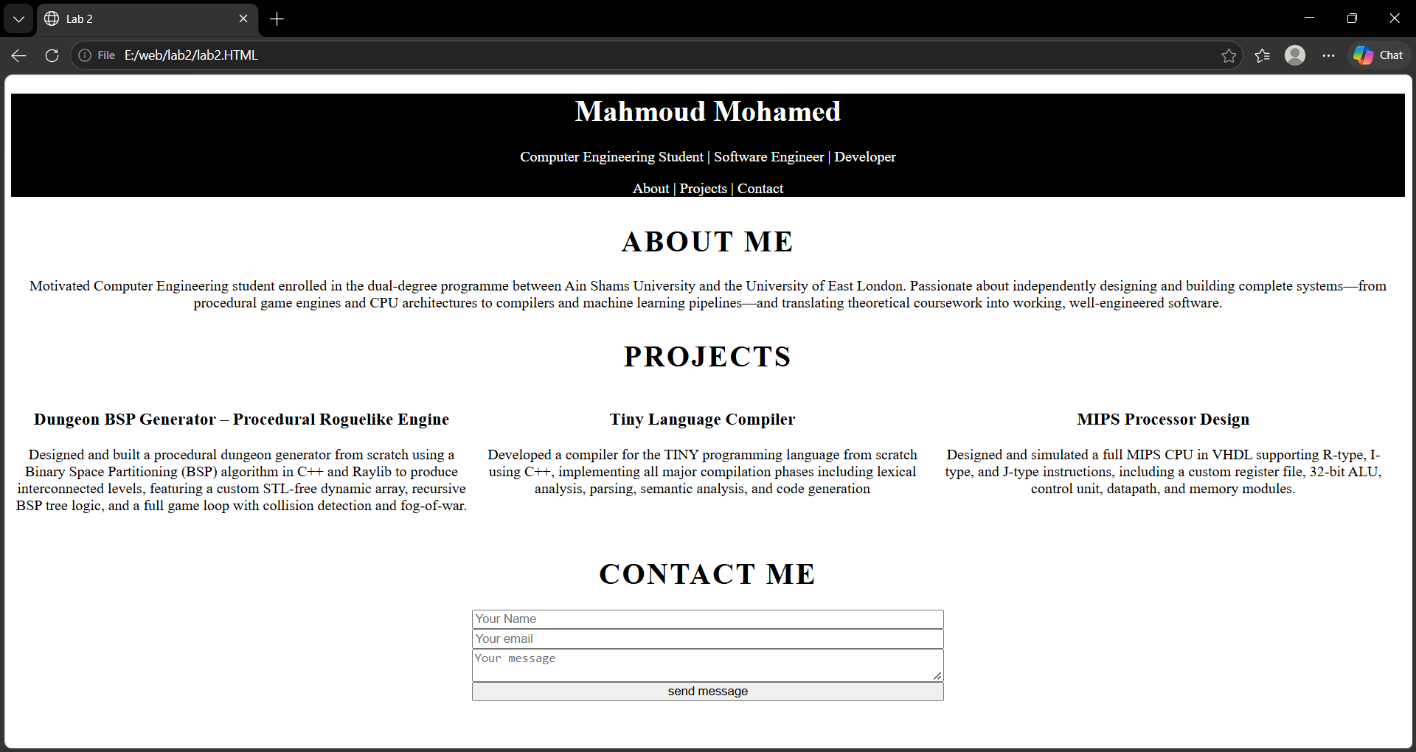

Repository Link:
https://github.com/7oka-code/Web_Develpoment-.git

