Capstone Project – Project Proposal
Thomas A. Aguirre
Applied Computer Education Department, Red River College Polytechnic
COMP-2702: Data Management
Miguel Guzman
2026-04-12

Project Description
- This project analyzes competitive Valorant matches from esports tournaments using a dataset with detailed match information. Each row represents a match, but some fields require cleaning and normalization before analysis. It was chosen due to its relevance to data analytics goals, personal interest in esports, and real-world complexity.

Business Case
- The purpose of this project is to analyze team performance and match outcomes in competitive Valorant, identify patterns, formats and map selections. I’m focusing on learning skills in data cleaning, semantic models and the goal to build an interactive dashboard. This project is relevant to esports, sports analytics and perform tracking.
Business Rules:
- One match includes exactly two teams
- One event includes multiple matches
- One team can play multiple matches across events
- One match can include multiple maps
- Map selection (pick/ban) occurs per match
- A team can appear as Team A or Team B

Data Source Documentation:
Dataset URL: https://www.kaggle.com/datasets/piyush86kumar/valorant-masters-toronto-2025?select=detailed_matches_overview.csv

Semantic Model
- The semantic model will be to normalize the dataset into multiple related tables. A central ‘Matches’ fact table will store core match information: date, event, format, score and patch, while separate dimension tables will be created for ‘Teams’ and ‘Maps’ to organize descriptive data. A bridge table will be used to handle the relationship between matches and teams. A ‘Date’ table will also be added to support time based analysis, including hierarchies such as year, month and day. Additionally, calculated columns such as match winner and measures like total matches and win rate will be created to enhance the analytics of the model.

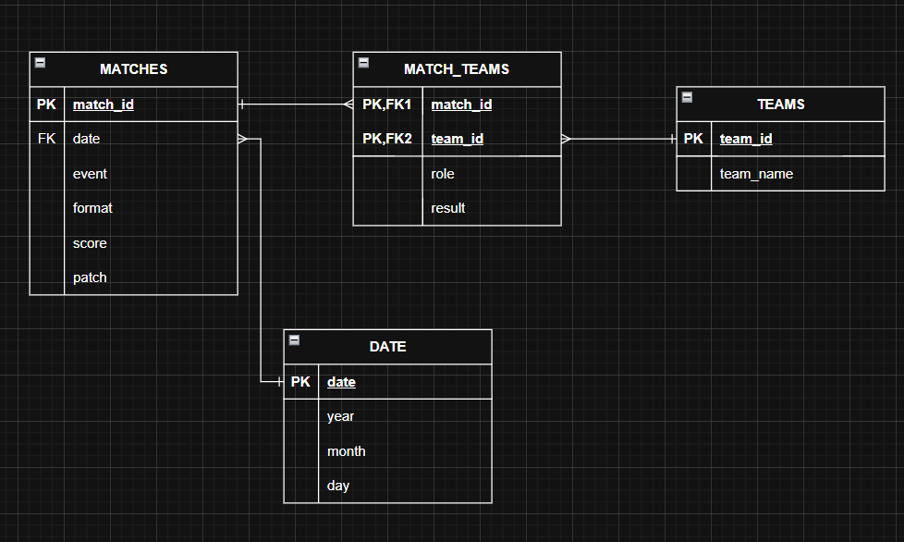

Analysis
- The analysis will focus on descriptive, comparative and time based approaches to evaluate team performance and match outcomes in competitive Valorant. It will examine key metrics such as win rate, total matches played, and score differences to compare teams across events, formats, and patches. The goal is to transform raw match data into meaningful insights that highlight patterns and support data-driven conclusions.

Power BI Report and Dashboard Design
- The Power BI report will be designed to present team performance, match outcomes, and trends in a clear and interactive way.
Planned Visualizations:
  - Bar Chart
Compare total wins per team.
  - Line Chart
Show number of matches over time.
  - Pie Chart
Display distribution of match formats.
  - Table / Matrix
Show detailed match information.
  - Card / KPI
Display total matches and average win rate.
  - Tree map
Show distribution of matches or wins by team within VCT Champions.

  - Custom Visual – Deneb (To be defined)
Intended to represent tournament progression in a more visual way.
Slicers:
- Team slicer to filter focus on the performance of a specific team.
- Date slicer (to filter matches over time.

Annex

