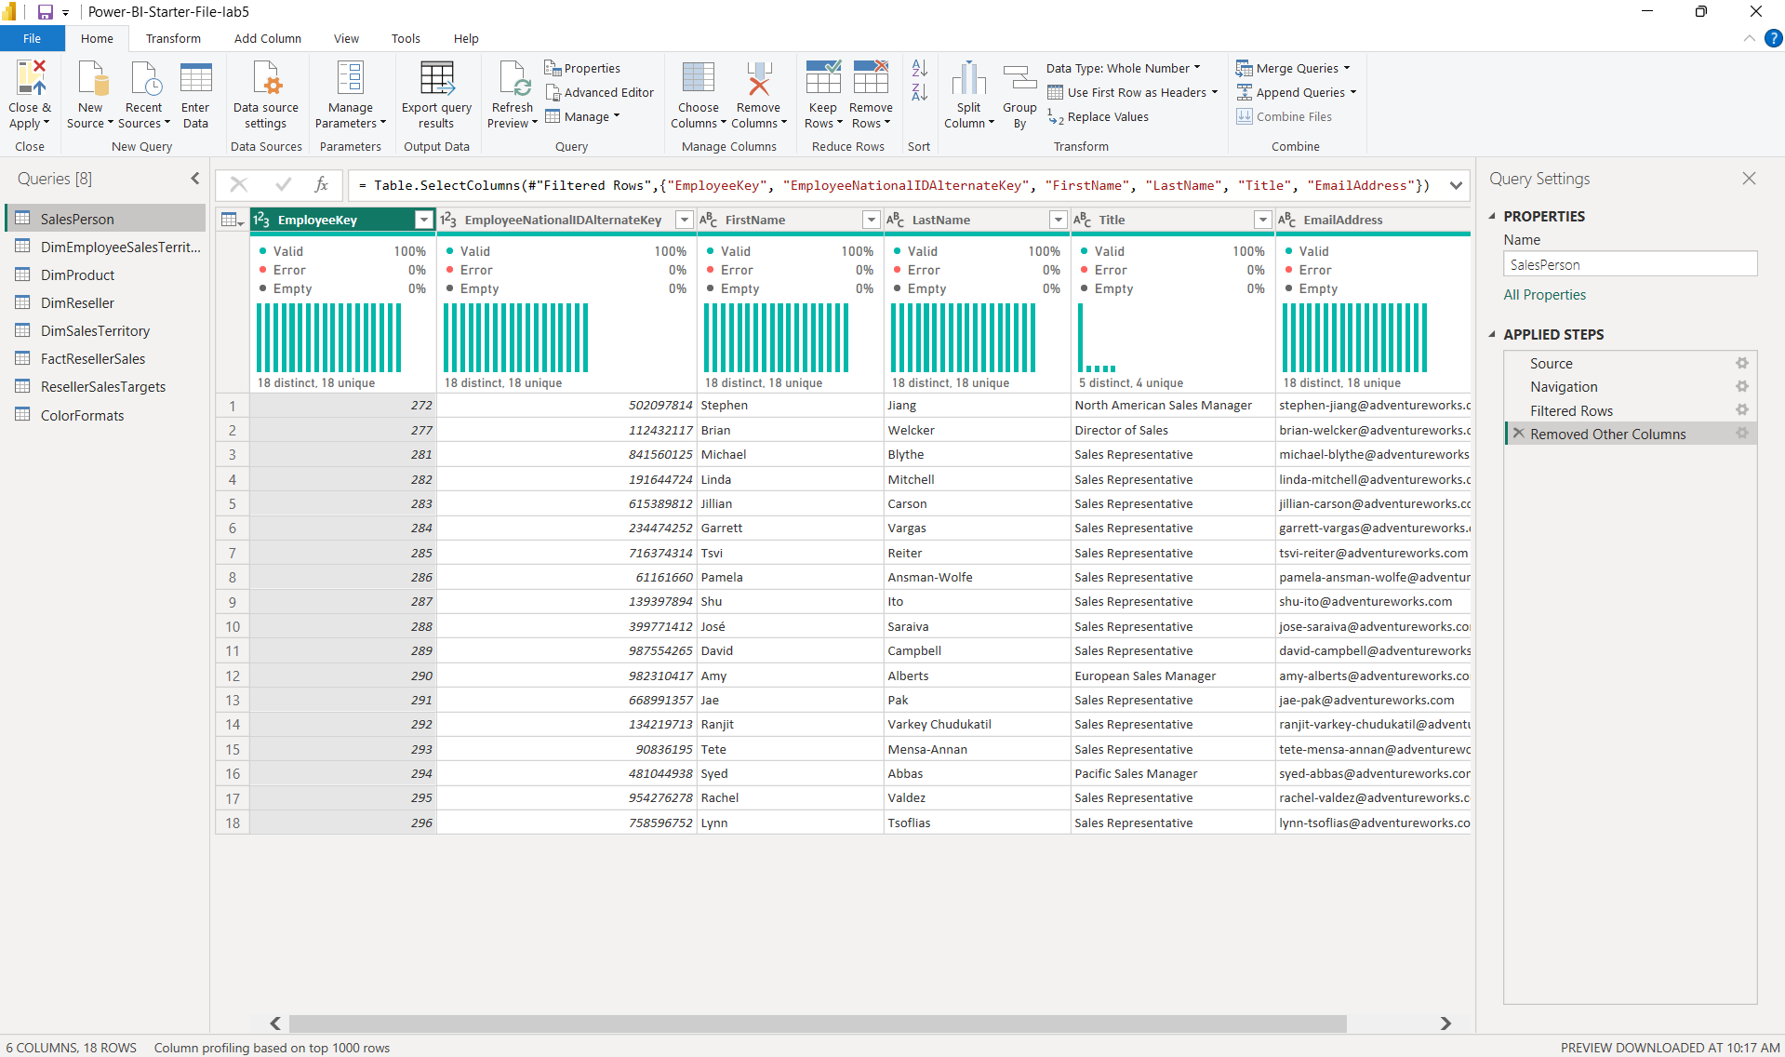
- Rename DimEmployee table to Salesperson
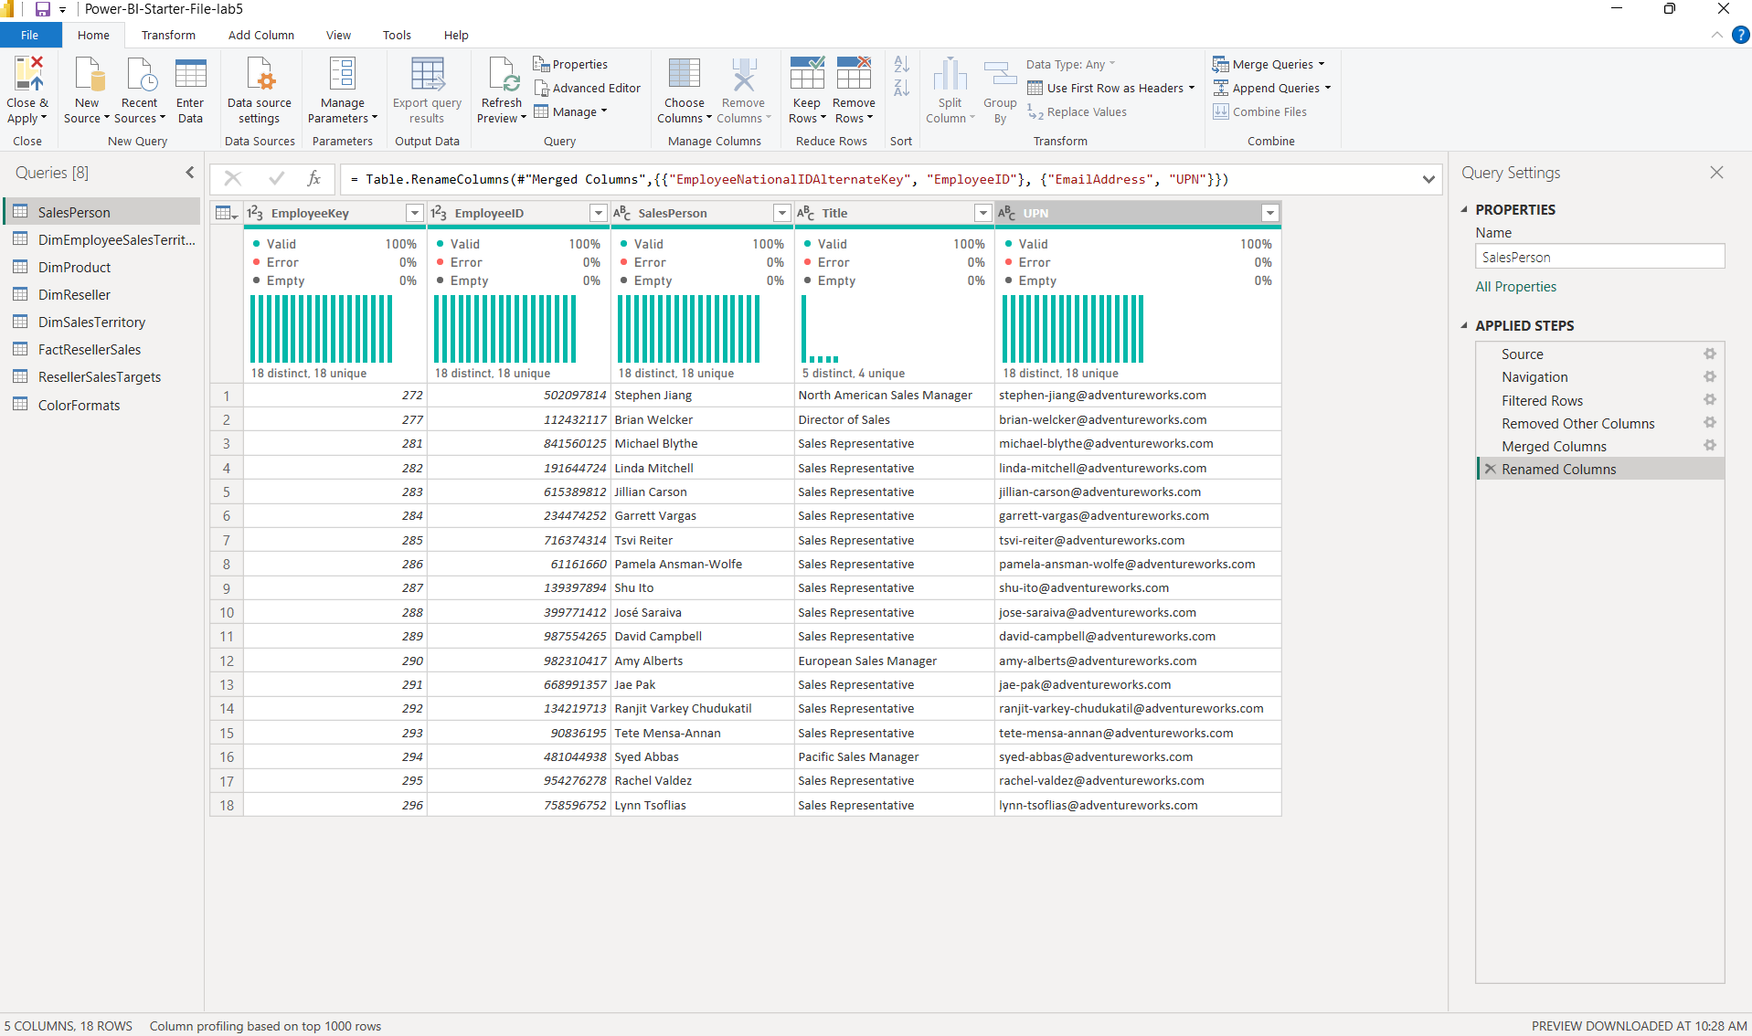
- Confirm Salesperson query has 5 columns and 18 rows

- Rename DimEmployeeSalesTerritory table to SalespersonRegion

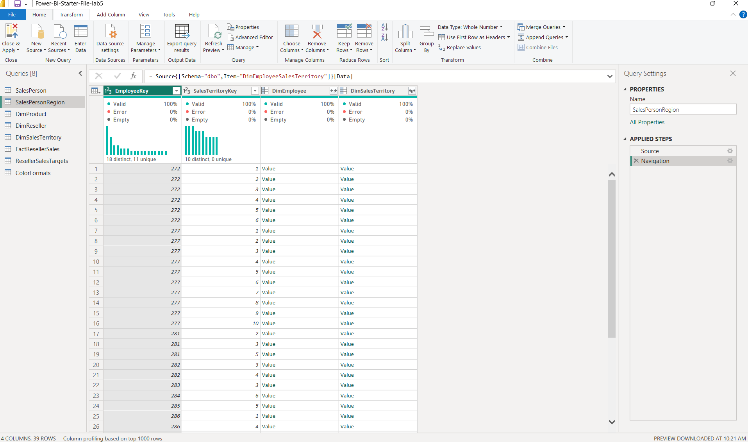
- Confirm SalespersonRegion query has 2 columns and 39 rows
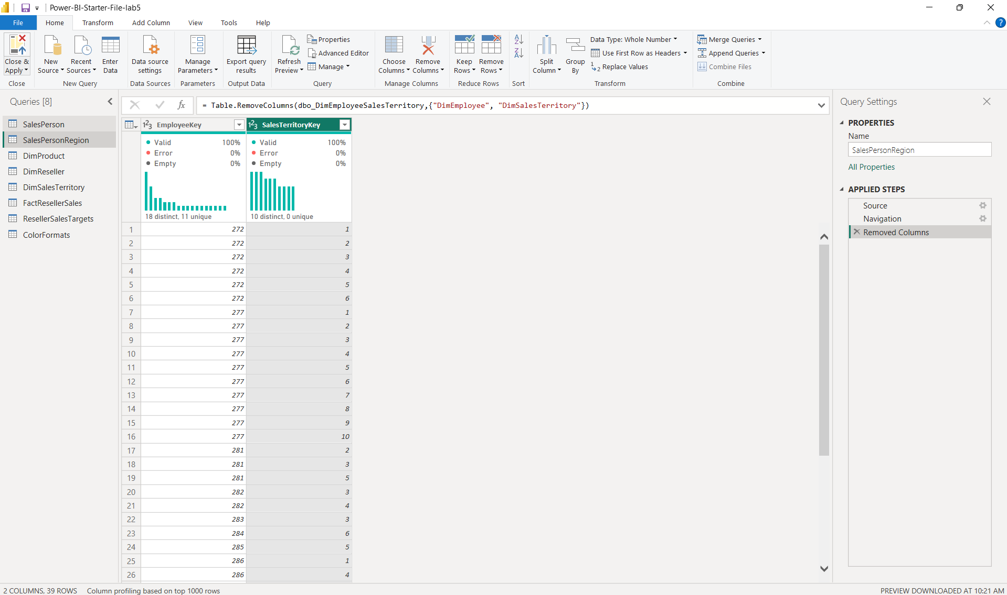
- Rename DimProduct table to Product
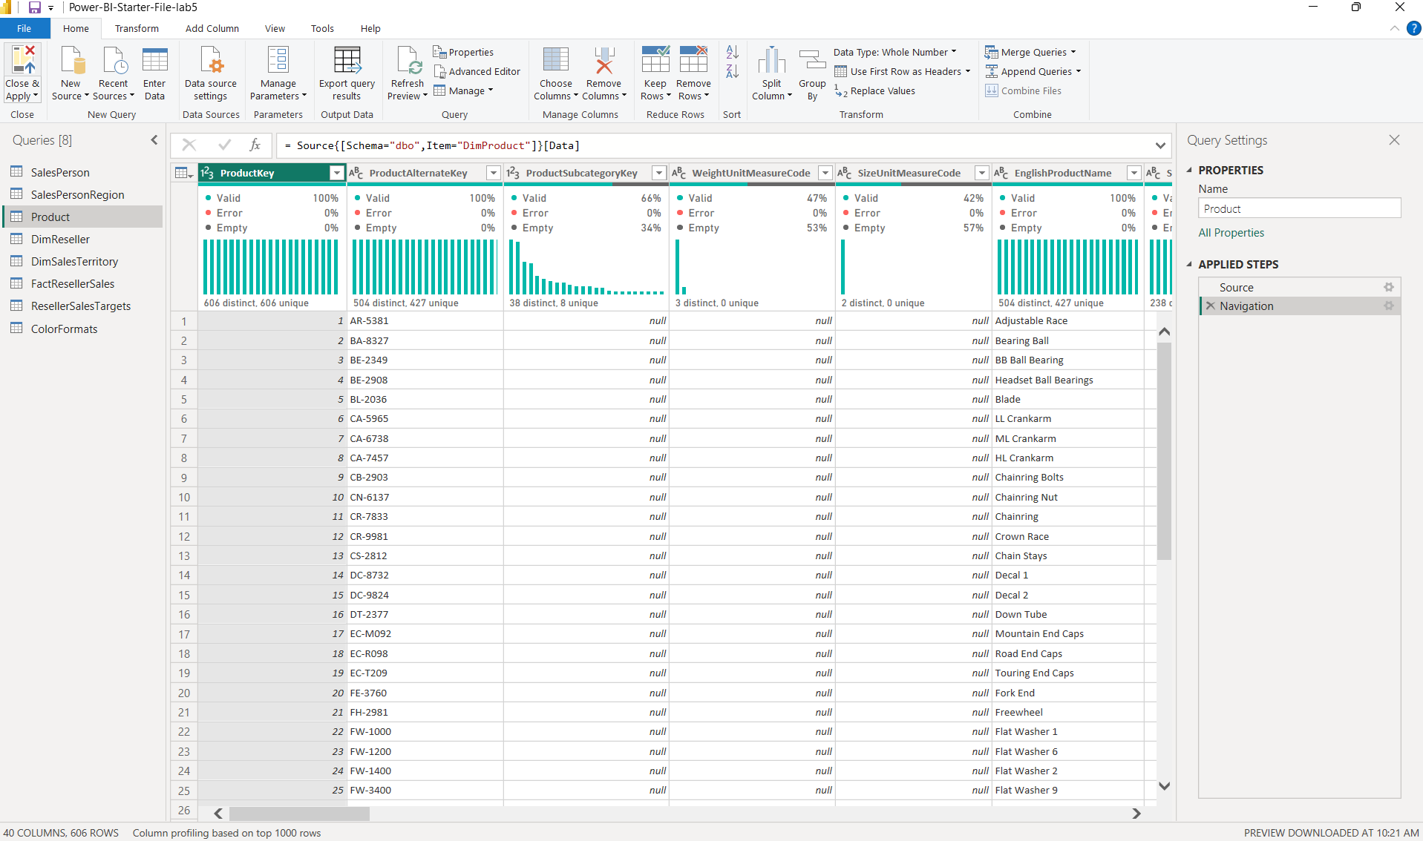
- Confirm Product query has 6 columns and 397 rows
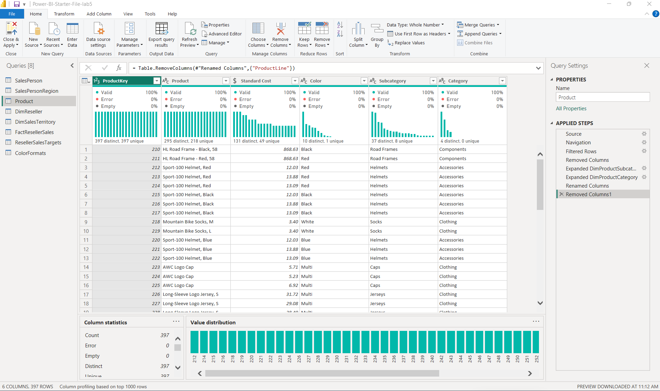

- Rename DimReseller table to Reseller
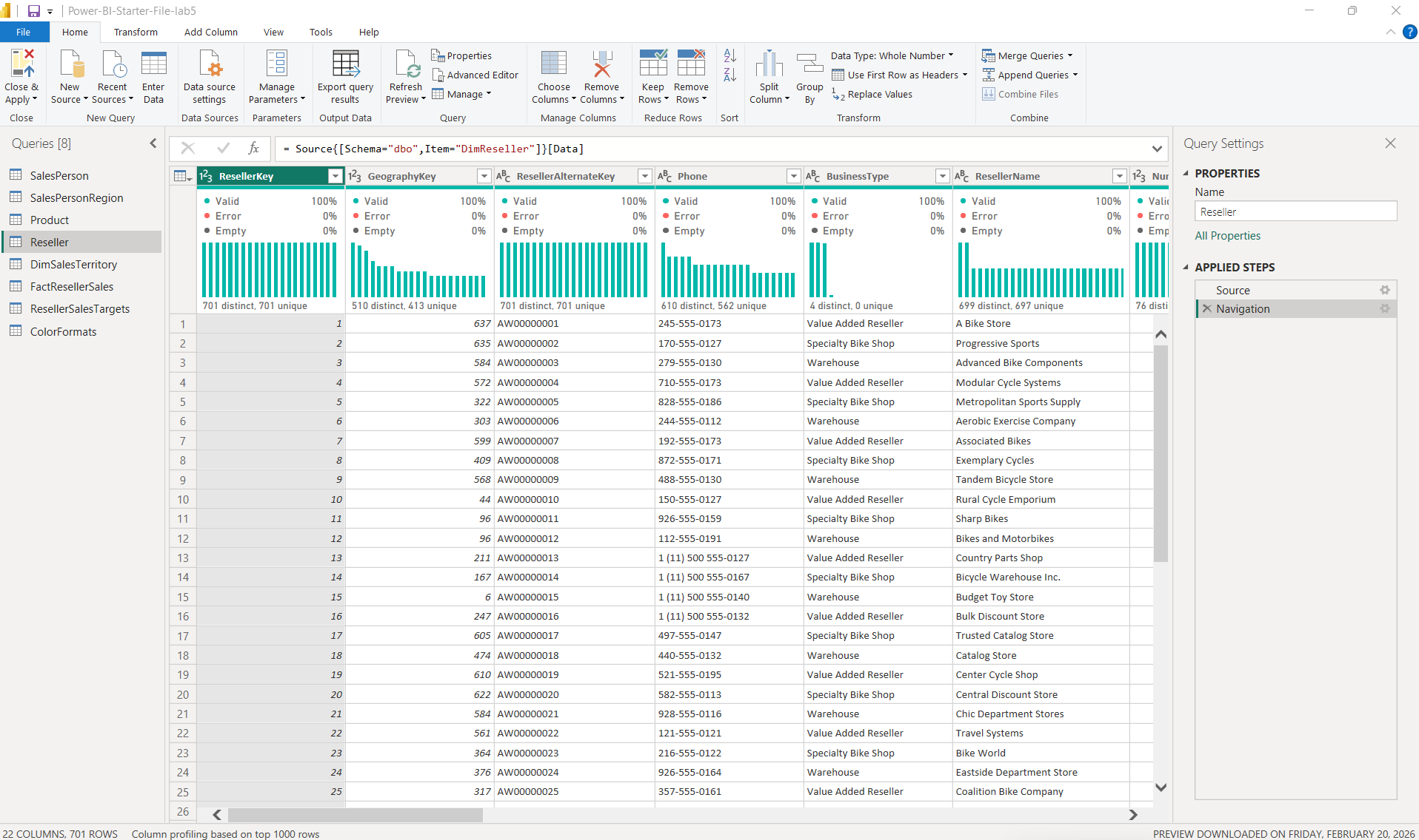
- Confirm Reseller query has 6 columns and 701 rows
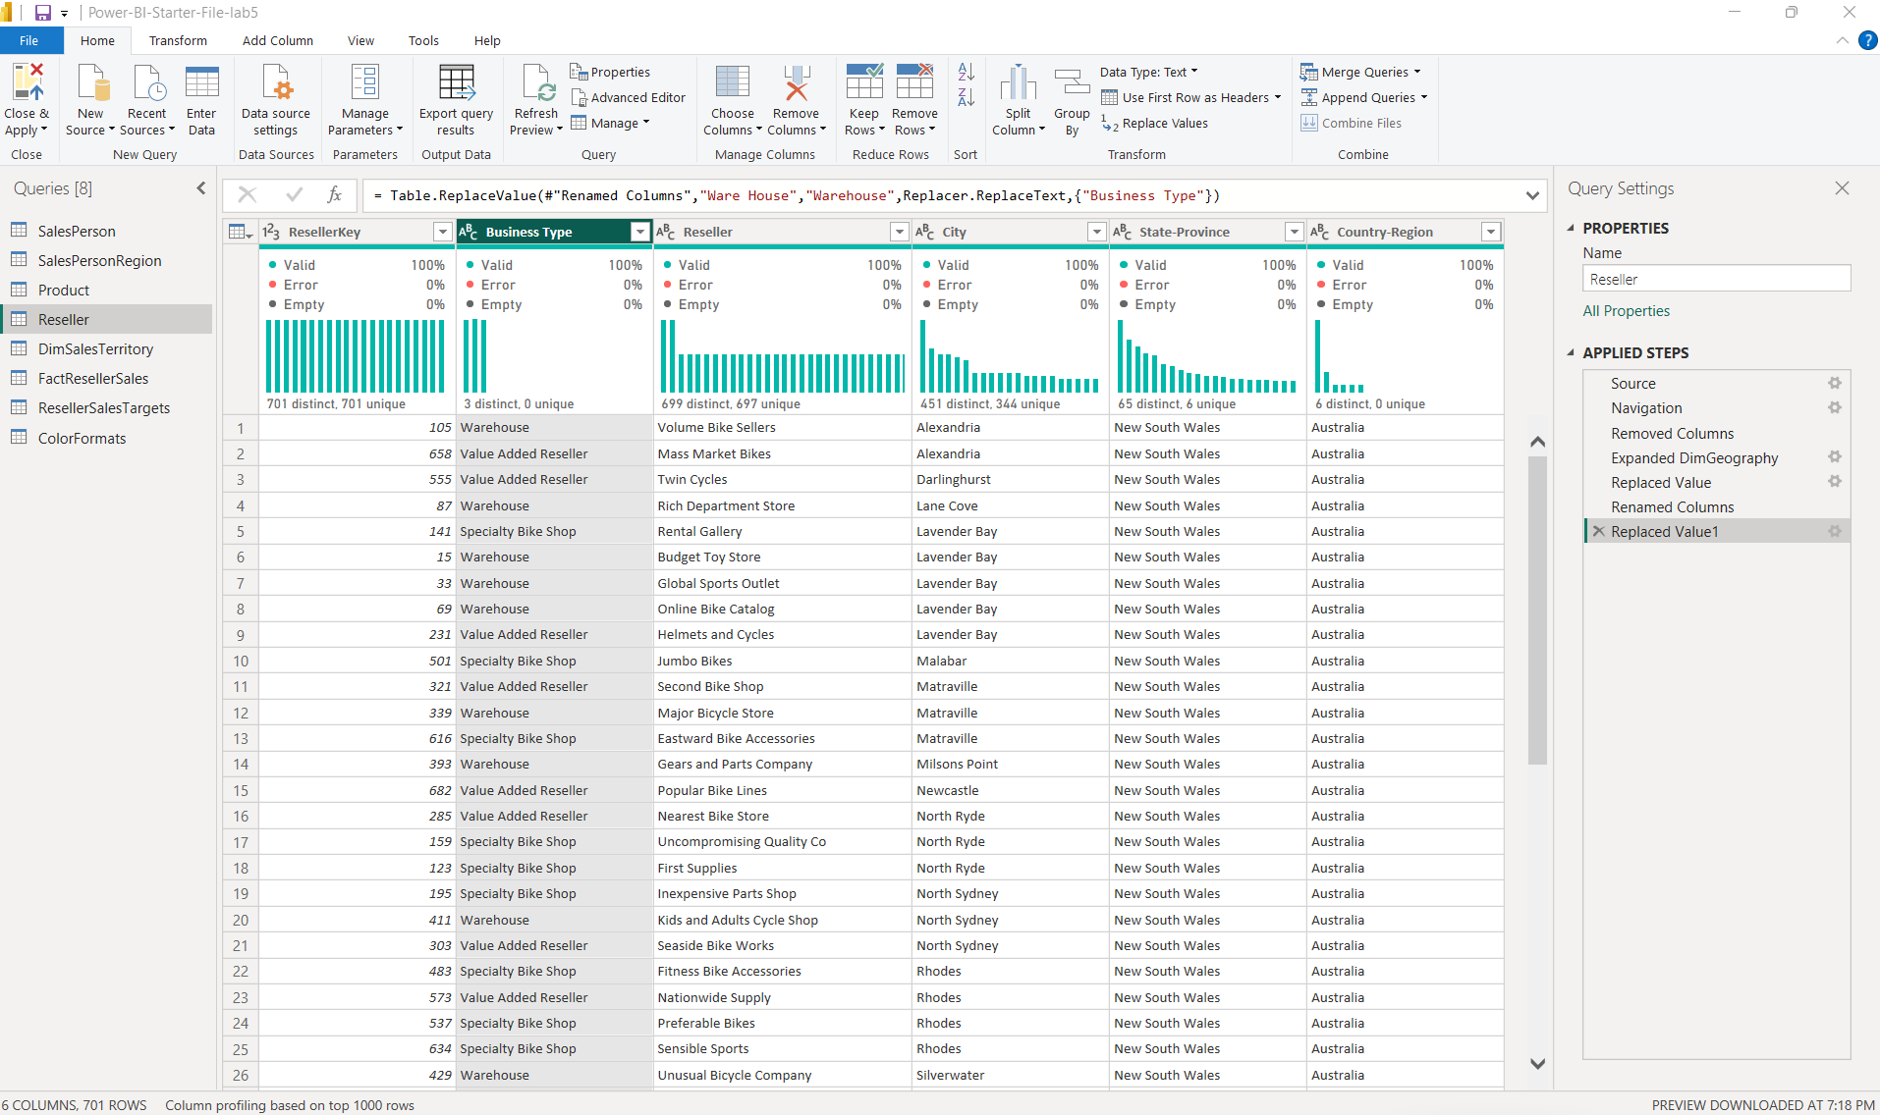

- Rename DimSalesTerritory table to Region
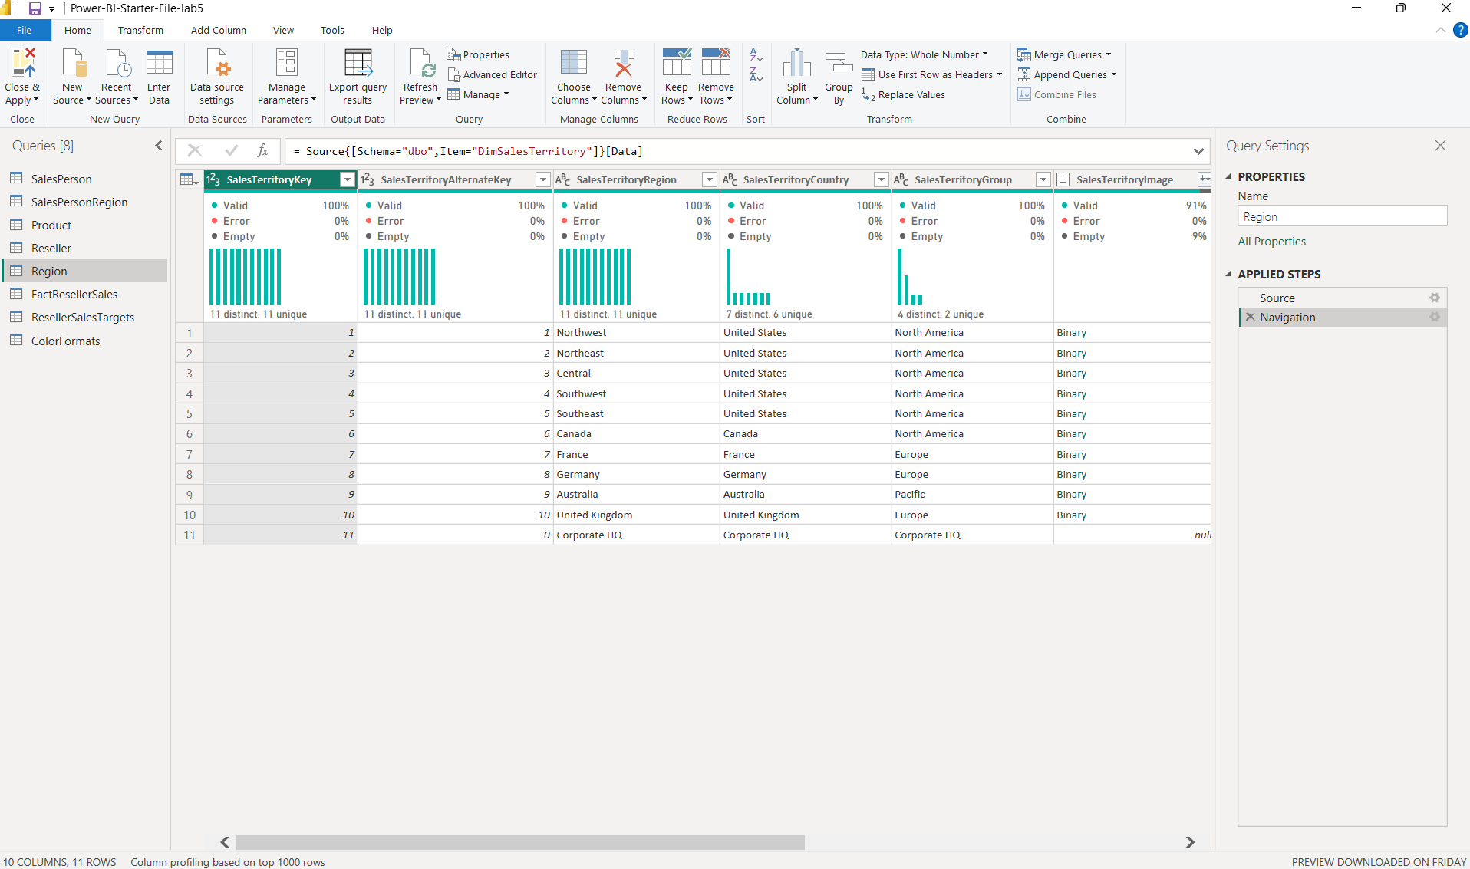
- Confirm Region query has 4 columns and 10 rows
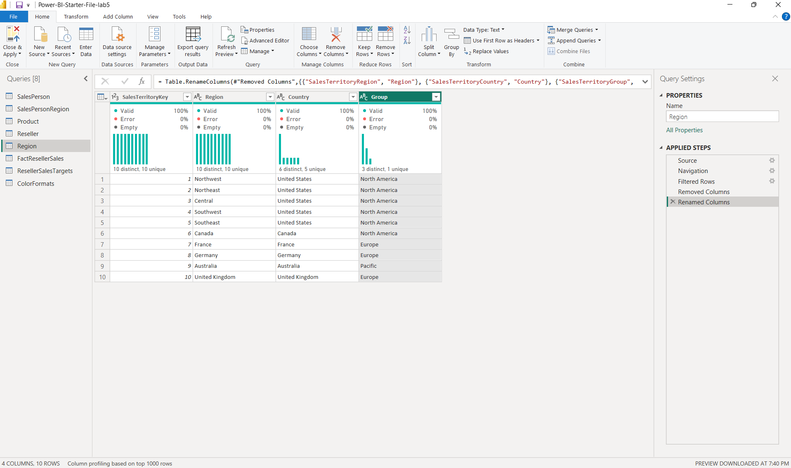

- Rename FactResellerSales table to Sales
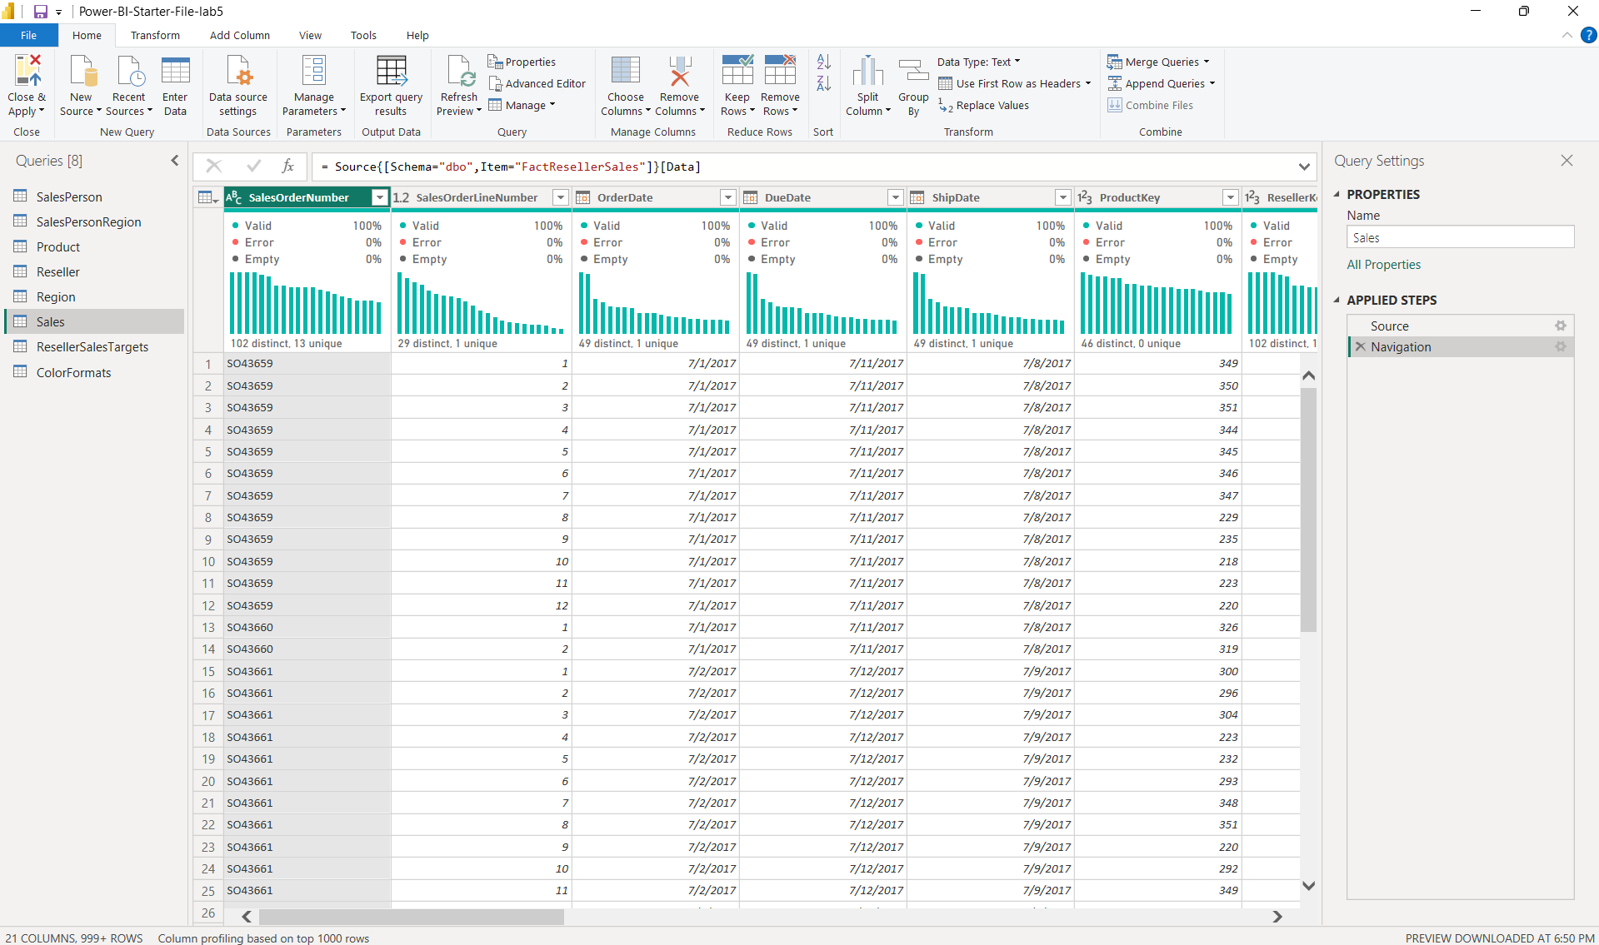
- Add a custom column called Cost and use the formula provided
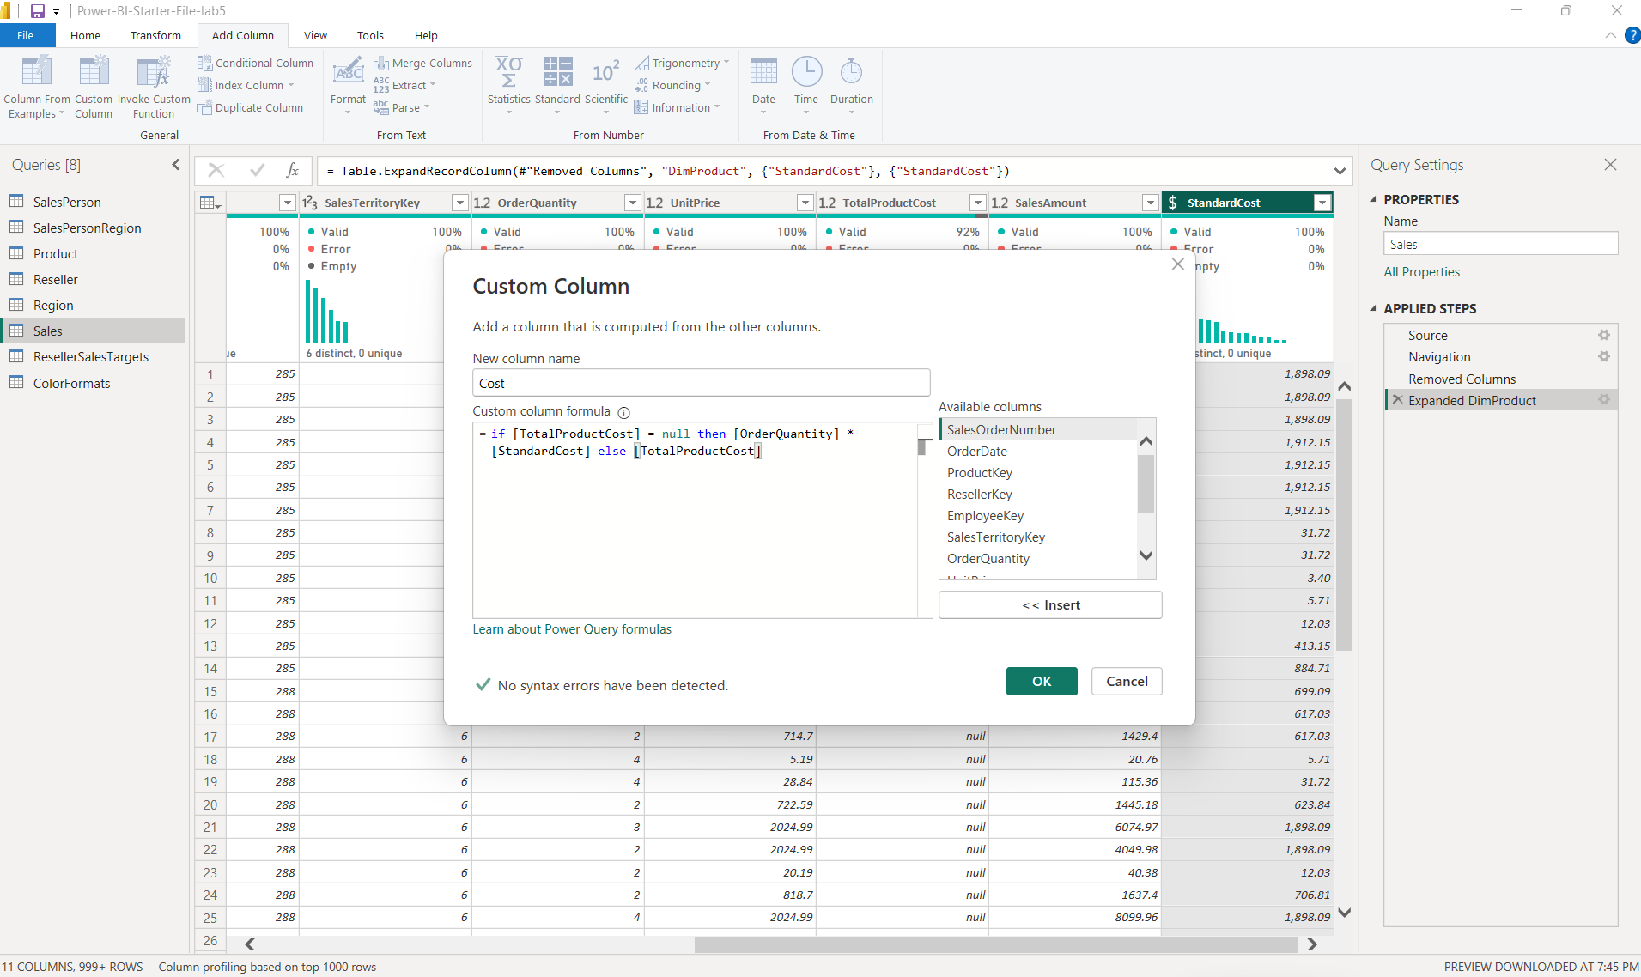
- Confirm Sales query has 10 columns and 999+ rows
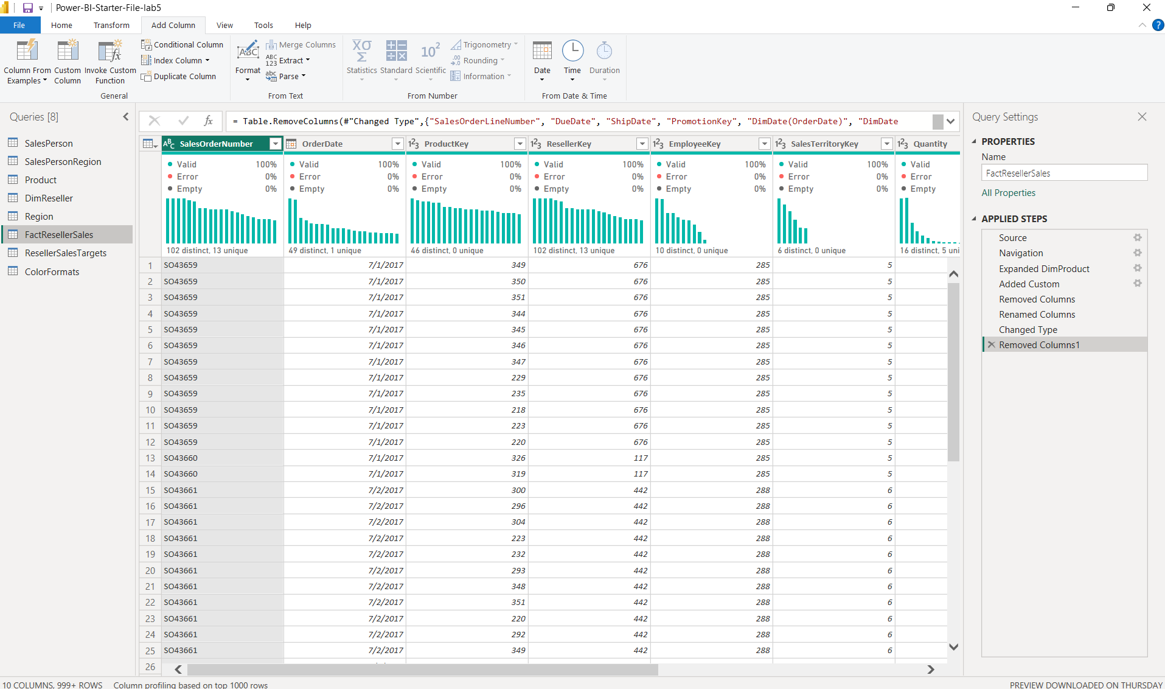
- Rename ResellerSalesTargets table to Targets
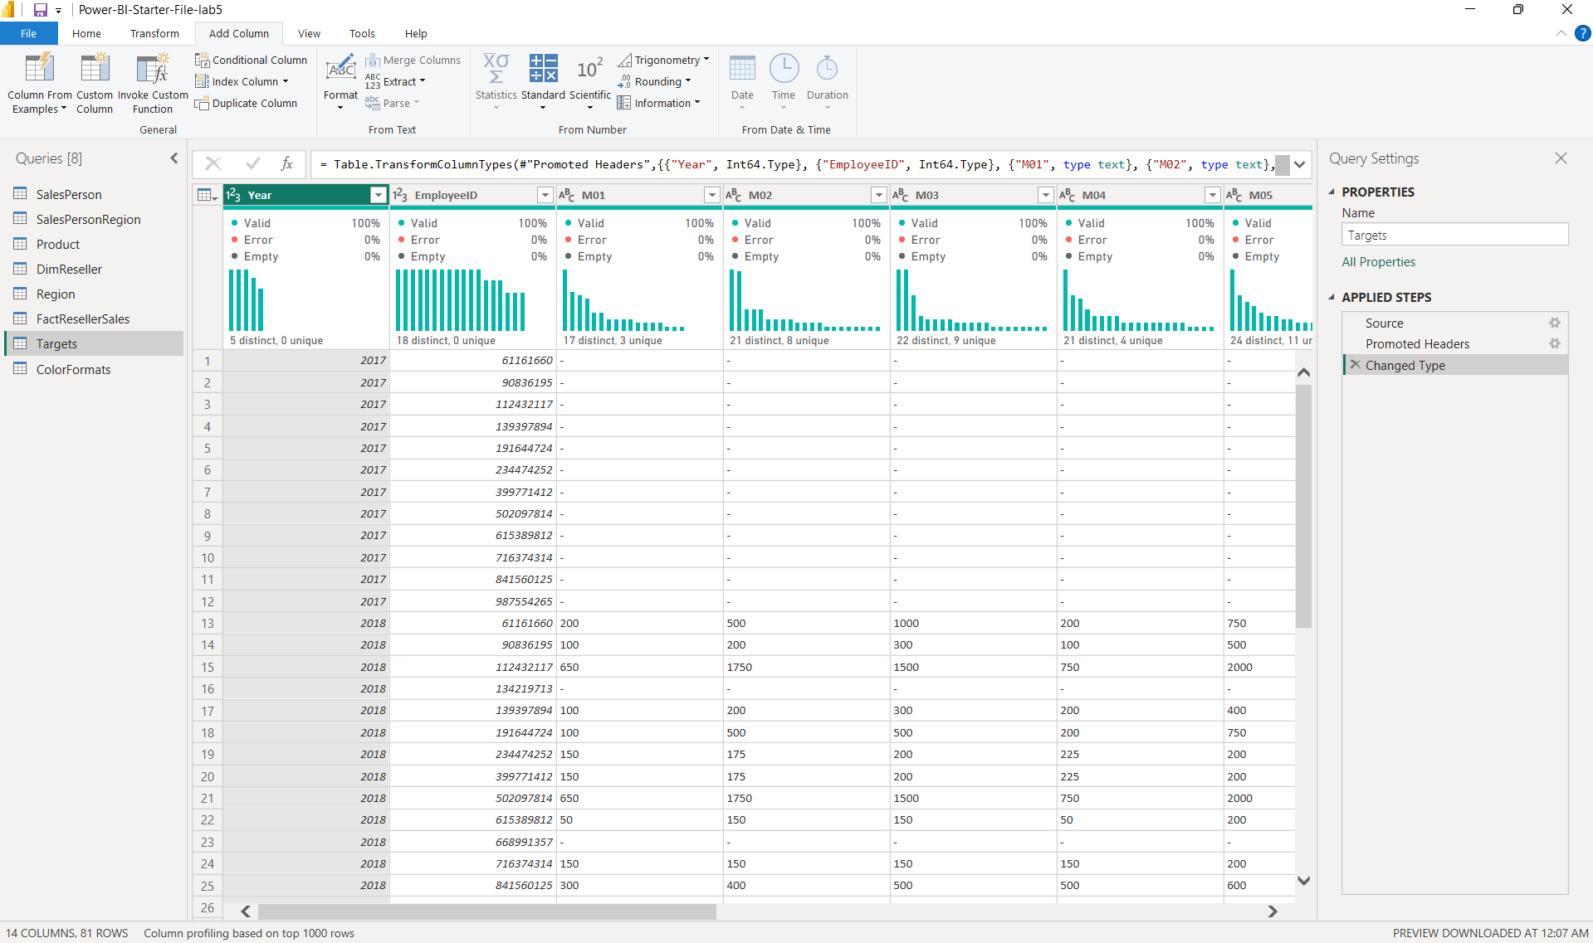

- Multiply Target values by 1000 by navigating to Transform >Standard > Multiply. Enter 1000 and click Ok
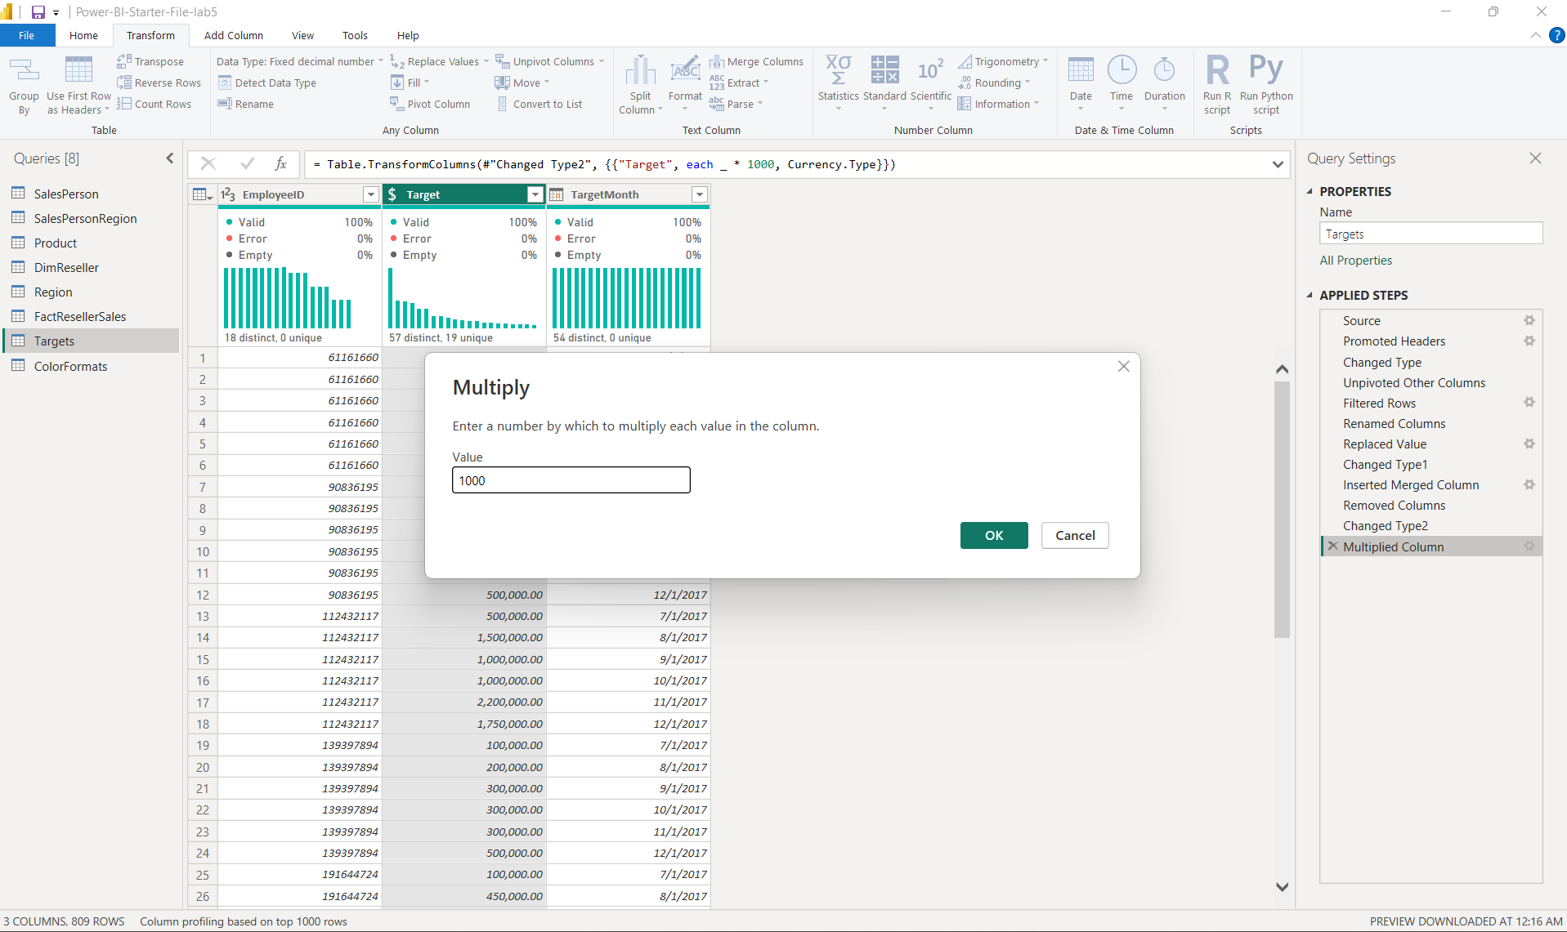
- Confirm Targets query has 3 columns and 809 rows
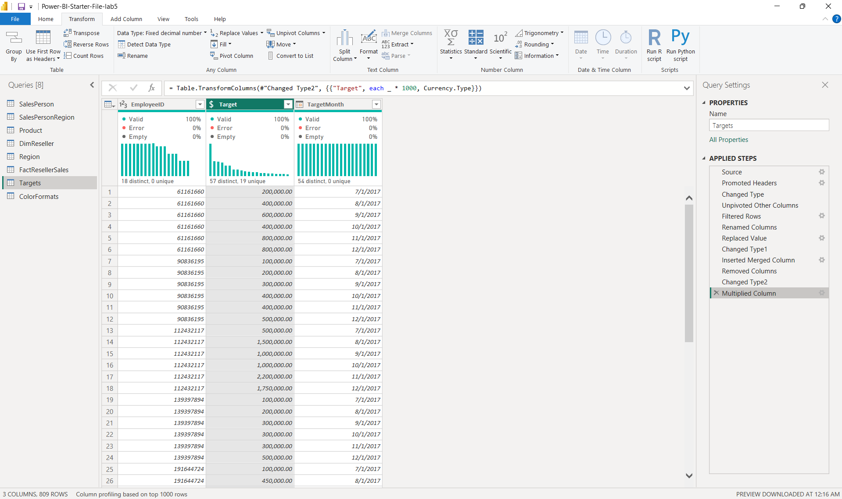
- Click on the ColorFormats query and notice that the first row contains the column names
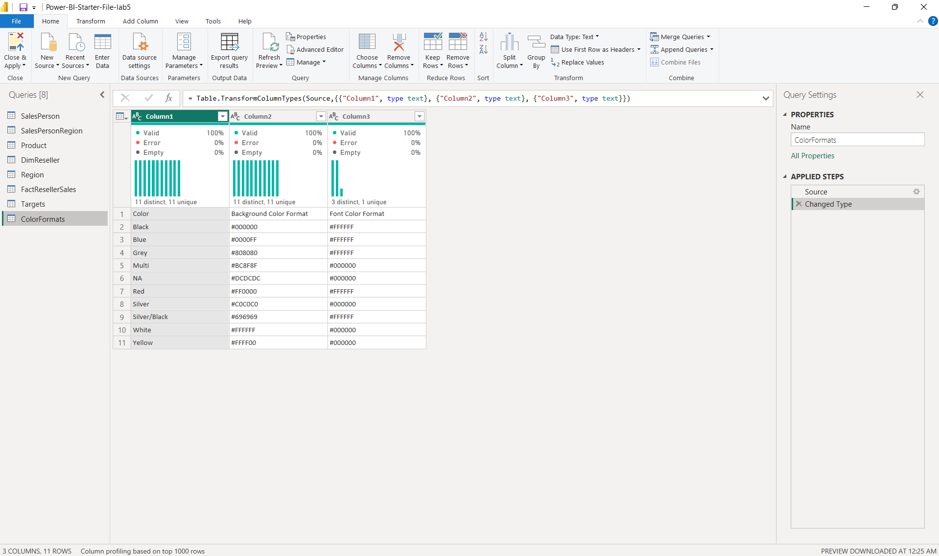
- Confirm ColorFormats query has 3 columns and 10 rows
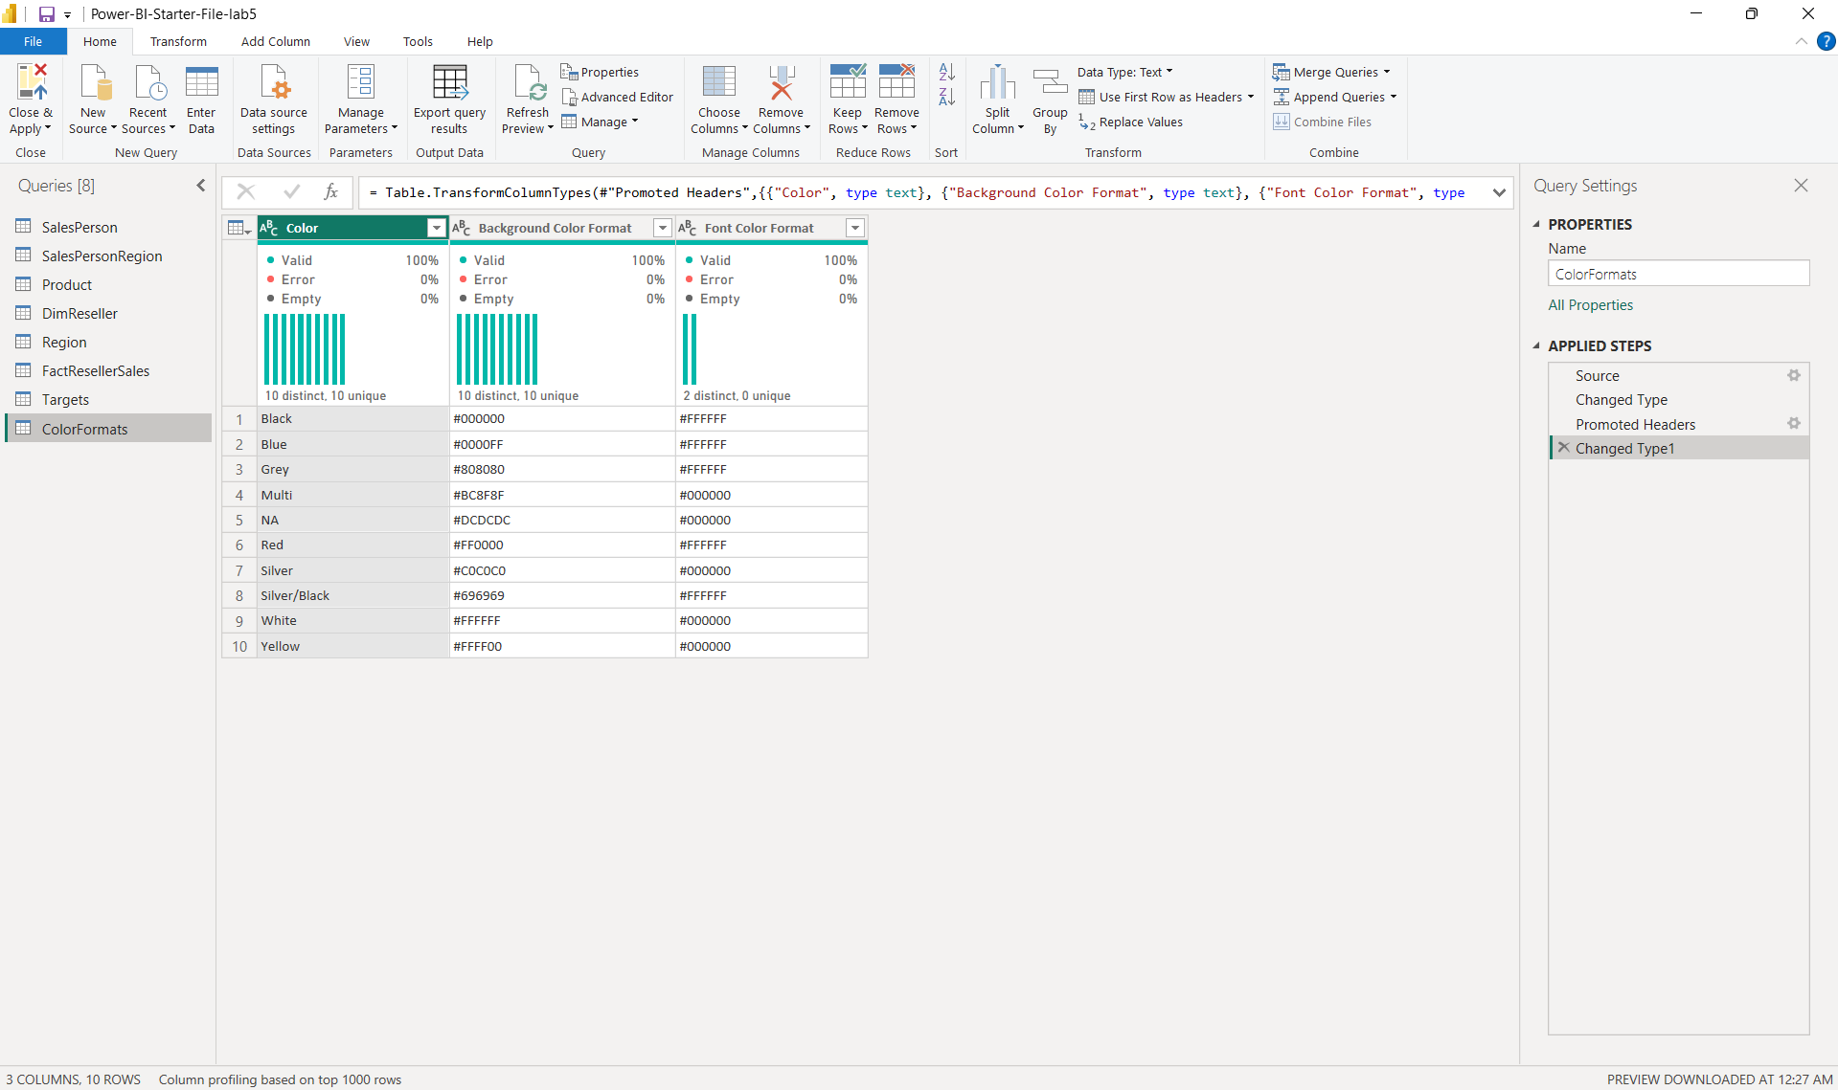
- Expand the ColorFormats to include Background Color Format and Font Color Format
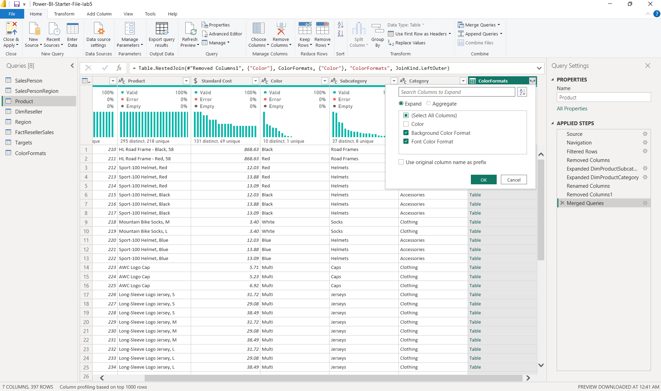
- Confirm Product query has 8 columns and 397 rows
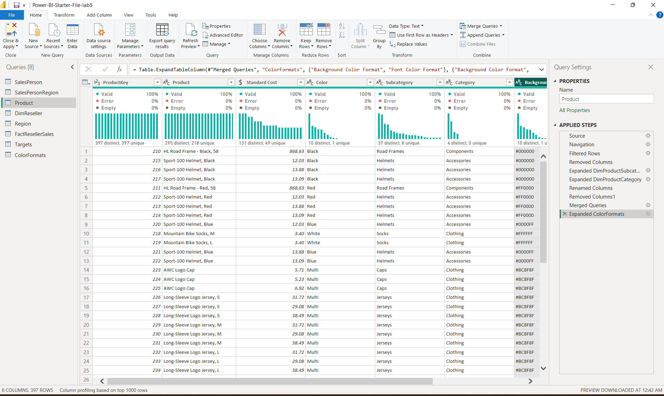
- Select ColorFormats query. In Query Settings, click on All Properties and uncheck the Enable Load To Report checkbox
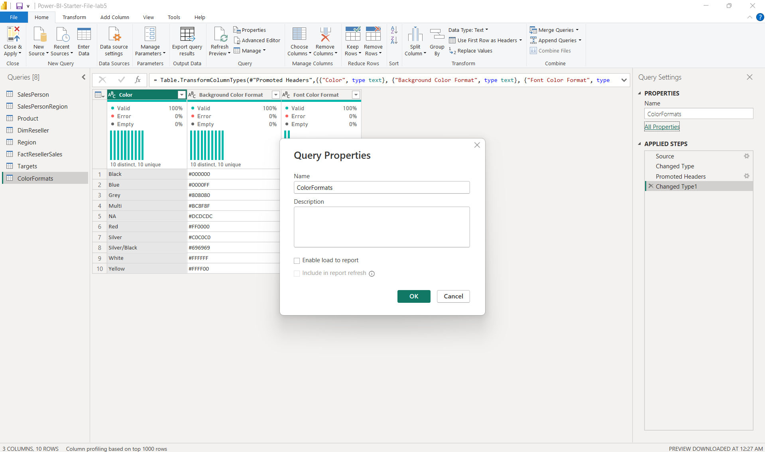
- Click Close & Apply and confirm 7 tables are loaded into the data model
