- On the Overview page, select the Year slicer. Navigate to the View tab, select Sync slicers and check boxes for Overview and My Performance pages
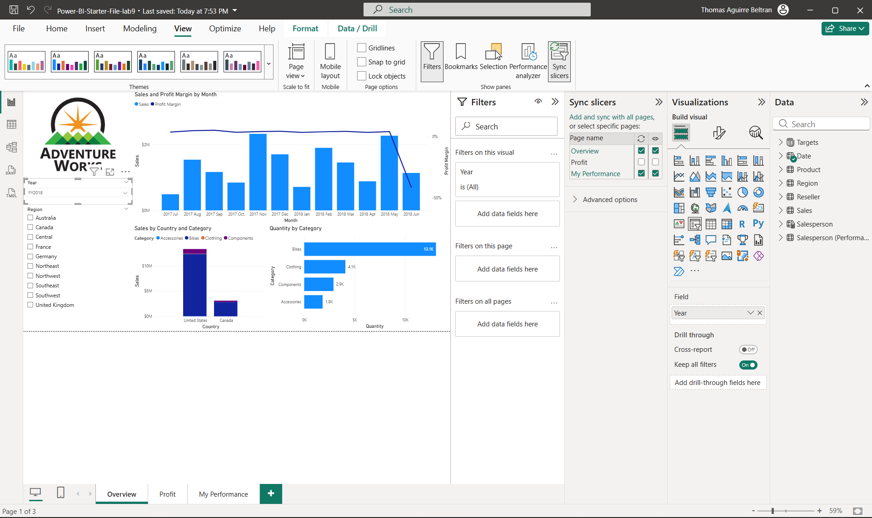
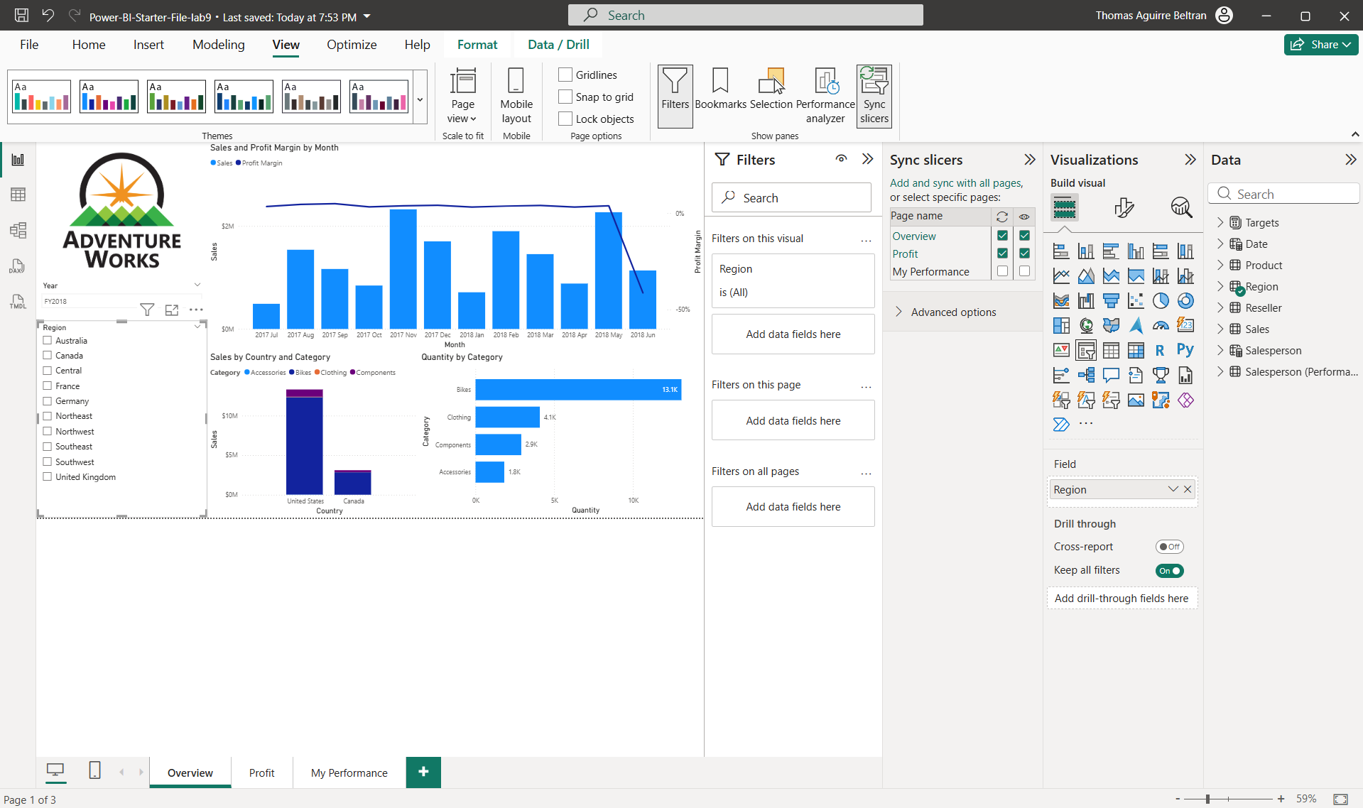
- On the Overview page, select the Region slicer. Sync slicers on the Overview and Profit page
- Drill-through page looks like grey header 20 pt with table
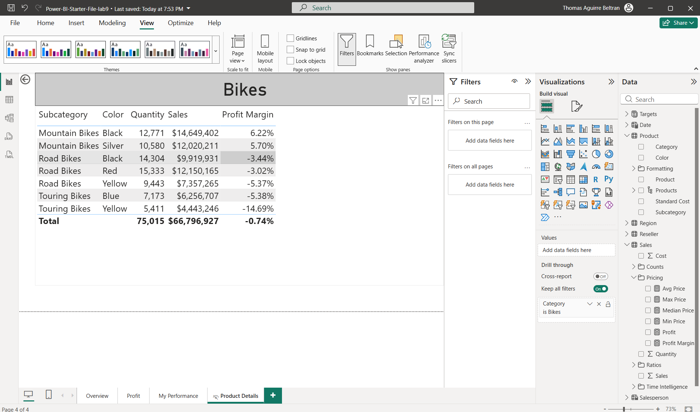
- Update conditional formatting icons, background color and font color
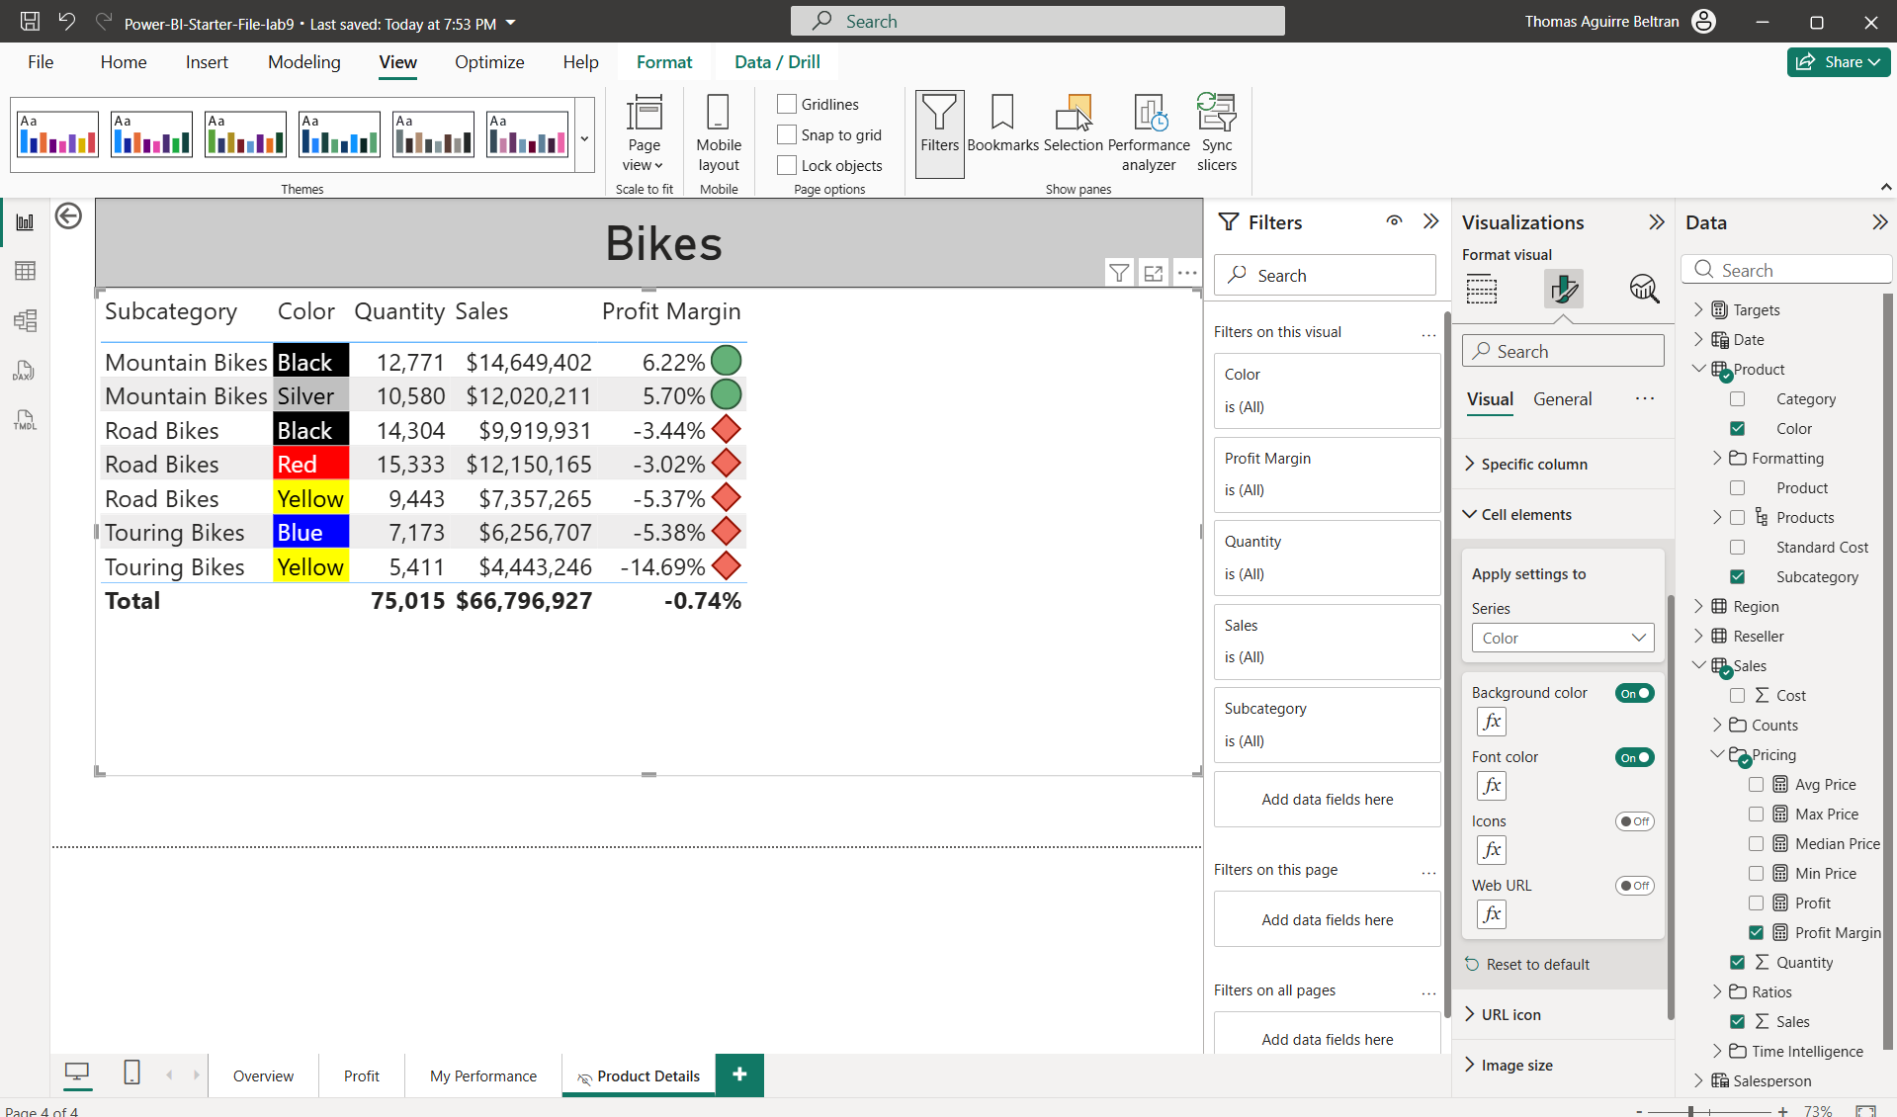

- Click on the bar chart bookmark to show bar chart that fits the screen
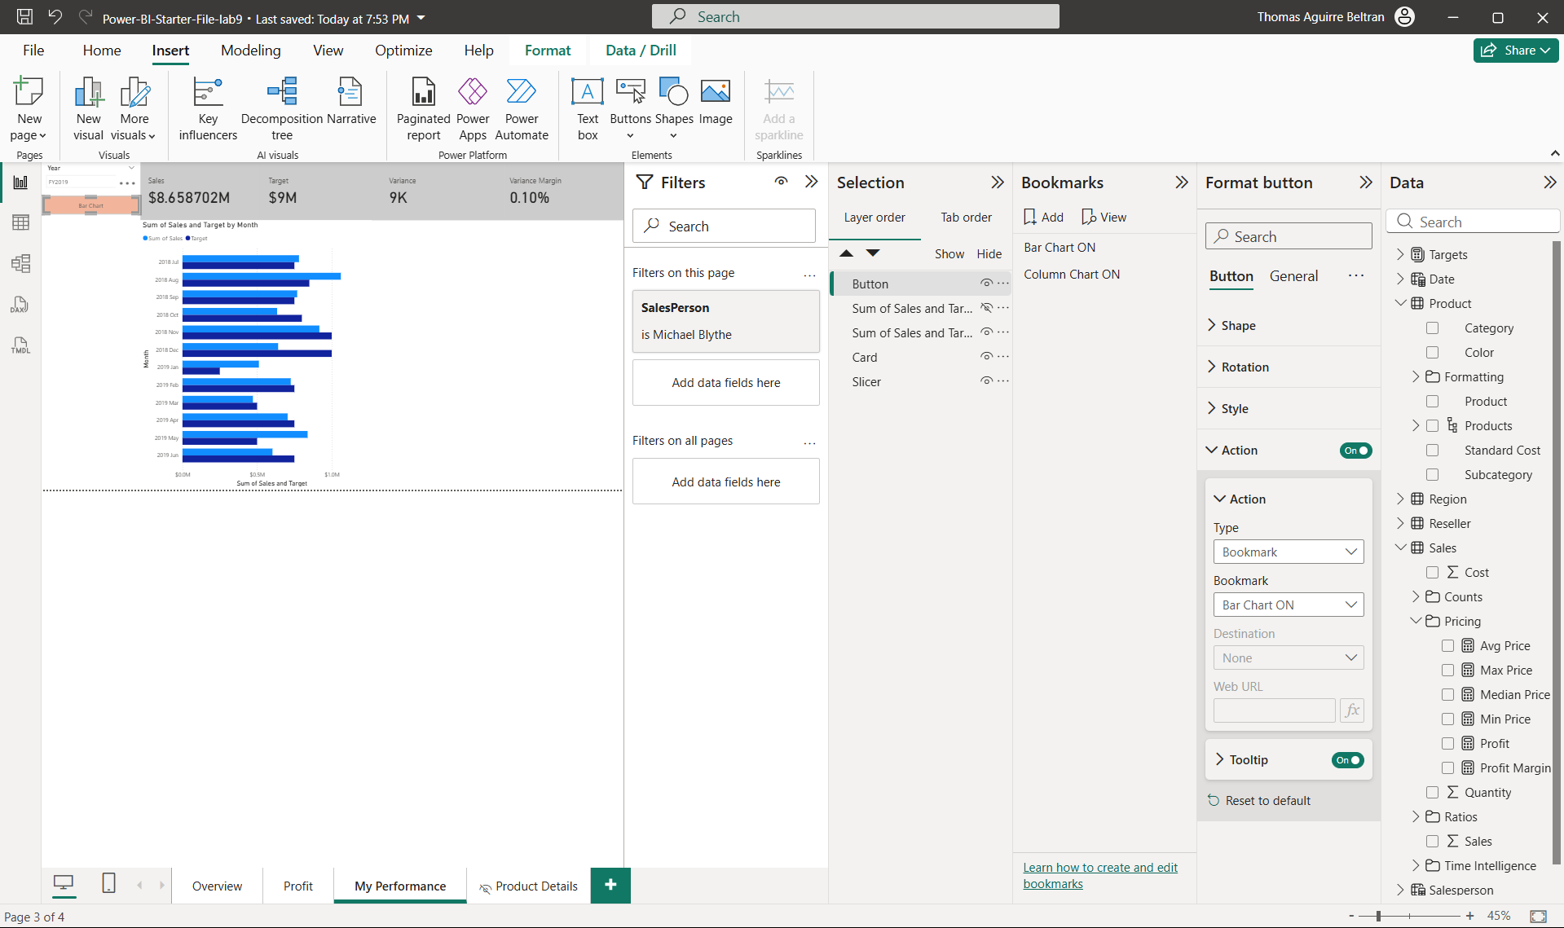
- Click on the column chart bookmark to show column chart that fits the screen
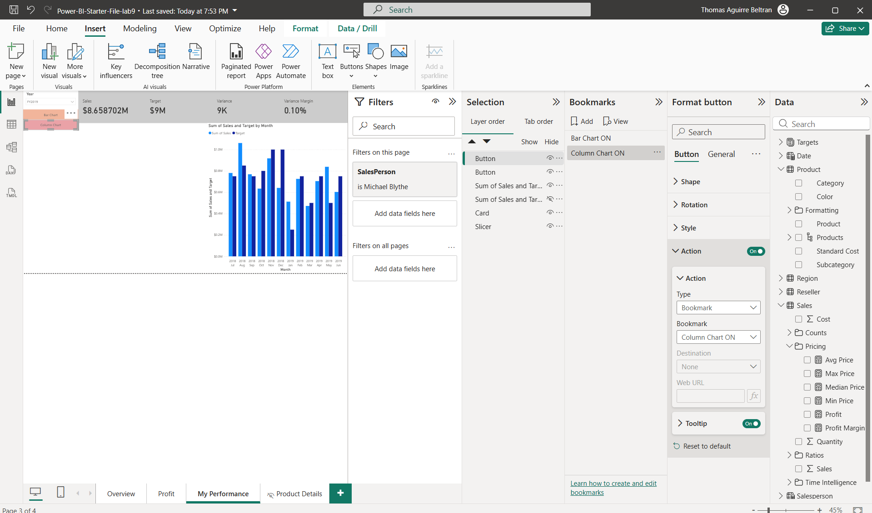

- Select Overview page, select Year FY2020 and select all in Region. Save the file
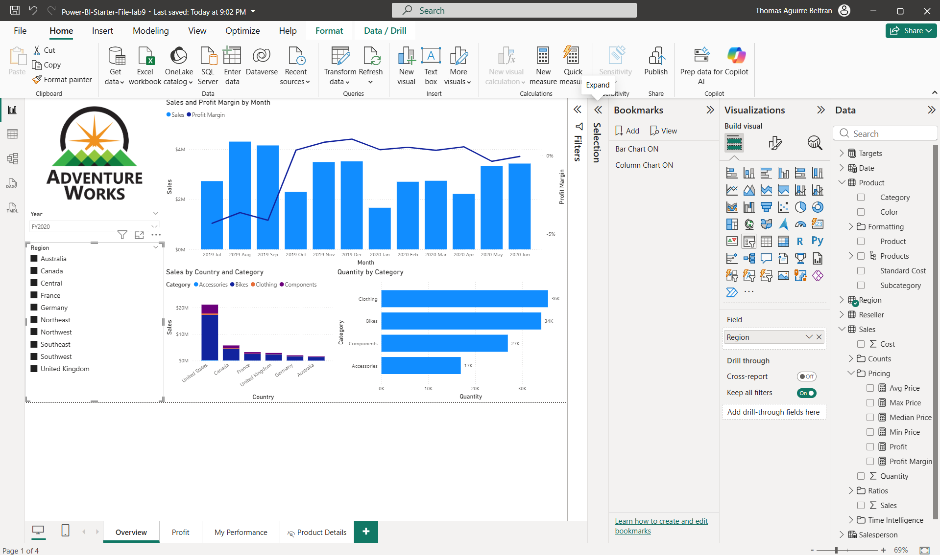
- Publish the file to My Workspace and select replace if prompted.
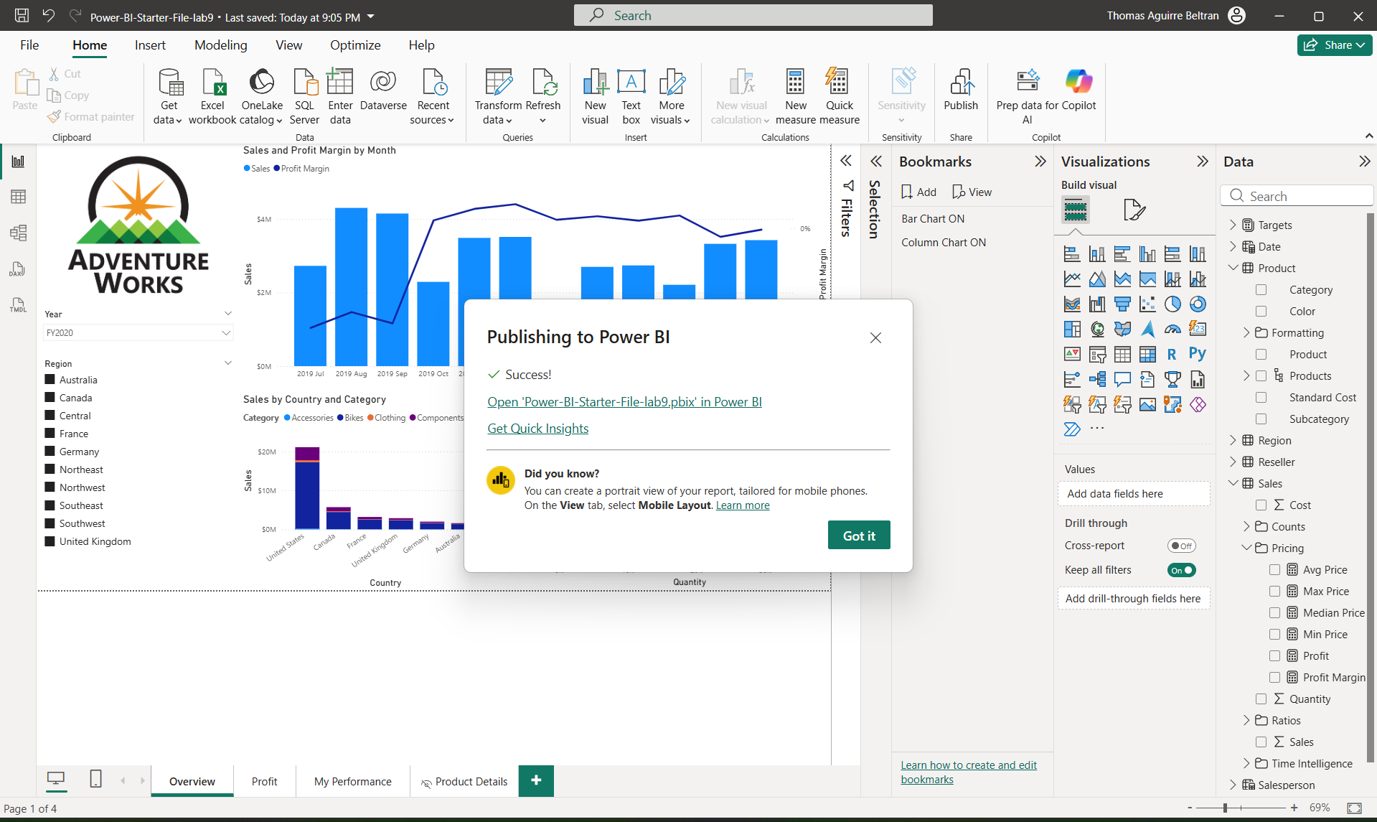
- Navigate to https://app.powerbi.com/ and click on the report published. Right-click on the Quantity by Category bar for Clothing and select Drill-through
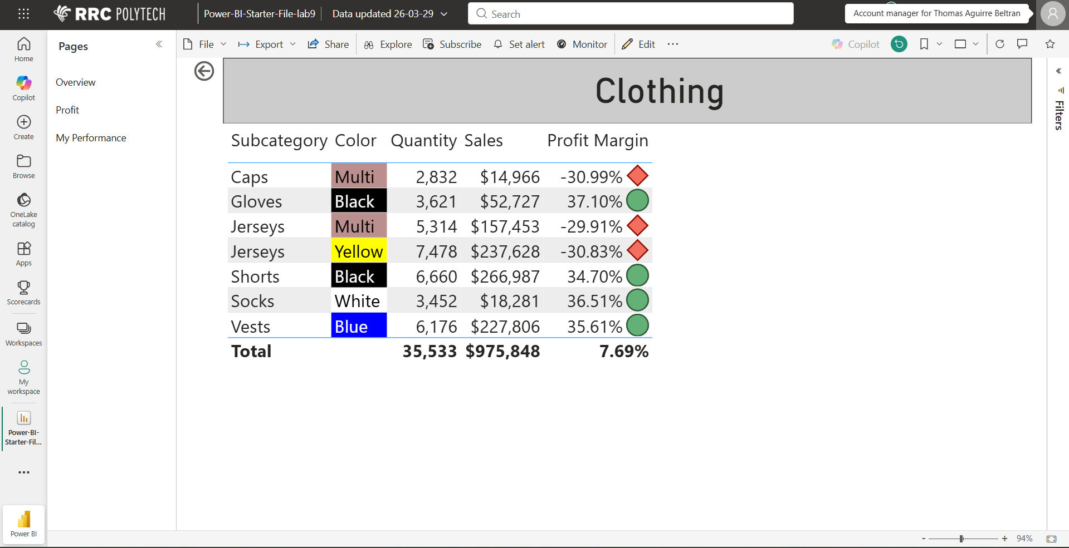
- Navigate to My performance tab and toggle between the Bar Chart and Column Chart buttons
