- All elements of the page present - Logo, 2 slicers and 3 visuals
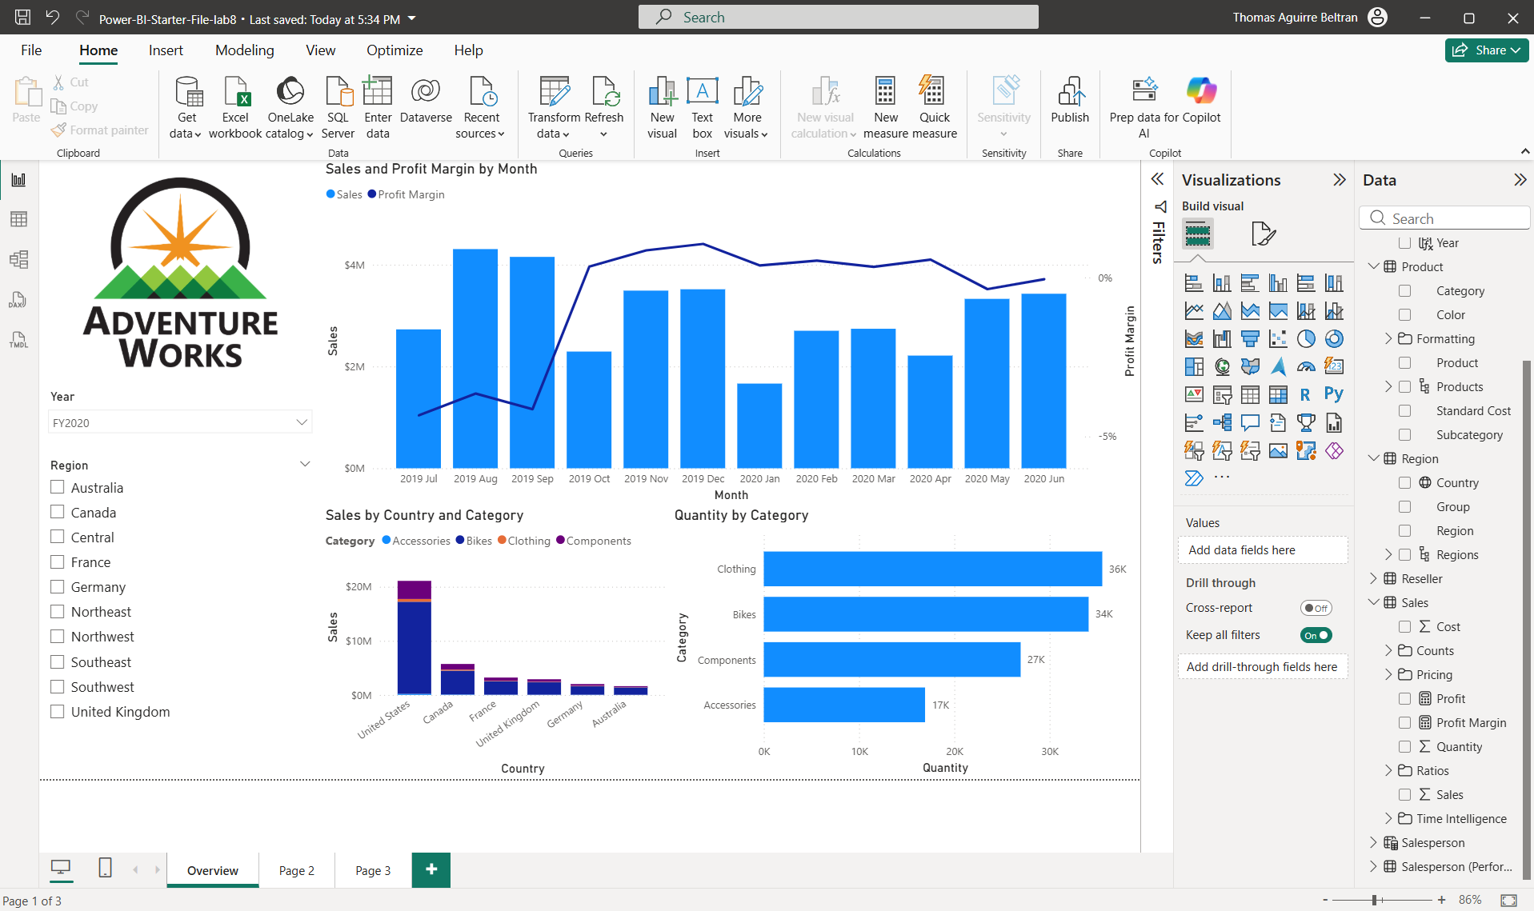
- All the elements of the page present - 1 slicer and 1 visual
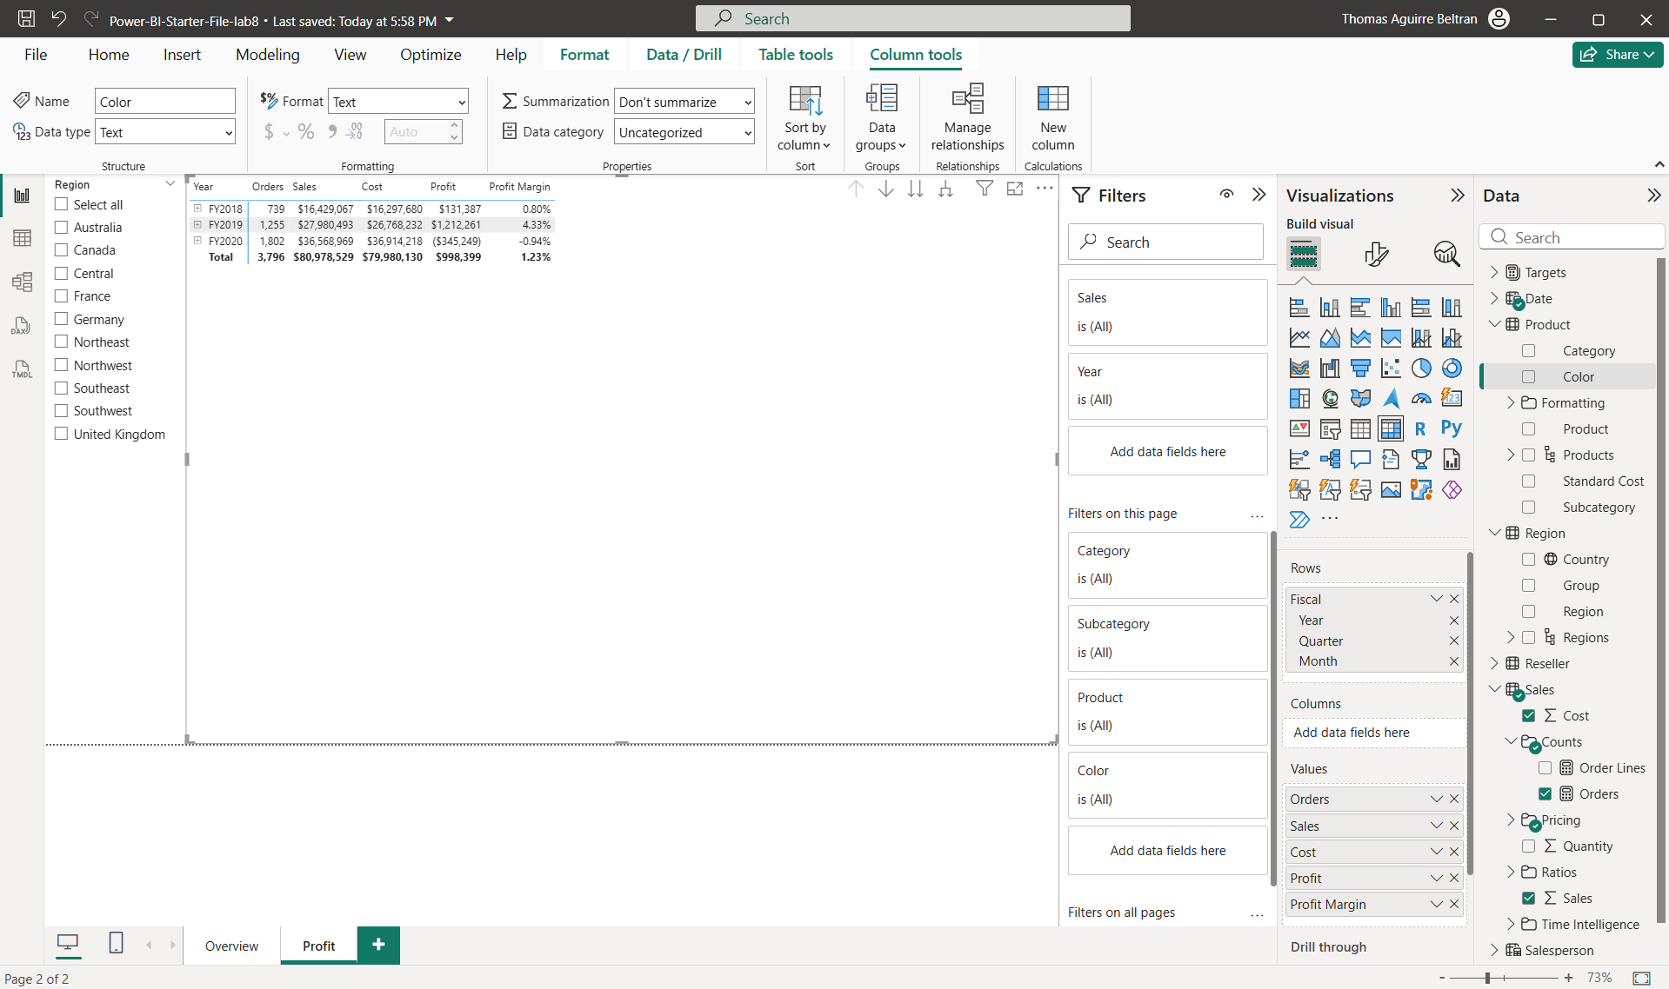

- All the elements of the page present - 1 slicer, 4 multi-row card, 1 column chart and 1 bar chart
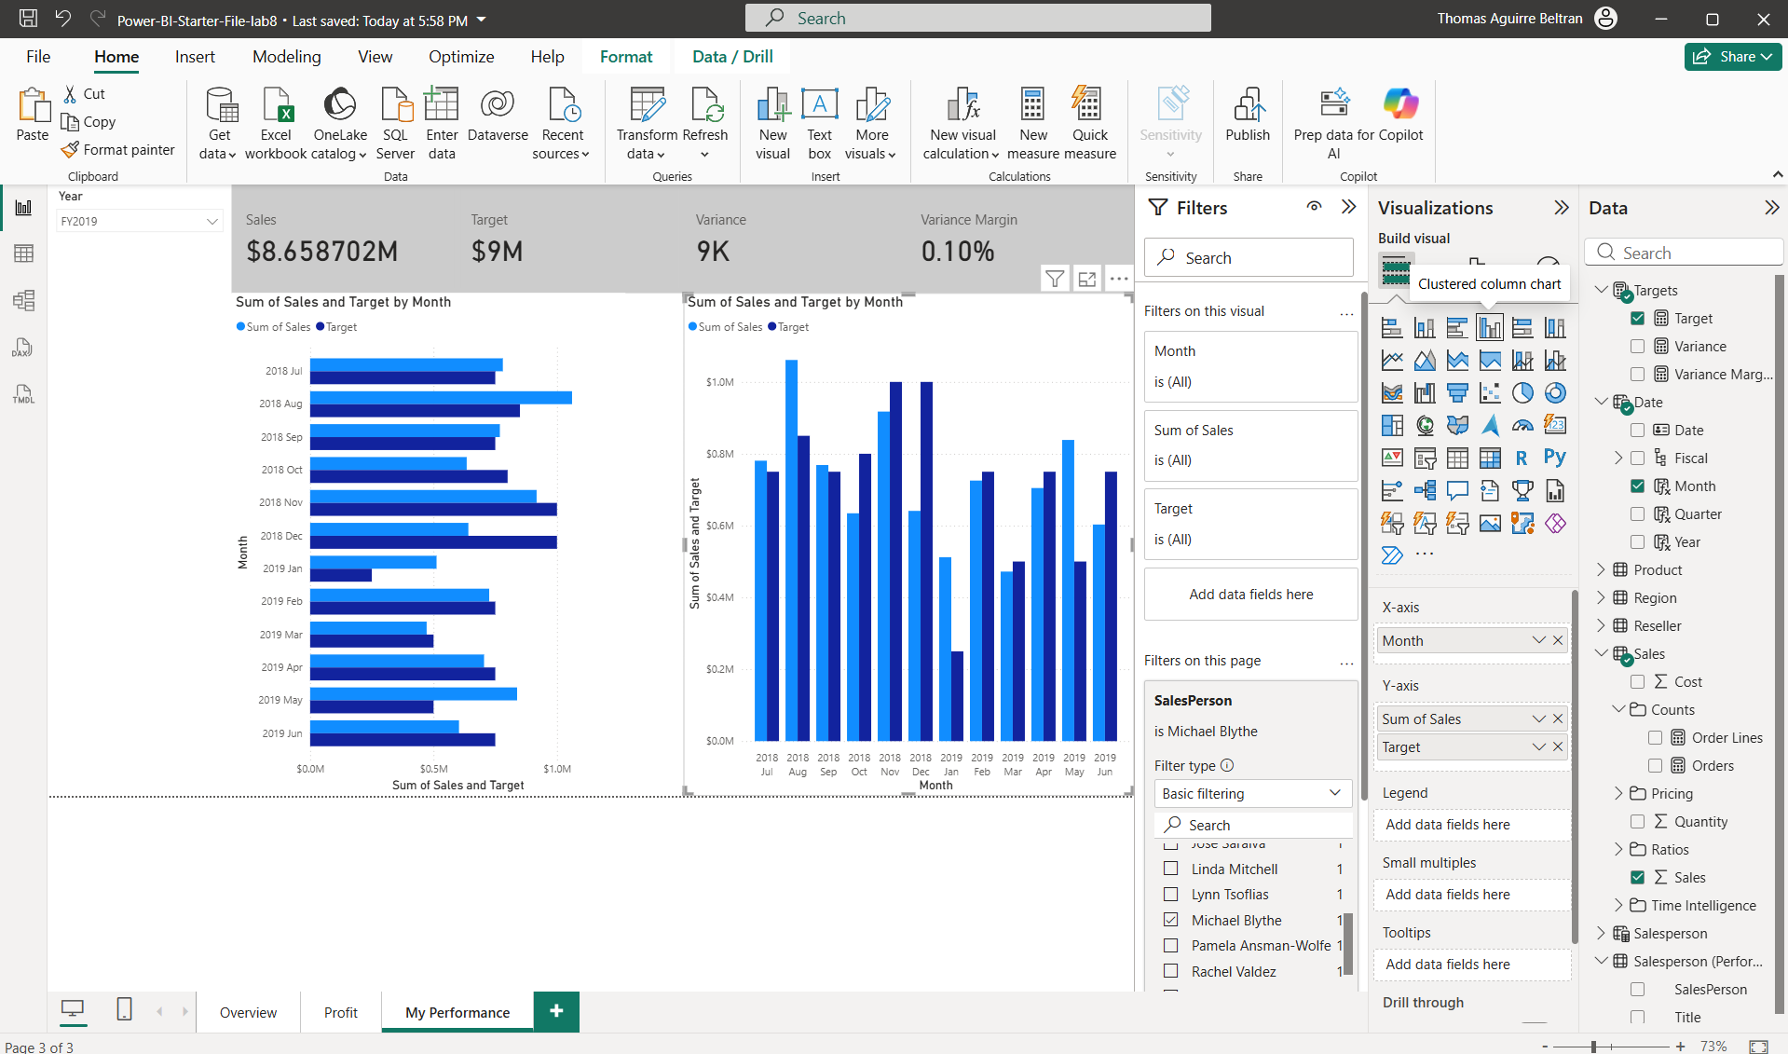
- Publish the report by selecting MyWorkspace
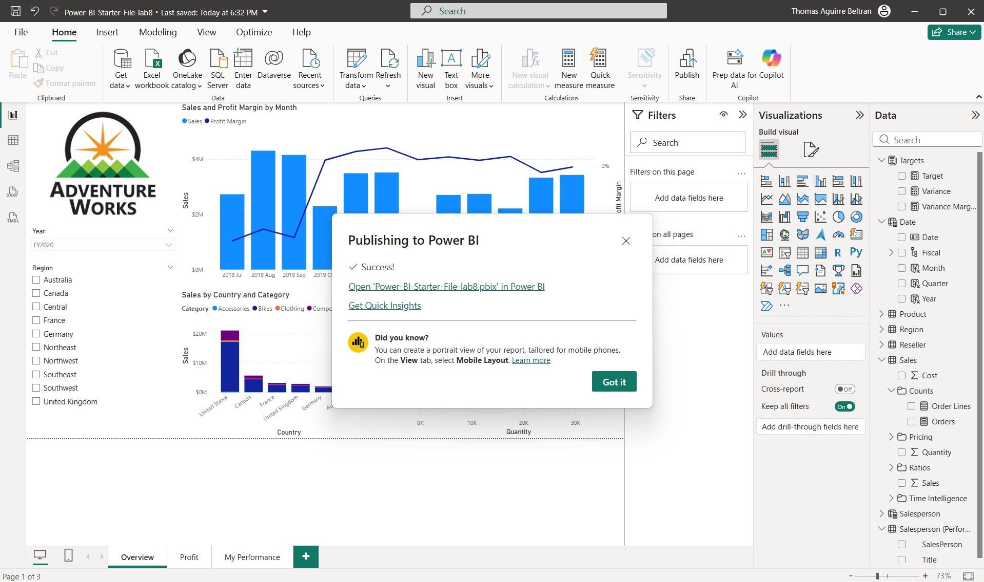
- On the matrix visual, drill into the Fiscal hierarchy
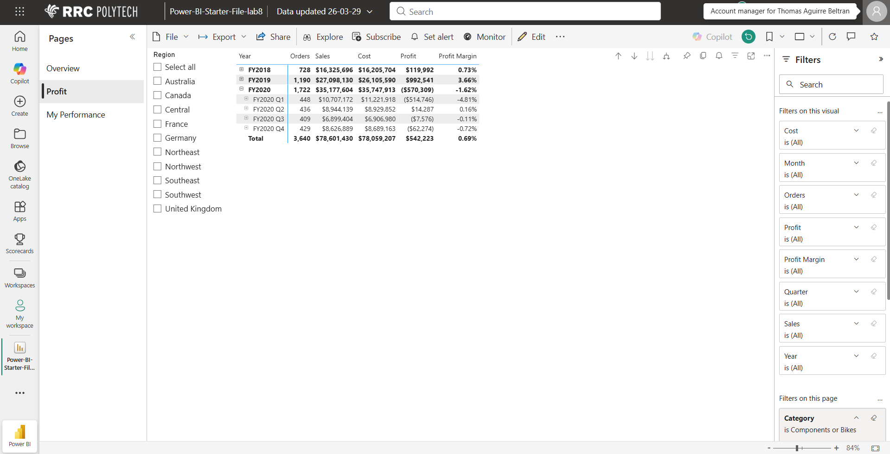
- At the bottom, notice the navigation functionality
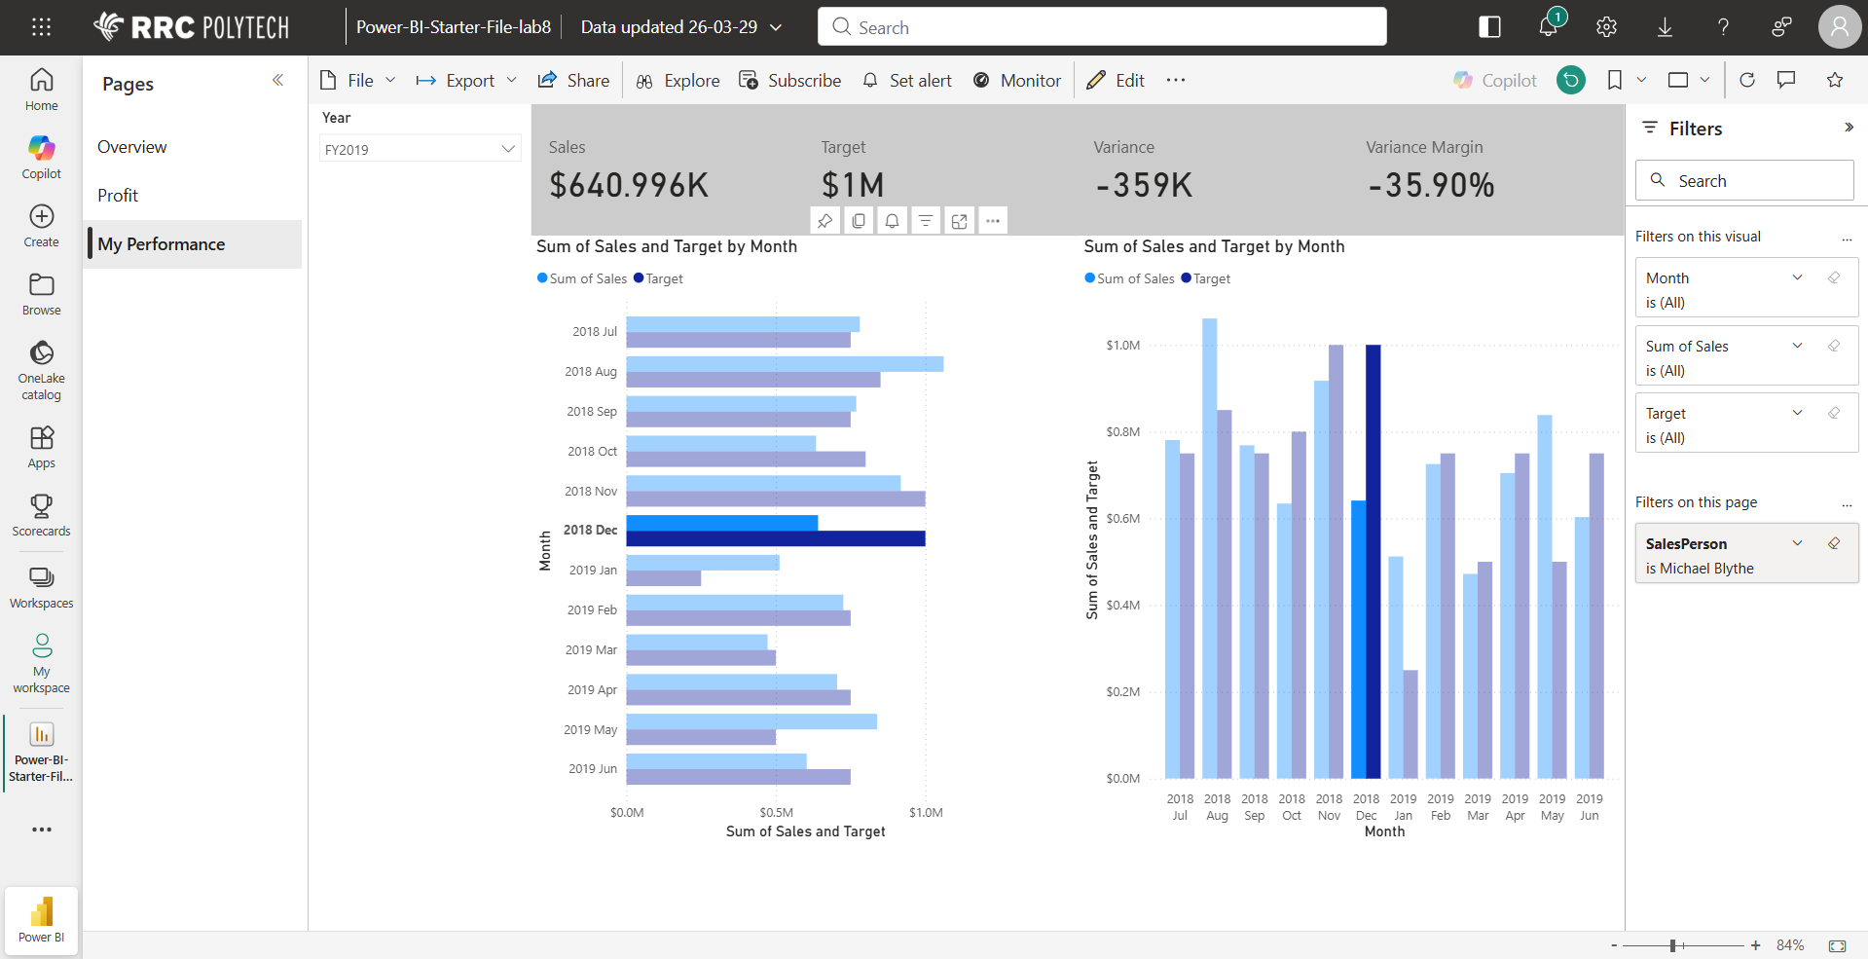

- Analysis of the different visuals to generate insights
- In FY2020 in profit page, there is negative profit even with high sales, meaning costs are too high.
- Profit margin changes a lot by month, showing unstable performance.
- The United States has much higher sales than Germany, showing dependence on one main market.
- In most months, sales do not reach the target, showing a consistent gap.

