CSAI 302 — Advanced Database Systems

Lab 4: B+ Tree, LSM Tree and R-Tree
A short theory summary and the steps we followed

Lab objectives
- Implement a concurrent B+ tree with bulk loading.
- Implement an LSM tree (memtable + SSTables + compaction).
- Implement an R-tree for geospatial queries.
- Benchmark insert-heavy vs read-heavy workloads.
Like Lab 2, this lab does not use PostgreSQL. The three index structures are written in plain Python, each in its own file, and one script runs the same workloads on all of them. Only the LSM tree uses the disk: it writes real files to a temporary folder and deletes them at the end.
File | What it is
bplus_tree.py | Concurrent B+ tree (latch crabbing) with bulk loading
lsm_tree.py | LSM tree: memtable, SSTable files with Bloom filter and sparse index, compaction
rtree.py | R-tree for 2-D data: window queries and k-nearest-neighbour search
test_indexes.py | Checks every structure against a simple, obviously correct model
bench_indexes.py | The benchmark: prints the result tables and saves the chart

1. Concurrent B+ tree with bulk loading

Theory
A B+ tree keeps keys sorted in a balanced tree. Internal nodes hold only keys and child pointers and are used to find the way down. All values are in the leaves, and every leaf points to its right sibling, so a range scan finds the first leaf and then walks sideways. The order is the maximum number of children of a node.
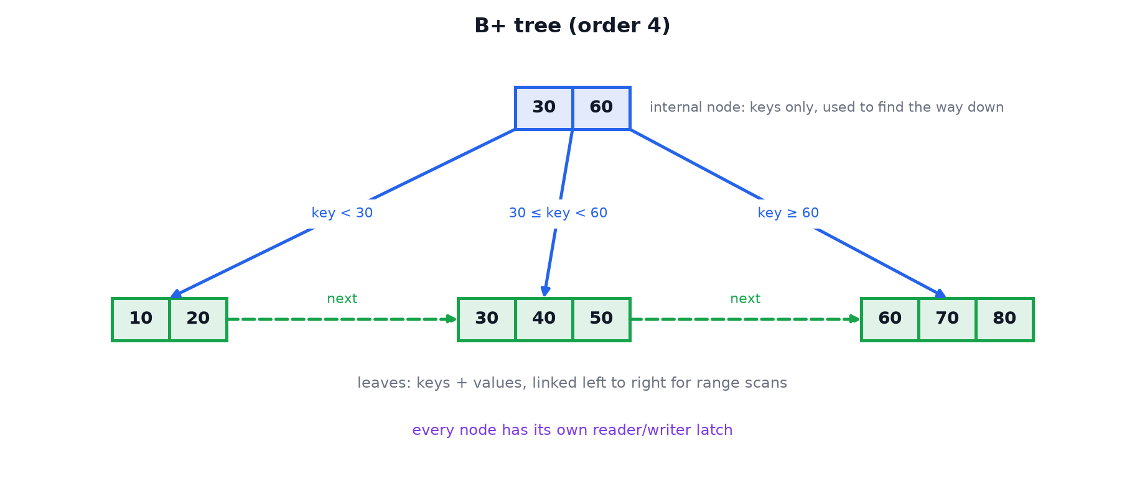
Figure 1. A B+ tree: internal nodes route the search, linked leaves hold the data.
Insert and split. A key is inserted into its leaf. If the leaf becomes too full it is split in half and the first key of the new right half is copied up to the parent as a separator. If the parent overflows it splits too, and its middle key is pushed up. When the root splits a new root is created; this is the only way the tree grows taller, so all leaves are always at the same depth.
Concurrency: latch crabbing. Every node has a reader/writer latch (many readers or one writer). A thread moves down the tree like a crab: it latches the child first and only then releases the parent, so no other thread can change the path under it.
Operation | Latches taken | Why
search, range scan | Read latches from root to leaf; along the leaves, latch the next leaf before releasing the current one | Readers do not block each other
insert (optimistic) | Read latches on the way down, a write latch only on the leaf | Most inserts fit in the leaf, so upper levels stay free
insert (pessimistic) | Write latches from the root; ancestors are released as soon as a node is safe | Used only when the leaf is full and must split

A node is safe when it has a free slot: a split below it cannot travel past it, so everything above can be released. There are no deadlocks because every thread takes latches in the same direction: top to bottom, and left to right along the leaves.
Bulk loading. Inserting N keys one by one costs N searches from the root and many splits. If the data is already sorted, the tree can be built bottom-up instead: cut the sorted input into leaves filled to a chosen fill factor, link them, then build each parent level from the smallest key of every child, until one node is left. That node is the root. There is no searching and no splitting.

What we did
- Wrote RWLatch (a reader/writer latch built on threading.Condition) and gave one to every node.
- Implemented search, range_scan, insert (optimistic, then pessimistic with crabbing) and a lazy delete that removes the key but does not merge leaves.
- Implemented bulk_load(items, fill=0.9), which builds the tree bottom-up from sorted pairs.
- Tested against a Python dictionary: 5,000 random inserts with order 4, then checked every key, range scans, deletes and the structure of the tree (sorted keys, separators, all leaves at the same depth).
- Tested concurrency: 8 writer threads and 4 reader threads at the same time on one tree. No insert was lost and no reader saw a broken node.
- Compared the ways of building a tree of 100,000 keys (order 64):
Method | Time (s) | Height | Leaves | Leaf fill
insert, random order | 0.846 | 3 | 2241 | 71%
insert, sorted order | 0.811 | 4 | 3125 | 51%
bulk load (fill 0.9) | 0.021 | 3 | 1786 | 89%
bulk load (fill 1.0) | 0.019 | 3 | 1588 | 100%

Result: bulk loading is about 40 times faster than inserting one by one, and it produces a smaller tree. Inserting keys in sorted order is the worst case: every split leaves behind a half-full leaf that never receives another key, so the leaves end 51% full and the tree is one level taller.

2. LSM tree

Theory
A B+ tree updates pages in place, so on disk every insert is a random page write. A log-structured merge tree (LSM tree) never updates in place: it collects writes in memory, writes them to disk as new sorted files, and cleans up later in the background.
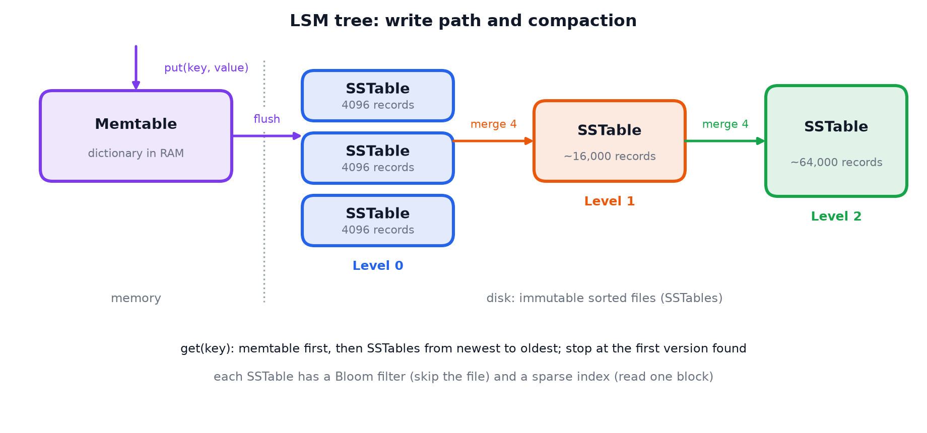
Figure 2. LSM tree: writes go to memory, are flushed to sorted files, and files are merged level by level.
Part | What it does
Memtable | Receives all writes in memory. Nothing touches the disk.
Flush | When the memtable is full (4096 entries) it is sorted and written in one sequential pass as an SSTable.
SSTable | Sorted string table: an immutable file of records sorted by key.
Tombstone | Files cannot be changed, so a delete writes a marker that hides older versions of the key.
Bloom filter | A small bit array per SSTable that answers "this key is definitely not in this file" from memory, so most files are skipped.
Sparse index | One entry per 32 records: says which block of the file to read, so a lookup reads one small block.
Compaction | Merges several SSTables into one, keeping only the newest version of each key.

Reading. Check the memtable, then the SSTables from newest to oldest, and stop at the first version found. The newest version always wins.
Compaction (size-tiered). Without cleanup the number of files, and so the cost of a read, would grow forever. When a level collects 4 tables they are merged into one bigger table in the next level. Tombstones are dropped only when merging into the bottom level, because higher up an older file could still contain the key.
The trade-off. Writes are cheap and sequential, but each record is rewritten several times by compaction (write amplification) and a read may have to look in several files (read amplification).

What we did
- Wrote SSTable: writes the sorted records to a file and builds the Bloom filter and the sparse index while writing.
- Wrote LSMTree with put, delete (tombstone), get and scan, plus the flush and the compaction.
- Wrote the k-way merge used by both compaction and range scans: it reads the sorted inputs together and keeps the newest version of each key.
- Tested against a Python dictionary with a very small memtable (64 entries) to force many flushes: 20,000 random puts, overwrites and deletes.
- Measured the write amplification in the benchmark: bytes written to disk divided by bytes inserted.
LSM tree ok (311 flushes, 152 compactions, 7 tables in 6 levels)

Result: after 311 flushes only 7 files remained, and every get and scan returned the same answer as the dictionary, including deleted and overwritten keys.

3. R-tree for geospatial queries

Theory
A B+ tree needs keys that can be sorted. Points on a map have two coordinates and no single order: sorting by longitude says nothing about latitude. An R-tree groups nearby objects into minimum bounding rectangles (MBRs). A leaf holds objects, and an entry in an internal node holds the rectangle that covers everything below it. Rectangles of neighbouring nodes may overlap.
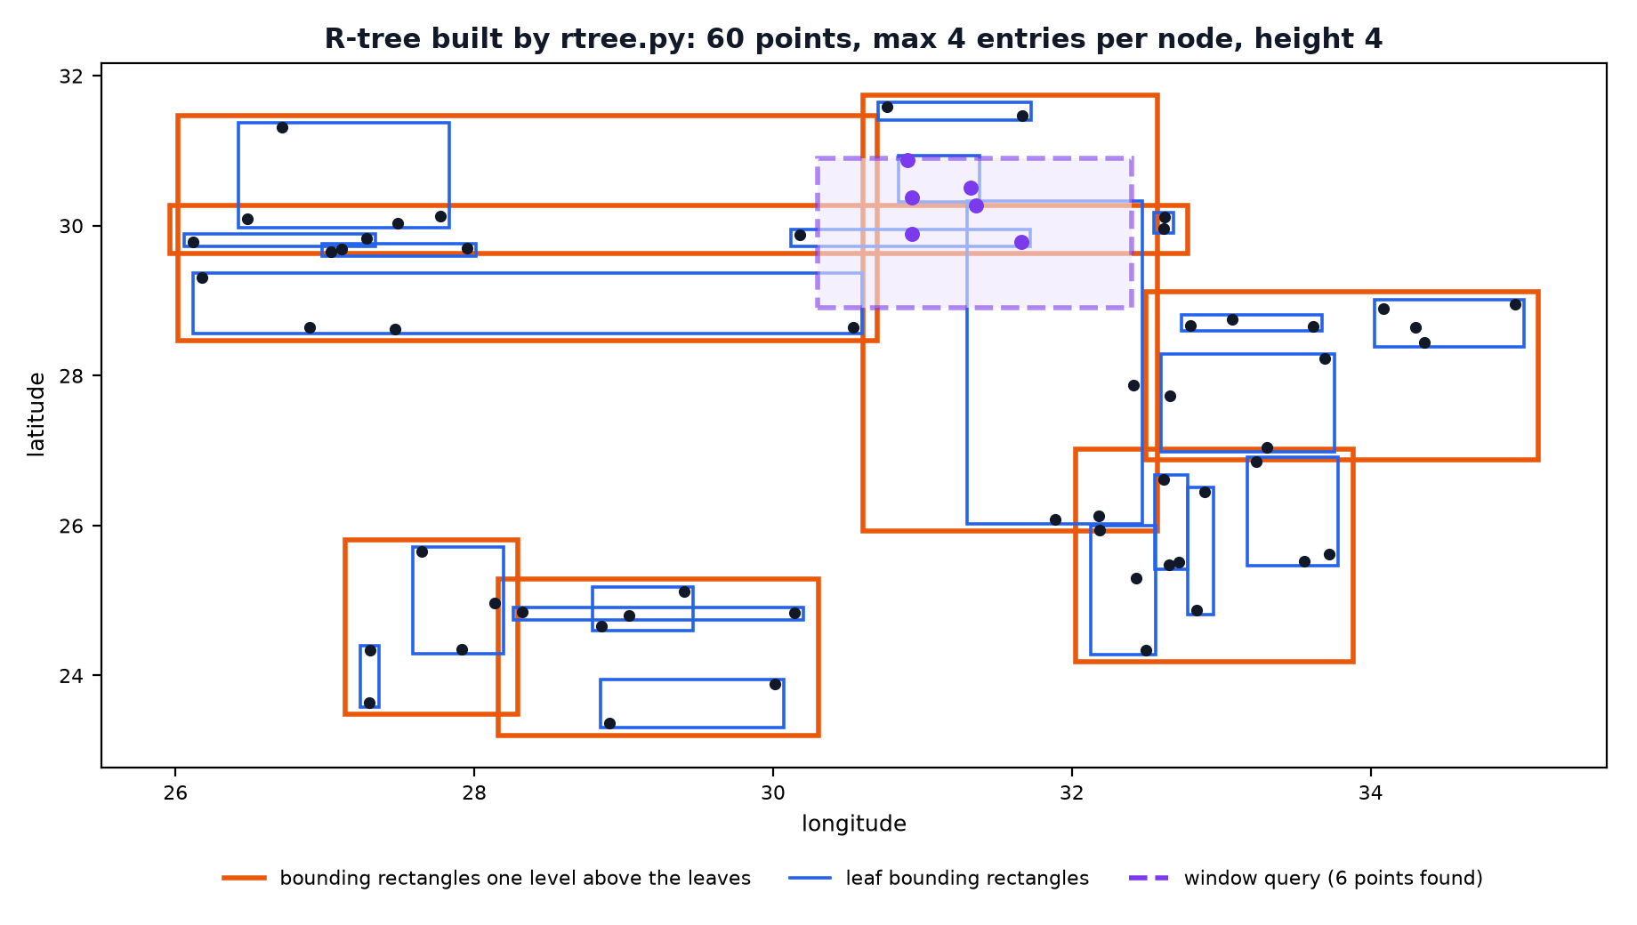
Figure 3. An R-tree built by our code. The query only opens the rectangles it touches.
Operation | How it works
Insert | At each level go into the child whose rectangle needs the least enlargement to cover the new object; then update the rectangles on the way back up.
Split | Guttman's quadratic split: pick as seeds the two entries that would waste the most area together, then give each remaining entry to the group that grows less.
Window query | Go down only into children whose rectangle intersects the query window. A whole subtree is skipped with one comparison.
k nearest neighbours | Best-first search with a priority queue ordered by the smallest possible distance to each rectangle. The first k objects taken from the queue are the answer.

A rectangle is stored as (xmin, ymin, xmax, ymax) with x = longitude and y = latitude; a point is a rectangle with zero area. Distances are simple straight-line distances in degrees, not real distances on the Earth's surface.

What we did
- Wrote the rectangle helpers: area, union, intersection test, enlargement and minimum distance to a point.
- Implemented insert with the quadratic split, search (window query) and nearest (k nearest neighbours).
- Tested with 3,000 random points in the area of Egypt (longitude 25–35, latitude 22–32): 200 window queries and 200 five-nearest-neighbour queries, each compared with a full scan of all points.
- Checked that rectangles (regions) can be inserted and found, not only points.
Result: all window and nearest-neighbour queries returned exactly the same objects as the full scan.

4. Benchmark: insert-heavy vs read-heavy

Setup
bench_indexes.py loads each structure first and then runs a mix of inserts and reads. The same list of operations is used for both structures being compared. Each timing is the best of 3 runs on a freshly built structure, with Python's garbage collector turned off because its pauses made the timings unstable.
Workload | Inserts | Reads
insert-heavy | 90% | 10%
balanced | 50% | 50%
read-heavy | 10% | 90%

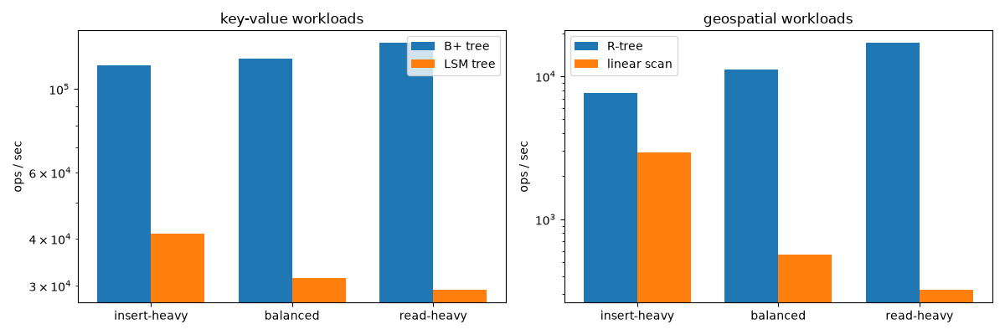
Figure 4. Operations per second for each workload (logarithmic scale).

B+ tree vs LSM tree
100,000 keys loaded, then 100,000 operations. A read is a lookup of an existing key.
Workload | B+ tree (ops/s) | LSM tree (ops/s) | LSM tree at the end
insert-heavy | 115,336 | 41,204 | 7 tables, 3 levels, write amplification 2.6×
balanced | 120,546 | 31,402 | 3 tables, 3 levels, write amplification 2.8×
read-heavy | 132,693 | 29,242 | 5 tables, 3 levels, write amplification 2.5×

- The trends match the theory. The B+ tree becomes faster as the share of reads grows, because a read is one walk down the tree with no splits. The LSM tree becomes slower as the share of reads grows: an insert is only a write to the memtable, but a read may have to check several files.
- The B+ tree is faster in every row, even insert-heavy, and this comparison is not fair. Our B+ tree lives only in memory and never writes to disk, while the LSM tree really writes and merges files. The advantage of an LSM tree is in disk I/O, and our B+ tree does not pay for any.
- What the disk I/O would look like. The LSM tree wrote about 63 bytes per insert, all sequential (a 24-byte record rewritten 2.6 times). A B+ tree on disk has to rewrite the whole leaf page for an insert: one random 4 KB page write, about 65 times more bytes, unless a buffer pool groups the writes. This 4 KB figure is an estimate from the page size, not something we measured. It is the reason write-heavy systems such as RocksDB and Cassandra use LSM trees.

B+ tree with several threads
The same 100,000 operations split over T threads (operations per second):
Threads | insert-heavy | balanced | read-heavy
1 | 118,965 | 124,396 | 130,556
2 | 111,855 | 118,280 | 124,545
4 | 117,808 | 122,184 | 131,883
8 | 116,393 | 118,597 | 128,251

The speed stays the same with more threads. Python has a global interpreter lock (GIL) that lets only one thread run Python code at a time, so threads cannot make this code faster. What the lab shows is correctness: many threads can use the tree at the same time without losing data. In a language without a GIL, the same latching rules are what allow threads working in different parts of the tree to run in parallel.

R-tree vs a full scan
20,000 random points loaded, then 2,000 operations. A read is a window query of 0.2° × 0.2°. The baseline is a plain list that is scanned completely for every query.
Workload | R-tree (ops/s) | Full scan (ops/s) | R-tree nodes visited per query
insert-heavy | 7,634 | 2,950 | 14.0
balanced | 11,146 | 563 | 9.7
read-heavy | 17,150 | 321 | 11.2

- A window query visits about 10–14 nodes of a tree of height 4 instead of comparing with all 20,000 points, so the R-tree is 53 times faster on the read-heavy workload.
- Inserts are where the R-tree pays: adding to a list costs almost nothing, while an R-tree insert must choose a subtree at every level and sometimes split. With 90% inserts the R-tree is only 2.6 times faster.
- The same lesson as the other two structures: an index makes reads faster by doing extra work on every write.

Summary
Requirement | How we achieved it
Concurrent B+ tree | A reader/writer latch per node and latch crabbing; optimistic inserts; tested with 8 writers and 4 readers
Bulk loading | Bottom-up build from sorted data with a fill factor; about 40× faster than single inserts
LSM tree | Memtable in memory, SSTable files with Bloom filter and sparse index, size-tiered compaction, tombstones
R-tree | Guttman R-tree with quadratic split; window and k-nearest-neighbour queries on longitude/latitude
Benchmark | Insert-heavy, balanced and read-heavy workloads on all three structures, with one chart

Structure | Good at | Pays with
B+ tree | Point lookups and range scans; stable read cost | Random page writes and splits
LSM tree | High insert rates; sequential disk writes | Slower reads and compaction (write amplification)
R-tree | 2-D window and nearest-neighbour queries | Expensive inserts; overlapping rectangles

Limitations
- The B+ tree is in memory only and delete does not merge nodes.
- The LSM tree has no write-ahead log, so the memtable would be lost in a crash. It uses one lock for the whole tree, and compaction runs inside put instead of in the background.
- The R-tree is not thread-safe and has no delete.
- Timings are from one laptop and change between machines; the counts (height, leaves, tables) do not.

