CSAI 302 — Advanced Database Systems

Lab 3: Shared Disk, Object Storage and TLS
A short theory summary and the steps we followed

Lab objectives
- Emulate a shared-disk architecture using local storage.
- Simulate object storage using S3-like APIs.
- Configure a database to use external object storage for large data.
- Enable TLS for database communication.
Everything runs on one laptop with Docker. The file compose.lab03.yaml starts three services: two PostgreSQL servers (node1 on port 5434, node2 on port 5435) and an S3-compatible object store (ports 9000 and 9001). Python scripts talk to PostgreSQL with SQL over TLS, and to the object store with the S3 API.
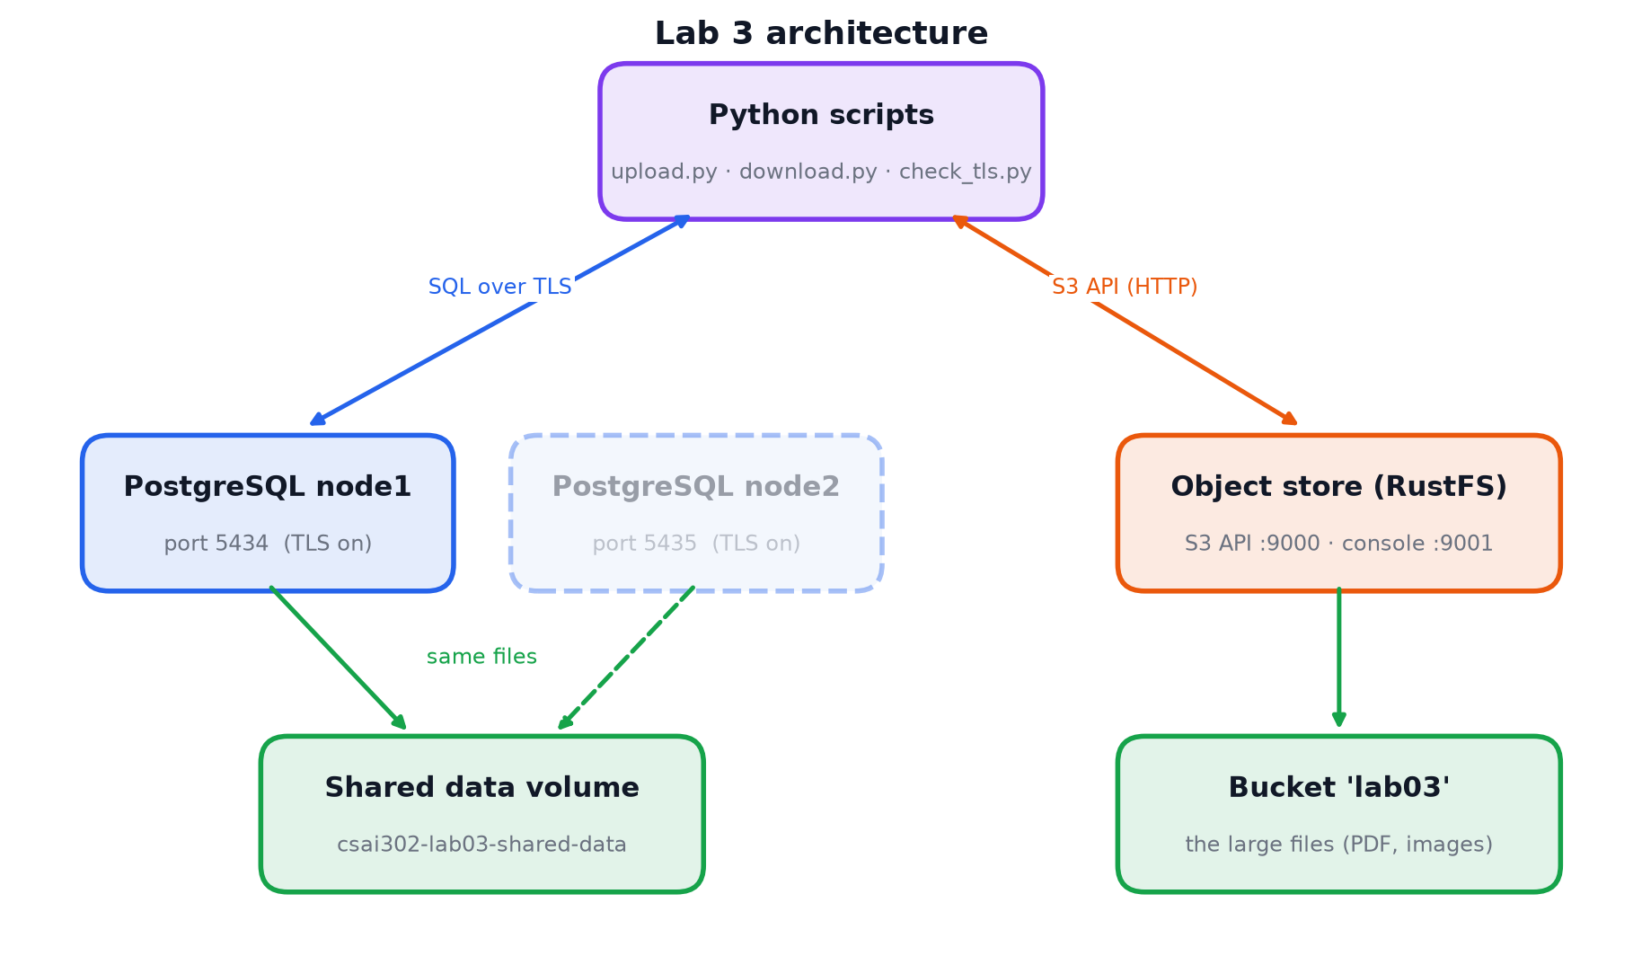
Figure 1. The whole lab: two database nodes on one shared volume, an object store, and Python clients.

1. Shared-disk architecture

Theory
When one server is not enough, a database can run on several servers (nodes). There are three classic ways to share the work:
Architecture | What is shared | Examples
Shared-memory | CPUs share the same RAM and the same disk | One large multi-core server
Shared-disk | Each node has its own RAM (buffer pool) but all nodes read the same disk | Oracle RAC, Amazon Aurora, Snowflake
Shared-nothing | Each node has its own RAM and its own disk; data is partitioned | Cassandra, Citus, MongoDB sharding

Advantage of shared-disk: if a node fails, another node attaches to the same disk and continues immediately (failover), with no data copied. Adding compute nodes is also easy.
Challenge: every node caches pages in its own buffer pool (Lab 2). If node A caches a page and node B changes it on disk, A may read an old copy (stale read); two nodes updating the same row can overwrite each other (lost update). Real shared-disk systems therefore need a cluster lock manager and cache invalidation between nodes.
PostgreSQL is a shared-nothing database: it does not coordinate two servers writing the same files. So in this lab only one node runs at a time, which demonstrates the shared storage and failover safely.

What we did
- Defined node1 and node2 in compose.lab03.yaml, both mounting the same volume csai302-lab03-shared-data (with restart: "no" so they never start together).
- Started node1 and created lab03.students with Ali, Sara and Omar.
- Stopped node1 (simulated crash) and started node2 on the same volume.
- node2 returned the three students without any copy, then inserted Mona.
- Stopped node2, started node1 again: node1 also saw Mona.
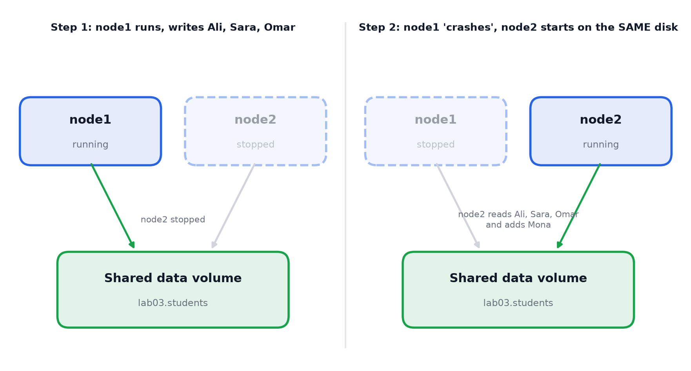
Figure 2. Failover on a shared disk: node2 continues with the data written by node1.
id | name | gpa | written_by
----+-------+------+------------
1 | Ali | 3.50 | node1
2 | Sara | 3.80 | node1
3 | Omar | 3.20 | node1
4 | Mona | 3.90 | node2
5 | Walaa | 4.00 | node2
Result: rows written by either node are visible to the other, because they share one disk.

2. Object storage with an S3-like API

Theory
Object storage keeps whole files as objects inside buckets. Each object has a key (its name, for example students/ali/notes.txt), the data, and metadata (size, content type, custom fields). It is accessed over HTTP with the S3 API, so programs anywhere can use it, and it scales to very large amounts of cheap storage.
 | File system | Object storage
Structure | Nested folders | Bucket + flat key ("folders" are only a key prefix)
Updating | Change part of a file in place | Replace the whole object (no partial update)
Access | From the same machine | HTTP API from anywhere
Typical use | Database data files | Images, PDFs, videos, backups, data lakes

MinIO vs RustFS: the lab suggests MinIO, but MinIO no longer publishes free Docker images. We used RustFS, an S3-compatible replacement with the same ports (9000 API, 9001 web console). Because the code uses the standard S3 API (boto3), it would work unchanged on MinIO or Amazon S3.

What we did
- Added the objectstore service (RustFS) to compose.lab03.yaml.
- Opened the web console, created a bucket and uploaded a file by hand.
- Ran object_storage/s3_basics.py, which performs the same operations through the API:
S3 operation | Meaning
create_bucket | Create a bucket
put_object | Upload an object (also used to "update": upload a new version under the same key)
list_objects_v2 | List objects, optionally by key prefix
head_object | Read only the metadata, without downloading the data
get_object | Download an object
generate_presigned_url | Temporary link that works without credentials and expires
delete_object | Delete an object

The web console is for people; the API is for programs. The console itself uses the same API.

3. Large data in external object storage

Theory
Large files (images, PDFs, videos) could be stored inside PostgreSQL in a BYTEA column, but that makes the database, its backups and its buffer pool much larger, and every SELECT * moves the file bytes. The common design is the pointer pattern: the file bytes go to object storage, and PostgreSQL stores only the metadata and the object's address (bucket + object_key), like a library catalogue card that says which shelf a book is on.
The cost is that two systems must stay consistent. If the file is uploaded but the database row fails, the object would be left without a row (an orphan), so the upload code deletes it again.

What we did
- Created table lab03.documents (schema.sql): student, file name, content type, size, SHA-256 fingerprint, bucket and object key.
- upload.py: computes the SHA-256, uploads the bytes with put_object under a unique key students/<id>/<uuid>-<name>, then inserts the row. If the insert fails, the object is deleted.
- download.py: asks PostgreSQL where the file is, fetches it with get_object, and checks the SHA-256 before saving it.
- Tested an upload for a student that does not exist: the foreign key rejected the row and no orphan object remained.
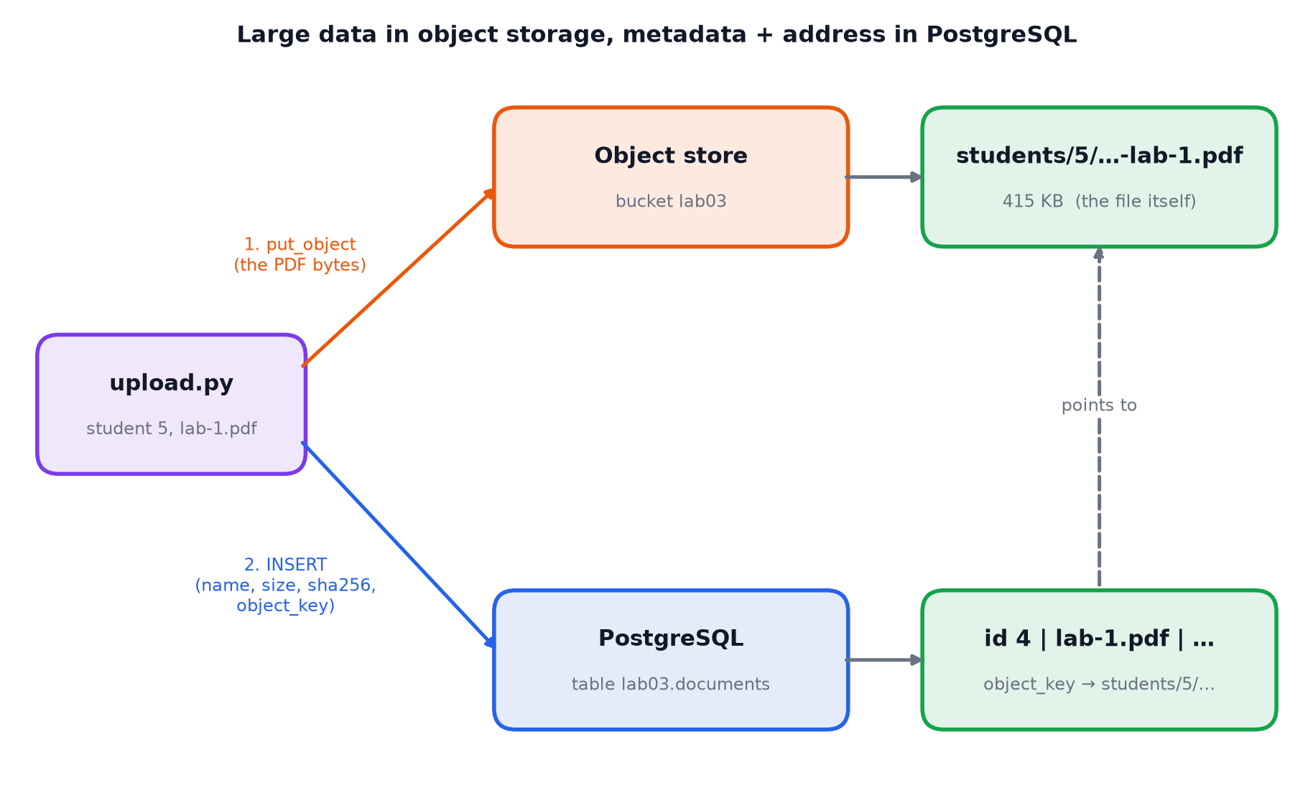
Figure 3. Upload: the PDF goes to the object store; PostgreSQL stores only its address.
id student file bytes object_key
1 Ali buffer_hit_ratio.png 66,676 students/1/2a4b...-buffer_hit_ratio.png
2 Sara README.md 4,357 students/2/ec1e...-README.md
4 Walaa lab-1.pdf 415,506 students/5/cb08...-lab-1.pdf

4. TLS for database communication

Theory
Without TLS, everything between the client and PostgreSQL travels over the network as readable text: the user name, the SQL queries and the returned data. TLS (the same technology behind the padlock of https websites) provides two things:
- Encryption: an eavesdropper sees only random bytes.
- Server identity: the client checks a certificate to be sure it is talking to the real database and not an impostor.
A Certificate Authority (CA) signs certificates, like an office that issues and stamps ID cards. The server shows its certificate (server.crt, for the name localhost) and proves it is the owner with its secret private key (server.key). The client trusts the CA (ca.crt) and checks the stamp and the name. In this lab we created our own local CA.
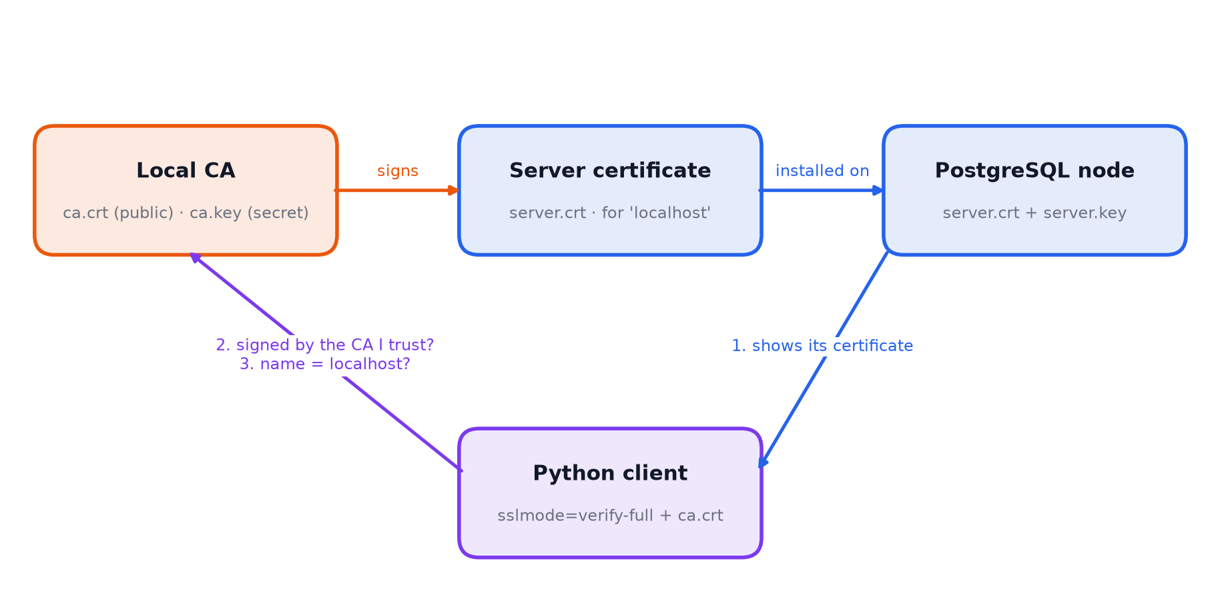
Figure 4. Certificates: the CA signs the server certificate; the client verifies it.
sslmode (client) | Behaviour
disable | No encryption
require | Encrypted, but the server's identity is not checked
verify-ca | Encrypted, certificate must be signed by the trusted CA
verify-full | As verify-ca, and the host name must match the certificate (safest)

What we did
- tls/make_certs.py: created the CA, the server certificate and key, and a second unrelated CA for testing. The .key files are secrets and are not committed to Git.
- compose.lab03.yaml: started both nodes with ssl=on, the certificate and key, and TLS 1.2 as the minimum version. The key is copied with permission 600, because PostgreSQL refuses a private key that others can read.
- tls/pg_hba.conf: network connections are allowed only as hostssl (with a password); hostnossl is rejected.
- Changed the Python scripts (common.py) and SQLTools to connect with verify-full and the CA certificate.
- tls/check_tls.py: tried five connection settings.
- tls/sniff_demo.py: recorded the network traffic with tcpdump to see what an eavesdropper sees.
Connection attempt | Result | Reason
sslmode=disable | Refused | pg_hba.conf rejects unencrypted connections
sslmode=require | Connected | Encrypted, identity not checked
verify-full + our CA | Connected | Encrypted, trusted CA, name matches
verify-full + a different CA | Refused | Certificate verify failed
verify-full + host db.example.com | Refused | Certificate is for localhost

Connected sessions reported ssl=true, TLSv1.3 and cipher TLS_AES_256_GCM_SHA384.
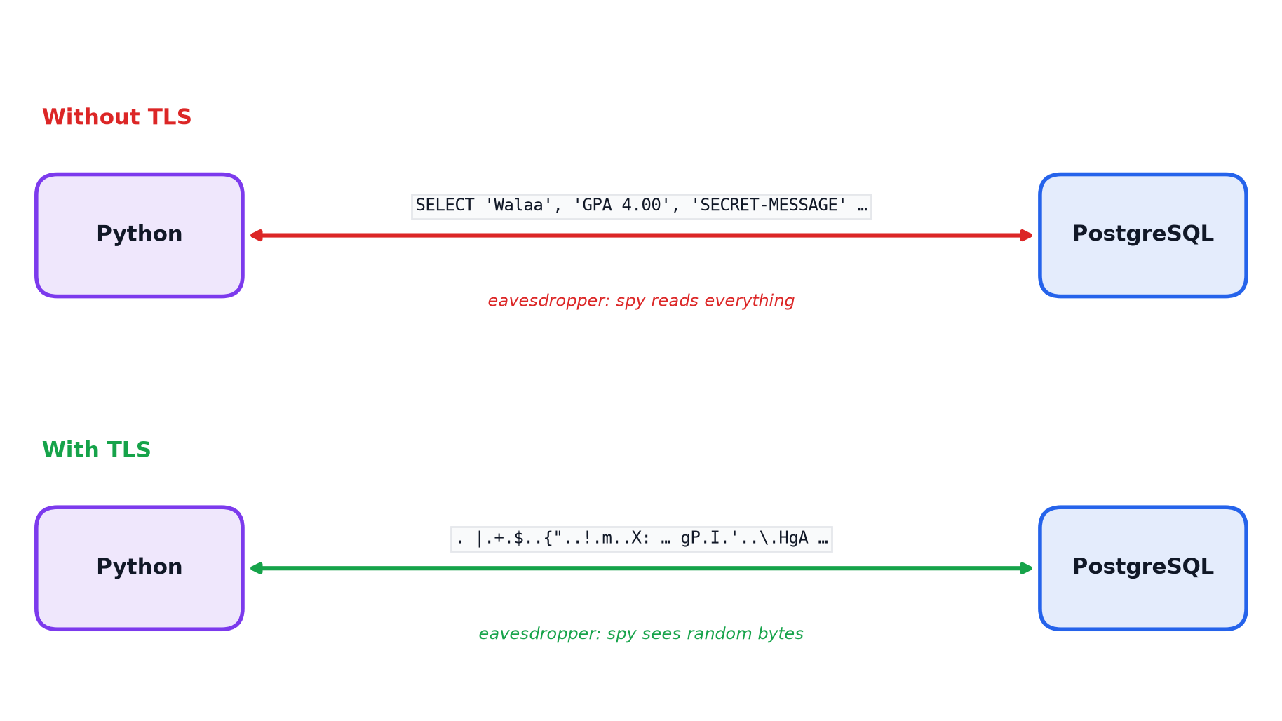
Figure 5. The same query captured on the network, without and with TLS.
In the capture without TLS, the query text, the values Walaa, GPA 4.00, SECRET-MESSAGE and the user name were all readable. With TLS none of them could be found. (The password itself was not visible in either case, because PostgreSQL's scram-sha-256 authentication never sends it directly.)
TLS protects data in transit (on the network). Lab 2's page encryption protected data at rest (on disk).

Summary
Requirement | How we achieved it
Shared-disk emulation | Two PostgreSQL nodes on one Docker volume; failover from node1 to node2
S3-like object storage | RustFS (S3-compatible) and the S3 API through boto3
DB uses external object storage | Files in the bucket, metadata + object key in lab03.documents
TLS for DB communication | Own CA and server certificate, ssl=on, hostssl-only pg_hba.conf, verify-full clients

