Low Level Design

Credit Card Default Prediction

|  |  |
| --- | --- |
| Written By | **Sandeep Pandey** |
| Document Version | 0.3 |
| Last Revised Date | 27 July 2021 |

Document Control

Change Record:

|  |  |  |  |
| --- | --- | --- | --- |
| **Version** | **Date** | **Author** | **Comments** |
| 0.1 | 25 July 2021 | Sandeep Pandey | Introduction & Architecture defined |
| 0.2 | 26 July 2021 | Sandeep Pandey | Architecture & Architecture Description appended and updated |
| 0.3 | 27 July 2021 | Sandeep Pandey | Unit Test Cases defined and appended |

Reviews:

|  |  |  |  |
| --- | --- | --- | --- |
| **Version** | **Date** | **Reviewer** | **Comments** |
| 0.3 | Yet to be fixed | iNeuron Team |  |

Approval Status:

|  |  |  |  |  |
| --- | --- | --- | --- | --- |
| **Version** | **Date** | **Reveiwer** | **Approved By** | **Comments** |
|  |  | iNeuron Team |  |  |

Contents

1. Introduction 3

1.1. What is Low-Level design document? 3

1.2. Scope 3

2. Architecture 3

3. Architecture Description 4

3.1 Data Description 4

3.2 Data Collection 4

3.3 Data Transformation 4

3.4 Data Pre-processing 4

3.5 Data insertion into Databases 4

3.6 Data Clustering 4

3.7 Model building 4

3.8 Cloud Setup 4

3.9 Pushing app to cloud 4

3.10 Application Start 4

3.11 Data for testing 4

3.12 Data validation 4

3.13 Data insertion into Databases 4

3.14 Data clustering 4

3.15 Model call for Specific cluster 4

3.16 Prediction 4

3.17 Saving output at Database 4

4. Unit Test Cases 4

# Introduction

* 1. What is Low-Level design document?

The goal of LLD or a low-level design document (LLDD) is to give the internal logical design of the actual program code for Food Recommendation System. LLD describes the class diagrams with the methods and relations between classes and program specs. It describes the modules so that the programmer can directly code the program from the document.

* 1. Scope

Low-level design (LLD) is a component-level design process that follows a step-by step refinement process. This process can be used for designing data structures, required software architecture, source code and ultimately, performance algorithms. Overall, the data organization may be defined during requirement analysis and then refined during data design work

# Architecture

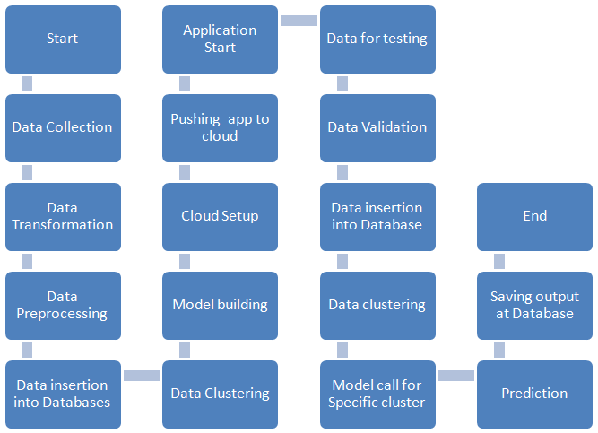

# Architecture Description

* 1. Data Description
  2. Data Collection
  3. Data Transformation
  4. Data Pre-processing
  5. Data insertion into Databases
  6. Data Clustering
  7. Model building
  8. Cloud Setup
  9. Pushing app to cloud
  10. Application Start
  11. Data for testing
  12. Data validation
  13. Data insertion into Databases
  14. Data clustering
  15. Model call for Specific cluster
  16. Prediction
  17. Saving output at Database

# Unit Test Cases

|  |  |  |
| --- | --- | --- |
| Test Case Description | Pre-Requisite | Expected Result |
| Verify whether the Application URL is accessible | 1. Application URL should be defined | Application URL is accessible |