Credit Card Defaulters Prediction System

Wireframe Documentation

Interface Page

We have one page to interact with credit card defaulter prediction system:

1. The link will be provided by the admin
2. User needs to provide the characteristics and payment history of the entity in webpage
3. After providing all the required details. User need to hit the submit button for prediction
4. Predicted value will be reflecting in same page.
5. Sample shown below:

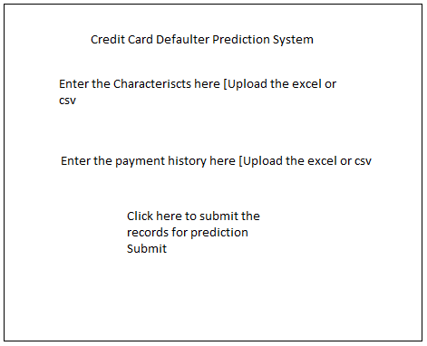

e Documentation