Operation Platform V1.1
China Operation Intelligence Platform
API Architecture, Signal Data Flow, and Overview Architecture
Evidence-driven Operation Platform · Mock Prototype Specification
Generated 2026-09-03

Product position: Operation Platform is not an ITSM, Incident Management, Monitoring, or Probe Management system. It connects evidence to accountable action: Detect → Understand → Act → Prove → Improve.

1. Executive Architecture
V1.1 adds a Signal Intelligence Layer upstream of the existing V1 P0 closed loop. External China-region events are normalized into a common Signal object, correlated into Problem Candidates, and then passed into the existing Problem → Operation → Action → Evidence → Verification → Outcome → History workflow.
External Sources → API / Integration → Source Adapter → Signal Service → Correlation → Problem → Operation → Action → Evidence → Verification → Outcome → China Operation Overview → History

2. API Architecture
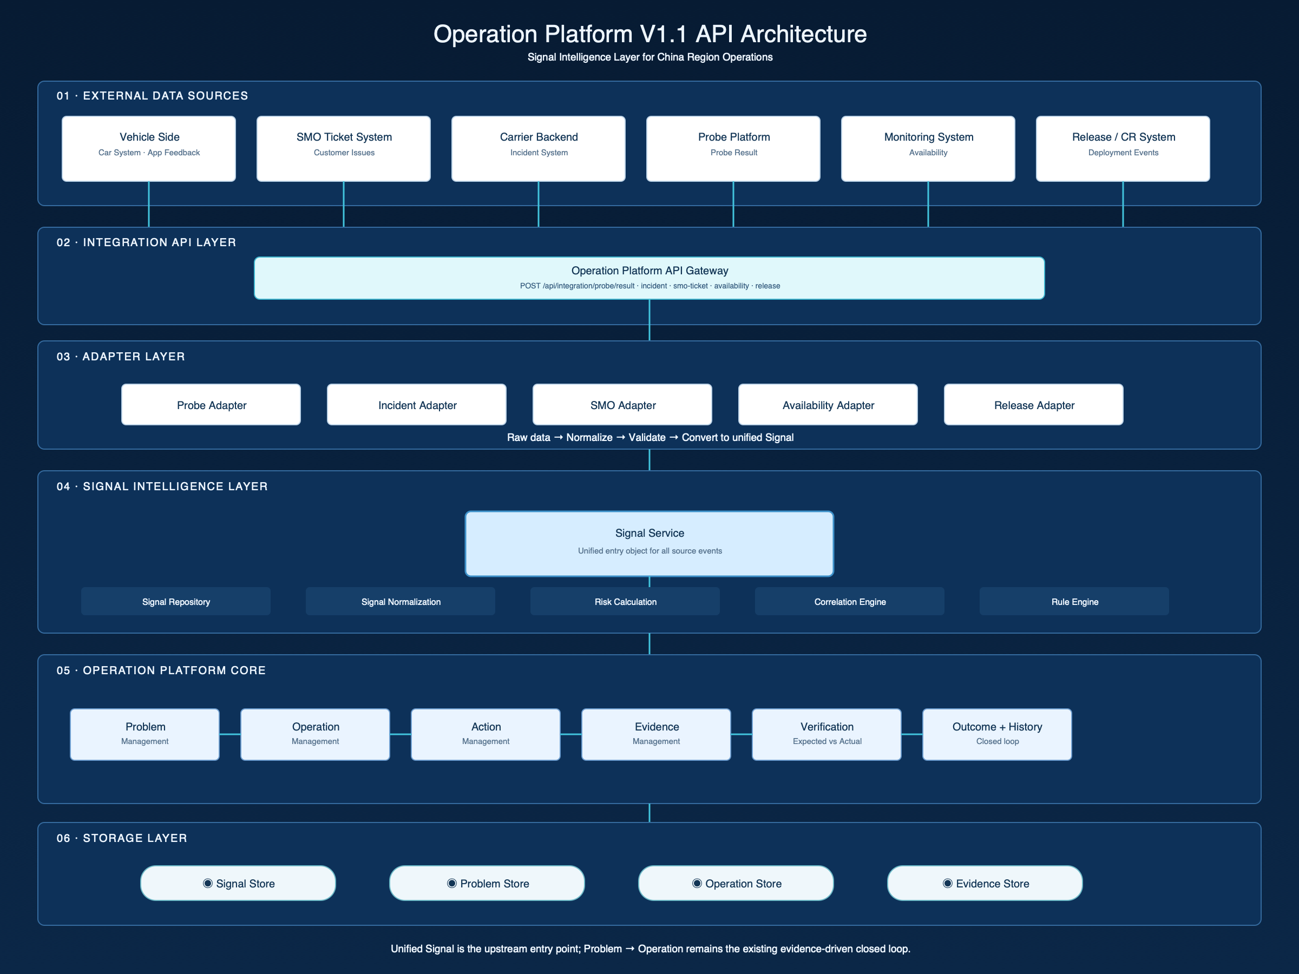
Figure 1. External sources, API boundary, adapters, Signal Intelligence, Operation core, and storage.

Reserved API contracts
POST /api/signals
GET /api/signals
GET /api/signals/:id
POST /api/problems/from-signals
POST /api/integration/probe/result
POST /api/integration/incident
POST /api/integration/smo-ticket
POST /api/integration/availability
POST /api/integration/release
These are mock contracts only. No real external API, Kafka, database, email ingestion, or AI correlation is introduced in V1.1.

3. Signal Data Flow
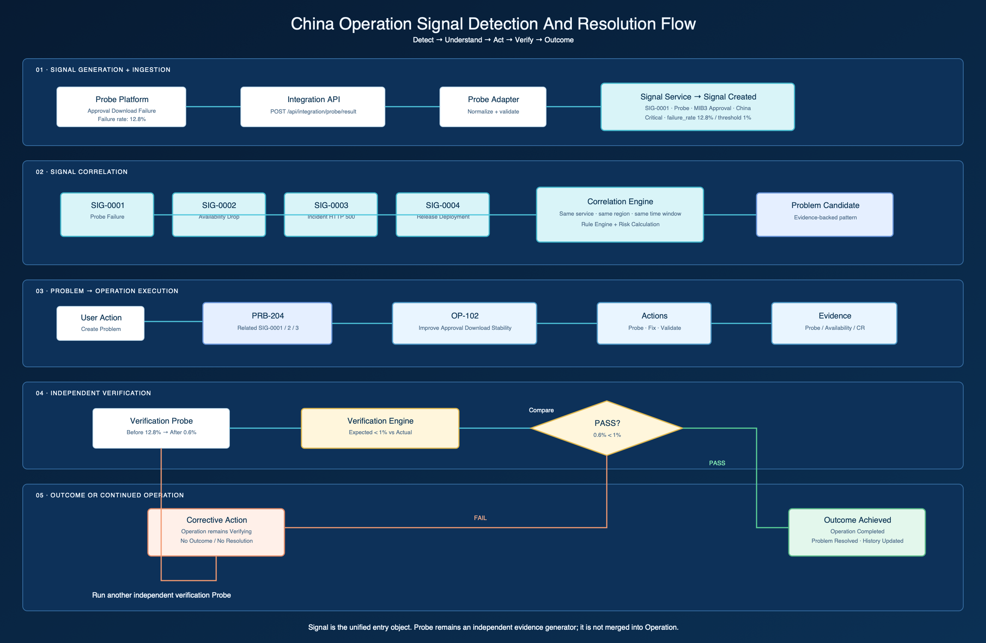
Figure 2. SIG-0001 is correlated with independent context, then moves through action, verification, and Outcome.

Reference demo flow
SIG-0001 (Probe, 12.8% failure, China)
→ Correlation (same service / region / time window)
→ PRB-204 Approval Download Instability
→ OP-102 Improve Approval Download Stability
→ Action + Probe / Availability / Release Evidence
→ Verification Probe (expected < 1%, actual 0.6%)
→ OUT-001 Objective Achieved
→ Operation Completed + Problem Resolved + History

4. China Operation Overview
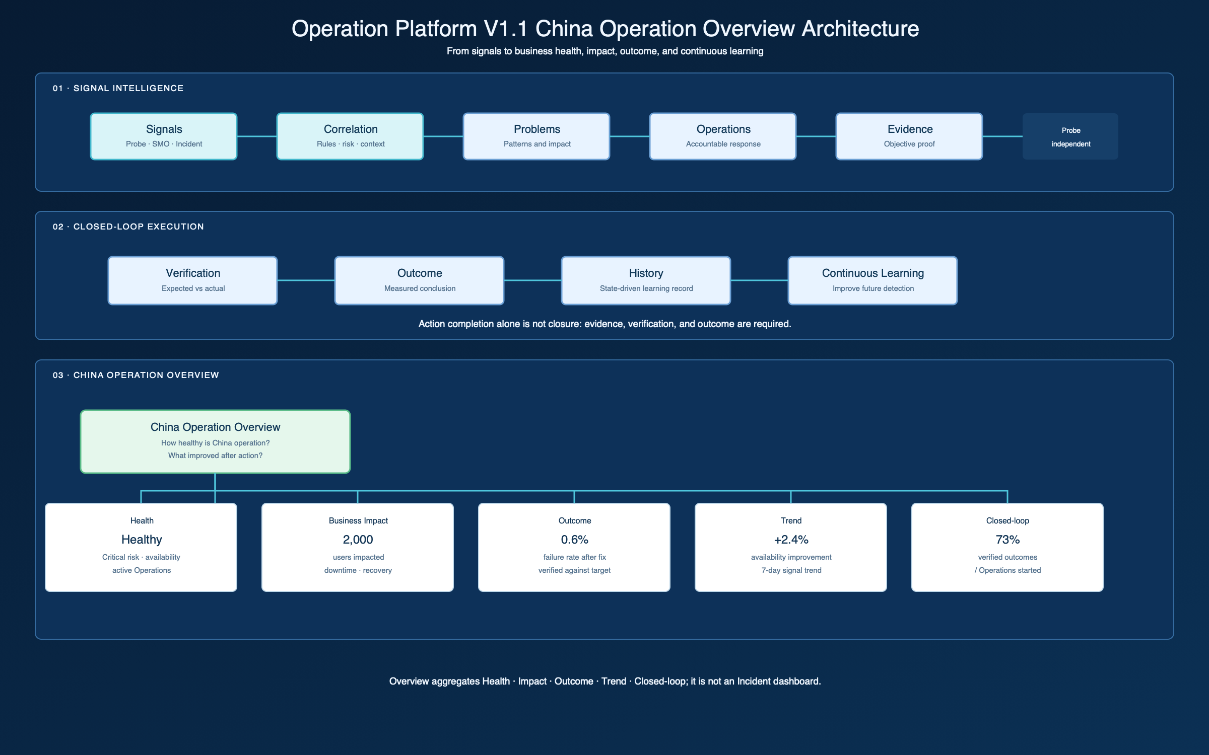
Figure 3. Overview aggregates Health, Business Impact, Outcome, Trend, and Closed-loop performance.
The Overview answers: How healthy is China operation? What did we resolve? Did our Operations actually improve the situation? Command Center remains a separate attention queue answering what needs action now.

5. Domain Model
Object | Role | Key relationship
Signal | Observed abnormal condition or business/technical event | Source event → Signal → Problem
Incident | Backend-reported technical context | Incident → Signal; may contribute to Problem
Problem | Correlated pattern across signals, impact, and evidence | Problem → Operation
Operation | Accountable effort with objective, owner, actions, and verification | Operation → Action / Evidence / Outcome
Action | Executable task with expected result and owner | Action → Evidence
Probe | Independent evidence generator | Probe Result → Signal and Evidence
Evidence | Objective proof of condition, action, or outcome | Evidence → Verification
Outcome | Measured conclusion after verification | Outcome → History

Signal contract
{
id, source, type, service, region, environment,
severity, status,
metric: { name, value, threshold, unit },
impact: { userAffected, businessImpact },
timestamp, relatedObjects, problemId, correlationScore
}

6. Rules and Boundaries
- Signal is the unified entry object; it is not an Incident and not Evidence.
- Rule-based correlation uses shared service, region, and time window; no AI is required.
- A Problem can exist without a Backend Incident. Unreported Problems are first-class attention items.
- Probe remains an independent product. Operation consumes Probe Results as Evidence.
- Action completion alone never closes an Operation. Only passed verification can create an Outcome.
- All Signal → Problem → Operation → Outcome state transitions are recorded in historyEvents.

7. Prototype Scope and Limitations
V1.1 uses Mock Data and a browser-local shared State Layer. The API files define the replacement boundary for future real services while the UI remains decoupled from source-specific payloads.
- No real Probe, SMO, Incident, Availability, or Release API connections.
- No production database, Kafka, email parser, AI root cause, predictive detection, or automatic Probe trigger.
- server.js remains unchanged.

