NASA PDS Android 1.0 Deployment Guide

Revision History
Author | Revision Number | Date
TCSASSEMBLER |  | 05.02.2012

1. Project organization 3
2. Application Setup 3
3. Features 3
4. Limitations 3
5. Verification 4
6. Resource Contact List 14

1. Project organization

The project has the following directory structure:
docs
Contains this document.
nasa-pds-api
This directory contains web application that provides SOAP API for android client.
It includes deployable war and sql dump of 19 example datasets..
nasa-pds-android
This directory contains eclipse project for android platform. It has standard structure, and can be easily imported into Eclipse. Folder bin contains last build of app: nasa_pds_android.apk.

2. Application Setup
- Create MySQL database called nasa_pds.
- Setup the MySQL instance, by adding to [mysqld] section the following property:
max_allowed_packet=16M
- Import test data from 19_datasets.sql. You may use following command:
mysql –u root –p nasa_pds <19_datasets.sql
- Deploy web service to Apache Tomcat 6.0 by copying nasa_pds_ws.war to TOMCAT_SERVER_ROOT/webapps dir.
- You may need to change database properties at:
TOMCAT_SERVER_ROOT/webapps/nasa_pds_ws/WEB-INF/classes/application.properties
- Start the server using startup.bat/startup.sh
- Now everything is ready to start android client. It can be started either on emulator or on real device. For convenience the project can be imported to eclipse using:
Import – Existing Project into workspace.
- After importing select deployment target and run the application. You will be prompted to enter host uri, that can be different. If you run from emulator, you may need to use 10.0.2.2, if you are running on device, that should be local network IP of machine, where web service is installed.
- Enjoy!

3. Features
- Fully implemented object browsing (Target Type – Target – Mission – Instrument – File).
- Viewing of Mission and Instrument objects (other entities do not have any interesting information).
- Flexible comparing of Mission objects.
- Searching object references in google.
- Ability to remove restriction filter while browsing, so you can see all Files not only for Instrument, but for specific mission or Target.
- Text search of entities.
- All loading is done in background.
- Data is displayed by pages.
- Formatted object descriptions without left and right indents.
- Color theme, and nice-looking images for all buttons.
- Submission was developed and test on real device, HTC Sensation.

4. Limitations
- Provided test data is only for COMET target type.
- Object description is already split to lines, so it is hard to format them.
- Metadata is empty for all objects in test datasets, that is why it is not displayed.
- SOAP support is not implemented in base Android framework, so modified kSoap2 lib is used.
- Viewing of images is not supported because FITS format is not easy to parse.
- API is very limited and it does not even expose all data from datasets.

5. Verification
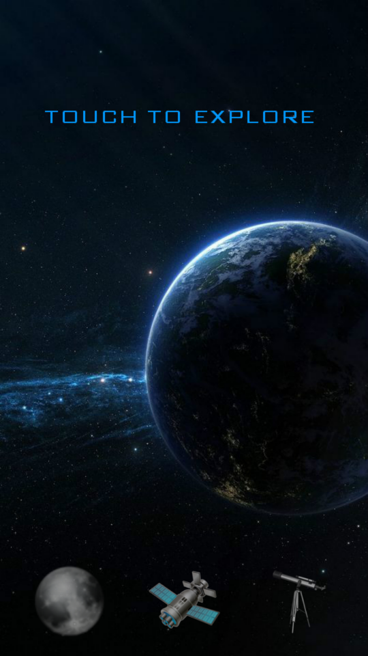
You can touch the buttons in the bottom of the screen to view Targets, Missions and Instruments.
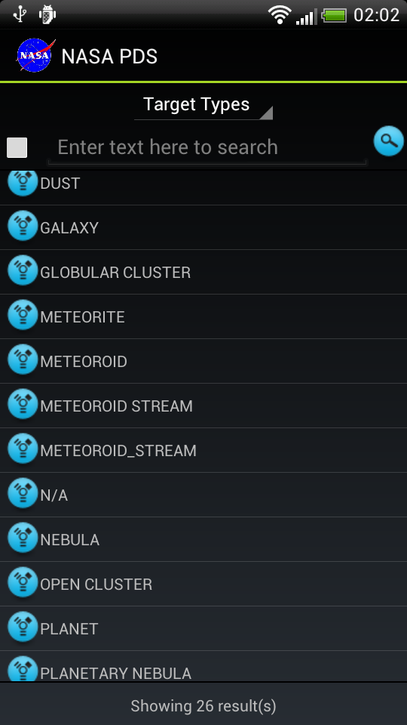
First browsing screen, here you can only choose COMET, because only such targets are present in example datasets. To navigate into item just click on it. Also you can use dropdown at the top to navigate directly to specific entities.
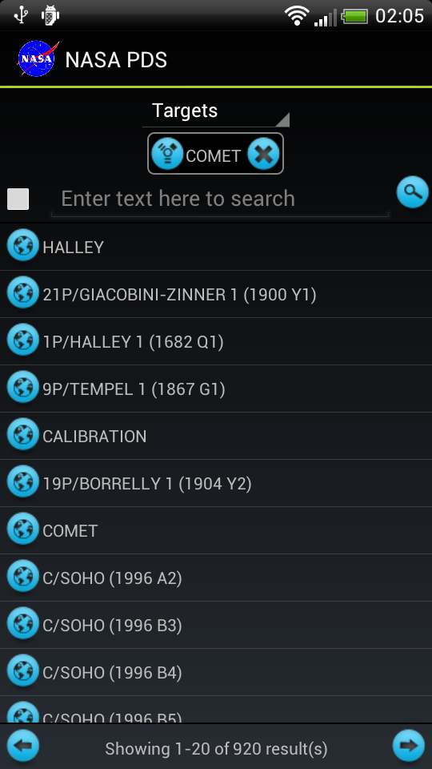

This is target sceen, filtered by type COMET. You can navigate to next/previous page using arrows in the bottom of the screen.
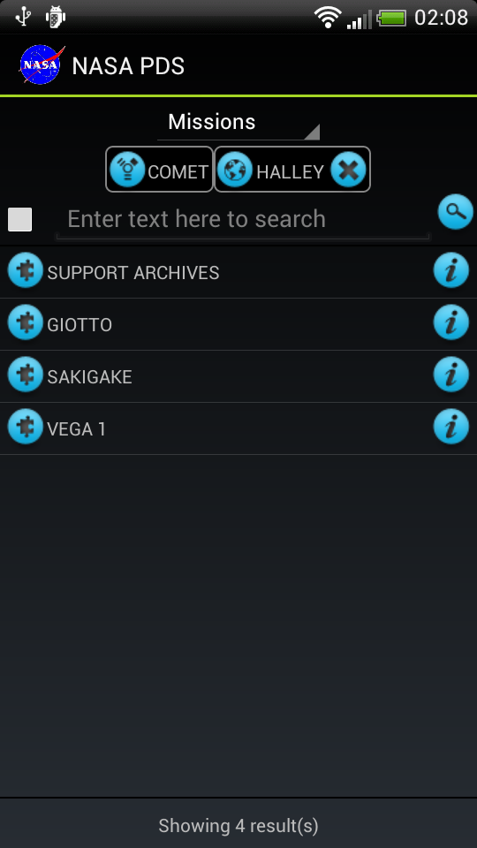
This is missions screen. You can view mission by clicking on (i) button on the right of it.
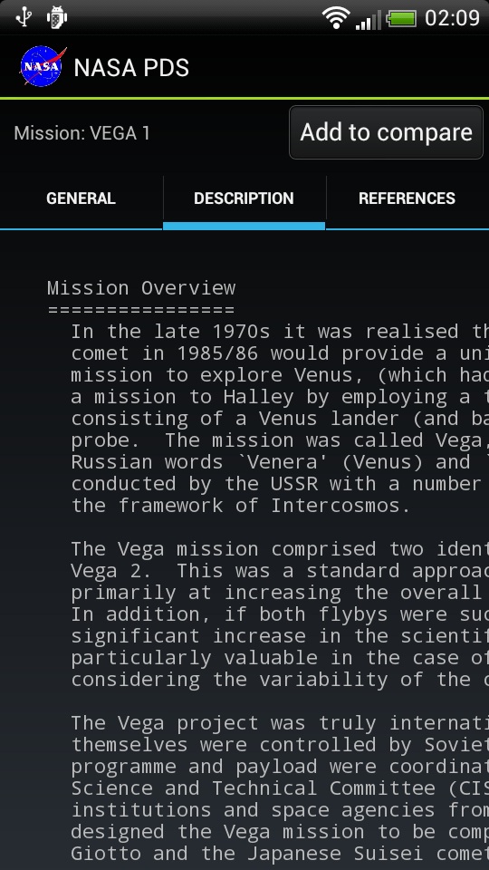
The mission view screen. Here you see tabs with information. Description is badly formatted because it is passed in such format from server. You can add mission to compare clicking Add to compare.
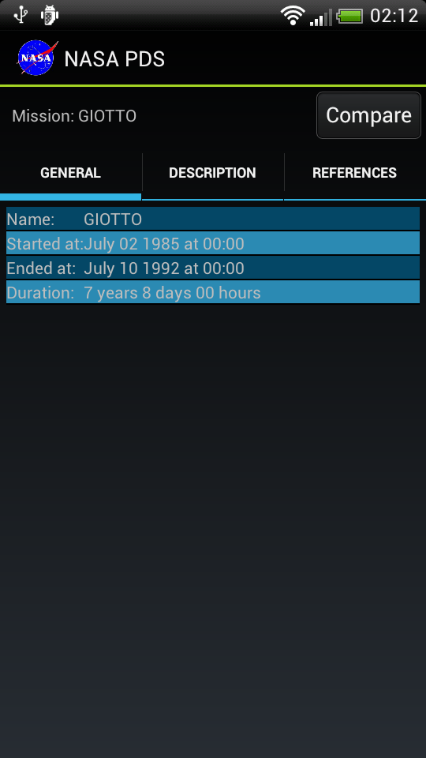
After you added several missions to compare Add to Compare button with change to Compare button so you will be able to navigate to Compare screen.
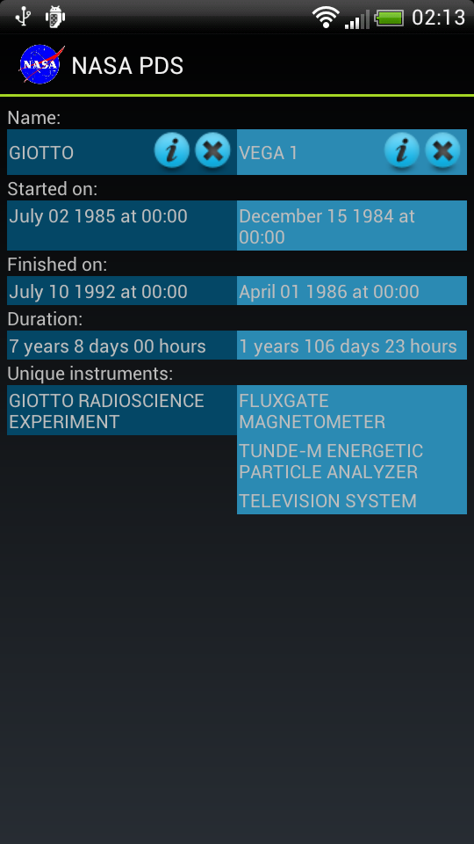
Compare screen. Here you see comparision on selected missions. You can review their information by clicking (i) button and remove them from compare by clicking (x) button.
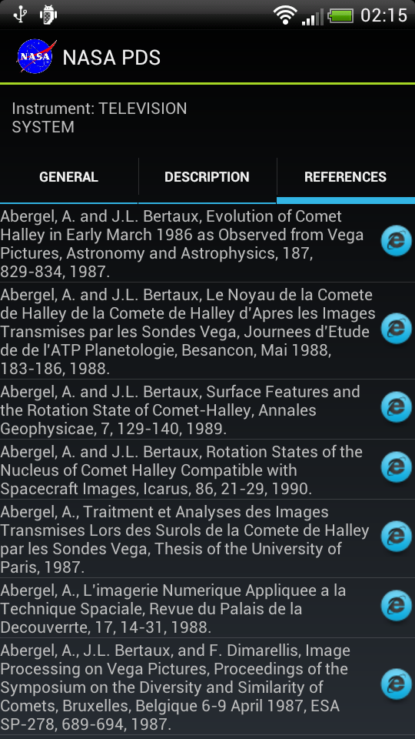
You can also view instruments (they are “inside” the mission) and their view is similar to mission view. At References tab you can search over the internet for that reference by clicking (e) button.
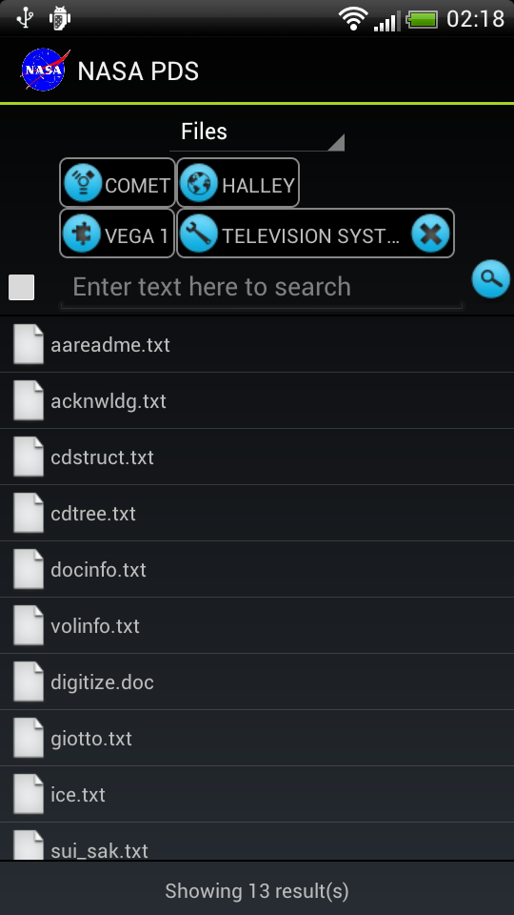
You can also browse files, they are “inside” the instrument. To view file content, click on it. Also you can remove restrictions in upper part of screen by clicking (x). So you will be able to browse all file for specific mission/target/target type. Be aware that there are a lot of files even for commets.
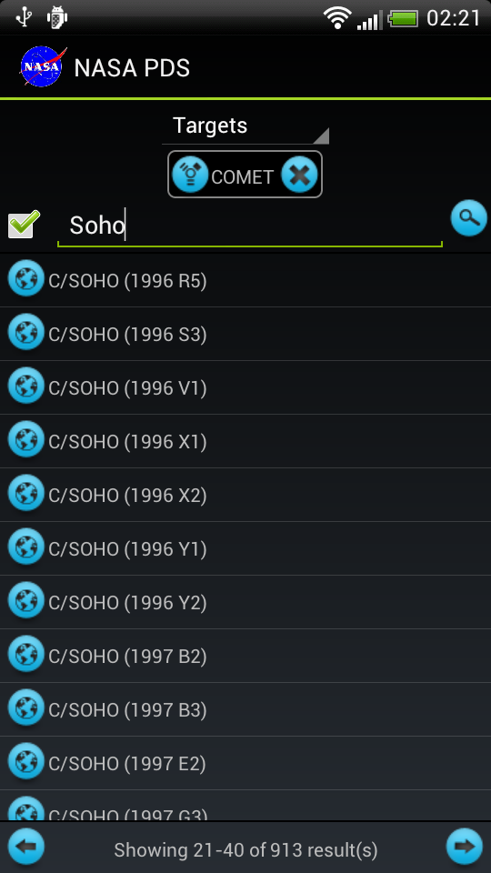
You can add filtering by text. For this check the box in upper section left to Edit text, enter filter text and press search button to the right. After that you will see all results that are filter by this text. To disable filtering just uncheck the box.

6. Resource Contact List
Name | Resource Email
TCSASSEMBLER

