**Name: Shiva Kumar Sundara Murthy**

**Student ID: 22024927**

**Module: Applied Data Science 1**

**Assignment 1: Visualization**

**Visualization 1:** This Line chart represents the Fossil Fuel consumption for different countries over year i.e. 1996 - 2003

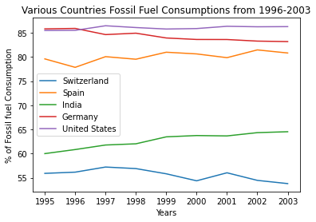

The line plot illustrates the consumptions of fossil fuel from 1996 to 2003 for various countries including Switzerland, spain, India, Germany, Untied States.

From the above graph we can observe that almost all countries had increased their fossil fuel consumption in the year 2003 when compared to 1996. United states was almost leading the table in regards to consumption from year 1996. Though India consumption had increased over years, it usage is moderate when compared to remaining countries. There is decline in line is observed for the graphs plotted for Switzerland and Germany. Though Germany ranks 1st in consumption in the year 1996, It is reduced and in second position in the year 2003. Switzerland was way lower in consumption from the year 1996 till 2003.

**Visualisation 2:** The Histogram chart represents the number missions launched by spaceX from 2006-2023

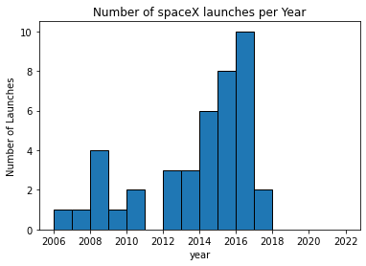

The Histo plot illustrates the number of mission launches from 2006 to 2023 by SpaceX.

From the above graph we can observe SpaceX have been launching the multiple missions over years, regardless success or failure missions spaceX is launching multiple missions from different Customer Countries which is either Government or Business. It is observed that SpaceX has launched approx. 10 missions in single year i.e. 2016. But it has launched very few i.e. 2 missions in the year 2018. In the year 2006,2007, 2009 spaceX launched only 1 mission.

It is also observed that 2009 till 2016 spaceX had rapidly increased their number of missions per annum (excluding 2011 it haven’t launched any mission in the year 2011), which in rather gave multiple success missions.

**Visualisation 3:** Pie plot represents the mean value of Fresh Water Withdrawals from various countries over years.

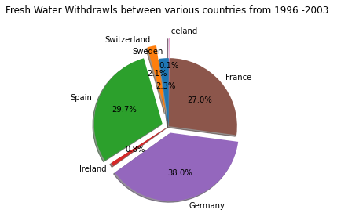

The Pie plot illustrates the Withdrawals of Fresh Water from 1996 to 2003 for various countries including Spain, Switzerland, Sweden, Iceland, France, Germany, Ireland.

The above graph illustrates the percentile of mean of total withdrawals of fresh water from 1996 – 2003 from various countries. It is observed that Germany is leading the table with 38% of total withdrawals when compared to remaining countries. Spain and France are next to Germany in position with 29.7% and 27% of total withdrawals. Both Sweden and Switzerland are almost withdrawal equal amount of fresh water which is approx. 2.2%. The Iceland withdrawals only 0.1% of total freshwater when in compared to remaining countries.

**Data Source Reference Link:**

[**https://www.kaggle.com/datasets/spacex/spacex-missions**](https://www.kaggle.com/datasets/spacex/spacex-missions)

[**https://databank.worldbank.org/source/world-development-indicators#**](https://databank.worldbank.org/source/world-development-indicators)

**GitHub Link :**

<https://github.com/7shivakumar/Visualization_22024927>