Biz4Kit — One-Page SaaS Outline
Oct 18, 2026 · @Ravin

Overview
Biz4Kit is a white-label operating workspace for small businesses: one app that generates the catalog, quotes, invoices, service packages and payment requests, and runs them under the business's own name, colours and logo.
Launch verticals: salons, wholesalers selling on IndiaMART, restaurants, IT services, small manufacturers, and design agencies — businesses with 1–15 staff that currently juggle WhatsApp, Excel and a PDF invoice template. All product copy and message templates are in English.
Three audiences, one workspace:
- Owner sets up the brand and the generators once.
- Team members convert leads into bookings, services and paid invoices.
- Customers browse the menu, request a quote, book and pay from a branded link, with no login needed.

Problem & solution
A small business loses leads because quoting takes hours, and loses cash because invoices go out late and get chased by hand.
Today | With BizKit
Price list lives in a WhatsApp image or a stale PDF | Live branded catalog page, edited in minutes
Quotes typed by hand, inconsistent pricing | Quote built from catalog items + rules, sent as a link, accepted with one tap
Invoice = Word template, payment = "please transfer" | Accepted quote becomes a numbered invoice with a UPI QR and a ready-to-send message; gateway links arrive in Phase 2
Leads tracked in chat threads and memory | Lead → Quote → Booking → Service → Paid pipeline, visible to the whole team
Generic tools that look like someone else's brand | Every page, PDF and email carries the business's name, logo and colours

Core generators
Five generators share one data model: a catalog item is the unit, and every quote, package, invoice and payment request is built from items. Standard rule for Phase 1: the only external services are Google sign-in and email (Resend). Every generator produces three things the business can use by hand: a shareable link, a PDF / document export, and a pre-written message (WhatsApp, SMS, email) the team copies or shares with one tap; email also carries notifications and approval links. Phase 2 connectors automate the same outputs; they never change them.
Generator | Input | Output (Phase 1, standalone) | Phase 2 adds
Catalog | Items: name, photo, price, unit (hr / piece / sqft), category, variants, add-ons | Public branded menu page, link + QR code, PDF menu, copy-ready "here's our price list" message; CSV import | AI ingest: photo of a price list, PDF, Excel or doc → structured items
Custom Quote | Picked items or a package, quantity, discounts, GST, notes, validity date | Doc-style editor (edit lines and text in place, comments, version history, like editing a doc here); quote link, PDF, pre-written send message; customer accepts on the link with their name | OTP-verified acceptance, auto-expiry reminders by email / WhatsApp
Service Packages | Bundle of items + fixed or tiered price (Basic / Standard / Premium) | Package cards on the catalog, bookable directly, usable as the starting point of a quote | Monthly auto-charge via gateway mandates
Invoice | Accepted quote, completed job or manual lines | Numbered, GST-compliant invoice (link + PDF); record cash / direct-UPI payments; status Draft → Sent → Paid → Overdue; pre-written reminder messages at +3 / +7 / +14 days for the team to send | Auto-sent reminders, recurring invoices, credit notes
Payment request | Invoice or deposit amount | UPI deep link + QR (static, no gateway needed), bank details block, pre-written "please pay" message; team uploads proof (PDF / image), owner approves, status turns Paid | Razorpay / Stripe / Polar hosted links, auto-reconcile, payouts, receipts

Customer portal (no login)
Customers reach the business at yourbrand.biz4kit.app or a custom domain and never see the Biz4Kit name.
- Browse menu — catalog and packages by category, search, photos, prices; mobile-first.
- Ask for a quote — pick items or describe the job, add photos, preferred dates and location; creates a lead instantly, shown in the team inbox and emailed to the assignee (Phase 1); WhatsApp push in Phase 2.
- Accept — open the quote link, choose optional items, accept with name + phone (the private link is the proof in Phase 1; OTP verification in Phase 2).
- Book — choose a slot from the team's availability for packages that are bookable directly.
- Pay — Phase 1: UPI QR / bank details on the invoice, upload proof (PDF or image), owner approves and marks paid. Phase 2: hosted gateway link, instant receipt.
- My orders — one private link per customer with all quotes, bookings, invoices and receipts (emailed magic links in Phase 2).

Team workspace
The team sees one pipeline: Lead → Quoted → Booked → In service → Invoiced → Paid. Mobile web first (staff work from phones on site), with a Linear-style board, keyboard shortcuts and a command palette (⌘K) for the owner on a laptop.
Module | What the team does
Leads | Inbox of quote requests and form fills; assign owner, set priority, add notes, snooze; source tracking (QR, Instagram, website, referral)
Quotes | Generate from a lead or a package, edit as a doc, duplicate, share; see opened / accepted / expired; follow-up nudges
Bookings | Calendar by staff member; drag to reschedule; conflict warnings; reminder message ready 24 h before (auto-sent in Phase 2)
Services / Jobs | Checklist per job, photos before / after, time logged, materials used; mark complete → auto-creates invoice
Invoices & payments | Generate, share, record cash / direct-UPI payments with a proof PDF or image; owner approves before status turns Paid; partial payments, overdue list; gateway reconciliation in Phase 2
Messages & exports | Every event has a pre-written message (new quote, reminder, payment request, booking confirmation) in English, in the brand's voice; copy, or share via the WhatsApp / SMS / email share sheet; every document exports as PDF, DOCX or CSV
Customers | Timeline of every quote, booking, invoice and message; tags; repeat-business prompts
Reports | Revenue, conversion lead→paid, outstanding, top services, staff utilisation; export CSV
Roles: Owner (billing, brand, payment-proof approval, all data) · Manager (everything except billing) · Staff (own bookings and jobs, create quotes and invoices) · Accountant (read-only finance + export). Activity log on every record.

Branded workspaces (Linear-style)
Each business is a workspace: its own slug, members, data and brand; BizKit is invisible to the customer.
- Identity — business name, logo (light + dark), favicon, tagline, contact details, GST / tax ID.
- Brand colours — pick primary and accent; the app derives the full theme (buttons, links, tags, PDF headers, email headers) and checks contrast automatically.
- Applied everywhere — catalog page, quote and invoice pages, PDFs, payment page, emails, WhatsApp templates, customer portal.
- Domain — brand.biz4kit.app free; custom domain (quotes.yourbrand.com) on the Agency plan (Phase 3) with auto-SSL.
- Document numbering — custom prefixes (INV-2026-001, QT-), terms and footer text, default taxes and currency.
- Workspace switcher — one login, many workspaces (useful for agencies and franchise owners); invite by email; SSO later.
- Dark / light and keyboard-first UI, like Linear; brand colour tints both themes.

Core flow
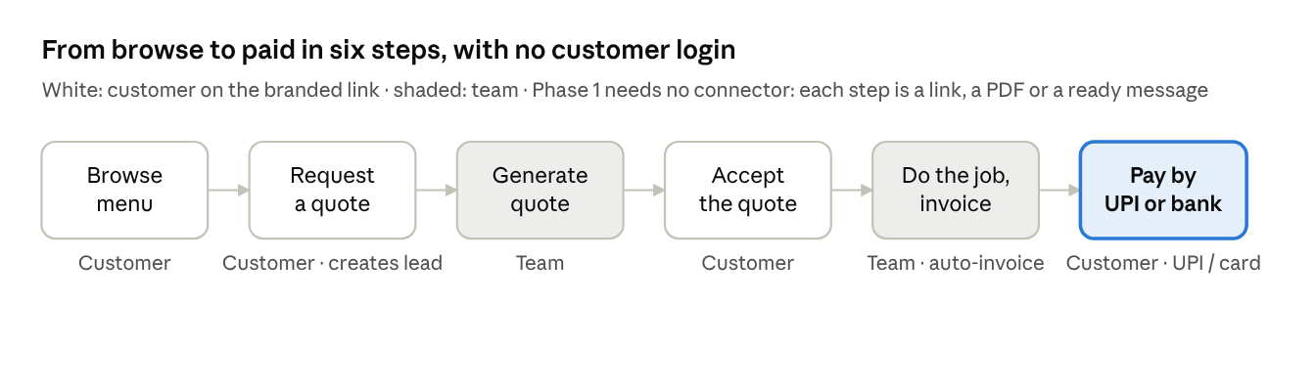
core flow · 6 steps, customer and team alternating
Every hand-off is a status change on the same record plus an email to whoever must act next (new lead to the assignee, proof waiting to the owner with an approve link, quote and invoice copies to the customer when an email is known). WhatsApp automation arrives in Phase 2; until then staff share the ready message by hand. Nothing is retyped between quote, booking, invoice and payment.

Tech stack & architecture
Multi-tenant from day one: every row carries a workspace_id, enforced in the API layer and with Postgres row-level security. Phase 1 has two external dependencies: Google OAuth and transactional email (Resend). Most code is generated by AI agents and verified by humans in a review loop, so the plan is sized in days and names what a human must verify for each package.
Layer | Choice | Phase | Why
Web app | Next.js (React, TypeScript), Tailwind, shadcn/ui; PWA with offline cache and local drafts; mobile-web first | 1 | SEO-friendly public catalog; one codebase for portal and workspace
Mobile | Expo (React Native) shell with Google login and persistent session; in Phase 1 the phone is for viewing, sharing, uploading proof, marking jobs done and creating quotes from packages via a form; full document editing is desktop / tablet only | 1 (shell), 3 (full) | Staff on Android get the jobs they need without a rich editor on a small screen
Auth | Better Auth, self-hosted on our Postgres: Google OAuth on web + mobile, persistent sessions with refresh and device list, pending invites visible to both owner and invitee, invite email editable, invite code fallback, re-auth before billing / deleting data | 1 | Standalone, no auth vendor; customers need no account (private links)
Email | Resend (one adapter, swappable): notifications to team (new lead, proof waiting with approve / reject links, quote accepted), copies to customers who gave an email, invites, magic links for My-orders | 1 | The owner never has to open the app to learn something needs them
Database | PostgreSQL (Drizzle / Prisma), row-level security per workspace | 1 | Tenant isolation; JSONB for catalog variants
Doc editor | Block editor (Tiptap / ProseMirror) for quotes and invoices on desktop: edit in place, comments, versions; a form-style line-item editor with live preview on phone; the same blocks render the web page and the PDF | 1 | Quotes behave like a doc you edit, without fighting a block editor on Android
Files & exports | S3-compatible storage (Mumbai region); server-rendered PDF, DOCX and CSV from the same React templates | 1 | Everything leaves the app as a document the owner can use by hand
Messages | Template engine producing pre-written messages per event, in the brand's voice; share via OS share sheet, wa.me deep links, mailto: | 1 | WhatsApp and SMS work with zero API setup
Payments (standalone) | Static UPI deep link + QR, bank details block; proof upload, owner approval (email link or in-app), optional threshold below which a Manager may approve | 1 | Gets money moving before any gateway contract
Admin & safety | Super-admin console (workspace lookup, suspend, support access); abuse controls on free subdomains (reserved names, report link, phishing-pattern checks); rate limits; known link-preview bots ignored when marking quotes viewed | 1 | Public pages under our domain need policing from day one
Connectors | Razorpay, Stripe, Polar for customer payments and plan billing; WhatsApp Business API; MSG91 / Twilio (OTP) — each behind one adapter; the business picks which providers to enable | 2 | Add vendors without touching generators
AI ingest | Claude API: photo of a price list, PDF, Excel, Word or a pasted message → structured catalog items, quote lines or customer records, reviewed before saving | 2 | Fastest onboarding path for a business with messy data
Theming | CSS variables generated from the workspace's brand colours; logo + colours per workspace, applied to web, PDF and messages | 1 | White-label without per-tenant builds
Infra | Vercel / Fly.io + managed Postgres; background jobs (BullMQ) for PDF generation and email; error tracking, funnel events, per-workspace audit log | 1 | Small team can run it and see where a business is stuck
Key entities: Workspace, Member, Customer, CatalogItem, Package, Lead, Quote, Booking, Job, Invoice, Payment, Message.

Pricing & business model
Per-workspace subscription with a free tier. Everything is free during the 10-day Phase 1 build and the pilot that follows; paid plans switch on with Phase 2 plan billing on all three providers, Razorpay (default in India), Stripe and Polar (merchant of record internationally); the business chooses which to enable. Prices are starting assumptions in INR; adjust after the pilot. Bookings and jobs ship in Phase 1 for everyone; whether they stay free after the pilot is a pricing decision, not a build decision.
Plan | Price | Users | Includes
Free | ₹0 | 1 | Catalog, 10 quotes + 10 invoices / month, UPI QR and manual payments, Biz4Kit badge, brand.biz4kit.app link
Starter | ₹499 / month | 3 | Unlimited quotes and invoices, custom colours and logo, no badge, gateway payment links, auto-reminders by email / WhatsApp
Team | ₹1,499 / month | 10 | Bookings and job tracking, packages, AI ingest, reports, roles, recurring invoices
Agency | ₹3,999 / month | 25 + | Multiple workspaces, custom domain, API, accounting sync, priority support, white-label emails from own domain
Other revenue: payment-gateway revenue share, SMS / WhatsApp message packs, add-on marketplace later (accounting sync, review collection).
Go-to-market: QR codes on shop counters and Instagram bios drive customers to the catalog; every quote and invoice carries a subtle "Made with Biz4Kit" link on the free plan, so each business markets the product to its peers.

MVP scope & roadmap
Phase 1 is the whole product running standalone, built in 10 days: AI agents generate the code in parallel and humans run a verification loop on every package (tests, review, a real device, an accountant for GST). External services are limited to Google sign-in and email. Phase 2 takes another 10 days to add connectors behind adapters plus AI ingest; nothing a connector does is new, it only automates a Phase 1 export. The human verification loop, not code writing, is the bottleneck; the WBS names what must be verified for each package.
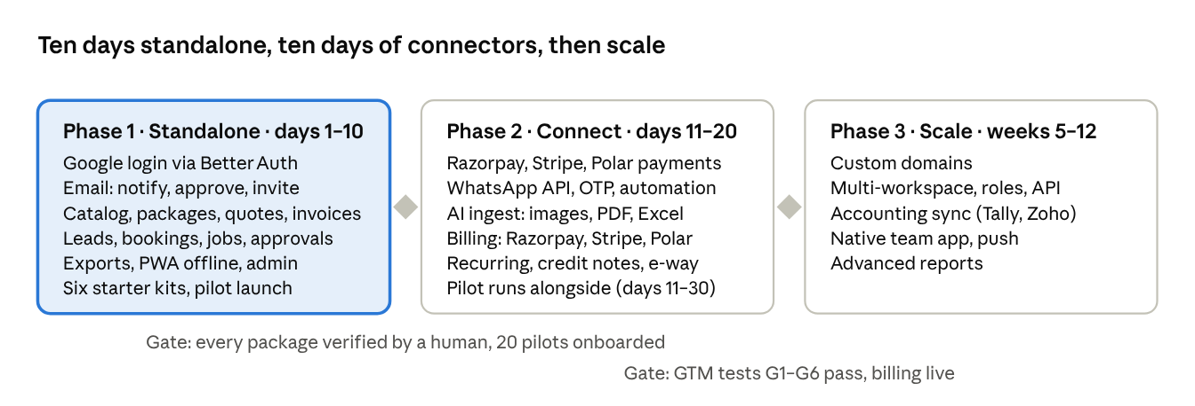
roadmap · 3 phases, 2 gates
Decisions taken
- Name: Biz4Kit (domain available)
- Launch verticals: salons, IndiaMART wholesalers, restaurants, IT services, small manufacturers, design agencies; engineering builds all six starter kits, the Biz4Kit team picks two to recruit pilots in (recommended: salons and IndiaMART wholesalers)
- Language: English only for the product and all message templates
- Timeline: Phase 1 in 10 days, Phase 2 in 10 days, AI-generated code with a human verification loop
- Email is in Phase 1: notifications, approval links, invites, customer copies
- Phone in Phase 1: view, share, upload proof, mark done, quote-from-package form; full document editing on desktop / tablet only
- Plan billing and payments: Razorpay, Stripe and Polar, all built, behind one adapter; each business enables the providers it wants
- Offline payments: any team member uploads proof (PDF or image); the owner approves in-app or from the email link; an optional amount threshold lets a Manager approve small payments
- Invites: pending invites are visible to the owner and to the invitee; the owner can edit the email; an invite code is the fallback when the Gmail differs
- No paid plan during Phase 1 and the pilot
Internal feature name: Apna Pradhan is the helper layer (remembers, reminds, speaks for the owner, guards the money). It is used by the team, not shown to customers; the product name stays Biz4Kit. Details in the Market fit & sales tab.

Gaps now in scope
Each of these was missing from the first plan and now has a WBS line.
Gap | Resolution | WBS
No notifications in Phase 1 | Email (Resend) + in-app inbox for new lead, proof waiting, quote accepted, invite | 1.6, 2.9
Approval stalls when the owner is away | Approve / reject links in the email; Manager threshold | 2.6
Rich editor on Android | Phone gets a form editor + preview; doc editor on desktop | 2.3
Offline required by NFRs but unplanned | PWA cache, local drafts, sync with conflict rules | 1.7
No mobile shell | Expo shell with Google login and persistent session | 4.3
No super-admin console | Workspace lookup, suspend, support access, audit | 3.7
Free subdomains open to phishing | Reserved names, report link, pattern checks, takedown flow | 3.8
No marketing site, terms, privacy, help | One-page site, legal pages, in-app help | 3.9
No go-to-market work | GTM verification plan below; pilot recruitment is a WBS line | 4.4
Invoice numbering and drafts | Number assigned at first share; drafts unnumbered; gap-free after | data model
Partially paid invoice could not go overdue | State machine fixed | data model
Proforma invoice missing (wholesalers) | Quote can be issued as a proforma with its own prefix | data model
E-way bills for goods above ₹50,000 | Out of scope for Phase 1; accountant review and decision in Phase 2 | 6.4
Link previews mark quotes "viewed" | Known preview bots ignored | 3.8
Google-only login lock-out | Invite visibility, editable email, invite code; owner can transfer ownership | 1.3
No cost model | Per-workspace cost sheet (email, storage, Claude API, gateway fees) | 4.5

Go-to-market verification
The pilot is an experiment with pass / fail numbers, run in the 20 days after Phase 1 ships, in the two chosen verticals.
# | Hypothesis | How we test | Pass | Fail → action
G1 | Owners will set up and share a branded catalog without help | Onboard 20 businesses (10 salons, 10 IndiaMART wholesalers) from personal outreach, Nashik first | ≥ 60% share the catalog link or QR within 24 h | Shorten Flow 1; add phone-call onboarding
G2 | Quotes get sent faster than today | Time from lead to first quote, measured in-app | Median under 10 minutes for ≥ 50% of workspaces | Fix the quote editor before anything else
G3 | Customers accept on the page | Accepted / shared quotes | ≥ 30% acceptance within validity | Study declined quotes; test trust cues
G4 | UPI QR + proof + approval is enough to get paid | Invoices paid and approved | ≥ 50% of invoices paid within 7 days; approval under 24 h | Move gateway links forward in Phase 2
G5 | Teams keep using it | Weekly active workspaces in weeks 2–3 | ≥ 60% | Interview churned workspaces; cut scope
G6 | They will pay | Ask every pilot owner for a ₹499 / month commitment at day 20 | ≥ 8 of 20 say yes | Reprice or move the free / paid line
G7 | The free badge brings new businesses | Sign-ups attributed to "Made with Biz4Kit" links | ≥ 5 organic sign-ups by day 30 | Add a referral incentive
G8 | QR on the counter is a lead channel | Leads with source = QR per workspace | ≥ 3 per salon per week | Redesign the QR card and placement
Channels to test in parallel: WhatsApp referrals from pilot owners, IndiaMART seller groups, Instagram DMs to salons, a QR counter-card kit. Each channel gets a tagged sign-up link so G7 and G8 can be attributed.

Risks & responses
Risk | Likelihood | Response
10-day timeline slips because human verification cannot keep up with generated code | High | Verification is scheduled per package in the WBS; anything unverified by day 9 is cut from the pilot, not shipped
Owner approval becomes a bottleneck | Medium | Email approve links in Phase 1; Manager threshold; gateway auto-reconcile in Phase 2
Stripe or Polar refuse service businesses in India | Medium | All three adapters are built; each business enables what works for it; Razorpay is the default
Private-link acceptance is disputed | Low–medium | Store name, phone, IP, timestamp and the exact version accepted; OTP in Phase 2
Google-only login locks someone out | Medium | Visible invites, editable email, invite code, ownership transfer; second provider in Phase 2 if needed
Phishing on free subdomains harms the brand | Medium | Abuse controls from day one; report link on every public page
WhatsApp Business verification takes weeks | High | Start Meta verification on day 1; Phase 1 never depends on it
GST or e-way bill errors on invoices | Medium | Accountant review of sample invoices before pilot; e-way bill decision in Phase 2
Six verticals dilute the pilot | Medium | Kits for all six, pilots in two
No revenue in the first 20 days | Accepted | Free by design; G6 tests willingness to pay before billing is built
Work breakdown structure with effort and dependencies: WBS
Documents to read before design: Design inputs
Market fit, moat, sales team and emotional selling: Market fit & sales
Build workflow, security, PII and the final go / no-go gate: Workflow & final verification
Build workflow, security, PII and the final go / no-go gate: Workflow & final verification
Architecture, API contract, adapters, acceptance criteria, test plan and vendor checklist: Architecture & contracts
Legal and compliance drafts for lawyer and CA review: Legal & compliance
Business plan, unit economics, pilot tracker, support, CA programme and hiring: Business plan

